Warehouse Design

I declare that this assignment is all my own work and that I have acknowledged all materials used from the published or unpublished works of other people. All references have been duly cited.
1.0 Introduction
1.1 Sealy’s Logistics is an Ecommerce fulfilment and logistics service company based out of Croydon, United Kingdom. We are offering businesses of various sizes the opportunity to offer its clients a 2-day shipping option alongside selling their products using their own websites but leaving the services such as packaging, labelling, shipping, tracking, order picking and inventory to us. Our potential customers can rest assured that they will get the most professional and quality service at the best and most competitive prices. The safety and care of the customers products are one of our top priorities. This project is going to cost £172,000 and this covers all the start-up costs including, sourcing of vehicles, staff, licenses, equipment and advertising.
1.2 Gerean Sealy the owner of this business is the project manager and is set to design the warehouse to meet his company’s customer service, business and staff requirements by using the following guidelines as a handrail to success;
1.2.1 Select the most appropriate warehouse processes.
1.2.2 Select the most appropriate warehouse resources.
1.2.3 Plan an optimal warehouse layout.
1.2.4 Evaluate and select the most appropriate warehouse handling and storage equipment.
1.2.5 Identify the legal and security requirements.
1.2.6 Develop and implement a financial budget for the warehouse operation.
1.2.7 Produce a financial report to show outcomes against warehouse operation.
1.2.8 Implement a warehouse contingency plan.
1.3 Using the above mention methods Sealy’s Logistics warehouse will be one of the best in the market giving it the competitive advantage over its competitors.
2.0 Warehouse Processes
2.1 Warehousing is the storage of good until required with the objective of holding minimum inventory that contributes to the most profits. The operations within the warehouse are to ensure the seamless flow of stock and information to satisfy the needs and requirements of the customer. Warehouse operation plays a vital part within the supply and distribution chain.
2.2 Products arriving at a warehouse subsequently are taken through a number of steps called processes. That flow within the warehouse can be divided into several distinct processes as warehouse operations have a fundamental set of activities in common (Frazelle , 2002)such as;
2.2.1 Receiving
2.2.2 Put-away
2.2.3 Storage
2.2.4 Order Picking
2.2.5 Packaging
2.2.6 Shipping
2.3 Receiving: This is the first process within the warehouse on arrival of goods. This is the unloading of goods from transportation into the warehouse. The following processes and procedure are to be carried out during the receipt process;
2.3.1 Unloading: Goods are to be unloaded from the delivery vehicle at the receipting bay by material handling equipment and placed into the staging area.
2.3.2 Quality Control: Goods are to be checked for damage to stock in the presence of the delivery driver and meticulous records are to be kept on the condition of the stock.
2.3.3 Counting: The quantity of the goods delivered must be checked against receipt documentation to ensure the correct quantity of the shipment has arrived. If there are any discrepancies this is to be documented, then flagged up to the supervisor immediately and the supplier is to be informed immediately to have the products replaced or investigated.
2.3.4 Scanning: Supplier shipping notice is to be scanned along with barcodes of goods to receipt it into stock. This scan will then update the Warehouse Management System giving the warehouse real time stock data and receipt information. It will also give the operator carrying out the receipt the stock location data for put-away.
2.4 Put-away: Commences after the delivery have been accounted for and items receipted. After the stock is receipted the warehouse management system will trigger a put-away task. The items are then re-scanned, and the stock location will then appear. This process is necessary as put away can reduce the time needed for the storage personnel to do their job. As care needs to be taken with some goods, they can be placed into storage directly by put-away staff.
2.5 Storage: The placement of stock within a location in the warehouse. Storage location assignments influences almost all key warehouse KPI’s i.e: order picking time, cost, inventory accuracy and shipping. There will be 2 types of storage areas and they are as follow;
2.5.1 Reserve Area: For bulk storage of pallets and other bulk items.
2.5.2 Forward Area: Where smaller items will be located on shelves.
2.6 Order Picking: A process of retrieving items from warehouse storage locations to satisfy customers orders (Coyle, Bardi, & Langley , 2003). With the assistance of the Warehouse management system and electronic data interchange (EDI) when a demand for an item is received an electronic order picking list will be sent to the picker device from the supervisor containing the item, quantity and location. Stock is then selected maintaining a good flow of stock rotation first in first out. The items will then be retrieved from the storage locations and brought to the packing area.
2.7 Packaging: After the picking of stock, the stock will be brought to the packaging section. There personnel will cross check the items picked against the order also carrying out a quality assurance check ensuring that there are no damaged items. The goods are then packed within and outer package to add an extra layer of security and protection so that the products arrive to the end user undamaged. This is necessary to save cost on item replacement and reverse logistics.
2.8 Shipping: The packages are then labelled, scanned and dispatched for ease of tracking. The item is then brought to the shipping area where it will be loaded to the delivery vehicle.
3.0 Warehouse Design
3.1 We are designing a warehouse to make maximum use of the real estate provided. To start up this project Sealy’s Logistics have made the decision that they are going to lease the material handling equipment as the technology and styles of these equipment gets upgraded annually. Leasing will give the company the option to exchange the equipment if a new and better version or model was to hit the market. We are then going to purchase the storage system as it gives the company the control over its maintenance, the options of selection and doesn’t bind them into a long contract. The following item was selected for use within the warehouse;
3.1.1 A combination of Reach trucks and Narrow Aisle forklifts. This will give the company the maximum use of the items both indoors and outdoors whilst using a smaller workspace requirement.
3.1.2 The Pallet Live storage system is going to be installed in the warehouse because it gives us 100% efficiency in stock control and rotation along with the best utilisation of the floor area. It also is very efficient with stock throughput speed, good access to loads and can be used with standard material handling equipment.
3.2 At Sealy’s Logistics our selection of material handling equipment is aimed at;
3.2.1 Promoting safety and improving working conditions.
3.2.2 Increasing productivity.
3.2.3 Controlling inventory.
3.2.4 Reduce damage and improve on quality.
3.3 For the selection of our material handling equipment we decide between 3 different variants i.e: Counterbalance forklift truck, Power operated Stackers and Reach trucks and Narrow aisle trucks ( man up and man down).
3.3.1 Counterbalanced Forklifts requires a 4m working aisle width and has a 10m high reach.
3.3.2 Power Stackers require a 3m working aisle and has a 6m high reach.
3.3.3 Reach trucks require a 3m working aisle and has a reach height of up to 10m.
3.3.4 Narrow aisle trucks require a 2m working aisle and has a reach height of up to 12m.
3.4 For the selection of our storage equipment we considered 7 options. Within the tables below each tick in the performance column represents 20%. This information was collated from the link 51 guidelines. https://www.ribaproductselector.com/Docs/5/04685/external/COL422885.pdf. The example below at figure 1 demonstrates the Pallet Live Storage.

Description | Performance
Space Utilisation of floor area | 
Utilisation of cubic storage
Access to individual pallet loads
Speed of access and throughput
Efficiency in stock rotation
Efficiency in stock control
Specialised handling equipment | None Required
Ease of relocation
Ease & Speed of installation
Adjustability of beam positions | Not Required
Figure 1. Storage system performance checklist.
3.4.1 Adjustable Pallet Racking: Gives 100% access to every pallet with a 60% utilisation of floor space, 60% speed of access and throughput, 80% stock rotation and 80% efficiency in stock control.
3.4.2 Double-Deep Pallet Racking: Gives 60% access to every pallet with an 80% utilisation of floor space, 60% speed of access and throughput, 60% stock rotation and 60% efficiency in stock control.
3.4.3 Narrow Aisle Pallet Racking: Gives 80% access to every pallet with an 80% utilisation of floor space, 80% speed of access and throughput, 80% stock rotation and 80% efficiency in stock control.
3.4.4 Push-Back Pallet Racking: Gives 60% access to every pallet with an 100% utilisation of floor space, 40% speed of access and throughput, 80% stock rotation and 40% efficiency in stock control.
3.4.5 Drive-In Pallet Racking: Gives 20% access to every pallet with an 100% utilisation of floor space, 40% speed of access and throughput, 40% stock rotation and 60% efficiency in stock control.
3.4.6 Mobile Pallet Racking: Gives 100% access to every pallet with an 100% utilisation of floor space, 20% speed of access and throughput, 40% stock rotation and 80% efficiency in stock control.
3.4.7 Pallet Live Storage: Gives 60% access to every pallet with an 100% utilisation of floor space, 80% speed of access and throughput, 100% stock rotation and 100% efficiency in stock control.
3.5 The warehouse is controlled by a one-way system for delivery vehicles to assist with complicated manoeuvres of large vehicle. Most vehicle using European roads have to be able to turn within the space between an inner circle of 5.3m radius and an outer circle of 12.5m radius (HSE, n.d.).
3.6 The warehouse is situated on 4500 sq. ft of land secured with a 200m x 200m wide compound providing enough space for the manoeuvring of goods vehicles within a secured compound. There is a car park to the front for customers and staff.
3.7 The warehouse is laid out to maximize the functions, so we can achieve the best space utilization and efficiency. The layout gives warehouse staff shorter distances to travel to place stock in storage after receipt which in turn maximises the speed of stock replenishment and order picking for dispatch to the customers. The layouts can be seen in figure 2.
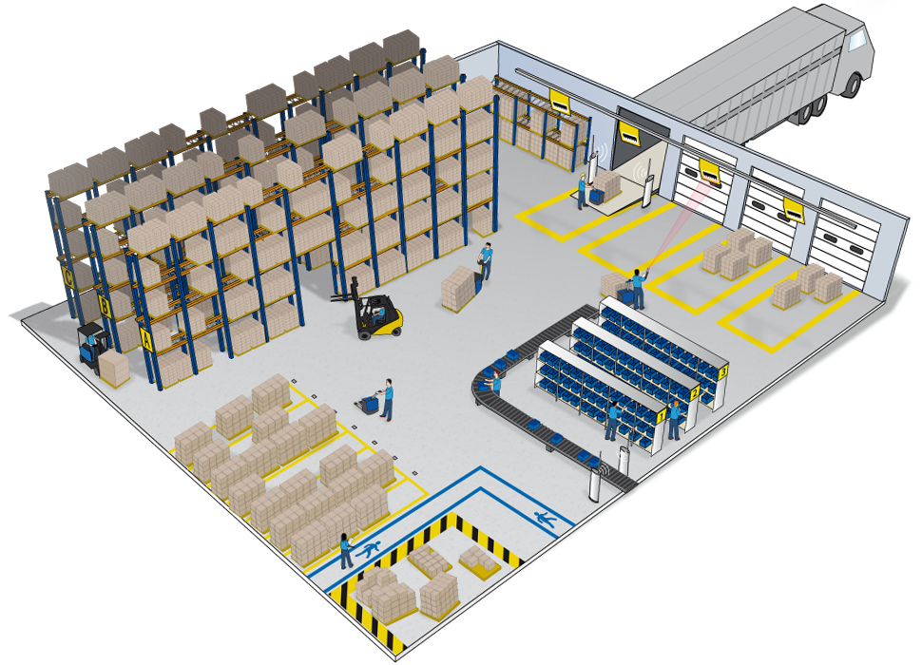
Packaging and Dispatch
Receiving
Storage
Shipping
Figure 2 Warehouse Layout
3.8 The warehouse has a combination of bulk storage and racking and shelving. This will accommodate bulky products and hazardous stores or stores which require separation.
3.9 Access to stock is a top priority in the layout of the warehouse. The flow of traffic for stock will adopt the U flow as depicted in figure 3.
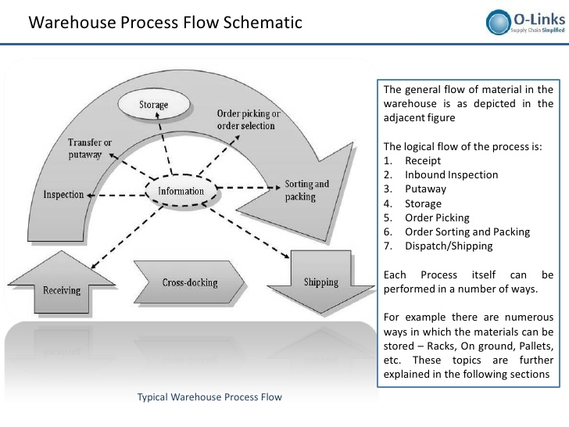
Figure 3 Product flow within warehouse.
3.9 The U flow will follow this logical process;
3.9.1 Receiving and Inspection
3.9.2 Put-away
3.9.3 Storage
3.9.4 Picking
3.9.5 Packaging
3.9.6 Shipping
4.0 Warehouse Security and Legal Requirements
4.1 There are rules and guidelines in place for the health and safety of both employees and employers. Due to the various risks that lies within working in the warehousing industry for example;
4.1.1 Slips and trips
4.1.2 Falling objects
4.1.3 Working at heights
4.1.4 Hazardous substances and fires
4.1.5 Manual Handling
4.1.6 Being hit by moving vehicles.
4.2 The company is going to make sure that the following requirements are adhered to;
4.2.1 Health and safety policies( Health and safety at work act 1974): This will entail the policy statement, health and safety risks, responsibilities, information, supervision and instructions, competency for tasks and training and accident and emergency procedures.
4.2.2 Risk assessments (management of health and safety at work regulations 1999 and Manual handling operations regulation 1992): These will cover the identifying of hazard, decide who and how they may be harmed, evaluate the risks and decide on precautions for staff, contractors and visitors.
4.2.3 Accident reporting (Reporting of Injuries, Diseases and Dangerous Occurrences Regulation 1995): Log books will be kept reporting all accidents or near misses in the work place.
4.2.4 Workplace Transport: Vehicles are properly maintained, drivers are trained, authorised and there are suitable, routes and parking.
4.2.5 Work Equipment (Provision and use of work equipment Regulations 1998): Ensures that all equipment is safe for use, suitable for use, operated by trained personnel.
4.2.6 Lifting equipment and forklift trucks (Lifting operations and lifting equipment regulations 1998): this law requires that equipment provided for use is strong and able for its intended use displaying its safe working loads, items are used safely and is subjected to thorough inspections and examinations.
4.2.7 Working at heights (Work at heights regulation 2005): Ensures that work at heights are planned and supervised adequately. Also, making sure that the equipment selected is correct for the job.
4.2.8 Security plan: this is required to check the physical security, standing operating procedures, data security, visitors, personnel training and security.
4.3 The physical security of the warehouse should include;
4.3.1 Barriers to prevent unauthorised entries
4.3.2 Alarms and CCTV systems
4.3.3 Perimeter security including fences, lights and security guards
4.3.4 Locking devices and key controls which will lock gates, doors and windows
4.4 Roving patrol internally by security team at irregular intervals to deter theft of stock by staff.
4.5 Restricted access is to be given to personnel based on their department or work zones.
5.0 Contingency Plans
5.1 Contingency plans have been drafted and implemented for this site and they are as follows;
5.1.1 There is a dedicated area away from the current standing building dedicated for the construction of a temporary building in case of a fire or any other unforeseen circumstances were to affect the main warehouse.
5.1.2 Sprinkler systems have been installed throughout the warehouse.
5.1.3 The data from the warehouse management system is backed up daily and kept offsite.
5.1.4 There is a generator installed in case of a power outage so that the processes can continue.
5.1.5 To deter theft there is CCTV installed within and around the warehouse as well as security officers.
5.1.6 Risk assessments are in place to minimise risk of injury and harm.
5.1.7 First aid training have been delivered to all staff, so they can perform basic life support in case of emergencies.
5.1.8 There are a stock of empty 20ft containers in the compound from delivery in case temporary storage is required.
5.1.9 To assist with the uncertain demand of stock safety stock is held at the supplier’s depot and we also have a second supplier in the case the original supplier can’t meet demand.
6.0 Financial Budget and Outcome

6.0 Financial Budget and Outcome
PLANNED EXPENSES | JAN | FEB | MAR | APR | MAY | JUN | JUL | AUG | SEPT | OCT | NOV | DEC | YEAR
Employee Costs | Start-up | Feb | Mar | Apr | May | Jun | Jul | Aug | Sep | Oct | Nov | Dec | YEAR
Wages | £14,000 | £14,000 | £14,000 | £14,000 | £14,000 | £14,000 | £14,000 | £14,000 | £14,000 | £14,000 | £14,000 | £17,000 | £171,000
Subtotal | £14,000 | £14,000 | £14,000 | £14,000 | £14,000 | £14,000 | £14,000 | £14,000 | £14,000 | £14,000 | £14,000 | £17,000 | £171,000
Warehouse Cost | Jan | Feb | Mar | Apr | May | Jun | Jul | Aug | Sep | Oct | Nov | Dec | YEAR
Licensing | £700 | £0 | £0 | £0 | £0 | £0 | £0 | £0 | £0 | £0 | £0 | £700 | £1,400
Warehouse Lease | £3,700 | £3,700 | £3,700 | £3,700 | £3,700 | £3,700 | £3,700 | £3,700 | £3,700 | £3,700 | £3,700 | £3,700 | £44,400
Gas & Electric | £600 | £600 | £600 | £450 | £450 | £450 | £450 | £450 | £600 | £600 | £600 | £600 | £6,450
Water | £100 | £100 | £100 | £100 | £100 | £100 | £100 | £100 | £100 | £100 | £100 | £100 | £1,200
Professional Expenses (legal fees) | £2,000 | £350 | £350 | £350 | £350 | £350 | £350 | £350 | £350 | £350 | £350 | £350 | £5,850
Insurance | £1,000 | £150 | £150 | £150 | £150 | £150 | £150 | £150 | £150 | £150 | £150 | £150 | £2,650
Telephone & Internet | £350 | £350 | £350 | £350 | £350 | £350 | £350 | £350 | £350 | £350 | £350 | £350 | £4,200
Vehicle running cost | £2,000 | £2,000 | £2,000 | £2,000 | £2,000 | £2,000 | £2,000 | £2,000 | £2,000 | £2,000 | £2,000 | £2,000 | £24,000
Office supplies & Equipment | £13,000 | £200 | £200 | £200 | £200 | £200 | £200 | £200 | £200 | £200 | £200 | £200 | £15,200
Storage Equipment | £50,000 | £0 | £0 | £0 | £0 | £0 | £0 | £0 | £0 | £0 | £0 | £0 | £50,000
Maintenance | £3,000 | £0 | £0 | £0 | £0 | £1,500 | £0 | £0 | £0 | £0 | £1,500 | £0 | £6,000
Vehicle Purchase | £70,000 | £0 | £0 | £0 | £0 | £0 | £0 | £0 | £0 | £0 | £0 | £0 | £70,000
Loan Repayment | £2,000 | £2,000 | £2,000 | £2,000 | £2,000 | £2,000 | £2,000 | £2,000 | £2,000 | £2,000 | £2,000 | £2,000 | £24,000
Security | £1,500 | £0 | £0 | £0 | £0 | £0 | £0 | £0 | £0 | £0 | £0 | £0 | £1,500
Subtotal | £149,950 | £9,450 | £9,450 | £9,300 | £9,300 | £10,800 | £9,300 | £9,300 | £9,450 | £9,450 | £10,950 | £10,150 | £256,850
Marketing Costs | Jan | Feb | Mar | Apr | May | Jun | Jul | Aug | Sep | Oct | Nov | Dec | YEAR
Web site hosting | £150 | £150 | £150 | £150 | £150 | £150 | £150 | £150 | £150 | £150 | £150 | £150 | £1,800
Collateral preparation | £1,500 | £0 | £0 | £1,500 | £0 | £0 | £1,500 | £0 | £0 | £1,500 | £0 | £0 | £6,000
Collateral printing | £200 | £200 | £200 | £200 | £200 | £200 | £200 | £200 | £200 | £200 | £200 | £200 | £2,400
Marketing events | £2,000 | £0 | £1,300 | £0 | £0 | £1,300 | £0 | £2,000 | £0 | £0 | £1,500 | £2,000 | £10,100
Miscellaneous expenses | £200 | £200 | £200 | £200 | £200 | £200 | £200 | £200 | £200 | £200 | £200 | £200 | £2,400
Subtotal | £4,050 | £550 | £1,850 | £2,050 | £550 | £1,850 | £2,050 | £2,550 | £550 | £2,050 | £2,050 | £2,550 | £22,700
Training/Travel | Jan | Feb | Mar | Apr | May | Jun | Jul | Aug | Sep | Oct | Nov | Dec | YEAR
Training classes | £2,000 | £0 | £0 | £0 | £0 | £0 | £0 | £0 | £1,000 | £0 | £0 | £0 | £3,000
Training-related travel costs | £2,000 | £0 | £0 | £0 | £0 | £0 | £0 | £0 | £900 | £0 | £0 | £0 | £2,900
Subtotal | £4,000 | £0 | £0 | £0 | £0 | £0 | £0 | £0 | £1,900 | £0 | £0 | £0 | £5,900
TOTALS | Jan | Feb | Mar | Apr | May | Jun | Jul | Aug | Sep | Oct | Nov | Dec | Year
Monthly Planned Expenses | £172,000 | £24,000 | £25,300 | £25,350 | £23,850 | £26,650 | £25,350 | £25,850 | £25,900 | £25,500 | £27,000 | £29,700 | £456,450

References
Coyle, J. J., Bardi, E. J., & Langley , C. J. (2003). The Management of Business Logistics: A Supply chain Perspective, 7th ed. Ohio: South Western, Mason.
Frazelle , E. H. (2002). Supply Chian Strategy: The Logistics of Supply Chain Management. McGraw-Hill.
HSE. (n.d.). Health and Safety Executive Site Safety. Retrieved from hse.gov.uk: http://www.hse.gov.uk/workplacetransport/vehiclehandling.htm
Tompkins, J. A., & Smith, J. D. (1998). The Warehouse Management Handbook 2nd Ed. In The Warehouse Management Handbook 2nd Ed. (p. 255).

