Introduction Outdoor Environments for Children's Scientific and Mathematical Learning

This portfolio explores the use of outdoor environments in early years’ education to support children's scientific and mathematical thinking. It discusses the potential of outdoor spaces, their risk-benefit assessment, and adult roles in facilitating learning. The portfolio uses theories, research, and pedagogical approaches to highlight the rich opportunities’ nature offers for curiosity-driven, experiential learning in science and mathematics.

The outdoor area image selected for this portfolio is a natural playground that provides a variety of learning experiences for young children. A variety of natural materials, including logs, stones, and branches, are found across the area, along with permanent and loose elements including wooden climbing frames a sandpit, and a woodland area with raised beds. Tall trees that cast shadows and produce captivating patterns of light on the ground.
This well-planned outdoor space promotes exploration and discovery and offers children a rich environment in which to playfully interact with scientific and mathematical ideas. Numerous opportunities for sensory experiences and enquiries are provided by the diverse textures, shapes, and materials, and the open-ended nature of many elements encourages imaginative play and creative problem-solving.
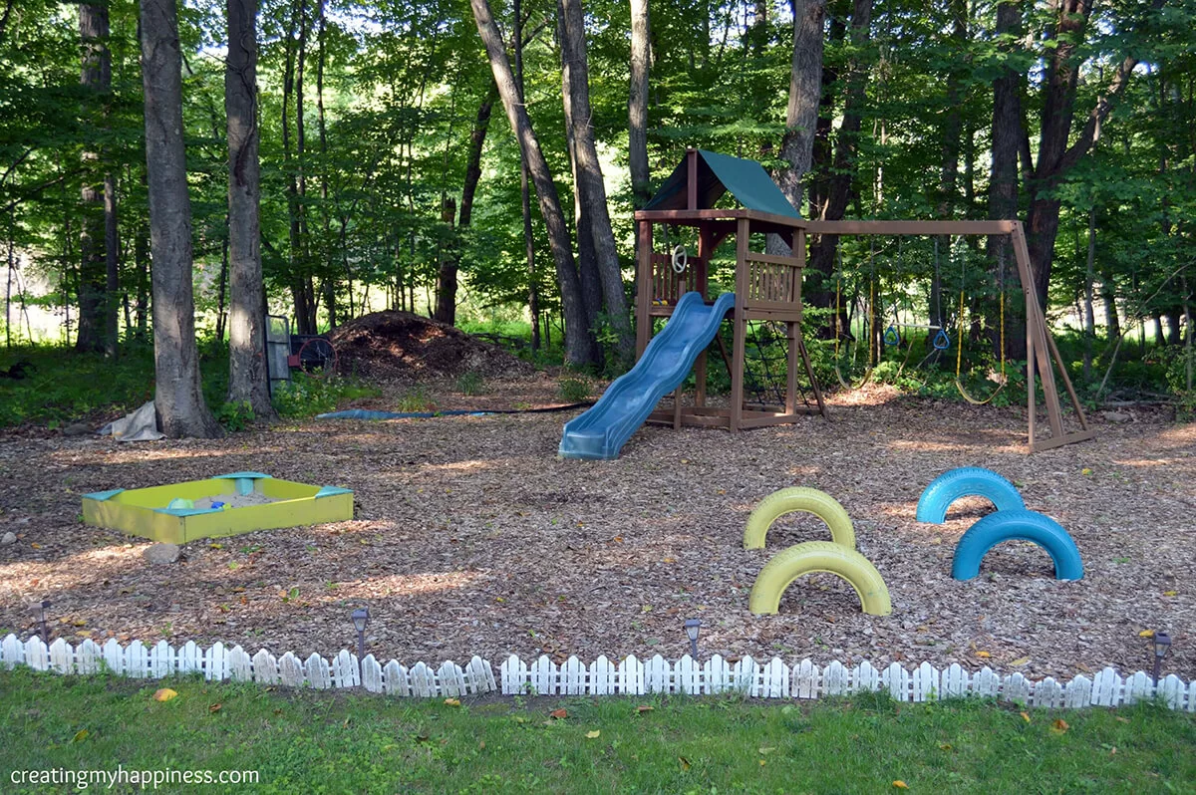

Part 1

Part 2
My pedagogy of teaching with a hook to spark their curiosity!!


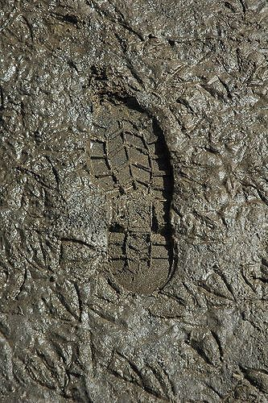


(Source: Theuniss, 2022) Source: Little T, 2024) Source: blé, 2024)

The Nursery class arrive at 8.45am, I prepared some muddy footprints through the class heading to the outside area to gain their attention and curiosity on arrival.
“Miss, who’s been here” I hear one little three-year-old boy shout. “It is footprints” I hear another little girl say. They chat to each other, and I listen from behind, more children arrive and again all question who’s been in their class. I can see from their faces they are curious and so out adventure today begins.
I call the children to the carpet area and allow them time to share their thoughts and ideas, use their imagination and discover whose footprints they think have been left over our classroom floor. One little boy shouted “I think Santa was here” I smiled and replied why do you think that? He replied innocently“ Santa comes at night” another little girl said, “have we been burgled” I looked back surprised “oh I don’t think anything is missing, can you see anything missing? ” they looked around the classroom and their little eyes scanned the corners of the classroom, one little girl shouted “Miss Tedi Twt has gone from his chair”. Tedi Twt is our class Tedi, and he gets to go home with a child every week for the weekend. He was missing!!


I sent the children to collect their coats as it was a little cold outside. There were twenty-two children nursery age, me and two teaching assistants. Our aim for today was to use observation, ask open-ended questions, provide further resources that they may ask for, support them when they require it, avoid interrupting their play and exploration and document to capture the children learning processes therefore we could revisit these observations with the children to deepen understanding and plan future explorations.

I said let us follow the footprints and see if we can find Tedi Twt!!! (Source: Tes.com, 2023)

The children were excited, their little faces showed happiness, excitement, and curiosity. Some were a little too excited, so I had to remind them that we must walk and not run.
We followed the footprints out of the classroom and along the ramp to the outside area, the footprints were even clearer outside and looked like giants’ feet according to one of the children, I asked why they thought they were giant’s feet,
And he replied, “they are big, big, big! Miss.” Yes, they are big, do you have big feet” I asked “No, I have little feet” the opportunity to compare sizes of big and small from a child’s observation was made, I drew this to the attention of the other children so they, so could compare their own feet to the big giant feet that they could see.
We walked on and what the children were not aware of the new outdoor play area that had been build.
They froze!!! I stopped them from going any further, and before I had the opportunity to say anything a little boy said, “the giant must have brought this for us” I smiled and said, “well he’s a very kind giant isn’t he.”
Tedi Twt was sat on the swing enjoying himself and the children walked into the new outdoor area in awe and wonder!!

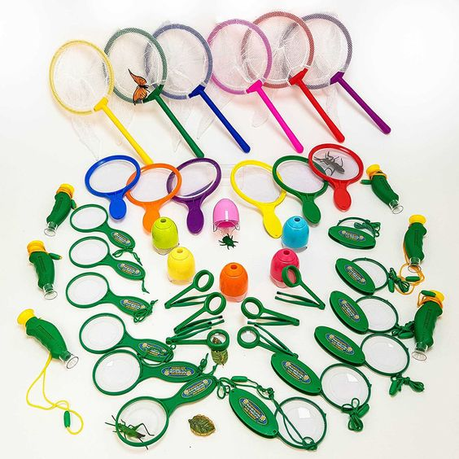
The area was secure, and the children could not wonder and get lost, if they could, I would discuss the dangers of wondering and to stay close to the adults. The children were eager to explore and learn through play, I discussed being careful of the new surfaces, to walk and familiarise themselves with the uneven surfaces. To be careful of low branches not to run into them and hurt themselves, not to put anything in their mouths and be mindful of living things such as insects, worms, slugs, and snails that could be living in here and to be kind. Most of all enjoy themselves, explore and have lots of fun.
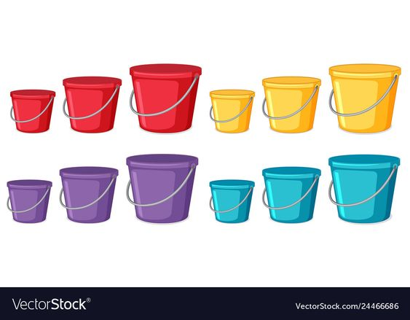

(Source: Pinterest, 2022)

I had added some buckets in assorted sizes and spades to the sandpit area for the children to use, I provided magnifying glasses, collection pots and other mini beast hunt equipment that may wish to use.
The children separated and led themselves to the areas that gained their curiosity the most, the adults also separated to observe and support the children in the different areas.
The climbing frame gained the attention of a group of little 3-year-old boys, they climbed to the top in a flash and slide down as fast as they could, they took turns they helped each other by taking turns and their enjoyment was clear by their facial expressions. It was Child A turn to go down the slide when I saw his eyes widen, and he started investigating the roof of the climbing frame, a spider’s web had filled the inside with web! he shouted to child B“ Spider-Man has been here, he webbed this roof” child B looked up and said “wow”!!

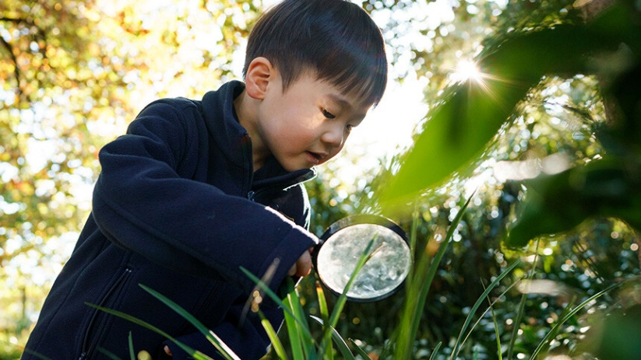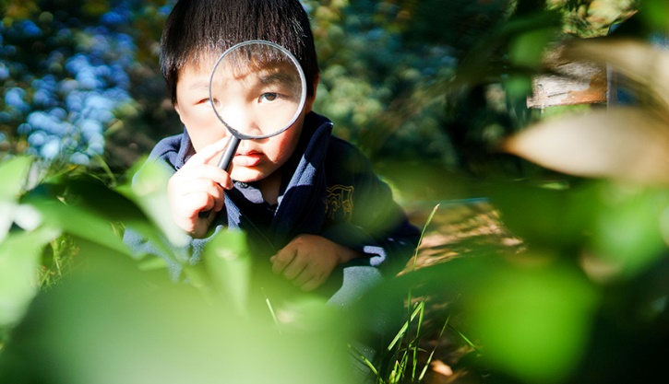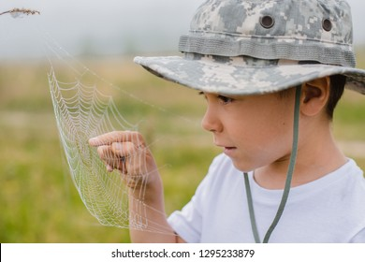
(Source: Burdan, 2022) (Source: Shutterstock.com, 2024)

There is the spider look and pointed up at the spider. “ Do not kill him” he added, I will go get the magnifying glass, so we can look at him, “we can call him Spider-Man.” One of the little boys held the magnifying class upside down, I modelled how to use it, and he copied. They took turns to look through the glass and I asked,“ what can you see?” Child A replied“ I can see his web” I continued, can you see any shapes or patterns? “Yes, he smiled, I can see circles and triangles” child B joined the conversation and said ”the pattern gets bigger and bigger” well done I praised them both that’s good-looking skills, unaware they were learning about, shapes, patterns, and sizes. By open ended questions children are encouraged to observe, think, and reflect on what they are doing. How many legs has he got ? They looked and counted.

They smiled and carried on playing, let’s play Spider-Man and have a race to see who is the fastest he said, child A slide down the slide and ran to climb back up the climbing frame whilst child B began to count 1,2,3,4,5,6, another few children joined the counting 7,8,9,10,11,12 STOP child A was back, your turn. GO! And the fun, the competitiveness the use of sequencing and counting continued but to them, they were just playing.

(Source: Learningandthebrain.com, 2024)

A living environment for examining plant development, insect life cycles, and seasonal changes are provided by the garden area and surrounding vegetation. Children can take part in tasks including sowing seeds, tracking their progress, and recognising the native plants and animals. They can also observe plant growth, insect behaviour, and soil composition, fostering a connection with nature and understanding of the ecosystem.
The climbing frame is an excellent outdoor laboratory for young scientists, allowing them to explore forces, motion, and ecology. It incorporates real-world mathematical problems, enhancing engagement and critical thinking skills, and promotes deeper understanding of maths and teamwork.

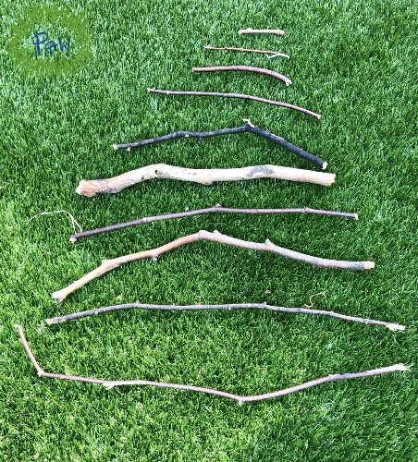
Near the climbing area two little girls were collecting sticks and stones in the woodland area, I could hear them talking and one of them said let us get a bucket from the sandpit, over they went took two buckets and continued to collect their natural treasures. I asked what they were going to do with all their items and one replied “I am going to sort them out” curious I said oh can I see, and she replied “yes, I am going to put them in order from the smallest to the biggest“ . Naturally, children use their imagination and use mathematical concepts without realising. One simple method of applying your mathematics teachings outside the classroom is to use sticks to compare lengths! Through comparing the lengths of sticks, they can start to learn about size and length. It is simple to conduct this exercise with children of different ages. Young children can compare two sticks at the most basic level. Which one has the longest length? Which is the shortest?
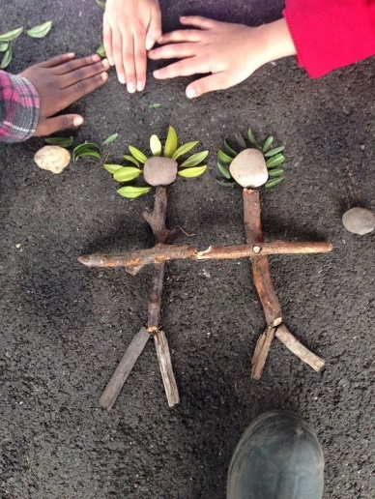

(Source: Family Trails, 2015) (Source: Sabrina, 2019)

The little girl had other plans with her sticks, she wanted to keep them, so we could build a fire if it got cold, so we could warm our hands and roast marshmallows as she had done that with her dad when they went camping and really enjoyed it. She had made that connection to an experience and was using her knowledge which is amazing. Intrigued I asked how we would start the fire, and she said “Dad showed me how to rub stones together” I was the one amazed! Waw, I replied that is a wonderful idea, but we would have to be incredibly careful would not we.
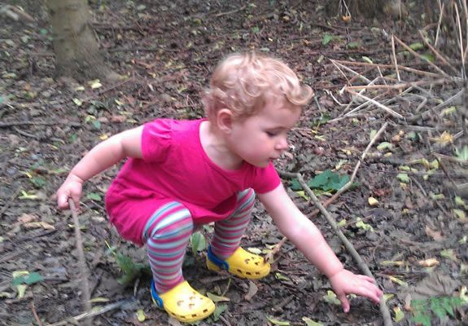

(Source: Hind, 2016)

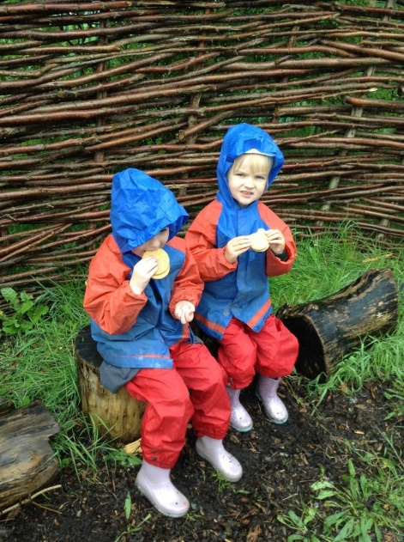
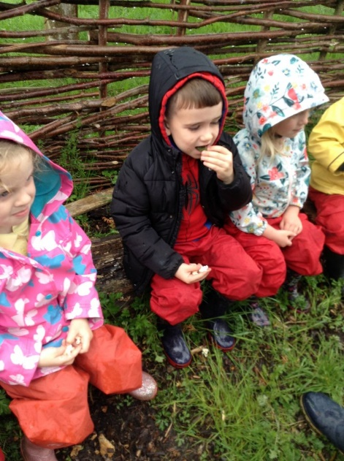
It was snack time, so all the children washed their hands, we discussed the importance of washing hands after being outdoors, they remembered the experiment we recently did with the pepper and soap learning about germs. We sat in a circle to eat cookies and drink milk together. As we sat together, I began to tell them a story, I had no book and explained they needed to use their imagination. We had practiced this previously, and they knew and understood. Storytelling boosts playtime, language development, memory, listening skills, emotional exploration, empathy, social bonds, communication, self-expression, imaginative play, cognitive development, motor skills, and spatial awareness. Children get the opportunity to act and repeat stories in the outdoors such as going on a bear hunt.
(Source: Harlowgreen.org, 2023)

After the story I asked the little boys to tell the other children what they found in the climbing frame and what they had named it, supporting sustained shared thinking, they were immensely proud of themselves and felt valued having the opportunity to share with the other children.
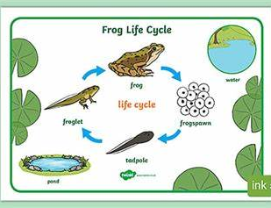
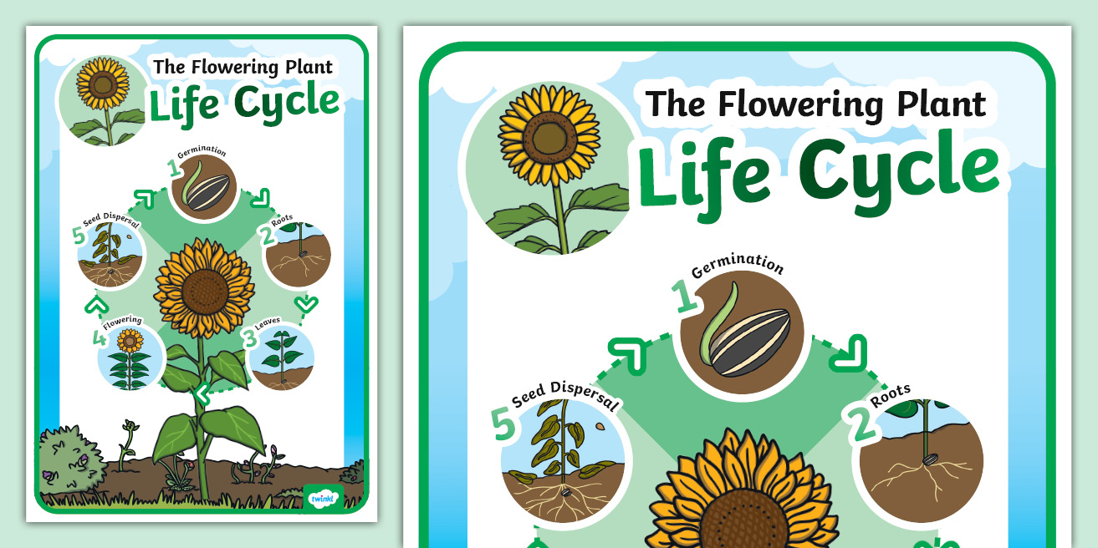
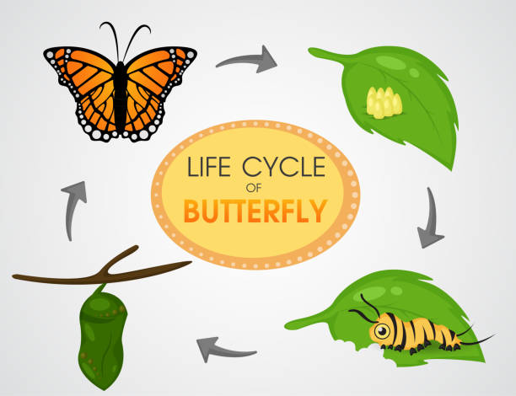
(Source: Twinkl, 2024)

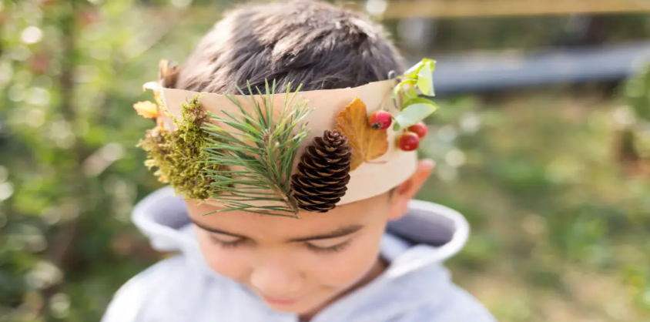
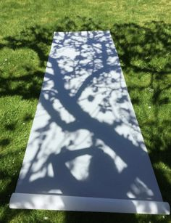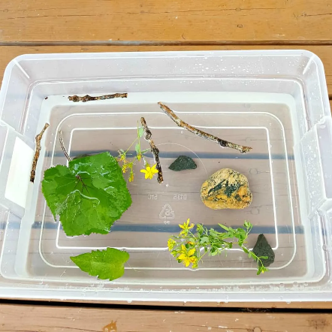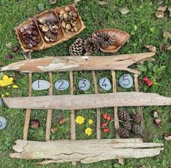

Part 3
RISK BENEFIT ASSESSMENT

Location / Activity: | Woodland / climbing frame/ sandpit. | Date:
Assessor: |  | Review date:

Your overall risk rating – Low, medium, or high – is based on your judgement about whether the BENEFITS of the activity or opportunity outweigh the RISKS.

Experience exploring outdoor space in photograph | How will young people BENEFIT from this activity? | Hazards and associated risks | Who is at risk? | PRECAUTIONS in place to reduce the risk of injury | Overall risk after precautions  RATING: L/M/H
Climbing frames, slides, swings, and uneven surfaces. | Physical development – children develop strength, muscle, balance, and cardiovascular health during physical activity growing into healthy, confident individuals.  Spatial awareness, taking risks and making their own risk assessment, supporting self-care.  Climbing improves hand and eye coordination.  Children learn to take turns and socialise on the equipment.  Climbing builds their confidence skills, as well as developing problem solving and critical thinking skills.  Slopes allows for children to be aware of gradients, movement, rolling, sliding. | Children may have falls, bumps, cuts, and bruises or other injuries. | Children and adults | Regular maintenance of structures and surfaces. Adult supervision and discussion before the children explore explaining that they should walk slowly and familiarise themselves with the area first. Appropriate clothing and footwear should be worn.  First aid Kit available if required. | L
Loose materials (sticks, stones etc)  Sand pit | Children can explore the materials they find and choose for themselves that they will use them for.  Multi-sensory experiences.  Improves children's Creativity skills and problem solving. Encourages open ended learning and questions.  Natural materials support curiosity and imagination and supports children's fine motor skills.  Some schemas are supported such as exploration with numbers. Children can count, order, compare | Tripping, throwing of materials and injuries | children/adults | Clear instructions and guidelines for safe usage.  Regular inspection of areas for any sharp objects. | L
Woodland area- children exploring what they see | The woodland area supports children to learn at their own pace, supporting impendence and accomplishment.  The children get the opportunity to gain experience about living things such as flowers, plants and insects and becoming aware of other living things and their life cycles, supporting them becoming ethical citizens and being kind to other living things.  The outdoor space encourages gross motor skills and physical movement such as running, jumping, skipping and dance.  Promotes the Children’s self-esteem, creativity and has a calming influence over children that may struggle with focus and attention.  The woodland enables supported risk taking with enterprising, creative contributors.  child centred learning, exploration and learning through play and experiences. | Exposure to soil, or low-level branches from trees. Bacteria, and plant allergies.  Insect bites and stings.  Awareness of poisonous plants or plants that cause irritations to the skin such as stinging nettles. | Children/adults | Adult supervision, discussing boundaries with the children so they are aware of exactly where they can go and where they are not to go.  Discuss the importance of not putting anything in their mouth, including their fingers and making sure Hand washing facilities are available. | L
Weather exposure | Opportunities for Seasonal awareness, and the weather, building on their vocabulary.  Songs and rhymes about the weather encouraging language skills and actions such as dail y coed sy’n cwympo lawr, rain rain go away, can y tywydd etc.  Opportunities to understand appropriate clothing for the weather.  Opportunities for -  Sun and keeping safe in the heat.  Rain, rainbows, and colours.  Snow, water, freezing and melting.  Thunder and lightning, sounds and instruments. | Too much sun exposure causing Sunburn, not enough water causing dehydration.  Wet weather conditions and too much exposure to wind, rain for extended periods, inappropriately dressed causing hypothermia.  High winds and storms causing trees to fall which could cause life threatening. injuries | Children/adults | Appropriate clothing for the weather – Hats and sun protection in the summer. Warm coats, gloves, and scarfs in winter, waterproofs, and wellington boots in wet weather.  Sheltered areas and regular breaks from direct weather.  Adult supervision and monitoring of weather conditions. Not taking children out in extreme weather conditions. | L

Part 4
According to Welsh Government (2019) and Kiewra and Veselack,(2016) Play is crucial for the early development of maths and numeracy because it helps children solve problems, investigate concepts, make connections, and work together. To build on the foundations laid in the early years, children must have the opportunity to work both independently and collaboratively in the early years and in the outdoor environment.

The Welsh Curriculum places a strong emphasis on the value of early mathematical and scientific skill development for children Welsh Government (2022b). A comprehensive and progressive learning experience is ensured by the curricular framework, which sets forth precise learning objectives and expectations for every developmental stage. The curriculum encourages teachers to use a "playful learning" method, in which children interact with ideas via investigation and learning, Tovey (2007) also believes in the same method.

For young children Martin (2020) and Richardson (2021) claim being outside promotes wellbeing as well as the growth of the social, emotional, spiritual, and physical areas of development. Being outside can also help children have prominent levels of engagement and confidence. Children can explore, practice, and improve their skills in an outdoor setting.
In addition Kiewra and Veselack,(2016) and Skarstein (2020) argue that offering chances to inspire amazement and wonder, the outdoors gives children the freedom to be themselves in welcoming, unstructured environments. Children's senses can be richly and authentically stimulated by the sights, sounds, textures, and smells they encounter in the great outdoors.

Children who interact with nature develop empathy for the environment, become conscious of their impact, and explore their surroundings, local communities, and the global community. Waite (2011) emphasizes the importance of considering the child's relationship with learning outside the classroom.
White (2020) and Waite (2011) suggest that children learn about features through direct experience, but not where they occur in the world. They suggest that developing a personal theory of learning outside the classroom can help plan for rich learning opportunities.

Both White (2020) and previously Tovey (2007) claim that the outdoor settings allow children to grow in understanding their place, explore physical potential, develop motor skills, and enhance balance and coordination. They also help them recognize and manage risk, fostering resilience and self-assurance.

Physical movement is so important for Children to grasp understanding of mathematical and scientifical concepts according to Knight (2009) and Keith (2018)They maintain that physical movement is crucial for children to understand mathematical and scientific concepts, as it helps them experience and practice these concepts in various activities such as swinging, rolling, jumping, hitting, and banging objects, considering factors like height, width, area, and volume.
Additionally, they learn about cause and effect, trial, and error, experimenting, forecasting, and hypothesising as well as how their own bodies affect the outside environment during play and exploration according to Tovey (2007).
Welsh Government (2022a) believes that the development of abilities essential to the four goals can take place in a rich and varied outdoor environment. Imagination, creativity, and curiosity are all enhanced when natural and limitless resources are used.
Children can learn scientific and mathematical ideas in an interesting and engaging way by participating in hands-on activities according to Beeley (2013) and Cremin et al., (2015) children can develop a greater appreciation for the subject matter and consolidate their comprehension by actively manipulating items, examining materials, and doing experiments with Building Blocks & Shapes. Children can better visualise geometric forms, practise spatial reasoning, and improve their problem-solving abilities by playing with building blocks. Children learn about qualities and classifications through sensory engagement with a variety of textures and materials through taste, smell, sight, and touch. Easy experiments that allow for observation, data collection, and conclusion-making include colour mixing, plant growth observation, and magnet effects exploration. The secret to teaching children effectively is to encourage their natural curiosity. Encourage children to investigate their environment, ask questions, and look for solutions. The ability to solve problems is crucial for success in science and mathematics. Give them open-ended tasks that make them think critically (Austin et al., 2015; Ephgrave, 2020).

According to Constable (2019) and Ephgrave (2020) Mathematics application requires strategic expertise in abstraction and modelling, fostering resilience, accomplishment, and enjoyment in learners. Math exercises encourage children to break down difficult issues into easier procedures, developing cognitive skills and identifying actions for performance enhancement. This prepares them to become capable, ambitious learners, as aimed by the Welsh Government (2019).

McCree, Cutting and Sherwin (2018) suggests that working with mathematics fosters and demands originality and curiosity, which are qualities that carry over into various areas of life. In many cases, Constable (2019) and Ephgrave (2020 )believe that when solving mathematical problems, children must use imagination and bravery to consider several options before determining the best course of action. Mathematical planning and modelling exercises help children improve their ability to translate concepts into actions which is suggested by Welsh Government (2019).

Murray (2019) emphasizes the significance of STEM education in early years, emphasizing inclusive and innovative approaches to develop scientific enquiry skills in young children. Beeley (2013) highlights the economic, cultural, and environmental impacts of these fields, highlighting the growing influence of young people's experiences on STEM learning.

The role of adults in supporting children's engagement with mathematical and scientific concepts in outdoor environments is crucial and multifaceted. The role of the adult in the early years is to put the child in the centre according to Welsh Government, (2022a) and Welsh Government (2022b) they must take notice of the child’s interest and fascinations, do they get involved ? and how do they cope and manage their emotions? Next the adult must analyse what they see and respond by planning future experiences based on what is needed for that child. Every child has a learning journey of their own, the role of the adult is to support them in progressing. The Adults, the experiences, the pedagogy and the environment around the child is vitally important in their development and supporting them to become the Four purposes of the Welsh curriculum.
Vygotsky's sociocultural theory cited by Aubrey and Riley (2022) emphasizes the importance of "scaffolding" in supporting children's learning process, guiding them in their "zone of proximal development," promoting independent learning through assistance. (Aubrey and Riley, 2022).
Through carefully planned activities Smidt (2011) and Skarstein (2020) believe adults can scaffold learning by providing just enough support to help children reach the next level of understanding. This might involve asking open ended questions, demonstrating techniques, or offering hints to guide exploration

Bruner’s work is influenced by Vygotsky and the emphasis of culture on learning according to Pound (2012). Bruner believes children turn experience into knowledge and education and in the early years it begins between mothers and their babies focusing on mother to child interactions, the playful interactions between babies and children supports their language development (Aubrey and Riley, 2022). In the early years settings Practitioners can introduce complex concepts in simplified forms for young children suggested by(Mooney, 2000) Tunnicliffe (2015) revisiting and building upon them over time. Bruner considers the diverse outdoor environment offers multiple contexts for reinforcing and expanding ideas for children. Children need to be hands on and active according to Bruner’s theory being Enactive, they need to see and experience it being Iconic before they can be symbolic and use the knowledge that they have or have learnt.

Mooney (2000), Aubrey and Riley (2022) discuss Piaget's cognitive development theory, which outlines children's learning process through phases characterized by specific thinking methods. Piaget emphasizes practical experiences and tangible materials, such as the outdoors, for supporting learning, especially for preoperational infants who struggle with abstract concepts.

The Studies by Brodie (2015) and Skarstein and Skarstein (2020) explains "persistent shared thinking." those beautiful, in-depth talks about everything and everything you have with children and is the role of the adult in the early years. shared thinking helps with this in three ways: it extends, models, and encourages children' thinking. Additionally, McLeod (2024) suggests Constructivism the learning theory that promotes children's active learning through experiences, reflection, and social interactions, fostering communication, critical thinking, and problem-solving abilities through guided discovery.

Observing children's behaviour patterns can help practitioners understand their thinking, according to Atherton (2014) and recognizing schemas , this then can lead to more attuned and conceptually relevant interactions. It allows the practitioner to support and scaffold for each child’s individual needs.

The term ‘metacognition' was first used by American developmental psychologist John Flavell in the 1970s as a result of his studies on children's awareness and regulation of their memory processes(Pound, 2012). Practitioners need to support young children in the way of understanding what they are learning, how they process what they have learnt and the best ways of reinforcing what they have learnt . For young children learning is a process that is practiced over and over.(Nicholson, 1971)
(Nicholson, 1971)The Theory of Loose Parts appears to be well-complemented in an educational setting by Anna Ephgrave's Planning in the Moment method, especially when it comes to children's freedom to select from all the resources accessible to them to further their learning in their own unique ways. (Constable, 2019)
The Scandinavian approach according to Pound (2012) to using the outdoors as a part of the pedagogy of early years settings has its roots in the work of Froebel, who believed the outdoors were the best environment for young children’s learning and development. There have been several studies over the past decade on difference elements of outdoor learning and the benefits. The Creative Little Scientists project according to Cremin et al.,( 2015) examined the relationship between inquiry-based science education and creativity approaches in early years highlighting the importance of teacher provision, the child , and playful exploration in fostering creativity and scientific inquiry. The study by Campbella and Speldewindea (2020) which was bases in Australia concluded that bush kindergartens provide a unique opportunity for children to engage in science learning and teaching through play, and that educators play a crucial role in scaffolding children's learning in these environments. Glenda Tinney(()) discusses the benefits of outdoor learning, including Forest School, in Welsh education, emphasizing its flexibility, accessibility, and professional development, and the need for inclusive use of the outdoors in settings in early years. Forest schools enhance children's self-confidence, environmental knowledge, social skills, wellbeing, self-regulation, resilience, and academic development, according to a study by McCree, Cutting, and Sherwin (2018).

Children can learn scientific and mathematical ideas in an interesting and engaging way by participating in hands-on activities. Children can develop a greater appreciation for the subject matter and consolidate their comprehension by actively manipulating items, examining materials, and doing experiments with Building Blocks & Shapes. Children can better visualise geometric forms, practise spatial reasoning, and improve their problem-solving abilities by playing with building blocks. Children learn about qualities and classifications through sensory engagement with a variety of textures and materials through taste, smell, sight, and touch. Easy experiments that allow for observation, data collection, and conclusion-making include colour mixing, plant growth observation, and magnet effects exploration. The secret to teaching children effectively is to encourage their natural curiosity. Encourage children to investigate their environment, ask questions, and look for solutions.
The ability to solve problems is crucial for success in science and mathematics. Give them open-ended tasks that make them think critically
Loode parts and barriers

