Wenshuo Zhang (1805199)
1805199@student.uwtsd.ac.uk
Data Governance
M6X01088 & Dr Nik Whitehead

Abstract
In this report, issues related to data governance of the data of UKAEA Transactions from April to June used in the data warehouse design in part 1 has been discussed. First, major elements of data governance have been put into four aspects including policy, quality, privacy, architecture and examples from the data warehouse designing and ETL process have been given to show the importance of data governance. Second, specific challenges the UKAEA faced of data governance in maintain the financial records has been proposed in different perspectives and useful solutions have been given to mitigate the impact. Finally, a summary has been given that organizations should put more attention into data governance of their data management.
Table of Contents
1. Introduction 1
2. Data Governance Elements 1
2.1. Policy, standards and strategy 1
2.2. Data Quality 2
2.3. Privacy, compliance and security 2
2.4. Data architecture and data integration 3
3. Data Governance Challenges 3
3.1. Identified Problems 3
3.2. Solutions for problems 5
4. Conclusion 6
Reference 6

Table of Figures
Figure 1 Example of a data record 2
Figure 2 Data record of 27th Feb 218 3
Figure 3 Record with Support Service area 4
Figure 4 Record with Support service area 4
Figure 5 Format Cells of Net Amount column 4
Figure 6 Special cases of format cells of Net Amount column 5
Figure 7 Data Records with missing values 5
Figure 8 Data Records with missing values after filling 6

Introduction

Data governance^{[1]} enables organizations to ensure the existence of high quality of data throughout the life cycle of data. The critical areas are data accessibility, homogeneity, integrity and safety. This includes establishing a data governance process to ensure that the enterprise manages data effectively, such as dealing with the negative impact of poor data quality, and that the enterprise can use the entire organization's data. Data governance involves creating the people, processes and information technologies needed to process organizational data consistently and correctly throughout the enterprise. A data steward is an important factor to ensure that data governance processes follow, implement guidance recommendations, and recommend improvements in data governance processes.

Data Governance Elements
In this stage, related elements of data governance for 2018 Q2 UKAEA Transactions dataset will be outlined and some relevant explanation will be given on them. Also, challenges that the organization faced will be identified and some effective solution will be proposed.

Policy, standards and strategy
Data governance policies^{[2]} describe how organizations should monitor their business activities to ensure data accuracy, accessibility, consistency and protection. At the same time, it stipulates the use and management rights of employees and procedures under different circumstances. Data governance policy is a flexible document that can change according to demand. Effective data governance strategies require cross-organizational information management and close collaboration with leaders, finance, information technology (IT) and data administrators.
The data used is about government spending from United Kingdom Atomic Energy Authority. It should first follow the law of the country and publish necessary data regularly to make people and organizations know the details of the sharing data. Also, the method of getting these data should also be shown on the detail of data and always make changes to fit the difference of policies.
One of the data standards^{[3]} created is interoperability, which is the ability to exchange standardized data between systems used by different agents. This includes which file format to use, formatting date, image format and so on. At the same time, the same information can be logged in and expressed in different file formats.
The institute that published UKAEA Transactions data is UKAEA Authority and the last updated date is 04 April 2019. The topic is about government spending and the government licence is given below. People who access to the website can download financial transaction data of UKAEA of each month and the file type is csv. Further, data attributes with specific data type should be determined.
The data strategy^{[4]} describes a series of decisions through which high-level action plans can be developed to achieve goals. Data strategy can help organizations to clarify the main purpose of their data, and guide organizations to manage strategic data.
The main purpose of the UKAEA Transaction data can be analysing different trend and impact of different expense types, areas and suppliers have on the amount they spent. Based on the results of which types, area or suppliers have larger impact, the financial managers of the UKAEA could make right decision for the organization.

Data Quality
Data quality^{[5]} is defined as the state of a group of qualitative or quantitative variables. The data quality will be high if the data meets the potential purpose of the operation. Meanwhile, with the increase of data volume, the problem related to internal data consistency has raised attention.
In UKAEA Transactions data, the completeness of data has a good performance. It only has nine records with missing value and the rest of records all have the full and right value of each attribute even though some value is not propriate. Also, the timeliness is mainly reflected in aspects that the data of transactions is published each month with no delays in the government website. Further, the accuracy of the data shows good performance too because each text field of different columns has been filled with specific types. Especially, the number in net amount attribute is shown in the type of currency. It has negative amount may has the meaning of financial deficits. Finally, the data in the dataset has a large reliability because it was collected from the government website and it is available for each citizen. Figure 1 shows a record of UKAEA Transactions data.
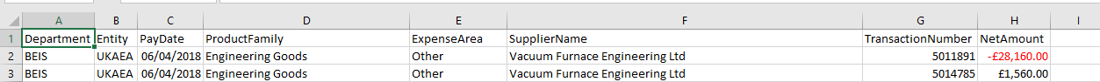
Figure 1 Example of a data record

Privacy, compliance and security
Data Privacy^{[6]} is a subtopic of information safety and deals with the correct processing of data concerns including sensitivity and regulatory. Practical issues of data privacy are often about whether data can be shared with others, how to find a proper method to interact and so on.
The UKAEA Transactions dataset does not include personal privacy data or information that has not been released or disclosed with the consent or authorization of the information provider and is protected by intellectual property rights. Therefore, users can use public data for correlation analysis.
Data compliance^{[7]} is the process of ensuring that data conforms to business rules, laws, regulations and certification requirements of an enterprise or organization. Data compliance is mainly embodied in five aspects: control, audit, compliance, compliance and consistency.
UKAEA is a research unit on fusion energy and related technologies that aims to become a pioneer in sustainable nuclear energy of the UK. At the same time, UKAEA is an administrative department and a non-sectoral public institution sponsored by the business, energy and industrial strategy departments. Therefore, the transaction data set can help departments to study different types of expenditure, the impact of projects and resource providers, meet the needs of departmental business development, and can make better strategic decisions based on the analysis results.
Data security^{[8]} refers to protect data in a database from destructive forces and unnecessary actions of unauthorized users, such as network attacks or data leaks. As a publicly published data set, data attacks should also be avoided to ensure the accuracy of data disclosure to the public and organizations, so that organizations and individuals can better understand their financial situation. At the same time, it ensures the direction of financial manager's policy making.

Data architecture and integration
Data architecture^{[9]} contains models, strategies, rules and standards in information technology. It aims to manage collected data, as well as rules and methods for storing, arranging, integrating and using data in the system. Enterprises’ requirements for data architecture include effective expansion of the system, performance level of access speed, transaction reliability and transparent data management.
In this point, the data set from UKAEA Transactions will be put into ETL process from the initial data to final tables and follow the standard procedure to analyse data. A mature process of ETL analysing has been set up and the results after the process will be stored, arranged, integrated in the specific database for future use and financial managers can make decisions based on that.
Data integration^{[10]} is achieved by data exchange among applications. It offers solutions to the data distribution and heterogeneity problem. The prerequisite for integrated application is that it must public the data design, i.e. table structure, inter-table relationship and the meaning of coding.
In enterprises, there are many information systems with heterogeneous features set on different hardware and software platforms due to the development time and sections. Even though the data source is independent, but they are like each other which makes the interaction among systems becomes difficult. Due to the need of further development, the existing information should be integrated to help different departments connect and share their information with convenience.
In the dataset of UKAEA Transactions, the data of different columns may come from different part of the department. To maximum the benefits of using the data, the integration between different attributes is necessary to give an overview of the full data set. As a result, the analysis of the data set can be more comprehensive, and it is easier to find out the relationship and difference between different attributes.

Data Governance Challenges
To meet the rules and standard of data governance, there are some problems^{[11]} that influence the process of data governance. In this part, problems related to the UKAEA Transactions data set will be identified and effective solutions will be put forward.

Identified Problems
- With data of UKAEA Transactions from different months, the data in one month could be found in the same file. In this report, data from April to June has been taken in to analysis. However, when the data was put into Tableau software to generate reports, there shows four months rather than three months of the data. Go back to the Excel file, there is a record linked to 27th February 2018. The record is shown in Figure 2 and it is not supposed to be here as it destroyed the consistency and integrity of the data set.
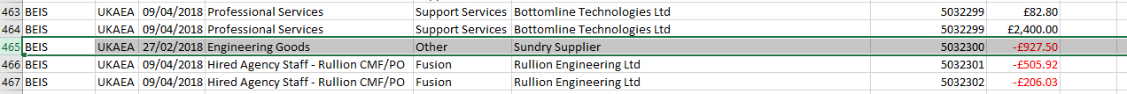
Figure 2 Data record of 27th Feb 218
- In the column of expense area, there shows an area called Support Service. When the data was put in to tableau software to analyse, an interesting thing happened that an area called Support service occurred with Support service simultaneously. The difference between the two areas seems to be the lower case letter or capital letter of the first letter of service. In Tableau software, it automatically recognize them into two different content while the two areas supposed to be the same in reality. Figure 3 and Figure 4 show records with the two areas respectively.
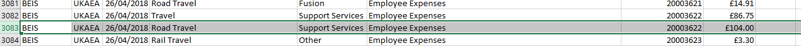
Figure 3 Record with Support Service area
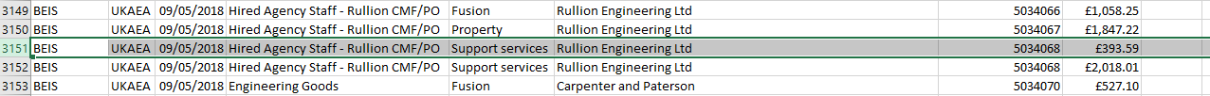
Figure 4 Record with Support service area
- The category of text fields of net amount is currency with two decimal places which is shown in Figure 5 and the negative values are marked with red. This setting is good for content recognition and shows the amount of expense clearly. However, when the csv file is opened in a computer of which the default language is not English, the symbol of pounds can’t be shown correctly, and the category of cells turn to General as shown in Figure 6. In addition, the category of currency can’t be put into Tableau software in normal ways as Tableau didn’t recognize it as a measure.
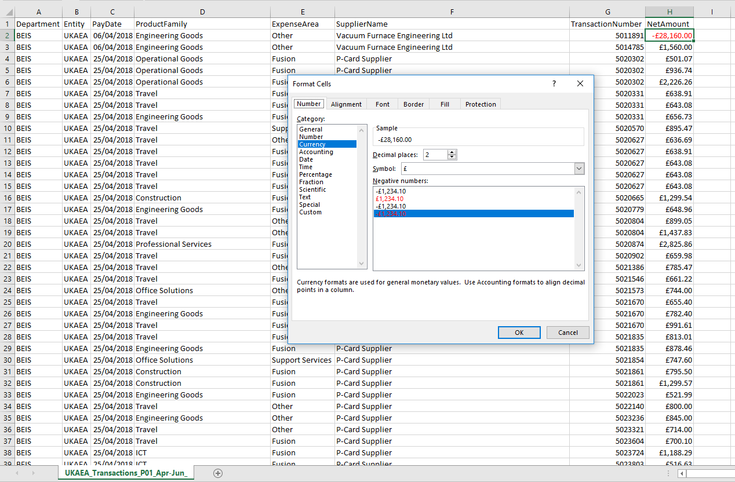
Figure 5 Format Cells of Net Amount column
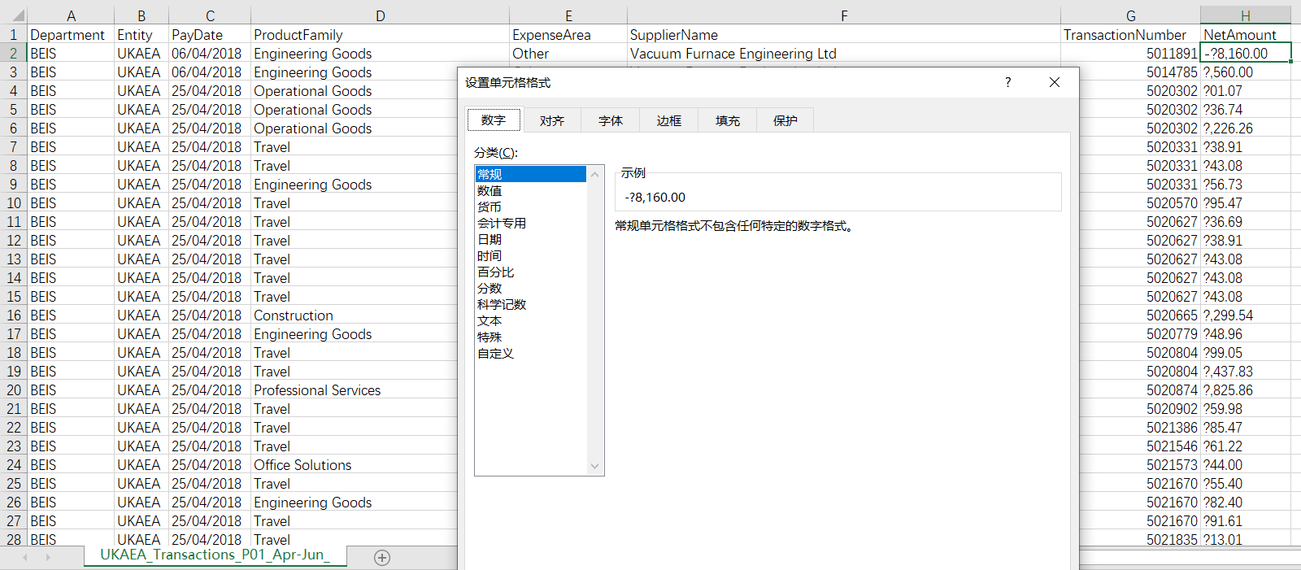
Figure 6 Special cases of format cells of Net Amount column
- In the data file of June, there has 9 records with some missing value as shown in Figure 7. The records with missing value only have three attributes which are department, entity and pay date, other value related to expense type, area, supplier, transaction number and net amount are left blank.
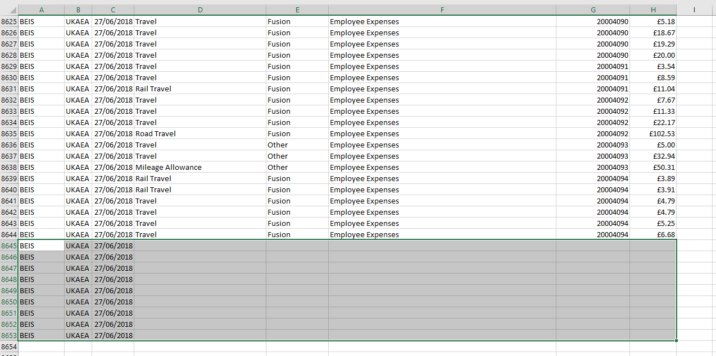
Figure 7 Data Records with missing values

Solutions for problems
- The mixed date of February and April brought some trouble to analysing process and this may be caused by operation mistakes of copying accidently or typing error. Suggestion to handle the wrong data mixed in correct data is to put all the data record in the sequence of pay date, so that the users or the managers could clearly see what happened in some specific dates and the mistakes can be found out easily.
- Under the circumstance that the same expense area comes in different spell formatting, there should be a data standard for texts. The format should not just be like strings, number or date, it should list the length, symbols, capital format and other relevant area. As a result of high standard, the data could be used easily and clearly to different part of organizations.
- The reason for the currency setting of cells under net amount column may be that it can clearly show to users and emphasis the currency used in the file. However, when the organization is a global company and the file may be used in other parts of the world, some thing wrong may happen with the symbol of the currency. A good idea for this is to put the currency unit behind the column name to show the currency used here rather than put the unit after each number. Also, before putting the data into Tableau software, the category of cells under net amount column should be turned into number, so that the Tableau software could recognize it as a measure.
- With missing value in some records, the blank cells should be filled with the value “Unknown” if it is a text field or 0 if it is a numerical field. Figure 8 shows the records after filling completely.
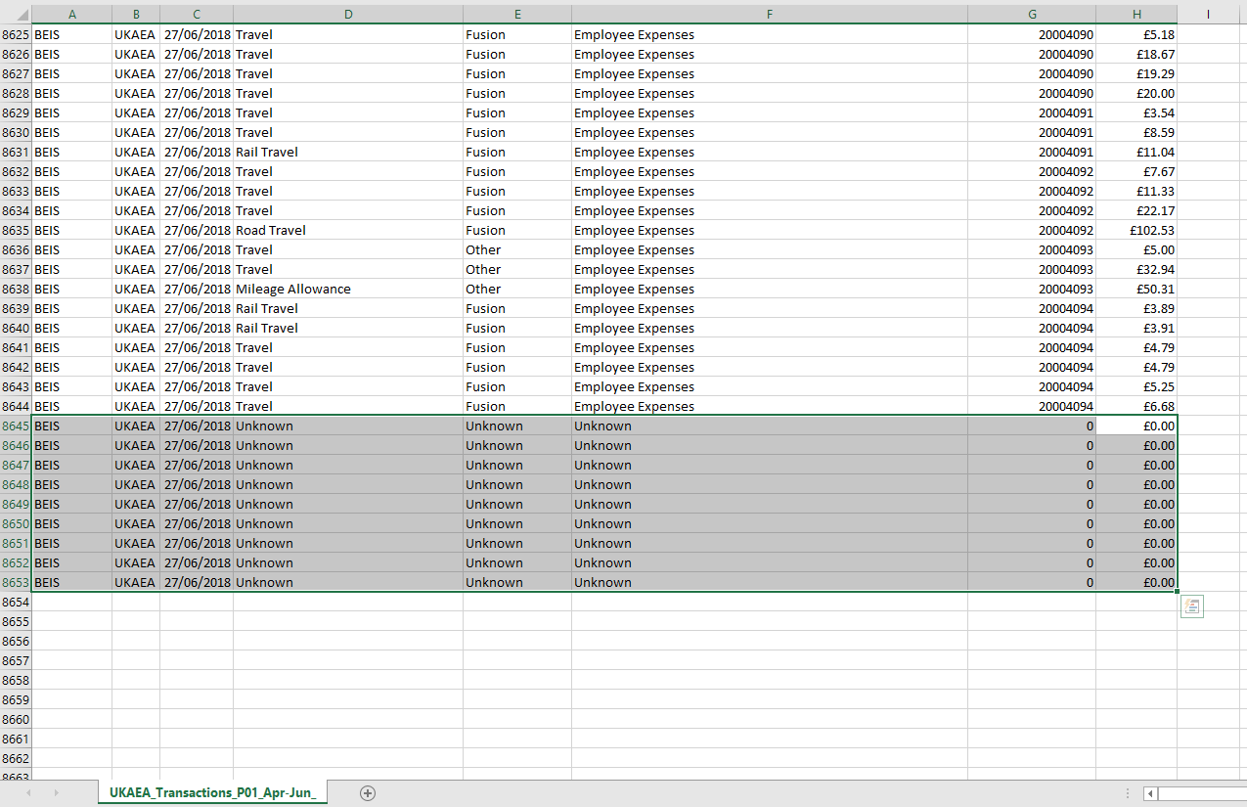
Figure 8 Data Records with missing values after filling

Conclusion
In summary, data of UKAEA Transactions from April to June 2018 which was used in designing the data warehouse in part 1 has been put as an example here to illustrate some specific challenges that the organization will face in the data governance process. The major elements of data governance including data strategy, standard, quality, privacy, consistency, safety, devise and integration has been outlines and specific examples from the transaction data set has been given. Further, some problems that occurred in the ETL process and analysing report generation process have been identified with some solutions attached to them. Finally, data governance is an important part for data management and has a more and more significant role in today’s business report.

Reference
[1] Khatri V, Brown C V. Designing data governance[J]. Communications of the ACM, 2010, 53(1): 148-152.
[2] Forbes.com. (2019). Data Policy 101: What Businesses And Consumers Need to Know About Privacy. [online] Available at: https://www.forbes.com/sites/homaycotte/2015/06/30/data-policy-101-what-businesses-and-consumers-need-to-know-about-privacy/#49117c9d5e89 [Accessed 10 Apr. 2019].
[3] Usgs.gov. (2019). Data Standards. [online] Available at: https://www.usgs.gov/products/data-and-tools/data-management/data-standards [Accessed 10 Apr. 2019].
[4] DXC Technology. (2019). Defining a data strategy: An essential component of your digital transformation journey. [online] Available at: https://www.dxc.technology/analytics/insights/143882-defining_a_data_strategy_an_essential_component_of_your_digital_transformation_journey [Accessed 10 Apr. 2019].
[5] Haustein S. Grand challenges in altmetrics: heterogeneity, data quality and dependencies[J]. Scientometrics, 2016, 108(1): 413-423.
[6] Chen D, Zhao H. Data security and privacy protection issues in cloud computing[C]//2012 International Conference on Computer Science and Electronics Engineering. IEEE, 2012, 1: 647-651.
[7] Security Intelligence. (2019). Data Compliance — Do You Really Have What It Takes?. [online] Available at: https://securityintelligence.com/data-compliance-do-you-really-have-what-it-takes/ [Accessed 10 Apr. 2019].
[8] Hayden L. IT security metrics: A practical framework for measuring security & protecting data[M]. McGraw-Hill Education Group, 2010.
[9] DATAVERSITY. (2019). Data Modelling vs. Data Architecture - DATAVERSITY. [online] Available at: https://www.dataversity.net/data-modeling-vs-data-architecture/ [Accessed 10 Apr. 2019].
[10] Talend Real-Time Open Source Data Integration Software. (2019). What is Data Integration? - Talend. [online] Available at: https://www.talend.com/resources/what-is-data-integration/ [Accessed 10 Apr. 2019].
[11] Infogix. (2019). 5 Challenges That Can be Solved with Data Governance | Infogix. [online] Available at: https://www.infogix.com/5-challenges-that-can-be-solved-with-data-governance/ [Accessed 10 Apr. 2019].

