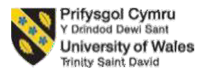
Student name: Antonina Vasileva Danchova
Student ID: 2211877
Module name and code: Hotel Placement Research Project BMIH6008
Institution and department name: International Hotel Management/Business School
University:University of Wales Trinity Saint David
Project supervisor name: Christopher Wilkin
Date: 12/06/2025

Topic: Explore the social media engagement strategies and their effectiveness in Oulton Hall Hotel, Spa, and Golf Resort by surveying consumers

Declaration
Hereby, I do declare that the research entitled “Explore the social media engagement strategies and their effectiveness in Oulton Hall Hotel, Spa, and Golf Resort by surveying consumers” submitted to the University is an original work which was done under the guidance of the module leaders.
The sources that have been used for information have been from credible sources, which are duly acknowledged.
I therefore do understand that I could be held responsible for any kind of plagiarism, if any.

Declaration of AI usage
Hereby, I declare that no generative AI-based solutions have been used for writing this research paper. I express my full dedication towards formulating original research that has been truly developed based on my knowledge and findings. The development of insights has been supported through detailed observations and understanding of facts from research conducted using freely accessible yet verified research sources, without relying on any AI-based tools.

Acknowledgement
For the research, I would like to acknowledge firstly my tutor for helping us to understand the assignment and to know how the assignment is to be carried forward. I would like to thank my friends and family members for their continuous support of me. I would also like to mention the credible information that I did gain from the use of Google Scholar and other academic sources.
Thank You.

Abstract
Aim: The core aim of the study is to investigate and analyse the social media engagement strategies and their effectiveness in Oulton Hall Hotel, Spa, and Golf Resort by surveying the customers in the age group of 60.
Literature: This chapter presented a thorough evaluation of the existing literature sources while examining the relevance of current literature in the context of the research topic. The literature sources used here have been examined in detail to understand how the social media marketing initiatives by brands impact consumer awareness about specific brands. The sources have also highlighted the impact of social media posts on the perceived value of consumers. In this context, a conceptual framework has been presented to clarify the relationship between multiple variables within the study. Further, the relevance of Planned behaviour theory and the Customer Buying Journey Model has also been elaborated in this section of the research study.
Methodology: The methodological aspect of the study is being elaborated in this chapter. The methodological choices included primary quantitative methodology. To ensure the utilisation of the same, the positivist methodology has been followed here. The chapter also elaborated on the other methodological choices, referring to Saunders’ Onion. Through this process, the research samples considered for this research are 60 individuals, who are consumers and followers of the Oulton Hall Hotel, Spa, and Golf Resort. The survey conducted utilised tools like Google Forms and MS Excel.
Findings: The findings of the study have been generated through the utilisation of a survey procedure where respondents included both male and female and from four age groups. The majority of the respondents have been identified to be belonging to the age group of 25 to 35. Apart from this, the survey responses clearly indicated that the brand follows Instagram and Facebook, mainly for digital marketing and brand policy promotion. Multiple content forms that are followed by the brand include event coverage, discounting information and behind-the-scenes content. However, the effectiveness of the brand content has been identified to be limited as there is a lack of influencer collaboration and customer reviews.
Conclusion: In conclusion, it can be stated that digital marketing prominently contributes to the developed brand presence throughout the social media platforms. However, the effectiveness of the brand marketing efforts, through the utilisation of social media platforms, also determines the abilities of the brand in terms engage the audience. Specific form of content and the purpose behind their circulation prove to be the relevant factors that determine the level of engagement of consumers. This chapter also presented a thorough evaluation of how the literature sources have been aligned with the findings. The relevance of the identified theories to the research findings generated through the survey has also been cross-verified in this chapter.
Recommendation: In response to the identified challenges, the mentioned recommendations include targeting the customers and developing the social media content, emphasising multiple media platforms, increasing the effectiveness of Oulton Hotel in showcasing offerings on social media platforms and integrating influencer collaborations as a part of the social media strategy.

Table of Contents
Chapter 1: Introduction 9
1.1 Background to the research project 9
1.2 Aim 10
1.3 Objectives 11
1.4 Research Questions 11
1.5 Summary 11
Chapter 2: Literature Review 13
2.1 Introduction 13
2.2 Conceptual Framework 13
2.3 Theoretical Underpinnings 14
2.3.1 Planned behaviour theory 14
2.3.2 Customer Buying Journey Model 15
2.4 The significance of social media engagement as a marketing strategy and its impact on the hospitality and tourism industry 16
2.5 Assessment of the impact of social media strategy in enhancing the online presence 18
2.6 Challenges that are encountered due to the implementation of social media marketing tactics 19
2.7 Literature Gap 20
2.8 Summary’ 21
Chapter 3: Methods 22
3.1 Introduction 22
3.2 Case Study's methodological approach 23
3.3 Research Approach 23
3.4 Research Philosophy 23
3.5 Data Collection Method 24
3.6 Data Analysis 24
3.7 Summary 25
Chapter 4: Findings and Discussion 26
4.1 Introduction 26
4.2 Findings 26
4.3 Discussion 39
Theme 1: Effectiveness of social media strategies adopted by Oulton Hall towards increased engagement and visibility of the brand 39
Theme 2: The key digital marketing trends aimed at improving Oulton Hall's online presence and its competitive position 41
Theme 3: Effective approaches to enhance Oulton Hall’s online presence and customer interaction 43
4.4 Summary 45
Chapter 5: Conclusion and Recommendations: 46
5.1 Conclusion 46
5.2 Recommendations 48
References 52

Chapter 1: Introduction

1.1 Background to the research project
The hospitality and tourism industry today has maximised the use of social media tools for building on engagement and enhancing customer satisfaction criteria (Khan and Abir, 2022). Focusing on Oulton Hall Hotel, Spa and Golf Resort is located in Leeds, thus offering an experience of the historic ambience with the historic mansion and most significantly with the spectacular setting (Tripadvisor, n.d.). This hotel has invested in offering sales and offers to attract customers looking for affordable stays with a friendly ambience. Designing the website to include social media tools like Facebook, Instagram, LinkedIn and YouTube, the hotel has been establishing its strong presence through online channels. The website, with a tap, lets the customers know of the various offers available, like saving 10% with direct booking online or joining the "Breakaway Club" at £49 to appeal and engage with the customers (Tripadvisor, n.d.). The mission of the hotel is to make the stay for the travellers a stress-free and enjoyable moment with the provision of around 3,650 bedrooms across the UK (LinkedIn, n.d.). To remain constantly active and attached to the users, the Facebook page has around 27K followers who are constantly updated on various offers and even responses to their needs and queries at the same time (Facebook, n.d.). According to Lim and Rasul (2022), a perception rather than an expectation has been generated among customers where brands would connect to them and do more than just focus on selling the products. Thus, there has been a note of shift from transactional to relationship marketing, which has led brands to use tools like social media for constructive outcomes to be gained.
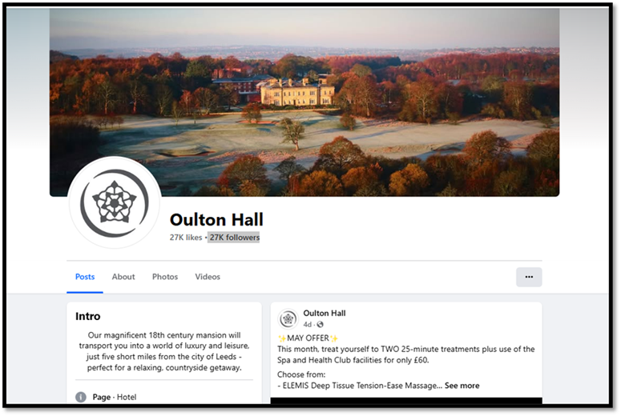
Figure 1.1: Facebook platform of Oulton Hall Hotel
(Source: Facebook, n.d.)
The research will therefore focus on the various social media engagement strategies applied by Oulton Hall Hotel and their effectiveness in enhancing the customer satisfaction level.

1.2 Aim
"To investigate and analyse the social media engagement strategies and their effectiveness in Oulton Hall Hotel, Spa, and Golf Resort by surveying the customers in the age group of 60”

1.3 Objectives
The objectives are:
1. To assess the effectiveness of social media strategies adopted by Oulton Hall towards increased engagement and visibility of the brand.
2. To determine the key digital marketing trends aimed at improving Oulton Hall's online presence and its competitive position.
3. To suggest approaches to enhancing Oulton Hall’s online presence and customer interaction.

1.4 Research Questions
Q1: How does Oulton Hall Hotel's social media marketing strategy improve customer engagement and brand awareness?
Q2: How do key digital marketing trends help Oulton Hall to enhance its online presence and its competitive position?
Q3: What approaches can be suggested to enhance Oulton Hall’s online presence and customer interaction?

1.5 Summary
Thus, the chapter does provide a brief overview of the brand, its social media presence and aim to investigate on the social media marketing strategies deployed to engage with the customers. The chapter has provided some research questions to be investigated further and the objectives to be investigated.

Chapter 2: Literature Review

2.1 Introduction
This chapter will provide a critical and systematic literature review focusing on the various themes to be discovered in the project related to the topic. The conceptual framework and the theoretical underpinnings would help to understand what the topic is about and how the business is implementing the strategies and their impact relating to the framework and the underpinnings.

2.2 Conceptual Framework
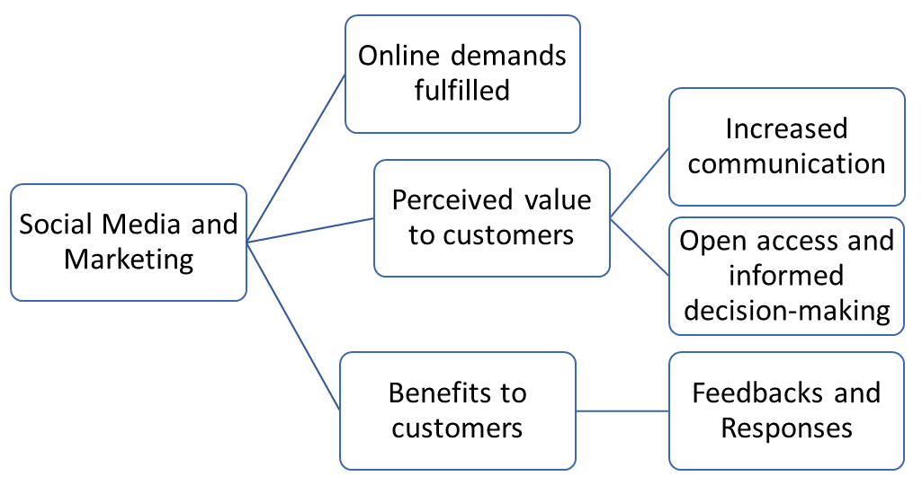
Figure 2.1: Conceptual Framework
(Source: Self-developed)

2.3 Theoretical Underpinnings

2.3.1 Planned behaviour theory
The theory suggests how an individual psychologically intends to perform certain actions, and the intentions do influence the actual behaviour (Bosnjak et al., 2020). This theory does project the emphasis on the planning element, which is developed when an individual undergoes certain experiences. For example, with the increased accessibility of product knowledge, brands do plan to expand their customer base to grow where they do find comfort, and even the organisation being transparent to the audience. The planned behaviour theory reflects the significance of intention, which influences the behaviours that are shaped by witnessing events, experiences being gained or observing the performances of the brands (Rozenkowska, 2023). According to customer purchase intention, it is highly shaped by the performance of the brands (Chen, 2024). In the contemporary era, customers demand more from a brand than just selling a product, and when the brand meets the criteria, it increases their satisfaction.
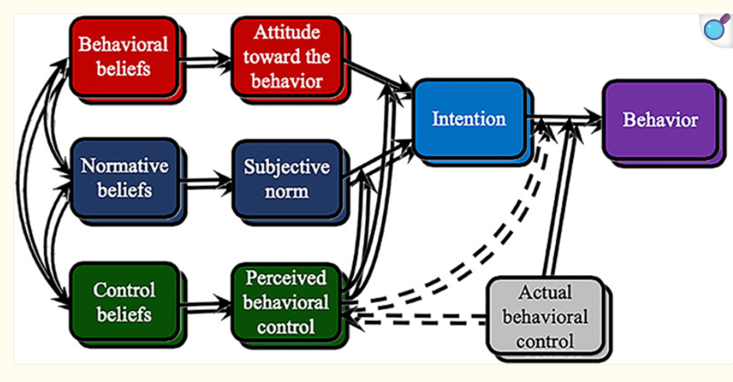
Figure 2.2: Planned Behaviour Theory
(Source: Bosnjak et al., 2020)

2.3.2 Customer Buying Journey Model
According to this model, customers pass through five stages before deciding on the final purchase intention. This model elaborates that the five stages are, namely, Awareness, Consideration, Purchase, Retention and Advocacy (Raeisi Ziarani et al., 2023). Additionally, Nilashi et al. (2023) pointed out that understanding the needs of the customers and then tailoring to their needs helps in integrating accuracy and meeting the satisfaction level. In the study of Harris et al. (2020), it is emphasised that psychologically, when customers are convinced through the efforts of the brands, the purchase intention develops. However, it is critical to retain customers with the growing threats of competitors or threats of substitutes. In the current era, companies are more aware of retaining users with different means, like through social media engagement, after-sales services and developing bonds with the users, thus developing trust.
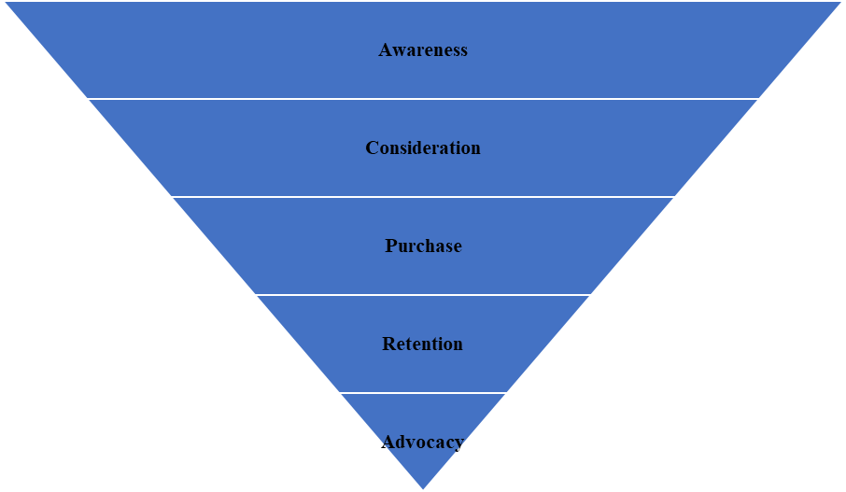
Figure 2.3: The Customer Journey Model
(Source: Learner)

2.4 The significance of social media engagement as a marketing strategy and its impact on the hospitality and tourism industry
In the contemporary era, to engage with the audiences and know their preferences and tastes, technology has assisted every sector. However, the hospitality and tourism sector has witnessed the maximum benefits with the introduction of technology and particularly the social media tools (Han et al., 2025). With social media used in the operations and marketing tactics, it is found that quality is enhanced (Cao and Weerawardena, 2023). For example, with social media presence, brands have enabled themselves to know the preferences of the users and tailor their needs adequately, which relates to the customers' buying journey being accomplished. The study of Khan and Abir (2022), similarly, in the research with the use of qualitative data, revealed that social media has helped to implement accuracy in business performance and offer top-notch services to the users, thus enhancing the quality. Tourists mainly have wishes and demand quality in the provision of services in international destinations (Liu et al., 2025). However, this has been possible with the help of the social media tools that interact with the users and know their demands and needs at the same time.
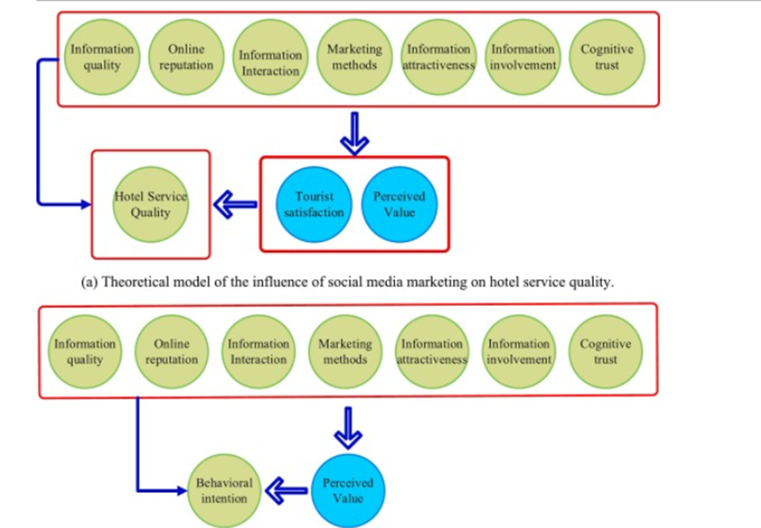
Figure 2.4: The influence of social media on the tourists' purchase intention
(Source: Yang, 2024)

2.5 Assessment of the impact of social media strategy in enhancing the online presence
Social media tools have been recognised so far to be the biggest advantage of technology, which has helped businesses to conduct operations online (Fraccastoro et al., 2021). The hospitality and tourism industry has gained the benefit of reaching out to the audiences and promoting the destinations or hotels to shape the mindset of the customers (Sampaio et al., 2024). According to the research of Hussain et al. (2024), it was found that social media strategy has enabled customers to just with one tap search for any information of any location and at any time. It is found that social media has added significant colours to the online presence of brands (Chopra et al., 2020). As observed, the media platforms themselves are reaching out to the audiences and informing them of every possible data, updating them on offers and allowing open access to search for any services.
Social media platforms have enabled two-way traffic to be possible, which is conducted between the customers and the brands online (Rosário and Dias, 2023). This is to state that through the posts, updates, reels and videos on different platforms, brands are endeavouring to communicate with the customers. Contrastingly, customers with their reviews, queries to agencies like TripAdvisor can know about their needs and even satisfy their doubts (Lama, 2024). Moreover, through social media advertisements, comparative analysis of the brands has become possible to be made by customers (Zhang, 2023). Here, customers can compare on price, facilities, services, reviews and other factors before shaping their final purchase intention (Prakash et al., 2021). Thus, social media has enhanced the source of communication between customers and brands.

2.6 Challenges that are encountered due to the implementation of social media marketing tactics
Due to the implementation of social media marketing tactics, organisations encounter challenges which impact the performance of the brands. The lack of skilled expertise is one of the crucial challenges which the industry faces in meeting the demands of the travellers (Recuero Virto, 2023). If the staff is not able to communicate effectively online with the customers, it will not only hamper the impression of the tourists but will also affect the organisational capability, as it will be questioned. Skilled expertise can anonymously communicate with the users with a few clicks and process their queries, thus saving time and effort (Yulia and Irina, 2023). Ineffectiveness of the brand in using social media is another challenge that can impact the purchase intention of the users. For example, if a brand has a social media page but is not frequently active, it will create a stagnant look in the ongoing online competition. The study does emphasise the need for the brands to communicate and make frequent updates to be made in social media to garner the interest of the users towards the brand (Jacobson, 2020). The experts or the marketing team need to have the talent to address the various queries of users related to the services that are posted on the social media pages (Vinerean and Opreana, 2021). Today, users mostly give opinions or reviews online in social media platforms; however, when the feedback is not responded to, it creates a poor impression on the brand’s engagement with the customers.

2.7 Literature Gap
The literature has broadly discussed the importance of the use of social media engagement tactics by the hospitality and tourism industry. It has included even the way social media tactics like user-driven content, or increasing visibility through posts and reels on platforms, have enhanced the experience of the travellers. Past research has focused repeatedly on a few areas, like reach, posts and quantitative metrics only. This literature has taken the attempt to investigate and analyse the effectiveness of the social media engagement strategies by discussing on purchase intentions of tourists, the expectations and the frequency of interaction between the brand and the customers.

2.8 Summary’
Thus, the chapter has discussed the themes associated with the research aim and, through a systematic literature review presentation, identified the impact of social media engagement strategies on the hospitality and tourism industry.

Chapter 3: Methods

3.1 Introduction
This research method section is designed with the help of the application of Saunders’ Onion to implement suitable methods for generating effective findings. With the help of the knowledge of the data collection method, the findings can be conducted with integrity and credibility.
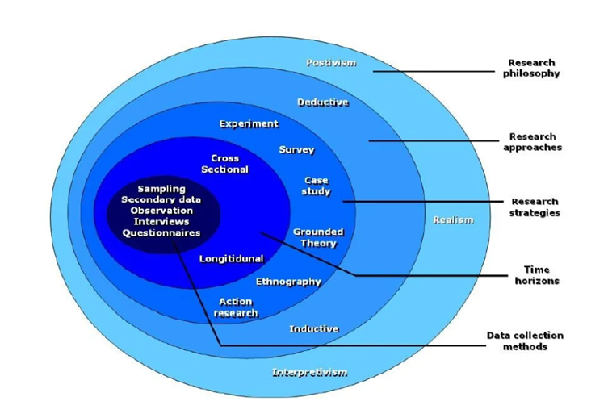
Figure 3.1: Saunders’ Onion
(Source: Thesismind, 2019)

3.2 Case Study's methodological approach
In the research project, the use of case studies helps to narrow down the focus and identify information surrounding the case study (Salmons, 2024). This research project has used the method to focus on Oulton Hall Hotel, Spa, and Golf Resort, thus helping to gain enriched data on the brand and its social media tactics. The advantage of the case study methodology approach is that it can be used for different research purposes (Yin, 2003). However, the disadvantage lies in the methodology, leading to multiple types of data that can be confusing (Salmons, 2024). For the case study to be conducted, the associated technique will be a survey of the population.

3.3 Research Approach
The research approach entails which approach to be taken, which acts as a help for the researcher to plan the strategy to be applied for responding to the research questions (Robson, 2016). Here, to respond to the research questions, a deductive approach is followed, which is based on the theoretical underpinnings. Through it, it has the advantage of linking the literature review themes to the theories for a justified response to the research questions. However, since it is structured with the research questions, the limitation lies in the researcher to explore other areas apart from social media engagement strategies.

3.4 Research Philosophy
For this research, Positivist philosophy has been chosen, which focuses on objective analysis and scientific methods, which would help to gather measurable data. The advantage lies in positivism to gain measurable data, while the disadvantage lies in only focusing on quantitative methods (McGiven, 2006). Positivist philosophy, though, gives factual data which helps to understand an issue from a better perspective, linking credibility, yet contextual understandings are often neglected (Park et al., 2020). In the tourism and hospitality industry, the brand performance and customer engagement are affected by social, cultural and even with brand's quality and offerings (Tahir et al., 2024). Thus, Positivist philosophy does have its advantages and limitations.

3.5 Data Collection Method
The data collection method is crucial, where there are mainly two methods, namely, Quantitative and Qualitative methods (Ussif et al., 2020). In this research, the primary quantitative data collection method is followed due to its advantage of offering reliable data for engaging in statistical analysis. However, the quantitative data method does have the limitation of only depending on responses given, which can be biased or incomplete (Chetty, 2024). Through the quantitative data, survey through online Google Form has been conducted which has helped to gain statistical data on the issue.

3.6 Data Analysis
For the data analysis, the online Google form is used, which has helped to gain statistical analysis that is done through the application of Microsoft Excel. Through the questionnaires, the responses of 60 participants have been collected, and this has helped to gather the statistical data in the form of a visual presentation.

3.7 Summary
Thus, this chapter has discussed in detail the various methods to be aligned with the following Saunders’ Onion. The research methods are chosen depending on the research questions and the objectives to be met. Therefore, the research method has pointed to the use and application of primary quantitative data, positivist philosophy and a deductive approach for gathering effective outcomes on the issue.

Chapter 4: Findings and Discussion

4.1 Introduction
The chapter presents a critical analysis of the social media engagement strategies for Oulton Hall Hotel through primary quantitative data collection. Therefore, the purpose of the chapter is to demonstrate the effectiveness of social media engagement strategies on customer interaction and brand visibility for hotel consumers. In order to do primary data collection, 60 participants have been selected to gather information regarding behaviour, preferences, and perceptions. Furthermore, the chapter is structured into two major parts, including the presentation of survey findings and critical discussion by aligning primary information. It will help to evaluate the effectiveness of current social media strategies in terms of enhancing Oulton Hall’s online presence and consumer engagement.

4.2 Findings
Q.1) Please specify your Age.
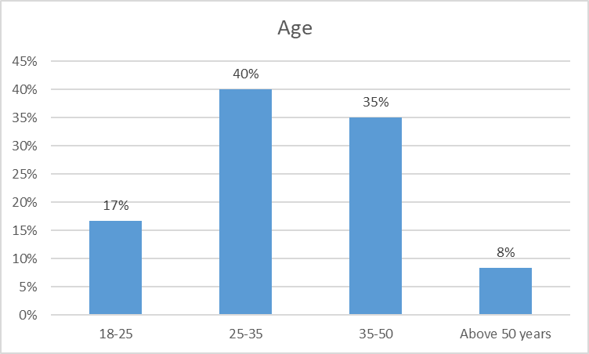
Figure 4.1: Age
(Source: Self-developed)
As per survey responses, 40% of the responses belong to the age group of 25-35, in comparison, 35% belong to the age group of 35-50. Therefore, most of the age group belongs to the professional segment, showing a major interest in the Oulton hotel. This indicated the professional group of consumers who are internet users and more likely visitors of Oulton Hall Hotel, Spa & Golf Resort, as they can afford it, or they have a strong purpose or preference to book a stay.
Q.2) Please specify your Gender
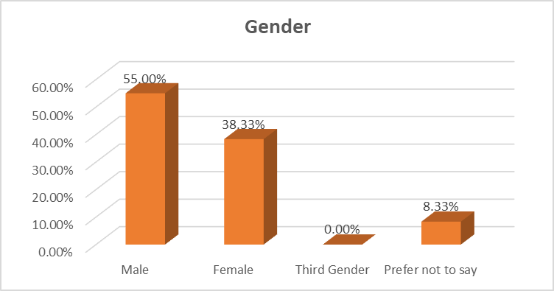
Figure 4.2: Gender
(Source: Self-developed)
As per the survey responses, most of the respondents of this survey are male, representing 55% of the respondents. Additionally, female respondents are also present, with 38% of the respondents, which promotes equality through the survey process. Additionally, collecting responses from different gender groups helps to review the perspective of individuals towards the social interaction approach by the hotel group to attract customers.
Q.3) How often do you use social media platforms to interact with brands?
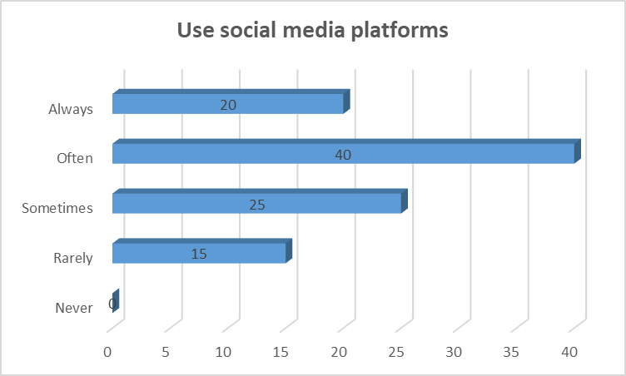
Figure 4.3: Use of social media for brand communication
(Source: Self-developed)
As per the responses gathered from this survey, it has been noticed that the majority of the respondents, representing 40% of them, often use social media platforms to interact with brands. This indicated the prominence of using social media platforms for brand communication purposes. Further, 20% of the respondents also mentioned that they always use social media to communicate directly with brands. Another 20% sometimes rely on social media interaction to understand and deal with brands.
Q.4) How often have you interacted with Oulton Hall Hotel through social media pages?
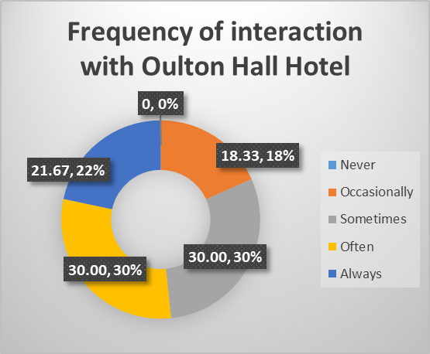
Figure 4.4: Frequency of interaction with Oulton Hall Hotel
(Source: Self-developed)
The responses gathered through the survey indicated that 30% respondents often use social media for interacting with Oulton Hall Hotel, whereas another 30% of the respondents sometimes use social media to interact with the brand. This indicated a mixed preference, as complete agreement on the dependence on social media is prominent here. However, the majority is towards social media usage, as 21.67% also mentioned that they always use social media platforms to interact with Oulton Hall Hotel.
Q.5) Which social media platform do you use to interact with Oulton Hall Hotel's brand content?
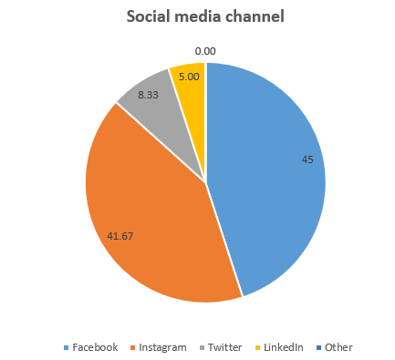
Figure 4.5: Social media channel of interaction
(Source: Self-developed)
From the survey responses, it has been found that, majorly of respondents use Facebook as a social media platform to interact with the content of Oulton Hall Hotel. Whereas, Instagram is another major platform, which is considered by 41.67% to engage with content across the Instagram platform.
Q.6) What type of content do you find most engaging across the social media accounts of Oulton Hall Hotel?
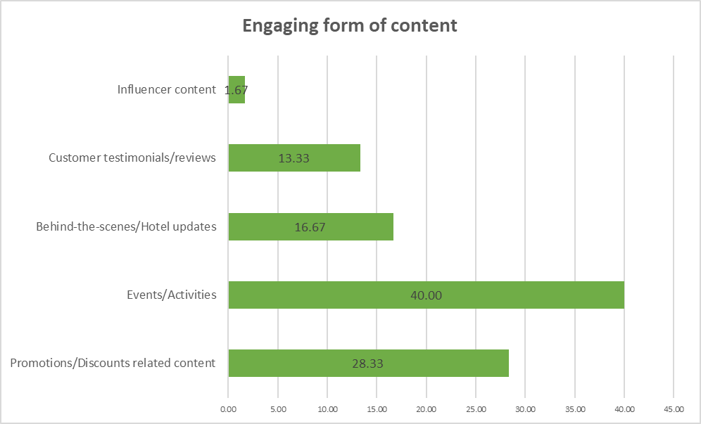
Figure 4.6: Engaging form of content
(Source: Self-developed)
According to the respondents, events and activities are considered to be one of the most effective engaging contents, which shows a significant interest by 40% of the respondents. This significantly shows a positive influence towards the engagement of individuals across social media content by organising engaging events and activities. Furthermore, promotions and discounts are considered to be another major area of interest among 28.33% of the respondents. Therefore, it helps to deal with the attraction of individuals towards the hotel while visiting across the region.
Q.7) What type of content do you find least across the social media accounts of Oulton Hall Hotel?
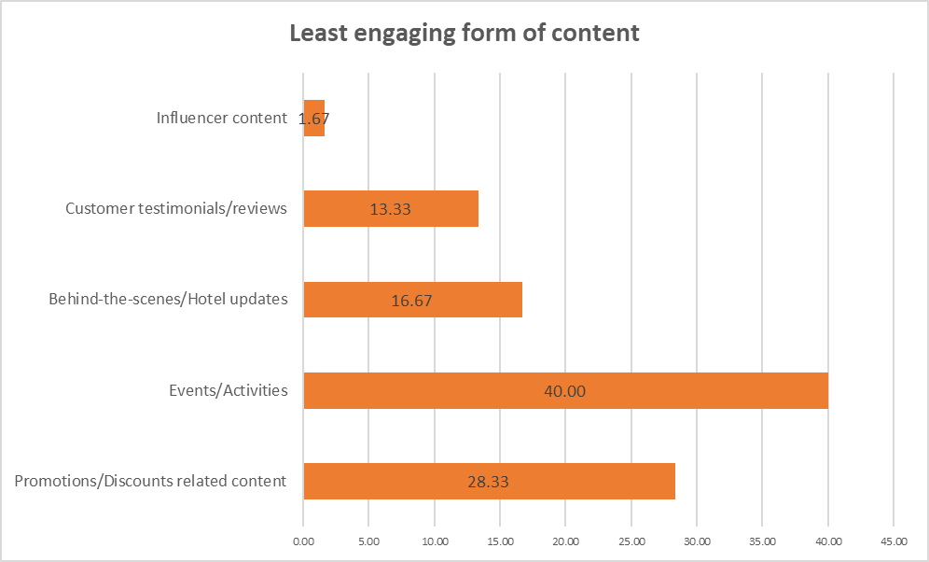
Figure 4.7: Engaging form of content
(Source: Self-developed)
There are some contents that need to be presented across social media platforms of the hotel industry, which might help to attract customers by engaging content. Through the survey, it has been found that 40% of the respondents have significantly shown that events and activities need some changes in presentation, as currently it is considered to be one of the least engaging content types as well. Additionally, promotions and discount content are found to be the least engaging activities across social media of the hotel, which might affect the customer attraction of individuals.
Q.8) Please rate the quality of the content shared on the social media pages of Oulton Hall Hotel?
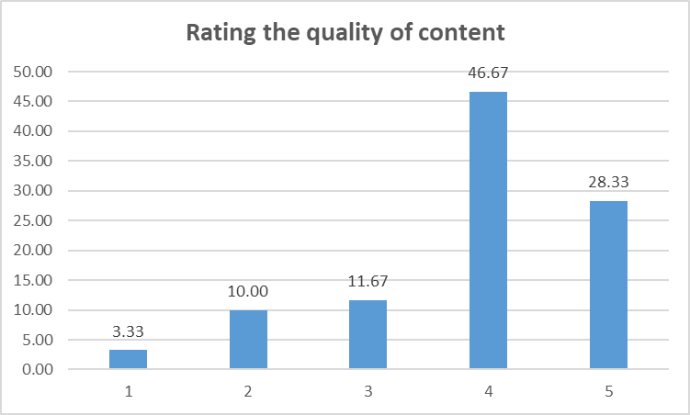
Figure 4.8: Rating of quality of content
(Source: Self-developed)
In the evaluation of the quality of content, most of the respondents found the social media content of Oulton Hotel to be rated as 4 out of 5. This shows that social media content helps to significantly engage individuals, as respondents found the content beneficial and significant to promote hotels across social media. Furthermore, there are some people who consider their content across different pages to be 5 out of 5 as well, which shows that social media promotions have an effective role in terms of driving sales across the company.
Q.9) Have you ever made a booking based on a social media post from Oulton Hall Hotel?
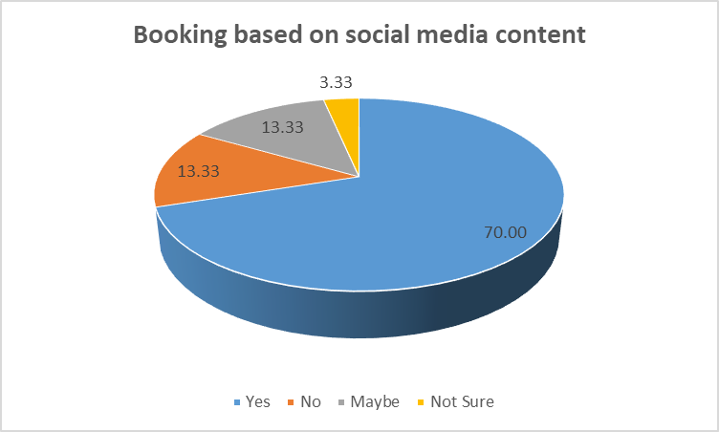
Figure 4.9: Booking based on social media content
(Source: Self-developed)
As per the previous discussion, a significant promotion through social media platforms has been found by the company. Therefore, it has a significant impact towards driving consumers, which is also found positive by 70% of the respondents. Therefore, social media posts and content have a crucial impact towards promoting their services across the company.
Q.10) Do you think that the social media content of Oulton Hall Hotel is effective in showcasing the hotel’s offerings?
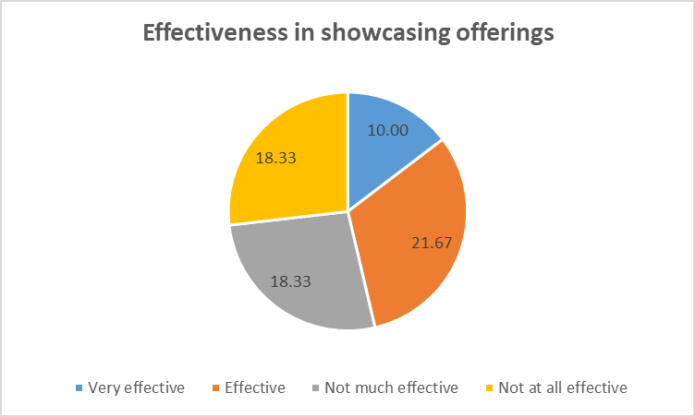
Figure 4.10: Effectiveness in showcasing offerings
(Source: Self-developed)
As the company is already engaged with customers through their social media content, which creates a significant impact in promoting the brand's approaches towards attracting consumers. Over 21.67% of the respondents have found that social media content helps to promote their offering towards consumers. This significantly shows a lower number of respondents in comparison with other questions, which creates a question in terms of creating content to showcase the offering.
Q.11) How likely are you to recommend Oulton Hall Hotel to others based on your experience with its social media engagement?
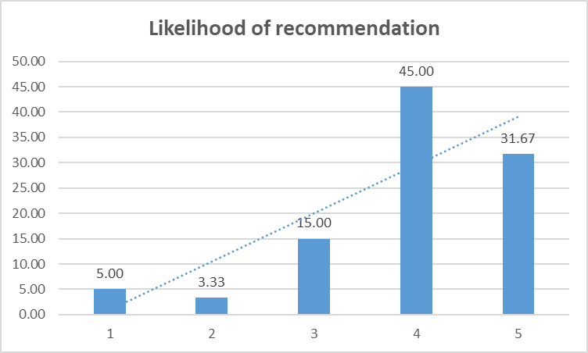
Figure 4.11: Likelihood of recommendation
(Source: Self-developed)
In terms of recommending the hotel through social media engagement, 45% of the respondents have considered giving it a 4 rating out of 5. This significantly shows that the company has a potential approach in terms of promoting its brands through social media content.
Q.12) In your opinion, what could Oulton Hall Hotel improve in its social media engagement to better connect with you as a consumer?
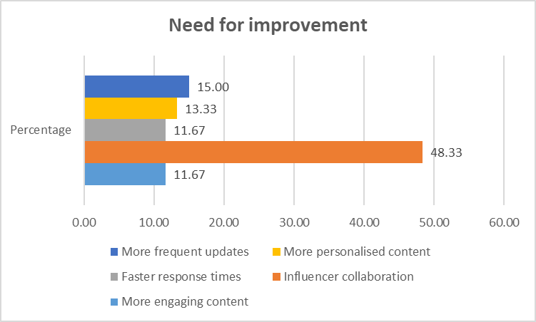
Figure 4.12: Need for improvement
(Source: Self-developed)
Through reviewing the improvement needs, it has been found that 48.33% of the respondents considered influencer collaboration a major area to be focused on. Therefore, Oulton Hall Hotel needs to work with some reputable social influencers to promote their brands and services through different platforms. This helps to attract a broad range of customers towards their operations. Furthermore, there are other areas of improvement that are also necessary, which are found by the respondents, including frequent update postings and personalised content development.

4.3 Discussion

Theme 1: Effectiveness of social media strategies adopted by Oulton Hall towards increased engagement and visibility of the brand
Liu et al. (2021) have mentioned that social media strategies have been found to be effective in terms of boosting consumer engagement towards developing brand visibility. This has been found to be effective in terms of having an evident approach towards creating a positive impact towards the improvement of their promotions across different regions (Lim and Rasul, 2022). From the survey results, Facebook and Instagram are considered to be one of the effective channels that have been used by the company in terms of engaging with their consumers. Therefore, it has a significant impact towards influencing bookings by different visitors across the country. Through the review of findings, the targeted demographics from the social media content are found to be 25-50 years majorly, who significantly spend time online to engage across different content. This helps to create a better engagement towards updating promotions, events, and visual content by targeting the audience to respond to the event. Through their recent social media posts, they have been seen to promote Spa and Health Club facilities to attract customers for maintaining well-being while travelling across the country.
Therefore, it helps to create a highlight for visiting the venue to positively consider the preferences according to their content. Although in contradiction to the effectiveness of the social media strategies of Oulton Hall hotel, their offers and promotional content are found to be the least engaging. Through the responses, it has been found that the content category of the hotel is effective. Although style, frequency, or creativity is found to be the challenging factor in maintaining the appeal and dynamics of showcasing different promotional factors by the company. Development of this factor helps to meet diverse audiences' preferences who seek different offers while visiting the location by creating a better engagement towards the organisation. Although major responses show that the technical aspects of the content are well-received value by maintaining a higher rating of 4 out of 5. Therefore, it is proven that the social media strategies are effective in terms of creating better engagement and brand visibility by considering better reach among the consumers. Additionally, the literature review also shows that the contemporary marketing technique is associated with the effectiveness of technological tools by different companies. Therefore, tactics towards developing this are necessary in terms of creating a relationship-based engagement (Li et al. 2021). According to Susanto et al. (2021) & Achmad (2023), social media marketing efforts help to maintain a proper transactional approach towards creating an effective digital presence. The Oulton Hall has been seen to be partially aligned with the digital shift through promoting content across Facebook and Instagram by ensuring promotional content and event updates. Even through the findings, it has been found out that 70% of respondents have confirmed to book their hotel room through Oulton Hall’s social media content by reviewing their engaging intentions. Therefore, social media marketing can directly influence travel decisions by creating engaged information through maintaining a perceived performance by meeting the intentions of consumers (Wang and Yan, 2022; Camilleri and Kozak, 2022).

Theme 2: The key digital marketing trends aimed at improving Oulton Hall's online presence and its competitive position
The current tourism and hospitality sector has been identified to be relying on social media platforms. The multiple hotels and restaurants are relying on social media to reach a wider group of consumers at a time (Ibrahim, 2021; Hu and Olivieri, 2021). This clearly indicates the significance of using social media platforms to improve the brand-consumer interactions. In this context, the responses gathered from the consumers of the Oulton Hall have also resulted in the generation of clear perceptions about the multiple social media marketing trends that are leaving a great impact on the minds of the consumers, irrespective of their age and gender. The survey responses indicated that Oulton Hall’s social media channels are mainly utilised for event coverage and behind-the-scenes portrayals. The brand also uses the platform to release information about the discounts.
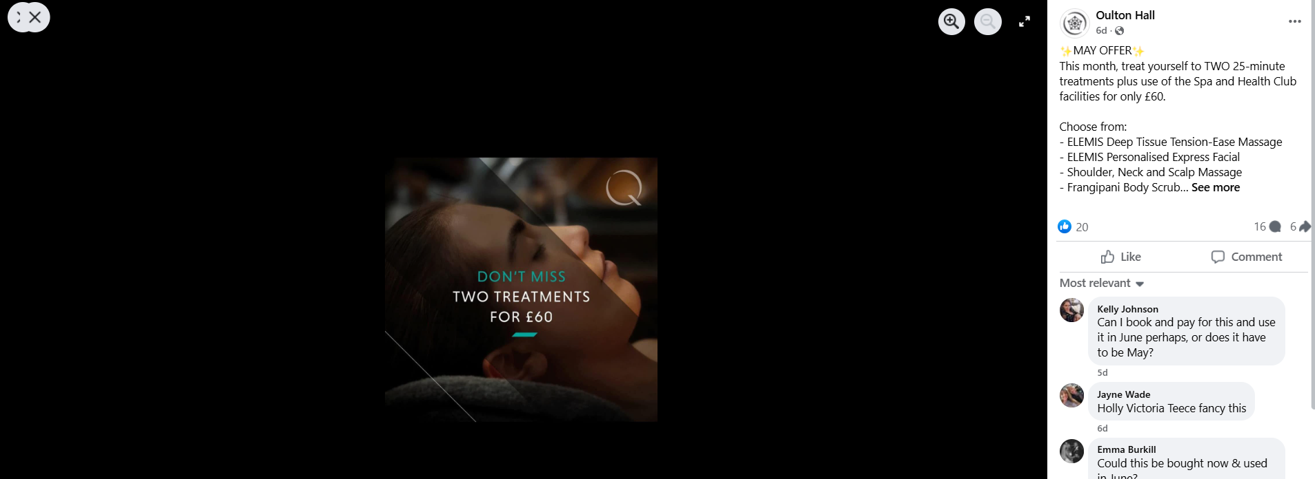
Figure 4.13: Facebook post of Oulton Hall
(Source: Facebook, 2025)
As per Fig. 4.13 presented above, the discount posts of the brand have been witnessed, which the brand has released using its Facebook Page. This indicated the prominence of using Facebook as a communication platform as well. In this context, the literature of Cao and Weerawardena (2023) suggests that social media usage in business communication enhances the quality of communication among brands and consumers. Jinyoung Yoo et al. (2023) and Dhanesh et al. (2022) highlighted that Instagram and Facebook are currently the most prominent platforms used for social media promotion of brands.
Brands are using these social media platforms for multiple purposes. For instance, the overall responses to the survey have highlighted that the brand uses social media platforms for the purpose of event coverage, while for promotional purposes, the discounting information of the brand is also circulated through these platforms. Joshi et al. (2023) highlighted that the current market is potentially using social media platforms to employ influencer marketing in their marketing agenda. Agustian et al. (2023) also shed light on the benefit of influencer marketing while stating that the efforts of influencer collaboration enhance the consumer trust about the brand, eventually not only increasing the engagement but also enhancing the sales potential. However, Oulton Hall has been identified to be lacking in this aspect. The consumer responses indicated that the brand content is not highly effective, as there have been specific gaps, including the lower rate of influencer collaboration, which often affects the engagement potential of the consumers. Therefore, in this aspect, the brand needs to potentially look forward to developing this aspect for better performance.

Theme 3: Effective approaches to enhance Oulton Hall’s online presence and customer interaction
Enhancing Visibility Through Richer Content
There are significant factors that might help to maintain a better presence towards developing consumer interaction through audience engagement across social media (Sunarso and Mustafa, 2023). It has been found through the survey that only 21.67% of respondents have considered the social media content to have an effective engagement factor in terms of driving bookings. This shows a major challenge of communication strategies in terms of social media promotions, which creates a significant factor for maintaining the trust of the consumer. As noted by Zhang et al. (2022), the factors of visible services and offers help to form cognitive trust through influencing consumer decisions. Although in terms of Oulton Hall’s limited visibility, the company has faced major challenges in maintaining their core services, including spa facilities, dining experiences, and historical ambience. Therefore, the company could promote their visibility through creating richer content and better offers. This might involve visual storytelling techniques by creating short videos and live facility tours across social media platforms to create more immersive content. Even the study of Dudley et al. (2023) shows that immersive and informative content helps to promote the experience of individuals towards maintaining visibility and perceived value.
Developing Influencer Collaborations
From the findings, it has been found that 48.33% of survey respondents have highlighted the need for influencer collaborations in terms of maintaining social media content to be engaging. Therefore, emphasising the factors is necessary to target a diverse range of audiences through effective social media content. The literature of Okonkwo and Namkoisse (2023) and Sankala (2024) significantly shows that emphasising influencer content helps to reach niche audiences by creating higher trust and authenticity. Through this, Oulton Hall can access organic, credible content from different types of travel and lifestyle bloggers. This helps to create a major impact on consistent interaction or follow-up by promoting satisfaction of individuals towards maintaining two-way communication (Prasanthi et al. 2024). This helps to maintain a better satisfaction towards developing satisfaction by enhancing the loyalty in real time (Listiawati et al. 2024).
Maintaining higher post frequency and consistency
The company have to maintain frequent and engaging updates towards the social media content, which helps to maintain better interaction with customers' needs. Through the survey, it has been found that infrequent or repetitive posts are a weakness in terms of social media management for the hotel. As mentioned by reviewing the literature of Silalahi and Guna (2024); and, Sunarso and Mustafa (2023), a consistent and strategic approach of content visibility helps to retain audiences better in a robust manner. Through this, management of better online visibility and audience retention could be done by the company through maintaining an active presence across different consumers. This helps to maintain a better frequency to engage with consumers to maintain better visibility through creating a robust engagement through different individuals.

4.4 Summary
The chapter presented key findings through collecting information by the primary quantitative method by following a survey. This would help to review the target age group of the company to maintain an effective social media presence by Oulton Hall Hotel, which helps to promote posts regarding events, promotions, and discounts across platforms like Facebook and Instagram. Further, discussion helps to provide an understanding regarding the effectiveness and lack of creativity or variation in the presentation of social media content by creating a degree of brand visibility. The discussion highlighted Oulton Hall’s social media strategy to have a crucial impact on supporting customer engagement by influencing booking decisions, which helps to create a positive impact on the degree of brand visibility. This helps to clearly showcase the importance of offerings, maintain consistent posting and create personalised content.

Chapter 5: Conclusion and Recommendations:

5.1 Conclusion
Oulton Hall, as identified, located in Leeds, did offer a historic essence to the customers, and this tended to be the main value offered to the users. However, with the changes in the business environment, competition has been so high that it has led to the introduction of the context of social media into business operations. This research, to identify the effectiveness of the social media platforms for engagement with customers did made use of the primary quantitative data to gather relevant information. Today, in the contemporary era, it is visualised that interacting with customers or informing customers has been much easier due to the integration of technology in operations. For example, from the use of technology to communicate with the audiences to gather data on the preferences of the users, social media has turned out to develop relationship marketing specifically, as noticed in the hospitality and tourism industry. Social media has been a two-way traffic communication portal that engages both parties, namely customers and brands. Social media with posts and updates interact with the customers, and with the reviews and feedback, users communicate back with the brand. Thus, social media has been one of the effective tools in communicating with the audience and engaging with them.
From the literature review, it is evident that social media platforms have enhanced the quality of services for the hospitality and tourism industry. The knowledge about the preferences and tastes of the users has today become possible with the use of various information present in social media platforms and streamlining them in the main productivity. Quality is essential for the tourism and hospitality industry since travellers demand exceptional services and affordable prices for enriching their travel experiences. Through social media tactics like Facebook, Instagram, and even YouTube, visual presentations on facilities, live guides on facilities like the room tour, the hotel tour or even the dining experiences are broadcast, which helps in informing the customers and has in adequate decision-making process. Planned Behaviour Theory, as it illustrates that it involves the psychological shaping of the minds of the individuals with the intentions being influenced, aligns with the industry-specific performances as well. For example, as found in the systematic literature review, social media engagement leading to the use of Facebook or other platforms does share information frequently about the brand, and this informs the customers on their present or future decisions. Thus, when a brand adequately informs the users through social media platforms, it will enhance the knowledge of the customers and allow them to decide whether to purchase the products or services or remain with the brand. Similarly, the Customer Journey Model emphasises understanding how the needs of the customers can be recognised and considers elements or services to be hated, which would gain the interest of the audience. Therefore, the hospitality and tourism industry, too, with adequate social media engagement, does meet the needs of the users, where the services are tailored to the demands of the customers.
From the primary findings collected through the survey, it is found that Oulton Hall Hotel focuses on sharing meaningful and useful content to the users. Through the sharing of the messages, the offers and discounts, brands do take the approach of communicating with the audiences, maintaining the quality. As the data revealed that often users have interacted with the Hotel, it has indicated that Oulton Hall does emphasise building interaction frequently to engage with the audience. As mentioned earlier that social media has led to a two-way traffic where both customers and brands communicate, the Hotel has embraced this approach skilfully. It had taken social media as one of the strong media for building relationships with the existing customers and attracting new customers too.
However, interaction also depends on the kind of content that is being shared by the brands, which appeals to the audiences or serves as a touchpoint. In the case of the Oulton Hotel, it has been revealed that they do host mainly events and activities online, after which they focus on advertisements. Even though it does share content like collaborating with influencers or posting customer testimonials, but host of events have been mainly conducted through social media platforms. Evidence gathered from the statistical analysis suggests that Oulton Hotel has made good use of the social media platforms and has created awareness as well.
Social media, as discussed in the literature review, is an effective tool for creating awareness of the offerings of the brands and being accessible to the customers. Oulton Hotel, as evidenced by the responses through primary findings, it is revealed that the brand has not been very effective. It is a concerning issue that the Hotel needs to emphasise since showcasing offers helps customers to know what the hotel is featuring and why they should visit the hotel for the availability of the services. Oulton Hotel is therefore found to miss out on one of the crucial aspects of promotions of offerings, which is mainly done by brands or hotels to attract customers and gain their trust.

5.2 Recommendations
From the research done on the social media tactics and marketing strategies used by Oulton Hotel online, an overview is gained on the current performance of the brand. From the primary findings and linking them with the critical study made in the literature review, some recommendations are made that Oulton Hotel could follow:
Targeting the customers and developing the social media content emphasising multiple media platforms: Targeting the customers increases the efficiency of any brand to generate product lines or services tailored to their needs and preferences (Wolniak and Grebski, 2023). Oulton Hotel has its target customers like the business travellers, the event planners or leisure travellers as the target market (Preneur, n.d.). Today, Oulton Hotel has acquired the shape of a luxury hotel, which is located on the outskirts of Leeds (Oulton Hotel, n.d.). With the offerings of historical magic to the experience of the ancient mansions, the Hotel attracts customers who love adventures. In the hospitality and tourism industry, the crucial task is to identify the nature of the travellers, what they demand, and meet the ever-changing marketing trends (Sampaio et al., 2024). Oulton Hotel has been providing services to its target customers, but with the change of time and the increasing influence of social media presence, the media content needs to be amended. As gathered evidence from the findings that Oulton Hotel on the quality of the content being shared by the Hotel on social media pages, it reveals that it is quite good. However, the industry is exposed to rapid market changes, which change the purchase intention of the customers. According to Díaz-Pompa et al. (2023), post-COVID-19, users became more concerned about the hygiene and safety maintained by the Hotels, which did affect their satisfaction level. Contrastingly with the rising inflation hitting hard the cost of living of users, the price offered by brands does not even bother the customers (Statista Research Department, 2025). Hence, the contents generated by brands like Oulton should do more with identifying the crucial needs of the users and tailoring the contents accordingly. Oulton should take the initiative of generating content where they could address the pains of the touchpoints. Thus, the prices offered with the services or the way Oulton is providing comfortable services at an affordable price could be promoted on online platforms like Facebook or Instagram.
Increase the effectiveness of Oulton Hotel in showcasing offerings on social media platforms: As identified from the primary findings that Oulton Hotel has not been very effective or least effective in showcasing offerings on social media platforms, there is scope to improve in this particular area. Showcasing offerings through social media has become the latest trend among businesses (Creevey et al., 2022). Due to this, customers are informed, and purchase intentions are enhanced (Cheng, 2024). From the quality of the information made available by a brand to implement marketing methods to promote the brand, it builds on the cognitive trust of the users (Armutcu et al., 2023). Social media has the power to prompt travellers to shape their purchase intention and make the final decisions of visiting a destination or purchasing the services of a hotel (Varkaris and Neuhofer, 2017). With various offerings curtailed by the brand, the Hotel can lead the customers to have an informed decision-making process. For example, with the offerings promoted in social media pages, Oulton Hotel can let the users know what the brand is providing in services, the reviews on the services, the new product lines introduced by the brand, and increase the means of engagement. Oulton, on its website, does promote discounts and savings that users can get while purchasing the services; similarly, it could promote the same on the social media pages where most users surf the internet for more information.
Integrate influencer collaborations as a part of social media strategy: The suggestion made in the primary findings, with the responses, it is found that Oulton is suggested to work more with influencer collaborations. According to Conti and D’Amario (2023), the new generation of users is more prone to watching blogs and travel guides by influencers that shape their mindset (Saini et al., 2023). Influencer marketing offers the opportunity to associate with the brand in exchange for payments and create content that can increase the customer base for the brand. Through the influencers, brands emphasise informing the core facts and features to the audiences and influence their viewpoints (Pricope Vancia et al., 2023). Hospitality and tourism industry collaborating with the influencers and posting of visuals, offers and discounts, and detailed information about the travel packages does increase the customer's satisfaction level and effectively communicates the needs of the users (Al-Dmour et al., 2023). Therefore, Oulton Hotel could work on collaborating with influencers to engage with the customers indirectly and increase the purchase intentions too.

References
Achmad, W. (2023) ‘MSMEs empowerment through digital innovation: The key to success of e-commerce in Indonesia’, Daengku: Journal of Humanities and Social Sciences Innovation, 3(3), pp. 46.
Agustian, K., Hidayat, R., Zen, A., Sekarini, R.A. and Malik, A.J. (2023) ‘The influence of influencer marketing in increasing brand awareness and sales for SMEs’, Technology and Society Perspectives (TACIT), 1(2), pp. 68-78.
Al-Dmour, R., Alkhatib, O.H., Al-Dmour, H. and Basheer Amin, E. (2023) ‘The influence of social marketing drives on brand loyalty via the customer satisfaction as a mediating factor in travel and tourism offices’. Sage Open, 13(2), p. 21582440231181433.
Armutcu, B., Tan, A., Amponsah, M., Parida, S. and Ramkissoon, H. (2023) ‘Tourist behaviour: The role of digital marketing and social media’. Acta psychologica, 240, p. 104025.
Asawawibul, S., Na-Nan, K., Pinkajay, K., Jaturat, N., Kittichotsatsawat, Y. and Hu, B. (2025) ‘The influence of cost on customer satisfaction in e-commerce logistics: Mediating roles of service quality, technology usage, transportation time, and production condition’. Journal of Open Innovation: Technology, Market, and Complexity, 11(1), p. 100482.
Atherton, J. (2023) Social media strategy: A practical guide to social media marketing and customer engagement. London: Kogan Page Publishers.
Bhatnagar, M. (2024) ‘Exploring Trust Building in E-commerce: A Multistage Analysis on Purchase Intention, Actual Purchase and Customer Satisfaction’. Educational Administration: Theory And Practice, 30(5), pp. 4723-4733.
Bosnjak, M., Ajzen, I. and Schmidt, P. (2020) ‘The theory of planned behavior: Selected recent advances and applications’. Europe's journal of psychology, 16(3), p. 352.
Camilleri, M.A. and Kozak, M. (2022) ‘Interactive engagement through travel and tourism social media groups: A social facilitation theory perspective’, Technology in Society, 71, 102098.
Cao, G. and Weerawardena, J. (2023) ‘Strategic use of social media in marketing and financial performance: The B2B SME context’. Industrial Marketing Management, 111, pp. 41-54.
Chen, S. (2024) ‘The impact of brand awareness on purchase intention. Highlights in Business’. Economics and Management, 30, pp. 239-246.
Cheng, M. (2024) ‘Social media and tourism geographies: Mapping future research agenda’. Tourism Geographies, pp. 1-10.
Chetty, P. (2024) Limitations and weakness of quantitative research methods. Available at: https://www.projectguru.in/limitations-quantitative-research/ (Accessed: 13 May 2025).
Chopra, C., Gupta, S. and Manek, R. (2020) ‘Impact of social media on consumer behaviour’. International Journal of creative research thoughts, 8(6), pp. 1943-1961.
Conti, E. and D’Amario, R. (2023) ‘The relationship between brands and influencers: an exploratory study in the hospitality industry’. J. Hospitality Tourism, 21(2), pp. 78-91.
Creevey, D., Coughlan, J. and O'Connor, C. (2022) ‘Social media and luxury: A systematic literature review’. International Journal of Management Reviews, 24(1), pp. 99-129.
Dhanesh, G., Duthler, G. and Li, K. (2022) ‘Social media engagement with organization-generated content: Role of visuals in enhancing public engagement with organizations on Facebook and Instagram’, Public Relations Review, 48(2), p. 102174.
Díaz-Pompa, F., Estévez-Matos, O., Santos-Assán, A.H. and López-Báster, L.E. (2023) ‘Health safety perception of hotel guests in the post-Covid-19 stage’. ReHuSo, 8(1), pp. 49-64.
Dudley, J., Yin, L., Garaj, V. and Kristensson, P.O. (2023) ‘Inclusive Immersion: a review of efforts to improve accessibility in virtual reality, augmented reality and the metaverse’, Virtual Reality, 27(4), pp. 2989–3020.
Evans, D., Bratton, S. and McKee, J. (2021) Social media marketing. London: AG Printing & Publishing.
Facebook (2025) Oulton Hall. Available at: https://www.facebook.com/photo/?fbid=1057514289757194&set=a.544464744395487 (Accessed: 13 May 2025)
Facebook. (n.d.) Log into Facebook. Available at: https://www.facebook.com/OultonHall/ (Accessed: 13 May 2025).
Fraccastoro, S., Gabrielsson, M. and Pullins, E.B. (2021) ‘The integrated use of social media, digital, and traditional communication tools in the B2B sales process of international SMEs’. International business review, 30(4), p. 101776.
Gonu, E., Agyei, P.M., Richard, O.K. and Asare-Larbi, M. (2023) ‘Customer orientation, service quality and customer satisfaction interplay in the banking sector: An emerging market perspective’. Cogent Business & Management, 10(1), p. 2163797.
Han, L., Mingying, H. and Peng, Z. (2025) ‘The influence of social media marketing on the quality of hotel services and the behavioral intentions of tourists’. Acta Psychologica, 255, p. 104881.
Harris, P., Pol, H. and Van Der Veen, G. (2020) ‘Customer journey: From practice to theory’. In The Routledge companion to strategic marketing (pp. 67-90)
Hu, L. and Olivieri, M. (2021) ‘Social media management in the traveller's customer journey: an analysis of the hospitality sector’, Current Issues in Tourism, 24(12), pp. 1768-1779.
Hussain, K., Alam, M.M.D., Malik, A., Tarhini, A. and Al Balushi, M.K. (2024) ‘From likes to luggage: The role of social media content in attracting tourists’. Heliyon, 10(19).
Ibrahim, B. (2021) ‘The nexus between social media marketing activities and brand loyalty in hotel facebook pages: A multi-group analysis of hotel ratings’, Tourism: An International Interdisciplinary Journal, 69(2), pp. 228-245.
Jacobson, J. (2020) ‘You are a brand: social media managers’ personal branding and “the future audience”’. Journal of Product & Brand Management, 29(6), pp. 715-727.
Jinyoung Yoo, J., Choi, S. and Song, H. (2023) ‘Effect of brand prominence on fashion advertising images on Instagram: a computational analysis’, International Journal of Advertising, 42(2), pp.384-407.
Joshi, Y., Lim, W.M., Jagani, K. and Kumar, S. (2023) ‘Social media influencer marketing: foundations, trends, and ways forward’, Electronic Commerce Research, pp. 1-55.
Khan, M.Y.H. and Abir, T. (2022) ‘The role of social media marketing in the tourism and hospitality industry: A conceptual study on Bangladesh’. In ICT as Innovator between Tourism and Culture (pp. 213-229). US: IGI Global Scientific Publishing.
Lama, R. (2024) ‘Importance of social media platforms in tourism industry’. U Futuristic Trends in Management, 3, pp. 107-117.
Li, F., Larimo, J. and Leonidou, L.C. (2021) ‘Social media marketing strategy: definition, conceptualization, taxonomy, validation, and future agenda’, Journal of the Academy of Marketing Science, 49, pp. 51–70.
Lim, W.M. and Rasul, T. (2022) ‘Customer engagement and social media: Revisiting the past to inform the future’. Journal of Business Research, 148, pp. 325-342.
LinkedIn. (n.d.) The QHotels Collection. Available at: https://www.linkedin.com/company/theqhotelscollection/ (Accessed: 13 May 2025).
Listiawati, L., Ahmad, Y.Z., Amelia, K. and Zaelani, A.B. (2024) ‘Analyzing the Influence of Endorsers on Brand Image Formation in Social Media: A Comparative Study of Celebrities, Influencers, and Emerging Trends’, Kampret Journal, 4(1), pp. 34–44.
Liu, J., Kuai, X. and Wang, P. (2025) ‘Research on the tourism service quality evaluation of Gongbei Lingnan community under the perspective of SERVQUAL theory’. Frontiers in Sustainable Cities, 6, p. 1502234.
Liu, Y., Liu, X., Wang, M. and Wen, D. (2021) ‘How to catch customers’ attention? A study on the effectiveness of brand social media strategies in digital customer engagement’, Frontiers in Psychology, 12, 800766.
McGiven, Y. (2006) The Practice of Market and Social Research, an Introduction. New York : Financial Times Prentice Hall.
Nilashi, M., Abumalloh, R.A., Ahmadi, H., Samad, S., Alrizq, M., Abosaq, H. and Alghamdi, A. (2023) ‘The nexus between quality of customer relationship management systems and customers' satisfaction: Evidence from online customers’ reviews’. Heliyon, 9(11).
Okonkwo, I. and Namkoisse, E. (2023) ‘The role of influencer marketing in building authentic brand relationships online’, Journal of Digital Marketing and Communication, 3(2), pp. 81–90.
Oulton Hotel (n.d.) THE HISTORY OF OULTON HALL HOTEL. Available at: https://www.oultonhallhotel.co.uk/media/ml5dgz40/history-of-oulton-hall.pdf (Accessed: 14 May 2025).
Park, Y.S., Konge, L. and Artino Jr, A.R. (2020) ‘The positivism paradigm of research’. Academic medicine, 95(5), pp. 690-694.
Prakash, C., Kumar, S., Dangi, A. and Yadav, K. (2021) ‘Exploring the Role of Social Media in Shaping Consumer Buying Behavior: A Factor Analysis Approach’. Academy of Marketing Studies Journal, 25(1), pp. 1-8.
Prasanthi, P., Kaur, M.R., Ilyas, M.M., Natarajan, S., Neelima, S. and Rajalakshmi, M. (2024) ‘The role of social media influencers in shaping e-commerce trends and consumer behavior’, Obstetrics & Gynaecology Forum, (3s), p. 2278.
Preneur. (n.d.) A Slice Of Luxury At Golf Resort & Spa Oulton Hall. Available at: https://www.preneur-world.com/oulton-hall/ (Accessed: 14 May 2025).
Pricope Vancia, A.P., Băltescu, C.A., Brătucu, G., Tecău, A.S., Chițu, I.B. and Duguleană, L. (2023) ‘Examining the disruptive potential of generation Z tourists on the travel industry in the digital age’. Sustainability, 15(11), p. 8756.
Raeisi Ziarani, M., Janpors, N.N. and Taghavi, S.M. (2023) ‘Investigation of the effect of customer journey experience on customer engagement considering the mediating role of customer trust’. In 5th International Conference on Brand Marketing, Challenges and Opportunities. Pp. 12
Recuero Virto, N. (2023) ‘Tourism Talent Shortage in the Fourth Industrial Revolution’. In International Handbook of Skill, Education, Learning, and Research Development in Tourism and Hospitality, Singapore: Springer Nature Singapore.
Robson, C. (2016) Real World Research, 2nd Ed, Oxford: Blackwell
Rosário, A.T. and Dias, J.C. (2023) ‘Marketing strategies on social media platforms’. International Journal of E-Business Research (IJEBR), 19(1), pp. 1-25.
Rozenkowska, K. (2023) ‘Theory of planned behavior in consumer behavior research: A systematic literature review’. International Journal of Consumer Studies, 47(6), pp. 2670-2700.
Saini, H., Kumar, P. and Oberoi, S. (2023) ‘Welcome to the destination! Social media influencers as cogent determinant of travel decision: A systematic literature review and conceptual framework’. Cogent Social Sciences, 9(1), p. 2240055.
Salmons, J. (2024) Case Study Methods and Examples, Sage Research Methods Community. Available at: https://researchmethodscommunity.sagepub.com/blog/case-study-methodology (Accessed: 13 May 2025).
Sampaio, C., Sebastião, J.R. and Farinha, L. (2024) ‘Hospitality and Tourism Demand: Exploring Industry Shifts, Themes, and Trends’. Societies, 14(10), p. 207.
Sankala, S. (2024) ‘The impact of social media influencer marketing on consumer behavior and brand loyalty’, Academy of Marketing Studies Journal, 28(2).
Silalahi, H. and Guna, S. (2024) ‘Enhancing Brand Awareness through Content Marketing Strategy Analysis in the Digital Landscape’, Journal on Economics, Management and Business Technology, 3(1), pp. 9–18.
Statista Research Development. (2025) Topic: Impact of inflation on travel and tourism worldwide, Statista. Available at: https://www.statista.com/topics/9662/impact-of-inflation-on-travel-and-tourism-worldwide/ (Accessed: 14 May 2025).
Sunarso, B. and Mustafa, F. (2023) ‘Analysing the Role of Visual Content in Increasing Attraction and Conversion in MSME Digital Marketing’, Journal of Contemporary Administration and Management (ADMAN), 1(3), pp. 193–200.
Susanto, H., Fang Yie, L., Mohiddin, F., Rahman Setiawan, A.A., Haghi, P.K. and Setiana, D. (2021) ‘Revealing social media phenomenon in time of COVID-19 pandemic for boosting start-up businesses through digital ecosystem’, Applied System Innovation, 4(1), p. 6.
Tahir, A.H., Adnan, M. and Saeed, Z. (2024) ‘The impact of brand image on customer satisfaction and brand loyalty: A systematic literature review’. Heliyon.
Thesismind (2019) Analysis of Saunders Research Onion. Available at: https://thesismind.com/analysis-of-saunders-research-onion/ (Accessed: 14 May 2025).
Tripadvisor (n.d.) Oulton Hall Hotel, 4 Star Country Hotel in Leeds. Available at: https://www.oultonhallhotel.co.uk/ (Accessed: 13 May 2025).
Ussif, D.R., Ertuğrul, A.P., Coskun, P.D. and Baycan, A.P. (2020) ‘Research methodologies: Qualitative quantitative and mixed research method in social sciences’. International Journal of Academic Multidisciplinary Research, 2.
Varkaris, E. and Neuhofer, B. (2017) ‘The influence of social media on the consumers’ hotel decision journey’, Journal of Hospitality and Tourism Technology, 8(1), pp. 101-118.
Vinerean, S. and Opreana, A. (2021) ‘Measuring customer engagement in social media marketing: A higher-order model’. Journal of Theoretical and Applied Electronic Commerce Research, 16(7), pp. 2633-2654.
Wang, H. and Yan, J. (2022) ‘Effects of social media tourism information quality on destination travel intention: Mediation effect of self-congruity and trust’, Frontiers in Psychology, 13, 1049149.
Wolniak, R. and Grebski, W. (2023) ‘The customization and personalization of product in Industry 4.0’. Sci. Pap. Silesian Univ. Technol. Organ. Manag. Ser, 2023, p. 180.
Yang, Y. (2024) ‘The Impact of Social Media on Consumer Purchasing Decisions’, Transactions on Economics, Business and Management Research. 8, pp. 9
Yin, R. K. (2003) Case Study Research, 4th Ed, London: Sage
Yulia, P. and Irina, N. (2023) ‘Digital skills research for tourism and hospitality staff’. International Journal of Media and Information Literacy, 8(1), pp. 178-190.
Zhang, G. (2023) ‘The influence of social media marketing on consumers' behavior’. Advances in Economics, Management and Political Sciences, 20, pp. 119-124.
Zhang, Z., Zhang, N. and Wang, J. (2022) ‘The influencing factors on impulse buying behavior of consumers under the mode of hunger marketing in live commerce’, Sustainability, 14(4), 2122.

