Halema Begum (1816637)

How does a disability stop being a disability? When you give that person an ability to do something in a way that is unique to them
BMHP5014_BIRM BSc Health and Social care
Changemakers: Creativity and Value Creation Task 1 &2

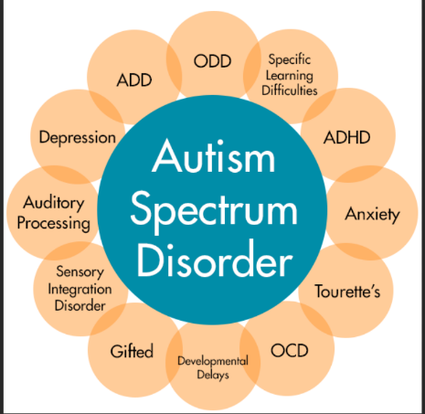
Task 1
Additional diagnosis
At times Autism is not a stand alone illness for an individual as at times can be associated with:
- ADHD
- OCD
- PICA
- Learning disability
- Global Delay
- Severe mental impairment

Diagnosis
Diagnosing and recognising Autism is getting easy as families are recognising that a child is not developing according to general milestones. Health care provides will take a parent concerns into consideration and Refer the child to paediatrician where tests will be carried out. (Diagnosing Autism, 2021)

Development
A lot of factors connected to autism that may raise alarm bells for parents
- Not responding to one’s name
- No babbling
- Not understanding gestures
- Not reaching miles stones
- Restricted or no Eye contact
(Signs of autism in children, 2021)

Educational setting
Settings can provide additional help for a child to thrive.
- Learning based on child’s needs
- One to one support
- Encouraging independence
- Childs needs being met
After a child gets diagnosed if a mainstream setting is not suitable an Educational health Care Plan can be applied for to enable a child to go to a specialist setting.
Autism
Specialist intervention
A child may require additional support from professionals to enable a better standard of life these could be
- Speech and language
- community Paediatricians
- occupational therapist
- social services
a lot of alternative therapy is also available. (McFayden et al., 2021)

Task 2
http:www.bloggr.com/letstalkaboutdisability
BLOGGR.com

www.nhs.uk/conditions/autism/signs/children
www.autism-society.org
verywellhealth.com/autism
Autism is a developmental disability and can range from someone leading a very independent fruitful life to someone being totally dependent. Signs can be apparent in babies when they are not hitting certain milestones such as responding to their names or babbling. Once signs are noticed, if parents access services to develop areas in which the child is lacking this will in turn help them in their future. Autism in some may go undetected and may also just be passed off as traits. (Oono et al.,2013)
If a child is diagnosed by a paediatrician at a young age then intervention can be put in to place to accommodate the child’s needs, that could range from school settings making adaptations for a child’s learning by offering one to one support or if they get an educational health care plan (EHCP) they will then be able to attend a specialist school that is more focused around the child’s needs. (Giserman Kiss, Feldman, Sheldrick and Carter, 2017)
Some children do need a substantial amount of specialist help from speech and language, occupational therapist, and community paediatricians. Some children that have Autism may also have additional disabilities like obsessive compulsive disorder (OCD), ADHD to name a few. (Johnson, Gliga, Jones and Charman, 2014)
If a child is to do well then parents need to also educate themselves in their child’s condition or they can not advocate for the child or know what the needs/wants are. Specialists and school provisions do facilitate several workshops that help get a better understanding of the disability.
Each child is unique in their own right and their needs are only specific to themselves. When exploring autism, it quickly becomes evident that no two children are the same, in this manner, concerning children with autism it is important to remember that generalisation and assumptions should not be made as to their requirements as often their individual needs will vary or be different
Early intervention in a child’s life is imperative to aid and support a person with special needs and promote independence. People take the simplest tasks for granted like talking or walking but for some children/adults with additional support these life skills can be taught which will have a life changing impact.

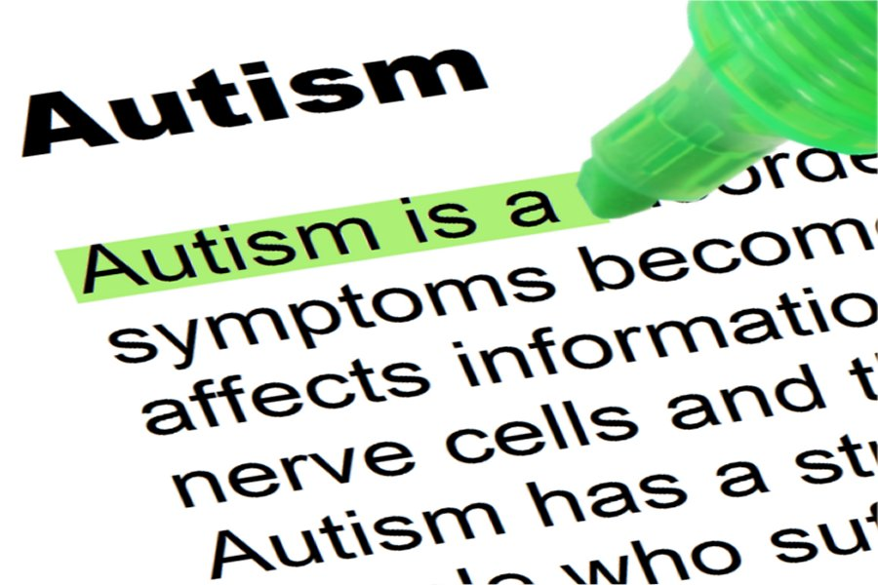
Autism

Innovation, creativity and values AUTISM

Find 2 Using www.medium.com/search locate a subject of your choice that you have opinions and expertise about. Find something you agree and disagree with. Write your opinion in the form of our Blogger.com post.
Add any weblinks, journal articles, books, videos etc here.

You can write your narrative around your blog here.

However, in (weblink) post it says XYZ and this makes me think …

Log on to www.pixlar.com and find a picture that demonstrates your thinking and put it here.

Username
Student No

Halema Begum
1816637
Awareness of Autism in the community is essential, as some may dismiss a person because “they do not look disabled”. Sometimes ignorance is bliss as the saying goes but the awareness of autism in certain ethnic backgrounds are very minimal. (Grinker, 2020) Talking about disability in certain cultures is like a taboo subject that can not be spoken about but what is this really accomplishing? Or who is the real victim if the topic is not addressed or acknowledged? (Abbott, 2011)

Reference list
Abbott, A., 2011. Tissue-bank shortage: Brain child. Nature, 478(7370), pp.442-443.
Grinker, R., 2020. Autism, “Stigma,” Disability. Current Anthropology, 61(S21), pp.S55-S67
Giserman Kiss, I., Feldman, M., Sheldrick, R. and Carter, A., 2017. Developing Autism Screening Criteria for the Brief Infant Toddler Social Emotional Assessment (BITSEA). Journal of Autism and Developmental Disorders, 47(5), pp.1269-1277.
Oono, I., Honey, E. and McConachie, H., 2013. Parent-mediated early intervention for young children with autism spectrum disorders (ASD). Cochrane Database of Systematic Reviews,.
Johnson, M., Gliga, T., Jones, E. and Charman, T., 2014. Annual Research Review: Infant development, autism, and ADHD – early pathways to emerging disorders. Journal of Child Psychology and Psychiatry, 56(3), pp.228-247
McFayden, T., Gatto, A., Dahiya, A., Antezana, L., Miyazaki, Y. and Cooper, L., 2021. Integrating Measurement-Based Care into Treatment for Autism Spectrum Disorder: Insights from a Community Clinic. Journal of Autism and Developmental Disorders,.
2021. [online] Available at: <https://www.autism-society.org/dsm-iv-diagnostic-classifications/#:~:text=The%20diagnosis%20of%20autism%20indicates%20that%20qualitative%20impairments,upon%20the%20presence%20or%20absence%20of%20specific%20behaviors.> [Accessed 28 February 2021].
nhs.uk. 2021. Signs of autism in children. [online] Available at: <https://www.nhs.uk/conditions/autism/signs/children/> [Accessed 26 February 2021].
Verywell Health. 2021. Diagnosing Autism. [online] Available at: <https://www.verywellhealth.com/autism-diagnosis-4014207#:~:text=Because%20autism%20cannot%20be%20diagnosed%20with%20a%20medical,spoken%20speech%20in%20an%20age-appropriate%20and%20meaningful%20manner.> [Accessed 26 February 2021].

