CHAPTER 3

3.0 Definition of Research
According to Kothari (2004) the purpose of doing research is to find a ‘truth that has not yet been discovered’ and he further suggests that research is key when studying social relationships as it identifies answers to social problems. On the other hand, Cameron et al., (2009), suggests that research within a business context includes undertaking a collection of data and interpreting it, followed by evidence to come up with actions, thinking, and decisions towards a specific interest within a business and its stakeholder. Saunders (2016) tells us that research can be conducted in many different ways including primary research which is original data, and secondary research that is from other sources such as academic books/journals, case studies etc.

3.1 Research Onion
The research onion developed by Saunders., et al (2009) will be used to explain and detail the primary research within the thesis, it will also find an eligible research strategy, data analysis technique, and a strong method of data collection. Figure 3.1 is the diagram of the research onion.
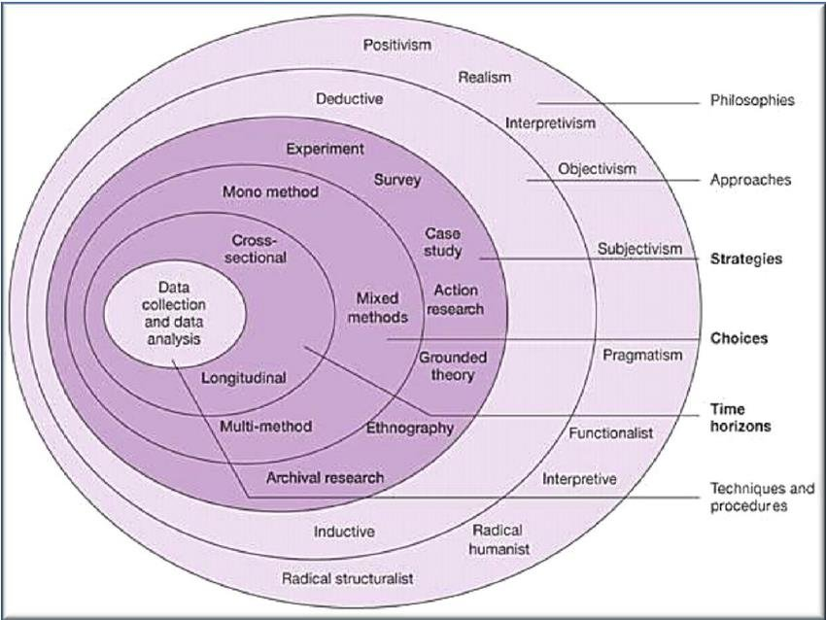

(Figure 3.1 Source Saunders., et al, 2009)
This chapter will be based around the research onion as it is most commonly used to structure the methodology to ensure this thesis is systematically explained. Table (3.1) is an overview of the approaches that will be utilised within the research from each layer of the research onion:
Layer | Approach Taken
Philosophy | Positivism
Approach | Deductive
Method | Mono-method
Strategy | Survey
Time Horizon | Cross-sectional
Technique and Procedure | Questionnaire
Table 3.1 – Overview of research approach
3.2 Philosophy
According to Sheehan et al., (2012) research philosophy is the correct method of collecting information, correct method for analysis, and is also used to identify assumptions of topics and the development of the information. Mertens et al., (2010) adds that philosophy is a substantial area of research whereby it will consume the majority of the third chapter. As the approach taken for research philosophy is positivism, a brief definition of both epistemological and ontological positions will be explained to further justify the approach.
O’Gorman et al., (2014) defines ontology as the ‘nature of reality’, but most importantly, how researchers identify reality and whether or not it should be subjective or objective, and he defines epistemology as being associated with human knowledge as it shows how we find the truth of reality. The research for this thesis will be made through an objectivist approach for the purpose of their being an objective (Carson et al., 2005).
Antwi et al., (2015) states that the positivist paradigm depends on deductive logic as it is also known as quantitative research because it believes knowledge it to be understood from experiment and observation with the aim to keep its reality (William, 2007). Kaboub (2008) adds that the positivist paradigm can only be undertaken by a single researcher because there is less interaction towards the candidates who are involved within the research, including online questionnaires. For the purpose of this thesis, the author will undergo the positivist paradigm because it is advised to be most suitable for the study, this will be done using an online questionnaire collecting quantitative data.

3.3 Research Approach
The research onion suggests there is either a deductive research approach or an inductive approach. Figure (3.2) shows both the deductive and inductive approach, and Gale et al., (2013) defines the deductive approach as the approach mainly used with quantitative research as it is there to either confirm a hypothesis/question or not, but also it is a way in which the development of the hypothesis is based within a theory. The figure (3.2) also shows it was a theory that was tested by empirical observations (Collis and Hussey, 2009).
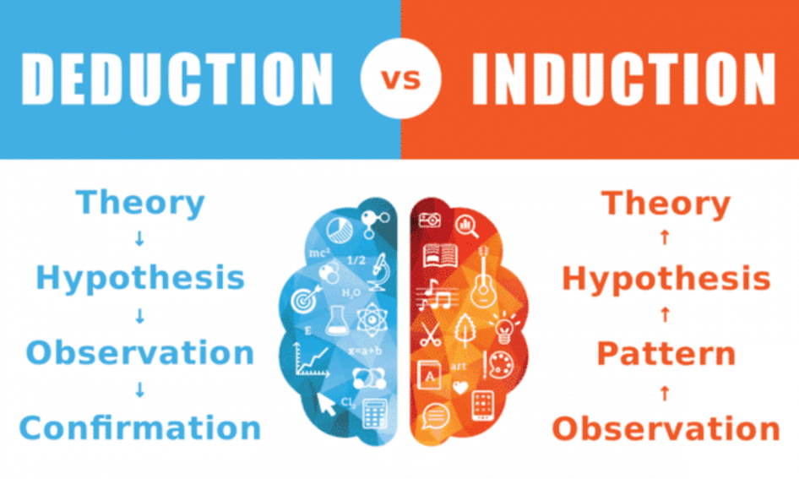
(Figure 3.2 Deductive and Inductive approach, Collis and Hussey, 2009)

3.4 Research Strategy
Burns et al., (2014) defines a research strategy as the ‘process of collecting and interpreting of data with clear objectives.’ Jalil et al., (2010) adds to this definition with, identifying the right research methodology is very significant and has the ability to identify issues that need to be investigated. Maxwell (2008), further suggests that as soon as a problem is noticed, then the aims of the research won’t be understood unless the appropriate research approach has been selected. An online questionnaire will be created and distributed for the purpose of this thesis’s primary research, and it will be further generalised and analysed.

3.4.1 Quantitative Approach
As previously mentioned, a quantitative approach is associated with a positivist philosophy and the quantitative approach was used within the online survey, to identify the general public’s, whom have a relation with social media influencers in the beauty industry, opinions on each question asked. Quantitative approach allows a larger amount of primary data surrounding individual opinions that was the further discussed after a large sample was collected.

3.5 Time Horizon
This section of the research onion is known as the penultimate layer, meaning there is a time requirement to conducting the research (Sahay, 2016), and the layer of the onion has two different approaches including cross-sectional (short term) and longitudinal (long term). For the purpose of this study, the decision to conduct a cross-sectional research was decided by the author for the main reason of them having a very small time frame to receive all the data they require. Malkoc et al., (2006) suggests that longitudinal studies typically track changes over a long period of time which is why this isn’t necessary for this research.

3.6 Collection Techniques and Procedures – Data collection and data analysis
It has already been identified that this research study provides quantitative data and is collected in a positivist form. However, there are different types of techniques that go along with the collection of the survey data – some being questionnaires or interviews. Although, this thesis will ask all participants exactly the same questions in order to identify necessary questions and prevent unwanted responses.

3.7 Questionnaire Structure
Collis and Hussey (2014) describes a positive approach to questionnaires as ‘close-ended’, which Cameron and Price (2009) agree as they have proved it to be effective whilst undergoing the collection of statistical data. A questionnaire approach was selected because it was deemed to be the most relatable to the study in regards to getting quantitative data. The survey has been designed with fifteen questions in order to specifically identify specialised questions for the study, it is shared through social media platforms, by the writer, including Facebook and Instagram, both platforms with people aged between 18-40 and over within the Swansea City area. Please check Appendix A for a copy of the online questionnaire.

3.8 Types of questions used in the online questionnaire
Throughout the survey, closed questions were asked to identify specific demographics of each individual respondent which is relevant for this study. The survey also provides structured responses in order to allow individuals to answer multiple choice questions as when it comes to being influenced through social media, there isn’t just one platform that can influence you for example. Finally, the survey provides a question with images of different social media influencers within the beauty industry from different ages, backgrounds, and different target markets, the aim of this question is to identify if there are specific influencers who influence anyone outside of their known audience.
According to Ilieva et al., (2002), there is one main strong advantage of carrying out online surveys and that is that you have the access to present your survey to the whole world and receive a large response. Cooper and Schinder (2011) support this statement and add that it widens the geographic reach and allows the survey to be completed autonomously with a larger time horizon. However, even though online surveys can be shared on the world wide web, this doesn’t mean that everyone who sees it is going to respond and it doesn’t mean that they will answer accurately (Rogelberg et al., 2006). Duffy et al., (2005) adds on to this statement with, 33% of people take time and answer online surveys accurately, this statistical finding proves that people don’t have all the time in the world to be answering a survey they may not have any interest in, this way, observations and/or interviews may suit the general public more.
Lefever et al., (2007) informs us that the main disadvantage of online surveys is the lack of respondents, meaning if less that one hundred people respond, then it is deemed as invalid as that amount of people isn’t enough to provide an honest reflection of their thoughts and opinions. For the purpose of this dissertation, the online survey created won’t be analysed until more than one hundred and fifty individuals have responded.

3.9 Piloting web-based questionnaire and distribution
O’Gorman and Macintosh (2015) inform us that before you publish an online survey, a pilot study must take place to make sure that there are no grammatical errors, or any error in general, the pilot study will highlight these errors that must be changed before publishing. For the purpose of this online survey, two different lectures pilot tested the survey for this dissertation.
The distribution of the online survey was sent to lecturers and peers though the university email system, with a message stating it wasn’t the real one, and asked people to give feedback as they could notice something that no one else might (McGrath et al., 2005). The survey was created through an online programme called Google Docs.

3.10 Sampling
Bell et al., (2018) believes that sampling in research involves a group of people, objects, or items that are selected from a larger population for measurement. Greener (2008) supports this with the sample should be representative of the population to make sure that the findings can be generalised from the sample to the population as a whole. Ghauri et al., (2020) suggests that sampling is a strength for online surveys as they are low in cost, due to a smaller selection of the population, less time consuming, and the scope of sampling is high meaning the researcher is concerned with the generalisation of the data instead of studying the whole population which would be impractical. However, Jawale (2012) makes a point of the disadvantages of sampling including chanced of bias opinions, it’s difficult to select a true representative sample, and finally it’s in adequate knowledge within the subject resulting in the study being misleading.
The sample will consist of participants in the category of Millennials and Generation Z of whom are familiar with the social media influence within the beauty industry. The online questionnaire is going to have a brief introduction paragraph stating, “This questionnaire aims to identify consumers thought process when it comes to purchasing beauty products promoted by social media influencers.”, this was decided to ensure every participant understands the purpose of the research. It will be distributed through social media platforms Facebook and Instagram due to the fact that the questionnaire wants to ask people who are influenced on these platforms. As there is a time restriction for the research, the aim of one hundred and fifty respondents minimum has been set. Once all of the data has been gathered together, it will be analysed and interpreted by the researcher who will then utilise tools provided by the questionnaire itself, the source being Google Docs.

3.11 Reliability and Validity
Lillis (2006) informs us that high levels of validity and reliability are vital for credibleness of quantitative research. Reliability is defined by Denscombe (2014) as, ‘whether or not a research instrument is neutral in its effects and consistent across multiple occasions of use’, meaning, would the research produce the same results if done again. On the other hand, validity is defined by Denscombe (2014) as, ‘the accuracy and precision of the data. It also concerns appropriateness of data in terms of the research questions being investigated. The basic question asks if the kind of data is right for investigating the topic and if it has been measured correctly.’
Riege (2003) mentions that reliability is a main implication for quantitative research and believes, if you are testing within the positivist paradigm, it will not highlight positive levels of consistency, instead it raises issues about the method of mensuration to the point of not being able to trust its consistency. However, Collis and Hussey (2003) argue that quantitative research tends to form results low in validity, in comparison to a qualitative approach, as this is due to the accuracy and ability the repeat experiments that show high consistency of results. This study will be double checked to make sure that the survey is developed professionally to prevent any issues to the validity.

3.12 Limitations of the Research
Due to this research having a limited time horizon, limitations are likely to occur. The main concern is ‘sample bias’, as this questionnaire is going to be distributed through social media platforms, this may not be a strong representation of the population at large, and this has the potential to affect the generalisability of the overall results. However, research was carefully selected in order to make sure no bias was present, also the use of the Gantt chart helped with time management was used to ensure the questionnaire was live for the public to respond to for 2 months and once shared through the different social media platforms, a small paragraph was mentioned explaining the purpose of the questionnaire to allow participants to understand before taking the survey.

3.13 Ethical Requirements
The first ethical requirement that will be taken is that the survey is for participants over the age of eighteen only, this will be explained throughout the sharing of the questionnaire on the different social media platforms to prevent a lack of communication. There will be no option on the age question for under eighteen anyway. Each and every respondent will be completely anonymous, and the data received from the survey at the end will stay confidential and be used for the research and the research only. The University of Wales Trinity Saint David policies and guidelines will be taken into close considerations at all times to ensure there is no breach of ethical requirements. Check Appendix B for the confirmed, and approved, ethics form provided by the UWTSD before the research.

