Zara James
P150964
Creative Venture M7X01792
Evaluative Report CW2

Figures

Figure 1: Domoney, D., 2017. Chelsea Flower Show: The Positive Power of Plants Top 20! - David Domoney. [online] David Domoney. Available at: <https://www.daviddomoney.com/chelsea-flower-show-the-positive-power-of-plants-top-20/> [Accessed 5 April 2021].

Figure 2: Clarke-clarke.sandersondesigngroup.com. 2021. Clarke and Clarke Design Book 2021. [online] Available at: <https://clarke-clarke.sandersondesigngroup.com/media/keth3bpt/clarke-and-clarke-design-book-ss21.pdf> [Accessed 18 May 2021].

Figure 3: 2021. Trend Bible Home and Interiors Autumn Winter 2021/22. [ebook] p.7. Available at: <https://moodle.uwtsd.ac.uk/pluginfile.php/472566/mod_resource/content/1/Trend%20Bible%20AW21-22%20Home%20and%20Interiors%20eBook.pdf> [Accessed 18 May 2021].

Figure 4: Zeng, S., 2015. Image Relay - Sian Zeng | In Real Homes Folder. [online] Sianzeng.imagerelay.com. Available at: <https://sianzeng.imagerelay.com/flc/imagebank/986479> [Accessed 5 April 2021].

Figure 5: Behance.net. 2021. Behance. [online] Available at: <https://www.behance.net/gallery/61264997/Heathrow-T5-Animated-Wallpaper> [Accessed 8 April 2021].

Executive summary

In this report, I will discuss how an interior design can not only change the look of a room but change how you feel within it. Plants and gardens have always played a big part in my life and have always inspired me. I will show how my knowledge of florals and botanicals has grown through my research and how colour and light affect this. Throughout my time on the course, I have grown as a designer and a person. Through my experiences, I have become more confident. My painted florals have been digitally manipulated into repeats, to fit all rooms and moods. The journey of my creative venture is very personal to me but also to the time that we are in. The spaces that we inhabit, may that be our homes or a commercial space, need to make us feel safe and benefit our wellbeing. We grow, learn, and change in these spaces and I want the surroundings to adapt to us.
My long-term goal is to be a designer, and design and paint for the rest of my life. Both for others and myself.

During my ‘Research Methods and Communication’ last Semester, I think I was ambitious and have given myself scope to research further and in more depth for this Semester. From my feedback, I learnt that I am sometimes repetitive, and I need to find new ways to get my point across. Writing isn’t my strong point, but throughout this report, I am going to push myself to communicate what I am thinking better. There is scope for further thought and research to be done. Throughout this report, I will explore how we can make ourselves happier and healthier in our own homes. By bringing this research into my physical work I will prove the following theories.

‘Floriculture, branch of ornamental horticulture concerned with growing and marketing flowers and ornamental plants as well as with flower arrangement.’ (Petruzzello, 2019) I love the word floriculture, and I feel that it exhibits exactly what I want this project to be. I want to know all about flowers and have become obsessed with the idea that florals and plants can alter our mood. These feelings from nature are deeply implanted in our brains.

There are lots of things that each individual person would say makes them happy. Some would say being with friends and family or being on holiday. Even though we all are individual people, and we all have our own opinions, likes, and dislikes, our minds are designed to be drawn to nature and the outdoors. In Simon Warrall’s article in National Geographic ‘We are wired to be outside’ he interviews author Florence Williams on her book ‘The Nature Fix’
‘The frontal lobe, the part of our brain that’s hyper-engaged in modern life, deactivates a little when you are outside. Alpha waves, which indicate a calm but alert state, grow stronger. When psychologists talk about flow there seems to be a lot of alpha engagement there.’ (Warrall, 2017)
Today we have the technology to know this, but for decades we have been drawn to nature, and it’s amazing healing and medicinal properties. This is not some new well-being trend, this is something that is deep within our DNA, nature makes us happy and relaxed. Williams’ book ‘The Nature Fix’ sets out to uncover the science behind nature's positive effects on the brain. ‘As our modern lives shift dramatically indoors, these ideas - and the answers they yield - are more urgent than ever.’ (Williams, 2017) 2020 (and now most of 2021) has become the year we stayed home, we have worked from home, relaxed from home, and even celebrated from home. I cannot speak for everyone, but I know from friends and family that I have spoken to, we all feel the same. This time spent in our homes has made us think about our spaces and how we can make them a happier and healthier place to be.

So we know that plants and nature improves our overall wellbeing, but are there specific plants that make us happier than others? David Domoney spent almost 5 years proving how much of a positive impact they can have on our lives. ‘It could be that the sight of a Christmas tree in the corner of the room fills you with joy over Christmas, or that a red rose on Valentine’s Day brings you happiness but, however you tap into it, the positive power of plants is abundant.’ (Domoney, 2018) I loved this quote from Domoney because it’s true. The positive power of plants can be through so many different ways. In the Chelsea flower show 2015, Domoney did an exhibition where he used facial recognition software to explore which plants made us the happiest. His ‘Positive Power of Plants’ campaign was designed to raise awareness of the positive impact that plants can have on our lives. From his research, he found that the Lily of the Valley was the plant that made people the happiest. Over 30,000 people visited the stand, and the results were clear. They said that Lily of the Valley triggered memories of walking in the wood and seeing the sprays of flowers. What I found quite interesting about this is that Lily of the Valley is quite poisonous if ingested, so although it was voted the happiest plant it can have some quite unhappy side effects.
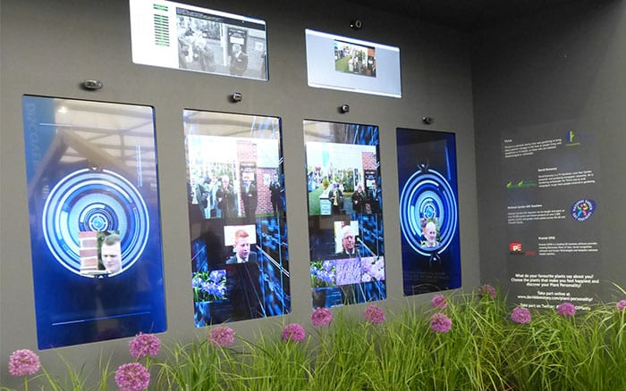
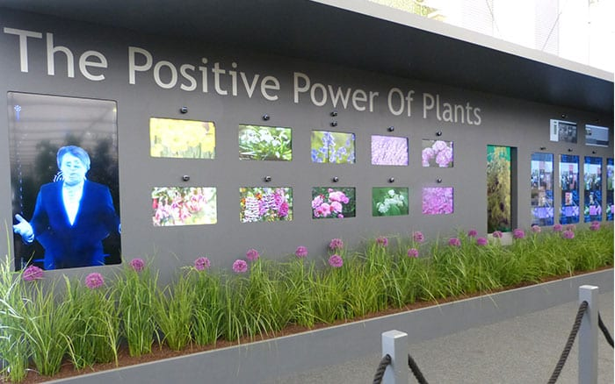

Figure 1: (Domoney, 2018)

Why do our brains react this way? Flowers and plants make us happy by triggering our happy brain chemicals like Dopamine and Oxytocin. ‘Flowers were a huge reward signal in the world our brain evolved in because they marked the coming of abundance after a hungry winter. Today we have enough to eat all year round so we don’t consciously link flowers with food. But the blossoming of a flower triggers the sense that something special is coming because it triggers dopamine.’ (Graziano Breuning, 2017) These chemicals are triggered naturally when we look at flowers and nature because that’s what we were designed to do! I love this about our brains and I want to slightly trick these feelings by using florals in the home, so you don’t have to go anywhere to feel these emotions.

I want to design for interiors and homewares. I find my style is bright, fun, and playful so sometimes (even though I always initially start designing for interior) I fall under the stationery and gift category. I feel that my designs work for both and can be edited to fit either. My playful painterly style may be ‘too much’ for some people to have in their homes all the time and that’s okay, I understand as I like a clean and bright space also. This collection is adaptable to the space and the customer's preferences. When doing market research I found that lots of the big brands have floral collections for this season (Spring/Summer 21/22). Clarke and Clarke’s new collection is called ‘Fusion’ and described on their website as ‘Soft painterly florals and brush stroke marks create impressions of abstract shapes and movement.’ (Clarke and Clarke Design Book 2021, 2021) From this description, I feel like my designs are right on trend! Looking at trends and looking at what other brands are doing is something that I will continue to do after I leave university. I can update my portfolio as the trends change to make sure my designs and style are always in fashion. I was very lucky to be able to get my hands on the Autumn 21/22 Trend Bible for Home and Interiors. In the Trend Bible, one of the trends is called ‘Soulful Sanctuary’. ‘This trend is driven by a desire to find synergy between body and mind, eliminating the daily stresses and anxieties in our lives. In the pursuit of a calmer approach to living, more emphasis is placed on environments, activities, and products that help consumers to decelerate their current pace of living.’ (Trend Bible Home and Interiors Autumn Winter 2021/22, 2021)
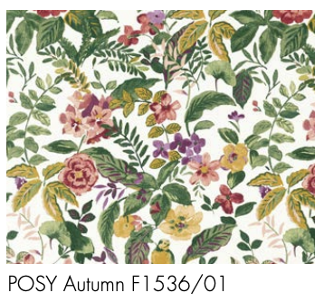
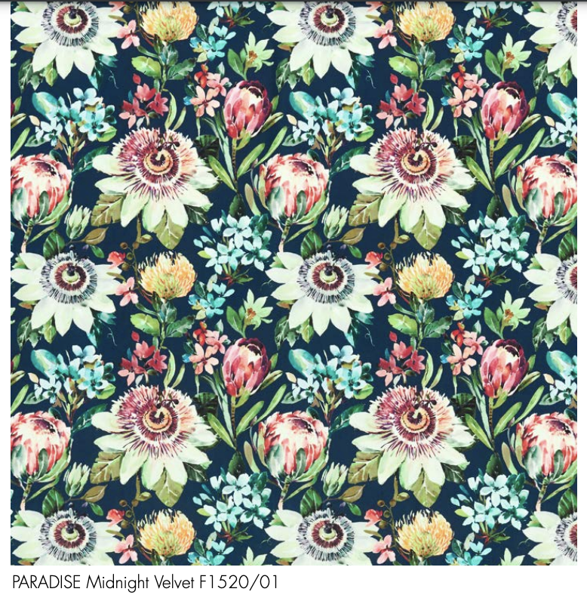
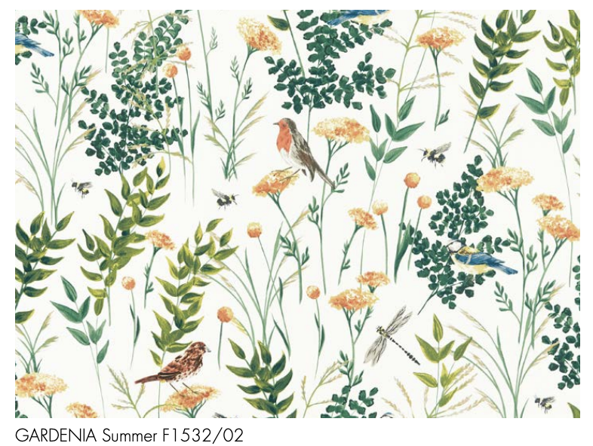

Figure 2: (Clarke and Clarke Design Book 2021, 2021)

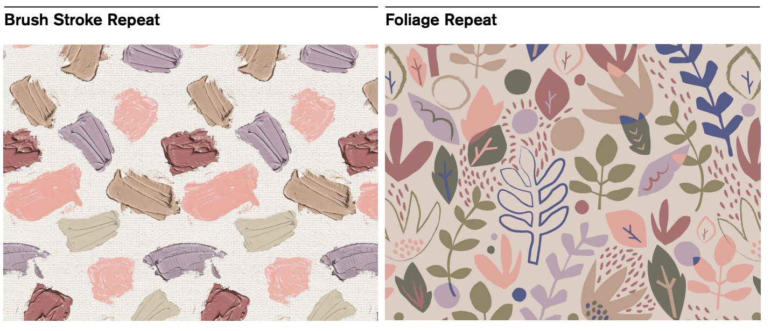

Figure 3: (Trend Bible Home and Interiors Autumn Winter 2021/22, 2021)

I have always wanted to design for interiors and throughout the pandemic and lockdown, it has been difficult to imagine designing for anywhere but the home. Although, as things are starting to reopen, we will hopefully be spending less time in our homes therefore I want to consider my designs being used in commercial spaces too. Restaurants and bars like The Ivy are known for being ‘Instagramable’ by using a maximalist design style. These spaces are used throughout the day and into the evening, so I wondered how the atmosphere changed. For example, somewhere like The Ivy in Cardiff does a lunch menu, afternoon tea, and also has a dinner menu where they serve cocktails. Surely, they would want to create different atmospheres for the different times of the day.
My idea was to create a wallpaper that could transform the space. Theoretically, the background of the wallpaper would change from a light green to dark as the sun sets or the flowers start to open as the sun goes around the room. There is a way that this could be achieved by using thermochromic ink. Thermochromic are screen printed inks that change when heat is applied – not sure if this would be reliable enough as in the UK the sun isn’t warm at the best of times and heating could have an unwanted effect. My other options were making wallpapers or designs that could be physically changed or interactively moved like stickers. Sian Zeng uses magnets to make her wallpapers interactive. ‘Our philosophy is to encourage playfulness and imagination, which is why we developed our range of interactive, magnetic wallpapers. Offering a fresh design perspective and a desire to create a whimsical narrative, our customers can play out their fantasies by moving a cast of magnetic creatures and buildings across the wall, adding quotes and stories with our write-on speech bubbles.’ (Philips, 2014) Zeng’s playful designs are aimed at children. This playful interactiveness isn’t really what I wanted for a restaurant or commercial space, but the idea of a continuously changing space is.

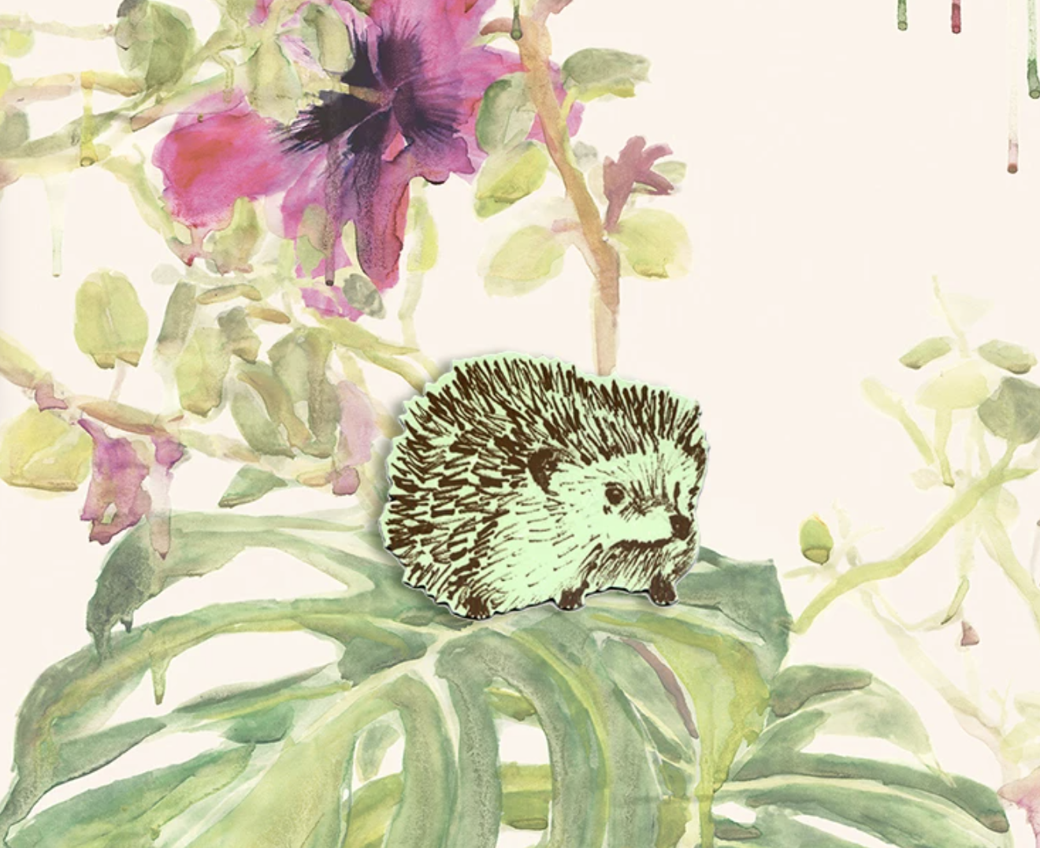
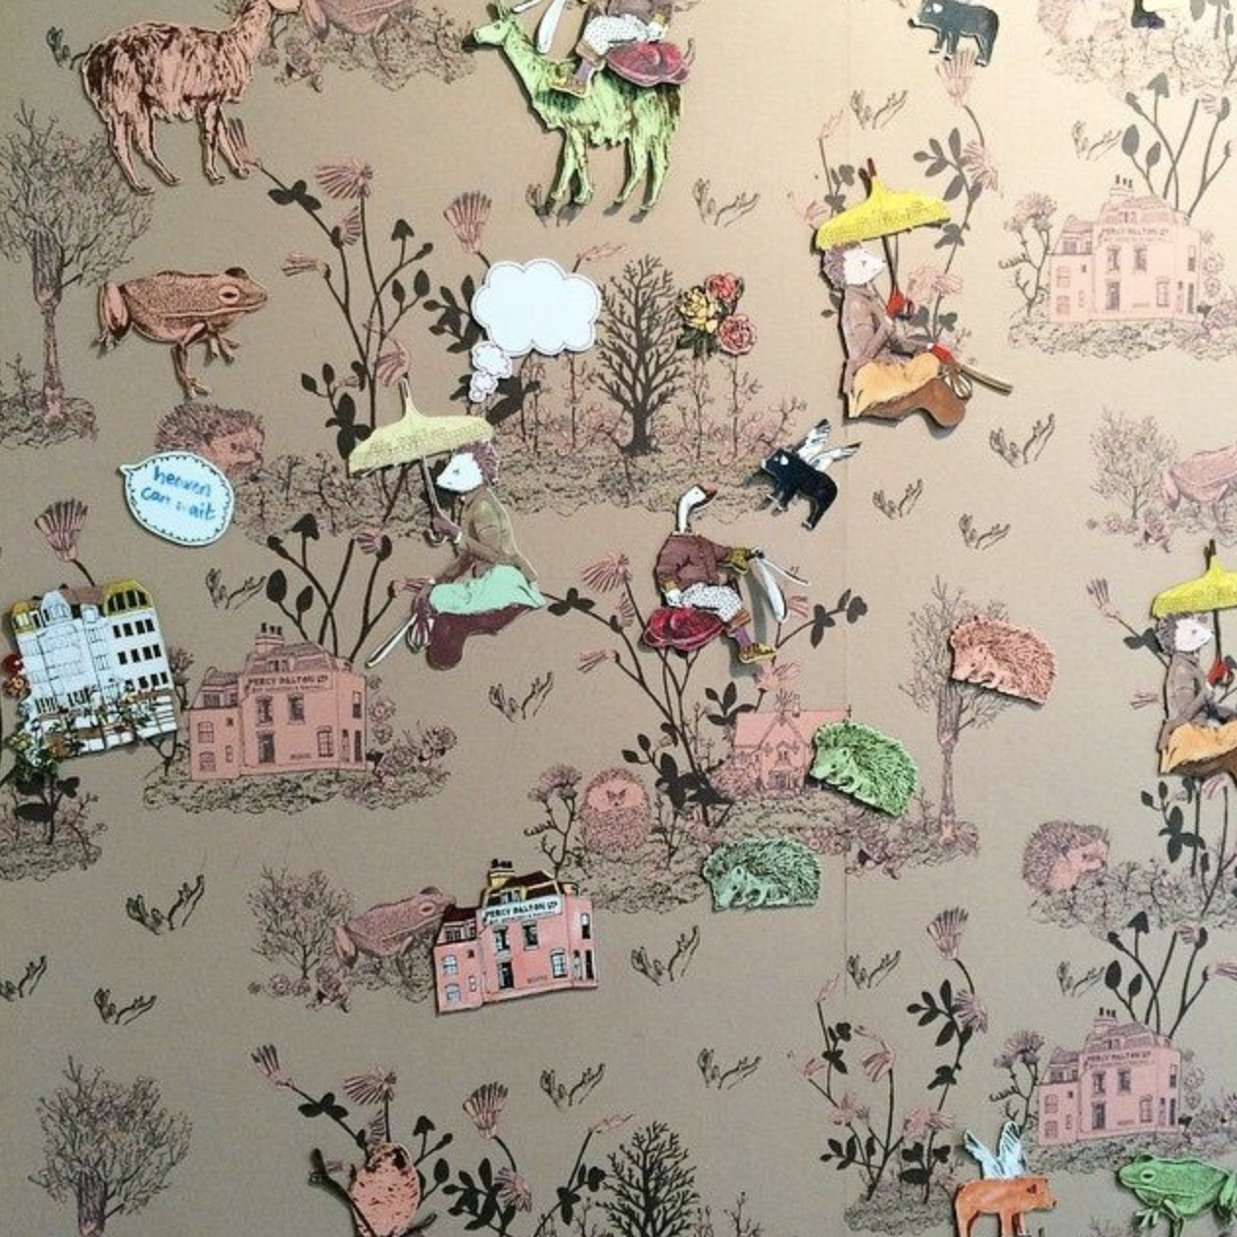
Figure 4: (Zeng, 2015)

Christopher Pearson created a series of animated wallpapers in 2005 since it has been part of exhibitions in Paris, Miami, Korea, Milan, and London and featured in shows at the Design Museum London; Dundee Contemporary Arts Centre; Hangaram Design Museum, Seoul; CODA, Amsterdam; Sketch Gallery, alongside a permanent position within the Houston Museum of Fine Art collection. ‘It's the longest installation to date shows it within the first club lounge of terminal 5, Heathrow since 2007.’ (Behance, n.d.) These animated wallpapers, although a bit glitchy as they were made in 2005 are exactly what I was imagining. I love the idea that the space is constantly changing and transforming. ‘Christopher Pearson brings William Morris’ famous “Willow Boughs” wallpaper (1887) to life using contemporary technology. It’s very subtle and at first glance, nothing seems to happen but all of a sudden a bird is fluttering or the leaves start waving and a zebra might enter the scene. The animated wallpaper idiosyncratically expresses Morris’ romantic ideas about nature, arts and crafts.’ (Look at your walls by Christopher Pearson – droog, n.d.) Pearson used some of William Morris's most famous designs and brought them to life, I want to bring my designs to life too. I think that this will have an even bigger well-being effect as it is as if you are actually in nature. The reason I am pitching this as only a commercial idea is that as you can see by the images below this would need to be projected onto a wall or played on a large-scale screen. For domestic use there could be a downloadable 'tv screen saver’ that matched the wallpaper behind that subtly moved and changed, maybe a bee could fly past, or a leaf could move in the wind.

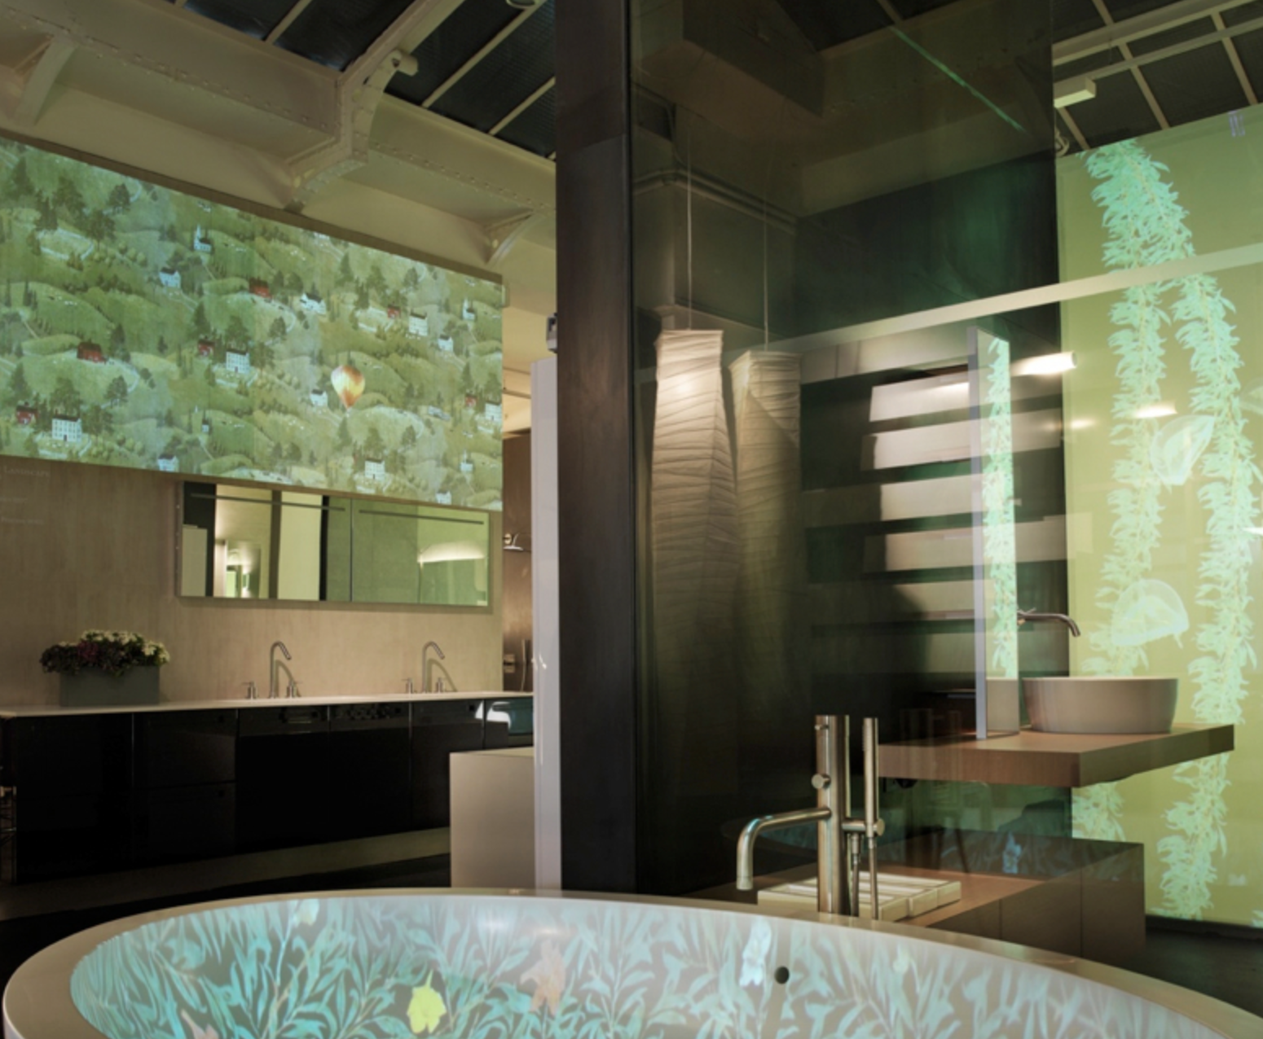
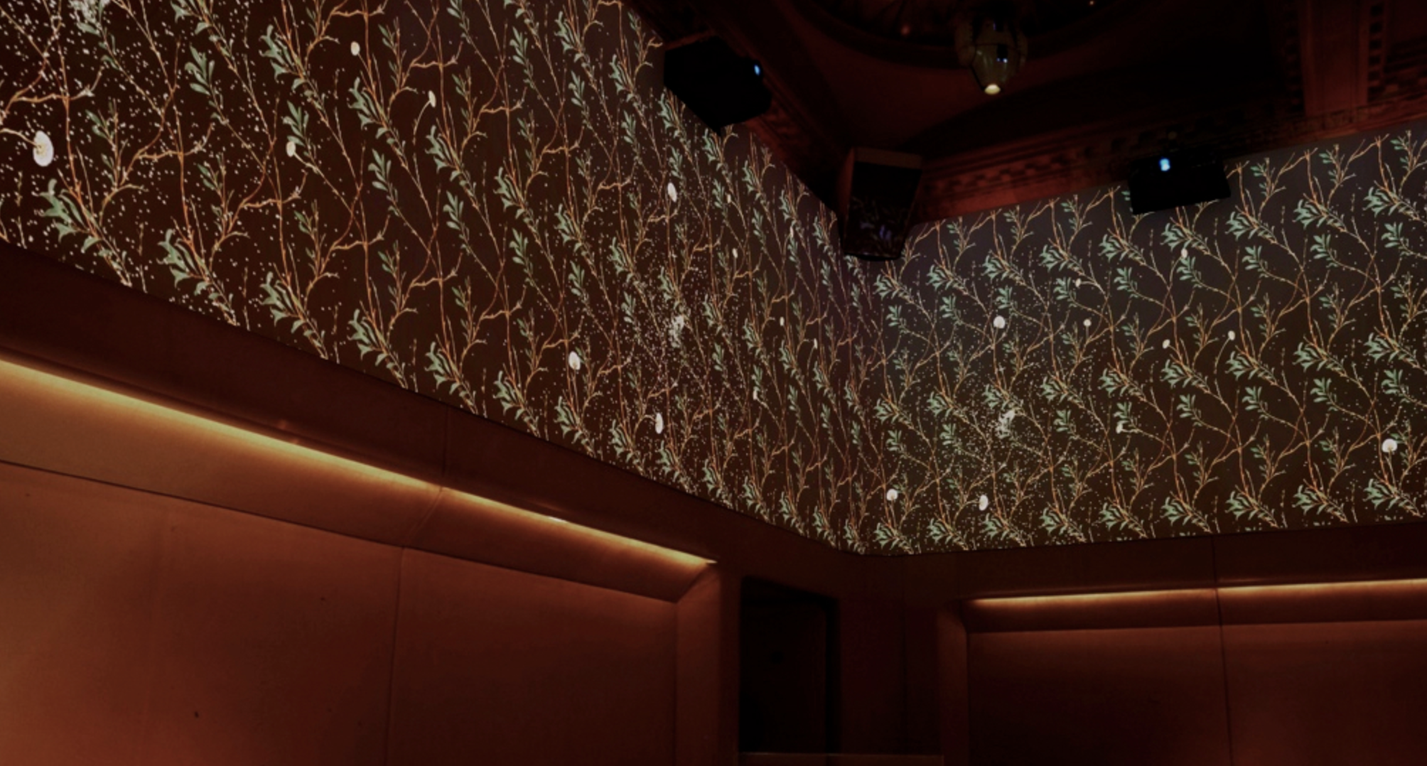
Figure 5: (Behance, n.d.)

Link to video of animated wallpaper

Another animation that inspired me is Michael Angove’s Jo Malone and the interactive display. ‘Twigs and branches unfold and multiply on screen then leaves, flowers and petals fill the screen with colour. Perch has animated our illustrations so that individual fruits or petals fall to the ground whilst butterflies and insects decorate the gently swaying finished composition.’ (Jo Malone London - Michael Angove, n.d.) This is what I want my animation to be like! This animation could also be used on my website and on my socials I think it would really make me stand out.

Link to video of interactive display

Throughout my time on the course, I have grown as a designer, but I think especially this past year my painting skills have become my greatest asset. I never really enjoyed screen printing and the unpredictability of it, I’ve always been quite a clean and tidy person and it’s the same in how I like to do my work and design. Since the end of my second year I have been designing in this way and I have fallen in love with this philosophy. Painting the florals in gouache and digitally manipulating them into a repeat or finished design. Although since my second year things have changed, I have become more confident in my painting and drawings and not so dependent on my digital skills (although they have still grown as well). I now spend more time on the painting, making sure I get all the detail and a real feel for the flower or plant, and less time in photoshop. I’ve learnt how to paint to make things easier for myself to repeat later on. I have my style and process and I love every minute of it. I had never used gouache before my first year and although I have been painting for the majority of my life it has made me fall in love with painting. ‘Gouache is a type of water-soluble paint that, unlike watercolour, is opaque so the white of the paper surface does not show through’ (Gouache – Art Term | Tate, 2021) I love to use gouache for multiple reasons, but I think as a designer it is such a good skill to have. By creating a portfolio full of paintings I am proud of will hopefully not only help me get a job when I graduate but also make me confident in applying for those jobs.

I would say that one of my biggest challenges is my confidence. I have got so much better throughout my time at university and in my social life, however, I feel that sometimes it still holds me back when I’m trying to express my ideas and when in group situations. I don’t think the pandemic has helped me in any way either, this is something I am constantly working on and hope to improve further in the future. One place that I enjoy ‘showing off' my work is online, especially Instagram. Instagram is turning into an online portfolio for me, where I can show work in progress and where my followers can scroll back, all the way to my foundation year, and see how much I’ve grown. I want to grow my Instagram more towards the end of this year and have all my work documented in a clean and engaging format. I’m a bit of a geek when it comes to online engagement and I have managed many social media accounts from Facebook and Instagram to Twitter. I love to see what people like, what makes them stop scrolling, and look at your post? What makes them click on your profile? The answer to that question is unknown. The post has to be engaging to catch people's eye but really, it’s up to that individual and their personal taste. The algorithm is something that gets spoken about a lot and it is very complicated. Instagram doesn’t put your feed in chronological order the posts that get put on your feed are all down to the algorithm. I have done a lot of reading in the past about this topic and the answer to how do I ‘beat’ the algorithm is just to show up on Instagram and post, may it be stories, feed, or even reels! By posting on Instagram it sends positive signals to the algorithm that will push you up the feeds of your followers. I find it hard especially at the beginning of a project, to post consistently. During my Creative Venture, I will plan my posts, so I post at least 3 times a week on my feed and then have extra stories and reels on top.

At the beginning of this academic year, I started an Etsy shop. I released four Christmas cards, they sold better than I could have hoped for and I had really good feedback. Since then I have released a few new cards, they haven’t sold as well but I haven’t posted about them as much or advertised them at all. I was surprised at how much of my time it took up at Christmas and decided it took a back seat to my degree. Although this is something I would love to continue with when I graduate. In a perfect world, I will get a job as a Surface Pattern Designer for an interior company or a gift company, and that is still my plan. I want to gain experience of working in a studio with other people and learn about the industry. However, I am a planner and I like to have backups. Therefore my backup plan is to start my own small business of cards, prints, gift wrap, notebooks, and all the little stationery accessories I can. My long-term dream is to have my own brand and have my designs being sold in shops like John Lewis and Sainsbury's, I want to walk into a shop and see my designs, may it be on a cushion or a notebook. Whichever path I take when I leave university, I hope to end up there.

Freelancing is something that I think would be a good option for me. During my Creative Enterprise and Practice report, I wrote about my first taste at freelancing. I enjoyed the experience, and it has given me the confidence to take on more freelancing opportunities. Recently the opportunity arose for me to design a few gift card designs for PetsAtHome. The company that contacted me is called Magnet and Steel, they are the World leader in supplying pet retail stores with calendars, books, greetings cards, gifts, and signs. I have worked with them before as they photographed my dog for one of their calendars, whilst on the shoot, I talked to them and they asked what I did in university. They followed me on Instagram and saw my Christmas cards which is what prompted them to email me and asked me to put forward a few pet-themed designs. This deadline has been pushed back until June, so I have nothing substantial to show at the moment, but I hope this is something that could lead to more opportunities in the future. I have also been looking at signing up to some freelancing websites, the two I have been recommended are Fiverr.com and Upwork.com. Both of these sites are like an online portfolio where people can search for example a ‘Surface Pattern Designer’ and all the surface pattern designers will come up with their work and their contact information. They also keep track of the work you have done like a mini portfolio and people can recommend you. I think this is something I can pursue whilst I am applying for jobs, to keep my portfolio growing and keep myself in the flow of working and being creative.

My action plan for after I graduate is just to apply for as many jobs as possible. I’m not going to be picky about where the job is or what exactly it is, I just want to gain experience and if that means I’ve got to move or designing something I don’t particularly want to, I’ve got to remember that it is just the first step, and if I don’t take that job, I might never have the experience to get my dream job. Moving somewhere new is a big step and it would have to be a very good opportunity (and good pay) for me to be able to afford to do something like move to London. I have already started applying to jobs, some local and some not. I have rewritten my CV and cover letter accordingly and will continue applying until succeed.

There are lots of ways I am ‘looking for jobs’. I have my LinkedIn account where I am posting and being present, by following and connecting with more people. I have also signed up for ‘The Dots’( which is like the creative version of LinkedIn) and keeping my Artsthread account up to date. I have also signed up to some job website mailing lists, so I get emails when new jobs are up. And I am following accounts on Instagram like @surfacedesigncommunity where they post about new jobs when they come about. I have made a list of 10 places I am going to apply to that I will mention now;-

Liberty is the first place that I am sending my CV and portfolio. I know this is a long shot, but they are hiring a new junior designer. Although this job is specifically for the Asian Market and fashion (both things I’m not very interested in) I’m applying anyway as Liberty’s is probably my number one dream job and I want to be on their radar as much as possible.

The second place I am going to apply to is Superdry. Again a fashion retailer, however, they are actively looking for an Assistant Print Designer. This is such a well-known brand, and again when a job like this becomes available, I would be silly not to apply for it.

Another place I will be applying is Papier. Papier is a stationery and greetings cards company based in London. The job advert is for a Stationary Designer who has 3-5 years experience, but I am going to apply anyway as I think my portfolio is strong and will stand out from the crowd.

Dunelm is also offering a Textile Artist Graduate Programme, this is one of the only graduate schemes that I have seen so again I think I need to apply.

Others that I will be applying to are; Asda – Assistant Print Designer, Imprint Group – Creative Designer, Orchard – Surface Pattern Designer, and Crunch Media – Junior Designer.

Below is a list of dream jobs that I am going to send my cover letter and CV, with a link to my website with my online portfolio.

Liberty
Sanderson’s (and all the companies they own)
Romo
Paperchase
OhhDeer
UKGreetings
Lick
Hallmark

I feel like this is a very good starting point and even though I am aiming high I think that’s good and shows how much my confidence in myself has grown since being at university. I also have a plan to keep my portfolio up to date and fill in the gaps that I think I am missing. This is something that Heather Fox said she did when she left university and claims it’s how she got her first job. I have a list of things like stationery and childrenswear, that I think some of my current and past work could also work for. So I am going to do some visualisations of these designs in these formats and add them to my portfolio. I am also going to do a watercolour mini collection which I will visualise onto women’s wear and children’s wear. Fashion isn’t something I have ever delved into whist in university as I’ve always loved interiors. However whilst looking for jobs I have realised that there are more fashion jobs than anything else and if I can gain some experience by working for a fashion brand I will. My portfolio is something I plan on keeping up to date and constantly adding to it by setting myself these mini briefs.

I have been very lucky to have been able to get two New Designers portfolio reviews. The first one is with Sanderson’s on the 17th of June and the second on the 22nd of June with Liberty’s. Both of these are a dream come true and I am so excited and nervous to speak to them. I will also be submitting work to both Sanderson’s and Liberty’s for their New Designers briefs, and I am also looking at submitting to Romo and John Lewis as I think the work that I have done for this project would fit well with their briefs. I am planning on submitting work from this project to all of these companies as I have a lot of different imagery and separate collections that I think will be a good match to these.

As I reflect on my creative venture, I can’t help but feel proud of the work that I have done. This has been by far my favourite project that I have ever done, and I am so happy with the outcome. I would have loved to have had a degree show, but I feel that the sample book I have made looks professional and shows my work off in a different way. It’s also something that I can keep forever, all my designs in one place. Throughout this project, I have painted a lot. At the begging of this project, I said I wanted to have a sketchbook full of lots of painted florals and I have done just that! I think I have a strong portfolio of paintings that I can show to any potential employer.

When I first started animating my designs, I was disappointed with them. They weren’t very long and weren’t very exciting. This was due to my lack of skills on After Effects (the programme I was using to create the animations) although after doing a few and looking back through my research I realised I wasn’t looking to have this mad and distracting wallpaper. It was meant to be subtle and natural almost, and I think this is what I achieved. Although I couldn’t project them onto a wall like I would have hoped to I have uploaded them to my website and I will be uploading them to my Instagram. This is something I hope to continue to do, even if it’s just for fun on my Instagram as I think it’s a good skill to have and I think it could draw attention to my designs and my social media accounts. Overall I am so happy with how this project has turned out. My time on Surface Pattern has been amazing and I have grown so much as a person and a designer. I hope to continue growing and learning in the next steps of my career and hope the next few years are as good as the last.

Bibliography

2021. Trend Bible Home and Interiors Autumn Winter 2021/22. [ebook] p.7. Available at: <https://moodle.uwtsd.ac.uk/pluginfile.php/472566/mod_resource/content/1/Trend%20Bible%20AW21-22%20Home%20and%20Interiors%20eBook.pdf> [Accessed 18 May 2021].

Clarke-clarke.sandersondesigngroup.com. 2021. Clarke and Clarke Design Book 2021. [online] Available at: <https://clarke-clarke.sandersondesigngroup.com/media/keth3bpt/clarke-and-clarke-design-book-ss21.pdf> [Accessed 18 May 2021].

Domoney, D., 2018. The positive power of plants - David Domoney. [online] David Domoney. Available at: <https://www.daviddomoney.com/the-positive-power-of-plants/> [Accessed 5 April 2021].

Droog.com. n.d. Look at your walls by Christopher Pearson – droog. [online] Available at: <https://www.droog.com/projects/look-at-your-walls-by-christopher-pearson/> [Accessed 5 April 2021].

Graziano Breuning, L., 2017. Why Flowers Make Us Happy. [online] Psychology Today. Available at: <https://www.psychologytoday.com/gb/blog/your-neurochemical-self/201706/why-flowers-make-us-happy> [Accessed 5 April 2021].

Michael Angove. n.d. Jo Malone London - Michael Angove. [online] Available at: <http://www.michaelangove.com/portfolio/jo-malone-london/> [Accessed 5 April 2021].

Petruzzello, M., 2019. Floriculture | Definition & Facts. [online] Encyclopedia Britannica. Available at: <https://www.britannica.com/science/floriculture> [Accessed 5 April 2021].

Philips, H., 2014. Magnetic Wallpaper by Sian Zeng - The English Room. [online] The English Room. Available at: <http://www.theenglishroom.biz/2014/07/06/magnetic-wallpaper-by-sian-zeng/> [Accessed 5 April 2021].

Tate. 2021. Gouache – Art Term | Tate. [online] Available at: <https://www.tate.org.uk/art/art-terms/g/gouache#:~:text=The%20term%20gouache%20was%20first,order%20to%20make%20it%20opaque.> [Accessed 5 April 2021].

Warrall, S., 2017. We Are Wired To Be Outside. [online] Science. Available at: <https://www.nationalgeographic.com/science/article/nature-fix-brain-happy-florence-williams> [Accessed 5 April 2021].

Williams, F., 2017. The Nature Fix. 2nd ed. [Place of publication not identified]: W.W. Norton & Company.

