Module tittle: Professional Career Development
BMSW4005
Date: 06/05/20
Student: Sara Castañares Esteban
ID Student: 1817439

- Introduction
- Own skills and experience
- Personal SWOT Analysis
- Career development
- References

- Introduction

This assessment is quite important for me after the decision that I took this year. Exactly 3 weeks ago I started my own digital marketing company, The Umbrella Girl Media Ltd.
It’s being an important step and I’m finding a lot of difficulties that I didn’t expect it, but I’m proud of the decisions that I’m taking for my future.

This would have been easier if I had spent many years in a marketing related industry working internally, but in my 20 years as a hairdresser, even though I have touched the marketing part and collaborated making content for social networks, I had to start studying first from the beginning. Being such a broad subject, you have to have at least a short knowledge of everything related.

Social networks, blogs, videos, audios, web marketing, internet ads etc. Today they play a key role in harnessing the possibilities provided by the advent of the Internet. On the other hand, there is real competition and a wide market: multinationals from different industries, companies, public bodies, businessmen, professionals, etc. They need the expertise of a digital marketing firm, to a greater or lesser degree.

Being an experience that's relaxing, imaginative and varied. Although the starting points are never easy, particularly if you don't have an initial client portfolio as is my case. In addition, competition in this sector is very strong and varied: large and small, specialised or full-service agencies, the company's own internal workers or the dreaded intrusion which haunts this sector dangerously. There are no entry barriers and there are many-individuals and businesses-who believe they can provide digital marketing services without proper expertise and training. The consequence is generally the provision of poor quality services and lower-average costs, which have an detrimental impact on the sector's reputation and credibility.

The goal is to captivate an audience more informed, demanding and filled with knowledge than ever before. To order to be successful in this climate, you must also continually train and upgrade yourself, and be up-to-date with the latest trends, news and features.

Sometimes an agency's promoters allow themselves to be entirely overwhelmed by the successful tasks or fail to build a market profile, thereby neglecting the selling of their services. Put your art to work for you, using marketing strategies called "assault"-build, shock, effect! -- And above all it organised and systematised the activities of trade. Organized your database, regularly and not sporadically, make connexions and presentations of your programmes, and follow-up.

In most of my project, I have decided to combine my experience of 20 years in the world of beauty with digital marketing, I am going to offer services to the hair and beauty sector. At the moment, I have 2 clients, a beauty salon and a film production company.

Avoiding jumping from one job to another, and besides, being my own boss, I decided to apply to an apprenticeship in a digital markting company, I was lucky to be able to combine it with the university and I started the practices 3 months ago, being online, Even if we are in a lockdown, I can continue working and learning at the same time at Social & Co.

- Own skills and experience

Although the job change will be more digital than manual, since in hairdressing the job requires more “hand-made” that comes from experience and courses, it is true that the world of beauty has made me grow professionally in many other aspects.

When problems arise, I can calmly and effectively find a good solution to solve it. I am also versatile and can work in different roles, be it in the reception, training and personal training. Good communication skills are important in any job and this is no exception. Regularly new clients come to the salon for many reasons, but mainly they have had a bad experience with their last salon. It is very important to reassure them and listen carefully to what the client wants and explain that it has been clearly understood and how it can be done. This is made a little easier due to my 20 years of experience in high end salons, however this is an asset to the company I work for.
Another role I've taken on in my job is managing your social media and marketing. An integral part of a business if you want to reach and connect with new and existing customers.
With knowledge and years of experience, I can solve any problem because I previously experienced the same situation, sometimes there is a delicate situation in which I need to be quick, avoiding bothering clients for being as professional as possible.

Communication:
Face to face, I have been working with clients for 15 years, my customer service has learned to find myself in situations where I have had to explain a service, a product or simply politely answer a phone call or give an opinion at a work meeting.

This skill is one of the fundamental skills for the workforce, it is necessary both outside and within an organization. Many students have difficulty in this area because they are used to communicating electronically, and a conversation in front of another person is very difficult for them. While for me, with my career in the companies I have worked, moving up, becoming a manager, giving conferences at events for 200-300 people and being a coach, I have more facilities to develop.

Team work and collaboration:
Previously, working as a team was the most important point of all. In the new digital marketing company, I will work alone but with many collaborations at the beginning until I have mastered all the necessary fields. Right now, I have a web designer, a logo designer, a photographer and a video editor. Therefore, I will have to contact them when I need their services.

In the future, I want to have more employees, so I will have to use my knowledge for a productive organization. Young adults must have the ability to work in a team structure. When young people join the workforce, they must learn to think of more than themselves and their own desires to achieve the common goal of the company or organization where they operate, my idea is to take on people who have a fresh profile and not much experience to be able to train them and that their method of work was inspired by my teachings. Teamwork requires employees to build relationships with their bosses and coworkers and establish the right context for these relationships.

Professionalism:
Since I am not moving from college or high school to a work environment, the degree of responsibility and self-management that is required to succeed in a job does not have to be completely different from those that are usually young. The key to professionalism is to develop good work habits. Trying to find a schedule, being responsible and organized are fundamental skills in professional devices.

Self-management and initiative:
Being the owner of the company, I am not going to have problems managing the business and taking the initiative. Working as a manager all these years has given me self-confidence and the ability to make decisions that I see no problem in planning, organizing and prioritizing work, including discipline, and continuing to the end with assigned tasks and projects. . Initiative is the ability to act or take charge of performing certain tasks without having to ask for it.

Critical and creative thinking:
In my career as a stylist, I have been in many competitions internationally, I have worked under a lot of pressure and I have had a lot of responsibility in creating new concepts in terms of training and fashion.
Critical thinking is based on being able to evaluate something by evaluating, analyzing and examining the topic or problem. In addition to accepting what is, it also seeks other possibilities. Creative thinking is a way of facing situations with a renewed perspective and suggesting new or non-traditional ideas or solutions. Both complement each other and are necessary in today's world of work. I can make decisions or solve problems using my creative and critical skills.

- Personal SWOT Analysis

Based in the Professional SWOT graphic business example (Anonymous, 2019)

Strengths:
- Knowledge and experience in previous salons.
- I’m creative and innovative.
- I have a good reputation for the big brands in hairdressing where I was working for.

Weaknesses:
- Although I had experience in digital marketing, I did not build a similar project before.
- The new website needs to compete with powerful brands in the same niche of the market.
- Budget: limited.

Opportunities:
- The project idea is unique and innovative which can lead the market.
- There is a big amount of people who is interested to invest in marketing.

Threats:
- Many competitors are presenting their offers after Corona virus crisis.
- Some people don’t believe in the power of the marketing.

- Career development

Gibb’s reflective cycle is a popular model for reflection. I’m going to explain the 6 stages of the reflection based in my career.

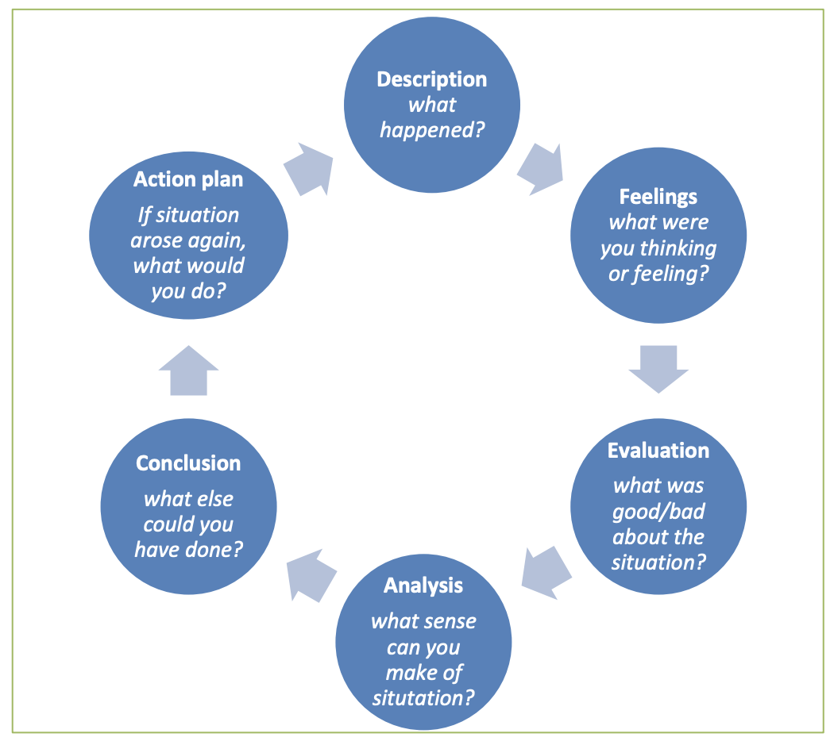

- Description

After 20 years of experience as a stylist, I have decided to change the direction of my working life and open a digital marketing company, with a large part of the business focused on the world of beauty, so that I can use my personal experience to help.

- Feelings

At the time I decided to carry out this project, I felt fear and stress, the idea of carrying out only one company made me instantly have many doubts. I was asking a lot of people and in fact I am currently teaching with a job coach who is guiding me in the process to have a clear and fixed idea of what I have to develop to guide the path of the brand. At present I am clear about what I want to achieve, but I need more training and that it is a profession that is constantly changing with technologies.

The best part of explaining feelings in this project is motivation.
I feel that my 20 years as a hairdresser, having passed through important jobs, although they have filled me professionally, has not convinced me to continue advancing, that is, there comes a point in this career, in which your next option is to open A business, and being a stylist is not just serving clients, owning a salon means being a boss, manager and worker. There are many roles at the same time that apart from stressful, the results do not depend only on you. In this country, you work in this profession as a freelancer, that is, in a salon you rent a chair or collect a commission from the work done on your own clients, therefore, the motivation for teamwork disappears, and the competition it becomes even a little selfish. It takes a lot of organization, a lot of insistence and a good staff to keep a good vibe in teamwork.

For me, the idea of ​​opening a business that not only depends on me, if not on my workers, and on top of that, in a terrain as complicated as offering an ambiguous service, is a risk and a stress for which I have always had Of course I didn't want to happen.

Besides, and in a very personal way, the fact of being a mother combined with this profession is very difficult, so I knew beforehand that I was going to stop working on this, the truth is that I had always thought that I would end up in an international firm Being a coach, but the thought of happiness of being able to have something of mine without charges above, has pushed me to fight for a dream that I have created little by little.
Austrian intellectual Viktor Frankl said in one of his books, "Our greatest human freedom is that, despite our physical situation in life, we are always free to choose our thoughts!" Important reflection for making decisions in the life of oneself, you should not be carried away by the intuition or advice of others, you can take all together, and take advantage of them, not because most of them do not understand what they are talking about or they don't appreciate you and want the best for you. But many people have limitations or have not been able to have a full education, I was forced to work and create a trade from a very young age, when I decided to start the change to my new job destination, part of my family did not take it well, first because of age, second, because of the cost of the process and third, because they don't see happiness in a work environment, they see the importance of money. At first, they made me even doubt if the path I was taking was the correct one, but later they were happy for me because I asked for their support and I thanked them. (Frankl, 1946)

- Evaluation

The situation in my current job making this decision was a bit shocking at first, since for my training, I needed my company to agree to give me time availability for my studies. Last year starting with university in business management, then to continue with my master in marketing strategy and then to start my apprenticeship at the other digital marketing company. Working and studying at the same time is something that is costing me a lot, but I only have the thought in the future that I am going to prosper in the workplace and have a better future and more independence. A very important point for which I made this decision is not having to depend on schedules or bosses, and honestly, it is what drives me the most to continue on my decision.

In her book "The 4-Hour Workweek", Timothy Ferriss says: “You are the average of the five people you associate with the most, so don't underestimate the effects of your pessimistic, unambitious or disorganized friends. If someone is not making you stronger, they are weakening you. ” (Ferriss, 2012)

It happened to me at the beginning that there were some of my friends who saw it crazy to get into all this by myself without having worked first. The choice to go to university 34 years after having already studied and advanced in a profession, was not everyone's liking, I even got negative opinions from family members. What I did was listen to more positive and ambitious people so as not to get discouraged.

- Analysis

My situation could have been better if my level of English was more advanced, having already been in London for 7 years, having met many people from my country, made me stagnate in the language for comfort, and always working in places with the same type of vocabulary daily, I did not make an effort to expand my grammar to be able to express myself better, at first when I entered university I was a little afraid of not giving up when talking to my classmates. That decision was delayed for fear of signing up, after that obstacle was improving having to speak and use new words in the business environment or the environment about the university, my vocabulary improved, not only my knowledge, and they have been giving me security throughout of the first year of the course of which I am very proud.

The positive part that has helped me the most is the previous experience I have had in other companies taking social networks, in some contributing knowledge, in others learning from the internal marketing department and in others being fully responsible and being paid for it as is this room in which I am currently working. My concern and curiosity about technologies and advances make me up-to-date on everything related to digital marketing.

- Conclusion

If I looked back, one of the things I would have emphasized the most was the language. When I came to the country, I should have focused more on trying to improve my language to have made the move to university earlier, I was also not very clear that what I wanted to do was digital marketing, in fact, I collaborated with a friend in an event company and weddings, but really the part I liked was the marketing part. I was testing various fields until I finally decided on this, it was a bit frustrating because there were people who criticized me for my constant job changes, today I wanted to work in one place, train in another, study online, try each site ... until finally I decided.

I think the other steps to follow were good, I only regret not having accelerated their process, since the sooner I start, the sooner you finish, I have chosen a path of study for 3 years and I am proud of the choice, marketing and business They are very broad words, if in the future my company was not good due to the characteristics or my lack of motivation, I could always choose another path.

Like Seth Godin says in his book “The Icarus deception”, “The fear has changed. It has ceased to be the fear of a wild animal for survival, the fear of the dark and of predators, to become the fear of disobedience, authority and to stand out, invented by the industrialists” (Godin, 2013)

The industrial society in which you live feeds on your fears and insecurities. Being afraid is not bad in itself. I would even go so far as to say that fear is necessary. But it is as necessary to have it as to understand it. The fear that you have but that is not understood is the fear that prevents you from creating and connecting with people, with your people. Being afraid is inevitable. Understanding fear is necessary and essential.

- Action plan

Although I have already set up the company, there are many aspects that I still do not handle. I am in continuous training, but I am going to do courses on content creation, photography, photoshop and video editing. I would also like to learn about web page design and CEO, but it is very soon yet, I prefer to perfect the previous ones shown.

Until I can fulfill that purpose, I will hire freelance services because I don't want to risk offering the customer a poor quality service and risk having a bad reputation, I will depend on your services until I can cover them.

My initial idea is to run the company in the best possible way, let's not forget that setting up a company and apart, working within it, are two different jobs and at the same time communicated with each other. You cannot leave one aside, because the other would fail, that's why the idea of ​​hiring freelancers. I really like the idea of ​​digital marketing, it is something that I enjoy doing, I love the phrase of Gary Keller in his book "The only thing": "Let's not get confused, serve two things and your attention will be divided; serve three and some of them it will fail ", I prefer to be focused on few things to be as productive and efficient as possible.

Also having a low budget to start, I will not start to see benefits in a long period of time, adding that I am still part-time in a salon, I cannot speed up the process, I prefer to delegate work but continue to take knowledge of everything related to When I have 4-5 clients, to be able to become independent and do it by myself. And later, I would like that in 3 years, to start delegating work for the growth of the company by hiring employees, not out of necessity to cover a lack of knowledge. I would like to start hiring people with apprenticeship, to be able to train them in the methodical way in which I run the company and also be able to give the opportunity to share knowledge as they are doing now with me.

The good thing about this business is the possibility that I have of being able to live in other parts of the world without having to be anchored in a city. Returning to my country temporarily is an option, so I could move depending only on a computer.

Eric Ries, in his book "The Lean Startup Method", explains how to approach the launch of new products and services based on validated learning, scientific experimentation and iteration that allows to shorten development cycles, measure progress and obtain feedback from Potential customers. Based on customer feedback, I want to add elements in the company, such as logo design or web pages, although I did not provide the service. But in the end, when you are involved in the world of digital marketing, everything is related and customer demand is the most important thing, I want the services offered by my company to be comprehensive enough to prevent the customer from going to the competition .

This method, especially recommended for startups, allows the Minimum Viable Product to be made at low cost to prototype and, once the product has been launched and its acceptance in the market confirmed, speed up the manufacturing process and the search for capital. (Ries, 2016)

References
Anonymous, 2019. Examples. [En línea]
Available at: https://www.examples.com/business/professional-swot-analysis.html
[Último acceso: 05 05 2020].
Ferriss, T., 2012. The 4-Hour Workweek. s.l.:s.n.
Godin, S., 2013. The Icarus deception. s.l.:s.n.
Ries, E., 2016. Lean Startup Method. s.l.:s.n.
Frankl, V., 1946. Man's Search for Meaning. s.l.:s.n.

