UWTSD

"Economic Crisis, Raising Finances and Stock Performance during Covid-19: A case study of the UK."
09/07/2021

Dissertation Proposal

BEATA DUDAK - 2010697

Supervisor

Jia Miao

Abstract
Aim of the research is to evaluate the economic crisis in the UK during Covid-19, its impact and its implications in light of raising finances and stock performances. The research aims at determining the factors that lead to an economic crisis and the impact of the economic crisis with regard to raising finances and stock performances.
The research will try to find the answers to the research question through qualitative research and secondary data collection. A lot of research literature, journal articles, government data websites, books and credible websites will be used to answer the research question.
Response to research aim and doing this research will evaluate the economic crisis, its factors and implications to analyse the financing issues and stock performances during Covid-19. The UK is facing the challenge of another economic crisis that is due to Covid-19. The Research will help readers to understand the economic crisis factors and reasons for making financial and nonfinancial decisions accordingly.
The benefit of this research is in form of knowledge as research will help readers to learn about raising finances and stock performances as well as application on businesses in economic crisis.

Table of Contents
Abstract 1
1. Introduction 3
1.1. Background of Research Problem 3
1.2. Research Aim 4
1.3. Research Objective 4
1.4. Research Questions 4
1.5. Significance of the Research 4
2. Literature Review 4
3. Methodology 6
4. Data Analysis Procedure 7
5. Ethical Approach 7
6. Research Timeline (GANTT Chart) 7
7. Research Limitations 8
References 9
Appendix: FTSE Index during Covid-19 11

Introduction
The economy is the backbone of a country, and a strong economy shows the financial strength of the country. The UK is a developed country, and its economy is among the top 5 larger economies in the world. The economic crisis hit the countries hard because the balance of payment disturbs, and economic activities are halted. The world faced major economic crises last year during Covid-19 that has shattered the world economy. The UK is affected badly due to economic crisis as GDP witnessed a record low, negative 9% approximately which is even worsens from the economic global crisis of 2008 (Lea, 2020). Economic crisis impacts the factors of raising finance and stock performances badly which can be seen in the stock exchange indices at the start of Covid-19. This research study is based on evaluating the economic crisis of the UK by evaluating stock performances and raising finances. The reason for explicitly focusing on the problem is the growing concerns with respect to raising finances and stock performances in the time of the Covid-19 crisis. Background of Research Problem

Background of Research Problem
Research is based on the economic crisis in the UK and its impact on raising finances by businesses and stock performances in the period during Covid-19. Covid-19 is the fundamental reason for the ongoing economic crisis in the world that has a highly negative impact on UK economy. By evaluating stock performance there is evidence of stock prices fluctuations and their relationship with the economy. It is observed that London Stock Exchange has collapsed during the first wave of Covid-19. This effect is seen all over the world. Figure 1 (Appendix) shows that the FTSE100 index was trading above the 7,500 level but has collapsed when the Covid-19 outbreak shattered the economy. A downward fall to less than 5,000 was witnessed in the index in March’20 (Statista, 2021). Raising finances issues is evaluated during the economic crisis where the organisations in many industries are facing cash flow issues. Hospitality, travel, tourism, supply chain and physical store chains are directly affected by the Covid-19 economic crisis because they are unable to generate cash to cope with the situation.
The research problem is crucial to analyse and develop a relationship between economic crisis and stock performance as well as raising finances. Background of research problem inviting to conduct in-depth and detailed research on the evaluation of economic crisis due to Covid-19.

Research Aim
The aim of the research is to evaluate the economic crisis in the UK, its impact and its implications in light of stock performances and raising finances (Davies, 2007). The research aims at determining the factors that lead to the economic crisis and the impact of the economic crisis with regard to stock performance.

Research Objective
Based upon the research problem and aim of the research, research has the following objectives:
- Evaluation of economic crisis because of Covid-19 pandemic in the UK
- Determine the stock performances and raising finances in evaluating the economic crisis in the UK.
- Establish a relationship between economic crisis and stock performance.
- Establish a relationship between economic crisis and raising finances.

Research Questions
Based upon the research problem and research objectives, the following research questions are established in order to find out the answers in this research study:
- How economic crisis can be evaluated through stock performances and raising finances?
- What is the impact of Covid-19 on ongoing economic crisis in the UK?
- Is there any relationship between economic crisis and stock performance and raising finances?

Significance of the Research
The Proposed research study is significant in nature because it will evaluate the economic crisis, its factors, implications as well as using stock performance and raising finances indicators to analyse the economic crisis. The UK is facing the challenge of the economic crisis that is due to Covid-19. The research will help readers to understand the economic crisis factors and reasons for making financial and nonfinancial decisions accordingly.

Literature Review
This research is based on a qualitative pattern where analysis will be done on the basis of already existing material. Economic crisis is usually challenging and complex events that are not easy to predict their tenure, effect, and remedies at a macro level. Once an economic crisis occurs, it affects all businesses and business activities. Catullo (2017) sheds highlights on economic crisis as a challenging and unpredictable wave having early signs on a macro level and then effect the stock exchanges, creditworthiness and thus affect businesses that lead an impact to the overall economy and households. Applying the Catullo observation to the current study, it is evident that Covid-19 hit the macroeconomy as the government has to take strict decision and then it ultimately shattered all the business activities. Businesses are facing difficulties in raising finances due to the situation as businesses are reluctant to invest in an economic crisis circumstance. Considering the substantial spread of the covid-19 and its tremendous impact on the financing and stock performances, the current study aims to critically evaluate the Covid-19 related to economic crisis in the UK.
Stock performance is linked with an economic crisis. Dang and Nguyen (2020) conducted a study to analyse the stock prices of different shares during the global economic crisis. Study results show that stocks that were giving higher returns before the economic crisis fall more sharply than other stocks. Liquidity risk was the major contributor to asset prices as per the study. Study shows the established link of stock performances with an economic crisis. However, there is another analysis that concludes a different relation. Fluctuation in market indices because of the economic crisis are critically utilised by Fox et al., (2016) in the article on economic crisis and integration of finance. It argues that share prices fall during the 2008 financial crisis was not due to economic crisis but due to lack of proper laws to prevent the share prices to fall so sharply. Economic crisis and non-implementation of proper regulations led to a sharp fall in share prices. The UK has higher percentage of small and medium businesses. Over 90% of the total businesses in the UK are small and medium businesses. It is important to figure out the effect of the economic crisis on these businesses that are not registered on stock exchange.
Brown and Rocha (2020) highlighted the Covid-19 has badly affected the financing raising capacity of organisations. There is uncertainty over the crisis which confused the investors whether they should invest or hold. Investment has decreased so organisations are facing difficulties in raising capital. UK government has spent billions in supporting the businesses that also built pressure on government finances. Authors further point out that raising finances through the debt market is badly affected during the crisis. Raising finances through equity market is even more difficult in the pandemic phase. Caldecott (2020) has tried to establish a positive link between transition finances during Covid-19. Author has proposed that it is time for sustainable financing where transition finance should be more in the mainstream so that organisations with high carbon use this facility to diminish their carbon use. Agreeing with the suggestion it is vital to use transition finance as means to achieve Sustainable Development Agenda 2030 by the UK government.
There is another view about the effect of the economic crisis that is based on green revolution in the wake of the economic crisis. Geels (2013) has a different point of view that sees a positive side of economic crisis because it paves the way for green investment in wake of raising finances. Green investment leads to convert the capitalist system to social system. However, this research by Geels might not be applicable in an economic crisis scenario when businesses think about survival or ad-hoc measures rather than thinking about sustainable investment. Government can apply such a mechanism that has a social agenda, but businesses usually have a commercial mindset, so they think about profits or financial survival during an economic crisis.
The Covid-19 has a drastic impact on the UK economy that resulted in the economic crisis in the country. Ozili and Arun (2020) have conducted a study on the impact of Covid-19 in an economic crisis that figured out the reasons behind the economic crisis. Due to government restrictions, all the economic activities have halted that result in the closure of various small and large businesses in the country. The writer further added that uncertainty in the virus situation and uneven government measures confused the business environment and investors were reluctant to invest and consumption also decreased. It has led to the economic crisis in the UK. In another research study, financial and non-financial assets are evaluated to figure out the impact of economic crisis. Covid-19 is considered as impact factor in the study. Study concluded that financial asset investment has performed better in economic crisis. Non-financial assets investment has caused more damage in the economic crisis (Sukharev, 2020). UK Government has made serious efforts to reduce the impact of economic crisis and support the businesses as well as individuals. This literature review has an emphasis on the economic crisis during Covid-19 and its implication on raising finances and stock performance.

Methodology
Research methodology is a crucial step in the research study that talks about how the research will be conducted. The interpretivism approach is applied in this research because the nature of the study is the evaluation of the already studied patterns. The Positivism approach is not applicable in this research because there is no involvement of statistical data or quantified numbers. The present research is based on the interpretation of concepts and their theoretical application, so a qualitative research approach is most appropriate (Cresswell, 2002). The quantitative approach is not applied because it is based on an already established study and there are no statistical tools to be applied.
Data collection is an integral part of research design that depicts which type of data is collected and which methods are applied to collect data. This research will use secondary data collection tools where data will be collected from various official sources, research articles on economic crisis and journals on the topic. The primary data collection approach is not used in this research because the nature of the study is broad, and it is not possible to collect primary data (Cameron and Price, 2009). Primary data would not be useful to provide a logical conclusion of the research due to sample size and budget constraints.

Data Analysis Procedure
As discussed in the research methodology, data analysis in this research will be based on qualitative research and secondary data collection. For this purpose, number of books, articles, journals, and websites will be taken as data sources and then the result will be arranged whether they support the relationship among economic crisis and stock performance or raising finances or no relationship could be developed between these variables (Davies, 2007). For this purpose, criteria would be including the data and research that are after the global financial crisis while the focus will be on Covid-19 impact on the economic crisis. Data must have the economic crisis, stock performance, raising finances, and Covid-19 impact.

Ethical Approach
There are some ethical approaches used in this research like all the acquired data that is used in this research is based on acknowledging the source (Cameron and Price, 2009). Research has made commitment that no data is fabricated to serve the researcher’s purpose. An unbiased data collection approach is used, and the researcher makes a neutral opinion for data analysis.

Research Timeline (GANTT Chart)

 | Dissertation Plan
 | ACTIVITY | Starting Week | Duration (Weeks) | WEEKS
 | ACTIVITY | Starting Week | Duration (Weeks) | 1 | 2 | 3 | 4 | 5 | 6 | 7 | 8 | 9 | 10 | 11 | 12 | 13 | 14 | 15
 | Research Proposal | 1 | 2
 | Dissertation Plan
 | Ch 1. Introduction | 3 | 1
 | Ch 2. Literature Review | 4 | 2
 | Ch 3. Research Methodology | 6 | 4
 | Ch 4. Research Findings | 8 | 3
 | Ch 5. Research Analysis | 11 | 1
 | Ch 6. Conclusion & Recommendations | 12 | 2
 | Dissertation Windup | 14 | 1

Research Limitations
Research limitations in the study are time and budget constraints. As this research topic is broad in nature so it needs plenty of time to conduct the research and conclude the research findings. Due to budget constraints, primary data collection is not possible. Another limitation is limited data available for secondary research. Research is specific to the UK so a large set of secondary data might not be useful and only limited relevant data is available.

References

Brown, R. and Rocha, A., 2020. Entrepreneurial uncertainty during the Covid-19 crisis: Mapping the temporal dynamics of entrepreneurial finance. Journal of Business Venturing Insights, 14, p.e00174.
Caldecott, B., 2020. Defining transition finance and embedding it in the post-Covid-19 recovery. Journal of Sustainable Finance & Investment, pp.1-5.
Cameron, S. and Price, D., 2009. Business research methods: a practical approach London: Chartered Institute of Personnel and Development.
Catullo, E., 2017. Early Warning Indicator for Crises in an Agent-Based Macromodel. In Introduction to Agent-Based Economics (pp. 105-124). Academic Press.
Cresswell, J., 2002. Research Design: Qualitative, Quantitative, and Mixed Methods Approaches, London: Sage Publications
Dang, T.L. and Nguyen, T.M.H., 2020. Liquidity risk and stock performance during the financial crisis. Research in International Business and Finance, 52, p.101165.
Davies, M., 2007 Doing a successful Research Project.New York: Palgrave MacMillan
Fox, E.G., Fox, M.B. and Gilson, R.J., 2016. Economic crisis and the integration of law and finance: The impact of volatility spikes. Colum. L. Rev., 116, p.325.
Geels, F.W., 2013. The impact of the financial–economic crisis on sustainability transitions: Financial investment, governance and public discourse. Environmental Innovation and Societal Transitions, 6, pp.67-95.
Hart, C., 2004. Doing Your Masters Dissertation (Essential Study Skills series), London: Sage Publications
Lea, R., 2020. UK’s record 20.4% drop in GDP in 2020Q2: worse than the Eurozone and the USA. Arbuthnot Banking Group, 24.
Mangena, M., Tauringana, V. and Chamisa, E., 2012. Corporate boards, ownership structure and firm performance in an environment of severe political and economic crisis. British Journal of Management, 23, pp.S23-S41.
Ozili, P.K. and Arun, T., 2020. Spillover of COVID-19: impact on the Global Economy. Available at SSRN 3562570.
Statista, 2021. FTSE100 Index btween December’ 19 and May’ 2021 [Online]. Statista. Accessed at: https://www.statista.com/statistics/1103739/ftse-100-index-uk/ [Accessed on June 24, 2021]
Sukharev, O.S., 2020. Economic crisis as a consequence COVID-19 virus attack: risk and damage assessment. Quantitative Finance and Economics, 4(2), pp.274-293.

Appendix: FTSE Index during Covid-19

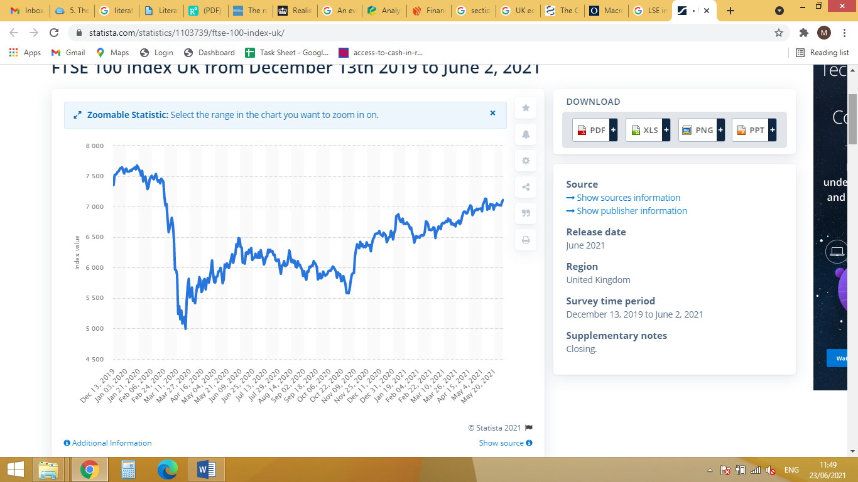
Figure 1: FTSE100 Index from Dec'19 to May'2021 (Ref: Statista, 2021)

