University of Wales Trinity Saint David
Wales Institute of Science and Art


Engineering Materials

Materials and Manufacturing
ACHA4025

Josh O’Rourke
2501321
Due Date: 27/04/26
Contents
Introduction 2
Literature Review 3
Methodology 5
Test Results 10
Data Analysis 12
Conclusion 13
References 14

Introduction
This report will investigate the failure of two aluminium driveshafts from Dakar Rally cars, identifying possible reasons as to why they failed during the fourth and fifth stages of the rally, including suggestions for improvement. A sample test was conducted to confirm relevant data in order to provide in depth comments on the materials properties and cause of failure. In addition, property data for the alloy will be provided, producing a conclusion and comments on the aluminium alloy, why it failed, and a summary of the data from the test.

Literature Review
The material used by the Dakar rally team for driveshafts is an aluminium alloy, the specific grade and temper is not provided, however a picture of the failed driveshaft and a value of the maximum stress during operation (90MPa) have been given. The driveshafts were manufactured and assembled the exact same way as previous cars, however the team used a different aluminium supplier, which is suspected as a cause of the failure as they may have provided aluminium that is not up to standard or lacks properties necessary for the kind of endurance the driveshafts of the rally cars require.
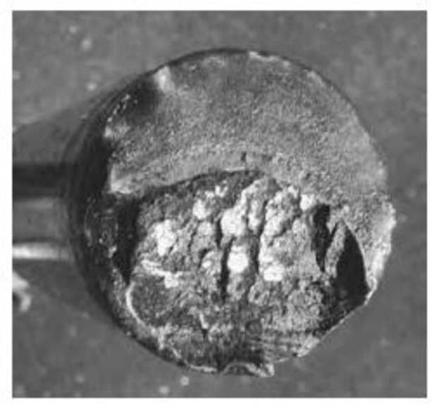
Figure 1: Failed Driveshaft Cross-Section
From the image of the failed driveshaft, it can be inferred that it was a fracture failure from extension or compression, and has a clear crack initiation (lower half), with crack propagation moving upwards to the more uniform, grainy part where there was rapid fracture. It is likely that this happened going over a dune where the driveshaft was stretched after landing. (The Extreme Engineering Required to Race the Dakar, n.d.)
There are various different methods to test the properties of the aluminium alloy, such as chemical composition tests, mechanical properties tests, grain structure tests, and non-destructive tests. Each of these tests provide vital information about the properties and capabilities of the aluminium. Chemical tests such as XRF (X-Ray Fluorescence) reveal impurities and the composition of the alloy. Mechanical tests include tensile, hardness, etc. tests which identify physical strengths and weaknesses of the alloy. Grain structure tests find the grain size, microscopic weaknesses, and possible failure points. Finally, non-destructive and basic value calculations include finding the density, magnetism, and chemical reactivity to determine the alloy mixture and the percentage of aluminium in the alloy. The test that was conducted for this report was a tensile test using a sample of the same alloy from the driveshafts of the Dakar rally cars. (Aluminium Alloy Development and Testing - Innoval Technology, n.d.; Sun et al., 2024)
It is very hard to identify the exact grade and temper of this aluminium alloy since the rally team has only provided a cross-sectional image of the fractured driveshaft, and claims the maximum stress measured on the part during operation was 90MPa, which would be far too low to cause a tensile fracture (BOLSHIKH, 2021). However, it is likely that the fracture did not occur suddenly, but was cracking from fatigue over time that lead to the final fracture. This would make sense as the driveshafts failed during the fourth and fifth stages of the rally, meaning the driveshafts could have began to fail from stage 1, building up to the final fracture.

Methodology
The tensile experiment conducted involved using a test sample of the aluminium alloy of the same grade as the Dakar rally cars’ driveshafts, combined with apparatus that allowed a controlled tensile load to be applied on the sample, with a means of accurately measuring the extension of the sample in order to calculate stress and strain values.
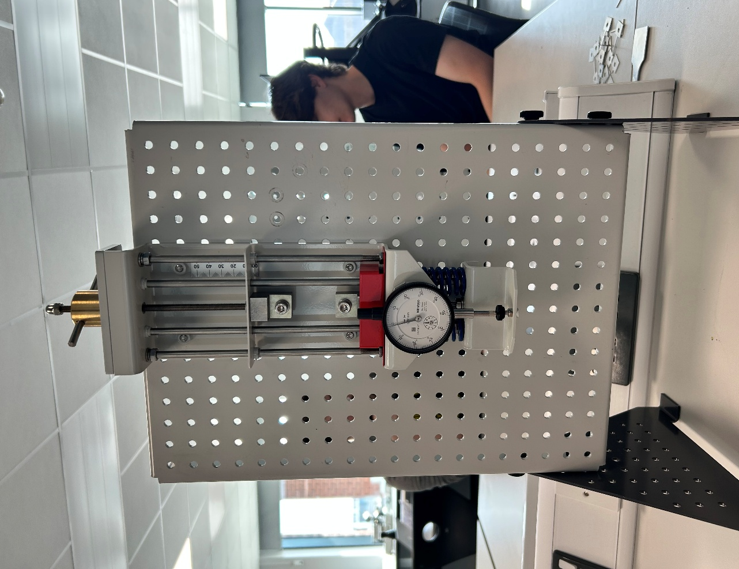
Figure 2: ES6 Test Kit
This image shows the apparatus that was used to carry out the tensile test on the aluminium sample; it involves a load nut, which is turned clockwise to apply a tensile load, a set of clamps in which the sample will be held, and a dial indicator which is used to calculate the extension of the sample (the amount the load nut is moved minus the dial indicator reading). The dial indicator is touching a pad underneath it, and as the sample is stretched, it will put pressure on the pin, causing the dial to move. As well as this, there are a set of springs under the chuck to make sure the dial stays accurate.

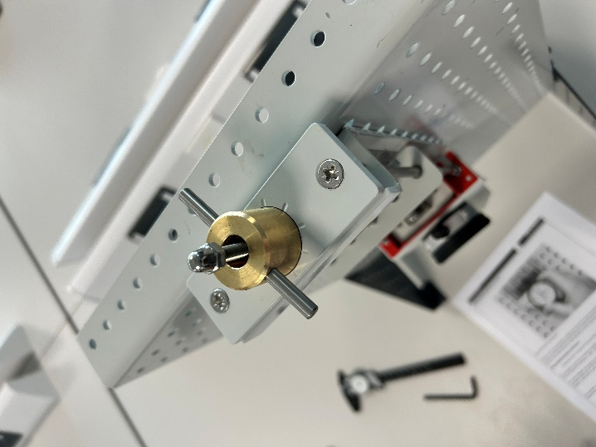
Figure 3: Load Nut
Each notch next to the load nut is equal to 0.1mm, for this test the nut was turned 0.2mm between each reading. The test was done with two people, one turning the load nut, and one watching the dial indicator and noting the reading – it is important to note that someone should always be watching the dial to make sure an accurate reading is taken.

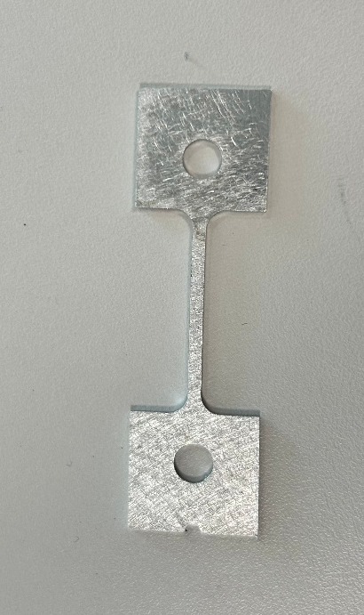
Figure 4: Aluminium Sample
This is the aluminium sample that was used for the test, it has two holes on either side to be clamped into the apparatus. The dimensions of the sample were taken prior to being clamped down, and they are: L = 30mm, H = 2mm, W = 1mm.
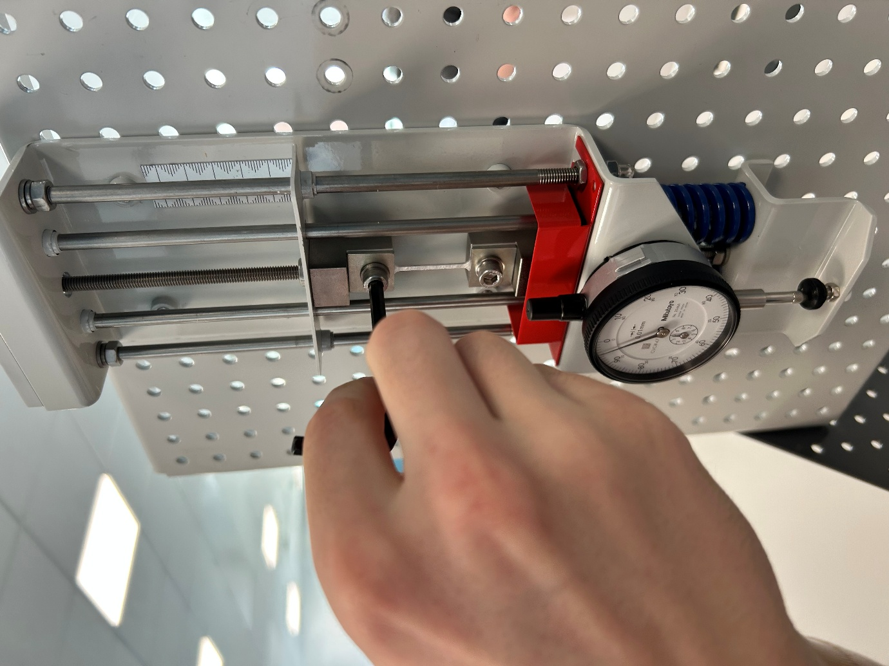
Figure 5: Clamping Sample
After taking measurements of the samples initial dimensions, it was clamped into the test kit using two bolts, ensuring that the sample is level and properly tightened in. The load nut was turned clockwise until the dial indicator started to show movement and the load nut pointed to one of the notches, then the dial indicator was zeroed and confirmed by both partners.
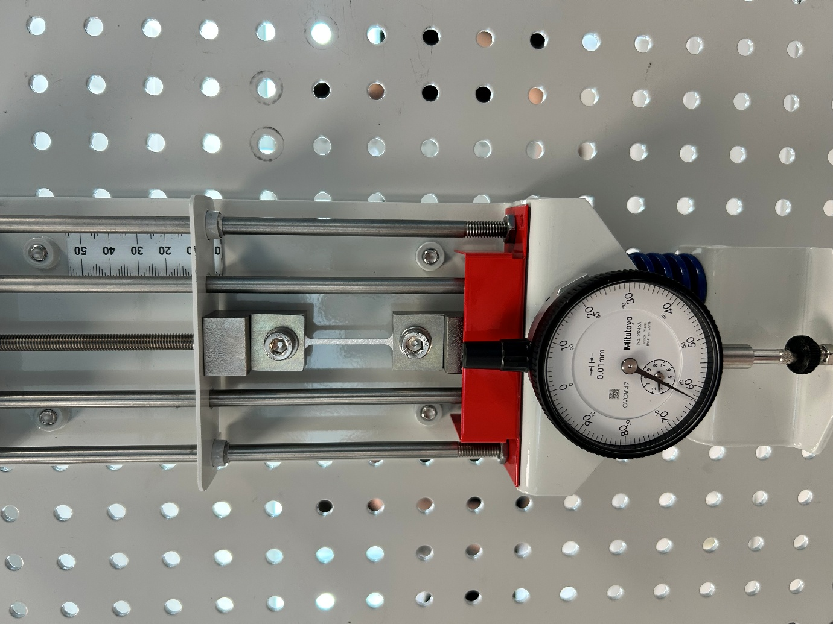
Figure 6: Sample During Test
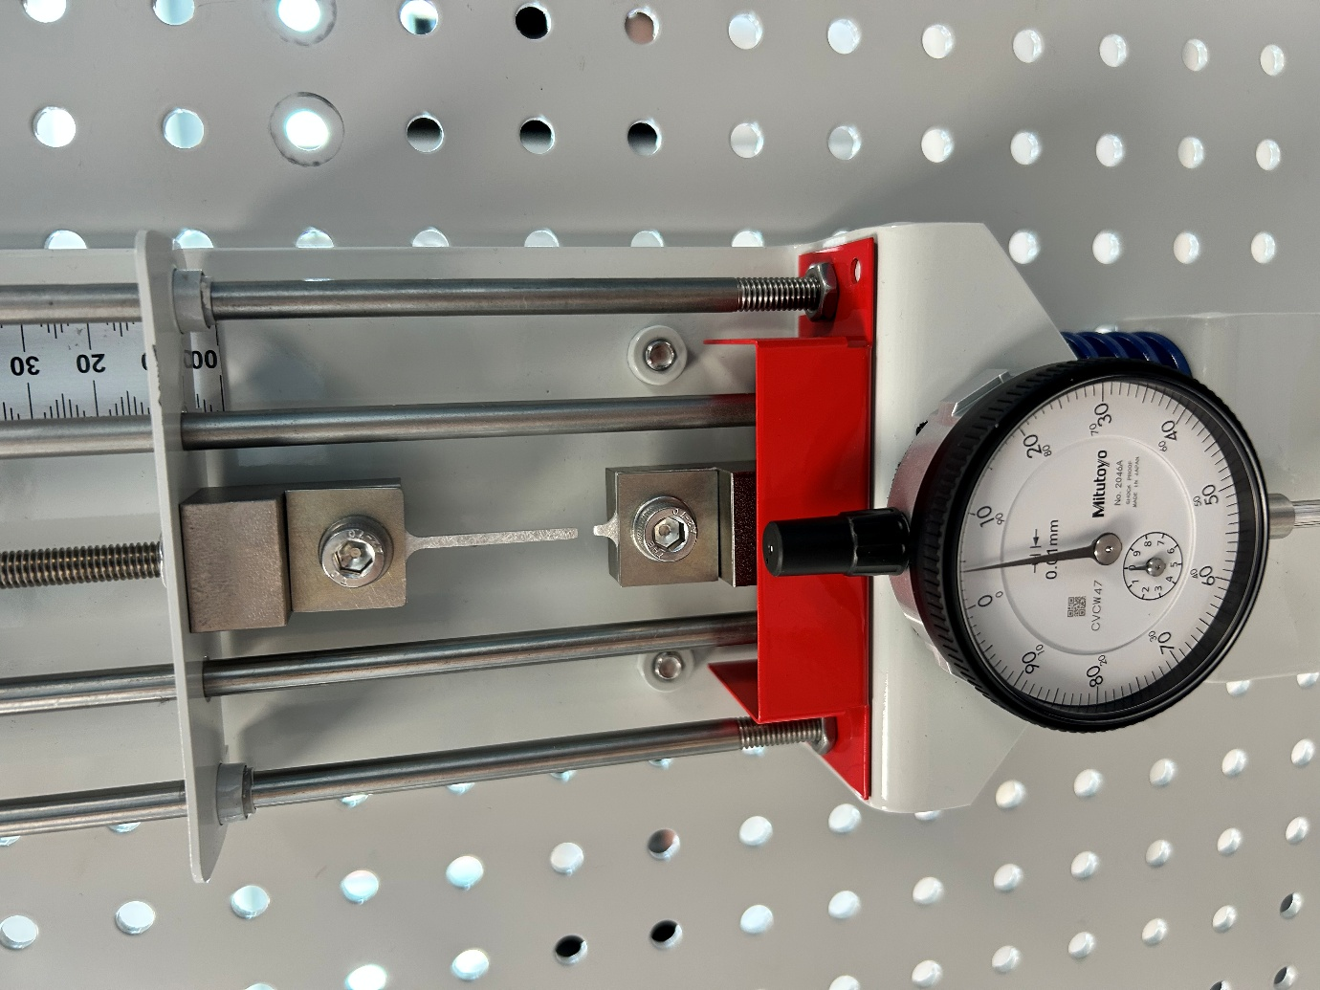
Figure 7: Sample Failure
Repeat the process of turning the load nut 0.2mm and taking note of the readings until the aluminium sample fails, the load nut will begin to become much tighter to turn as the sample gets closer to failure.

Test Results
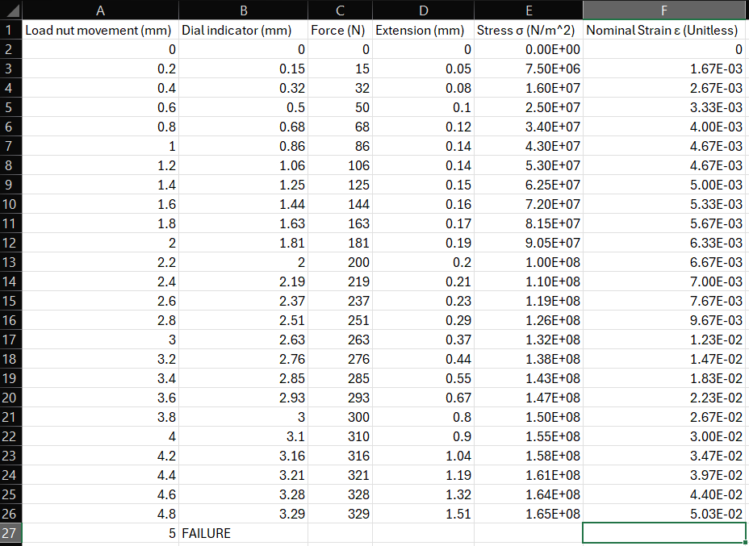
Figure 8: Test Data
This is raw data taken from the test, by taking measurements of the dial indicator as the nut was moved, the extension could be found using: Extension = Load Nut Movement – Dial indicator; the force could be found as well using: Force = Dial Indicator x 100. Furthermore, the stress and strain of the material using the equations: σ = Force / Area, and ε = Extension / Length.

Figure 9: Stress vs Strain Graph
This graph was created from the stress and strain data gathered from the test results, it indicates the elastic limit, yield point, and ultimate tensile strength (as shown on the graph).
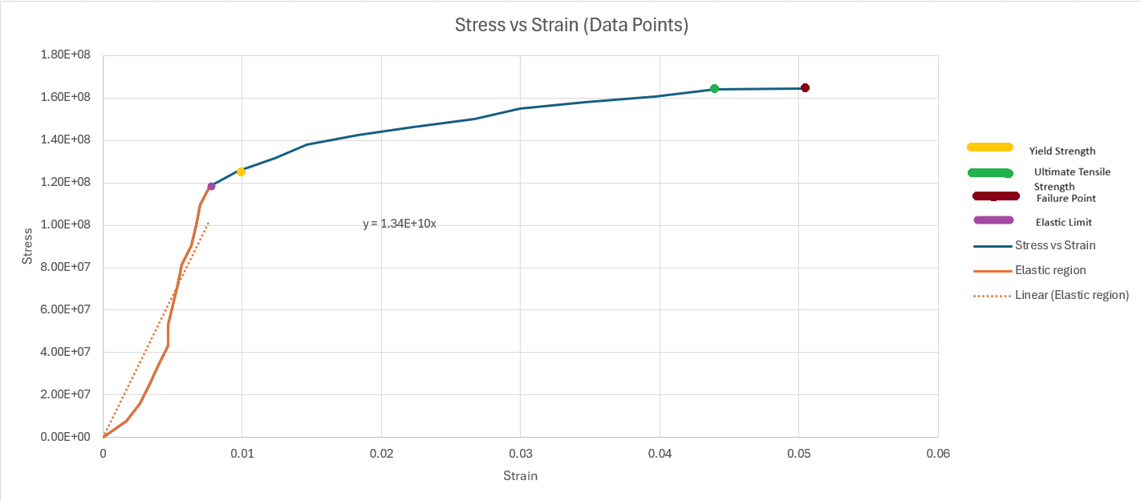
Figure 10: Stress vs Strain graph with Elastic Region
This graph includes the elastic region (from 0 to the elastic limit). By plotting a line of best fit of this region, the Youngs modulus can be identified: 13.4 GPa. It also indicates the fracture point, yield strength, and ultimate tensile strength.

Data Analysis
As seen in the test results, the aluminium sample failed at 5mm of load nut movement, the highest tensile force it could take was 329 N; given that the cross sectional area is 2 mm^2 (2E-6 mm^2), the ultimate tensile strength is 1.65 GPa. This is not always the case, for this experiment the ultimate tensile strength was just before the fracture point, in many cases, the ultimate tensile strength is much before the fracture point, samples will plastically deform (meaning it will not go back to its original length) before failure. (What Is Tensile Testing? - TWI, n.d.)
It is important to note that an ultimate tensile strength of 1.65 GPa would seem far to low to be an aluminium alloy, however this is because of the size of the test sample. If a larger sample was used, it would increase the accuracy of the calculated data as with the sample being much smaller, it means that variations or any outliers will cause the calculated data like stress and strain to appear inaccurate.(Tensile Test Experiment, n.d.)
The elastic limit is 119MPa, therefore the yield strength is 121MPa (as yield strength is 2% more that the elastic limit). This is important because the Dakar rally team previously measured the maximum stress of the aluminium during operation to be 90 MPa, and as 121MPa is greater than this, it gives a clear indication of why the alloy failed. The stress through the driveshaft will have exceeded the maximum load that it could handle, causing a fracture.
At the start of the graph (near zero) there is a less steep incline which is caused by the test rig taking up the slack through the bolts and chucks, even though the load nut was turned until the indicator dial started to move, there was still some slack within the test apparatus which influenced the first few values of the readings slightly.

Conclusion
It is fair to say that the most likely cause of the Dakar rally cars driveshafts is the type of aluminium alloy the teams’ new supplier has provided. If the manufacturing, instalment, and design was kept identical to previous iterations, it leads to the conclusion that the driveshafts underwent tensile loads that the alloy was not capable of handling, and fractured as a result. Moving forward, a change in material would be a good option for the team, the driveshaft needs to be able to withstand large tensile loads, be light, and manufacturable. A good option is 4140 chromoly steel, which is it repairable, manufacturable, tough and, most importantly, very resistant to tensile loads; it is a near perfect choice of material, being versatile with great strength to weight ratios. (AISI 4140 Chrome-Molybdenum High Tensile Steel, n.d.). It is also already widely used in Dakar rally car components.
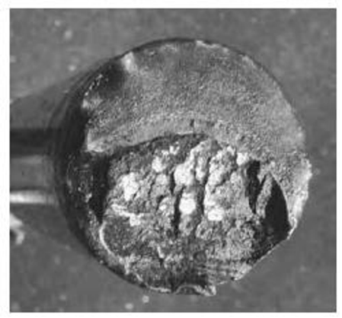
Figure 11: Driveshaft Fracture
The data gathered from the test does not comply what the rally team claimed with saying the maximum stress applied was 90MPa at face value; the data from the test says that the maximum yield stress is 121MPa, and 90MPa is clearly lower than that. Even though the maximum stress applied was only 90MPa, it was a repeated load. This lead to weaknesses in the driveshaft, such as small notches or cracks – things that could easily be looked over – will build up over stages from impacts like jumping over dunes, sudden impacts, and heavy tensile loads, eventually leading to the fracture. The grain pattern of the cross-section clearly shows the build up of small damage at the bottom, showing how the cracks propagate up through the shaft.
Figure 12: Sample Failure
The point of failure for this sample was near a change in diameter at the transition between the gauge section and the grip section. This Indicates that the samples grain is weaker at the intersection between the curve and the gauge section.

References
AISI 4140 Chrome-Molybdenum High Tensile Steel. (n.d.). Retrieved April 27, 2026, from https://www.azom.com/article.aspx?ArticleID=6116
Aluminium Alloy Development and Testing - Innoval Technology. (n.d.). Retrieved April 27, 2026, from https://www.innovaltec.com/aluminium-consultancy-services/alloy-development/
BOLSHIKH, A. (2021). Computational and experimental study of the strength of a composite drive shaft. Transport Problems, 16(1), 75–86. https://doi.org/10.21307/TP-2021-007
Sun, Y., Wang, Z., Xia, J., & Chen, X. (2024). Tests, simulations and design of aluminium alloy equal-leg angle section stub columns after exposure to fire. Engineering Structures, 314. https://doi.org/10.1016/j.engstruct.2024.118405
Tensile Test Experiment. (n.d.). Retrieved April 27, 2026, from https://www.mtu.edu/materials/k12/experiments/tensile/
The extreme engineering required to race the Dakar. (n.d.). Retrieved April 27, 2026, from https://www.redbull.com/int-en/extreme-engineering-dakar-rally
What is Tensile Testing? - TWI. (n.d.). Retrieved April 27, 2026, from https://www.twi-global.com/technical-knowledge/faqs/what-is-tensile-testing

