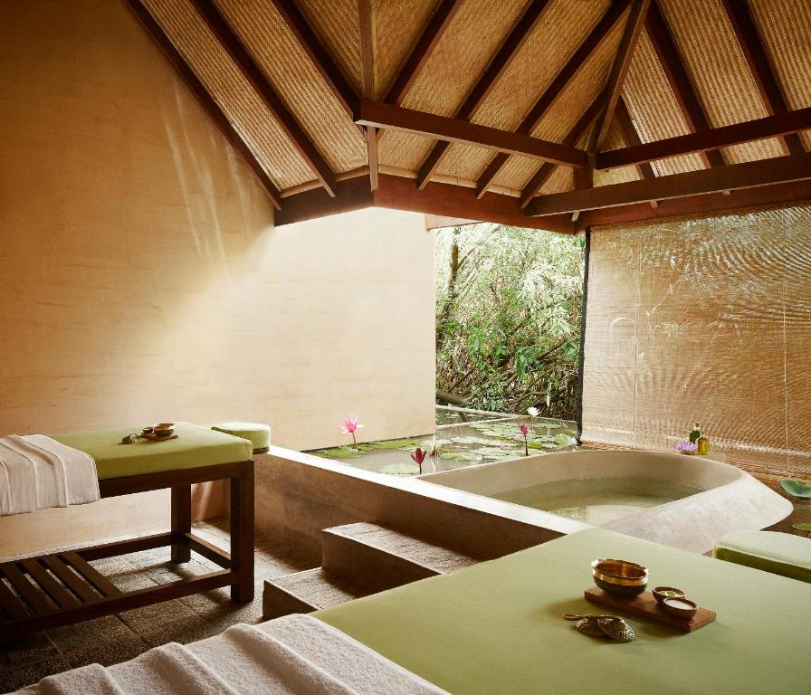

Jetwing Vil Uyana Sustainability Report
BMIH5006
Sustainable Hospitality & Tourism Management
Lisa-Marie Bassler

Bianca Postelnicu 2223852

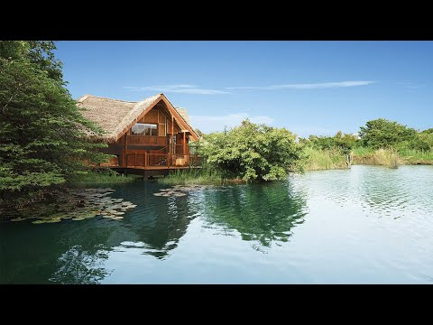
Executive Summary

The hospitality industry's sustainability is the primary focus of this report, with particular attention on certifications such as Green Key and EarthCheck using Jetwing Vil Uyana in Sri Lanka as a case study.

Introduction
Sustainability in the hospitality industry includes practices that reduce environmental impact, benefit local communities, and maintain operational efficiency. Green Key and EarthCheck certifications confirm these efforts to conserve resources, improve energy efficiency, reduce waste, and preserve biodiversity.

Description of Current Practices
Jetwing Vil Uyana implements several sustainable initiatives:
- Artificial Wetlands for Wastewater Management: Uses natural filtration systems to handle wastewater, reducing freshwater consumption, and improving biodiversity.
- Renewable Energy Systems: Uses solar panels, biomass boilers trough locally sourced cinnamon wood waste, and biogas units converting organic waste into energy, by this means reducing greenhouse gas emissions.
- Biodiversity Conservation: Transforms degraded land into thriving ecosystems, creating habitats for native and endangered species.
- Community Engagement and Organic Farming: Sources organic food from local farmers and provides training programs for employment in hospitality and eco-tourism.

Alignment with Global Standards
Jetwing Vil Uyana's practices are consistent with, and often exceed, Green Key and EarthCheck standards, demonstrating leadership in sustainable hospitality.

Benefits of Identified Practices
The hotel's initiatives leads to environmental benefits, operational cost savings, and an excellent reputation among eco-conscious travellers.

Challenges in Implementation
Challenges include financial investment, resistance to operational changes, and maintaining high sustainability standards over time.

Conclusion
Jetwing Vil Uyana exemplifies the integration of luxury and sustainability, serving as a model for the global hospitality industry.

Recommendations
To further improve its sustainability activities, the hotel could establish a Virtual Sustainability Academy, launch a Green Certification Mentorship Program, create an Employee Innovation Lab, and develop an Interactive Guest Engagement App.



Table of Contents
- Introduction
- Description of Current Practices
  - Artificial Wetlands for Wastewater Management
  - Renewable Energy Systems
  - Biodiversity Conservation
  - Community Engagement and Organic Farming
- Alignment with Global Standards
- Benefits of Identified Practices
- Challenges in Implementation
- Conclusion
- Recommendations
- References

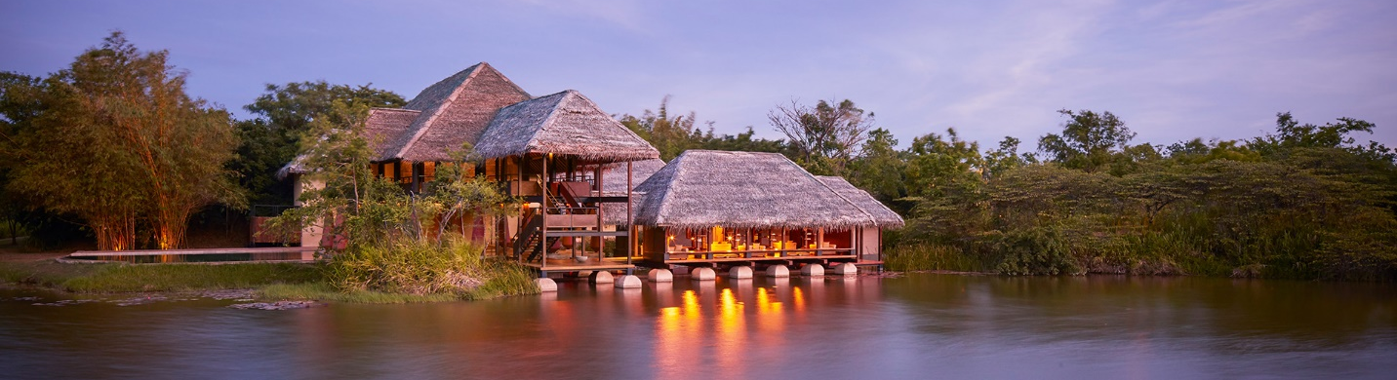

Introduction
Sustainability in the hospitality industry refers to practices that reduce environmental impact while also benefiting local communities and maintaining operational efficiency. These practices have become essential for addressing issues like climate change, resource depletion, and inequalities in society. Sustainable hospitality values resource conservation, energy efficiency, waste reduction, and biodiversity preservation, which brings long-term benefits for the environment and society.
Green Key and EarthCheck certifications are important tools for promoting sustainability. Green Key is concentrating on energy efficiency, water conservation, and waste management, encouraging hotels to use resources responsibly. EarthCheck sets broad guidelines for biodiversity conservation, community engagement, and carbon reduction, so it offers a framework for sustainable tourism. These certifications help confirm a hotel's commitment to sustainability, which builds trust among stakeholders and guests.
Jetwing Vil Uyana, located in Sri Lanka, is a prime example of sustainable hospitality as it is in the top 15 most sustainable hotels on the planet. The hotel incorporates new technologies such as artificial wetlands for wastewater treatment, renewable energy systems, and biodiversity conservation. By exceeding global certification standards, Jetwing Vil Uyana has proven itself as a global model for balancing luxury and environmental responsibility and trough its initiatives it demonstrates how eco-tourism can benefit both ecological restoration and community development, creating a standard for the industry.

Description of Current Practices
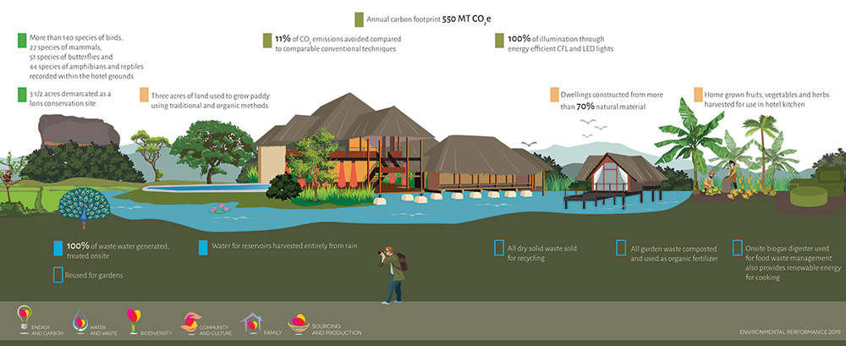Jetwing Vil Uyana fully integrates sustainability into its operations, with priority placed on resource conservation, biodiversity preservation, renewable energy, and community engagement. These practices demonstrate how hospitality can combine environmental responsibility and luxury.

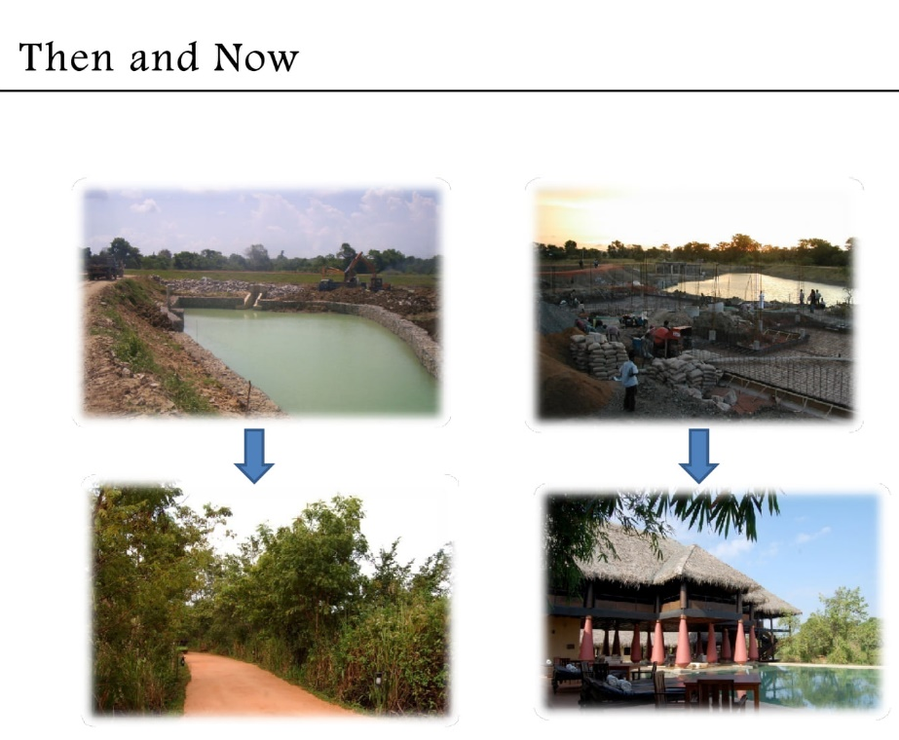
1. Artificial Wetlands for Wastewater Management
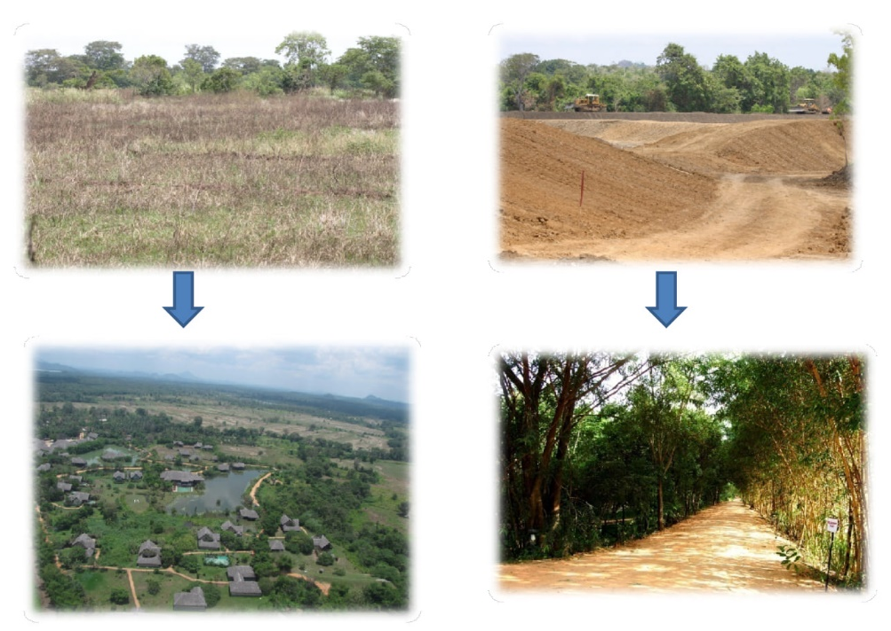
Jetwing Vil Uyana treats wastewater using artificial wetlands, an environmentally friendly system that uses plants and microorganisms to naturally filter and purify water. The treated water is re-used for irrigation because it reduces the need for freshwater and pollution. This system is more efficient than traditional wastewater treatment facilities, requiring less energy and maintenance while providing long-term environmental benefits (Jewting Hotels, 2024c).
On top of treating wastewater, wetlands upgrades the biodiversity system by providing habitat for a variety of species, including birds, amphibians, and small mammals. This helps to restore the ecosystem in the area by transforming degraded agricultural land into a vibrant natural habitat (Jetwing Hotels, 2014). This dual benefit of resource management and biodiversity support defines the initiative as an outstanding example of integrated sustainability.

2. Renewable Energy Systems
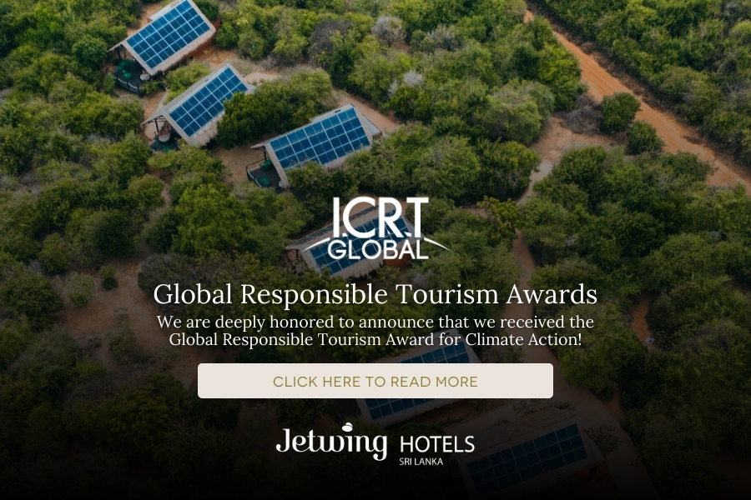
The hotel has implemented renewable energy systems to reduce its reliance on non-renewable resources and lower carbon emissions. Solar panels generate electricity for daily use, significantly reducing dependence on grid energy. Biomass boilers generate hot water from cinnamon wood waste, a locally sourced material, which decreases the use of fossil fuels. The biogas units convert organic waste, such as kitchen scraps, into energy for the hotel, resulting in a circular system of waste reuse (Jetwing Hotels, 2024a).
This integrated energy approach achieves several objectives: it reduces greenhouse gas emissions, promotes local economic development by sourcing biomass from nearby farms, and reduces waste to landfills. These systems demonstrate the hotel's ability to balance operational efficiency and environmental sustainability.

3. Biodiversity Conservation
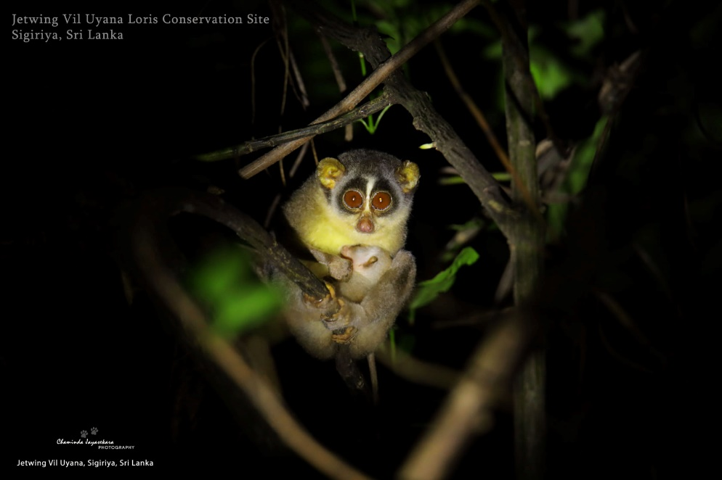
Jetwing Vil Uyana has transformed degraded land into healthy ecosystems through advancing biodiversity conservation. The creation of artificial wetlands and reforested areas has provided habitat for native species, including several endangered species and all these efforts not only restore ecological balance, but also improve the surrounding environment (Jetwing Hotels, 2024b).
The hotel collaborates closely with conservation experts to monitor the health of these ecosystems and protect their longevity. Guests are offered opportunities to observe and appreciate the wildlife, with education and awareness built into the tourism experience. This approach demonstrates how tourism can directly benefit environmental conservation.


4. Community Engagement and Organic Farming
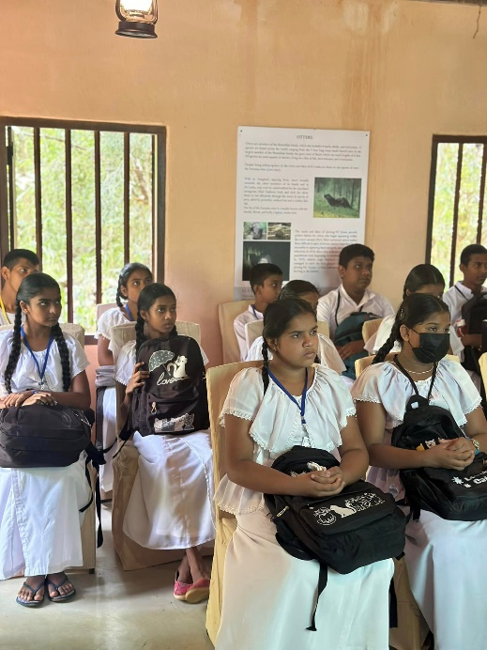
Jetwing Vil Uyana actively supports the local community by sourcing organic food from nearby farmers, which decreases transportation-related emissions and providing income to rural households. This impact-sourcing model boosts the local economy and supports sustainable agricultural practices (Jetwing Hotels, 2024e). The hotel also invests in training programs for locals, preparing them for careers in hospitality and eco-tourism. These initiatives help local families to benefit from sustainable tourism (Jetwing Hotels, 2024f).
Staff and community members are both offered educational programs to raise environmental awareness and encourage collective responsibility for sustainability. This ensures that the hotel's impact extends beyond its walls, contributing to long-term positive change in the region.
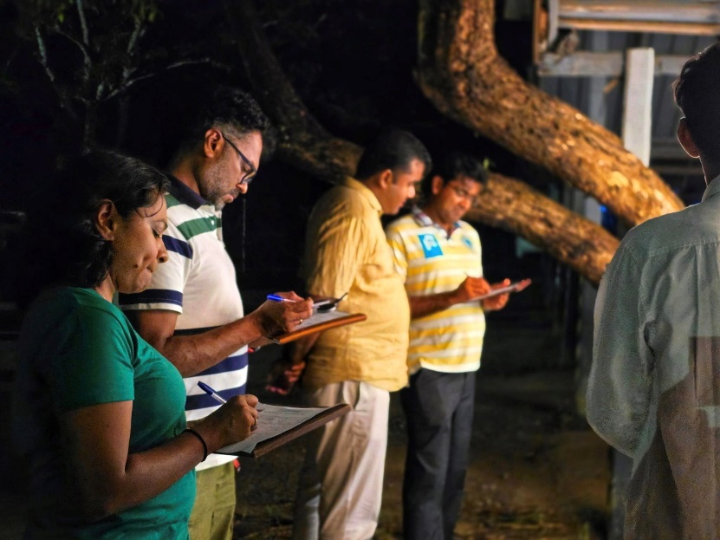
Jetwing Vil Uyana demonstrates how hotels can integrate sustainability into their operations in an all-embracing way. The hotel provides a detailed blueprint for sustainable hospitality by managing wastewater, using renewable energy, restoring biodiversity, and partnering with communities and its practices only demonstrate a commitment to both the environment and local communities, making it a leader in eco-tourism.

Alignment with Global Standards


Meeting and Exceeding Green Key and EarthCheck Certifications
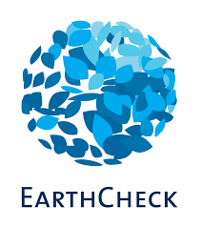
Green Key and EarthCheck are two internationally renowned sustainability certifications that Jetwing Vil Uyana's sustainability initiatives closely follow. Green Key certification promotes resource conservation, waste management, and energy efficiency (Green Key, 2024). According to Mzembe et al. (2020), Green Key certified hotels are known for their use of renewable energy systems such as solar panels and biomass boilers, as well as their wastewater management solutions. Jetwing's artificial wetlands and biogas production systems meet these requirements, that shows innovative solutions to waste and energy reduction.
EarthCheck, a sustainable tourism standard, promotes biodiversity conservation, community engagement, and carbon footprint reduction. Jetwing's conversion of degraded land into ecosystems that support native species exceeds these criteria. The hotel also works with local communities on organic farming, which is an important aspect of EarthCheck's framework (Swarna et al., 2023). Furthermore, Geerts (2014) emphasises the importance of certification in establishing guest trust and combating "greenwashing," which Jetwing has overcome through transparent environmental reporting.

Global Leadership in Eco-Tourism
By going above and beyond certification requirements and introducing repeatable innovations, Jetwing Vil Uyana demonstrates leading-edge ecotourism and outstanding experinces for its customers. Swarnaet al. (2023) found that a growing number of travellers prefer hotels that prioritise sustainability and offer unique experiences. Jetwing's practices, such as its circular energy systems, help it maintain its competitive advantage in attracting environmentally conscious travellers while remaining successful and sustainable.
Jetwing Vil Uyana brings together environmental and social responsibility into hospitality operations, exceeding Green Key and EarthCheck standards, demonstrating how sustainability can drive both environmental and economic success (Mzembe et al., 2020).

Benefits of Identified Practices

Environmental Impact
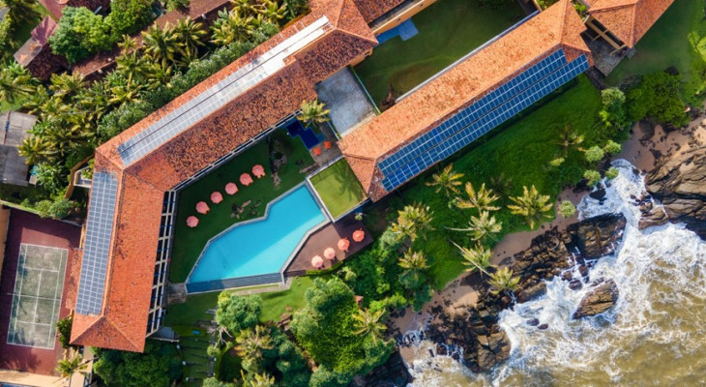Reduced carbon emissions and increased resource conservation are two obvious environmental benefits of Jetwing Vil Uyana's sustainable practices. Artificial wetlands naturally treat wastewater, making it safe for reuse in irrigation. This approach reduces water pollution and promotes biodiversity by creating habitats for native species such as birds and amphibians. It also promotes groundwater replenishment, which benefits the local ecosystem (Justino et al., 2023).
The hotel's use of renewable energy, such as solar panels and biomass boilers, reduces its reliance on fossil fuels and the biomass boilers, which use cinnamon wood waste, significantly reduce greenhouse gas emissions while utilising local resources. Biogas systems improve sustainability by converting organic waste into usable energy while reducing landfill waste and methane emissions (Anusha and Bandara, 2020).
Other than that, Jetwing's efforts to rehabilitate degraded land have resulted in habitats for endangered species, which has promoted ecological restoration. Collaborating with conservationists helps guarantee these ecosystems are well-managed, which contributes to long-term biodiversity protection.

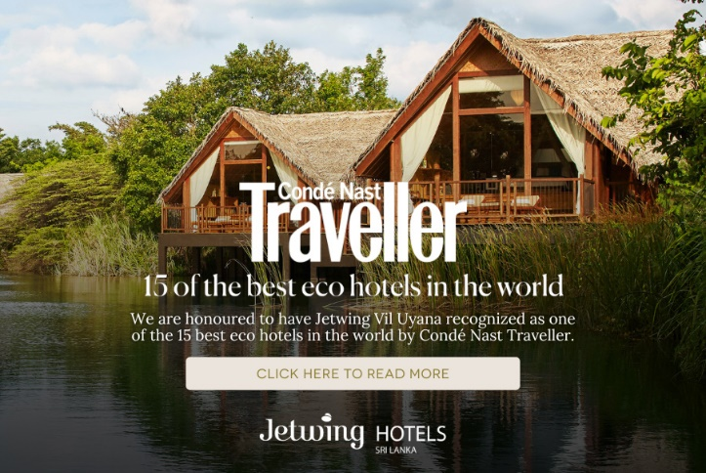
Operational and Marketing Impact
Saving costs and running more efficiently are two outcomes of Jetwing Vil Uyana's sustainability efforts. Solar energy and biomass boilers replace traditional power sources, significantly lowering energy costs. For example, biogas systems reduce waste disposal costs while producing energy for hotel use, showing how sustainable practices can increase profitability (Zhang et al., 2019).
From a marketing standpoint, these practices help Jetwing's reputation and attract environmentally conscious travellers, linking its strategy to green certifications such as Green Key and EarthCheck. Making use of the hotel's commitment to sustainability, it helps the business build trust among guests and stakeholders. According to research, guests prefer hotels with visible environmental initiatives, which results in increased loyalty and longer stays (Qubbai et al., 2023).
Jetwing's dedication to sustainability not only boosts its market competitiveness, but also attracts a larger audience. Combining environmental efforts with social initiatives, such as community engagement, increases its value and differentiates it from other hotels (Chung, 2020).

Comparison with Other Hotels
Among the world's most prestigious resorts, Jetwing Vil Uyana stands shoulder to shoulder with the Maldives' Soneva Fushi and French Polynesia's The Brando. All three prioritise renewable energy and biodiversity conservation. Soneva uses solar energy and waste-to-energy systems, while The Brando prioritises rewilding and carbon neutrality. Jetwing's community initiatives, such as partnerships with local farmers for organic produce, provide a social dimension to the company's sustainability strategy. Jetwing stands out as a model of sustainable hospitality due to its balance of environmental and community-focused actions (Leonidou et al., 2013).

Challenges in Implementation

1. Financial Investment and Infrastructure Development
Implementing sustainable practices often necessitates significant financial investment. Renewable energy systems, such as solar panels and biomass boilers, as well as infrastructure, such as artificial wetlands, have received significant investment. According to Sardianou and Kostakis (2020), the high initial costs of installing and maintaining sustainable systems are still a major barrier for many hotels. While these systems may result in long-term savings, limited access to capital or public funding may limit initial implementation (Buffa et al., 2018).

2. Overcoming Resistance to Operational Changes
The opposition to change from both personnel and management presents an additional challenge. Implementing sustainable practices frequently necessitates the reorganisation of daily operations and the retraining of staff. Kaur (2021) observes that insufficient awareness and fear regarding increased workload may result in unwillingness to embrace eco-friendly practices. Moreover, managers may hesitate to change standard procedures, especially when the anticipated advantages are long-term rather than immediate.

3. Long-Term Maintenance of High Standards
Ensuring sustainability standards persistently necessitates constant surveillance and adjustment. Maintaining the efficacy of renewable energy systems and artificial wetlands necessitates continuous maintenance and technical expertise. Khatter et al. (2021) believe that a deficiency in skilled staff and proper training may result in inconsistencies, compromising long-term objectives. Moreover, varying guest preferences and economic constraints may divert attention from sustainability initiatives.

Conclusion
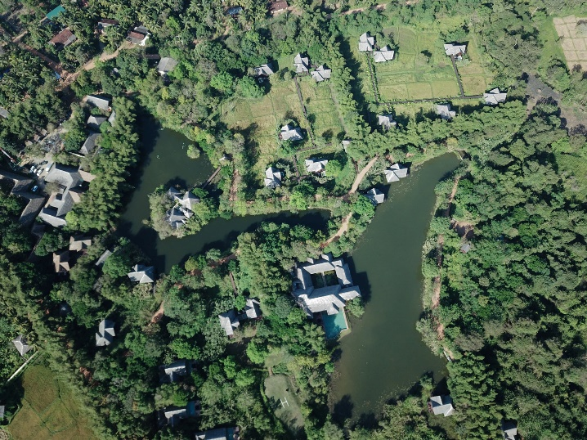
Jetwing Vil Uyana exemplifies the successful integration of luxury and sustainability in the hospitality sector. The implementation of artificial wetlands, renewable energy systems, and biodiversity conservation shows a strong dedication to minimising environmental impact and fostering local ecosystems. These initiatives have lowered operational expenses and improved its standing among environmentally aware travellers.
The hotel’s community-oriented initiatives, including the promotion of organic agriculture, demonstrate its extensive influence beyond conventional environmental advantages. By surpassing the standards set by certifications such as Green Key and EarthCheck, Jetwing has shown its leadership in eco-tourism. Its efforts not only safeguard the environment but also serve as a definitive model for other hotels aspiring to adopt sustainable practices. Jetwing Vil Uyana’s accomplishments demonstrate that sustainable tourism can be both significant and feasible, providing a valuable model for the international hospitality sector.

Recommendations
Jetwing Vil Uyana has achieved notable advancements in sustainability; however, additional measures might improve its effectiveness. The following recommendations focus on practical improvements grounded in international best practices:

1. Virtual Sustainability Academy
Jetwing Vil Uyana may expand its global influence by creating a Virtual Sustainability Academy. This digital platform may provide workshops, courses, and webinars centred on sustainable tourism and environmental conservation. The academy is going to spread Jetwing's exemplary practices, including its implementation of artificial wetlands and renewable energy systems, to a worldwide audience. It would also cultivate a global community committed to sustainable hospitality, positioning Jetwing as a centre for eco-tourism education. Research demonstrates that virtual platforms effectively promote sustainable behaviour, as studies indicate their capacity to improve knowledge retention and stimulate pro-environmental practices through interactive and engaging tools (Wismantoro et al., 2022; Poudel & Nyaupane, 2013).

2. Green Certification Mentorship Program
Jetwing Vil Uyana may position itself as a leader in sustainable hospitality by initiating a Green Certification Mentorship Program. This initiative will help other hospitality businesses in obtaining certifications such as EarthCheck and Green Key by spreading Jetwing’s experience in biodiversity conservation and renewable energy implementation. Mentorship programs are essential for building industry collaboration while raising sustainability standards. Research indicates that mentoring peers to earn recognised certifications strengthens industry credibility and increases leadership status (Bramwell & Lane, 2011; Lozano-Oyola et al., 2012).

3. Employee Innovation Lab
Creating an Employee Innovation Lab would allow Jetwing’s employees to actively engage in sustainability initiatives. This internal platform may encourage employees to propose and develop projects, contributing to a culture of innovation. By offering tools and support for the execution of feasible concepts, the lab would foster sustainability as a collective effort throughout every level of the organisation. Employee-driven initiatives have demonstrated improved operational efficiency and sustainability results (Halme, 2001). Additionally, local involvement in sustainability initiatives may improve competitiveness and provide lasting operational advantages (Lozano-Oyola et al., 2012).

4. Interactive Guest Engagement App
For better guest participation in its sustainability initiatives, Jetwing Vil Uyana could create an Interactive Guest Engagement Application. This application will offer real-time updates regarding the hotel's conservation initiatives, environmentally sustainable activities, and sustainability practices. Elements such as virtual tours, educational materials, and interactive challenges could optimise sustainability initiatives, motivating guests to engage actively in environmental efforts. Studies indicate that interactive tools significantly improve environmental awareness and promote behavioural change in tourists (Poudel & Nyaupane, 2013). Moreover, digital platforms have been demonstrated to increase engagement and promote environmentally conscious choices (Wismantoro et al., 2022).

Reference list
- Anusha, E. and Banadara, W.A.R.T.W., (2020). Biomass for boilers installed in large scale industries in Sri Lanka. International Journal for Research in Applied Sciences and Biotechnology (IJRASB), 7(6), pp.90-101. https://ijrasb.com/index.php/ijrasb/article/download/301/294
- Bramwell, B., & Lane, B. (2011). Critical research on the governance of tourism and sustainability. Journal of Sustainable Tourism, 19(4-5), 411-421. https://doi.org/10.1080/09669582.2011.580586
- Buffa, F., Franch, M. and Rizio, D., (2018). Environmental management practices for sustainable business models in small and medium sized hotel enterprises. Journal of Cleaner Production. https://doi.org/10.1016/J.JCLEPRO.2018.05.143.
- Chung, K., (2020). Green marketing orientation: achieving sustainable development in green hotel management. Journal of Hospitality Marketing & Management, 29, pp. 722 - 738. https://doi.org/10.1080/19368623.2020.1693471.
- Geerts, W., (2014). Environmental certification schemes: hotel managers' views and perceptions.. International Journal of Hospitality Management, 39, pp. 87-96. https://doi.org/10.1016/J.IJHM.2014.02.007.
- Greenkey.global, (2024). Good Practices. https://www.greenkey.global/good-practices
- Halme, M. (2001). Learning for sustainable development in tourism networks. Business Strategy and the Environment, 10(2), 100-114. https://onlinelibrary.wiley.com/doi/epdf/10.1002/bse.278
- Jetwing Hotel, (2014). Jetwing Vil Uyana's Green Story. Youtube Video. https://www.youtube.com/watch?v=22IIa46iwNQ
- Jetwing Hotels, (2024)a. Climate Action. https://www.jetwinghotels.com/sustainability/climate-action/
- Jetwing Hotels, (2024)b. Heritage Stewardship. https://www.jetwinghotels.com/sustainability/heritage-stewardship/
- Jetwing Hotels, (2024)c. Resource Efficiency. https://www.jetwinghotels.com/sustainability/resource-efficiency/
- Jetwing Hotels, (2024)d. Thriving Community. https://www.jetwinghotels.com/sustainability/thriving-community/
- Jetwing Hotels, (2024)e. Impact Sourcing. https://www.jetwinghotels.com/sustainability/impact-sourcing/
- Jetwing Hotels, (2024)f. Empowered Family. https://www.jetwinghotels.com/sustainability/empowered-family/
- Justino, S., Calheiros, C., Castro, P. and Gonçalves, D., (2023). Constructed Wetlands as Nature-Based Solutions for Wastewater Treatment in the Hospitality Industry: A Review. Hydrology. https://doi.org/10.3390/hydrology10070153.
- Kaur, B., (2021). A Study of Barriers to Environmentally Sustainable Practices in Hotel Businesses in Punjab, India: Preliminary Findings. Academica Turistica. https://doi.org/10.26493/2335-4194.14.71-86.
- Khatter, A., White, L., Pyke, J. and Mcgrath, M. (2021). Barriers and drivers of environmental sustainability: Australian hotels. International Journal of Contemporary Hospitality Management, 33(5), pp. 1830-1849. https://www.proquest.com/scholarly-journals/barriers-drivers-environmental-sustainability/docview/2548806484/se-2?accountid=130472
- Leonidou, L., Leonidou, C., Fotiadis, T. and Zeriti, A., (2013). Resources and capabilities as drivers of hotel environmental marketing strategy: Implications for competitive advantage and performance. Tourism Management, 35, pp. 94-110. https://doi.org/10.1016/J.TOURMAN.2012.06.003.
- Lozano-Oyola, M., Blancas, F., González, M., & Caballero, R. (2012). Sustainable tourism indicators as planning tools in cultural destinations. Ecological Indicators, 18, 659-675. https://doi.org/10.1016/j.ecolind.2012.01.014
- Mzembe, A., Lindgreen, A., Idemudia, U. and Melissen, F., (2020). A club perspective of sustainability certification schemes in the tourism and hospitality industry. Journal of Sustainable Tourism, 28, pp. 1332 - 1350. https://doi.org/10.1080/09669582.2020.1737092.
- Poudel, S., & Nyaupane, G.P. (2013). The role of interpretative tour guiding in sustainable destination management. Journal of Travel Research, 52(5), 659-672. https://doi.org/10.1177/004728751347849
- Qubbaj, A., Peiró-Signes, Á. and Najjar, M., (2023). The Effect of Green Certificates on the Purchasing Decisions of Online Customers in Green Hotels: A Case Study from Saudi Arabia. Sustainability. https://doi.org/10.3390/su15075892.
- Sardianou, E. and Kostakis, I., (2020). Perceived barriers to invest in renewable energy sources in the Cretan hotel industry. International Journal of Sustainable Energy, 39, pp. 240 - 249. https://doi.org/10.1080/14786451.2019.1673393.
- Spenceley, A. (2019). Sustainable tourism certification in the African hotel sector. Tourism Review of AIEST - International Association of Scientific Experts in Tourism, 74(2), pp. 179-193. https://www.proquest.com/scholarly-journals/sustainable-tourism-certification-african-hotel/docview/2209898258/se-2?accountid=130472
- Swarma, F.M.M, Khan, S., Nambiar, S.R. and Kumar S.P., (2023). Sustainability Certifications for Tourism, Travel and Hospitality (TTH) and the Indian industry response. https://doi.org/10.46647/ijetms.2023.v07i01.057.
- Wismantoro, Y., Aryanto, V., Pamungkas, I.D., Purusa, N.A., Amron, A., Chasanah, A.N., & Usman, U. (2022). Virtual reality destination experiences model: A moderating variable between Wisesa sustainable tourism behaviour and tourists’ intention to visit. Sustainability. https://doi.org/10.3390/su15010446
- Zhang, C., Sun, J., Lubell, M., Qiu, L. and Kang, K., (2019). Design and simulation of a novel hybrid solar-biomass energy supply system in northwest China. Journal of Cleaner Production. https://doi.org/10.1016/J.JCLEPRO.2019.06.128.

I confirm that I have not presented any AI generated text as my own work. I confirm I have copies of my drafts, notes, and other resources I used before, and after the use of AI tools which I may be asked to provide in evidence.

