UNIVERSITY OF WALES TRINITY SAINT DAVID
LONDON CAMPUS
Assignment 2
Learning in the Digital Era
Video Link: https://youtu.be/TLms9JOd_Ic

Module Name: Learning in the Digital Era
Module Code: ACCA 4025

Student Name: Ammar Doudou
Student ID:2439672
Group:1

Lecturer’s Name: Koushik Modak

Table of Contents
Introduction 2
Main Body 2
Conclusion 9
References 9

Introduction
A general introduction for this word document (Briefly in a few sentences explain what this report is going to be about)

Main Body
Write one/two sentences.
Video Link: https://youtu.be/TLms9JOd_Ic
Slide 1 COVER PAGE
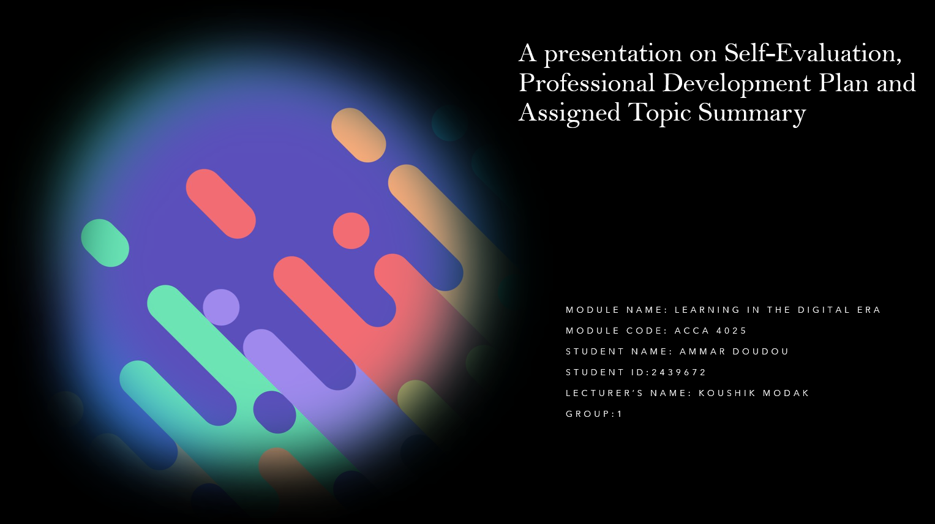

Slide 2 CONTENTS

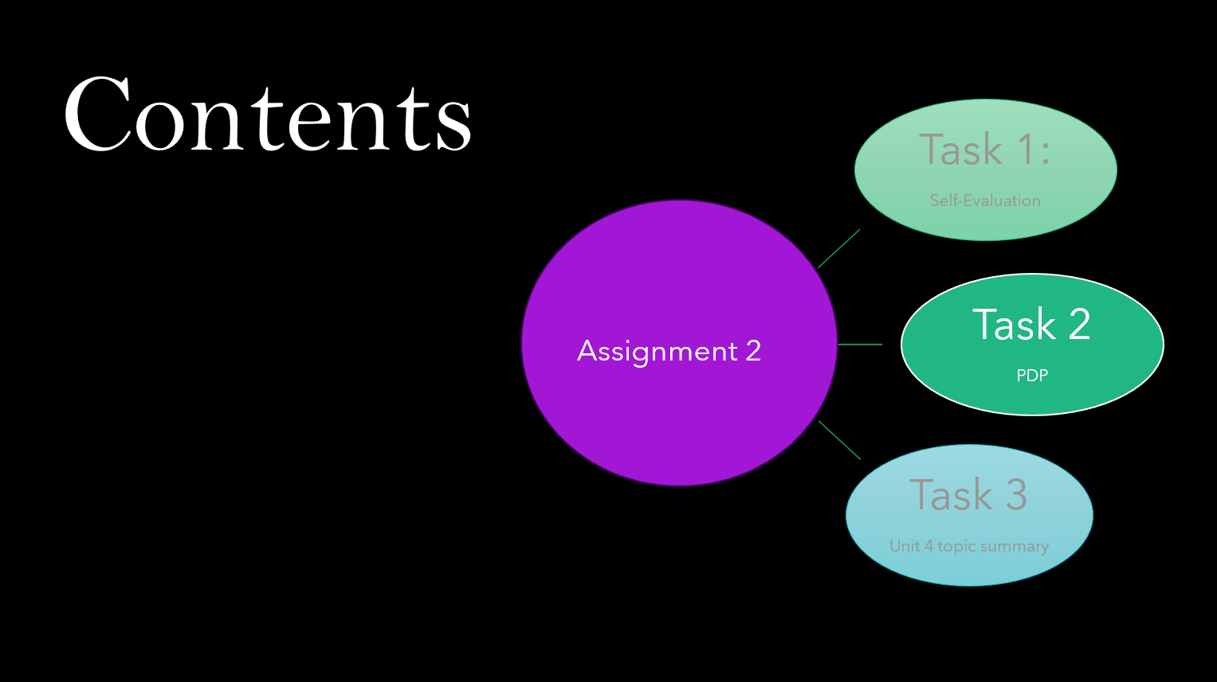

Slide 3 INTRODUCTION
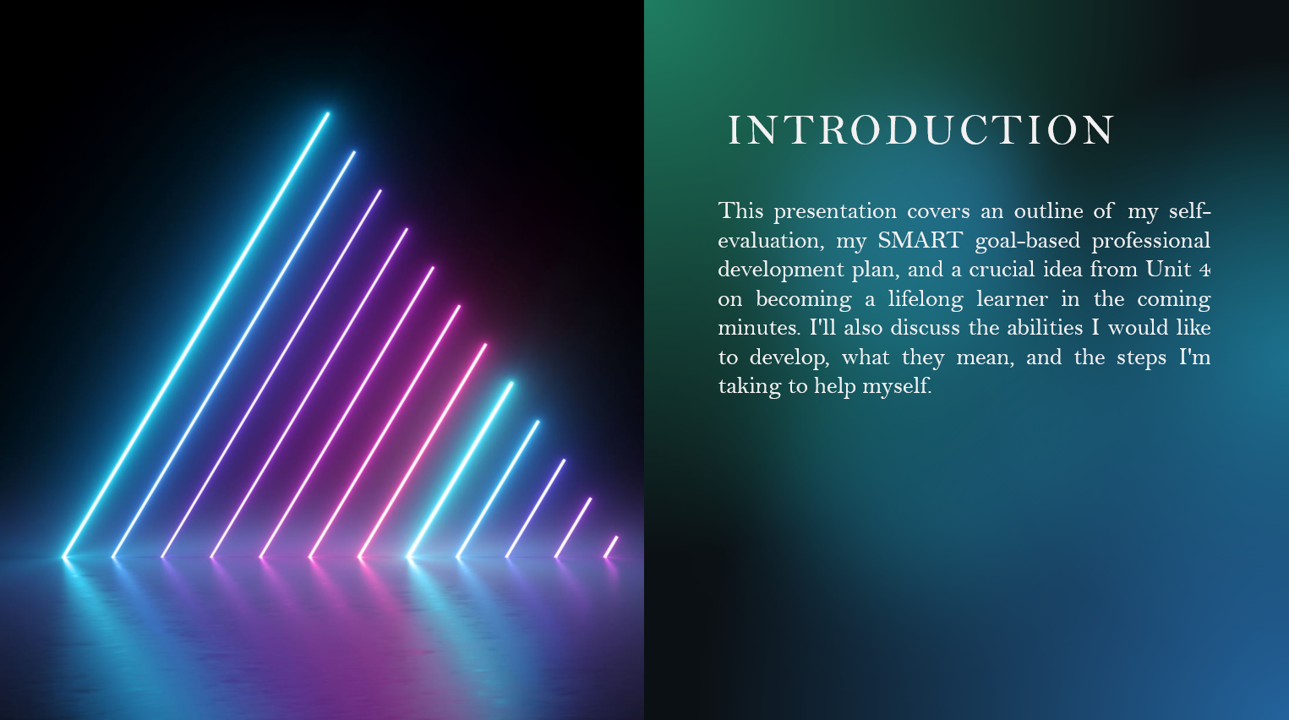
This presentation covers an outline of my self-evaluation, my SMART goal-based professional development plan, and a crucial idea from Unit 4 on becoming a lifelong learner in the coming minutes. I'll also discuss the abilities I would like to develop, what they mean, and the steps I'm taking to help myself.

Slide 4 MAIN BODY
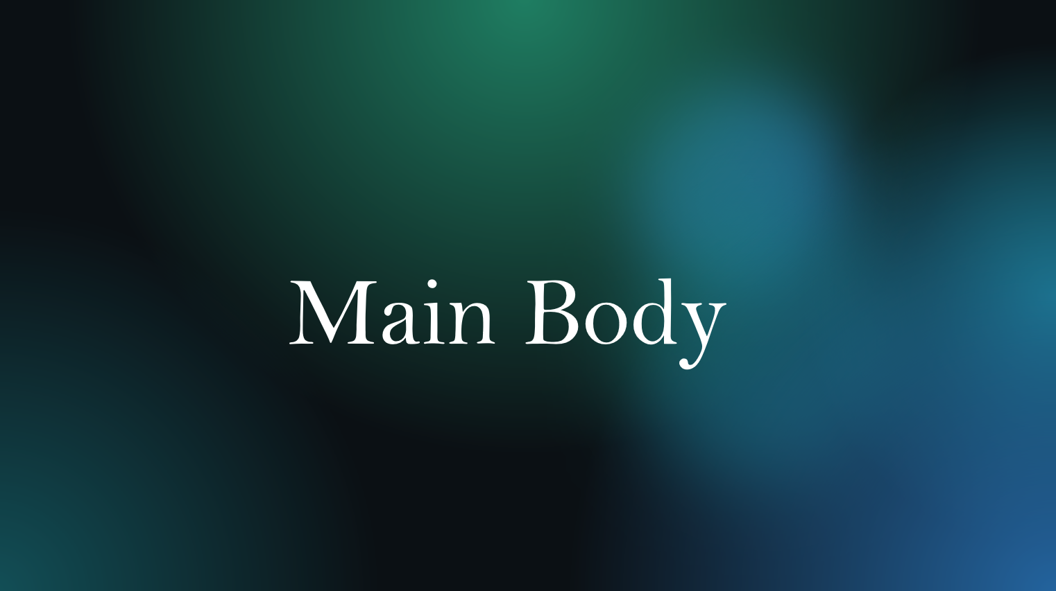

Slide 5 GIBB’s REFLECTIVE MODEL
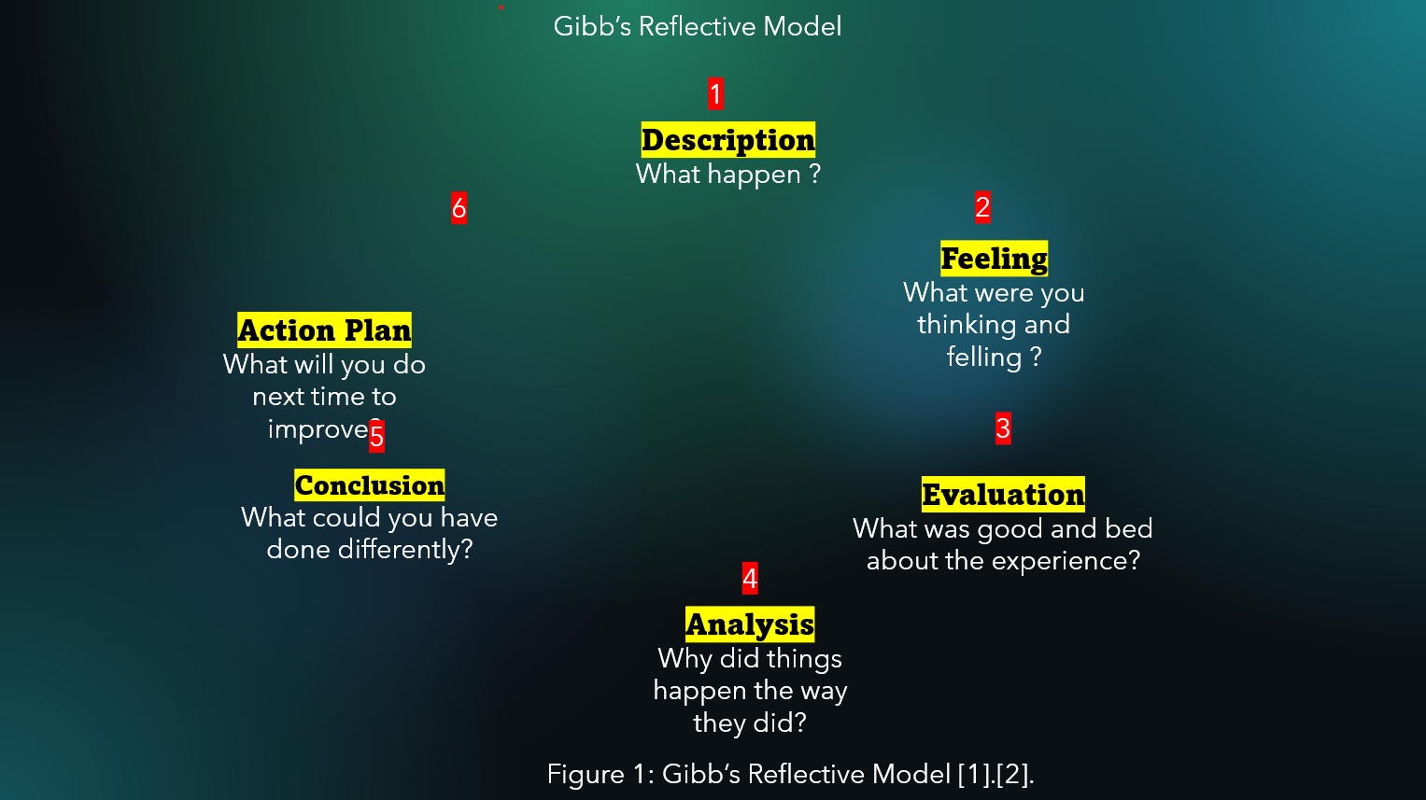
1.Description
I choose to reflect on my experience working on this year's university assignment. It was difficult because I had to manage deadlines that occasionally felt overwhelming, master new tools, and balance a variety of activities. I also had to work independently, which was something I had never done before [1].
2. Felling's
To be honest, I was confused and sometimes worried at first. I had doubts about my technical abilities and was concerned about the quality of my work. However, I was also driven because I wanted to do well and show myself that I could manage it. I began to feel more in control and confident as I worked on the project more [2].
3. Evaluation
Looking back, there were advantages and disadvantages to the experience. Positively, I gained a lot of knowledge about research, time management, and work planning. Asking for assistance when I needed it also became more natural to me. On the downside, I first had trouble organising myself, which caused several chores to take longer than they should have. I also noticed that I occasionally refrain from asking questions because I don't want to appear as though I don't understand things [3].

Analysis
When I consider why things happened the way they did, I see that my lack of confidence and experience was the main cause of most of my problems. I should have broken things down into parts, but instead I was worried too much. After I changed that strategy, things got easier. I also discovered that although working independently might be challenging, it drives you to establish your own style and accept accountability for your decisions. My personal and technical development was helped by this opportunity [4].
Conclusion:
I found out that I can do more than I thought and that it's important to stay organized and ask for help when I need it.[5].
Action Plan:
The next time, I'll plan, break things up into smaller parts, and ask questions earlier. My goal is to keep improving my confidence and time management skills.

Slide 6 TASK 1: SELF EVALUATION
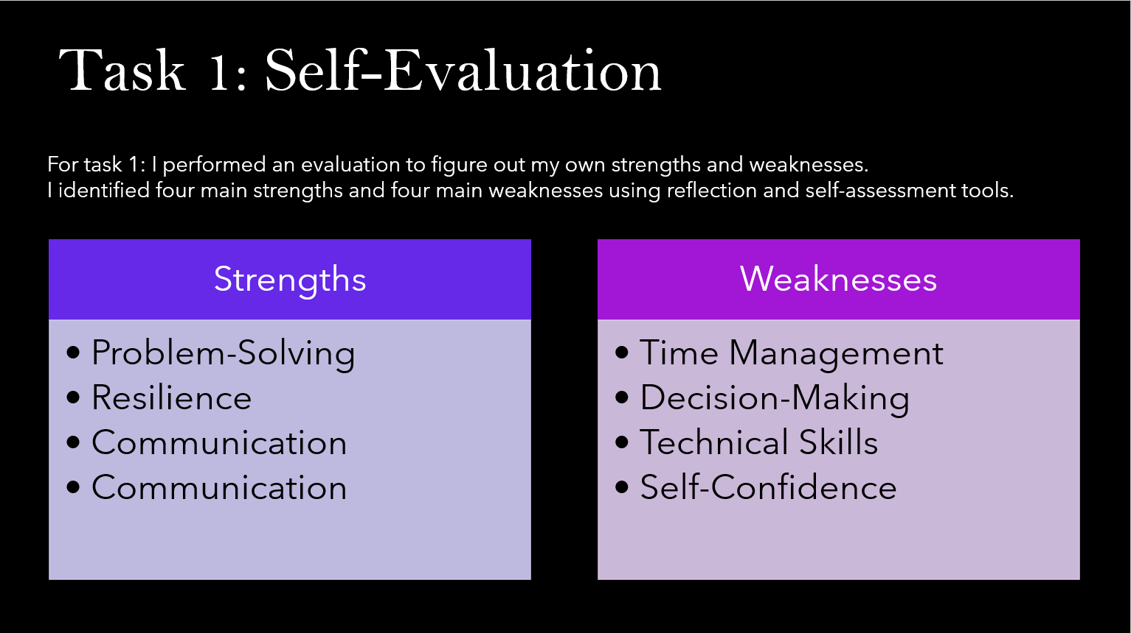
For task 1: I performed an evaluation to figure out my own strengths and weaknesses.
I identified four main strengths and four main weaknesses using reflection and self-assessment tools.

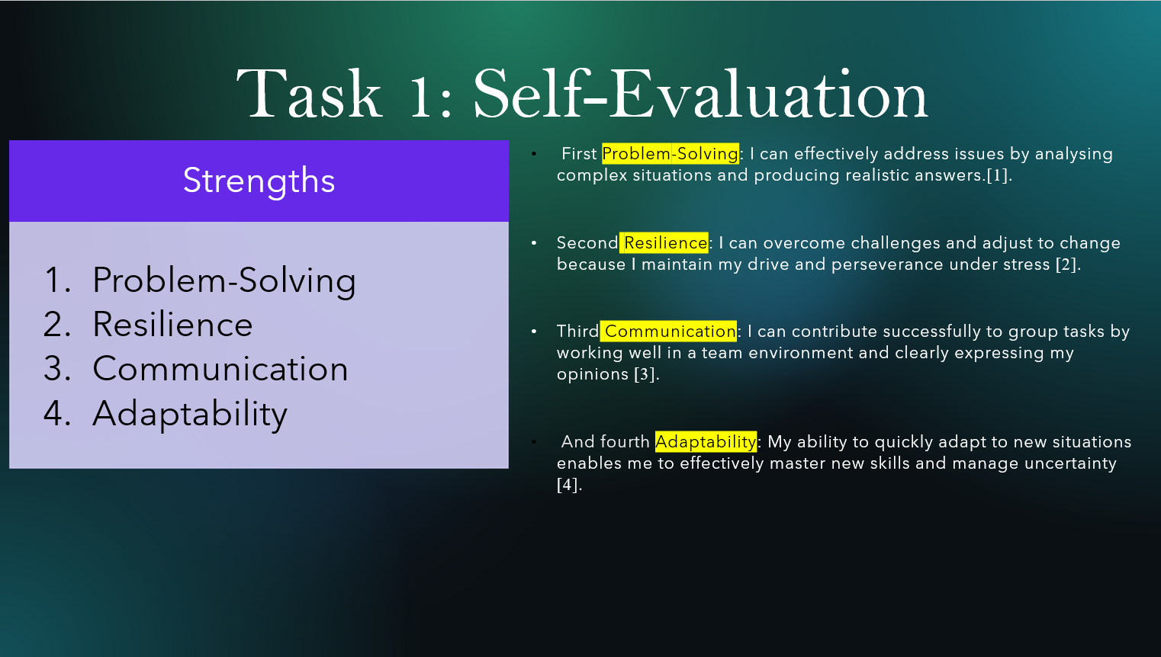
- First Problem-Solving: I can effectively address issues by analysing complex situations and producing realistic answers.[1].
- Second Resilience: I can overcome challenges and adjust to change because I maintain my drive and perseverance under stress [2].
- Third Communication: I can contribute successfully to group tasks by working well in a team environment and clearly expressing my opinions [3].
- And fourth Adaptability: My ability to quickly adapt to new situations enables me to effectively master new skills and manage uncertainty [4].

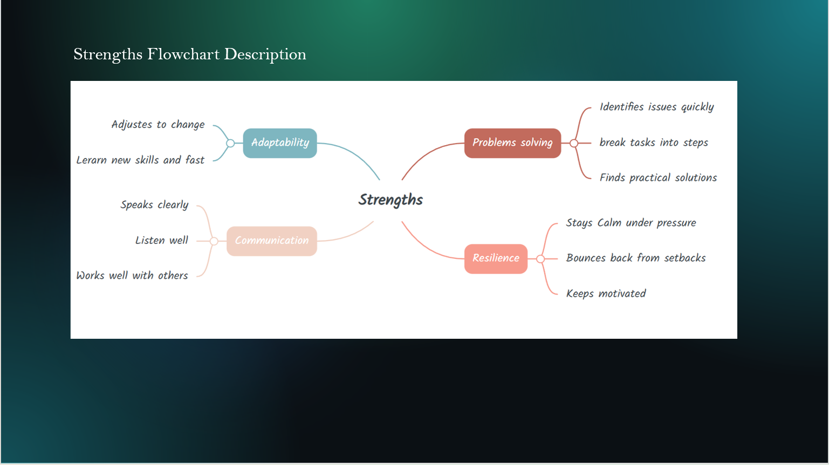
The four main abilities I am focusing on improving are shown in this flowchart: problem-solving, resilience, communication, and adaptability. My professional and personal development is made easier by these abilities. Communication improves my ability to share and understand ideas, problem-solving helps me to approach issues with logical thinking, resilience keeps me motivated in the face of setbacks, and adaptability allows me to confidently adapt to new situations. When combined, these abilities improve my capacity to advance both academically and in potential career settings [1].
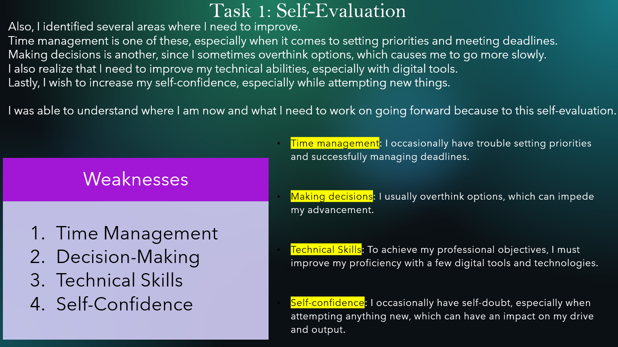
Also, I identified several areas where I need to improve.
Time management is one of these, especially when it comes to setting priorities and meeting deadlines.
Making decisions is another, since I sometimes overthink options, which causes me to go more slowly.
I also realize that I need to improve my technical abilities, especially with digital tools.
Lastly, I wish to increase my self-confidence, especially while attempting new things.
- Time management: I occasionally have trouble setting priorities and successfully managing deadlines.
- Making decisions: I usually overthink options, which can impede my advancement.
- Technical Skills: To achieve my professional objectives, I must improve my proficiency with a few digital tools and technologies.Self-confidence: I occasionally have self-doubt, especially when attempting anything new, which can have an impact on my drive and output.
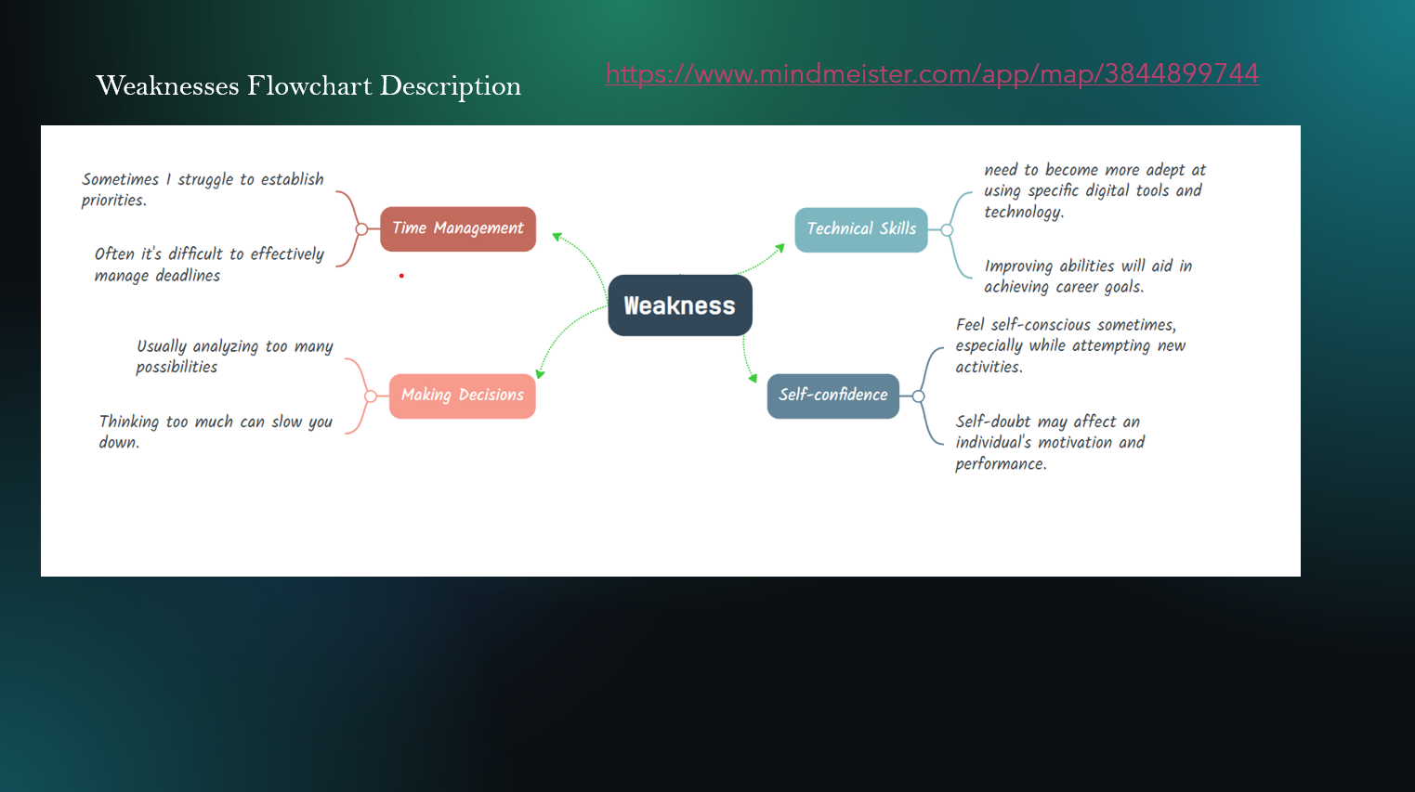
- This flowchart shows the four main areas—time management, decision-making, technical skills, and self-confidence—that I have found to be weaknesses in myself through reflection. I provide a quick explanation of each area to demonstrate how it impacts my performance. I can see where I need to improve by understanding these weaknesses, and I can use this knowledge to direct both my career and personal growth [1].

Slide 8 PROFESSIONAL DEVELOPMENT PLAN
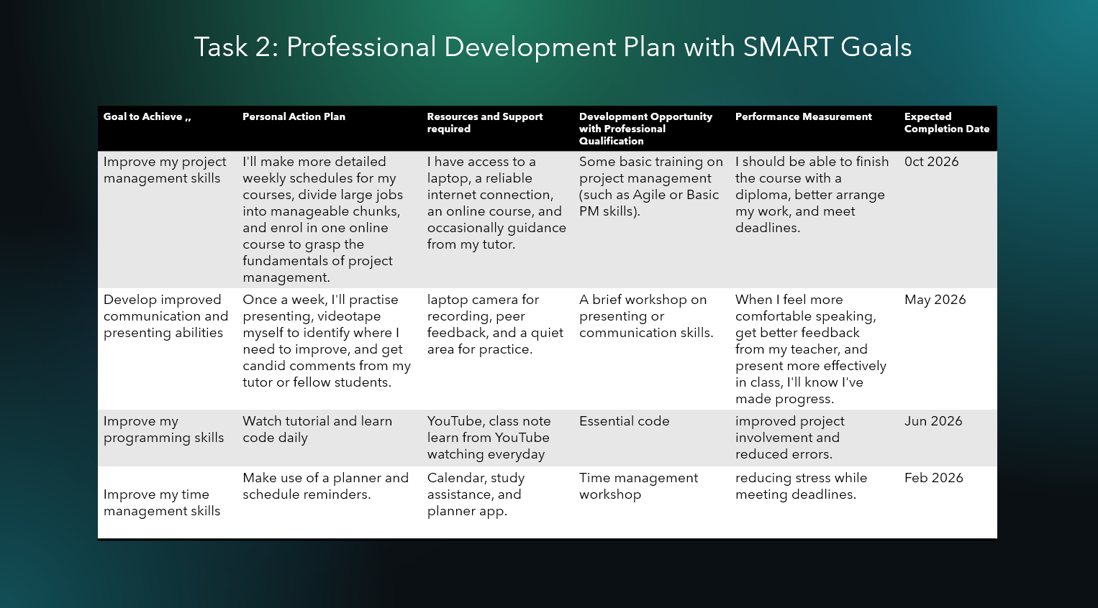
Brief explanation:
In order to improve important academic and professional abilities, such as project management, communication and presentation, programming, and time management, this Professional Development Plan lays out specific SMART targets. The plan outlines doable steps, necessary resources and assistance, pertinent development opportunities, and quantifiable performance indicators to monitor each goal's advancement. Each target also has a realistic completion date, ensuring that the strategy is timely and attainable. Overall, the plan offers an organised and methodical approach to personal and professional development, promoting continual improvement and the achievement of academic and career goals.

Slide 9 UNIT 4 TOPIC SUMMARY
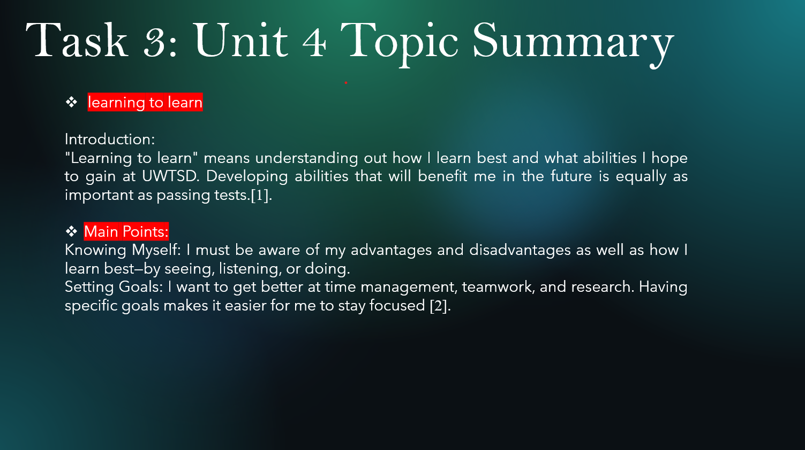
Brief explanation:
- learning to learn
Introduction:
"Learning to learn" means understanding out how I learn best and what abilities I hope to gain at UWTSD. Developing abilities that will benefit me in the future is equally as important as passing tests.[1].
- Main Points:
Knowing Myself: I must be aware of my advantages and disadvantages as well as how I learn best—by seeing, listening, or doing.
Setting Goals: I want to get better at time management, teamwork, and research. Having specific goals makes it easier for me to stay focused [2].

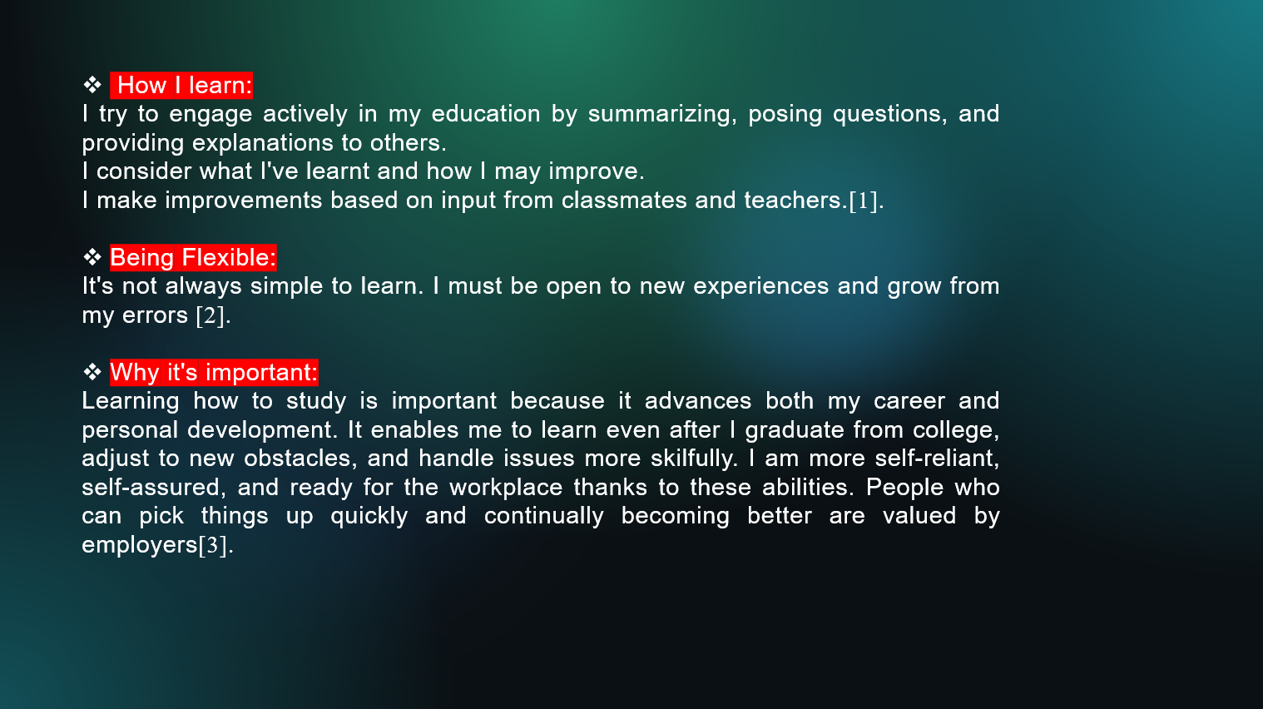

- How I learn:
I try to engage actively in my education by summarizing, posing questions, and providing explanations to others.
I consider what I've learnt and how I may improve.
I make improvements based on input from classmates and teachers.[1].
- Being Flexible:
It's not always simple to learn. I must be open to new experiences and grow from my errors [2].
- Why it's important:
Learning how to study is important because it advances both my career and personal development. It enables me to learn even after I graduate from college, adjust to new obstacles, and handle issues more skilfully. I am more self-reliant, self-assured, and ready for the workplace thanks to these abilities. People who can pick things up quickly and continually becoming better are valued by employers [3].

Slide 10 CONCLUSION

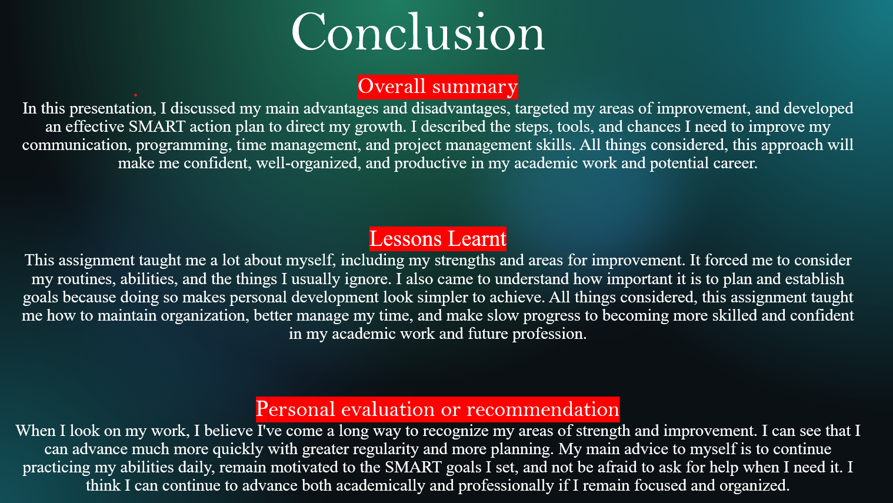

Brief explanation:
Overall summary
In this presentation, I discussed my main advantages and disadvantages, targeted my areas of improvement, and developed an effective SMART action plan to direct my growth. I described the steps, tools, and chances I need to improve my communication, programming, time management, and project management skills. All things considered, this approach will make me confident, well-organized, and productive in my academic work and potential career.
Lessons Learnt
This assignment taught me a lot about myself, including my strengths and areas for improvement. It forced me to consider my routines, abilities, and the things I usually ignore. I also came to understand how important it is to plan and establish goals because doing so makes personal development look simpler to achieve. All things considered, this assignment taught me how to maintain organization, better manage my time, and make slow progress to becoming more skilled and confident in my academic work and future profession.
Personal evaluation or recommendation
When I look on my work, I believe I've come a long way to recognize my areas of strength and improvement. I can see that I can advance much more quickly with greater regularity and more planning. My main advice to myself is to continue practicing my abilities daily, remain motivated to the SMART goals I set, and not be afraid to ask for help when I need it. I think I can continue to advance both academically and professionally if I remain focused and organized.

Slide 11
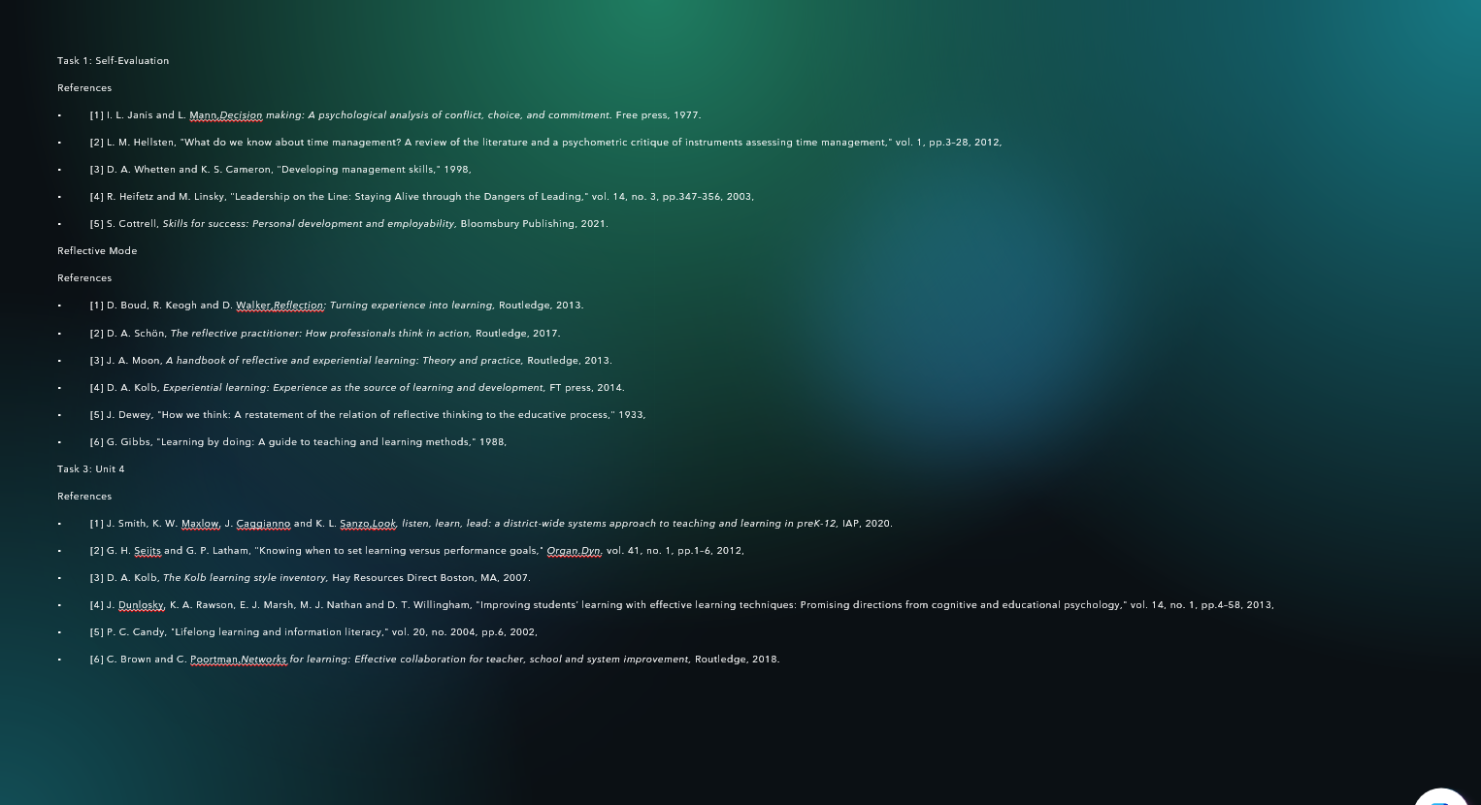

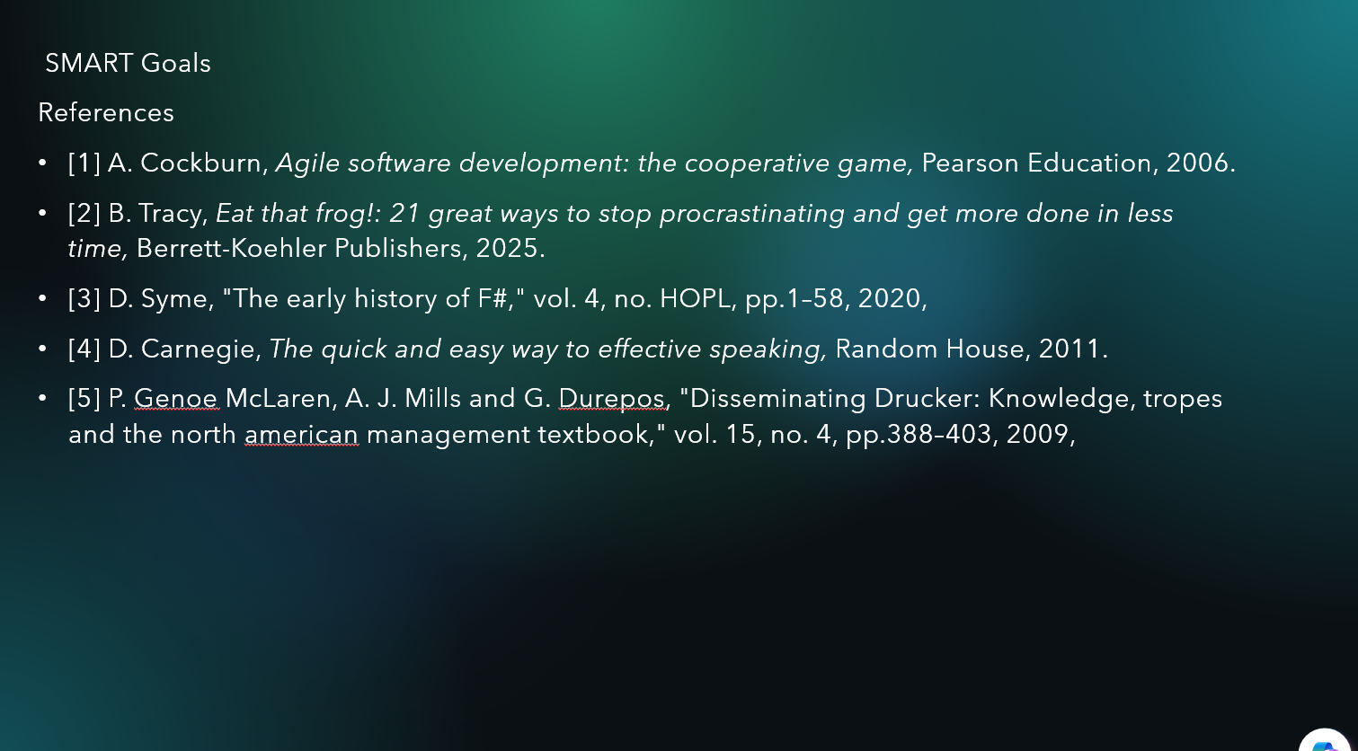

Conclusion
In this presentation, I discussed my main advantages and disadvantages, targeted my areas of improvement, and developed an effective SMART action plan to direct my growth. I described the steps, tools, and chances I need to improve my communication, programming, time management, and project management skills. All things considered, this approach will make me confident, well-organized, and productive in my academic work and potential career.

References

Task 1: Self-Evaluation
References
- [1] I. L. Janis and L. Mann,Decision making: A psychological analysis of conflict, choice, and commitment. Free press, 1977.
- [2] L. M. Hellsten, "What do we know about time management? A review of the literature and a psychometric critique of instruments assessing time management," vol. 1, pp.3–28, 2012,
- [3] D. A. Whetten and K. S. Cameron, "Developing management skills," 1998,
- [4] R. Heifetz and M. Linsky, "Leadership on the Line: Staying Alive through the Dangers of Leading," vol. 14, no. 3, pp.347–356, 2003,
- [5] S. Cottrell, Skills for success: Personal development and employability, Bloomsbury Publishing, 2021.
Reflective Mode
References
- [1] D. Boud, R. Keogh and D. Walker,Reflection: Turning experience into learning, Routledge, 2013.
- [2] D. A. Schön, The reflective practitioner: How professionals think in action, Routledge, 2017.
- [3] J. A. Moon, A handbook of reflective and experiential learning: Theory and practice, Routledge, 2013.
- [4] D. A. Kolb, Experiential learning: Experience as the source of learning and development, FT press, 2014.
- [5] J. Dewey, "How we think: A restatement of the relation of reflective thinking to the educative process," 1933,
- [6] G. Gibbs, "Learning by doing: A guide to teaching and learning methods," 1988,
Task 3: Unit 4
References
- [1] J. Smith, K. W. Maxlow, J. Caggianno and K. L. Sanzo,Look, listen, learn, lead: a district-wide systems approach to teaching and learning in preK-12, IAP, 2020.
- [2] G. H. Seijts and G. P. Latham, "Knowing when to set learning versus performance goals," Organ.Dyn. vol. 41, no. 1, pp.1–6, 2012,
- [3] D. A. Kolb, The Kolb learning style inventory, Hay Resources Direct Boston, MA, 2007.
- [4] J. Dunlosky, K. A. Rawson, E. J. Marsh, M. J. Nathan and D. T. Willingham, "Improving students’ learning with effective learning techniques: Promising directions from cognitive and educational psychology," vol. 14, no. 1, pp.4–58, 2013,
- [5] P. C. Candy, "Lifelong learning and information literacy," vol. 20, no. 2004, pp.6, 2002,
- [6] C. Brown and C. Poortman,Networks for learning: Effective collaboration for teacher, school and system improvement, Routledge, 2018.

SMART Goals
References
- [1] A. Cockburn, Agile software development: the cooperative game, Pearson Education, 2006.
- [2] B. Tracy, Eat that frog!: 21 great ways to stop procrastinating and get more done in less time, Berrett-Koehler Publishers, 2025.
- [3] D. Syme, "The early history of F#," vol. 4, no. HOPL, pp.1–58, 2020,
- [4] D. Carnegie, The quick and easy way to effective speaking, Random House, 2011.
- [5] P. Genoe McLaren, A. J. Mills and G. Durepos, "Disseminating Drucker: Knowledge, tropes and the north american management textbook," vol. 15, no. 4, pp.388–403, 2009,

