By Ceri Jones
Student No P034043
STARBUCKS REPORT
MODULE M3X9111

STRATEGIC MANAGEMENT & SUSTAINABILITY

Contents

1. Executive Summary 2
2. Introduction 2
2.1. Objectives 3
2.2. Starbucks’ business strategy 3
2.3. Competitive edge 4
2.4. Porter’s Generic Strategies 4
3. Key Findings 5
3.1. Differentiation strategy 6
3.2. Generic strategies reviewed 6
3.3. Starbucks’ Differentiation strategy 6
3.4. Brand equity 7
3.5. Research & Development 7
3.6. Sustainability, CSR and the Green agenda. 8
3.7. Differentiation strategy - strengths 8
3.7.1. Distinguishing itself from its competitors 9
3.8. Gaining a competitive edge 9
3.8.1. Premium price for a premium product 10
3.9. Differentiation strategy - weaknesses 10
3.9.1. Risk of replication 10
3.9.2. Spiralling costs and risks from substitutes 11
4. Conclusion 11
5. Recommendations 12
6. Bibliography 13

Table of figures
Figure 1 Hierarchical Levels of Strategy
Figure 2 Porter’s Three Generic Strategies
Figure 3 America’s Same-Store Sales Growth - Starbucks Company Filing
Figure 4 Competitive Advantage Diagram

Executive Summary

The remit of this report is to identify, analyse, and evaluate Starbucks’ strategy and propose recommendations for improving Starbucks’ performance. Background information for this report was gathered from academic textbooks, journals, and Starbucks’ own website. The report found that Starbucks’ strategy is one of differentiation, as described in Porter’s Generic Strategies. Starbucks achieve their differentiation strategy through brand equity, research and development (R&D), and sustainability, corporate social responsibility (CSR) and green agenda.
The advantage of Starbucks’ differentiation policy is that it allows Starbucks to:
- Distinguish itself from its competitors: By offering a superior product and service, Starbucks is able to distance itself from the competition.
- Create a competitive edge: Starbucks’ differentiation strategy allows it to gain a competitive edge over its competition, resulting in a strong market position.
- Charge a premium price for a premium product: By placing the highest importance on the quality of its products and services, Starbucks is able to charge a premium price.
The disadvantage of Starbucks’ policy is that it leads to:
- Risk of replication: Starbucks has a business model that if replicated could lead to competitors creating equally successful businesses.
- Spiralling costs: If Starbucks are to provide products and services ethically, their costs will be much greater than that of their competitors.

- Introduction
Starbucks Corporation is a premier roaster, marketer and retailer of speciality coffee. Through their company-operated and licensed stores, Starbucks offer a wide range of coffee and tea products, food, snacks, juices and bottled water (Starbucks, 2017). Starbucks was founded in Seattle, America, in 1971 and now operates in 75 countries worldwide. Known across the world as an ethical company for the way it treats its customers and suppliers, Starbucks continues to expand into developing and emerging countries, such as India, with the goal of remaining the most respected and recognised coffee brand in the world (Starbucks, 2017).

2.1. Objectives

This report will analyse, identify, and evaluate Starbucks’ strategy and propose recommendations for improving Starbuck’s performance.

2.2. Starbucks’ business strategy

An organisation's core competencies should be focused on satisfying customer needs or preferences in order to achieve above-average returns (Johnson et al, 2009). This is done through business-level strategies. According to Johnson et al (2009), business-level strategy details actions taken to provide value to customers and gain a competitive advantage by exploiting core competencies in specific individual product or service markets. The other main levels at which companies operate are corporate-level strategy and operational/functional-level strategy as shown in fig 1 (Hill & Jones, 2013).
To gain a competitive advantage, Starbucks operates at a business-level strategy.

Figure 1
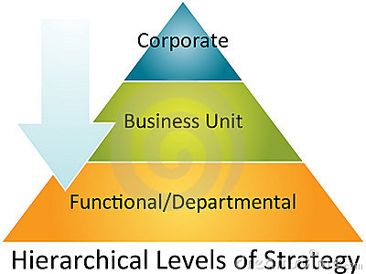
Source (All Answers Ltd, 2017)

2.3. Competitive edge

According to Chacarbaghi & Lynch (1999), competitive advantage is a condition that allows a company to produce a good or service at a lower price or in a more desirable fashion for customers. These conditions allow the product or service to generate more sales or superior margins than its competition. Competitive advantages can be attributed to a variety of factors, including cost structure, brand, and quality of the product (Hunt & Morgan, 1995). The more sustainable the competitive advantage, the more difficult it is for competitors to neutralise the advantage. The two main types of competitive advantages are comparative advantage and differential advantage (Hunt & Morgan, 1995).
Porter suggests three generic business strategies that could be adopted in order to gain competitive advantage.

2.4. Porter’s Generic Strategies

Figure 2
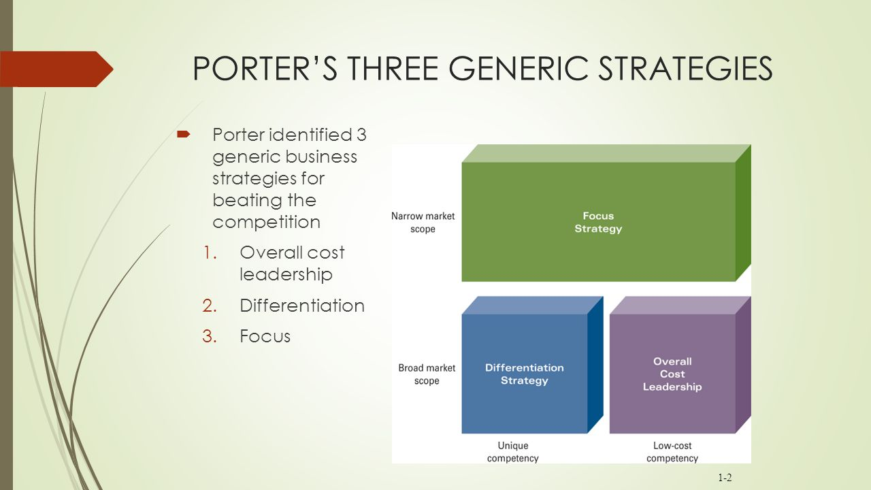
Source (sideplayer.com, 2017).

The strategies that Porter suggests are appropriate to seek a competitive edge are overall cost leadership, differentiation and focus (see fig 2). Focus strategy can be split into cost focus and differentiation focus. The strategies relate to the extent to which the scope of a business' activities is narrow versus broad, and the extent to which a business seeks to differentiate its products (Porter, 2008).

- Key Findings
Starbucks was founded in 1971 but did not start flourishing until 1984 when Howard Schultz, director of retail operations and marketing, convinced Starbucks to replicate the espresso coffee culture of Italy in its stores (Starbucks, 2017). By offering a large variety of coffees in numerous flavours, Starbucks differentiated from the more traditional coffee houses of the time and gained a competitive edge. Since it was founded in 1971, Starbucks has aligned itself to coffee producers and suppliers and increased its size significantly by acquiring a number of other coffee shops such as Seattle’s Best Coffee and Evolution Fresh. According to Starbucks Annual Report of 2016, it now has 25,085 retail outlets worldwide (Starbucks, 2017).
In line with Porter’s Generic Strategies, Starbucks’ differentiation strategy has proved to be a success and is still proving successful today (as is shown in fig 3 on the same-store growth on growth figures for 2016) (Market Realist, 2016).
Figure 3 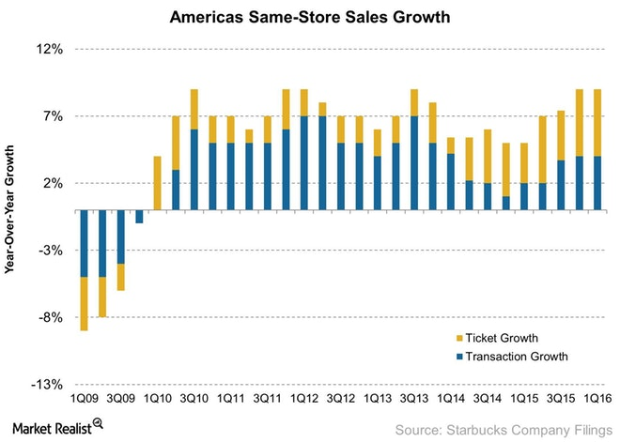

Differentiation strategy

Differentiation strategy calls for the development of a product or service that offers unique attributes that are valued by customers, and that customers perceive to be better than, or different from, products of the competition (Porter, 2008). The value added by the uniqueness of a product may allow a company to charge a premium price for a premium product. The business hopes that the higher price will exceed the extra costs incurred in offering the unique product. Because of the product’s unique attributes, if suppliers increase their prices, the company may be able to pass on the costs to its customers who are unable to find substitute products easily (Porter, 2008).

3.2. Generic strategies reviewed

Businesses that fail to effectively pursue Porter’s generic strategies are often said to be ‘stuck in the middle’. This is when a company is unable to offer features that are unique enough to convince customers to buy its products, or when a company’s prices are too high to compete effectively based on price. Businesses that are ‘stuck in the middle’ are often said to perform poorly (Porter, 2008).
Businesses do however have the option of using Bowman & Faulkner’s Strategy Clock principle, which bases strategy on the principle that competitive advantage can be achieved by providing customers with what they want or need (Johnson et al, 2011).

3.3. Starbucks’ Differentiation strategy

Starbucks use differentiation strategy by selling coffee of the finest quality to customers wanting the very best coffee house experience. Starbucks also use differentiation strategy to gain brand equity (Kotler et al, 2002).

3.4. Brand equity

Brand equity is described as the way consumers think, feel, and act, with respect to the brand (Kotler et al, 2002). By offering their customers the unique ‘Starbucks Experience’ of high-quality drinks and snacks served in a clean and friendly retail store, Starbucks has grown their brand equity. As their stores also reflect the culture of the communities in which they operate, Starbucks has built a loyal customer base.
Keller et al (2011) describe brand equity as the commercial value that derives from consumer perception of the brand. Starbucks’ brand equity was damaged in 2012 by the revelation that it paid no corporation tax in the United Kingdom. Starbucks somewhat rebuilt its reputation by promising to pay back £10 million in taxes in each of the following years (The Guardian, 2012).
Starbucks has leveraged its brand equity by merchandising products and licensing its brand logo out to franchisees.

3.5. Research & Development

R&D is a valuable tool for growing and improving businesses. R&D involves developing new and improved products. Starbucks continues to develop its range of coffees, snacks and juices. Starbucks currently has more than 30 blends and single-origin premium coffees (Starbucks, 2017). By offering more products at a premium price, Starbucks can continue to be profitable.
Starbucks also research and develop new and innovative ways in which to improve customer experience. As well as having a large social media presence, Starbucks have also introduced a rewards system and ‘Starbucks Card’ in an attempt retain customer loyalty. Being the first coffee chain to carry out trials to integrate voice ordering technology into their stores has also ensured Starbucks continue to have a sustainable competitive edge over their rivals.
Starbucks has leveraged its R&D technology with its mobile application ‘Starbucks App’ in both apple and android software.

3.6. Sustainability, CSR and the Green agenda.

Brundtland (1987) defines sustainability as meeting the needs of the present without compromising the ability of future generations to meet their needs. Starbucks was the first company to include 10% recycled plastic in their cups and offer a discount to customers who brought in a reusable cup to their stores. By promoting the sustainability agenda, Starbucks is seen as socially responsible by their customers who are therefore more likely to buy their products in return.
Starbucks has also has created a policy called C.A.F.E (Coffee and Farmer Equity) which is similar to Fair Trade policy. C.A.F.E. shows responsibility towards the moral, environmental and quality aspects of processing and selling coffee (Marques & Utting, 2010). Starbucks focuses on farmers and stakeholders because they are sustainable to the company (Freeman, 2010). Johnson et al (2011) describe stakeholders as those individuals or groups who depend on an organisation to fulfil their own goals and on whom, in turn, the organisation depends. Stakeholders are also affected by CSR (Elkington, 2006).
CSR is a concept that was developed in the 1970’s which is concerned with the ways in which an organisation exceeds its minimum obligations to stakeholders specified through regulation (Johnson et al 2011). Customers are also more likely to buy the products of a company if they know it practices CSR (Drucker, 2014).

Starbucks is seen as a ‘green’ company by their customers for having energy efficient stores that use renewable energy. These stores also focus on recycling and reducing waste. Starbucks must continue to convince their customers that they differentiate from their competitors by putting the planet before profit if they are not to be accused of greenwashing (Kolb, 2007).

3.7. Differentiation strategy - strengths

The strength of differentiation strategy is that it allows a business to distinguish itself from its competitors and gain a competitive advantage (Barney, 2014).

3.7.1. Distinguishing itself from its competitors

By offering a superior product, Starbucks is able to distance itself from the competition. By offering differentiators such as a premium product mix, premium locations, and superior customer service, Starbucks has built itself into a premium valued brand which is costly to imitate for competitors.
Starbucks differentiation strategy has seen Starbucks build a strong market position within the coffee industry and global brand recognition. In 2016, Starbucks was 64th in the top 100 global brands in the world (Starbucks, 2017).
Companies can also become valued brands by following the value chain. The value chain is a framework that businesses can use to identify and evaluate the ways in which their resources and capabilities can add value and competitive advantage (Kaplinsky, 2000).

3.8. Gaining a competitive edge (see fig 4)

Starbucks’ strong market position and brand recognition worldwide allows it to gain a competitive advantage (see fig 4) when expanding further into international markets. In recent years, Starbucks has also gained a competitive advantage from using superior distribution channels and supplier relationships to that of their rivals in the coffee industry.
Figure 4
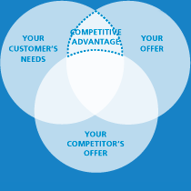
Source (Tronvig Group, 2017)

3.8.1. Premium price for a premium product

Starbucks avoids standardisation of its products, even when producing on a grand scale. By placing the highest importance on the quality of its products and services, Starbucks is able to charge a premium price.
Starbucks is also able to charge a premium price for its products and services thanks to the loyalty of its customers. Brand loyalty is defined as a pattern of consumer behaviour whereby the consumer becomes committed to the brand and makes repeat purchases from the same brand over time (Kapferer, 2012). Loyal customers consistently purchase products from their preferred brand, regardless of convenience or price. Companies often use different marketing strategies to cultivate the loyal customer, including loyalty programs, trials and incentives. Starbucks have their own loyalty card that rewards customers with loyalty points for every time they visit one of their stores (Starbucks, 2017).

3.9. Differentiation strategy - weaknesses

The weakness of differentiation strategy is that it does not take into account the risk of replication or the threat of spiralling costs and substitutes (Cleveland et al, 1989).

3.9.1. Risk of replication

Starbucks has a business model that if replicated could lead to competitors creating equally successful businesses. There are few barriers to entry for companies wanting to copy Starbucks’ business model. The initial investment for a competitor wanting to start up a coffee shop is relatively low, and although the coffee industry is competitive, there is the chance to be successful, as coffee drinkers can switch allegiance and brand loyalty from a company such as Starbucks whenever they desire.

3.9.2. Spiralling costs and risks from substitutes

As Starbucks provides products and services ethically, its costs tend to be greater than that of its competitors. This, in turn, leads to its price for a cup of coffee being higher than its rivals. In times of economic downturn, industries such as the coffee industry are highly sensitive to the macroeconomic factors that affect the growth in household disposable income. Customers can easily move from Starbucks to a cheaper coffee chain who offer drinks at a lower price.
Starbucks policy of charging premium prices to cover their costs could also mean their customers turn to cheaper substitutes such as alcoholic drinks or energy drinks. Customers can also choose to stay at home and make their own coffee, although Starbucks is addressing this threat by selling coffee makers and premium coffee packs in grocery stores.
There is also the threat to Starbucks’ profit margin from price volatility in the global market, with significant fluctuations in the market prices of high-quality coffee beans.
Starbucks policy of charging premium prices could also pose some weakness for it to succeed in developing countries where customers cannot afford to pay top-end prices for coffee.

- Conclusion
Starbucks’ successful use of differentiation strategy has allowed it to distinguish itself from its competitors by developing unique products and services that are valued by its customers. By gaining a competitive advantage, Starbucks has been able to charge a premium price for a premium product. By using Porter’s differentiation strategy, Starbucks has been able to build brand equity, continue research and development and promote sustainability.
The disadvantage of Starbucks differentiation strategy is that it does not stop competitors from attempting to replicate Starbucks’ business model and it can lead to spiralling costs.

- Recommendations
Going forward, Starbucks has the opportunity to:
- Take advantage of its brand equity to expand into emerging and developing markets.
- Continue to research and develop its fresh fruit juice drinks to take advantage of the demand for healthier products by today’s consumer.
- Continue to expand its retail operations with the introduction of new innovative outlets, such as their new 24-hour drive-throughs.

Starbucks must be alert to the threat of:
- Increased competition.
- Market saturation within developed countries.
- Changing consumer tastes moving towards a healthier lifestyle.

- Bibliography
Barney, J.B. (2014). Gaining and sustaining competitive advantage. Pearson Higher Education.
Baumgartner, R.J. and Ebner, D. (2010). Corporate sustainability strategies: sustainability profiles and maturity levels. Sustainable Development.
Chacarbaghi, K. and Lynch, R. (1999). Sustainable competitive advantage: towards a dynamic resource-based strategy. Management Decision.
Chartered Institute of Marketing.com (2017). [Online] Available at: https://www.cim.co.uk (Accessed 19 October 2017).
Cleveland, G., Schroeder, R.G. and Anderson, J.C. (1989). A theory of production competence.
Dibb, S. and Simkin, L. (1996). The marketing planning workbook: effective marketing for marketing managers. Cengage Learning EMEA.
Drucker, P. (2014). Innovation and entrepreneurship. Routledge.
Drummond, G., Ensor, J. and Ashford, R. (2010). Strategic marketing. Routledge.
Elkington, J. (2006). Governance for sustainability. Corporate Governance: An International Review.
Freeman, R.E. (2010). Strategic management: A stakeholder approach. Cambridge university press.
Hill, C.W. and Jones, G.R. (2013). Strategic management theory. South-Western/Cengage Learning.
Hooley, G. and Piercy, N.F., I Nicoulaud, B. (2008). Marketing Strategy and Competitive Positioning. Harlow: Pearson Education.
Hunt, S.D. and Morgan, R.M. (1995). The comparative advantage theory of competition. The Journal of Marketing.
Johnson, G., Scholes, K. and Whittington, R. (2008). Exploring corporate strategy: text & cases. Pearson Education.
Johnson, G., Scholes, K. and Whittington, R., (2009). Fundamentals of strategy. Pearson Education.
Kapferer, J.N. (2012). The new strategic brand management: Advanced insights and strategic thinking. Kogan page publishers.
Kaplinsky, R. (2000). Globalisation and un-equalisation: What can be learned from value chain analysis? Journal of development studies.
Keller, K.L., Parameswaran, M.G. and Jacob, I. (2011). Strategic brand management: Building, measuring, and managing brand equity. Pearson Education India.
Kolb, R.W. (2007). Encyclopaedia of business ethics and society. Sage Publications.
Kotler, P. and Gertner, D. (2002). The country as a brand, product, and beyond: A place marketing and brand management perspective. Journal of brand management.
Marketline.com (2017). [Online] Available at: https://ezproxy.uwtsd.ac.uk/login?url=http://advantage.marketline.com (Accessed 19 October).
MarketRealist.com (2016). Available at: https://beta.marketrealist.com/2015/10/expect-starbucks-store-sales-growth-4q15?utm_source=redirect5&utm_medium=auto (Accessed 29 October 2017).
Marques, J. and Utting, P. (2010). Business, politics and public policy: Implications for inclusive development. Springer.
Moodle.com (2017). [Online] Available at: https://moodle.swanseamet.uwtsd.ac.uk/login/index.php (Accessed 20 October 2017).
Porter, M.E. (2008). Competitive strategy: Techniques for analysing industries and competitors. Simon and Schuster.
Sideplayer.com (2017). [Online] Available at: http://slideplayer.com/slide/8976871/ (Accessed 20 October 2017).
Starbucks.com (2017). [Online] Available at: https://www.starbucks.com/ (Accessed 2 November 2017).
The Guardian.com (2017). Starbucks To Pay £10m corporation tax [Online] Available at: https://www.theguardian.com/business/2012/dec/06/starbucks-to-pay-10m-corporation-tax (Accessed 30 October 2017).
Thompson, J.L. and Martin, F. (2010). Strategic management: Awareness & change. Cengage Learning EMEA.
TronvigGroup.com (2017). [Online] Accessed at: http://www.tronviggroup.com/competitive-advantage-diagram/ (Accessed 31 October 2017).

