Domestic Electrical Provision for the Future

Name: Jonathan Preston

Student Number:1807552

Programme of Study: BA Business and Management

Module: Business Inquiry and Research

Tutor: Dr Alex Bell

Date: 29/04/2020

Introduction

This study report aims to gain an understanding of how much people value their current domestic electrical supply and if a technological leap that could bring cost reduction, low maintenance and convenience for the average consumer may be traded off in an acceptance that to live more sustainably requires a considerable shift in consumer behaviours. There is some evidence to suggest that consumers may be drawn to products or services that portray a positive brand benefit. According to the journal article ‘consumer attitude and purchase intention towards green energy brands’ the theory states three individual phycological benefits which can promote the consumers attitude regarding green energy brands. This may consequently lead to an increase the possibility of a purchase. This has been referred to as the ‘warm glow, self-expressive benefits and natural experiences (Apaolaza-Ibáñez, 2012). The study poses questions to ascertain people’s perception of themselves regarding sustainable living and how they intemperate their surroundings
Residential status may have an impact on how an individual makes decisions on their contribution to carbon reduction for example those who may be renting their home, living with parents or living in student accommodation would not have the option to switch their electrical energy provision, however they may aspire more to living sustainably. Another objective of this study is to try and identify what drives people to change their behaviours in a way that would involve them having to make some small personal sacrifices and lifestyle changes.
Research has previously been carried out in this field. In a qualitative study carried out by the Centre for Economic Psychology participants were interviewed about their income, social class, and their attitudes to environmental issues. In the study the results suggested that income and demographics had no influence on consumption behaviours, however those who had a positive attitude to environmental issues were more likely to change their behaviours (Lewis & Brandon, 1999). This research looks to take a more practical look at what may be required to inspire consumers to embrace an alternative way of home living.

Methodology
By employing the methods of quantities research, it was possible to derive insights and arrive at a practically definitive answers to the research questions (Bhatia, 2018). Using Google Documents, the questions listed below were used to create an online survey. Considerations to maintain appropriate human protection whilst participating in an online survey were met by incorporating a participant agreement section which required acknowledgment prior to participation of the survey (Hvizdak & Buchanan, 2009).

Participant Agreement
You are being invited to participate in a research study titled Domestic Electrical Provision for the Future. This study is being carried out by Jonathan Preston at the University of Wales. The purpose of this survey is to collect information for a business and enquiry research exercise. If you agree to take part in this study, you will be asked to complete the questionnaire below which will take approximately 5 minutes. The data collected will be used to assess domestic energy consumers appetite for a more sustainable and affordable method of electrical energy consumption. Responses are anonymous and all data collected will be permanently deleted once the study is completed on April 22nd, 2020. By clicking “I agree” below you are indicating that you are at least 18 years old, have read this consent statement and agree to participate in this research study.

A link was created, and the survey was sent to 30 participants which comprised of a diverse subject group. The survey was closed after 7 days and all survey responses were exported from Google Documents and downloaded into an Excel spreadsheet where the data was cleaned and coded. It was then possible to import the data into the Statistical Package for the Social Science (SPSS) Software. These methods have enabled research to be carried out objectively using measurements of the data collected via surveys, questionnaires or polls. The raw data can be analysed to produce statistical, numerical or mathematical information which in turn can allow the researcher to determine any particular phenomenon that is evident across the respondent groups (Babbie, 2010). The research procedure compiles in numerical date and logical information from an objective viewpoint. The data remains unchanged incorporating detail and convergent logic thus providing a natural unrestricted outcome (Mujis, 2010).

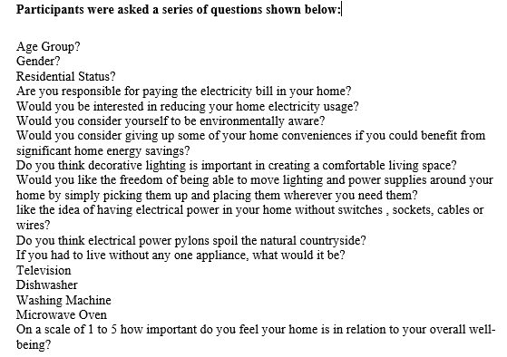

Data Presentation and Findings

Do electricity pylons spoil the countryside?
The bar chart below (Fig.1) shows how the age of the participants may have a bearing on their opinion regarding electricity pylons and the visual impact on the countryside. A total of 16 participants do see pylons having an adverse visual impact on the countryside which would support the research into providing an alternative method of domestic electrical energy provision. However, it was the youngest age group (18-30) who returned the most responses to support that view.

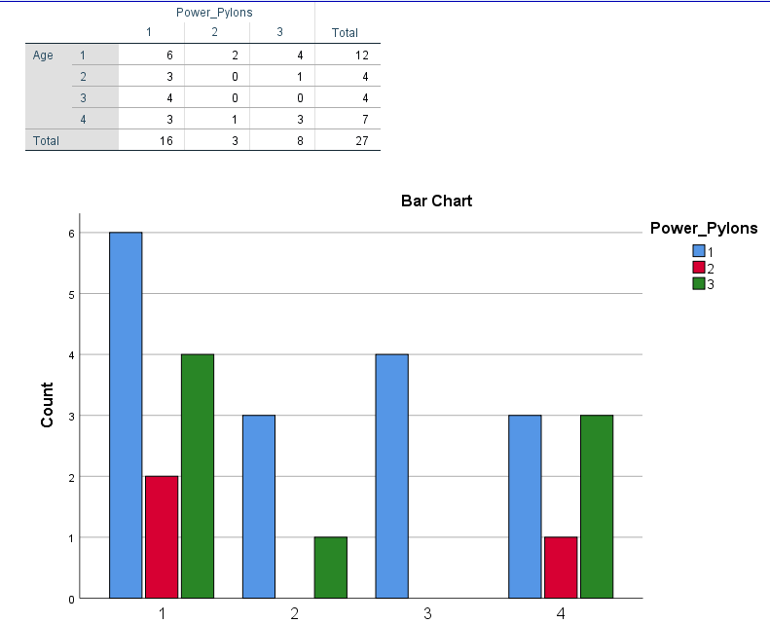

(Fig.1)
Residential status and overall wellbeing

All participants answered the question with none opting for a preference not to say. The data below (Fig.2 ) indicates that there is clear correlation between those who own their home and the importance of how the home impacts on wellbeing. This is not to say that to own a home is to have a better standard of wellbeing, it is to suggest that those who do own their residence deem the home to be an important factor in their overall wellbeing.

Residential Status * Wellbeing Crosstabulation
 |  | Wellbeing |  |  | Total
 |  | 3 | 4 | 5 | Total
Residential Status | 1 | 1 | 2 | 8 | 11
Residential Status | 2 | 1 | 0 | 4 | 5
Residential Status | 3 | 0 | 1 | 3 | 4
Residential Status | 4 | 1 | 4 | 2 | 7
Residential Status | 5 | 0 | 0 | 1 | 1
Total |  | 3 | 7 | 18 | 28
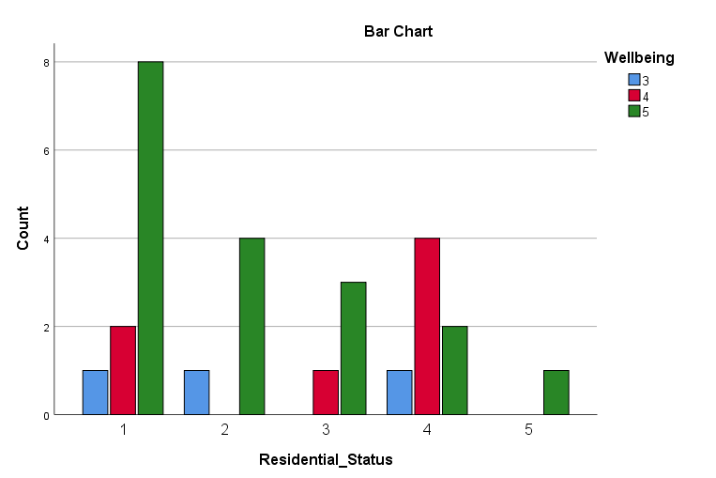
(Fig.2)
Giving up home conveniences and paying the bill
Not surprisingly as the crosstabulation shows, there is a reluctance to give up the convenience of some electrical appliances if there is no responsibility to pay the electrical service charges. 7 participants who are responsible for the electricity payments would be happy to give up certain appliances if it meant them benefiting from significant home energy savings. Only 4 participants would not give up an appliance whether they paid the bill or not. As shown below (Fig.3) , 7 bill payers show a preference to give up an appliance while 11 respondents were willing to consider it.

Billpayer * Giveup_Conveniences Crosstabulation
 |  | Give up Conveniences |  |  | Total
 |  | 1 | 2 | 3 | Total
billpayer | 1 | 7 | 2 | 11 | 20
billpayer | 2 | 4 | 2 | 2 | 8
Total |  | 11 | 4 | 13 | 28
(Fig.3)

Again, in the crosstabulation shown below (Fig.4) between the bill payer and reducing electricity usage the data shows that it is the bill payer who is more willing to reduce domestic electrical consumption.

Bill_Payer * Reduce Usage Crosstabulation
 |  | Reduce Usage |  |  | Total
 |  | 1 | 2 | 3 | Total
Bill_Payer | 1 | 15 | 3 | 2 | 20
Bill_Payer | 2 | 3 | 4 | 1 | 8
Total |  | 18 | 7 | 3 | 28
(Fig.4)

What appliance could you live without?

Interestingly the washing machine is the only is the only appliance that every respondent could not live without. Represented numerically by the number 3 it is not represented in the data, meaning it was not selected at all. 5 respondents chose the Television, 8 chose the Microwave Oven and 15 opted to live without a Dishwasher. (Fig.5)

Live_Without
 |  | Frequency | Percent | Valid Percent | Cumulative Percent
Valid | 1 | 5 | 17.9 | 17.9 | 17.9
Valid | 2 | 15 | 53.6 | 53.6 | 71.4
Valid | 4 | 8 | 28.6 | 28.6 | 100.0
Valid | Total | 28 | 100.0 | 100.0
(Fig.5)

Interestingly the washing machine is the only is the only appliance that every respondent could not live without. Represented numerically by the number 3 it is not represented in the data, meaning it was not selected at all. 5 respondents chose the Television, 8 chose the Microwave Oven and 15 opted to live without a Dishwasher.

Conclusions
Based on the analysis of key parts of the data it has illustrated a consumer interest in adopting innovative and sustainable methods of domestic electrical power consumption. A general perception that electrical pylons are unsightly in the open countryside was found to be a prominent sentiment amongst the majority of participants and showed no correlation to the demographic of the study group. However residential status did display a correlation with the importance of the home environment and overall wellbeing. This could be interpreted as a phenomenon displaying a human need for ‘belonging’ and how that may be achieved by having personal possession of one’s property. In terms of the research this section of society could be identified as target customers for sustainable energy provision. Due to their strong connection to the home environment and their willingness to embrace innovative energy solutions they could be key in influencing the energy market in meeting a possible demand for an emerging new energy market.
Financial factors have also shown to be important. Householders who are responsible for paying for home energy have displayed an interest in reducing cost and limiting household appliances. However, the home washing machine is an appliance no participant would want to be without. This will present a challenge for sustainable energy supply due to the high energy consumption of such appliances. To conclude, this research has provided an insight into the current consumer psyche which shows some evidence of an appetite for change. This could be driven by market conditions in an uncertain future and where dependence on national energy providers could be expensive, high maintenance and unsustainable.

References
Apaolaza-Ibáñez, P. H. (2012). Consumer attitude and purchase intention toward green energy brands:The roles of psychological benefits and environmental concern. Journal of Business Research, 1254-1263.
Babbie, E. R. (2010). The Practice of Social Research . Belmont CA: Wadsworth Cenage.
Bhatia, M. (2018, June 11). A Complete Guide to Quantitative Research Methods. Retrieved from Humans of Data: https://humansofdata.atlan.com/2018/06/quantitative-research-methods
Hvizdak, E. E., & Buchanan, E. A. (2009). Online Survey Tools: Ethical and Methodological Concerns of Human Research Ethics Committees. Retrieved from Journal of Empirical Research on Human Research Ethics: https://doi.org/10.1525/jer.2009.4.2.37
Lewis, A., & Brandon, G. (1999). Reducing Household Energy Consumption: A Qualative and Quantative Field Study. Journal of Environmental Psychology, 75-85.
Mujis, D. (2010). Doing Quantitive Research with SPSS. London: Sage Publications.

