Network Services

George Cristian Petrescu

Student ID: P151317

Course : Computer Networks

Module: Network Services

Tutor: Dr. Tim Bashford

Contents
1. Worksheet 1 2
1.1 Screens 2
1.2 Questions 7
1.2.1 7
1.2.2 8
1.2.3 8
1.2.4 8
1.2.5 8
2. Worksheet 2 9
2.1 9
2.2 Questions 17
2.1.1 18
2.2.2 18
2.2.3 19
2.2.4 19
3. Worksheet 3 20
3.1 Screens 20
3.2 Questions 25
3.2.1 25
3.2.2 25
3.2.3 25
3.2.4 26
4. Worksheet 4 27
4.1 Screens 27
4.2 Questions 34
4.2.1 34
4.2.2 34
4.2.3 35
4.2.4 35
4.2.5 36

Figure 1 ARP Process[6] 21
Figure 2 DHCP Process[6] 29
Figure 3 Relay Agent[3] 30
Figure 4 DNS Process[6] 37
Figure 5 FQDN Role[7] 38
Figure 6 Failover Cluster[12] 39

Worksheet 1

1.1 Screens

Setting up IP and Gateway
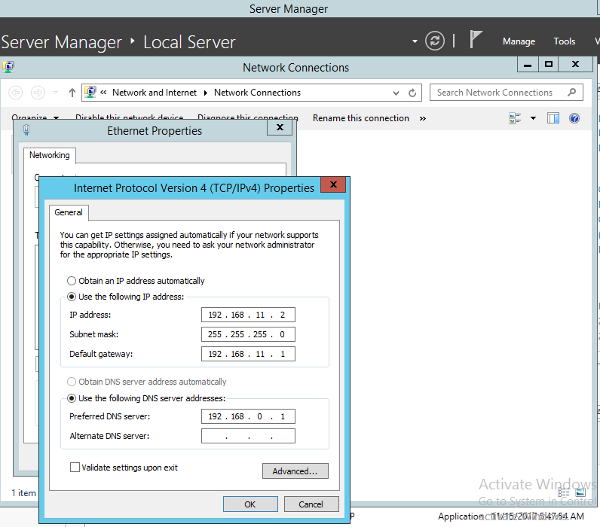
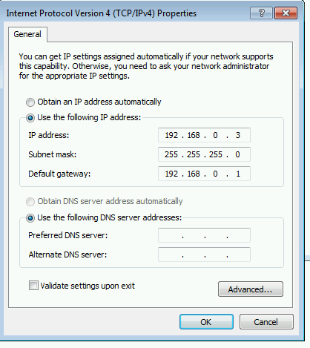
Unsuccessful ping to Servers
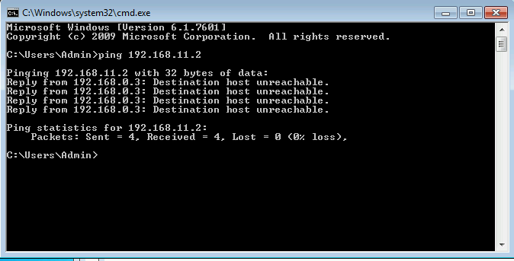
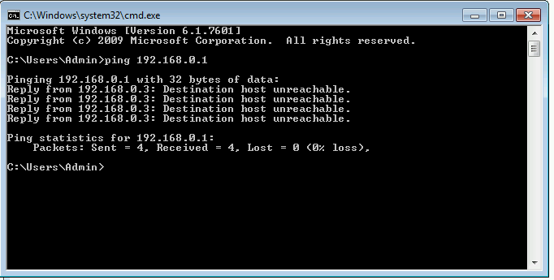
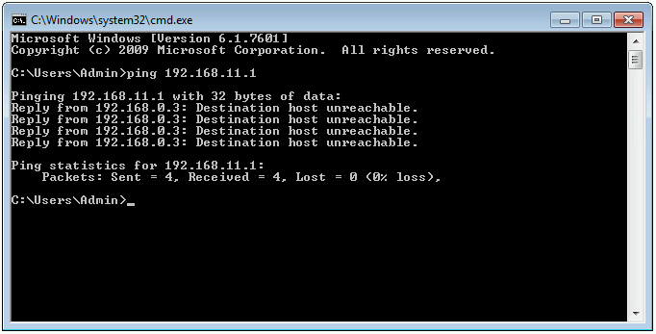

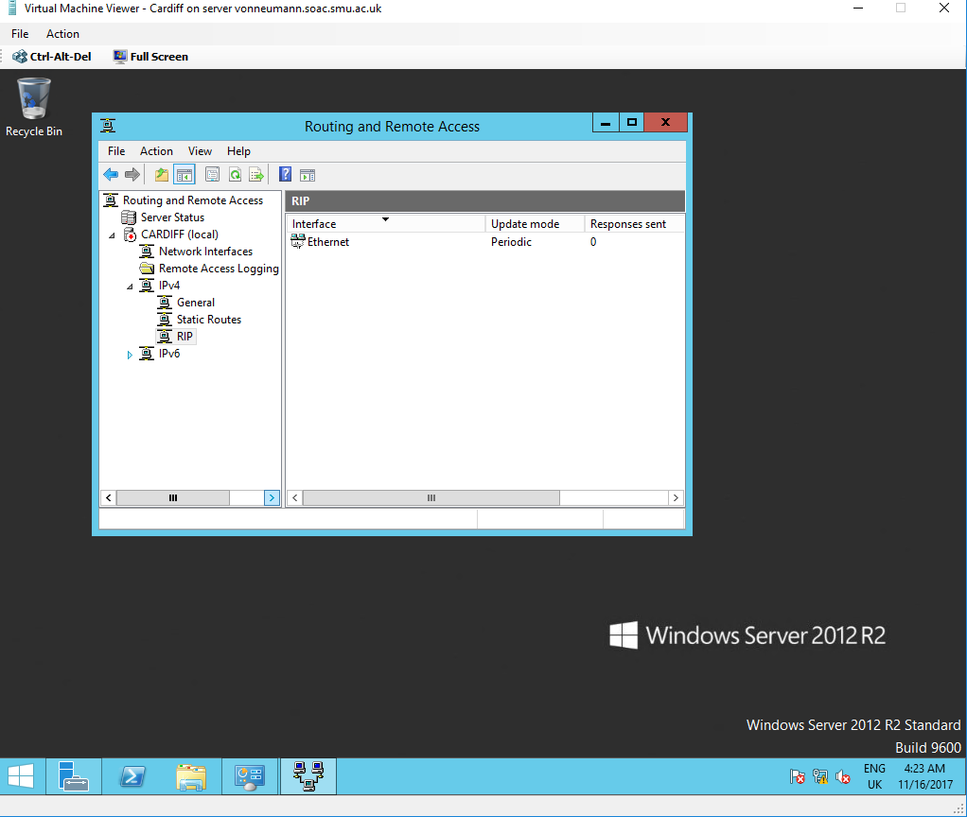
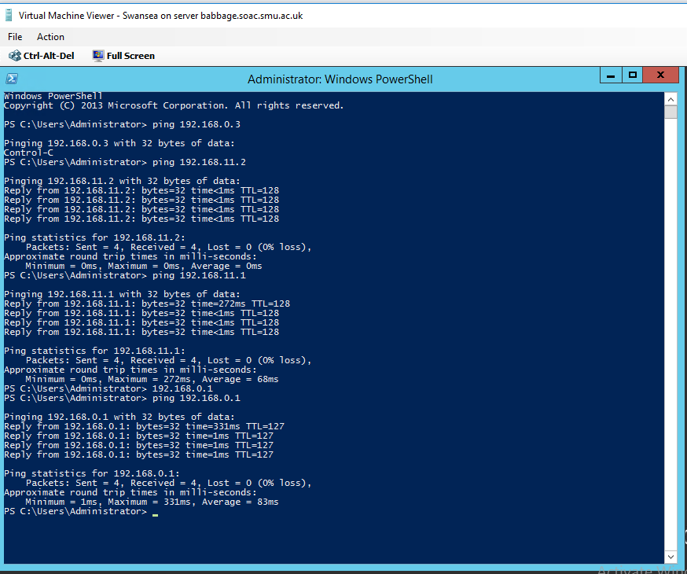
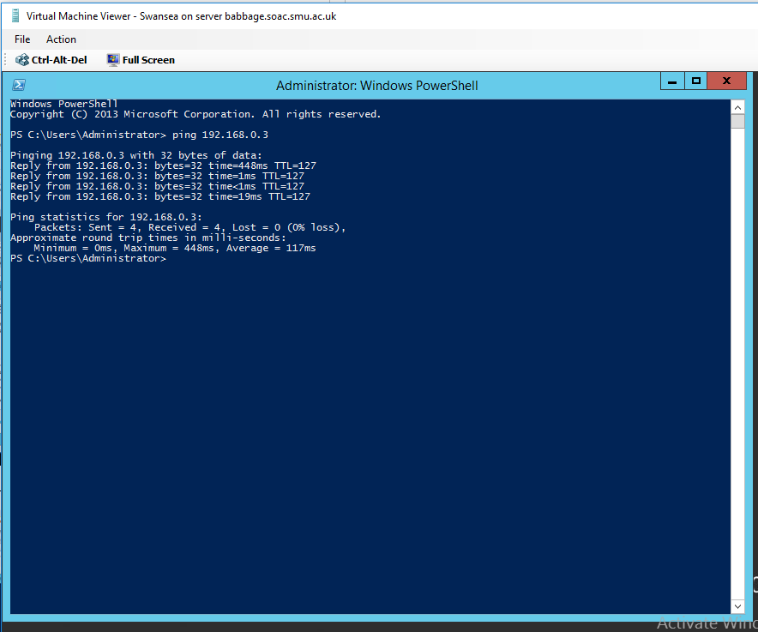

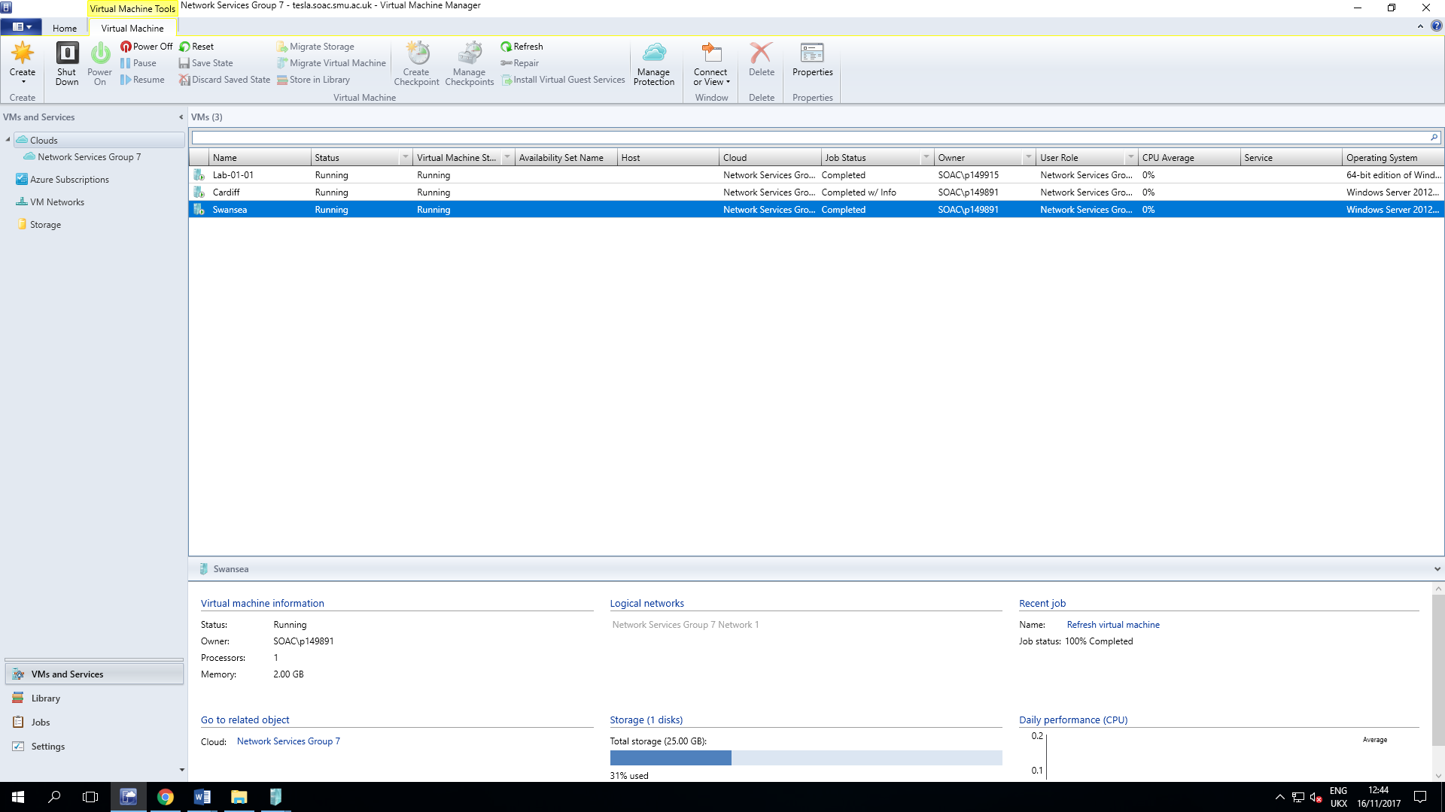

Questions

1.2.1
Identify the benefits of Type 1 Hypervisor software services and briefly evaluate some suitable products

The benefits of type 1 Hypervisors are[1][2] :

- Faster performance due to the fact that running directly on the hardware and eliminates a layer of overhead which is the client`s operating system .
- Security improved providing better isolation between desktop images and eliminating possibility of attacking the hosts operating system running directly on the hardware
- Bring your own PC enabled on Hypervisor Type 1
- Better management

The best products on the market of Type 1 Hypervisors are[1] :

- VMware`s vSphere / ESXi
- Microsoft`s Windows Server 2012 Hyper-V
- Citrix`s XenServer
- Red Hat`s RHEV
- Red Hat`s KVM

1.2.2
Define the role of Routers in the Network Architecture, what types can be used?

The Routers in a Network Architecture connect multiple networks together . They do this by deciding the path on which the data is transmit and they transmit the data , securely , between networks .
The routers that can be used are hardware based or software based [3]–[6].

1.2.3
Identify and discuss the usage of common Routing Protocols, what are the associated benefits of using Routing Protocols?

Routing Protocols are a set of rules that routers use to determine best path for sending data .The Routing Protocols define what rules will be used when a router shares , with other routers , routing information . Routing Protocols also determine the way routed protocols are routed [3], [5], [6] .
The benefits of using Routing Protocols are :

    - Easy to use and to configure
    - Widely used and known

1.2.4
Define the role of Routing Tables, what are they. Breakdown and analyze the information a Routing Table provides us with .

The routing table stores information about routes (directly-connected or remote ) to networks . The router use the information from the routing table to forward the packet towards destination . If no route is stored in the Routing Table about the destination then the router forwards the packet toward default route if it`s available , and if not , the packet is dropped .
The Routing Table shows us the paths the packet will take when it is send to a specific destination and what will happen when there is no path available toward that destination ( either default rute either dropped )[1], [4].

1.2.5

What is the Subnet Mask , what is the significance of this in the Routing Table .

The Subnet Mask is a 32 bit number that splits an existing IP address intro Network Address and Host Address .In the Routing Table it will help the Router to recognize the bits that represent the subnet and the bits that represent the host and so the router will be able to know if the IP Address specified is local or not[1], [5].

Worksheet 2

2.1
Screens

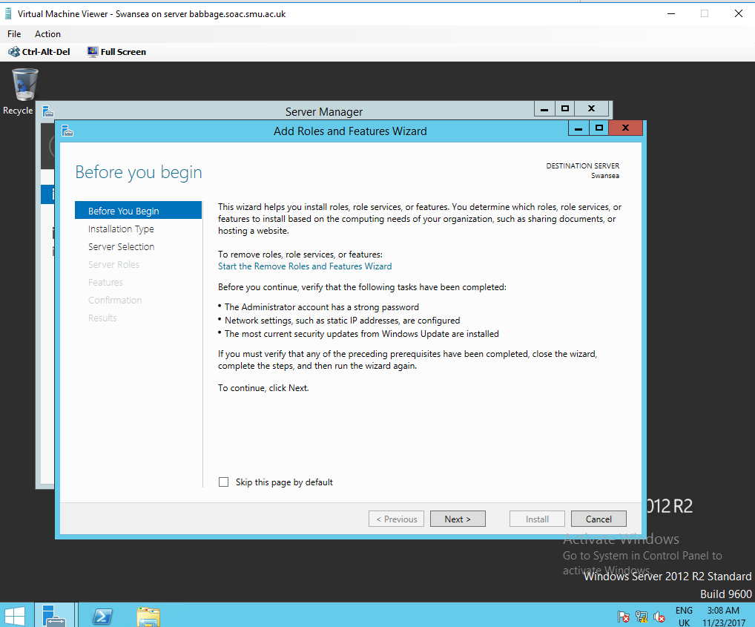
Setting up web server
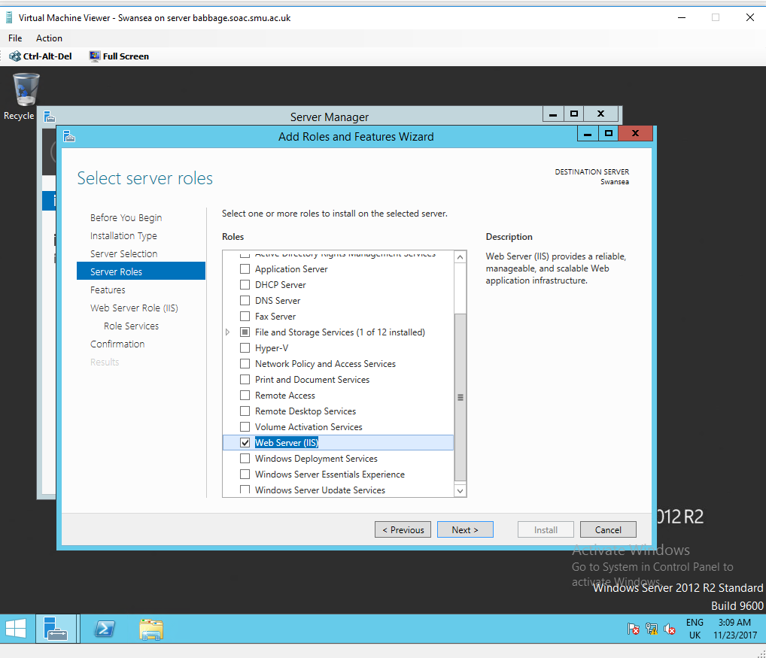
Setting up FTP service
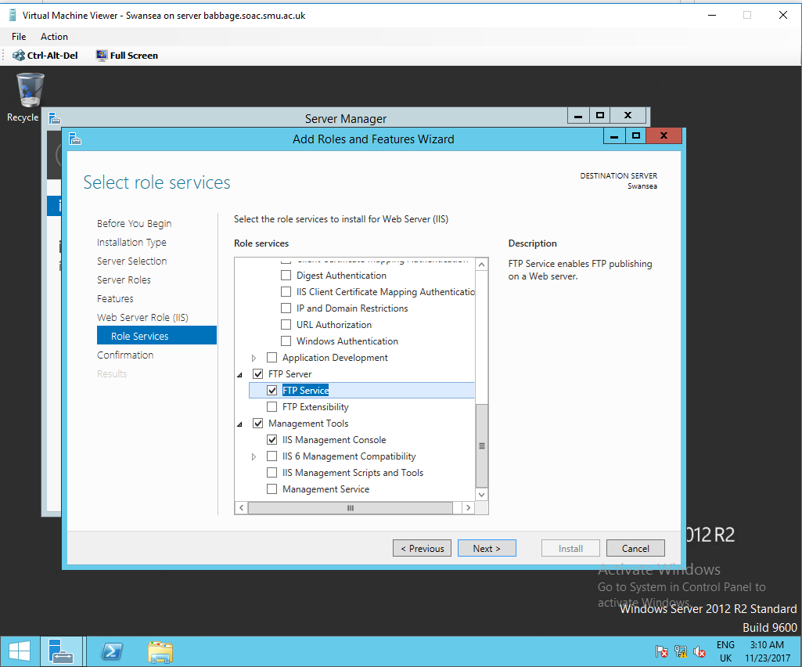

Setting up local users folder
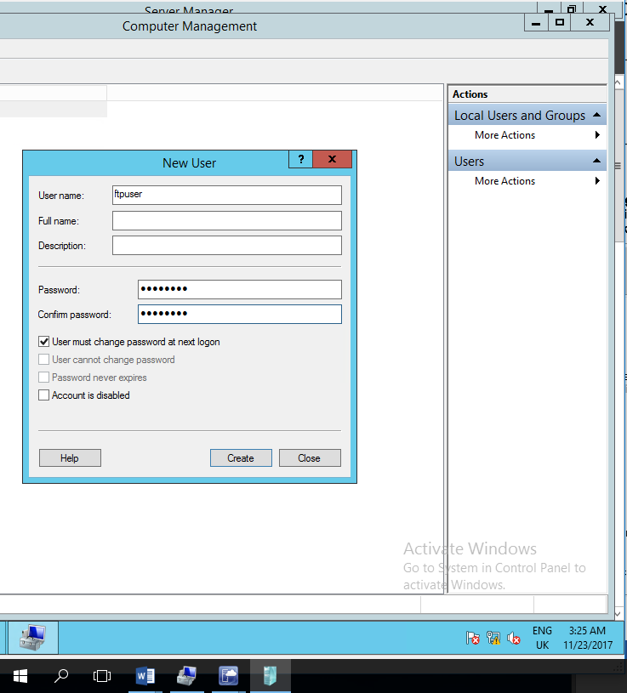
Setting up directory
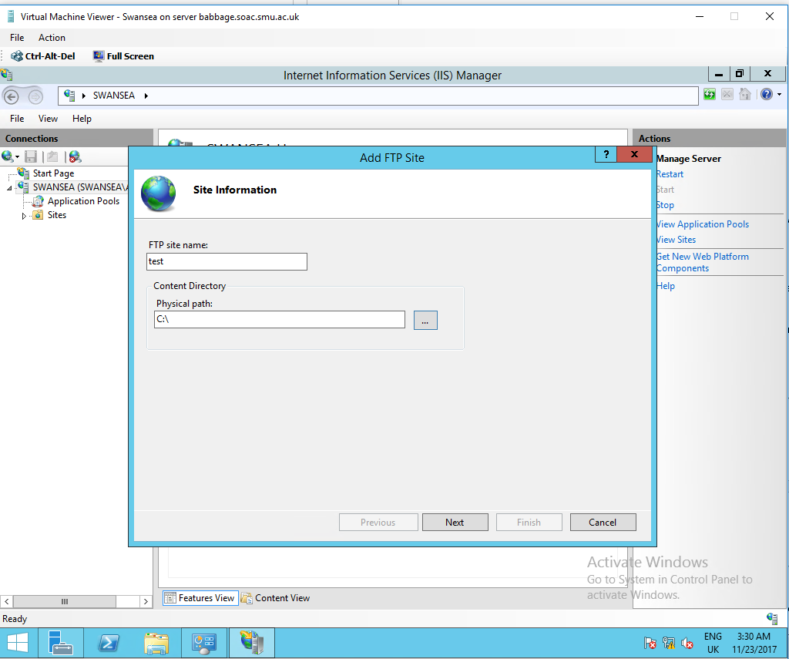
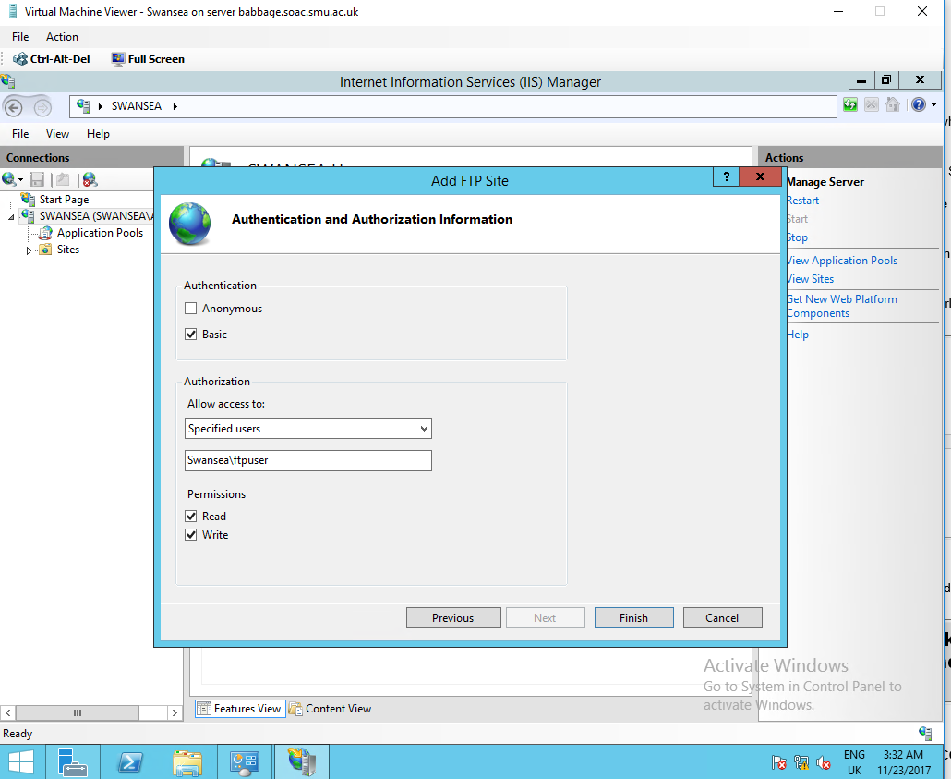
Creating banner messages
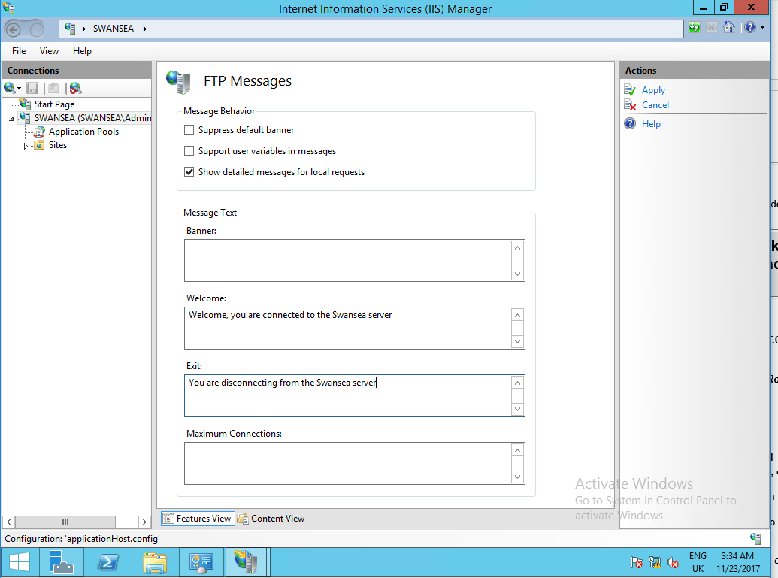
Proof of text file in folder
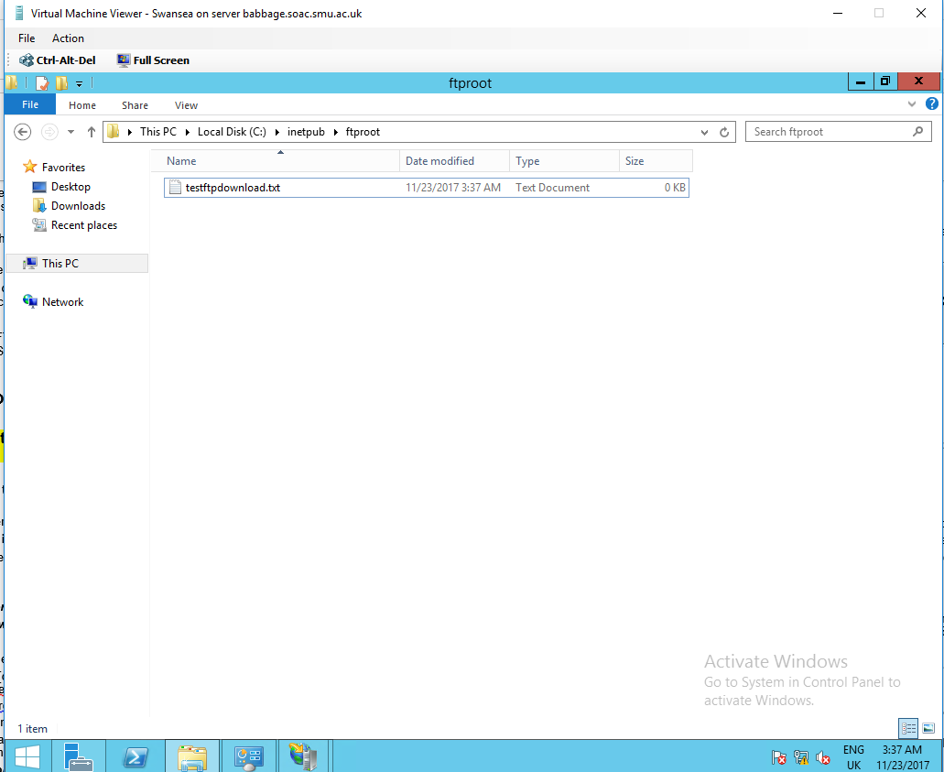
Proof of pinged file from Cardiff server in folder
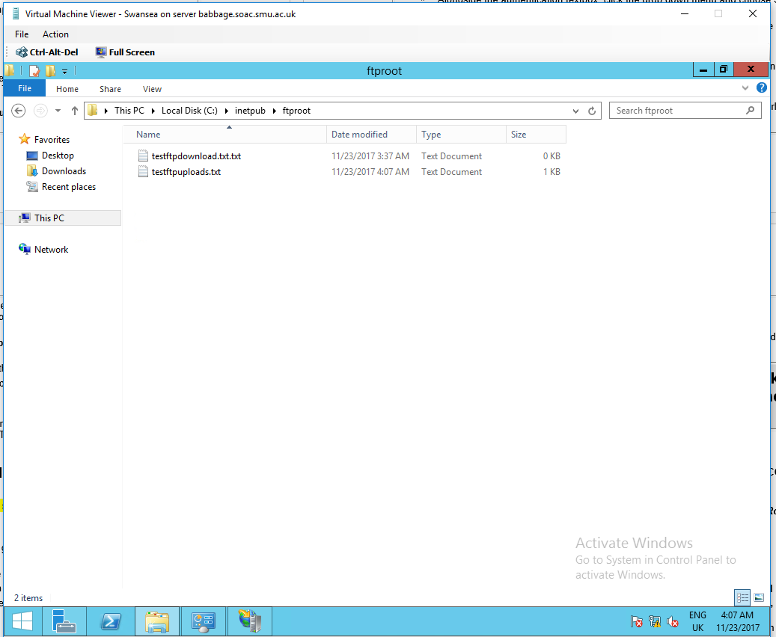

Ping from Lab to FTP
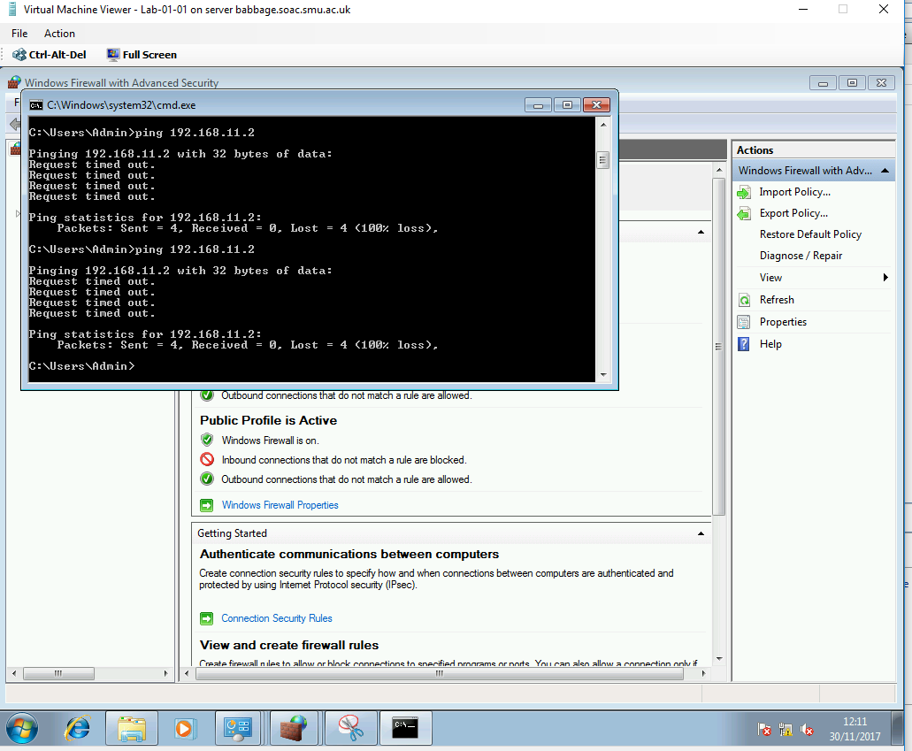
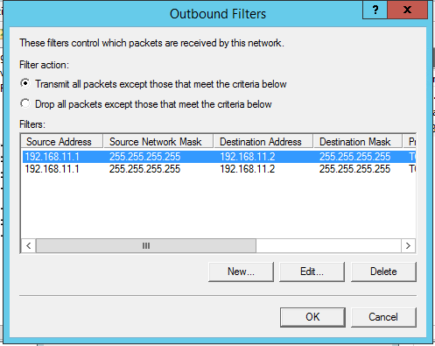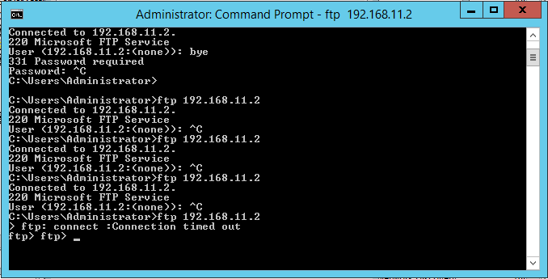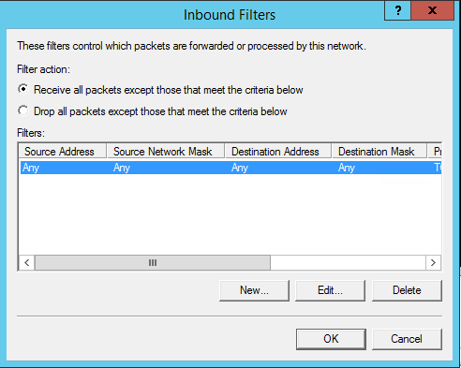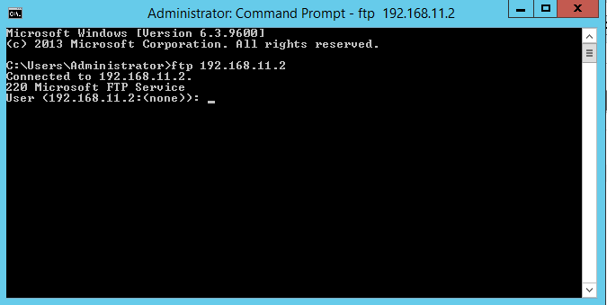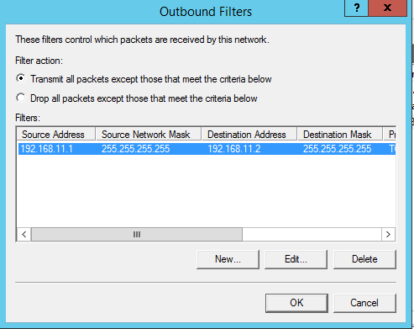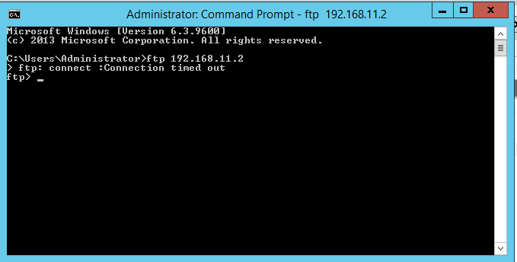

2.2 Questions

2.1.1
Describe (using appropriate illustrations) how the ARP process operates in Networking Contexts?

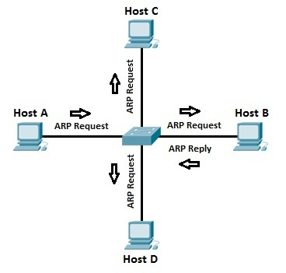
Figure 1 ARP Process[6]

If Host A wants to communicate with host B and knows the IP address of host B but not the MAC address then host A will broadcast an ARP request with Host B address and MAC address of FF:FF:FF:FF:FF:FF which is the Ethernet broadcast address .The switch will send the ARP request to all the Hosts available on the network ,but the port from which came the request .All the Hosts will receive the request but only the one that matches the IP address will respond with an ARP Reply that will contain Host B`s MAC address[5], [6].

2.2.2
What is Packet Filtering? In our context, why is Packet Filtering termed ‘IP Packet’ Filtering? Why would you use Packet Filtering in your Network? What are the perceived benefits ?

Packet Filtering is a security method that can allow or deny packet access at a network interface based on source address , destination address , ports or protocols . It`s used IP Pcket Filtering because the filter used in IP Packet traffic . The advantages of Packet Filtering are[1], [3] :
- Application independence as the filter don’t rely on other applications
- High performance as it doesn`t use too many resources
- Scalability as you can easily remove or add new rules

2.2.3
Why is it possible for contradictory filters to occur when you use packet filtering? Give an example of a Contradictory Filter.

Contradictory filters are possible because you can configure separately input and output filter for the network interface .

An example is when you have a device with 2 network interfaces and you put an input filter to allow a type of traffic on one to be received and on the other interface you deny access to the same traffic , so the traffic will be stopped in your device and will not go further[1], [7] .

2.2.4
FTP Server is just one Role/Service we can configure our Server to provide? What other roles can the Server provide that would benefit our Infrastructure in both a local and remote context ?

Other roles that would benefit our infrastructure are [7]:

- Active Directory Domain controller
- Filer Server
- SQL Server
- Exchange Server
- Mail Server

Worksheet 3

3.1 Screens

Installation of DHCP server
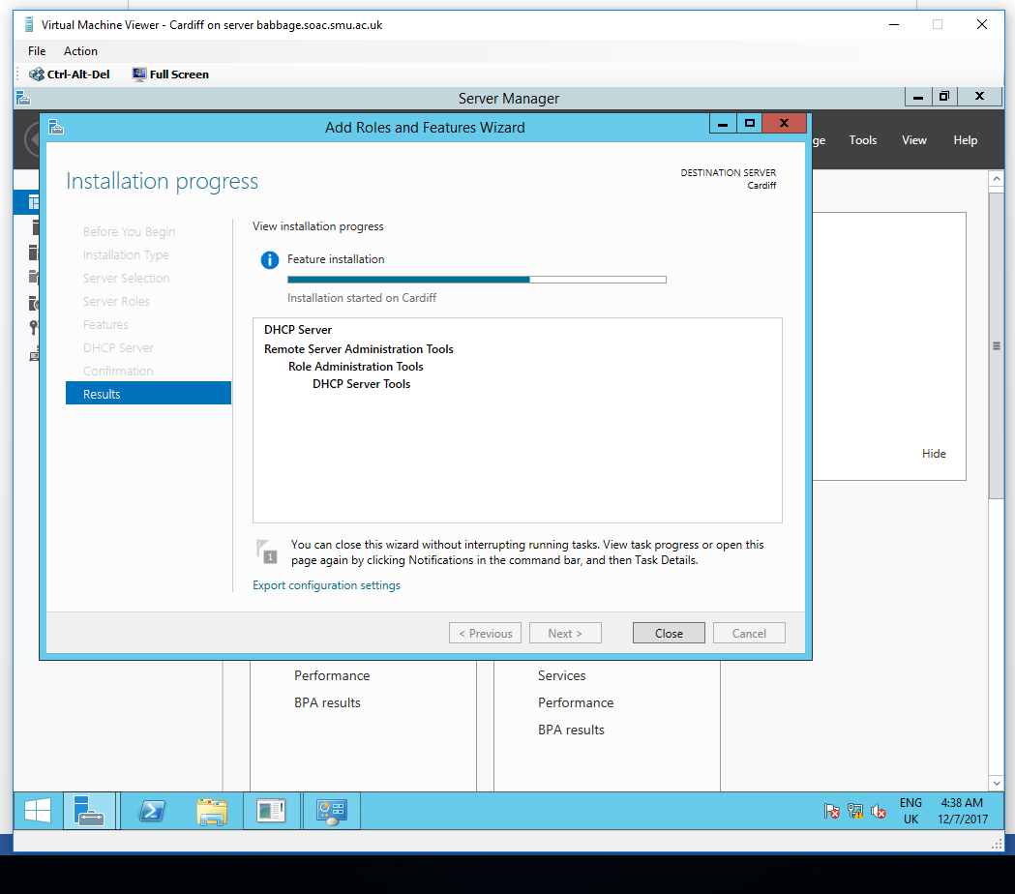
- DHCP Authentication
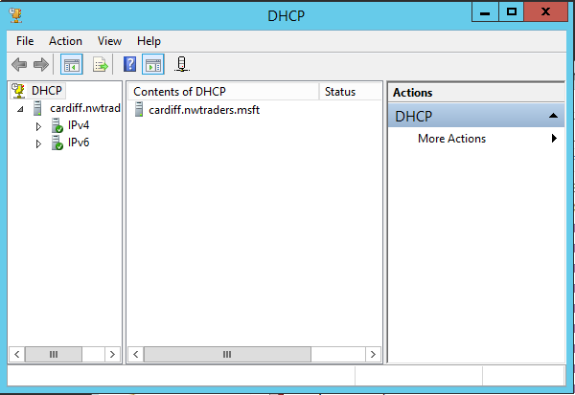
- DHCP Scope
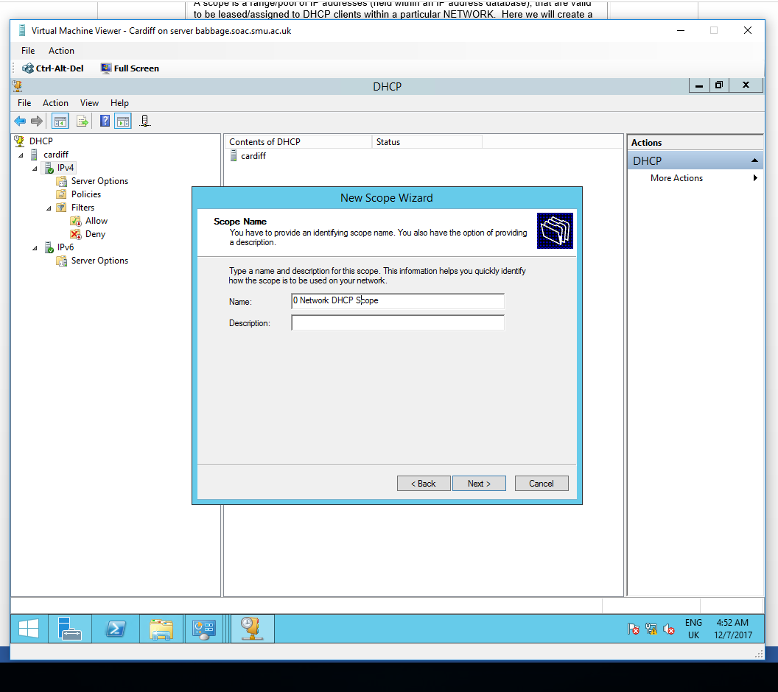
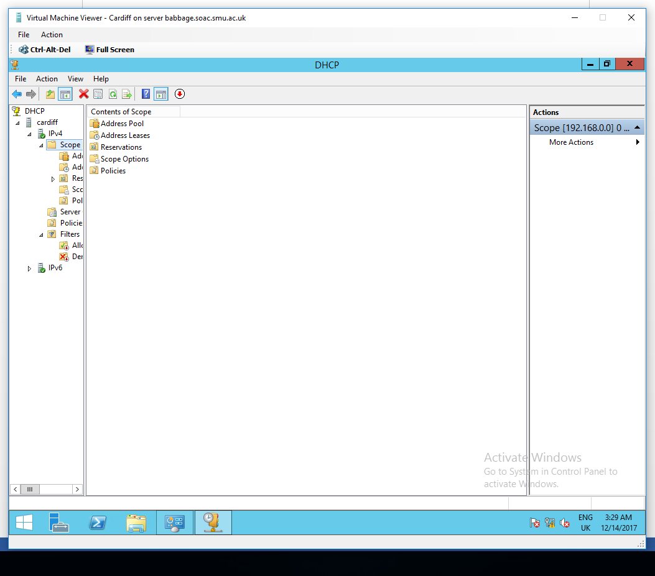
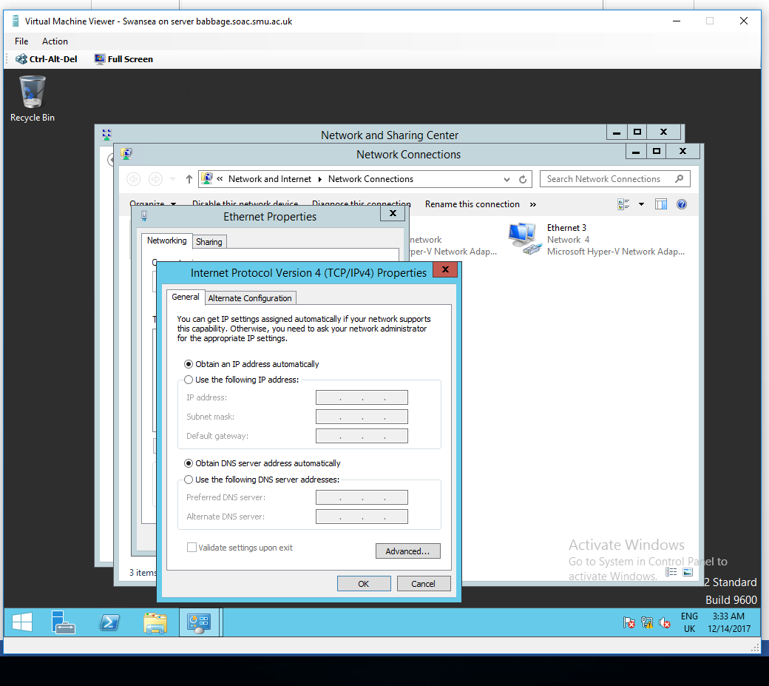
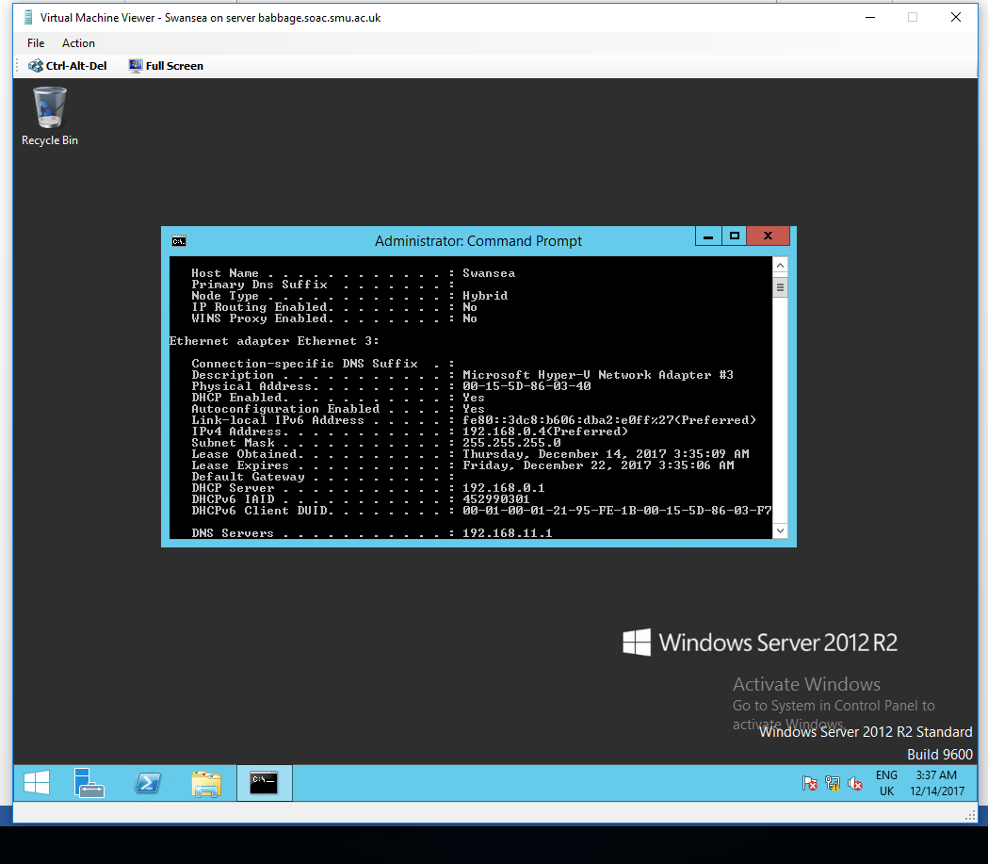
- DHCP Reservations
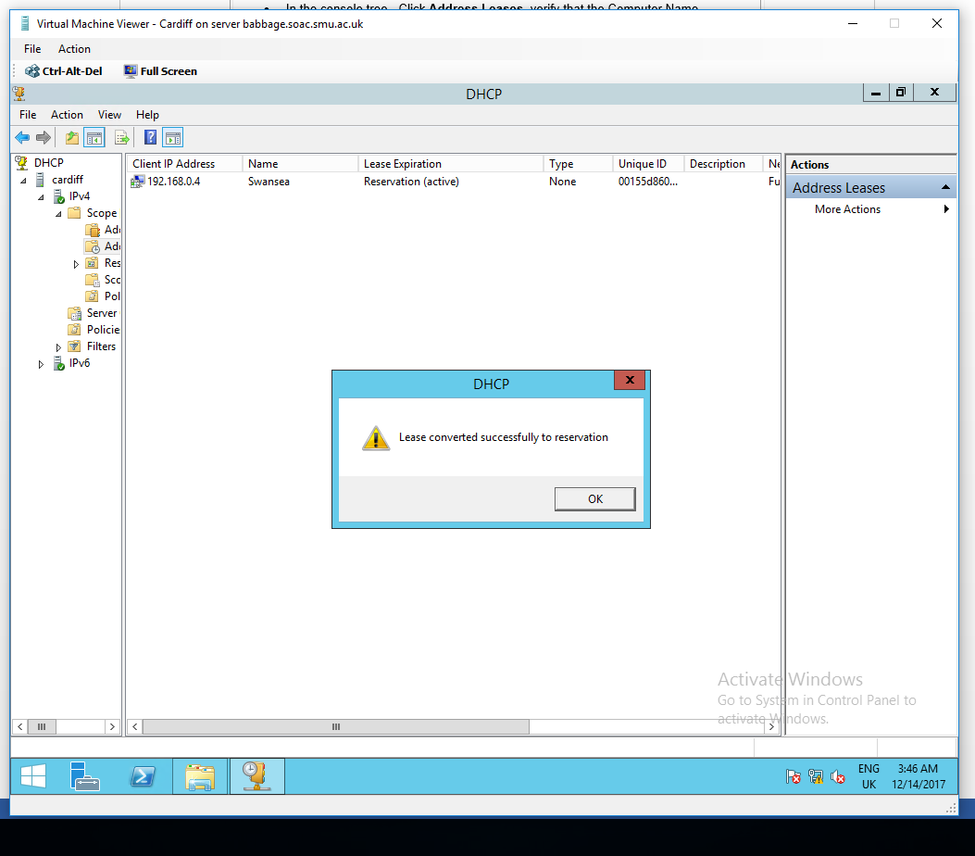
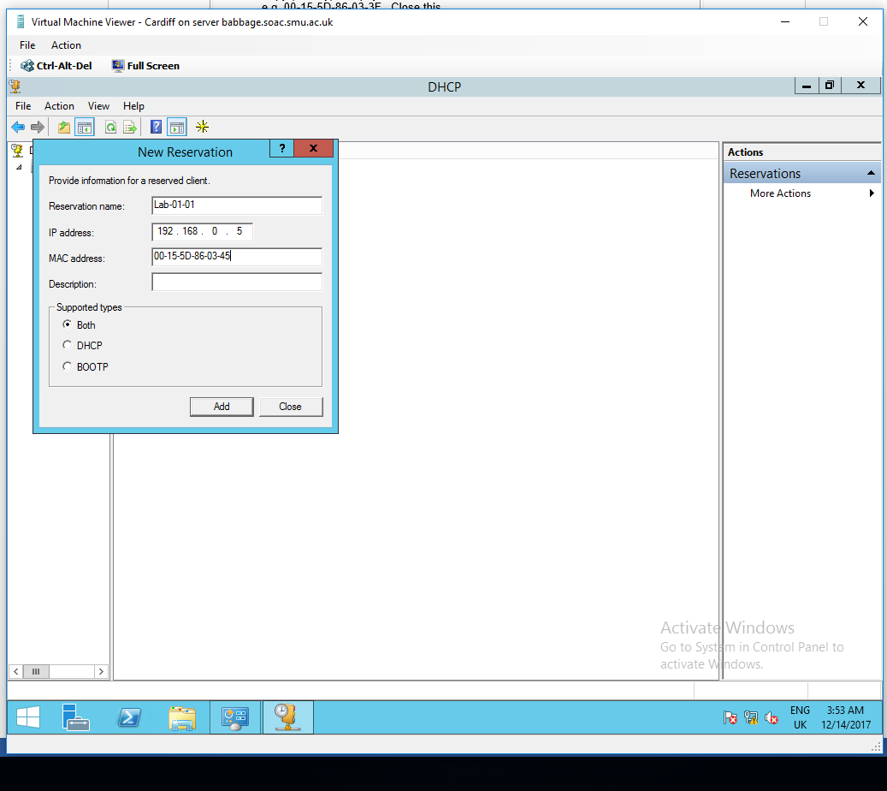
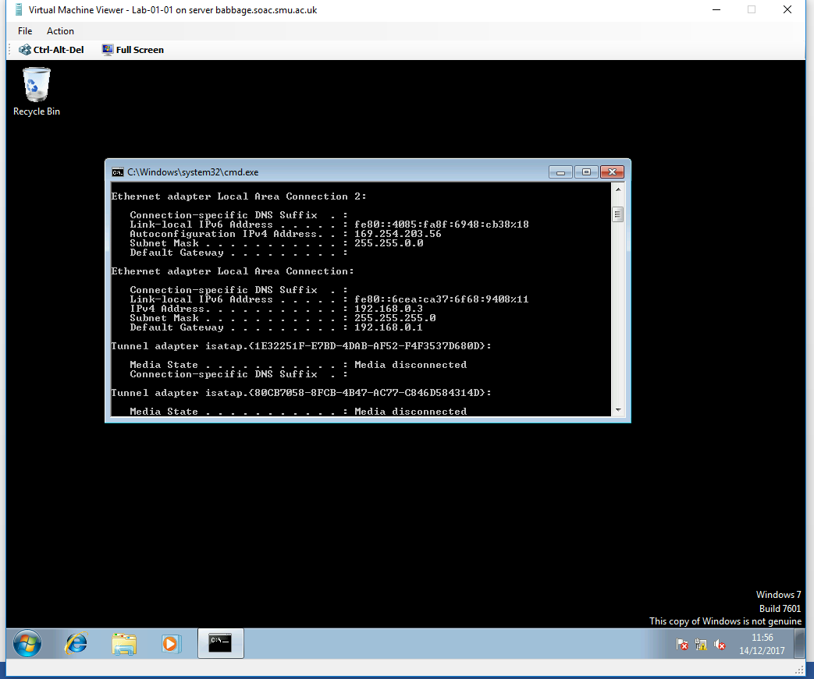
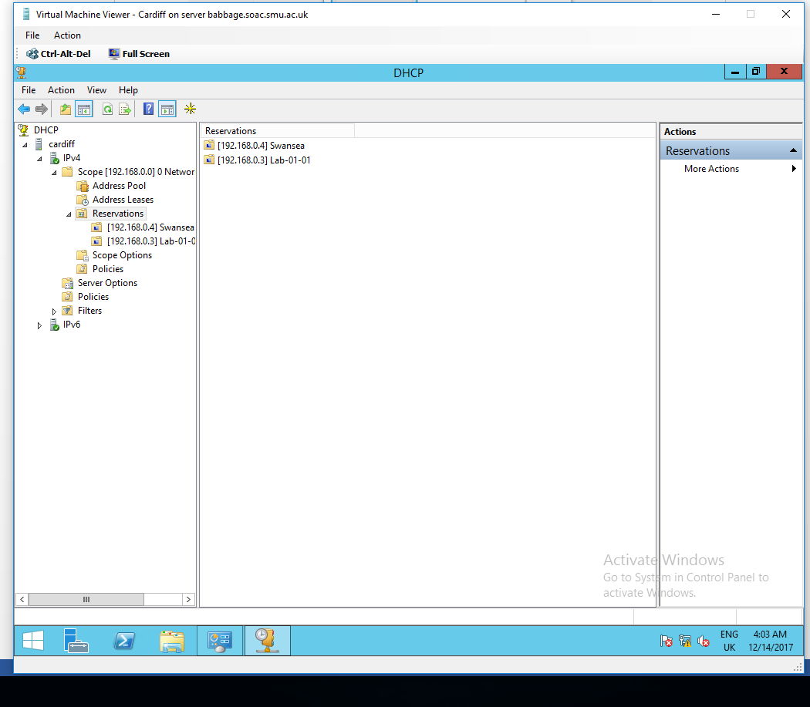

3.2 Questions

3.2.1
Define the role of the DHCP Server in your Network?

DHCP Server Allow the Hosts from the network to get network configuration automatically from the server , when they connect to the network[6] .

3.2.2
What happens when we have dynamically configured TCP/IP for our NIC, but then consequently cannot contact a DHCP server?

The NIC will get an APIPA address 169.254.0.1/24 and will not be able to access the network[3] .

3.2.3

Illustrate (with illustrations!!) the 4 stage process involved when DHCP clients look to obtain an IP address via DHCP?
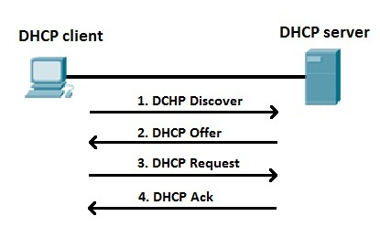
Figure 2 DHCP Process[6]

3.2.4
Describe the advantages of using a relay agent. Explain (with descriptions and illustrations) how and why we would setup the Relay Agent on our Router?
With the aid of a relay agent you can[3], [8], [9] :

- Forward request across networks through routers .
- Use only one DHCP server across a bigger network
- Allow DHCP servers on different subnets to cover for eachother

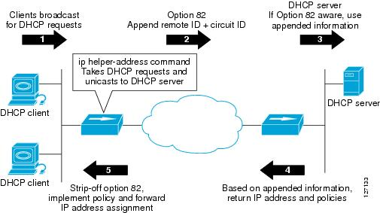
Figure 3 Relay Agent[3]

Worksheet 4

4.1 Screens

- Planning & Deploying DNS
Cardiff Tasks
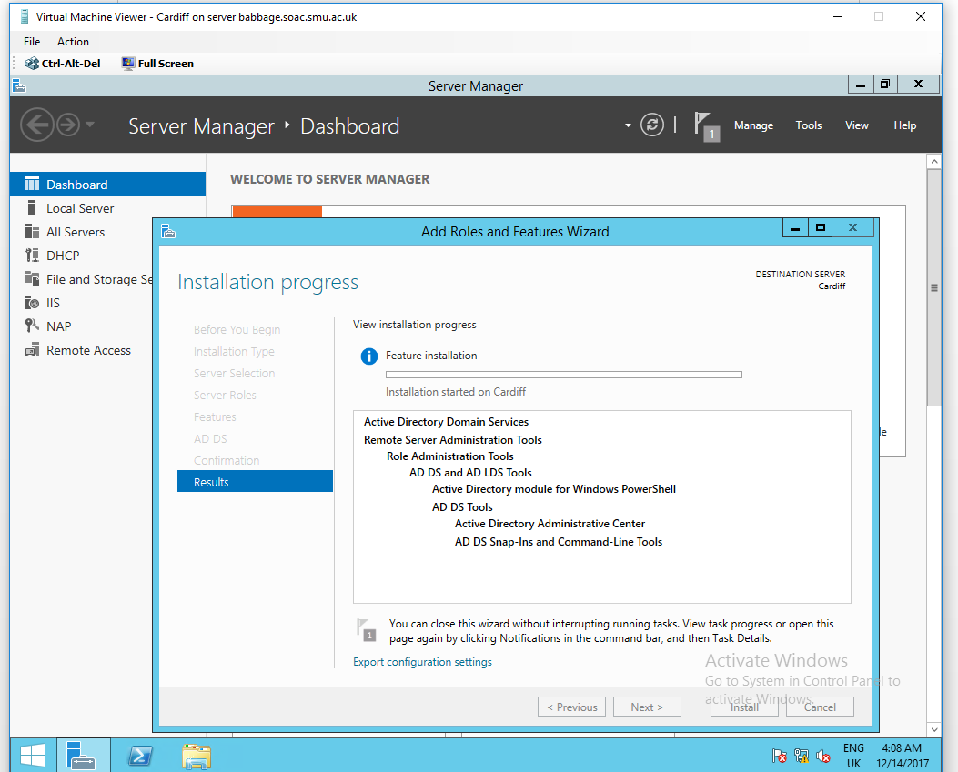
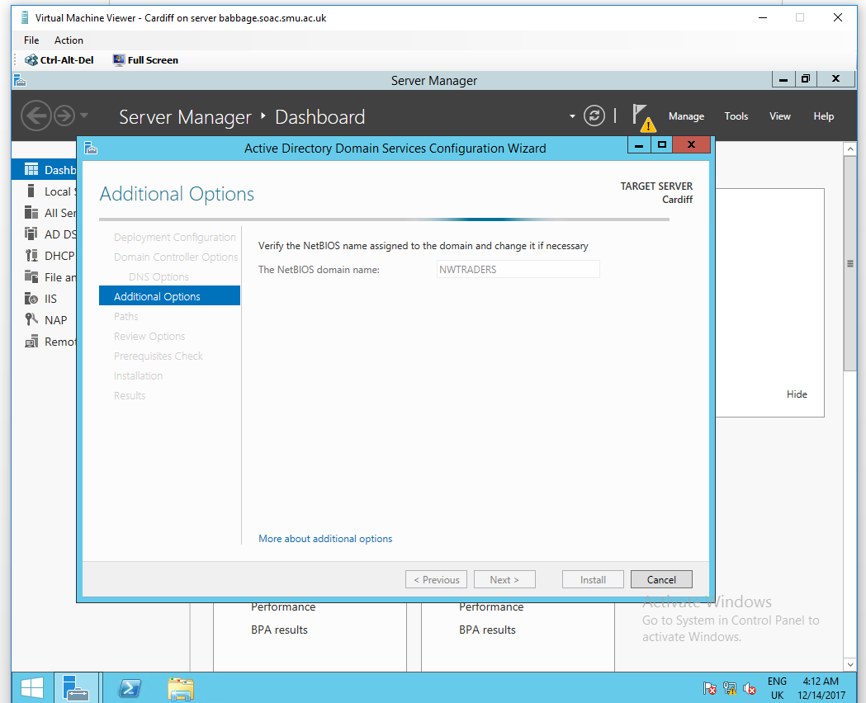
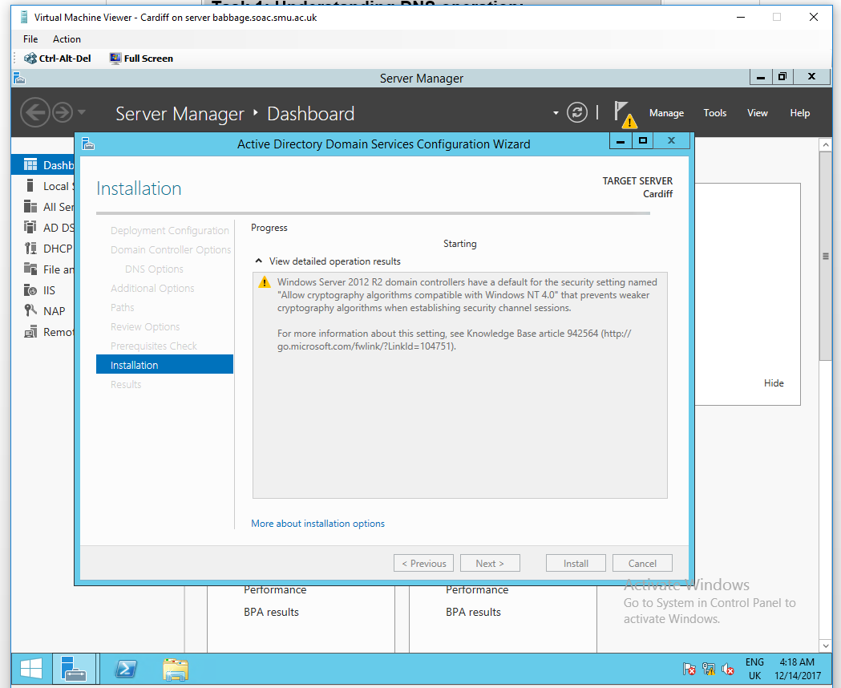
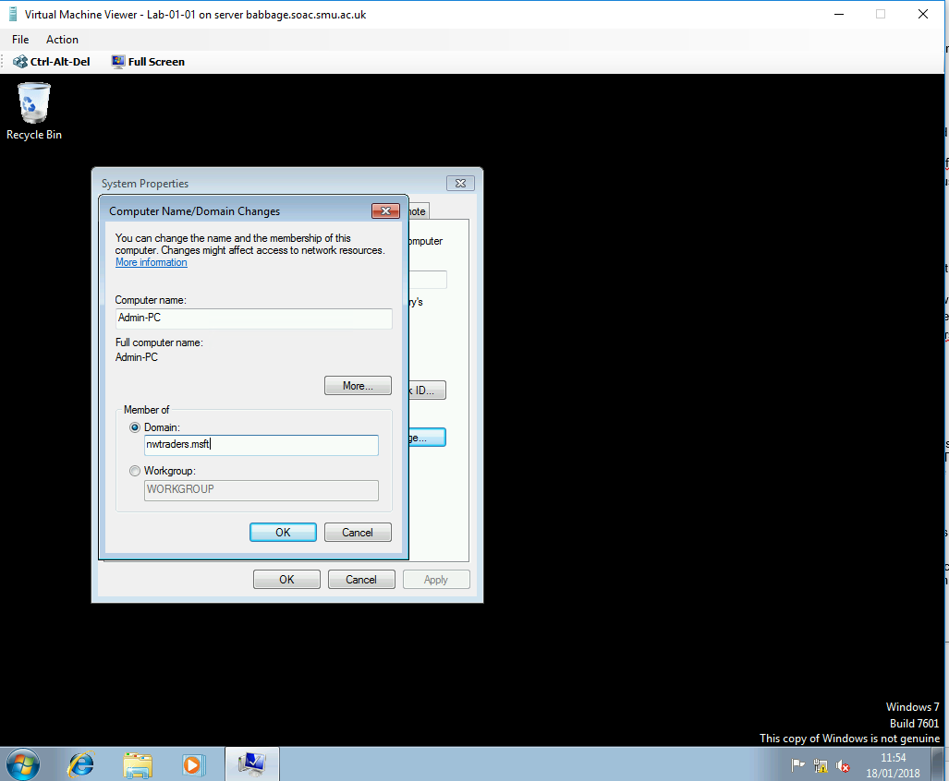
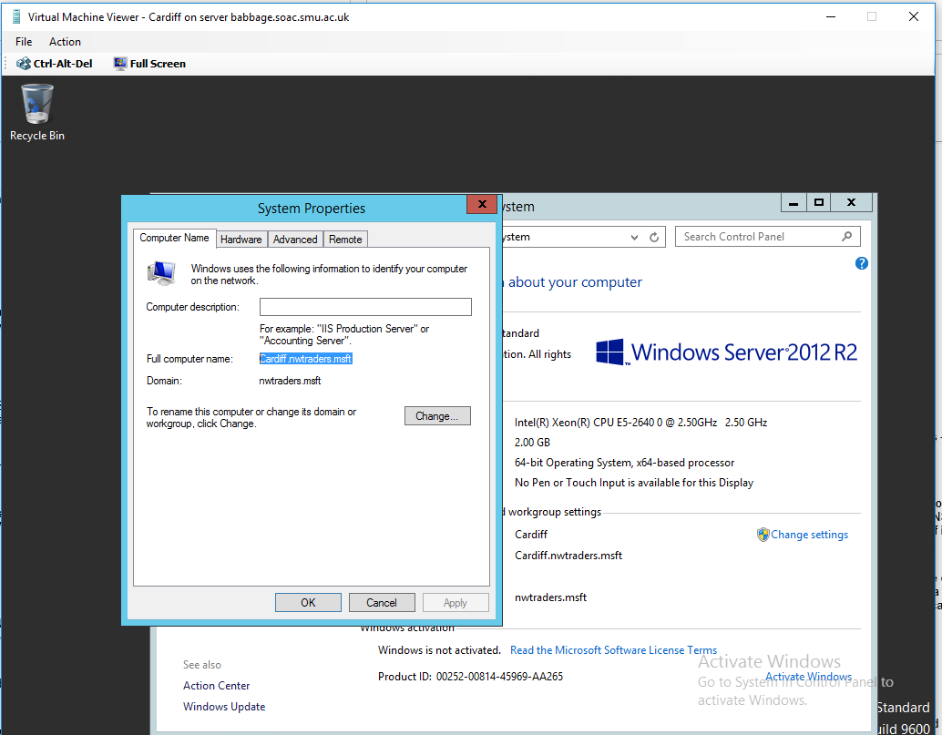
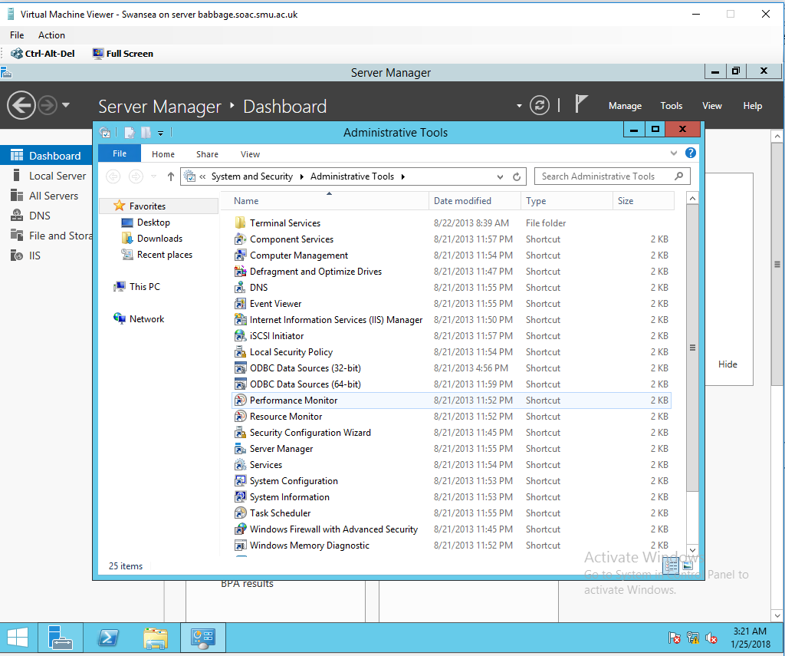
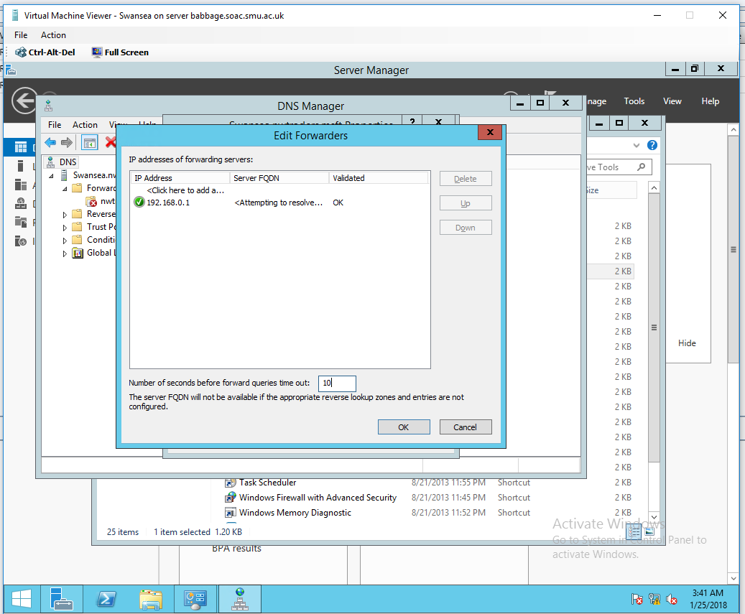
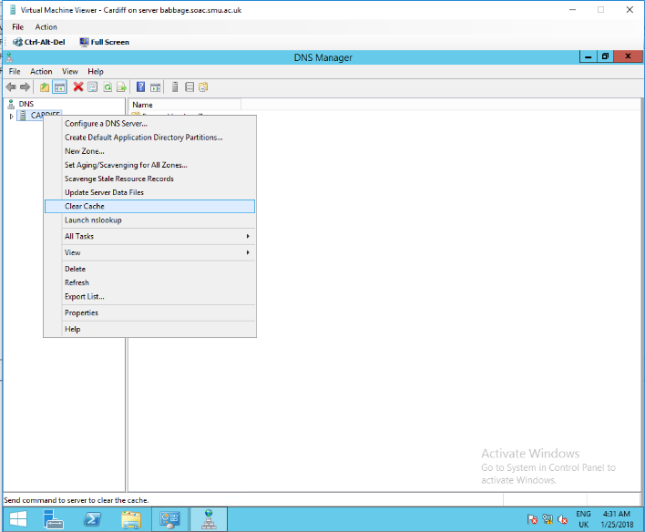

Swansea Tasks-
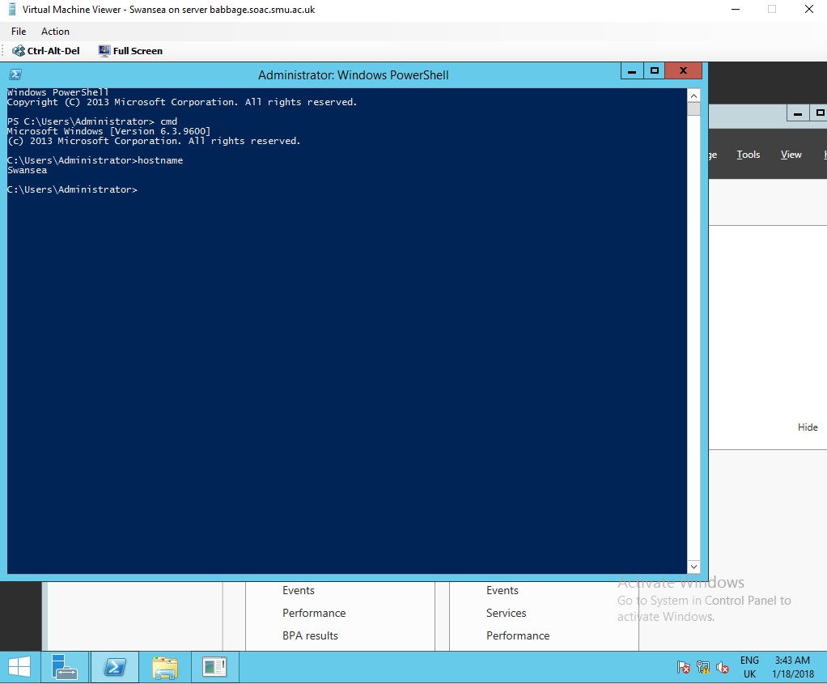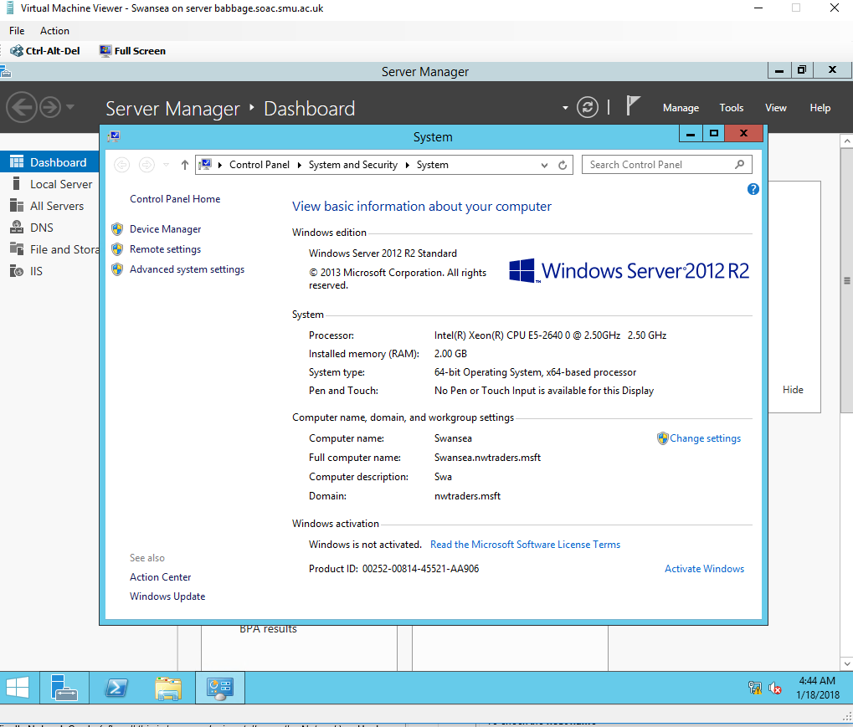

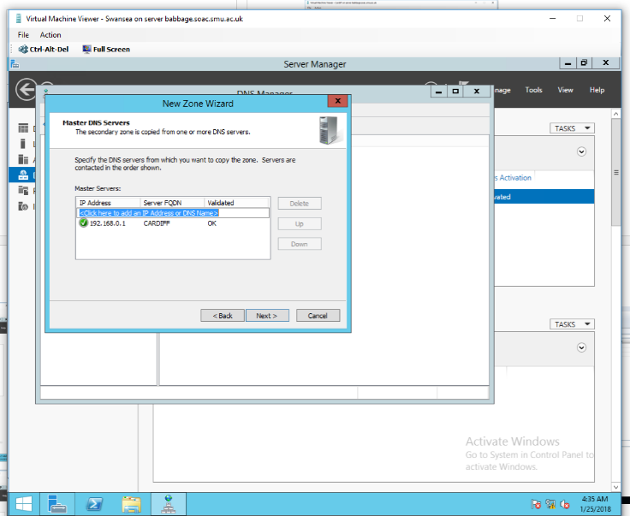
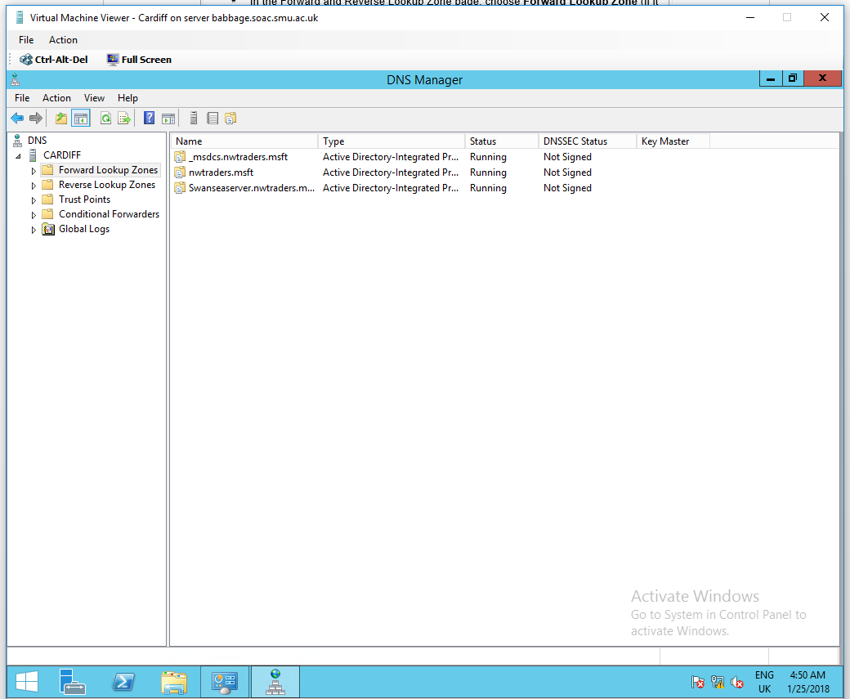
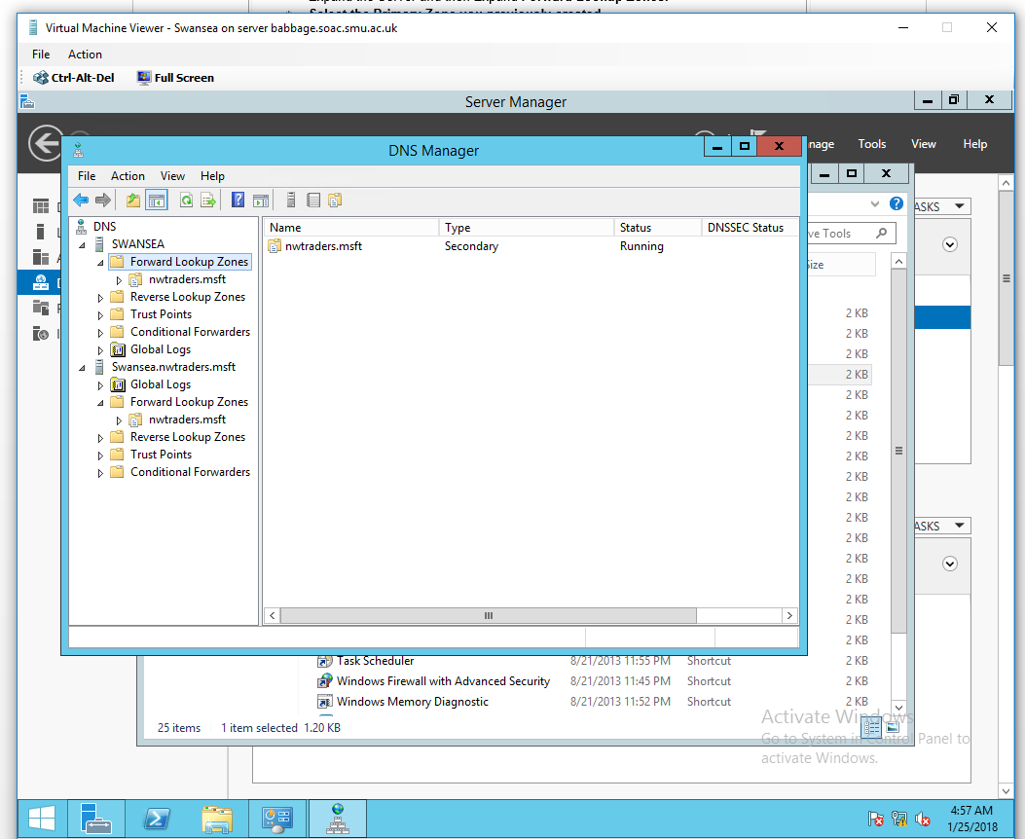

Web creation
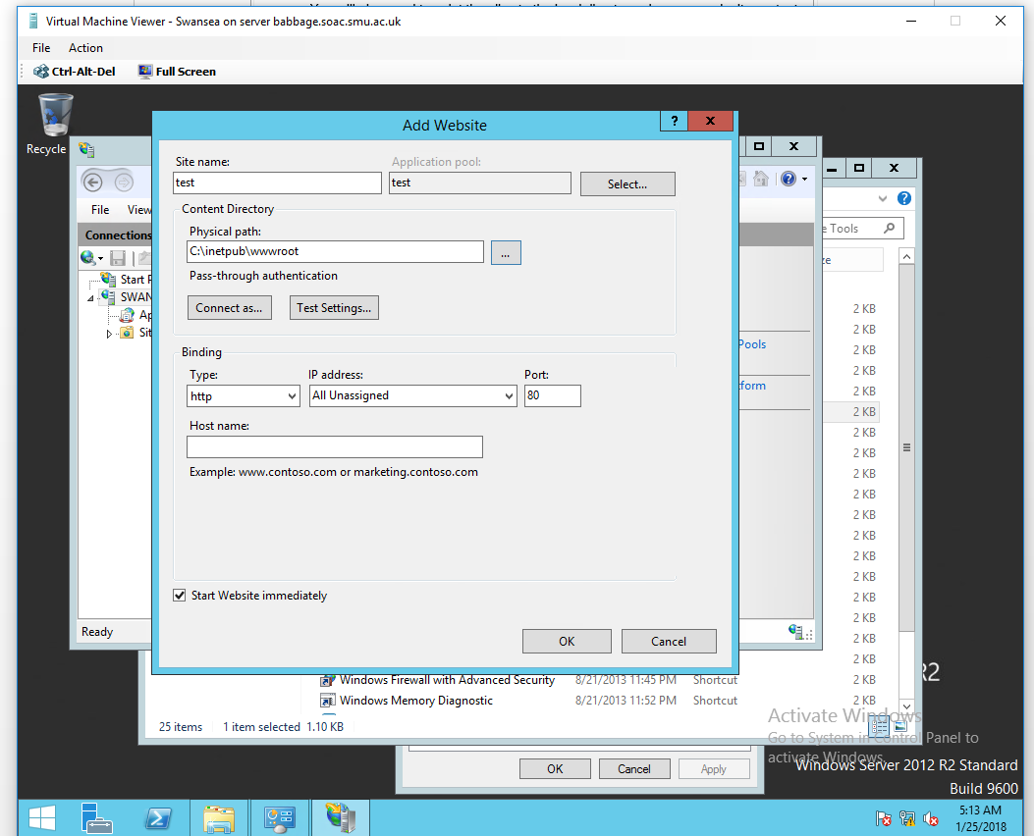
Evidence of Website
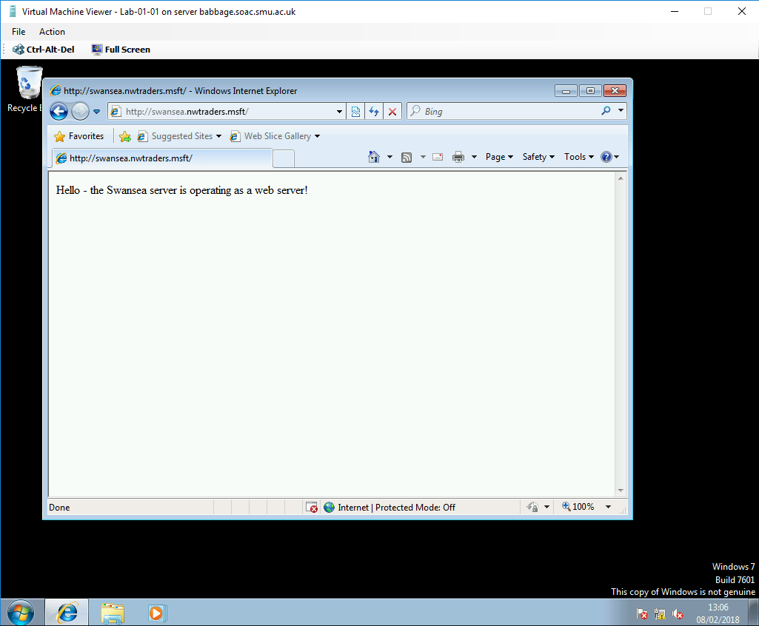

Questions

4.2.1
What steps does a client take (what is the process involved) when trying to resolve a Name to an IP address?

When trying to resolve a Name to an Ip address , the host sends a DNS request to the DNS server ,that is specified in the NIC settings , asking the IP address allocated to that Name.
The DNS server replies with the IP address allocated to that Name[3], [6], [10] .

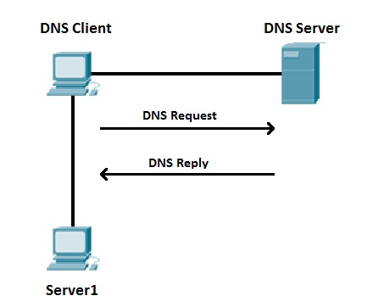
Figure 4 DNS Process[6]

4.2.2
Describe how the Recursive Query and Iterative Query Processes resolve DNS Client Requests ?
The Recursive Query is when a host send a DNS request to the DNS server and specifies that the DNS server must give answer using its recordings and if there are none for the request , to reply with and error[1], [5] .

The Iterative Query is when The host sends a DNS request to the DNS server and specifies that the DNS server must give the best answer without asking help from other DNS servers . The result if oten a referral to other DNS server [1], [5].

4.2.3
Explain the significance of root hints and how this process enables us to resolve names that are not managed (or kept in an authoritative DNS server in our network)?

Root Hints are DNS information in a DNS server .Root Hints offer records that can be used by DNS to find other DNS servers , authoritative for the root of the DNS domain namespace tree .Root Hints are used to prepare servers authoritative for non-root zones so that they can learn and discover authoritative servers that manage domains located at a higher level or in other subtrees of the DNS domain namespace [4], [5] .

4.2.4
We have a Server called Server1, this server will be hosted in a subdomain called ‘subcontA’ with a root domain called nwtraders.msft, answer the following questions:

(1). What is the exact FQDN for this host.

Server1.subcontA.nwtraders.msft

(2). Illustrate how the Domain Name System breaks up this FQDN into Host and
Domain Namespace.

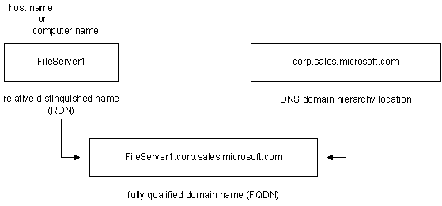
Figure 5 FQDN Role[7]

4.2.5
Explain how DNS Zones are used in DNS, give examples to illustrate the use of multiple
zones and how these can be used to manage resource records of domains. What
important factors/characteristics do we need to be aware of?

A zone is a partition of the DNS namespace that contains the records for the DNS domains that belong to the zone.
There are 3 types of zones[5], [7] :
- Primary zone in a DNS server is the read/write copy of the DNS zone in which DNS records are created dynamically or manually . This zone must be installed in the internal network to be protected as it can be edited .
- Secondary zone are the read-only copies of the primary zone of the DNS domain . This zone can be installed externally (usually in the DMZ ) as it cannot be modified .
- Stub Zone contain only the NS Name Servers (DNS server ) records of their authoritative DNS domains . Stub Zones can work on slow transfer links such as dial-up connections.

- Worksheet 5

Clustering is a method used in multiple-node computer system to deliver certain functionality and features wanted by the external users [11]. There are two types of clusters :
- Failover cluster
- Parallel cluster

We are going to discuss the Failover cluster in this paper .

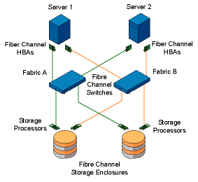
Figure 6 Failover Cluster[12]

Failover Cluster is a group of independent devices that work together to get a higher availability and scalability of mission-critical applications .Failover Cluster is used with critical applications that need uptime. For a Failover Cluster there are needed between 2 and 8 servers which are called nodes, 2+ switches to connect existing components and 2 SAN trays with Data storage in RAID 10 [or 5/6 ] and Quorum in RAID 1[5] .
Information is written on the SAN which is visible to all the servers but only one server can access it at one point in time . Server migration [ change of server ] will occur if [5]:

- It was requested by an administrator of the cluster
- The server that was running the process is overloaded
- The server that was running the process cannot continue it due to as failure , hardware os software .

If the server that was running thee process it`s still active , it will suspend it`s activity and send a snapshot of its activity to the SAN storage . The server that takes its place , reads the information from SAN and resumes the process from where it was paused . The cluster then updates all system information so the new server will take the network identity of the previous one[5], [7], [11].
The Quorum defines the level of tolerance the cluster has . It is a device that holds basic cluster information.
Failover Clusters are used for [7]:
- Critical databases
- File sharing on networks
- Business applications
- Customer services [ e-commerce ]

[1] IBM, “No Title,” 2018. [Online]. Available: www.ibm.com. [Accessed: 01-Feb-2018].
[2] VMware, “No Title,” 2018. [Online]. Available: www.vmware.com. [Accessed: 01-Feb-2018].
[3] CISCO, “No Title,” 2018. [Online]. Available: www.cisco.com/. [Accessed: 01-Feb-2018].
[4] CISCO, “No Title.” [Online]. Available: www.ciscopress.com. [Accessed: 01-Feb-2018].
[5] UWTSD, “No Title.” [Online]. Available: https://moodle.uwtsd.ac.uk/. [Accessed: 01-Feb-2018].
[6] “No Title.” [Online]. Available: study-ccna.com. [Accessed: 01-Feb-2018].
[7] MICROSOFT, “No Title.” .
[8] JUNIPER, “No Title.” [Online]. Available: www.juniper.net/. [Accessed: 01-Feb-2018].
[9] IETF, “No Title.” .
[10] D. Jaramillo, N. Katz, B. Bodin, W. Tworek, R. Smart, and T. Cook, “Cooperative solutions for Bring Your Own Device (BYOD),” IBM J. Res. Dev., vol. 57, no. 6, p. 5:1-5:11, 2013.
[11] “EMC Corporation ; Patent Issued for Non- Disruptive Storage Device Migration in Failover Cluster Environment,” no. July, pp. 1–4, 2014.
[12] dell, “No Title.” [Online]. Available: dell.com. [Accessed: 01-Feb-2018].

