LV6 Contemporary Themes
– Conference Learning Log

Student Name: | Mohamad Issa

Week 1 | Monday April 27th, 2020
Planning:

- All team members to choose a topic for their conference.
- Divide the group into three main areas.
- A meeting to be set up weekly.
- Setting tasks for every week to meet the deadline.

Organising:

- Dividing ourselves into separate groups to breakdown the workload (management, marketing and technical)

- Team Selection:

Management: Molly, Laurence, Ranad
Marketing: Katie, Robbie, Abdul, Pavel, Jaliya
Technical: Mo, and Dan

Managing:

- A Gantt chart has been added to teams for the management team to keep track of progress.
- Minutes will be taken by the management through the project.
- Management team to offer support through the project.

Marketing:

- To define strategic marketing plans.
- To communicate with rest of the team.
- Innovate and design any marketing material for the conference

Technical:

- Assisting in improving standards
- Assisting in emerging alternatives and options
- Assisting in evaluating, selecting, and refining alternatives and options
- Assisting in the formation of the final recommendation
Problems/Resolution Action Plan:

- As a first week of the project maybe some confusion on what the responsibilities of each team is.
- Team members would change their teams according to personalities in each team but not the experience.
- group review Mondays weekly and teams to agree on individual meeting days.

Focus for the Week:

- Brainstorming on how to deliver the conference in most effective way.
- Virtual Conference to be arranged.
- Teams to be allocated.
- Theme to be discussed.

Student Signature:

Mohamad Issa

Date:

27/04/20

Week 2 | Monday May 4th, 2020
Planning:

- Highlighting individual chosen themes & allocating general conference theme accordingly.
- Conference management.

Organising:

- Umbrella theme chosen: Current Issues affecting global tourism & hospitality.
- Individual themes specified:
Abdul; Wellness, Laurence; Terrorism and hotel strategies, Jaliya; Technology & paperless offices, Dan; Mass Tourism, Molly; Food tourism (or Sustainable menus), Mo; Globalisation, Ranad; Political instability and tourism.
- Decision made on how the Presentation’s structure will be: brief external video introducing topic – individual introduction – presentation – repeat throughout conference.
- Guest speaker arranged; Samantha Wilson-Croft from Twr Y Felin by Dan.

Managing:

- No meeting minutes available for the management team during this week as a recap to know what their plan is.
- Meeting minutes are not descriptive does not meet professional work that should be undertaken.
- Project manager has shown efficiency in dealing with issues in teams.

Marketing:

- Team has assigned a captain to lead and support team members. team captain is Robbie and his responsibilities to make solve communicating issues, delegating tasks, and ensuring deadlines are met.
- The team has discussed innovation of online presence and materials that should be produced.
- Assigning tasks to team members to aid progress.

Technical:

- Due to lack of experience of marketing team in creating websites and logos, the technical team will be supporting marketing team and deliver their requirements.
- Update on website progress and gathering relevant resources from the team.
- Logo samples were designed.
- Website template sample is ready.

Problems/Resolution Action Plan :

- Lack of communication between all teams’ members.
- Personal issues blocking the progress and that could affect on future communication and delivering a quality work.
- Meetings not as effective as it should for a teamwork.
- Lack of understating roles and responsibilities.
- The project became more as a competition than teamwork.
- Therefore, Polls to be set up for all team members to vote on brand name and logo, and website template.

Focus for the Week:

- An overall introduction video summarising all chosen topics will be put together as opposed to individual videos for each topic.
- Generating public interest to attract viewers.
- Importance of attendance from all team members.
- Marketing team to Goals: deciding on logo, website colour scheme and email signature to reinstate brand and develop a brand voice, and
- Consider creating an e-mail list to create publicity ready for website launch

Student Signature:

Mohamad Issa
__________________________________

Date:

04/05/20
_________________________________

Week 3 | Monday May 11th, 2020
Planning:

- Instead of multiple guest speakers have spotlight videos which may be promotional or encourage donations to relevant charities.
- All team members to record themselves for videos to be uploaded on the website.
- Team name, logo and website design all confirmed now.
- Bio’s and picture are all done and sent to technical team to be uploaded.
- About us section completed by marketing team and they are currently working on an invitation email.

Organising:

- Have current deadlines been met.
- Discuss how exactly everyone will record themselves and the upload process.
- Marketing team: Progress check, flyer/email list and slogan.
- Progress check, update through Gantt chart.
- Deadline for videos and creating 1-1 with every team member to be recorded.

Managing:

- Management team have discussed Potential Slogan was suggested by technical and marketing team “Welcoming Change”.
- Management team have discussed technical meeting and confirmed together for 1st of June for recording deadline.
- Also, discussed marketing team responsibilities (included in the minutes)

Marketing:

- Marketing missed the deadline for production of flyers.
- Marketing to work with me to create promotional content using Canva pro.
- Mailing List and Contact list, for Universities, Colleges and Hospitality Industry Locations.

Technical:

- Promotional video uploaded on the website.
- Some profiles are uploaded, ticket event I created.
- Dan to receive all the videos and upload them on YouTube channel.

Problems/Resolution Action Plan:

- More effective communication and deadlines were set for this week are met.

Focus for the Week:

- Proposed a technical team meeting to discuss access to the website and how it will work in order to decide if we are going to have individual promo videos or just one initial video.
- Weekly update of Gantt chart and Website to assure team of the progress we are making.
- Promotional video, presentation slides and video of yourself presenting all to be sent to technical team.

Student Signature:

Mohamad Issa
__________________________________

Date:

11/05/20
_________________________________

Week 4 | Monday May 18th, 2020
Planning:

- At this stage of the project almost everything should be going as planned previously, only that everyone should be able to meet the deadlines.
- General recap and updates.

Organising:

- set up a meeting between technical and marketing for any support.
- Everyone is working towards the deadlines.

Managing:

- No meeting minutes were shared with the team by the management team.

Marketing:

- About us section information is not ready.
- Decision has been made on the layout of bio, pictures, and links to videos.

Technical:

- Website Layout discussed with marketing team and been adjusted.
- Technical meeting has discussed Copyright of social media platform of WiX.com and YouTube.
- 30 second video about yourself and the topic or Bio and Picture poll suggested by the team.

Problems/Resolution Action Plan:

- Only issue the management team missing some meeting minutes and the minutes are not descriptive.

Focus for the Week:

- Need to create a brief overview of the conference.
- Everybody to have access to the website so they can see the updates and take screen shots for their learning logs.
- Upload the rest of the profiles on the website.
- Marketing team to write About us section, Flayer information and conference description for the website

Student Signature:

Mohamad Issa
__________________________________

Date:

18/05/20
_________________________________

Week 5 | Monday May 25th, 2020
Planning:

- To finish website layout and upload all the profiles.
- To update about us section and conference description section as well.
- To update the flyer with the written information.

Organising:

- Organizing meeting with marketing team to receive all the missing information and descriptions.

Managing:

- Management meeting minute not descriptive.

Marketing:

- Blurb/ Intro for the conference
- One section regarding the website, about us section.

Technical:

- All profiles are ready
- All sections are filed with needed information.
- Suggestion to add another section for assignments paper to be added on the website.

Problems/Resolution Action Plan:

- No issues

Focus for the Week:

- To get presentation slides ready for recording.

Student Signature:

Mohamad Issa
__________________________________

Date:

25/05/20
_________________________________

Week 6 – Final Week | Monday June 1st, 2020
- All videos recorded, received, and uploaded to the website
- Only to meet with John, Sam, Dan, and Laurence to pass the password of social media platform.

Student Signature:

Mohamad Issa
__________________________________

Date:

01/06/20
_________________________________

Conference Review | Planning; Organisation; Management; Marketing of the Event and Conference Delivery

The conference project could deliver a better quality within in weeks but with the pressure of other work to do at the same time and the rushing in first weeks left a huge gap after the 3ed week of planning for the project.

It could be easier and more descriptive to deliver what learnt from the project through a report or essay.

Delivering the project through online platform can allow more people who interested in the chosen topic to access and watch the presentation than just one time not recorded conference. Information’s are available at any time for anyone who would like to have knowledge about the industry through the eyes of its students.

Appendixes:

Meeting minutes – April 20
Location: Online – Microsoft Teams
Date: 20/04/20
Time: 9am – 12pm

Attendees: Molly, Dan, Laurence, Robbie, Mo, Abdul, Jaliya, Sam

Agenda items
- Virtual Conference to be arranged
- Teams to be allocated
- Theme to be discussed

Action items | Owner(s) | Deadline | Status
Team Selection | All | 20/04/20 | Marketing – Ranad, Katie, Robbie, Paval, Jaliya  Management – Molly, Laurence, Dan  Technical – Mo, Abdul
Theme | All | 22/04/20 | All to decide theme of conference
Format of video | All | 22/04/20 | YouTube, Short Vids, Pay to view etc.
Attendance of all members | Management Team | Continuous | On-going, maintain contact with groups and assure attendance
Finalise individual presentation topics | All | 27/04/20 | All members to agree topics for presentation

Meeting minutes – April 27
Location: Online – Microsoft Teams
Date: 27/04/20
Time: 10am-11am
Attendees: Molly, Dan, Laurence, Mo, Abdul, Jaliya, Paval, Ranad

Agenda items
- Grouping team advancements
- Highlighting individual chosen themes & allocating general conference theme accordingly
- Conference coordination

Discussion
- Update on website progress and gathering relevant resources from the team
- Umbrella theme chosen: Current Issues affecting global tourism & hospitality
- Individual themes specified:
Abdul; Wellness, Laurence; Terrorism and hotel strategies, Jaliya; Technology & paperless offices, Dan; Mass Tourism, Molly; Food tourism (or Sustainable menus), Mo; Globalisation, Ranad; Political instability and tourism
- Presentation’s structure: brief external video introducing topic → individual introduction → presentation → repeat throughout conference.
- Guest speaker arranged; Samantha Wilson-Croft from Twr Y Felin by Dan.
- Whole group review mondays weekly and teams to agree on individual meeting days.

Action items | Owner(s) | Deadline | Status
Send photos to Mo for website | All | 04/05/2020 | Ongoing for all group members
Teams to create brief overview of objectives | All | 04/05/2020 | On-going for all groups, creating a shared online document for all to view.
Attendance of all members | Management Team | Continuous | On-going, maintain contact with groups and assure attendance

Meeting minutes – April 27
Location: Online – Microsoft Teams
Date: 27/04/20
Time: 9am – 12pm
Attendees: Molly, Dan, Laurence, Robbie, Mo, Abdul, Jaliya, Sam, Ranad

Agenda items
- Virtual Conference to be arranged
- Reiterated points from previous meeting
- Discussing rebranding of the conference: Current Issues Affecting Global Tourism & Hospitality
- Allocation of individual themes for conference
- Time slots for one to one meetings and team meetings

Action items | Owner(s) | Deadline | Status
Guest speaker arrangement | All | 04/05/20 | Contact Ryan Peters to be guest speaker (Level 4 Lecturer).
Ensure themes allocated to students who were absent | All | 04/05/20 | Back brief student who were absent, and ensure all themes are set.
Timeline | Management Team | On Going | Strategic timeline to implement deadlines and update regularly.
Team Brief Meetings | Management Team | 04/05/20 | 09:00-09:30 Management  09:30-10:00 Technical  10:00-10:30 Marketing

Meeting Minutes – April 27
Location: Online – Microsoft Teams
Date: 27/04/20
Time: 9am – 10am
Attendees: Molly, Dan, Laurence, Mo, Abdul, Jaliya, Sam, Ranad, Paval

Agenda items
- General update

Discussion

New course materials provided on Moodle

Next week Sam will host individual meetings, 10 minutes each

Rather than completing a documentation report now must complete a weekly learning log to be submitted at the end of term with an appendix that holds all extra materials we create.

Umbrella theme is key to a successful marketing strategy.

Action items | Owner(s) | Deadline | Status
Review Updated Course Materials | All | 04/05/20 | To be completed
Theme | All | 27/04/20 | Review as a team and report back to Sam.
Learning Logs | All | 10/06/20 | See course materials and fill out weekly to be submitted at the end of term with appendix containing all materials.
Attendance of all members | Management Team | Continuous | On-going, maintain contact with groups and assure attendance. Will reach out to members who did not attend.
Finalise individual presentation topics | All | 27/04/20 | All members to agree topics for presentation

Meeting minutes – May 3
Location: Online – Microsoft Teams
Date: 03/05/20
Time: 10am – 11pm
Attendees: Molly, Laurence, Ranad, Mo, Jalyia, Katie, Robbie, Dan

Agenda items
- Website/ Name of website
- Marketing direction

Action items | Owner(s) | Deadline | Status
To come up with a brand All 08/05/20 Pending
And logo.

Management - Meeting minutes – May 4
Location: Online – Microsoft Teams
Date: 04/05/20
Time: 9am – 12pm
Attendees: Molly, Laurence, Ranad, Sam

Agenda items
- Assignment of project manager
- Website & Publishing
- Self-Exec Summary

Action items | Owner(s) | Deadline | Status
Brand, Logo and Today Pending
Company name Management
Team
Decision making with teams “”
Self-exec Summary All 08/05/20 Send to marketing
Contemporary Theme All 06/05/20 Pending
Confirmation

Marketing - Meeting minutes – May 5
Location: Online – Microsoft Teams
Date: 04/05/20
Time: 10am-11am
Attendees: Robbie, Jaliya, Abdul, Laurence, Ranad, Sam

Agenda items
- Appointing team captain to oversee progress and support team members
- Discuss advancements of online presence and materials produced
- Assigning relevant tasks to the rest of the group to aid progress

Discussion
- Robbie to captain the marketing team, communicating issues, delegating tasks and ensuring deadlines are met
- Goals: deciding on logo, website colour scheme and email signature to reinstate brand and develop a brand voice
- Consider creating an e-mail list to create publicity ready for website launch
- Importance of attendance from all team members

Action items | Owner(s) | Deadline | Status
Send headshot and bio on yourself and why this chosen theme | All | 06/05/2020 | Ongoing for all group members
All to vote on name and logo | All | 04/05/2020 | On-going for all groups and team members
Attendance of all members | Management Team | Continuous | On-going, maintain contact with groups and assure attendance

Meeting minutes – May 4
Location: Online – Microsoft Teams
Date: 04/05/20
Time: 11.30am – 12.15pm
Attendees: Laurence, Robbie, Mo, Abdul, Ranad

Agenda items
- Discussing brand advancements
- Marketing requirements
- Guest speakers

Discussion
- Polls to be set up for all team members to vote on brand name and logo
- An overall introduction video summarising all chosen topics will be put together as opposed to individual videos for each topic
- Generating public interest to attract viewers
- Mohammed unable to be guest speaker, other options explored and emails to be sent out
- Importance of attendance from all team members

Action items | Owner(s) | Deadline | Status
Send headshot and bio on yourself and why this chosen theme | All | 06/05/2020 | Ongoing for all group members
All to vote on name and logo  Source video for overall theme  Email guest speakers | All  Tech & All  Management | 04/05/2020  15/05/2020  06/05/2020 | On-going for all groups and team members  On-going for all
Attendance of all members | Management Team | Continuous | On-going, maintain contact with groups and assure attendance

Logo 1

Logo 2

Logo 3

Logo 4

Logo 5
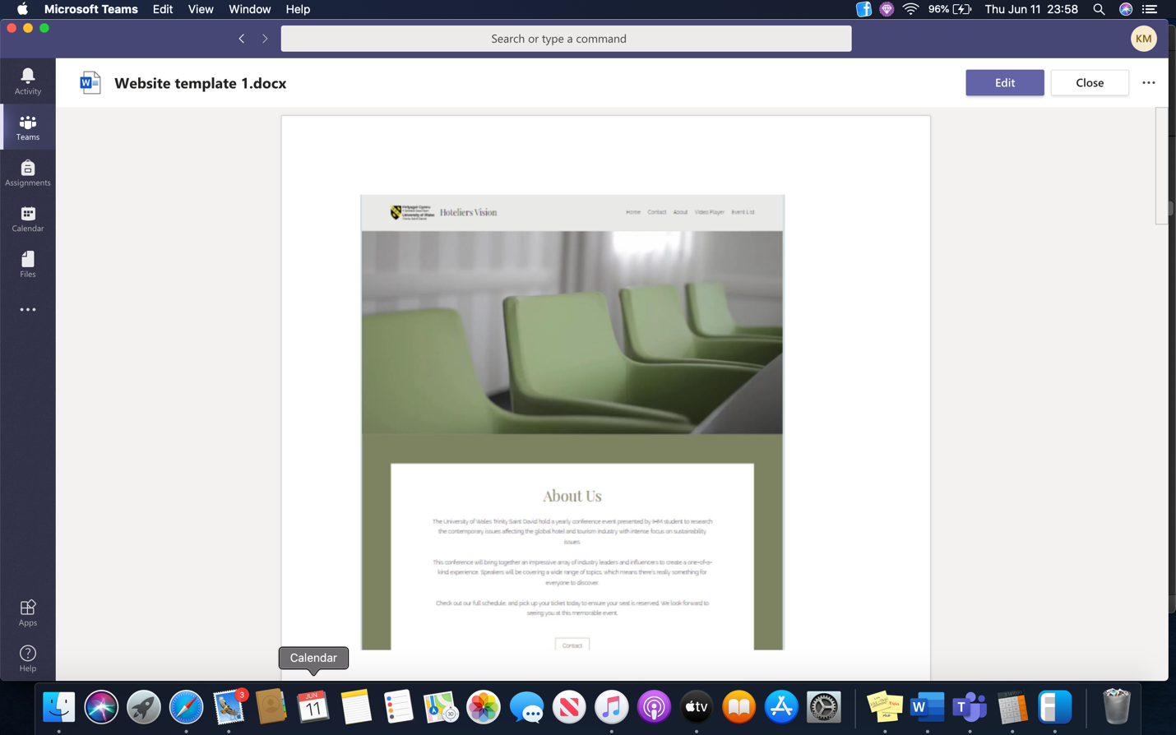
Website Template 1
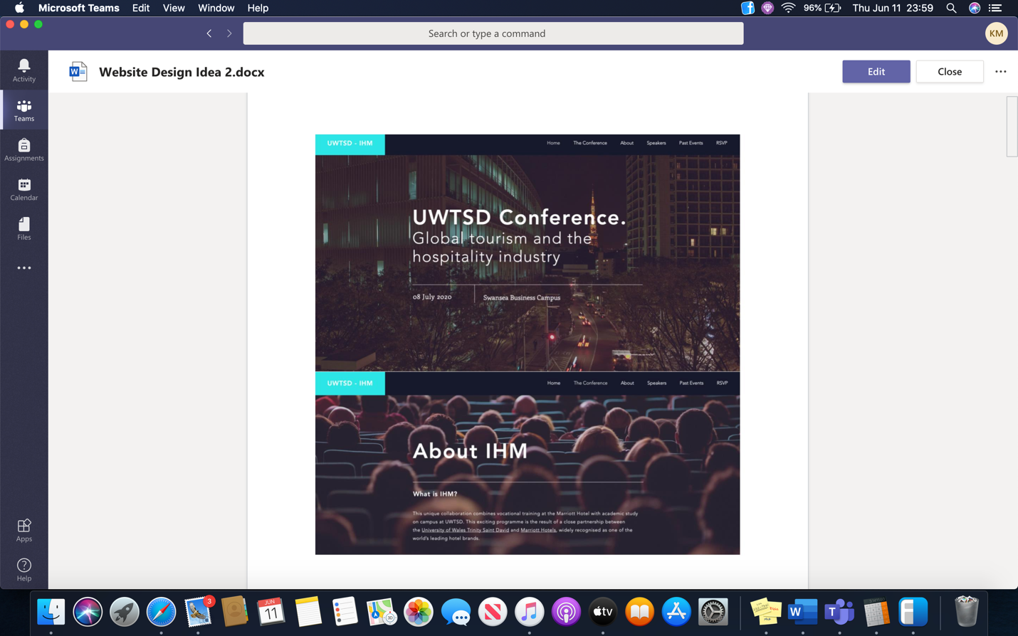
Website Template 2


Final Logo

Meeting minutes – May 18
Location: Online – Microsoft Teams
Date:
Time: 9am – 12pm
Attendees: Molly, Dan, Laurence, Katie, Ranad, Robbie, Mo, Abdul, Jaliya, Sam

Agenda items
- Recap on deadlines
- Molly, Robbie and Mo arrange a joint meeting
- Logo
- Picture and Bio over 30 second video of self intro
- Discussion about video to introduce topic
- Website layout
- Presentation recording

Action items | Owner(s) | Deadline | Status
Presentations to All 01/06/2020 Pending
teams
Mo 18/05/20 Done
Mo to assist Marketing
Newsletter, email template Marketing 22/05/20 Pending
Ranad to call potential guest speakers
Management 25/05/20 Pending

Technical - Meeting minutes – May 18
Location: Online – Microsoft Teams
Date: 18/05/20
Time: 9am – 12pm
Attendees: Dan, Laurence, Mo

Agenda items
- Website Layout
- Videos uploaded to YouTube
- Pictures, Biographies and Direction on the website
- Copyright given as soon YouTube has verified the person as real, however this is not needed as we are keeping it private.

Action items | Owner(s) | Deadline | Status
Mo to edit website 20/05/20 Pending
and have buttons underneath pictures

Work upload video to YouTube to get URL 20/05/20 Pending
Presentation to Sam 01/06/20 Pending

Marketing - Meeting minutes – May 26
Location: Online – Microsoft Teams
Date: 26/05/20
Time: 9am – 12pm
Attendees: Laurence, Abdul, Jaliya, Robbie
Agenda items:
- -Blurb/ Intro for the conference
- -One section regarding the website, about us section.

Contact list for the email campaign

Jackie Jones Email- Jaqui.jones@uwtsd.ac.uk
Programme Director Tourisme
UWTSD

Dr Anita Zhao Email: a.l.zhao@swansea.ac.uk
Associate Professor
Business and Tourism
Swansea University

Emily Bacon Email- emilybacon@gowercollegeswansea.ac.uk
Lecturer
Travel and Tourism
Gower College
Swansea

Dale Davies Email – dale.davies@nptcgroup.ac.uk
Lecture
Hospitality and Tourism
Neath College
Neath

Mr Michael Bolton Email – m.bolton@bridgend.ac.uk
Lecture- Catering
Bridgend College
Bridgend

Gaurav Chawla. Email – Gaurav.chawla@southwales.ac.uk
Senior Lecturer Hotel and Hospitality
University of South Wales
Newport

Dr Emma Bettinson Email - ebettinson@cardiffmet.ac.uk
Senior lecturer Tourism and Hospitality
Cardiff metropolitan University
Cardiff

Dr Jennifer Hill Email - Jennifer.Hill@uwe.ac.uk
Senior Lecture – Tourism
University of West of England
Bristol

Dr Sumeetra Ramakrishnan Email - s.ramakrishnan@surrey.ac.uk
Programme Leader – Hospitality and Tourism
Surrey University
Surrey

Dr Lorraine Brown Email- lbrown@bournemouth.ac.uk
Associate professor – Tourism and Hospitality
Bournemouth University
Bournemouth

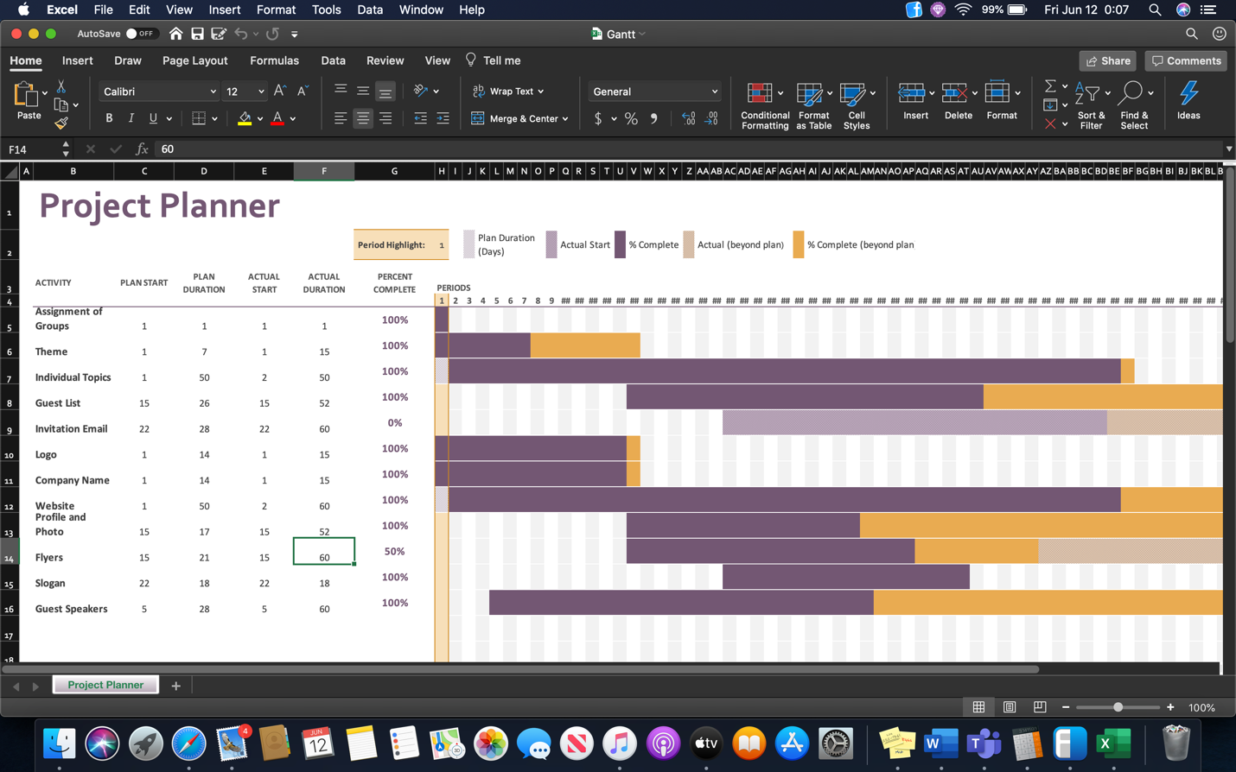

Meeting Minutes – June 2
Location: Online – Microsoft Teams
Date: 02/06/2020
Time: 10-10:30am
Attendees: Molly, Mo, Jaliya, Dan & Laurence

Agenda items
- Final details

Discussion
Completion of recording power points, to be sent to technical if not recorded on teams with Sam.
Technical to start upload of presentations to youtube and the website.
No further guest speakers available
Due to no communication with marketing team we are unable to finish the flyers/leaflets, technical have a template but no content for them.
All Bios have been uploaded
Change the date of conference on the website
About us and Hospitrinity information to be updated
Dan to meet with John and Sam to show them how to navigate the website.
Action items | Owner(s) | Deadline | Status
Completion of recording powerpoints | Everyone | 02/06/2020 | Due by 5pm
Upload of videos | Technical | 07/06/2020 | To be completed
Flyer template upload to teams | Technical | 05/06/2020 | To be completed
Change Date of conference | Technical | 02/06/2020 | Complete
Information Update | Technical/Molly | 02/06/2020 | Complete
Spelling/Grammar check website | Molly | 05/06/2020 | To be completed
Show John and Sam the website | Dan | 08/06/2020 | To be completed

Email to possible attendees and to develop contact list for future


To __________,

We are a student group of the International Hotel Management class at the University of Wales Trinity St. David with the purpose of increasing conversations about contemporary themes in the hospitality and tourism sectors.

To meet this purpose, we have created a website as a virtual area where collaboration can occur about these broad themes such as waste issues, biodiversity loss, health and wellness, and terrorism.

The form it will take is monthly slide shows with specific topics, a monthly newsletter, and interaction in blog format.

We invite you to participate in one or all of these endeavours.

A final ask is that you forward this on to your students so they can participate with us increasing the diversity and creativity to our website.



