Introduction

In this case, a transition is the steps a young child takes from home into a pre-school setting. Children will often be eager to progress into a new environment, whereas others will find this period difficult and be apprehensive (Parentzone Scotland, no date).

Cologon (2014) agrees that while lots of children will be excited to explore a new setting, others will be anxious. She emphasises the importance of early years practitioners being inclusive and planning transitions that are suitable for all children and families. Working in partnership with families aids this process. Cologon (2014) continues to explain that there is vertical and horizontal transition. Vertical being when there is just one transition from home to pre-school, but horizontal being when multiple transitions are taking place. This is sometimes the case for children with families who access external support services like therapy and childcare facilities. The child may find it stressful to enter a new transition phase to pre-school so transition planning should suit the diversity of backgrounds.

Bronfenbrenner (1979) highlights that a child will develop greater if there is a strong connection between the settings they are a part of. His beliefs show that partnership between families, enables a smooth transition and therefore a well-developed child.

Bronfenbrenner’s (1979) ‘ecological systems approach’ illustrates how children’s development is impacted by so many factors on a daily basis. A child is involved in a variety of microsystems on different levels. When transitioning to pre-school a child is entering a new microsystem. All of these interactions contribute to how a child learns and grows. For example, if a child has a problem at home, although not related, it can affect their behaviour at the pre-school setting.

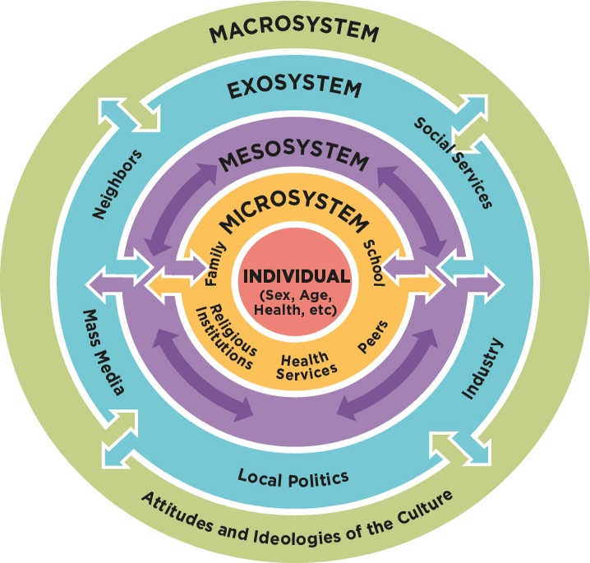

(Source: NAP, No date)

How to use this Handbook
This guide has been created for early years professionals who are working with young children that are transitioning from home into a pre-school setting aged 2-3 years. The guide explores the needs of the child in the process and the role the adult plays in meeting the needs of the child. The guide also investigates the effectiveness of partnerships with families, early interventions and proposed outcomes.



(Source: Shutterstock, No date)
The early years practitioner can use this handbook to further develop their knowledge on the needs of the child during an early year’s transition, but also the responsibilities they have and the part they play in facilitating a smooth transition. This guide will inform the practitioner of the positive outcomes a child can achieve if an early year’s transition is successful.

The Needs of the Child
Foundation years (2012) state that all children should feel welcome, safe and appreciated in their setting by practitioners. They also believe that a good quality education is provided when practitioners understand that during the early years,children develop drastically in terms of physical and cognitive growth. Children should be provided with an environment that maximises their academic and social capabilities. Children should never be disadvantaged due to their ethnicity, background, gender or disabilities and should be assisted in overcoming any barriers they may face. Foundation years (2012) also explains that during transitions into early years settings, children should be given tasks that evolve what they are already capable of. This will provide children with a positive outlook towards their setting and avoid upset or reluctance to participate early on and will underpin attitudes to future learning.

Mosaic Nursery (2019) explain that once the core needs of the child are understood, it can help practitioners deliver quality care and education. Some examples of these core needs are:
- Nurture- Children should be nurtured and provided with genuine love and care.
- Security- Children should always feel secure in the environment they are in. If a child feels comfortable in their surroundings, it encourages the development of behavioural and emotional skills.
- Physical Activity- This keeps children healthy, as well as allowing them time to bond with peers which encourages the formation of relationships.

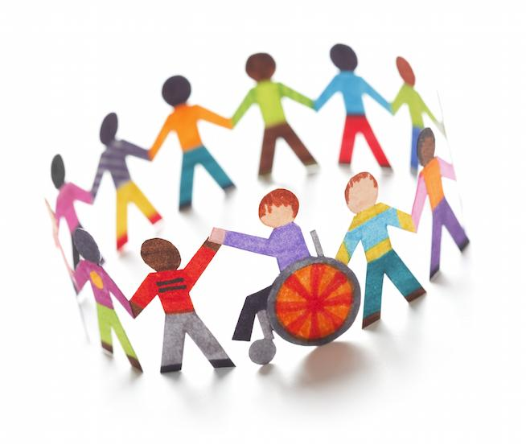

(Source: ravishly, 2015)

Lindon (2012) supports Mosaic Nursery (2019) theories and states that in the early years, children are assisted best when adults have a genuine care regarding their physical and emotional development. Children develop holistically and rely on both their physical and cognitive skills when carrying out tasks. Lindon (2012) suggests that practitioners keep this in mind when teaching children and only focus on one development area if observations give a reason to do so. For example, a child not socialising with peers would call for more focussed support.

A study conducted by Shonkoff and Phillips (2000) found that in the early years, a child’s brain development peaks. This occurs in an overlapping process whereby new brain cells are made, but also the cells migrate to where they need to be in order to make new connections. The study found that when a child is stimulated in an environment such as an early year setting, the new experiences trigger the brain to connect nerve cells, therefore having a variety of different stimulus in the early years has a detrimental effect on the development of the brain.

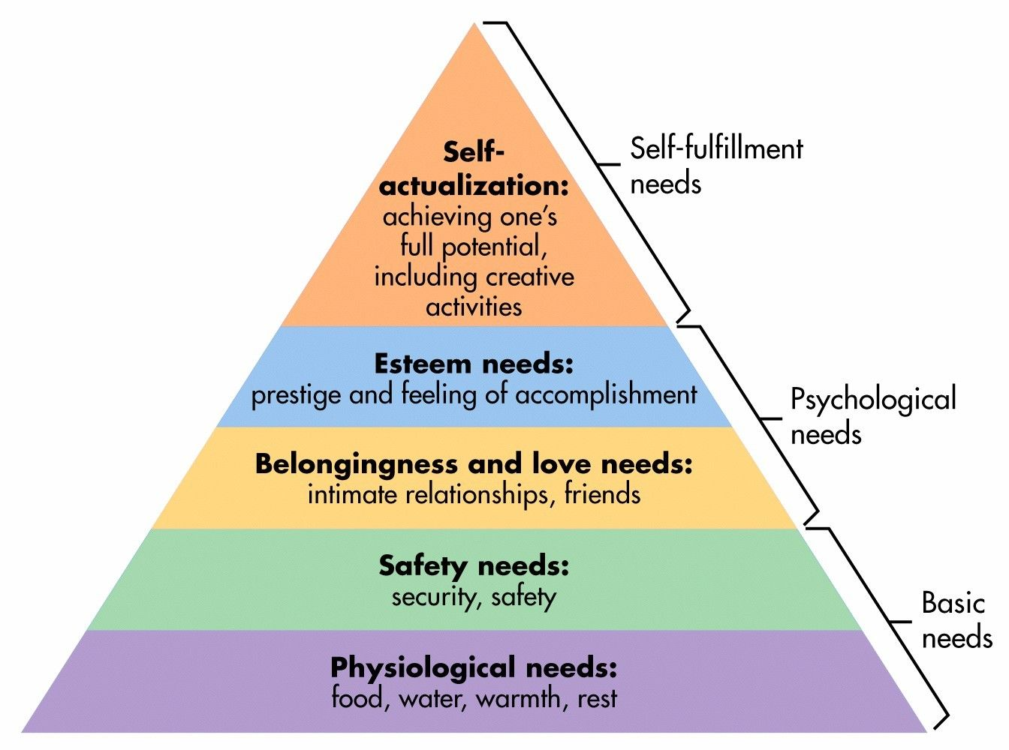

(Source: SimplyPsychology, 2020)

The above image is of Maslow’s Hierarchy of Needs. Maslow (1943) suggested that the needs at the bottom of the pyramid must be met before moving on to satisfy the next need. For example, a child’s basic needs that enable them to live must be met before they can feel safe and secure. Once they feel safe and secure, they can start to form meaningful relationships. Once these relationships are formed they can feel happy with themselves and achieve their full potential. However, Maslow (1987) corrected his earlier statements and explained how the hierarchy should be used more as a guide rather than the idea that every single need has to be met to progress.

Unicef (2017) states that Article 31 of the UNCRC gives all children the right to play. Vygotsky (1978) articulates how when a child engages in play, it is not just to evoke feelings of pleasure. A child in pre-school will start to experience needs and desires that they want to fulfil immediately. If these desires cannot be satisfied the child will feel frustrated and proceed to engage in make- believe play to relieve these feelings of frustration. Vygotsky (1978) also explains the ‘Zone of Proximal Development’ which observes the variability between what a child can accomplish on their own versus what they can accomplish if given the directions from an informed partner. For example, a child could not build a Lego model alone, therefore a teacher gave them suggestions and assisted them in building the Lego model. When the child builds a Lego model in the future, they will recall the skills the teacher taught them and apply these. Vygotsky (1978) suggests that practitioners’ pair less capable children with more capable children as the Zone of Proximal Development suggests that the less capable children will benefit and learn from their more capable classmates.

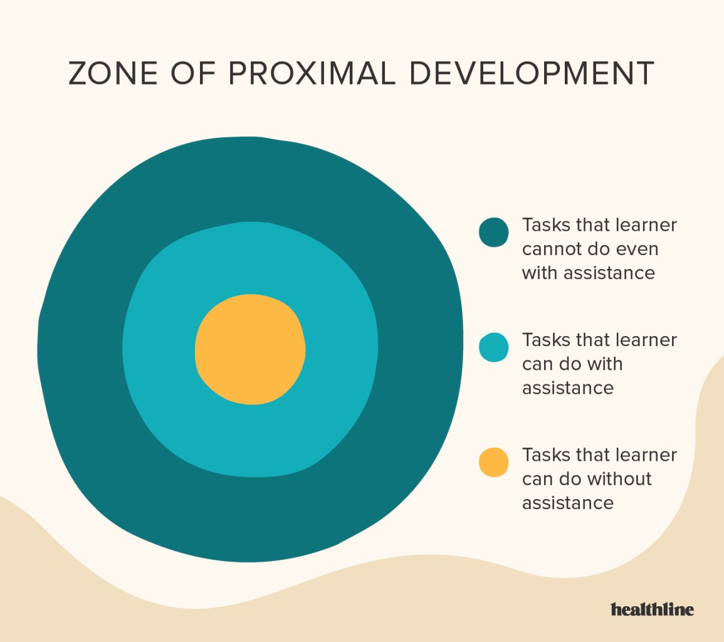

(Source: healthline, 2020)
Piaget’s (1980) findings suggested that children develop due to biological maturation and the surroundings they are involved in. Children build a picture on the world they live in by challenging what they know, with findings in their surroundings.

The Role of the Adult
Welsh Government (2017) asserts that it is the role of the practitioner to provide children with a secure and inspiring environment. The Welsh Government (2017) also explain how practitioners should be knowledgeable in terms of how children develop socially and academically.

UNICEF (2017) summarises Article 12 as the thoughts and opinions of a child must be taken seriously. When practitioners are preparing for a transition, each individual child’s thoughts and emotions should be taken into consideration as suggested by Tower Hamlets Council (no date). They also argue that it is the role of the practitioner to enable a sleek transition that is easy on the child, so that they are able to continue their cognitive and physical development. Tower Hamlets Council (no date) also explain the correlation between a successful transition and a child’s progression. A successful transition facilitates the development of a child, in terms of their competence, confidence in ability and self- worth. Practitioners are also expected to support families during transitions as their views should also feel respected.
Attachment is described as a long lasting, profound emotional connection between two individuals, a person will feel more content and comfortable around the person they are attached too (McLeod, 2017).

Bowlby (1952) proposed his maternal deprivation theory in which he argued that if a child had not formed a loving, strong attachment to their mother, then they would be more likely to have emotional and behavioural issues as they got older. Bowlby (1952) suggested that the bond a child builds with their mother is a blue print for the type of attachments they will form with others in later life.
Goldberg (2000) criticises Bowlby’s (1951) maternal deprivation theory, explaining that Bowlby predominantly focussed on the mother as the care-giver. Goldberg (2000) proceeds to argue that Bowlby’s views are outdated and society is now diverse and multi-cultural and that what matters is the quality of care a child is given, not by who.

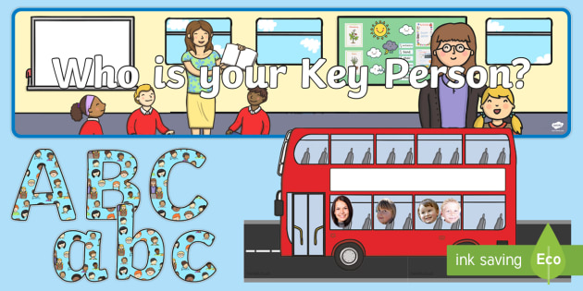

(Source: twinkl, No date)

Although Bowlby (1951) and Goldberg (2000) disagree as to whether it matters who the caregiver is. They both acknowledge that a child forming attachments is necessary.
Tower Hamlets Council (no date) state that when a child enters a transition phase, they can feel nervous and unsure as to what their new setting has to offer. The same feeling often goes for parents too. A Key Person system can ease these feelings of worry and allow the child and family to settle swiftly.

Elfer, Goldschmeid and Selleck (2003) explain that a Key Person System should be in place during transition to an early year setting to encourage the formation of emotional bonds between a certain child and a specific practitioner. Each Key Person will usually be assigned to a group of children. The Key Person will embody these traits:
- Sensitive.
- Available.
- Approachable.

The Key Person will meet with the children they are assigned to before they are due to start at the practice to build up rapport and get to know the child as well as open lines of communication with the child’s family. The key person will be responsible for the physical and emotional needs of the child. For example, if a child is crying, it will be their Key Person who meets them to offer emotional support and comfort (Mickelburgh, 2011)

Department for Education’s (2017) work showed that when a child is transitioning to a new environment such as an early year setting, there should be support in place to ease this process. Before a child starts a setting, Key persons from the setting should visit the children and families at home to collect background information on the child to build a picture of who they are as an individual. Children and families should also be invited to visit the setting, giving the children an opportunity to become familiar with their new surroundings, whilst also putting the parents at ease that their child will be entering a safe place.
It is also recommended to provide parents with a ‘Welcome- Pack’ that contains information on all key dates and events that parents should know about. This is an effective way of involving parents in their child’s life at the setting (Patel, no date)

.

Partnerships



(Source: The Restorative Foundation, no date)
As part of the National Minimum Standards for childcare in Wales, parents are continuously updated on what their child is doing and how they are developing and achieving (Welsh Government, 2016).

In an early -years setting, there should be an open line of communication between the setting and parents. The child’s key person will be the port of communication between the setting and parents (Pacey, No date). It is the responsibility of the key person to keep parents updated on the progression of their child. Pacey (No date) also express that during a transition, parents and carers should be involved from the initial stages. There is no one size fits all in regards to transitions, and the Key Person should be prepared to meet the diverse needs of families with an emphasis on inclusion. For example, a family whose first language is not English should be catered for like any other child (Pacey, No date).

Thomas (2019) asserts that if there is a strong relationship between setting and parents, then transition can actually be a happy and thrilling experience as opposed to a difficult stressful period. Thomas (2019) also proposes that transitions in these years often cause more emotional turmoil for parents rather than children, in turn these feeling of worry can transfer to the child. Therefore, practitioners should work with parents to make sure they are discussing the new setting in a positive light to the child to enable the child to be excited, not fearful. Pacey (No date) agrees that the process is hard on parents and that once a child starts a setting, a parent can feel a void and that they are no longer a part of their child’s life. A weekly chat with a parent can help diminish these feelings, and enable them to feel a part of their child’s life in school.

Mickelburgh (2011) also agrees that parents can find transitions challenging. Her work has also identified that some parents will need to be reassured that a child’s bond with their Key Person will not be in place of the bond with parents at home. The Key Person should also respect boundaries and whilst their role is to emotionally and physically support the child, they should remain professional and not undermine the role of the parent or carer. Mickelburgh (2011) explains that a child does not just have one attachment and that although the child has a bond with a Key Person, they still require attachments at home. Working in collaboration is highlighted as beneficial to everyone involved.

Information shared by parents must be confidential and the setting requires parents’ permission before information is shared. Unless there is reason to believe the child will come to harm if the information is not shared (Mathivet, No date)

Gasper (2010) notes that when there is a solid relationship between parent and Key Person, this has a positive effect in terms of multi-agency work. For example, if observations of the Key Person have identified that a child has a speech and language problem, if there is a good relationship between Key Person and parent, the parent will trust the Key Persons opinion and allow them to access external support such as a speech and language therapist. This benefits the child as they can access services promptly.

Interventions
An intervention in the early years is when observation allows practitioners to determine if a child is in danger of achieving poorly. Early intervention can help to deal with issues before they have long lasting effects that can negatively impact a child in later life (Early Intervention Foundation, 2018).

At the centre of early intervention is the desire to provide children with more protection factors than factors that can put them at risk. Research has enabled us with knowledge of the factors that can benefit and negatively impact a child’s life. The goal of intervention is to outweigh negative factors, with positive (Early Intervention Foundation, 2018).

NSPCC (2019) asserts that the overall goal for early intervention is to facilitate a positive outcome for the child. Early Intervention supports children as well as their families and is a joint effort.

An example of when early intervention is necessary is if a practitioner has observed a child being bullied. Kidscape (No date) explains how bullying can cause a child to:
- Lack confidence
- Develop mental health issues
- Have feelings of loneliness
- Have poor academic success

All these factors put a child at risk of a poor outcome, so the NSPCC (2019) advise early intervention. These interventions can take a variety of methods, such as:
- Home visits- Practitioner can visit the family to discuss the matter. The child and families viewed must be listened to and they should play a pivotal role in what the next course of action is.
- School based programs- The Association for Child and Adolescent Mental health (No date) explain how in some schools the child’s key person works alongside a councillor to equip the child with coping mechanisms that can be implemented in school.
Some other behaviours that practitioners should be alert to are:
- Poor behaviour
- Low attendance
- Poor health
These factors all warrant an early intervention to ensure these issues are improved on to allow the child to achieve the best possible outcome (NSPCC, 2019).

Proposed Outcomes
Welsh Government (2019) set out an Early Years Outcomes Framework, in which they discuss the outcomes they want children 0-7 years old to achieve in Wales.
The outcomes they expect children to achieve in the early years are:
- They feel secure, and that they are actually secure.
- They receive quality care and are appreciated.
- They are strong willed, with coping mechanisms that enable them to achieve.
- They are in good health.
- They have the capability to learn and progress in their learning.
- They are living in a safe environment and poverty has not put them at risk of not achieving.

Donaldson (2015) carried out a review on the curriculum in Wales on request of the Welsh Government. His findings suggested that in the Welsh school system, too many children were underperforming academically and socially, not due to their capability, but because of various challenges they faced. He proposed that a curriculum should cater for all children and have high expectations of achievement. This combination of driving standards and educational inclusion will assist in diminishing the factors that cause poor academical outcomes. Donaldson (2015) also suggests that the curriculum was outdated and too complex and no longer fulfilling the needs of children. He proposed a new curriculum where the outcomes for the child are that they are:
- Ambitious and able to learn now and in the future.
- Creative and prepared to engage fully in all aspects of life.
- Ethical and knowledgeable people not just in Wales, but globally.
- Of good health, motivated and want to be respected in communities.

A tool that can aid practitioners in achieving these outcomes is Sustained Shared Thinking (SST). SST describes the deep, meaningful conversation that a practitioner will have with a child. During these conversations, the practitioner and child will be working together to discuss and solve problems (Brodie, No date). Vygotsky’s (1978) work would suggest that these conversations can also be between peers if one child is ‘the more knowledgeable other’. SST is a two-way stream of communication where both parties are contributing. This way of communicating has proved effective in allowing children to develop a deeper meaning to their learning and development. Children also feel safer to share their thoughts and feelings in a non- judgemental way of communicating.

