RIPE CROPS BAKERY SHOP PROJECT MANAGEMENT PLAN

STUDENT NAME: DARIUS APOSTOL
STUDENT ID: 1915417
MODULE CODE: BMSW5104
LECTURER NAME: DR. SUJEEWA HERATH
Table of Contents
Introduction 3
Projects outline 3
Scope of the projects 3
Stakeholder analysis 4
Allocation of resources 5
Work Breakdown Structure 6
Project Schedule Plan 7
Projects success criteria 7
Projects deliverables 8
Constraints of projects 9
Risk assessment 10
Conclusion 10
References 11

Introduction
The idea to launch new products within the bakery shop depends mostly on food taste, and food quality to process the customer chain to increase the sales revenue of the bakery shop. The Ripe Crops Bakery Shop proceeded with the idea to launch the new products oats, bread, and buns. The new products of oats, bread and buns are effective to attract the customers of the young generation being more healthy to make sure that there will not be any kind of harmful ingredients been consumed by the customer, especially the children who are mostly found off the bakery items.

Projects outline
The project outlines of the new products are effective in measuring the integration of better business marketing to improve the potentiality of business growth and capabilities in order to process the business market of new products. In recent generations, most people have been fond of healthy foods to ensure their health and fitness are reminded well. In the bakery shop, most of the bread and buns items are usually made from wheat flour, which is not so much healthy for the young generation. For this reason, the Ripe Crops Bakery Shop has launched a new idea to make the buns and beards with oats to serve the customers (Salmen, 2021). The ingredients which will be used to make the buns and bread are mostly based on healthy ingredients to make sure that the customer will be happy to consume our products. The use of oats to make the bread and buns is effective in measuring the customer scale in a wide range due to the people's awareness about the decision of remaining healthy and positive. The projects of the company are based on financial analysis and operation due to the implications of the new product launch. As per the static analyses, the price value of the oats is a little bit costly compared to kinds of wheat flour. That is why, the Ripe Crops Bakery Shop needs to analyse the financial structure to launch the new products of oats bread within their bakery shop due the measure the customer analysis of excessive piece range. Description of the projects is been developed by the idea and implication of new products launch to make sure the Ripe Crops Bakery Shop has huge profit and earns huge amount money by incrassating the company potentiality and income margin. The benefits of the project outline are measured by the successful implication of the new project palling and interrogation.

Scope of the projects
The scope of the projects mostly depends on the attraction of the customers and the business of the new customer chain. In the United Kingdom, a large number of customers are not allowed to consume food which is made of milk items and wheat flour, sugar containers, and other ingredients that are not good for health. For this reason, the projects planning to offer the customer's oats items like oats bread, oats buns, and oats biscuits are effective to improve the customer chain and enhance the potentiality to make new customer chains in different countries. The scope of the projects has been highlighted with the new thought process to live healthy east the best, which is the main overview of the Ripe Crops company (Chumnumpan and Shi, 2019). The oats operation is also going to be used to make other items like cream rolls, pizza base, burgers bun and patty, and other items to make sure that the children also love to have these new products. Due to the health consciousness, the children are also not allowed to commence fast food like pizza and burgers due to heavy counties of flours and unhealthy elements, for this reason, our bakery shop is going to offer the children and young generation the healthy fast food to make sure the customer chain will be developed without any kind of unethical practice which is the primary scope of the objects towards the Ripe Crops Bakery Company (García-Quevedo et al. 2018). The scope and the purpose of the Ripe Crops Bakery Shop are based on the procedure that follows the healthy lifestyle of the customers. The dimensions of a scheme define its specific "goals, deliverables, features, and functions ', in addition to measuring the sales encasements and extreme customer orientation by launching the new food products of oats, bread and buns. The scope of the projects is positive to analyse the resource implication and involvements of the stakeholders and supply chain management within the Ripe Crops Company.

Stakeholder analysis
The stakeholder management within the Ripe Crops Bakery Shop is based on the agricultural field mostly to collect the raw materials for making the food items, but on the other hand, this company needs the stakeholder involvement to make sure the investment and the operation of the bakery shop have been maintained and measured and well structured. The events of the stakeholder management are effective in launching the new idea and plan within the company to make sure the supply chain management has been effectively joined. The inability of the inefficiency of the raw materials within the company affects the company's operating cycle and affects the new idea of the product's launch. The stakeholders' management provides the company to make the potential for the better customer analysis in order to implicate the growth and development of the bakery shop. The idea of launching the new products mostly depends on the supply chain management, which are the suppliers of raw materials like soymilk, sugars leaves, high-quality oat, and other matters to produce the bread and buns within the bakery shop.

Allocation of resources
Raw materials
Based on the new products launch idea and concept of the new products within the Ripe Crops Company the main resource of the material is based on the sufficiency of raw materials (Burghate, 2018). The different ability of the raw materials within the bakery shop is effective to improve the production ratio and increase the positive sales structure.
Financial asset
The financial asset of the company is effective to measure the implication of the cost efficiency of the projects, the ability of the peaking ratio and the cost management depend on the financial asset. The investments and the involvement of the stakeholders is being analysed together with the implication of the financial resource of the Ripe Crops Bakery Shop.
Budget
- 3 employees – £3,278.4/month
- Equipment - £19,394
- Location - £1,500/month + £1,500 deposit
- Materials - £2,500 stock
- Utilities - £2,000/month
- Other - £1,000
- Total : £31,172.4 (for opening)
Technological implication
The implication of the technological help within the company is effective to increase the potentiality of the operation to improve the opportunity of new products launch in order to develop the patentability of the organisation. The implication of the new products launch is also based on the possibilities of technological implementation.
Market analyses
The analysis of the market situation are effective to measure the actual position of the recent market process which has been effective to analyse the resource implication of marker positivity. The analysis of the marker is effective to measure the growth of the customer analysis to understand the customer demand in recent times.
Customer preference
The analysis based on the customer satisfaction and customer preference has been effective to measure the recent customer demand in order to offer the best products to the customers, for this reason to analyse the customer's preference and customer demand is one of the most important resources of the organisation to launch the new idea of products (Morgan et al. 2019). Based on recent market research on customer experience the company is decayed to implicate the design about the health ideas to launch the new products of the oats products.
Other ingredients
Other ingredients like the mechanism process, technological implications, asset development are being effective to measure the implementation of the business resources in order to process the new products launching within the Ripe Crops Bakery Shop to attract the customers in terms of developing new ideas and plans.

Work Breakdown Structure
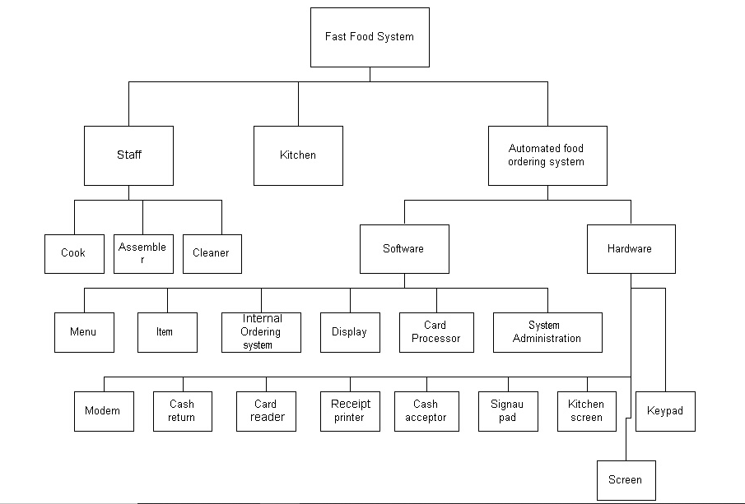
Figure 1: Work Breakdown Structure of Ripe Crops Bakery Shop
(Source: https://user.eng.umd.edu/~austin/ense621.d/projects04.d/project-food-ordering.html)
The implication of the Work Breakdown Structure of Ripe Crops Bakery Shop is based on three important aspects. The best aspect is being the operational activity of the kitchen staff and next the selling process and customer support applicability to measure the sales review and customers station of the Ripe Crops Company (Radziszewska-Zielina, and Sroka, 2018). The events of the stakeholder management are effective in launching the new idea and plan within the company to make sure the supply chain management has been effectively joined to implicate the possibilities of the Work Breakdown Structure.

Project Schedule Plan

Figure 2: Gantt chart
(Source: self-created)

Project schedule plan

TASK | STARTING DATE | END DATE
Projects outline | 1.12 | 10.12
Scope of the projects | 2.12 | 11.12
Stakeholder analysis | 3.12 | 12.12
Allocation of resources | 4.12 | 13.12
Work breakdown structure | 5.12 | 14.12
Projects success criteria | 6.12 | 15.12
Projects deliverables | 7.12 | 16.12
Constraints of projects | 8.12 | 17.12

Projects success criteria
- Health benefit
The implication of the new business idea to launch the new products of the oats buns and bread is highly healthy to consume (Schaller et al. 2020). For this reason, the success of the business process has been developed by the implication of the health benefits. The ingredients of the oats bread and buns is healthy so based on the high health benefit the products are going to be successful.

- Customer service
The analysis of the customer service within the Ripe Crops Bakery Shop is affected by the implication of the customer satisfaction and customer preference. This business process has been successful due to the measurements of the recent customer service and allocation of the customer preferences in order to process the new business idea and plan.
- Customer satisfaction
The business idea of the new products launch is based on the customer satisfaction in order to measure the customer preference and customer satisfaction (Arunachalam et al. 2020). The ingredients which are used to make the oats specialties are healthy and helpful to digest for all ages. For this reason the customers' satisfaction of these products is going to be very high which is the primary key objective of the product's success.
- Market implementation
The analysis of the health benefit, customer satisfaction and customer service worth in organisation are the first criteria to get success with the recently launched products of the Ripe Crops Company. The implementation of the productive market implementation is beneficial to measure the success and orientation of the new launched products of the company.

Projects deliverables
The projects deliverables have been impactful to measure the concrete or supernatural factors of the business aspects in order to process out the business plan and implicate the benefits of the new business idea of the new products launching which are beneficial to be offered within the dimensions of the new project managements within the organisation in order to process the idea of the new products launching towards the customers of the Ripe Crops Bakery Shop (Yu et al. 2020). The implication of the project's deliverables has been essential to measure the implication of the unity of long attributes of the company profile. The implication of the project's deliverables guides any "project-related output" proposed in order to measure the project phases.
Project deliverables ought to be decided upon before the project's planning phase to correctly set anticipations and assign help, and reported within a "governing project charter" to be referenced throughout the course of the task.

Constraints of projects
Time constraint: The implication of the time constraint to launch the new projects of the Ripe Crops Bakery Shop refers to the scheme’s timetable for the fulfilment, to manage the deadlines preparation time of the oats bread and buns to offer the customer on time phase which is impactful to measure the customer service and customer satisfaction. The implication of the time constraint is beneficial to measure the time limitation to serve the customers after launching the products of oats specialties to measure the time allocation.
Scope constraint: The dimensions of a scheme define its specific "goals, deliverables, features, and functions' ', in addition to measuring the sales encasements and extreme customer orientation by launching the new food products of oats bread and buns. The implication of the scope constraint provides the ability to get success to launch the new products of the Ripe Crops Bakery Shop (Agnihotri and Bhattacharya, 2020.). The ability of the scope constraint is effective to measure possibilities of success ratio of the new product launch. The oats operation is also going to be used to make other items like cream rolls, pizza base, burgers bun and patty, and other items to make sure that the children also love to have these new products.
Cost constraint: The implication of the cost constraint is to measure the ability of the sales ratio in order to improve the pricing condition of the new food products by the Ripe Crops Bakery Shop. This process has been beneficial to set the financial structure of the projects to launch the new products and analyse the possibilities to market the sales position of the new products. The cost constraining measures the price range of the new launched products by the Ripe Crops Bakery Shop. The cost allocation is effective to benefit price integration.

Risk assessment
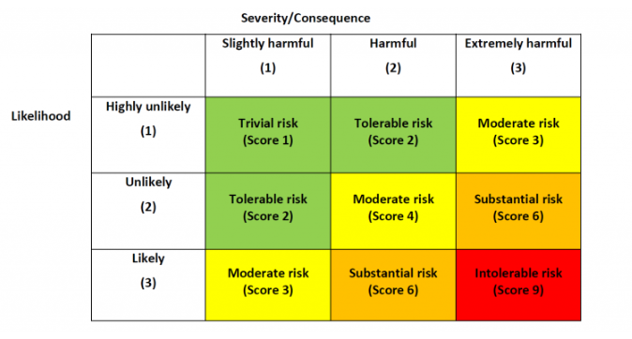
Figure 3: Risk assessment
(Source : https://www.shipownersclub.com/implementing-risk-assessments/)

Conclusion
The scope of the projects has been highlighted with the new thought process to live healthy is the best, which is the main overview of the Ripe Crops Company. The ingredients which will be used to make the buns and bread are mostly based on healthy ingredients to make sure that the customers will be happy to consume our oats products.

References
Agnihotri, A. and Bhattacharya, S., 2020. ESOPs and new product launch: Conditional effects of financial slack and ownership concentration. International Journal of Innovation Management, 24(03), p.2050021.
Arunachalam, S., Bahadir, S.C., Bharadwaj, S.G. and Guesalaga, R., 2020. New product introductions for low-income consumers in emerging markets. Journal of the Academy of Marketing Science, 48(5), pp.914-940.
Burghate, M., 2018. Work breakdown structure: Simplifying project management. International Journal of Commerce and Management, 3(2), pp.453-461.
Chumnumpan, P. and Shi, X., 2019. Understanding new products’ market performance using Google Trends. Australasian Marketing Journal (AMJ), 27(2), pp.91-103.
García-Quevedo, J., Segarra-Blasco, A. and Teruel, M., 2018. Financial constraints and the failure of innovation projects. Technological Forecasting and Social Change, 127, pp.127-140.
Morgan, T., Obal, M. and Anokhin, S., 2018. Customer participation and new product performance: Towards the understanding of the mechanisms and key contingencies. Research Policy, 47(2), pp.498-510.
Radziszewska-Zielina, E. and Sroka, B., 2018. Planning repetitive construction projects considering technological constraints. Open Engineering, 8(1), pp.500-505.
Salmen, A., 2021. Does digitalization boost companies ‘new product launch success? An empirical study. SCENTIA International Economic Review, 1(1), pp.62-83.
Schaller, L., Eichhorn, T. and Kantelhardt, J., 2020. CONSOLE Project-Deliverable 2.3-" Report on European in-depth case studies".
Yu, L., Duan, Y. and Fan, T., 2020. Innovation performance of new products in China's high-technology industry. International Journal of Production Economics, 219, pp.204-215.

