

The Bhopal Disaster

Jennifer Roper
1704516

UWTSD
2019
2434 Words

Contents

Introduction 3
Causes 4
Impacts on the environment 4
Lesson learned 5
Measures Taken 6
Conclusion 6
References 6

Abstract

After what has been described as the worst industrial accident in history the company involved, Union Carbide Corporation or UCC for short, tried to distance itself from any legal responsibility for the accident despite the devastating effects it on the environment and the local people. Though the company eventually accepted the moral responsibility for the accident and paid a small fee in compensation, many local people never were compensated, and the environment has yet to be properly cleaned up due to a constant shift of blame for responsibility.

Introduction

In the 1970s, the Indian government put policies in place in encouragement for foreign companies to invest in the local industry and insisted that a significant percentage of the investment would have to come from local shareholders if a company was to use this policy. The American company, Union Carbide Corporation (UCC) made a request to build a plant to manufacture ‘Sevin’ a common pesticide used in Asia. The government itself had a 22% stake in the company. The plant was built in Bhopal due to the central location and the access to the transport infrastructure and this area was only zoned for light industrial and commercial use and not hazardous industry. The plant was only initially approved for the formulation of pesticides from chemicals imported from the parent company in small quantities, however, due to competition in the chemical industry the company began to manufacture raw materials within the one facility which is extremely hazardous process.
In 1984, the demand for pesticides was dramatically decreased due to widespread crop failures and the company had decreased its production. Managers were directed to close the plant in preparation for its sale due to the lack of profit. There was no buyer found so the company planned to dismantle the key production units and move the plant to another developing country, but during that time, the company continued to operate with safety levels and procedures far below the standard and though the government was aware of all the safety problems it was reluctant to place a pollution control burden on the struggling industry because of the feared economic effects of losing such a large employer.
Immediately after the accident, the streets of Bhopal were littered with human corpses and carcases of farmstock and pets. Within the first 48 hours the death rate ranged as high as twenty per thousand of the population compared to the average of one per thousand. An estimate of around 3800 people died immediately, mostly the people in the slum housing adjacent to the plant. Local hospitals quickly filled with injured and treatment was slow due to a lack knowledge of what exactly the gas was. In the first few days after the accident it was predicted that around 10,000 people were killed with 15,000 to 20,000 premature deaths being linked to the leak in the following two decades. The worst effected victims were those less than 5 years old, with a death rate of around thirty-three per thousand. It was also predicted that more than half a million people were exposed to the gas and several studies conducted after the accident showed increased mortality and increased health detriments in the exposed populations. It is even harder to track the adverse health effects as many people who were affected left the area immediately following the disaster and never returned, but many proposed health effects include issues with ocular, respiratory, gastrointestinal, genetic, psychological and neurobehavioral functions.
After the disaster UCC began to disassociate itself from the responsibility for the leak and tried to shift the blame to the company's branch in India rather than the parent company, as the plant was based off Indian subsidiary. There were also attempts to place the blame on unknown Sikh extremist groups and disgruntled employees as a terrorist attack and sabotage, but these are all debunked by numerous sources. Though, to this day the company still states on their website that the Bhopal disaster was “caused by deliberate sabotage.” The company has also shrunk to one sixth of its size in an effort to restructure and avoid a hostile takeover. UCC placed a significant portion of its assets out of the legal reach of victims and instead gave shareholders and the top executives the profits.

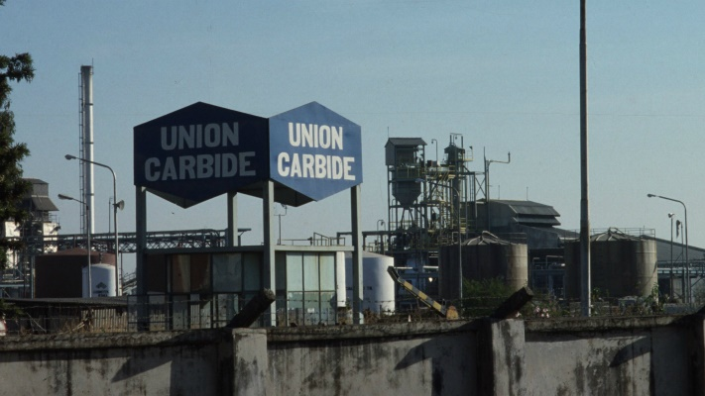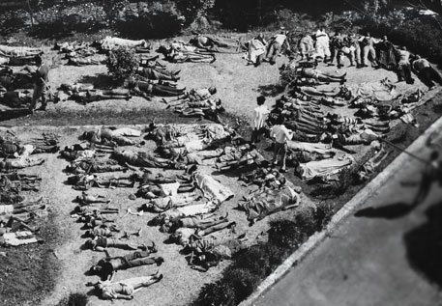

Union Carbide plant and bodies of victims

Causes

On the 2nd December 1984 and approximately, the operators of the plant noticed a small leak of Methyl Isocyanate (MIC) gas and the increased pressure inside the storage tank. The open gas scrubber, a safety device designed to neutralise toxic discharge from the MIC system, had been turned off 3 weeks prior. A malfunction had allowed one tonne of cleaning water to mix with 40 tonnes of MIC and a 30-tonne refrigeration unit normally served as a safety component had been drained its coolant for its use in another part of the plant. Pressure and heat from the exothermic reaction in the tank continue to build and the gas flare safety system was out of action and had been for the past 3 months. At around 1am on December 3rd, the safety valve gave way and sent a plume of toxic MIC gas into the atmosphere.
Even to this day, UCC has not stated exactly what was in the toxic cloud released however it is known that when MIC is exposed to 200 degree heat it forms into a degraded MIC that contains a more deadly, hydrogen cyanide and there was clear evidence that the temperatures at the time did reach this level and symptoms in victims showed characteristics of acute cyanide poisoning. Although the company did initially recommend the use of sodium bisulphate to treat acute cyanide poisoning symptoms, they later withdrew the statement, which prompted suggestions that they were attempting to cover up the evidence of the presence of HCN and its presence was vigorously denied by the company.
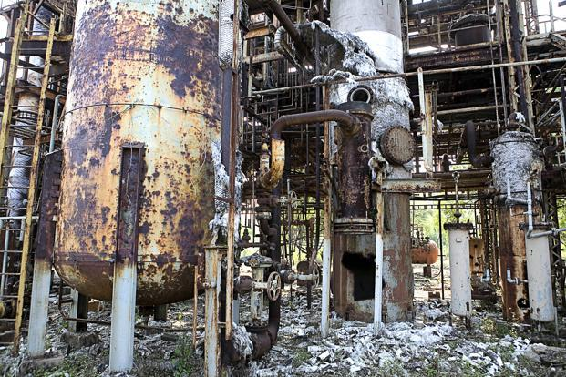
Damage caused by explosion

Impacts on the environment

Despite the fact that the operation was discontinued in this plant, there was a failure to clean up the industrial site completely and the plant continues to leak several toxic chemicals and heavy metals. Many of which have found their way into local aquifers, and dangerously contaminated water is now being added to the list of things that's been left behind for the residents of Bhopal who already struggled with unsanitary water conditions due to the dumping of sewage into drinking water sources. Contamination of the water that both animals and humans drink from is dangerous due to the bioaccumulation of the contaminants, which work their way up the food chain and are consumed through the meat that residents of Bhopal eat and through the water that they drink. These toxins will have lasting effects on human health and even people born after the events will be affected by it almost thirty-five years later.
With the recent industrial growth there has been an increase in small scale industries that are clustered around the major urban areas in India. There are generally more lenient rules for the treatment of waste produced by these industries due to less waste generation within each individual company. This has allowed the SSIs to dispose of untreated wastewater into drainage systems that flow directly into rivers. Meaning dangerously high levels of heavy metals such as lead, cobalt, nickel, zinc and many others have been detected in rivers posing a health risk to the people living there. The land pollution due to an uncontrolled disposal of industrial solid and hazardous waste is also a problem throughout India. With rapid industrialization, the generation of industrial solid and hazardous waste has increased a large amount and it is having dramatic impacts on the environment.
The majority of people in the affected area are poor and uneducated so they are not aware of the problems that are caused by exposure to toxins that remain on the site. Most residents are not aware of the contamination of ground water in the area and others are aware of the contamination but continue to consume it because there are not any alternative sources of water. Around 700 tonnes of toxic waste in the form of corroded metal and other scrap lie exposed in the factory premises worsening the suffering of residents living close by. A Greenpeace scientific study in 1999 confirmed the presence of several life-threatening toxins such as mercury, chlorinated pesticides and pollutants within the scattered waste. The study also revealed some of the toxic pollutants were carcinogenic which has been related to the chronic illnesses suffered by the residents. The investigation once found more than 20 tonnes of hexachlorocyclohexane, an organic pollutant linked to immune system and reproductive disorders, in sacks lying in an open shed in the abandoned factory.

Lesson learned

Bhopal highlighted the dangers of rapid expansion and industrialization of developing countries without the evolution in the safety regulations and although the company in question didn't go to India to avoid environmental regulations that are in place in the US (where the parent company is based) but rather, it went to exploit a growing market. This being said a universal regulation for hazardous industries should be provided to prevent events like Bhopal from reoccurring.
The allowance of hazardous industry in urban built up areas should be accompanied by financial support in order to build and develop local communities and their medical systems and other necessary services in order to reduce the devastation in the case of an industrial accident. With Bhopal, had there been proper plans place to deal with an industrial devastation then there potentially could have been far fewer casualties. Additionally, if the company would have been open about what exactly was released into the air then treatment could have been made more swiftly to those affected. The existing health infrastructure also needs to be taken into account when industries are choosing a site as the public health infrastructure in Bhopal was very weak in 1984, tap water was only available for a few hours a day and was of very poor quality and with no functioning sewage system, untreated human waste was dumped directly into nearby lakes, one the source of drinking water and although the city had four major hospitals there was a shortage of physicians and hospital beds and there was no mass casualty emergency response in place in the system.
Since the disaster environmental awareness and activism in India increased significantly, the EPA was passed in 1986 and it strengthened India's commitment to the environment. Under the new act the Ministry of Environment and Forests was given overall responsibility for administering environmental laws and policies and it established the importance of integrating environmental strategies into all industrial development plans for the country. Though it has been a recent concern that economic problems are taking priority over the environmental protection.
The lessons of acute and chronic effects of exposure to pesticides and their precursors in Bhopal has not changed agricultural practice patterns. An estimated 3 million people per year suffer the consequences of pesticide poisoning with most exposure occurring in the agricultural developing world. It is reported to be the cause of at least 22,000 deaths in India each year.
Some positive changes were seen following the Bhopal disaster however, with the British chemical company, ICI, whose Indian subsidiary manufactured pesticides, increased their attention to health, safety and environmental issues following the disaster. The company now spends 30–40% of their expenditures on environmental related projects but thought they still do not adhere to standards as strict as their parent company in the UK it is a start.

Measures Taken

On December 7th, a multi-billion dollar lawsuit was filed by an American attorney in the US court leading to the beginning of legal trials of the global disaster. With the ethical effects on the Bhopal people being largely ignored, in March of 1985, the Indian government enacted the ‘Bhopal Gas Leak Disaster Act’ which ensured the accident, and all resident’s claims would be dealt with speedily and equitably with the Indian Government acting as the sole representative for the victims in the legal proceedings. A settlement by the Indian Supreme Court meant that Union Carbide Corporation accepted more responsibility for the incident and paid $470 million to the Indian government to be distributed to the claimants though this was based on the claim that only 3000 people died and 102,000 suffered with permanent disabilities. Upon announcing the settlement, the shares of UCC rose by 7% or $2 each.
If the compensation in Bhopal had been paid out at the same rate as the asbestos victims were being awarded in US, the liability would be more than $10 Billion of the value of the company and by October 2003 according to the Bhopal Gas Tragedy Release Rehabilitation Department compensation been awarded to around 554,895 people for injuries received and 15,310 survivors of those killed, though the average amount paid to families of the dead was $2200.

Conclusion

The events of Bhopal happened due to lack of regulation in India and the company’s inability to enforce any sort of standard they did in the mother company in America. Due to the lack of regulation and the knowledge that UCC had that it was cheaper for them to ignore a lot of safety procedures and environmental regulation and protection actions lead to devastating effects. The company was not held as responsible as it should have been for clean-ups and pay-outs to the victims and to the environment, because of the government ties with the company and the shares that the government held in the company. The country would lose out on a lot of money and a large employer if it were to prosecute UCC as they should have. Rapid industrialization of India is coming at the detriment of human and environmental health and this is happening in many developing countries as well. Warnings of the Bhopal disaster should have been recognised and appropriate steps taken to improve the conditions and means by which companies operate there. There is a lot more work required to be done to improve the overall safety standards for industries that operate outside of their parent countries.

References

Sriramachari, S. "Bhopal Gas Tragedy: Scientific Challenges and Lessons for Future." Journal of Loss Prevention in the Process Industries 18.4 (2005): 264-67. Web.
Broughton, E. (2005). The Bhopal disaster and its aftermath: a review. 4th ed. [ebook] Available at: https://www.ncbi.nlm.nih.gov/pmc/articles/PMC1142333/ [Accessed 10 May 2019].
Malini, N. (2019). Bhopal Gas Tragedy – A Social, Economic, Legal and Environmental Analysis. [online] Mpra.ub.uni-muenchen.de. Available at: https://mpra.ub.uni-muenchen.de/37856/1/MPRA_paper_37856.pdf [Accessed 10 May 2019].

