


Digital Surveying

The Dylan Thomas Centre

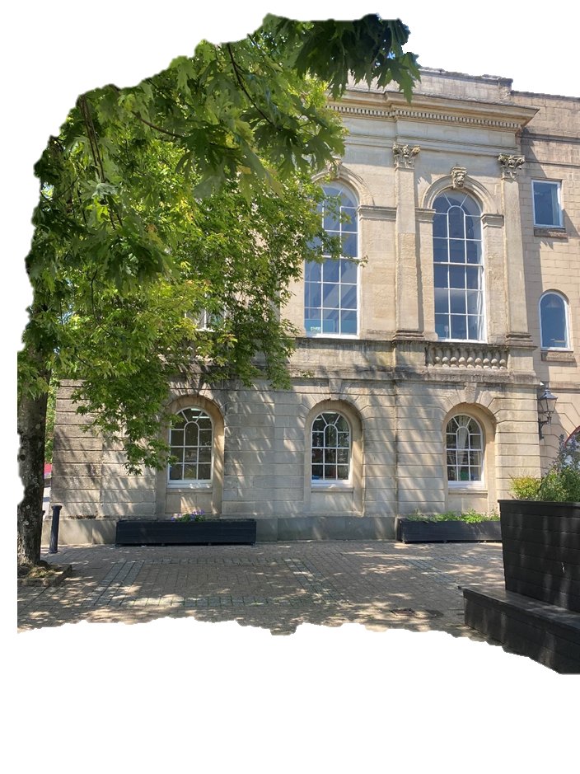

Written by Joanna Weedon
2414801
ACBA4017

Contents
Glossary Of Terms 3
Introduction 4
Survey Objectives, Scope & Methodology 4
Digital Tools and Technologies 7
Survey Planning 9
Challenges and Solutions 11
Conclusion and Recommendations 12
Figure List 13
References 13

Glossary Of Terms
BIM (Building Information Modelling): 3-dimensional model replicates the building and how it works. Useful for planning, facilities, and day to day operations.

CAA (Civil Aviation Authority): Organisation with legislative responsibility for flying drones in the UK.

CADW: Welsh Heritage Services with responsibility for supervision of old buildings and monuments in Wales.

Conservation: Care and maintenance of heritage assets.

Digital Twin: to the moment of a building or estate in digital form.

Drone (UAV – Unmanned Aerial Vehicle): a flying camera used to take aerial photographs.

Grade II* Listed Building: one of the categories used to designate an important structural asset because of history and design.

Orthophoto: a flat detailed photograph of a building or area that gives the accuracy of a map.

Photogrammetry: use of drone images to measure and create 3D models.

Planned Preventative Maintenance (PPM): a plan to look after the asset on a routine basis.

Point Cloud: a set of points collected by laser scanners used to show the exact appearance of an asset.

Risk Assessment: check of workflows that could be unsafe and the planning to mitigate these challenges.

Thermal Bridging: areas of a building where heat is escaping around windows or external doors.

Thermal Imaging Camera: camera that sees heat instead of light. Showing warm and cold areas in colours (red to blue) highlighting damp or heat escape.

TLS (Terrestrial Laser Scanning): a ground mounted laser scanner capable of creating 3D images of a building by bouncing laser beams from its surface.

3D Model: digital version of an asset viewable from any angle.

Introduction
Building Surveys are a crucial foundation to make informed decisions on the construction, conservation, and facilities management sectors (CIPFA, 2023). Surveys can provide owners, occupiers and investors essential data on the buildings structure, plant, facilities and equipment. The information can help with PPM (planned preventative maintenance), restoration, legal compliance, and long-term conservation planning (Innovus, 2024). Building surveys also underpin asset valuation, insurance, lease negotiations, and planning applications, making them a vital tool across the building lifecycle.
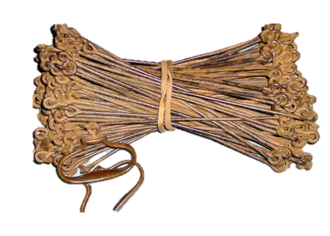
Surveying of buildings has been transformed over recent decades. From theodolites (measuring angles) that go back to the 1550 or chains (measuring distances) in the 16th century. These methods have been adapted and updated to digital tools that offer speed, accuracy and reproducibility.

Figure 1 - Historic Chain used for measuring

New technologies such as drone base photogrammetry, terrestrial laser scanning (TSL), 3D modelling, and Building Information Modelling (BIM) have allowed survey’s to produce reports which fosters better collaboration among stakeholders which improves project coordination and reducing errors, extracting information in safe environment promoting a safer working environment, whilst sharing transformative data across the board (RICS, 2025; UK BIM Framework, 2021). In relation to listed buildings, the latest technologies are significant as they can record intricate details whilst being non-invasive and without damaging the fabric of the building (Historic England, 2018).
The benefits of digital surveying allow surveyors to carry out remote inspections using the virtual walkthrough, helping with the ability to analyse and record the building condition off-site mitigating for disruption to the operations.
Data can be used to predict potential future challenges like thermal loss, moisture ingress, structural movement informing a preventive maintenance plan for the building.
Digital twinning would be in place for the facilities team and used for future refurbishments, conservation considerations and sustainability benefits. The imaging aids decision-making and reduces foreseeable risks with the accurate, accessible and reusable data feeding into architects, surveyors, conservation officers and facilities teams.

Survey Objectives, Scope & Methodology
The following sections of this report will show recommendations for surveying the Dylan Thomas Centre, a Grade II* listed building located in Swansea’s Maritime Quarter. The building not only has an exhibition for the life of Dylan Thomas but also operates as a restaurant, function and conference facility and a cafe bookshop comprising a multi used building operating with the limitations of a 18th century listed building (Meet in Wales, 2025). These factors will mean that a survey needs to be conducted without impacting operational use and be sensitive to a building that is important to Wales.
Constructed in 1825-1829 the building will present both opportunities and restrictions for surveyors working in a heritage context. The appropriate digital tools and techniques for surveying will be identified based on their suitability and practicality whilst executing a high -quality survey extracting the relevant information for the future health of the building.
One of the principal objectives of surveying the Dylan Thomas Centre is to digitally capture and document the architectural structure and thermal efficiency, which will provide information to support the continued use, conservation and strategic management of the property.

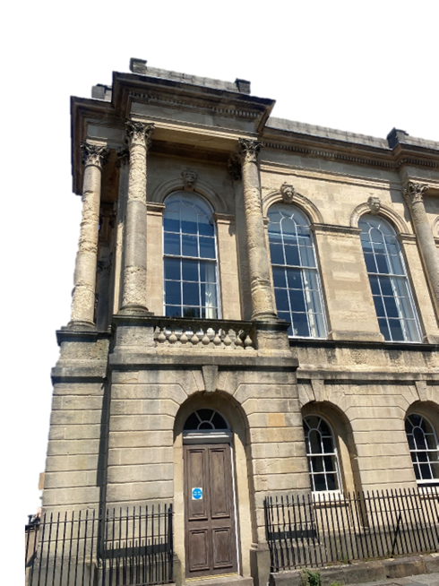
The survey will focus on the key areas below:-
Figure 2 - External Image of The Dylan Thomas Centre

- External Façades: Erosion of facing stone, cracks, vegetation growth, missing pointing, saturated masonry and any visible mechanical and electrical systems.
- Roof: Condition of roof covering, missing leadwork, failure of flashings any roof penetrations such a vents, skylights, flues etc.
- Rainwater goods: Plant growth in gutter systems, hoppers, any failed disconnections
- Structure Stability: Defects in any of the walls, substantial cracks, bulges
- Doors and Windows: Condition of frames and glass work.
- Internal spaces: Flooring, walls, original features and any visible mechanical, electrical and plumbing systems.
- In addition to the architectural detail we will also be looking at the thermal efficiency of the building. Heat loss, thermal bridging and moisture related issues. We would commonly find this around window junctions, doorways, roof areas and external walls. (Historic England, 2017)

Survey Outputs:-
- Comprehensive 3D digital image of the building, depicting internal and external aspects with highly detailed spatial precision.

- Record the situation of architectural features to apprise master planning including conservation, maintenance and restoration works.

- Evaluate the thermal performance of the building envelope using thermal imaging technology, helping to recognise areas of heat loss, moisture ingress, and insulation failure—crucial for improving energy efficiency within conservation restrictions.

- Generation of a data-rich model supplying Building Information Modelling (BIM) environments, supporting shared design, refurbishment, and heritage management.

- Compliance with the Planning (Listed Buildings and Conservation Areas) Act 1990 and any other relevant legislation or guidance applicable to listed structures.

- Provision of a long-standing digital asset archive, appropriate for use in future conservation reports, funding bids, heritage impact assessments, and building performance reviews.

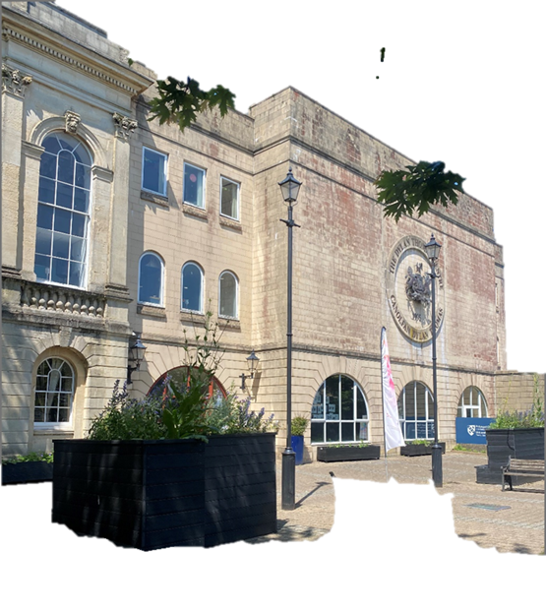
Figure 3 - External Image of The Dylan Thomas Centre front entrance

Digital Tools and Technologies

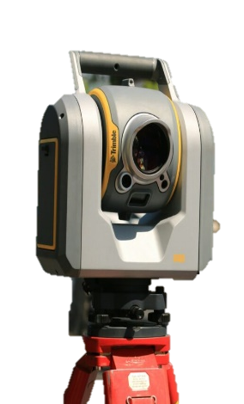
Terrestrial Laser Scanning (TLS)
Figure 4 - TLS

TLS is a technology that works by discharging laser pulsations of light that mirrors detail from buildings and/or their environment from apparatus located at ground-level. These pulses collect extremely detailed images with millimetre-level precision. The TLS analyses the location and perspective of each reflected point producing for the user an in-depth three-dimensional illustration denoted as a ‘point-cloud’. These are processed and explored, applying sophisticated software, for architects and surveyors to be able to visualise, measure and engineer highly accurate information. (GeoAI, 2024)

Unmanned Aerial Vehicles (UAV’s) with Photogrammetry

Commercial UAV’s or Drones are fitted with powerful high-resolution cameras, thermal sensors or LiDAR technology to create real-time aerial views of a building allowing users to capture roofs, vented details, such as flues and chimneys, and parapets.

The UAV is able to measure distance and formulate three-dimensional maps providing detailed imagery of high-level exterior structures. (TechTarget, 2024)

Thermal Imaging Cameras

Also known as infrared cameras these instruments capture changes in heat signatures from objects. All material emits heat and the warmer an object is the more infrared emissions are released.

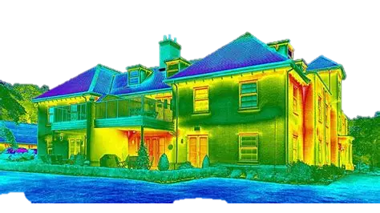
These temperature changes are transformed by the camera into heat maps – cooler materials may appear blue, warm areas read and extremely hot areas can show up as white. The corresponding digital images provide a detailed understanding of building fabric way more advanced than using the human senses of touch, smell and eyesight.(Thermal Engineering, no date).
Figure 5 - Thermal Image example

Building Information Modelling (BIM)

The BIM model is built by using data captured by the various methods described above, i.e. Thermal Imaging Cameras, UAV’s and TLS. The output of this of embedded date-process is a comprehensive 3-D model displaying the physical and functional construction of a single structure and what condition the building material might look like by linking images and thermal scan records.

When a building has been listed it is of vital importance to prevent disturbance of the materials. (Cadw, 2011)

With the onset of technological advances in surveying and recording such as thermal imaging cameras, drones and laser scanning it is now possible to produce comprehensive surveys of a building without the use of extensive scaffolding and risky manual inspections that might damage an important listed building.
The Dylan Thomas Centre, situated in the Maritime Quarter close to the River Tawe and the former site of West Docks, was originally built in 1825-29 to replace a previous guildhall and named as the Old Guildhall. The building is a 2-storey, Neo-Classical 6 bay structure with a Bath Stone entrance front and tall round-arched windows. A later 3-storey extension was added. Architect: John Collingwood Building: Thomas Bowan
The interior comprises fine classical details which have been retained and preserved through the various uses of the building. The building was designated a Grade II* by CADW in 1987. (Cadw, no date)
Grade II* are particularly important buildings of more than just special interest. Thought to make up approximately 7% of listed buildings in Wales. (Cadw, no date)
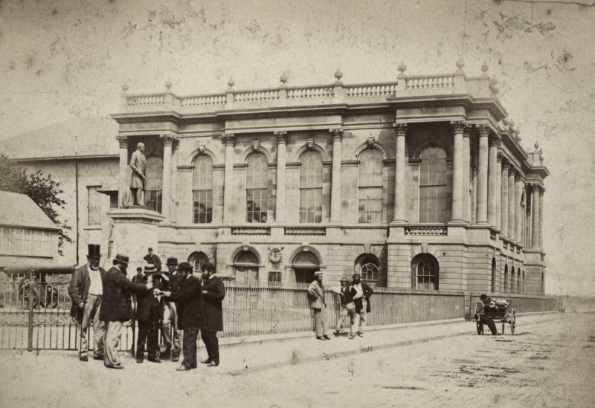
Figure 6-West Glamorgan Archive Service 1870 The Old Guildhall Swansea

Survey Planning

To carry out the survey we will be looking at a phased approach that will be heritage sensitive and aligned with guidance from the Royal Institution of Chartered Surveyors. As the Dylan Thomas Centre is Grade two listed in use building, we will be prioritising non-invasive techniques, limit disruption to public and operational functions, and gather all relevant data needed for conservation and planning purposes. (RICS, 2014)

To achieve this, we can breakdown the survey into the following phases.

Brief and Stakeholder Engagement

The objectives and outputs will be agreed with the relevant stakeholders. this will ensure that all deliverables are aligned with the brief and add meaningful value. Survey dates can be scheduled and planned to ensure a smooth process, allowing minimal disruption. (RICS, 2014)

Desktop Survey/ Pre – Survey Assessment and Risk Planning

Before an onsite survey. We would suggest reviewing any archival materials and planning history. These documents can allow a team to understand areas that need greater attention due to deterioration or previous alterations highlighting features that may not be visible anymore. (Historic England, 2016).

Following on from the desktop survey, a preliminary site visit should be conducted to asses technical factors for the survey
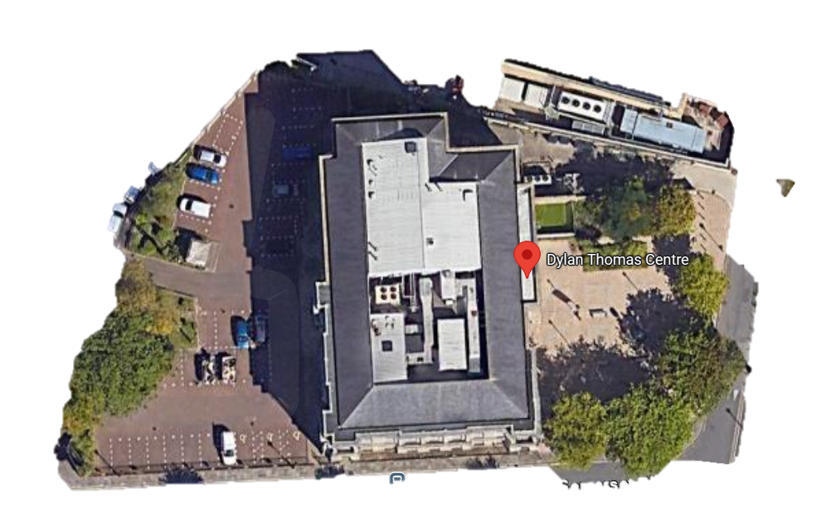
- Access routes – equipment and personnel

Figure 7 - Arial Image of The Dylan Thomas Centre

- UAV flight routes – understanding any obstructions such as trees/nearby structures. (RICS Earth Observation, 2023)
- TLS scanner positioning – ensuring adequate visibility and complete point cloud coverage
- Thermal Imaging – suitable locations for optimal readings

On-site Data Capture

Once the preliminary survey has been completed, with the site access, scanning locations, and environmental conditional reviewed, we can the move onto the on-site date capture stage. This stage will involve the coordination use of the digital surveying tools, TLS for interiors and ground level exteriors, UAV for high-level features and thermal imaging in areas of suspected heat loss or moisture ingress such as windows, rooflines and external wall junctions. (Historic England, 2018).

Processing of data and BIM Integration

The data collected from the digital surveying tools will then be imported into and developed to create a BIM model from the point clouds, photographs and thermal imagery. This model will provide a detailed 3D visual representation of the Dylan Thomas Centre incorporating spatial zones, accurate measurement, photographic documentation, including links to thermal imaging outputs derived from the surveyor’s data. (Historic England BIM for Heritage, 2017; ISO 19650 Guidance, 2021).

Handover

The final deliverables will include:
- BIM model
- Orthophotos and 2d Plans
- Thermal Imaging documentation
- Photographic Condition report

All deliverables, including the BIM model, orthophotos, thermal imagery, and condition reports, will be organised in accordance with ISO 19650 and PAS 1192 to ensure consistent documentation across all areas of the building and to facilitate secure, long-term digital preservation (UK BIM Framework, 2021).

Challenges and Solutions
Areas | Challenges | Solutions
Drone permissions | Due to the location of the Dylan Thomas Centre, UAVs activity must comply with the Civil Aviation Authority (CAA). The licenced drone operator will need to carry out a risk assessment, typically through a PDRA-01. The flight must comply with CAA safety Distances, altitude restrictions, horizontal safety distances from uninvolved parties and privacy guidelines (CAA, 2023a).In addition to CAA approval, permission will need to be obtained from the building manager and local council/highways, if they flight route is over public roads, parks, or footpaths. | The drone will be operated by a licensed operator under the CAA PDRA-01 regulations. Scheduling of flighting will be planned at low- traffic times i.e early morning, with permission granted from the building manager and local council where flight paths cross public land. To ensure public safety, areas will be sectioned off with signage (CAA, 2023a; CAA, 2023b).
Data Collection - TLS | TLS scanning and Thermal Imagining results can be affected by reflective surfaces, such as polished metal, glass or wet areas. For thermal imaging, these materials reflect ambient infrared radiation, rather than emitting their own heat, therefore false reading can occur (Historic England, 2018) TLS, transparent materials or reflective areas can cause singal loss or scattering resulting in voids in the point cloud data. | To overcome data voids from reflective surface areas, multi – angle scanning on highlighted areas can take place to ensure sufficient data is collected from the TLS. Thermal imaging will be conducted, on dry and cool days (Historic England, 2018).
Management risks | A high volume of data will be collected in various formats from the TLS, UAV and thermal imaging camera. If the incorrect systems are used to extract and store this information, there’s a risk of file management or inconsistency across outputs, leading to obscured final survey results | The extracted information will be store using a structured folder format and naming protocols aligned with ISO 19650. BIM will be utilised to secure storage, access and version control.
Misinterpreting thermal results | The thermal imaging camera cannot always indicate genuine defects, which can lead to misleading conclusions. (Historic England, 2017). | Anomalies will be verified using photography from the TLS/Drone and site context to avoid false conclusions. (Historic England, 2017).
Conservation constraints | When surveying a grade listed two building, there must be minimal contact with historic materials., therefore all equipment and personnel must adhere to the conservation best practice. (Historic England, 2016). | Surveying equipment will be placed using non-intrusive methods, such as padded supports. Involved personnel will follow historic England’s soft access guidance to protect the listed building fabric. (Historic England, 2016)

Conclusion and Recommendations
The digital survey strategy for the Dylan Thomas Centre using TLS, UAV and Thermal Imaging feeding into a BIM model guarantees delivery of an extensive record of the building’s condition: fabric, the sensitive listed features, and the overall condition of the structure. This data is critical to the conservation and operational planning for the owners and users. And should incorporate the following measures:-
- Every 3 to 5 years re-run the surveys to determine any changes to the condition or any thermal inefficiencies
- Keep up to date the BIM model as a ‘live’ digital twin, recording any interventions and compliance records with building and conservation standards.
- Use thermal imagery to target energy improvements thereby saving revenue and resources and enhancing sustainability where practical.
- Internal Team Training – ensure that operational and facility staff can interpret BIM Models and thermal reporting. This will help with energy insecurities, provide agile decision-making forums reducing external consultant costs.
- Early engagement with architects, conservation officers and local authority planners should the need arise to make repairs or alterations by sharing digital outputs.

Figure List
Figure 1 - Compleat Surveyor (no date) Chains & Perambulators. Available at: https://www.compleatsurveyor.com/AncientInstruments/ChainsPerambulators/ChainsPerambulators.html (Accessed: 31 July 2025).

Figure 2 - Author’s own (2025) Photograph of Dylan Thomas Centre façade, taken on 29 June 2025, Swansea.

Figure 3 - Author’s own (2025) Photograph of Dylan Thomas Centre front entrance, taken on 29 June 2025, Swansea.

Figure 4 - GeoAI (2024) What is Terrestrial Laser Scanning? Available at: https://geoai.au/what-is-terrestrial-laser-scanning/ (Accessed: 31 July 2025).

Figure 5 - iRed (2017) Infrared building survey [image]. Available at: https://ired.co.uk/wp-content/uploads/2017/07/Infrared-Building-Survey.jpg (Accessed: 31 July 2025).

Figure 6 - Twitter (2022) Image of the Dylan Thomas Centre façade [photograph]. Available at: https://pbs.twimg.com/media/Fiup1dNXkAA2x-Q.jpg (Accessed: 31 July 2025).

Figure 7 - Google Images (2025) Screenshot of search result for ‘Dylan Thomas Centre aerial view’. Captured on 31 July 2025. Available at: https://images.google.com (Accessed: 31 July 2025).

References
Cadw (2011) Conservation Principles for the Sustainable Management of the Historic Environment in Wales. Welsh Assembly Government. Available at: https://cadw.gov.wales/sites/default/files/2019-05/Conservation_Principles_EN_0.pdf (Accessed: 31 July 2025).

Cadw (no date) Listed Building Report for ID 11643. Available at: https://cadwpublic-api.azurewebsites.net/reports/listedbuilding/FullReport?id=11643 (Accessed: 31 July 2025).
Cadw (no date) Understanding listing in Wales. Welsh Government’s historic environment service. Available at: https://cadw.gov.wales/advice-support/historic-assets/listed-buildings/understanding-listing#section-what-is-listing (Accessed: 31 July 2025).

CAA (2023a) PDRA01 - Pre-defined Risk Assessment for Drone Operators. Civil Aviation Authority. Available at: https://www.caa.co.uk/drones/specific-category/pdra01-operational-authorisation/ (Accessed: 31 July 2025).

CAA (2023b) Drone and Model Aircraft Code: Flying Safely and Legally in the UK. Civil Aviation Authority. Available at: https://register-drones.caa.co.uk/drone-code (Accessed: 31 July 2025).

CIPFA (2023) The importance of building conditions surveys. Available at: https://www.cipfa.org/cipfa-thinks/articles/the-importance-of-building-conditions-surveys (Accessed: 31 July 2025).

GeoAI (2024) What is Terrestrial Laser Scanning? Available at: https://geoai.au/what-is-terrestrial-laser-scanning/ (Accessed: 31 July 2025).

Historic England (2016) Understanding Historic Buildings: A Guide to Good Recording Practice. Available at: https://historicengland.org.uk/images-books/publications/understanding-historic-buildings (Accessed: 31 July 2025).

Historic England (2017) Thermography in Historic Buildings. Available at: https://historicengland.org.uk/whats-new/research/back-issues/thermography-in-historic-buildings/ (Accessed: 31 July 2025).

Historic England (2018) 3D Laser Scanning for Heritage: Advice and Guidance (3rd ed.). Available at: https://historicengland.org.uk/images-books/publications/3d-laser-scanning-heritage/ (Accessed: 31 July 2025).

Innovus (2024) Building surveys: ensuring compliance and safety. Available at: https://www.innovus.co.uk/insights/the-role-of-surveyors-in-ensuring-building-compliance-and-safety (Accessed: 31 July 2025).

Meet in Wales (2025) Dylan Thomas Centre. Available at: https://www.meetinwales.com/attraction/museum/dylan-thomas-centre-2167637 (Accessed: 31 July 2025).

RICS (2014) Measured Surveys of Land, Buildings and Utilities (3rd ed.). Royal Institution of Chartered Surveyors. Available at: https://www.rics.org/profession-standards/rics-standards-and-guidance/sector-standards/land-standards/measured-surveys-of-land-buildings-and-utilities (Accessed: 31 July 2025).

RICS (2023) Earth Observation and Aerial Surveys. Royal Institution of Chartered Surveyors. Available at: https://www.rics.org/content/dam/ricsglobal/documents/standards/Earth%20observation%20and%20aerial%20surveys_reissue%20Jan%202023.pdf (Accessed: 31 July 2025).
RICS (2025) BIM and the Power of Data in Construction. Available at: https://www.rics.org/news-insight/latest-news/news-opinion/bim-and-the-power-of-data-in-construction/ (Accessed: 31 July 2025).

TechTarget (2024) What is a Drone? Understanding the Basics and Future of UAV Technology. Available at: https://www.techtarget.com/iotagenda/definition/drone (Accessed: 31 July 2025).

Thermal Engineering (no date) How does a thermal camera detect heat? Available at: https://www.thermal-engineering.org/how-does-a-thermal-camera-detect-heat/ (Accessed: 31 July 2025).

UK BIM Framework (2021) Guidance Part D: Developing Information Requirements. Available at: https://www.ukbimframework.org/wp-content/uploads/2021/02/Guidance-Part-D_Developing-

