University of Wales Trinity Saint David
Wales Institute of Science & Art


Motorcycle Geometry & Handling
Motorcycle Technology (ACHA4027)

Noah Kenneford
2400270
(12/2025)
Contents
1. Introduction 1
2. Geometry 2
3. Top Speeds 7
4. Analysis 11
4.1 Rake and Trail 11
4.2 Wheelbase 12
4.3 Centre of Gravity 13
5. Modern Motorcycles 14
6. Suggested Improvements 16
7. References 17

Introduction
This report will explore the geometry and handling of different motorcycles of different styles, compare them to each other and modern machines, and suggest improvements to their design to improve handling characteristics.

Geometry
For this report two motorcycles have been chosen for measurement and assessment.
The first is a Kawasaki ER-6N from 2007, a parallel twin 649cc ‘middleweight’ naked bike in its standard configuration for the most part. The second is a 1992 Kawasaki ZXR750 H2, an Inline-4 748cc sports bike, which has been modified for racing use.
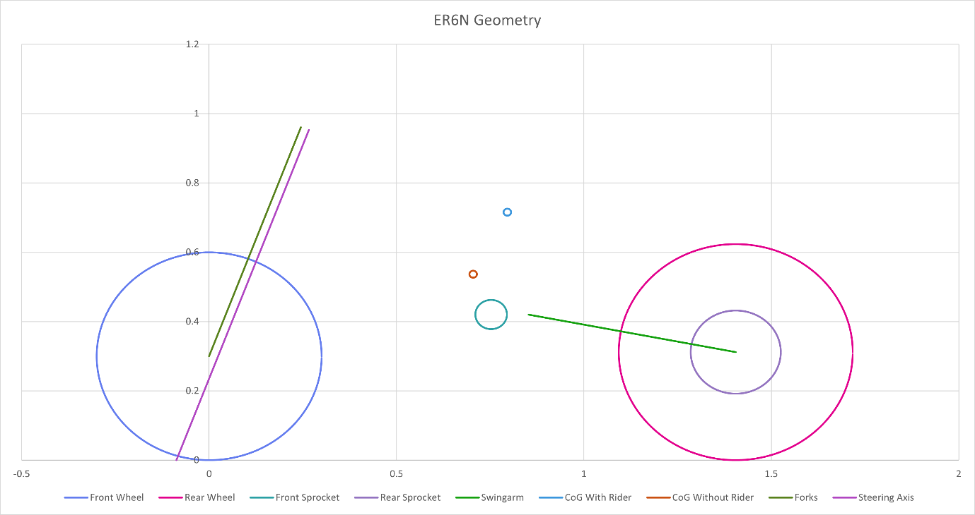
From both data has been gathered – notably the trail, rake, wheel sizes, geometry reference points, and weights for the end of attaining the motorcycle’s Centre of Gravity (CoG).
Figure 1 - ER6N Geometry
Figure 1 shows a graph showing some of the geometry of the ER6N, including wheel sizes, drive sprockets, the swinging arm, front suspension forks, steering axis and the CoG for both the bike with and without rider.
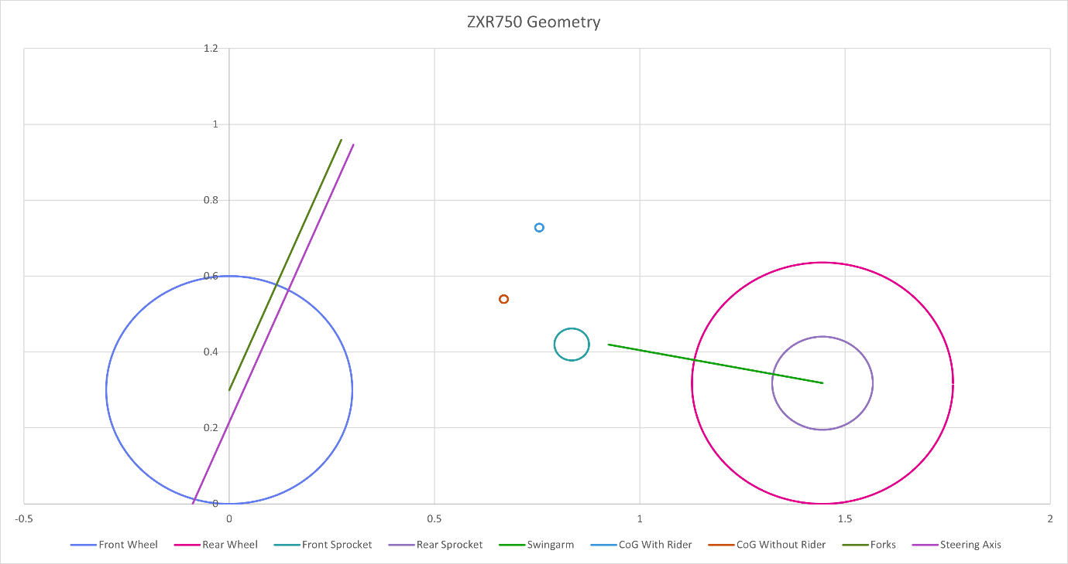
Figure 2 shows the same graph, but for the ZXR750. The dimensions are roughly the same despite 15 years of development; most important dimensions are detailed in the following table.
Figure 2 - ZXR750 Geometry
Bike | ER6N | ZXR750
Rake (Measured/according to manufacturer) in degrees | 21.5/24.5 | 20.5/24.5
Trail (Calculated/according to manufacturer) in mm | 93.95/102 | 77.7/100
Triple Clamp Offset (Measured) in mm | 22.5 | 32.25
Wheelbase in m | 1.405 | 1.445
Tyre Sizes (F/R) | 120/70/16 160/60/17 | 120/70/16 170/60/17

Some of these figures differ from the values given by the manufacturer in the respective Owner’s Manuals – this could be due to several reasons, such as the manufacturer having a rider sat on the bike while it being measured. The geometry reference photos used here were taken without a rider, measured as shown in Figures 3 & 4.

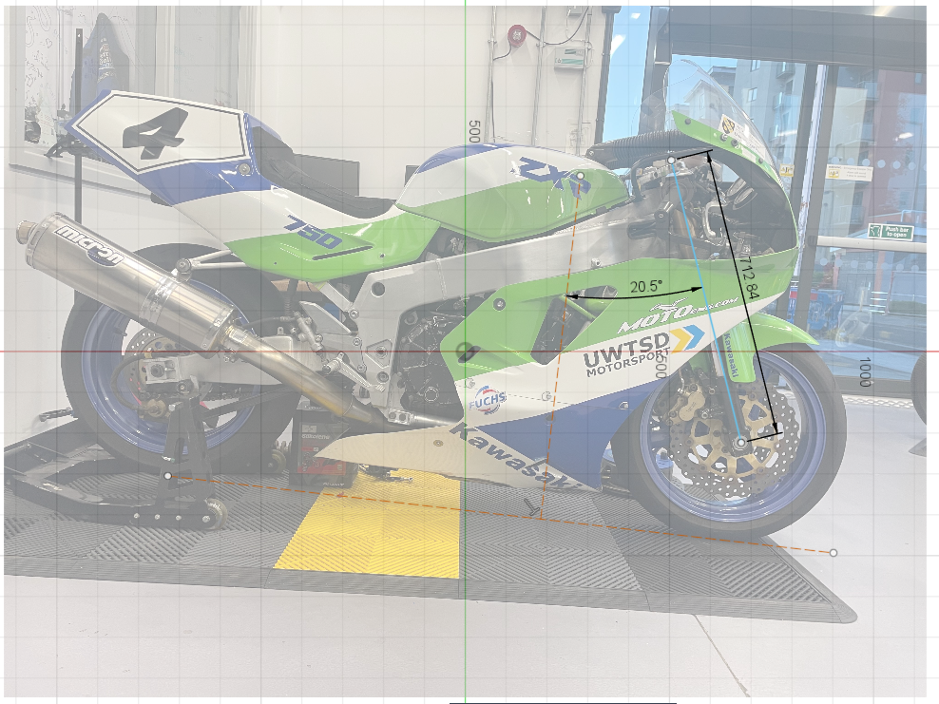
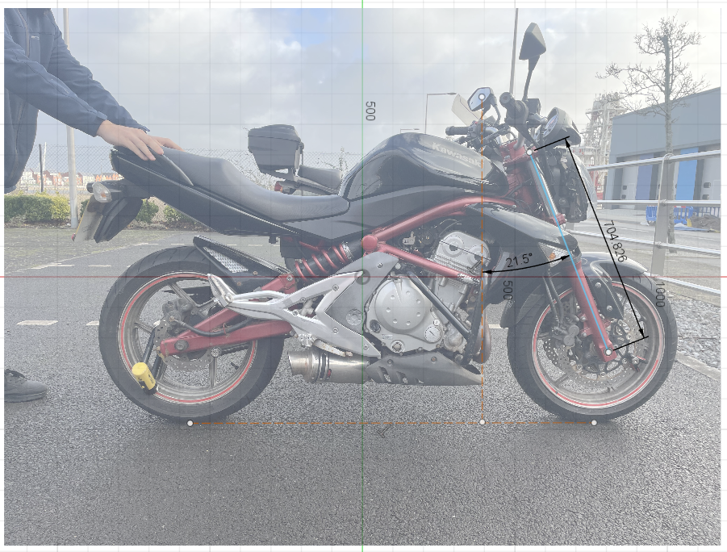
Figure 4 - ZXR750 Reference photo with measurements
Figure 3 - ER6N Reference photo with measurements
For both the reference image was scaled to a known dimension on the bike, in this case the wheelbase. A flat line was taken from the bottom of each tyre, and measurements for the rake angle and fork length were taken. Triple Clamp Offset was measured by hand, with straight edges and a steel rule.
Using these measurements and the known tyre sizes, the theoretical value for Trail was calculated using the formula:
$$Trail=\frac{Front Wheel Radius ×Sin\left(Rake Angle\right)-Triple Clamp Offset}{Cos(Rake Angle)}$$
With the geometry known, measurements were taken with each bike to obtain the Centre of Gravity by weighing the front and rear wheels. This was done with and without the rider, and with the rear wheel elevated by a known distance. Measurements as taken and the resulting Centre of Gravity statistics are shown in Figure 5.
Figure 5 - CoG Calculations for both bikes
The calculations for obtaining the Centre of Gravity are as follows:
$$XCoG= \frac{Rear Wheel Load ×Wheelbase}{Total Weight}$$
$$YCoG= \frac{Wheelbase ×(Rear Wheel Load on floor-Rear Wheel Load Lifted)}{Total Weight ×tan⁡(Angle of bike while lifted)}+Average Wheel Radius$$
These equations are used for both unloaded and with rider calculations and find the distance from the front wheel and the ground of the Centre of Gravity. Assuming the motorcycle is symmetrical, the CoG will be on the centreline of the bike, however this will obviously change with rider position.
From the X and Y positions, it is simple to find the percentage of weight on each wheel in each configuration and compare the front-rear balance of the motorcycle.

Top Speeds
An important part of analysing a motorcycle’s performance is knowing the top speed of the bike. Using known and measured characteristics of the selected motorcycles, we can work out a theoretical top speed and see what it is governed by.
Figure 6 shows data on each motorcycle’s drivetrain, listing the reductions as the power makes its way through the gearbox and final drive to the wheel.
Figure 6 - Drivetrain characteristics
This data is all taken from the Kawasaki Owner’s Manuals (Kawasaki 2007)(Kawasaki 1992) and shows the gear ratios and drives, with wheel diameters and shift ratios taken from looking at the bike itself and working out diameters from tyre sizes. It is worth noting that as the ZXR750 is a race modified bike, the tyre sizes and final drive ratio are non-standard.
This data gives a theoretical top speed obtainable by the gearing for a given RPM – 214km/h for the ER6N and 207km/h for the ZXR750. However, it is not always possible to reach this speed due to the forces acting against the acceleration of the bike, namely rolling resistance and aerodynamic drag.
For the purposes of this project, the rolling resistance Force has been simplified. The formula used for it here is:
$$Force=0.02 ×Mass ×Gravity$$
Which gives a static amount of resistance at any speed – working out to around 59 Newtons for the ER6N and 62 Newtons for the ZXR750.
Aerodynamic Drag force is calculated using:
$$Force=\left(0.5 ×Density of Air\right)×Drag Coefficient ×Frontal Area ×{Velocity}^{2}$$
The Density of Air is assumed constant for both bikes, at 1.167kg/m^3.
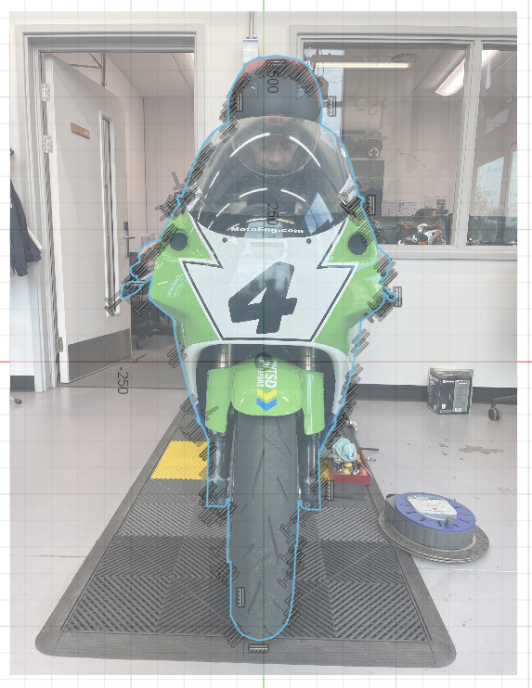
The Frontal Area of both bikes was measured using scaling in CAD software, similarly to working out the geometry. Figures 7 shows the method for tracing the outline for frontal area of the bikes, and the CAD software works out and tells the user the area of the shape based off the known dimensions the image is scaled to.
Figure 7 - Scaled and outlined frontal area calculation
The next unknown variable in the equation is the Coefficient of Drag for each motorcycle. This is not data that is widely published if at all and is difficult to find an estimate that is anywhere near accurate.
Using data from (Kraig Schulz 2016) and (Araki, Gotou 2001) it is possible to guess at some rough figures for the Coefficient of Drag. Neither of these sources are especially well sourced on typical drag figures for different kinds of motorcycles, however a figure of Cd 0.8 was decided on for the ER6N, and a figure of Cd 0.7 was decided on for the ZXR750.
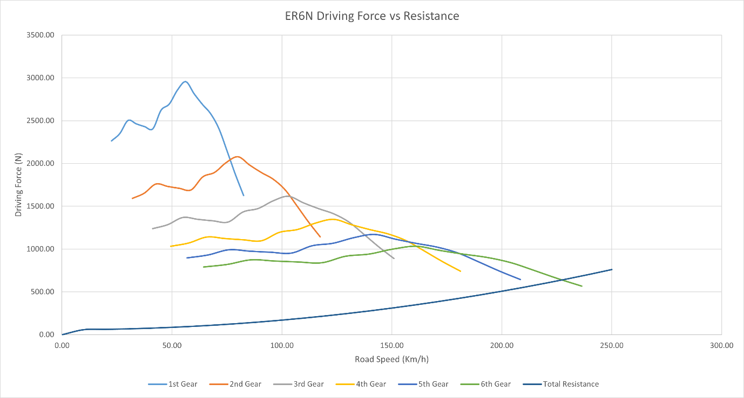
Using the gearbox speed information and Dyno power figures for both motorcycles the driving force is figured out for the speeds along the range, and plotted against the force required to accelerate the motorcycle against rolling resistance and drag force as shown in Figures 8 and 9.
Figure 8 - ER6N Driving Force vs Resistance

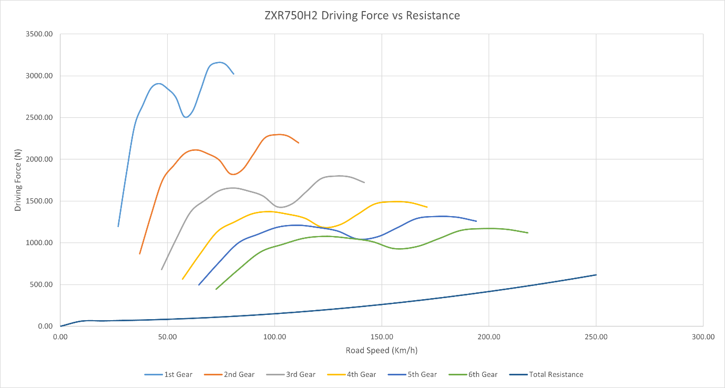
In Figure 8 the force given in 6th gear, near the top geared speed, crosses with the plotted line for resistance to motion. At the point the lines cross – in this case around 225km/h – the motorcycle would no longer provide enough driving force to overcome the resistive forces and cease to accelerate.
Figure 9 - ZXR750 Driving Force vs Resistance
Figure 9 shows a different story for the ZXR750. In this case the driving force in every gear is greater than the resistances and will be able to reach its maximum speed without encountering any significant difficult due to rolling or aero drag forces. This is often the case with 4-cylinder sports or racing motorcycles. They are geared ‘shortly’ to maximise acceleration at the cost of top speed. This is because when racing on short circuits, the maximum length of straight is too short to reach a top speed governed by aerodynamic drag.
On the other hand, the ER-6N is geared far longer. This is because it is not used (at least in this case) as a racing motorcycle and designed for use on the roads. When riding on the road, a rider will not want to be sitting on a motorway or fast road at a point high in their rev range. This can be uncomfortably loud and cause unnecessary wear on the engine or rider’s sanity. The gearing is made longer so that the engine sits at a sensible middle-range RPM at a projected speed.

Analysis
The two selected motorcycles are designed for different purposes but share some similarities as well as their differences. Here are some of the attributes of both bikes and how they affect them.

4.1 Rake and Trail
Rake on the motorcycle refers to the angle from vertical at which the forks face the floor. The closer they are to vertical the more agile and nimble the motorcycle will feel and react at the cost of stability. (Frendo, Sisi et al. 2006).
Trail acts similarly – less trail means quicker steering response and agility, where more trail creates stability and aids the gyroscopic effect that keeps the motorcycle upright.
In this case both motorcycles have the same trail listed by the manufacturer at 24.5 degrees. This puts both near the middle-ground in terms of handling, where a 20-degree trail would be considered extremely sporty, and 30 degrees would be more suited for touring and cruising (Gadola, Chindamo et al. 2019). The same applies to the trail values, with the ER6N being 102mm from factory and the ZXR750 being 100mm.

4.2 Wheelbase
Like Rake and Trail, the Wheelbase of a motorcycle will affect how it performs. The shorter the wheelbase is, the more easily it turns in. A longer wheelbase provided better stability, especially at higher speeds. (Gadola, Chindamo et al. 2019). A short wheelbase would be better suited to a small capacity motorcycle taking a lot of corners, where a long wheelbase would be better suited to a large motorcycle that travels at high speeds.
In this case the bikes have similar use cases. The ER6N needs a balance of stability and agility to make for fun everyday use on the roads, and the ZXR750 needs the balance for a mix of long straights and short corners on a racetrack.

4.3 Centre of Gravity
The CoG on a motorcycle is very important for handling. When the CoG on a bike is low to the floor it will feel stable and predictable at low speeds and makes it more agile and easy to turn. An increase in the CoG height can make it less manoeuvrable, but more stable in a straight line (Sun, Yan et al. 2025).
When looking at both bikes side by side the data shows that when stationary and unloaded both bikes have a near 50/50 weight distribution, which is ideal for performance. When a rider is sat on the bikes, they also have similar distributions, however the ZXR750 is closer to 50/50 with a rider sat on board.
It is important to note that the rider position plays a large part in CoG position – as they weigh somewhere between ¼ to ½ of the total weight of bike and rider a small movement can shift the balance significantly.

Modern Motorcycles
Two comparable modern bikes to the previously selected are the current Kawasaki Z650 motorcycle and the World Superbike Kawasaki ZX10R.
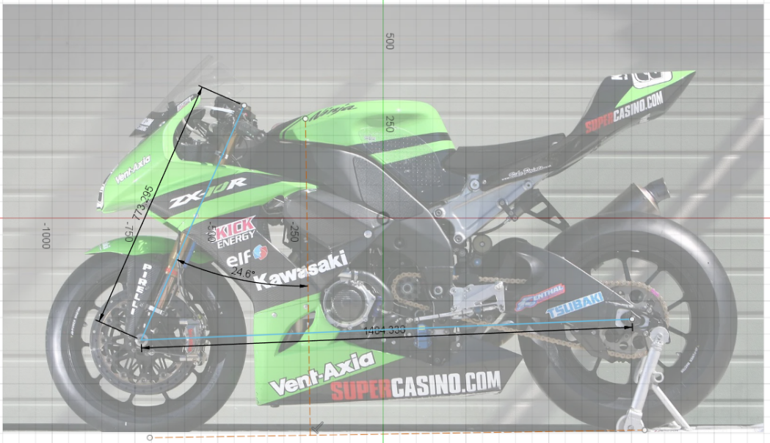
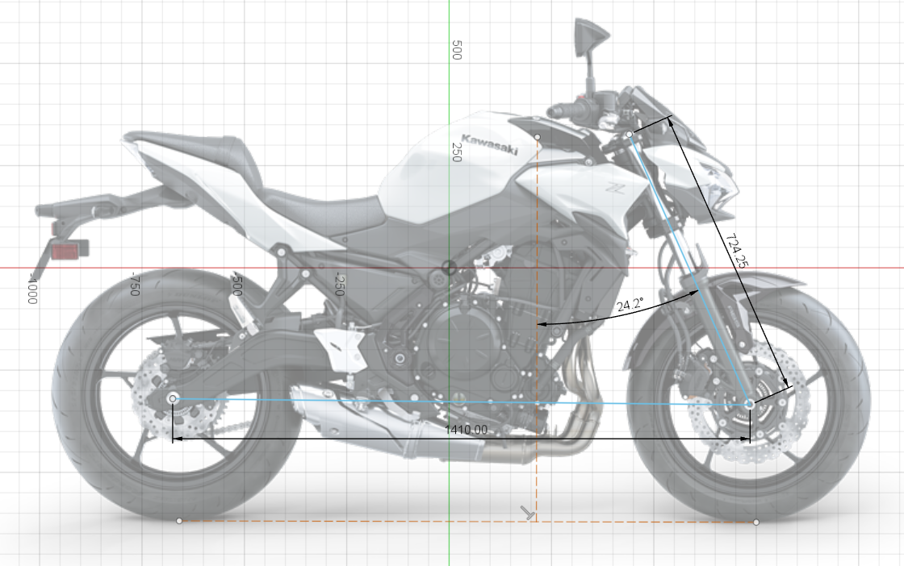
Due to not having physical access data acquired has been minimal, however some things have been gathered based off of photos online, as shown in Figures 10 and 11.
Figure 11 - ZX10R Angle Measurements (crash.net)
Figure 10 - Z650 Angle Measurements (Kawasaki 2025)
The Z650 and ER6N show very similar measurements. They are designed for the same purpose, so it makes sense for this to be the case. The CAD Calculated rake is 24.2 degrees, very close to the supposed 24.5 degrees of the ER6N. Wheelbase is also similar at 1410mm for the Z650 and 1405mm for the ER6N. They are both designed to be sporty when needed, but also comfortable and practical for everyday use. A pure track machine like the ZXR750 or ZX10R would not be suited to the design of these bikes.
Between the ZX10R and the ZXR750 there are similarities – they share similar rake angles and presumably trail by extension. There is a slight difference in wheelbase, with the ZXR being 1445mm to the ZX10R’s 1404mm. This can make a large difference to the bike’s capability to turn into corners. Both are clearly designed to be track machines, with their low rake angle and short wheelbase enabling them to turn quickly into corners and maintain speed.

Suggested Improvements
Both older bikes could have some improvements made to tailor them more towards their role.
The ER6N could focus more on being a touring bike – a slightly larger rake angle with lengthened trail and a longer wheelbase would benefit the experience when riding long distances on a motorway, or when carrying a pillion or luggage.
The ZXR750 is known to be heavy and hard to turn. It could make use of a shorter wheelbase to match its modern counterparts, potentially with a slightly shortened trail and lower rake angle value. Most importantly however would be the ability to fine tune these characteristics. Modern competition machines can tweak and fine tune every handling aspect of the bike, such as an adjustable headstock angle to change the rake. This would allow the rider to feed back and change anything they’re not happy with, making them faster.

References
ARAKI, Y. and GOTOU, K., 2001. Development of aerodynamic characteristics for motorcycles using scale model wind tunnel.
CRASH.NET, WSBK Kawasaki ZX10R.
FRENDO, F., SISI, A., GUIGGIANI, M. and DI PIAZZA, S., 2006. Analysis of motorcycle models for the evaluation of the handling performances. Vehicle System Dynamics, 44, pp. 181–191.
GADOLA, M., CHINDAMO, D., VITALE, F. and BONERA, E., 2019. The Design of A Motorcycle Featuring Fully Independent Adjustability for Front Suspension and Steering Geometry. IOP conference series.Materials Science and Engineering, 538(1), pp. 12064.
KAWASAKI, 2025. 2026 Kawasaki Z650.
KAWASAKI, 2007-last update, Kawasaki ER-6n Owner's Manual. Available: https://pws.ktivs.net/assets/manuals/99976-1319_EN-1bbfa247dea63bf39254e1d8362e6eab/index.html [01/12, 2025].
KAWASAKI, 1992-last update, Kawasaki ZXR750 Owner's Manual. Available: https://pws.ktivs.net/assets/manuals/99922-1544-04_EN-ee92fee69216c22f8125901e2bcc64c3/index.html#p=11 [03/12, 2025].
KRAIG SCHULZ, 18 April, 2016-last update, Schulz Engineering Electric Motorcycle Aerodynamics. Available: https://schultzengineering.us/aero?utm_source=chatgpt.com [05/12, 2025].
SUN, H., YAN, Y., LIU, J., LIU, X., ZHANG, L. and SHI, C., 2025. Evaluation of Motorcycles’ Handling and Stability Under Slalom Conditions. Machines (Basel), 13(3), pp. 198.

