Project Initiation Document

Student Name: Daniel Newman
Student Number: 1702330
Module Title: Project Management and Research Methods
Module Code: ACDA5004
Lecturer: Sue Maw

Contents
- Background and introduction – Page 3
- Objectives – Page 3
- Scope – Page 3
- Constraints – Page 4
- Authority – Page 4
- Resources – Page 5
- References – Page 5

Background and introduction
The intention of this project is to make our local communities safer in the event of a major disaster. The brief states that the project should be helpful or informative during the event of a disaster such as an earthquake. So after forming a group of three members, Daniel Newman, Josh Ford and Scott Mainwaring, the group began working on a project and conducting ideas for a website which could be used in the event of an emergency. What the group came up with was a website that could display a database of users sorted by street which would let others see if members of their community are safe.

Objectives
- The website will allow users to enter details about themselves that would help others in the local community know how that individual is doing in the event of a disaster. For example, the user might write a comment to tell others in the community that their house was too unsafe to stay in and that they’ve relocated to somewhere safer whilst it goes under repair. Another user might not have updated or added their details which would allow other users to know that that person might not be safe.
- The website must clearly define what fields are required and what fields are not required and tell the user what their information will be used for.
- The main goal of the website is for the people who are not as effected by the disaster to check up and knock the doors of those who have not used this website. However, effort will be made to encourage the user to knock on doors and call the police if they are concerned for the wellbeing of anyone, this is for the safety of the user.
- In the event of most disasters around the world police will respond to those who are able to call them and later search parties would be sent to wreckages in an attempt to save others. This website should act as an in-between so that those who are not safe and unable to call the police can hopefully be found before it’s too late by a search party. The quicker people are found in a disaster scenario, the better off their chances of survival will be.

Scope
There are some features that the group decided to include and some the group decided not to include due to various factors. The very first thing the user should see when they visit the website is a page with instructions on it detailing how the website works. The main page should show information such as how to use the system and what to do and what not to do when checking on anyone in the local community. There should be two main features on the home page, a button to input/update your personal details and a search bar to search for a specific postcode to see the details and notes of your local community. If the first of those features is clicked, then the website will re-direct the user to a page that will allow them to enter personal details. The only details required are house number, address and postcode; the group felt that these details are public information and so they would not be a problem to ask for under the data protection act. [1] The user would be made aware of the law beforehand and told that if they do decide to input any extra data then others would be able to see it displayed if they searched for the postcode and would also have to agree to those terms. The user would be able to use tick boxes to indicate if they are safe or not and a notepad field in which the user can write posts about whatever’s going on such as saying that they’ve made food for the town and that they’re happy to give them out to anyone that needs them. Because the data will be deleted every two weeks this will mean the user has to enter these details every two weeks for the duration of a disaster period so that the data is up to date.

Constraints
- The chances of everyone on any given street using the website and regularly updating their account or even wanting to use the website in the first place is low.
- There is a chance that the disaster in question could destroy electrical mains and make using the website impossible for some people. Reports say that Hurricane Irma in the US in 2017 caused a major blackout for about 4.5 million people [2] if the same happened then it would be impossible to use the website.

Authority
Daniel Newman: Project Manager, developer, designer
Josh Ford: Lead Designer, developer
Scott Mainwaring: Lead Developer, designer
Sue Maw: Sponsor

Below is the Gantt Chart created for the project. The time frame and tasks are required to be completed by the deadline of 18/01/2019. The group has allocated more time than the group believes it should take to complete these tasks, this is so that in the event of unforeseen occurrence or busy schedules the tasks could still be done by the given time frame.

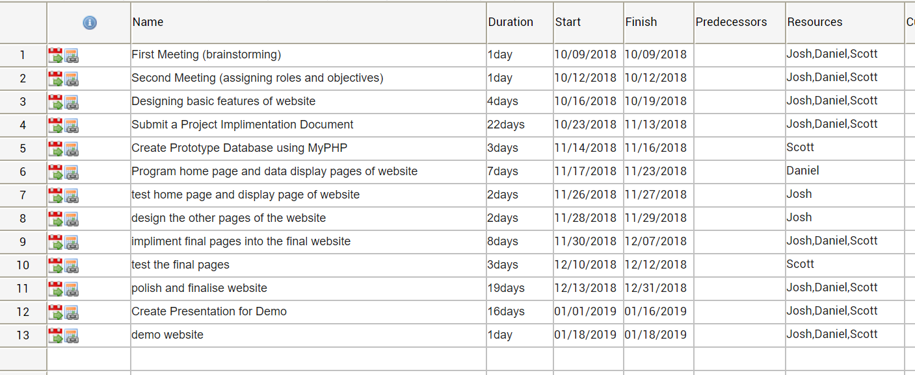

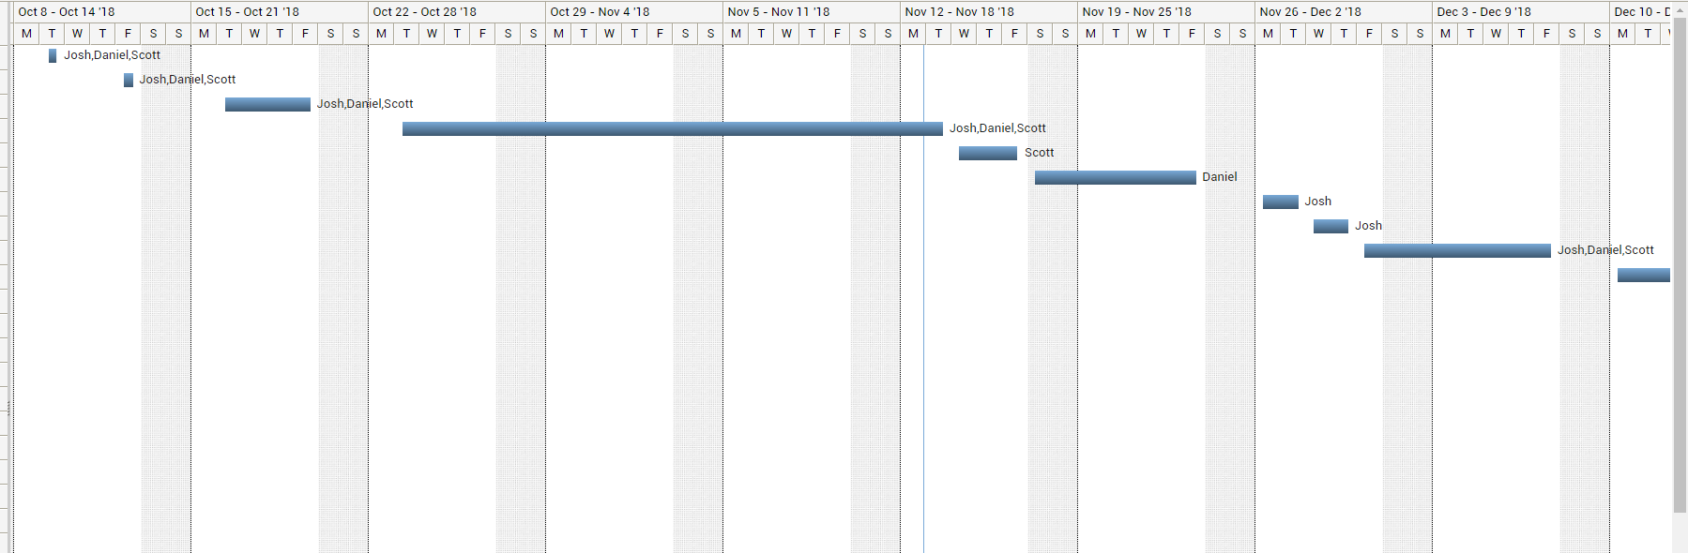

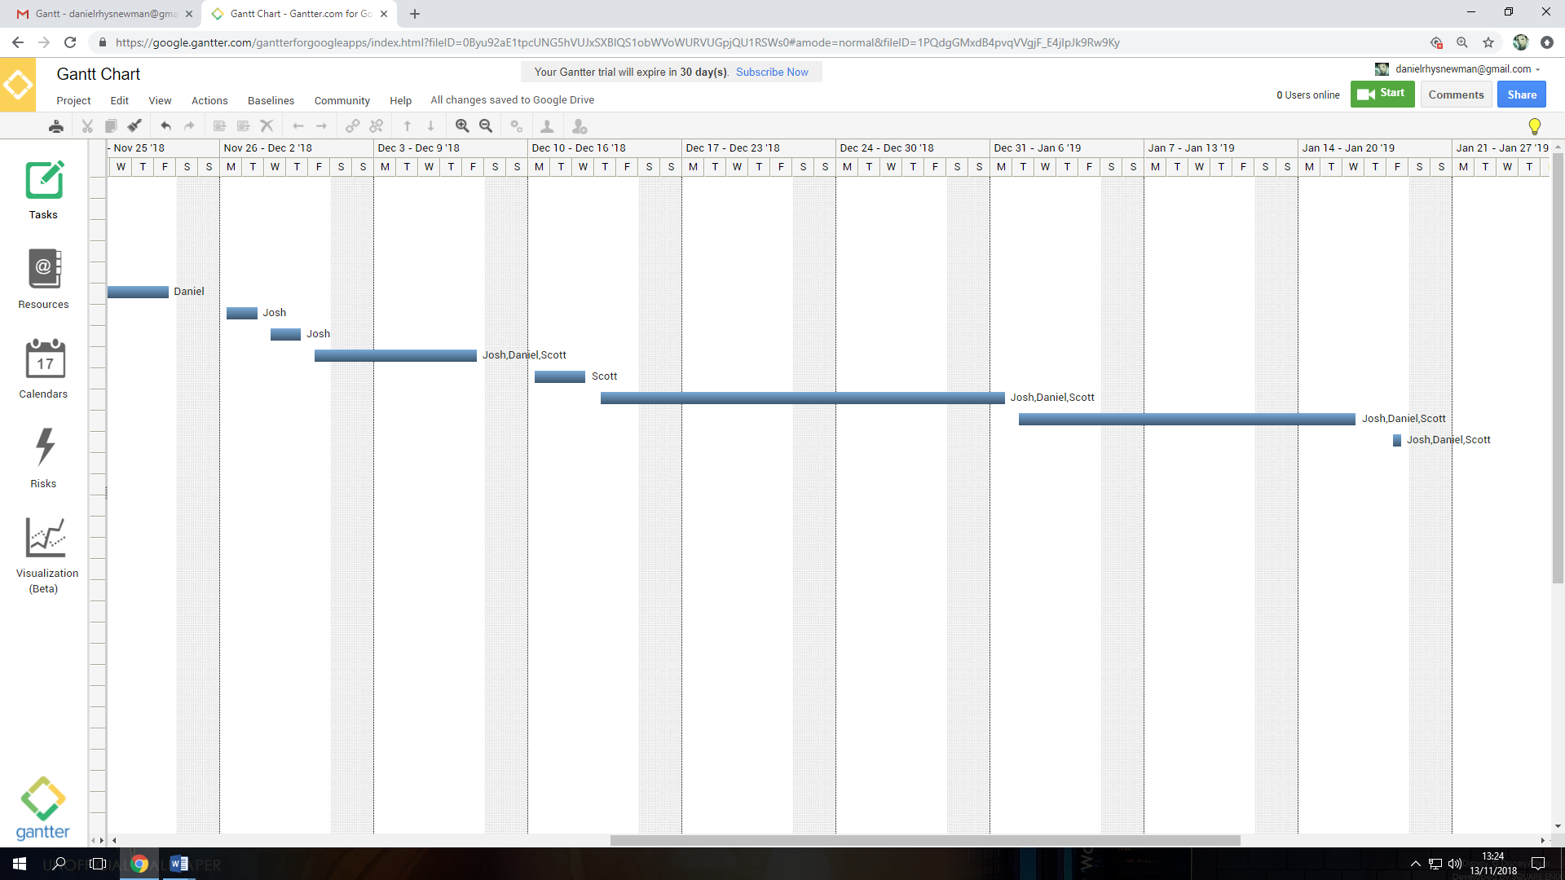

Resources
- The website will be programmed by hand using HTML, CSS and Javascript.
- The database will be created using phpmyadmin and then ran using a WAMP server so that it can be accessed on a LocalHost website.

References

[1] | Government, "Data Protection Act 2018," Legislation.Gov.uk, 23 May 2018. [Online]. Available: http://www.legislation.gov.uk/ukpga/2018/12/introduction/enacted. [Accessed 12 November 2018].
[2] | C. Daileda, "Irma causes one of the largest natural disaster power outages in U.S. history," MashableUK, 12 September 2017. [Online]. Available: https://mashable.com/2017/09/11/hurricane-irma-power-outage-florida/?europe=true#ik_ZI3AWmOq7. [Accessed 10 November 2018].

