Research and case scenario in Data Security and Compliance
Kara Thomas
Student University of Wales Trinity St David, Swansea, Wales
2304862@student.uwtsd.ac.uk

Abstract
Firewalls, VPNs and access control are used throughout computer systems. However, it is not as simple as implementing them all without thought as they each have their own drawbacks and benefits. With CyStresSolution’s new information security unit being developed then it needs to be decided what kind of overall impact these security tools have for the company. Moreover, a plan for the information security unit must have a solid structure for it to work efficiently. A mixture of sources including journal articles and websites have been used to conduct this research. Then an additional set of lecture notes were used to aid the formation of the information security plan. When carrying out my research of firewalls, VPNs and access control I found there are multiple advantages and disadvantages to each showing that careful implementation needs to be considered if any of these need to be applied. For the new information security unit an in-depth plan was created to showcase suggestions for how the company should carry out the unit. This included how to carry out their risk management, laws they needed to be aware of to avoid prosecution, and recommendations for carrying out contingency plans along with which types would be the most beneficial give certain circumstances.

Research in Data Security and Compliance
- Introduction
This research paper will be split into two parts. In this section of the research paper, I will discuss different types of security technologies. Security technologies have the purpose of providing security for networks, systems and infrastructure. There are different types of software, techniques, and devices that are classed as security technologies which include but are not limited to Fire Walls, VPNs, and Access Control. in addition to discussing the multiple kinds of security technologies the report will also talk about the positive and negative impacts those technologies bring to companies. This includes what type of impact they bring which includes but is not limited to whether it helps protect, detect or reacts to the company’s IT infrastructure and the systems within it. [1] [2]

- Firewalls

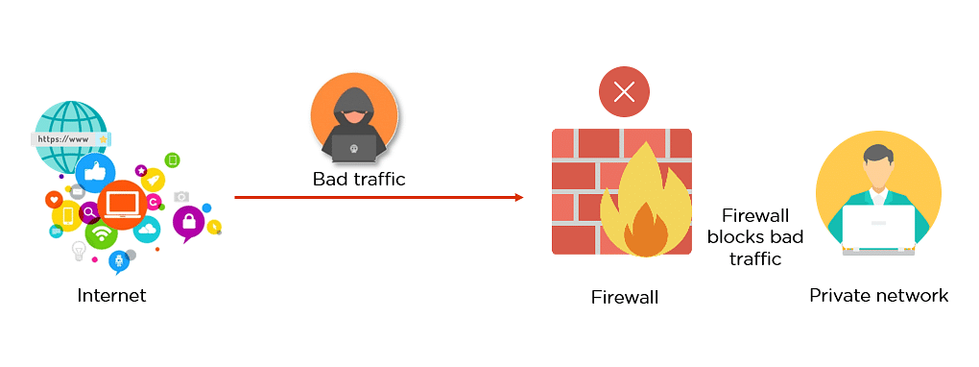
Figure: Firewall diagram
Source: [3]
A firewall is either a device or a piece of software that controls what traffic you can or cannot receive on an internal network from an external network. To do this the firewall has the job of deciding what can or cannot go through the ports of devices on the network. To decide what the firewall should or shouldn’t push through the ports it compares the data trying to go through the ports with preset security rules. [4]
Overall firewalls are crucial to a company’s environment as able to detect what’s happening on their network and protect it. As the preset security rules are able to outline what criteria makes up suspicious and unwanted traffic, it means if those rules are thought out properly firewalls can effectively detect any potentially dangerous traffic. This leads to how firewalls can protect, they do so by blocking the potentially dangerous traffic which could be malware such as viruses, ransomware and trojans. If malware infected the company’s network it could lead to data being stolen, devices being unusable, and using the devices to attack other companies. [5]

- Proxy Firewalls
There are multiple types of firewalls for different purposes, one of these firewalls is Proxy firewall. A proxy firewall helps your device connect to network (normally the internet) by acting as a gateway between the two. A proxy firewall is also a proxy server meaning it can give more functionality than a traditional firewall. It is able to detect viruses and decrease the bandwidth on the network by caching websites. Additionally, they can access websites and services that would otherwise be blocked and conceal any information a user has. [6] [7]

- Proxy firewalls
Proxy firewalls are useful as they can act as a firewall along with the additional benefits of having a built-in proxy server allows for quicker network speeds and a safer network by spotting any viruses.

Proxy firewalls have unique strengths that traditional firewalls don’t have. First of all, they are the most secure type of firewall which would make them preferable to companies as security is crucial for a network. What makes proxy firewalls more secure than traditional firewalls is due to proxy firewalls having their own IP address, they can stop the network from directly communicating with other systems.

However, proxy firewalls bring new weaknesses that traditional firewalls don’t have. One weakness is they are difficult to use, which could lead to the company to be deterred from using them. Another weakness is they can make the company’s internet connection slower. This in turn can cause less work to be done due to waiting employees waiting for the internet to load and losing morale when they become frustrated with it. The slow internet is caused by each outgoing and incoming packet having their own established connection. [6] [8]

- Cloud firewalls
For general cloud services there are three main types which are IaaS (Infrastructure as a Service), SaaS (Software as a service) and PaaS (Platform as a service). Some popular providers that run these cloud services are include Google Compute Cloud and IBM SoftLayer
Although firewalls have their own model known as the FWaaS (Firewall-as-a-service). FWaaS firewall’s function and act like traditional firewalls except they are hosted in the cloud. FWaaS Firewalls have the purpose of protecting cloud platforms and applications.

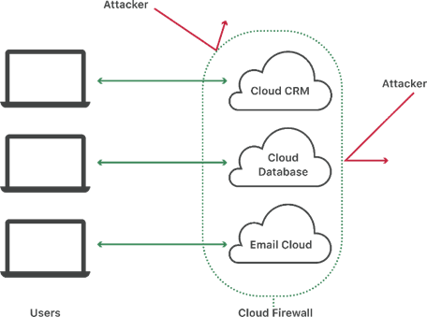

Figure: Cloud firewall diagram
Source: [9]

They have standard advantages of firewalls such as blocking any traffic that is deemed malicious. However, they also have unique advantages that can help a business including if a company uses cloud services along with any applications such as Microsoft Azure, then the use of FWaaS firewalls allow for easy integration with cloud services. Adding onto that point cloud firewalls can be scaled up easier. [9]
Another advantage is that due to the traffic not going through a hardware firewall it eliminates the possibility of any network choke points. To clarify a network choke point is when a certain area of the network is extremely slow or is limited which in turn causes reduces the network’s efficiency. [10]

However, Cloud firewalls also have their own disadvantages that directly impact a company. One disadvantage is the cloud service that the FWaaS firewall is running on goes down then it leaves the company vulnerable to any attacks on their network. Another disadvantage of cloud firewalls is that they can get expensive. The service that the cloud firewall runs on is normally done through a payment plan where the company will have to pay based on how much bandwidth, storage and processing power is used. Furthermore, an additional disadvantage is that running a cloud firewall can take up too much memory and processing power leading to the network being slowed down. [11]

- VPN
A VPN (Virtual Private Network) allows a device to have an encrypted connection over the internet, allowing for any private data that is being transmitted will be done so securely. To use a VPN, you need to choose a VPN provider that is best suited for the company. Popular providers include Surf Shark, Nord VPN, and CyberGhost VPN. When purchasing a VPN plan the company needs to look at the encryption’s strength, how many devices can use the VPN, and the quality of the customer service. [12]

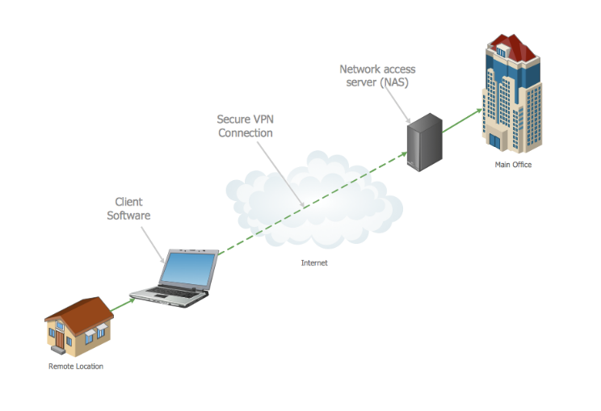
Figure: VPN Diagram
Source: [13]

VPNs are beneficial for companies as they prevent the traffic from the company’s network from being looked at by unauthorized users. [14]

Another example is with site-to-site VPNs. Site to site VPNs allow for two or more networks to connect to each other, which can be for corporate networks or connecting branch offices together. [15] An advantage of using site to site VPNs is that shared resources can be easily accessed without direct use of the internet by using file servers or databases. This lets employees access the resources needed no matter where they are. [16]
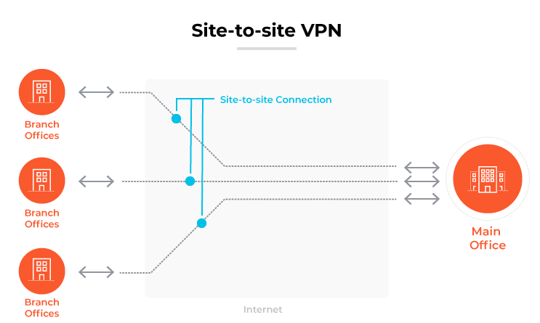
Figure: Site to site VPN
Source: [16]
Furthermore, if a company uses a VPN server it can benefit the company as VPN servers are useful and efficient for scalability. This is because they allow for remote employees and employees present at the company’s office to all use the same network at the same time.
Although there are disadvantages such as it being complicated to configure meaning a specialist employee is needed to configure it along with maintaining VPN gateways. An additional disadvantage of using VPNs is that they could reduce your internet speed. This is because VPNs have a secure encryption process that takes time to carry out. [17]

- Remote Access VPNs
Remote access VPNs allows for devices to connect to private networks such as a company network through a secure and encrypted manner by using a tunnelling approach.
For a remote access VPN to work the client and the server both need to use the VPN protocol. These could be either the Point to Point Tunneling Protocol (PPTP), Layer Two Tunneling Protocol (L2TP), or the Internet Protocol Security (IPSec). [18]

Remote access VPNs have unique benefits for companies, one of which is that they are convenient for remote workers. This allows anyone who has a long or nearly inaccessible commute to be more consistent and have an easier time carrying out the work as they do not have to worry about travelling. Additionally, if the company decides to have all their staff to work from through remote access VPNs then it could mean that the company does not need to have a physical office which can save the company a big expense. Or if they do need one then they can make their employees only come in on certain days (such as twice a week) and for the rest of the week the office can be closed, allowing for money to be saved on utilities such as electricity and water. This also means when the company is looking to hire more employees, they can have a bigger pool of candidates as location isn’t a factor they need to consider if they have a suitable device and an internet connection.

Another benefit is by employees using remote access VPNs, it allows for their network connection to be a lot more secure. This is an affordable way for a company to add an extra protective measure for data security, especially since other methods for a company to improve their data security can be quite costly.

There are risks for a company to use remote access VPNs. One such risk is that you cannot see what is occurring within a VPN connection. This is due to the encryption style of SSL VPNs. The downside to this is that if a bad actor (such as an employee with malicious intent) has been able to carry out an attack on the connection whoever is managing the network will not be able to intercept the attack.

Another disadvantage of remote access VPNs is they do not check the strength and security of the recipient device’s network. This in turn can cause malware including worms and ransomware to infiltrate the company’s network.

Furthermore, if anything happens to the remote access VPN connection due to a malfunction or an issue with the VPN provider for example, then it can interrupt the workflow of a business and result in employees needing to catch up on work. If only one or two employees work remotely then it will cause minimal disruption. However, if the company heavily relies on remote access for their employees to do their work, then the business could grind to a halt. Especially if the connection is down for a long time which could have big consequences such as losing current clients and money being lost from nonproductive hours of work. [19] [20] [21] [22]

- Access Control
Access control is used to control what users can do on computer systems including what programs can be used and having certain system privileges. This is carried out by the user’s credentials being identified and then based on those credentials the user is allocated the proper level of authorization. There are multiple ways a user can be identified such as with username and password, pins, and authentication apps.

The purpose of access control is to limit the risk of having unauthorised access to the company’s network and in turn its data. If a cyber-attack happens and the company’s data is accessed it can have serious consequences such as the data being sold, used to hack into employee accounts and/or deleted.
There are multiple different types of access control, the first one to cover is role-based access control. Role-based access control is when computer system privileges and restrictions of individuals or groups of employees are set based on their role in the company. For example, a standard employee would not have access to change network settings while system administrators would. This is because a regular staff member may not know what they are doing, causing incorrect configurations to be set and a lot of problems to be caused.
Another type of access control is mandatory access control. Mandatory access control is dependent on a security level which is based on what kind of data or an area of a computer system that needs to be accessed. For example, if the data that an employee needs to access is personal employee data such as bank information for payroll, then it would have a higher security level than data that is just company sales figures.
It also has its own model that is formed by an employee hierarchy being created. This hierarchy gives each level the relevant access to the required data or computer systems which is based on the security level of said data/computer systems. Additionally, because of the hierarchical system staff can also access all the data and systems in the ranks below them. [23] [24]

Access control brings many benefits for businesses. One such benefit is it is easy to manage their employees’ details such as their username and password. Furthermore, this allows the company to have more control which in turn means any issues with the credentials can be sorted out quickly. Another benefit for companies is that they can use other types of credentials for access to the building such as key cards. Using these types of credentials means only authorised workers can get into the building, making the security for the building more efficient. [25]

Risks can be created if companies who use access control carried it out and use it poorly. One such risk is having unauthorised access, which can be caused by poor password management. An example of a poor password policy is having minimal password requirements for an employee, including not requiring an employee to use numbers, symbols and capital letters. Another example is not making employees regularly update their passwords. This can lead to data breaches and data being leaked. The solution to this is to make sure employees’ passwords are at a minimum required length, along with a mix of symbols and numbers. Moreover, they need extra ways to verify employees with multi-factor verification. This could be done with the use of biometrics including getting an employee to use their fingerprint or face scan to verify it is them. [26]
Or having the employees using a third-party application such as Microsoft Authenticator.
[27]
Another risk is malicious employees at the company finding ways such as with malware or using other employees’ credentials to gain extra privileges through privilege escalation. This can lead to private data being accessed, new “employees” being added, and system settings being overridden. [28]
- Group Policy
An example of Access Control being used in the workplace is Group Policy. A Group Policy is a set rules set for groups of users or for computer configurations throughout a company’s network. [29]
When a Group Policy is used with an active directory all settings that have been configured are stored in a Group Policy Object (GPO). GPOs are virtual places for policy settings and security permissions to be stored which in turn can be used on users and computers within the Active Directory.
There are different policies that can be set, these include managing criteria that passwords can have, allowing/denying the ability for users to log on to the company’s network remotely, and deciding how the user’s desktop will look. [30] [31] [32]

- Conclusion
To conclude this section of the report demonstrates what the security technologies firewalls, VPNs and access control are and how It impacts a company. Firewalls have a positive impact for a company, the main advantages of them are that they are able to detect any suspicious traffic on their network and when detecting it they are able to block it from going to any devices within the network. VPNs bring a mixture of advantages and disadvantages. The main advantage they bring is that they prevent people from looking at the company’s network traffic. The main disadvantage they bring is that they are very hard to set up meaning a specialist would be required to set it up. The final security technology I covered was access control which overall has a positive impact, the main advantage of access control is that it creates structure by giving employees certain permissions and in turn limits the risk of unauthorised access.

Planning CyStresSolution’s new information security unit

- Introduction
CyStresSolution (also known as CSS) is a company that is focused on helping other companies protect themselves from possibly devastating cyber-attacks. They carry this out by providing threat intelligence and consulting companies.
CyStresSolution is creating a new information security unit which in this report I will demonstrate a plan I have created to prepare the unit. This plan will contain a mix of charts, diagrams and tables.

- Organisation structure

The new information security unit will carry out four crucial objectives that support and are beneficial for the company. These four objectives are:
• Allowing the company to safely run programs and software on its ICT systems.
• Protecting the company’s technology assets
• Prevents any disruption to the company’s functioning
• Safeguard the data the company gains and stores
These objectives of the fundamentals of keeping the company afloat.
- Allowing the company to safely run programs and software on its ICT systems.
For the company to be able to achieve software and programs being run safely they need to have a computer environment that is capable to do so. When this is achieved management needs to oversee any decisions relating to the safeguarded environment, so it continues to flourish.
- Protecting the company’s technology assets
For the company to have their technology assets secured they need to have a secure hardware framework that correlates with the size of the company. When the company gets bigger, they may need to implement extra security resources.
- Prevents any disruption to the company’s functioning
The people that are responsible for stopping any disruption to the company are management. The implementation of this is more focused on the company side of things rather than the technological side.
- Safeguard the data the company gains and stores
The key to effectively protecting data the company gains and stores is to protect it through all cycles of use, this includes:
• Its transmission
• While it is being processed
• When it is in storage
If a company does not store any data, then that means the company will have a harder time carrying out tasks. For example, If the new information security unit does not store firewall logs that contain information about suspicious activity on the network then the employees will have a harder time noticing which threats and in turn stopping them. [33]

- Relevant policies and procedures
When forming the unit there needs to be policies and procedures in place. The difference between a law and a policy is that a policy is a principle that showcases what is and what is not appropriate for the workplace, and it is followed by and created by the company. While laws are a set of rules established in countries that are used to control the actions of the inhabitants of the country and even enforce penalties when required. [34]

One important policy for the unit that should be implemented would be a recruitment policy. A recruitment policy contains a consistent system for how the company is meant to hire people. The policy would outline the relevant expertise, and the desired qualifications needed for the role. This is so the hiring team can follow this policy to ensure that the staff hired for the role is done so in an unbiased manner, by making unbiased decisions towards the potential hire. [35] [36] [37]
Another important policy is the health and safety policy. The health and safety policy shows how the company outlines how the workplace should act in guidance with health and safety laws. This could include it being told which people within the company oversee health and safety, carrying out a risk assessment, and/or making sure employees have the appropriate training. [38]

It would also be beneficial for CyStresSolution to adopt a security policy. One security policy that should be adopted is the Enterprise information security policy. The Enterprise information security policy contains the company's view on how their security system should be set up. Based on their perspective the relevant roles and responsibilities are given to make sure important information is safe.

For security policies to be viable they need to:
• Be monitored by a manager.
• Be carried out by a set of reviews.
• have a way for recommendations to be suggested.
• Make an insurance policy and give it to the policyholder.
• And finally, their policy management would be automated. [39]

- Laws and ethics
The information security unit needs to abide by the law as not doing so can cause massive problems for CyStresSolution, including being sued and in turn losing a lot of money and potentially getting shut down. There are multiple types of law including constitutional, statutory, and regulatory.
One important law that is related to the unit is the Computer Misuse Act 1990. The Computer Misuse Act 1990 is a law that makes the following three acts illegal:
• A person having unauthorised access to a computer system
• A person having unauthorised access to a computer system with the purpose of carrying out additional offenses.
• A person having unauthorised access to a computer system with the intent of causing damage to the system.

Another law that is crucial in the planning for the unit is The Data Protection Act 2018. This act has been put in place to control how companies use people’s personal data. This is relevant as the unit may be handling personal data of employees or clients that they are working with.
The people within the company who handle personal data need to follow data protection principles which are set of stern rules. These rules make sure the data is:
• Used justly and ethically
• Clearly stated for why it is being used/kept and as such is only used for what is required.
• Accurate and current
• Disposed of when it is no longer needed
• Kept securely
Regarding more sensitive data including but not limited to sexual orientation, race and health there is more powerful legal protection in place.
This law is extremely important to keep in mind for the information security unit as abiding by the act shows that the unit and CyStresSolution as a whole is storing data properly and safely. If they fail to follow the law however it can lead to fines up to £17 million or 4% of the company’s global turnover it is decided on depending on which one costs more. [40] [41] [42] [43]

- Governance and strategic planning for security
Information security governance is when executive management carry out a set of obligations. The outcome they want to achieve from this is strategic alignment, risk management, resource management, performance measurement and value delivery to be carried out. Information security employees all throughout the information security unit have a part to play in implementing governance. Below showcases each class of employees’ responsibilities to achieve this.
Role | Responsibilities
Regular Staff | Carry out policies, report any data vulnerabilities,
Supervisor | Conduct training and apply compliance
Department Head | Establish policy, deal with security breaches, apply compliance, and oversees executing an audit.
Chief Risk Officer | Establish policy, deal with security breaches, apply compliance, and oversees executing an audit.
Chief Information Officer | Establish policy, deal with security breaches, apply compliance, and oversees executing an audit.
Chief Security Officer | Establish policy, deal with security breaches, apply compliance, and oversees executing an audit.
Chief Executive Officer | Watch over the company’s security structure, brief the company’s board and the public on any decisions made.

If staff do not carry out their duties and do not work cooperatively this leads to the structure not working. [44]
- Risk management
Risk management is needed in the new information security unit as with it the company can identify a risk and assess how big of a risk it is. Then they can follow this up by taking the relevant measures to reduce the risk as much as possible. There are three main components to risk management which are risk identification, risk assessment and risk control.
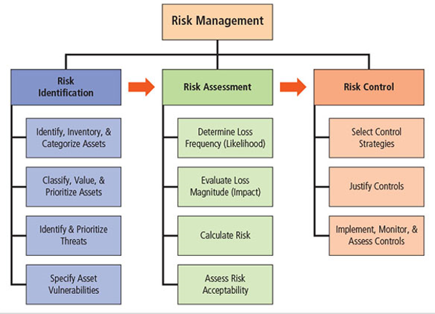
Source:[45]

Risk identification is the process of spotting any issues that can prevent a company from carrying out what they need to do. Examples of risks the unit would need to be aware of could be data breaches, data theft, and any accidents that occur within the company.
Risk assessment is when any weaknesses are assessed to see how much of a risk they are to the company. When carrying out a risk assessment a rating is normally given to each vulnerability.

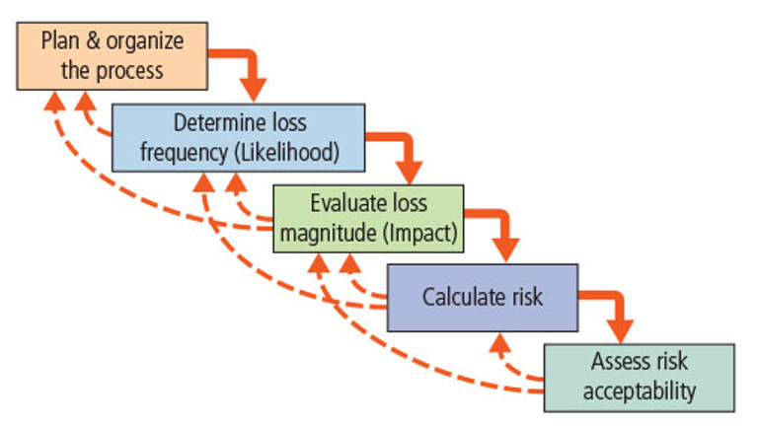

Source:[45]
There are five stages to carry out a risk assessment which are plan the process, determine likelihood of the risk occurring, evaluate the Impact, calculate the risk and gauge the risk acceptability.

For the information security unit, a great method that would be appropriate for them to use to carry out these steps would be a 5×5 risk assessment matrix.
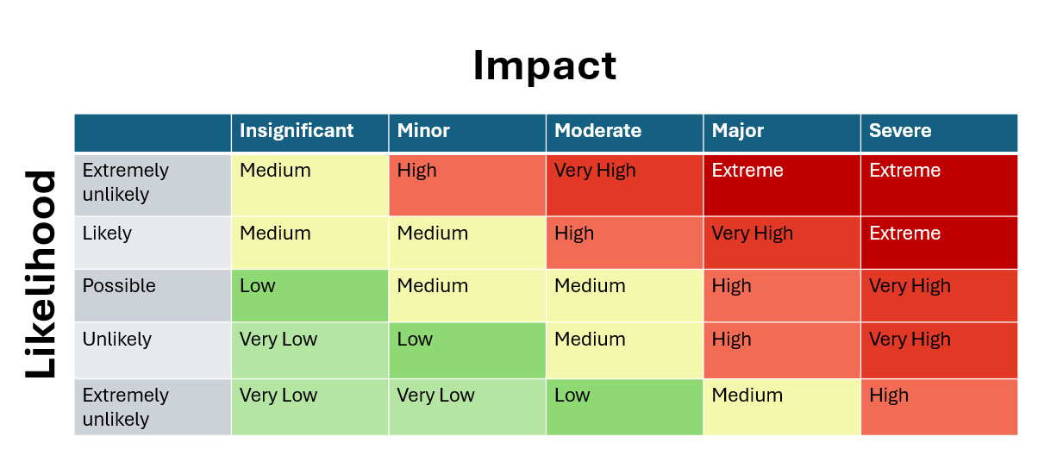
Diagram: 5×5 risk assessment matrix
5x5 risk assessment matrix’s have the likelihood rating on one side of the matrices and across the top has the impact. Then based on these factors the rest of the grid is filled in with the relevant risk level. These are traditionally colour coded to emphasis the risk levels. This diagram is useful as it allows the team behind the risk assessment to determine what risks to prioritise based on its impact and how likely the risk will happen.
Risk control is to analyse the results from the risk assessment to carry out the fitting measures to reduce or stop risks.

There are five different approaches that can be taken to control a vulnerability which are:
• Accept
• Defend
• Migrate
• Terminate
• Transference
[45]
- Contingencies planning
A contingency plan is a plan that is set up to prepare for a potential incident and if it occurs it can be executed. It also contains all the required information for it to be carried out effectively. There are multiple types of contingency planning processes which are:
• Business impact analysis
• Incident response
• Disaster recovery
• Business continuity
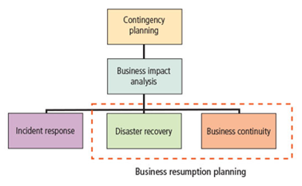
Source:[42]

- Business Impact Analysis
Business impact analysis is used to identify what particular business activities need to be prioritised when it comes to the recovery process. Once they have decided which business activities need to be put first then the company is able to decide which resources are given out and can set up effective contingency plans. [46]

- Incident Response Planning
An Incident response plan is used to spot an incident and based on the classification of the incident the relevant response is implemented. An incident is a type of attack that endangers either the availability, confidentiality, or integrity of the company’s information resources.
- Disaster recovery
The disaster recovery plan is used to prepare for a disaster to occur along with the recovery process from the attack.
Before the contingency planning team carries out a disaster recovery plan they need to choose if the attack they are facing is a disaster or an incident. From there it can be decided if a disaster recovery plan or incident response plan is more appropriate.
- Business continuity
The business continuity plan is used for when an attack causes the company’s tasks to be halted and plans out where these tasks will be reallocated to.
These are all traditionally carried out within one electronic document that is stored digitally. This is done so employees can access the document easily and quickly when it is needed.[42]

- Conclusion
In conclusion my plan for a new Information security unit would be beneficial for their company as it goes in depth on topics such as contingency planning, risk management and policies. With discussing contingency planning I covered the different types of contingency planning and how they are important for different scenarios the information security unit might face such as disaster recovery which is used to identify from a disaster and from there help CyStresSolution bounce back from it efficiently. Furthermore, with risk management I covered the importance of it as it is used to assess how big of a risk an issue is which helps the company prioritise what they need to so all issues are dealt with swiftly. I suggested a method the information security unit could use called a 5×5 risk assessment matrix which based on the impact the risk could cause along with how likely it would happen determines its overall risk factor. If CyStresSolution uses this method to decide a problems overall risk factor, then they will know how urgently they need to deal with it meaning they can allocate the right amount of time and resources. Without this they could allocate too much time and resources and waste them on a threat that does not need it leading to other areas being vulnerable. Or they cannot give enough leading to them being under prepared. Moreover, I also covered policies and procedures as it is important for the unit to know how to deal with situations when they happen. One policy I discussed is the Enterprise information security policy, this policy is set in place as a way to assign the needed roles and responsibilities to employees. This is based on the company’s idea of how their security system should be set up. This is important as it gives the company structure and makes it clear what everyone’s objectives are and in turn that makes having a secure information security unit way easier to achieve.

References

[1] | EC-Council University, "All You Need to Know About Network Security, Firewalls, and VPNs," EC-Council, N/A. [Online]. Available: https://www.eccu.edu/blog/cybersecurity/network-security-firewalls-vpns/#:~:text=In%20addition%20to%20blocking%20unauthorized,%2Dservice%20(DoS)%20attacks. [Accessed 30 November 2024].
[2] | K. Johnson, "Top 7 types of data security technology," Tech Target, 8 July 2022. [Online]. Available: https://www.techtarget.com/searchsecurity/feature/Top-7-types-of-data-security-technology. [Accessed 30 November 2024].
[3] | S. Satish, "What is a Firewall? A Guide to Network Security and Safety," Simplilearn, 10 December 2024. [Online]. Available: https://www.simplilearn.com/tutorials/cyber-security-tutorial/what-is-firewall. [Accessed 11 December 2024].
[4] | Microsoft, "What is a Firewall?," Microsoft, N/A. [Online]. Available: https://support.microsoft.com/en-gb/office/what-is-a-firewall-6870c88d-69b6-4db4-9cb1-0e4afa7a8603. [Accessed 30 November 2024].
[5] | National Cyber Security Centre, "Mitigating malware and ransomware attacks," National Cyber Security Centre, 13 February 2020. [Online]. Available: https://www.ncsc.gov.uk/guidance/mitigating-malware-and-ransomware-attacks. [Accessed 30 November 2024].
[6] | TechTarget Contributor, "Proxy Firewall," TechTarget, N/A. [Online]. Available: https://www.techtarget.com/searchsecurity/definition/proxy-firewall. [Accessed 30 November 2024].
[7] | Cisco, "What Is a Firewall?," Cisco, N/A. [Online]. Available: https://www.cisco.com/c/en_uk/products/security/firewalls/what-is-a-firewall.html. [Accessed 30 November 2024].
[8] | J. C. P. F. E. W. Johanna Ullrich, "The role and security of firewalls in cyber-physical cloud computing," EURASIP Journal on Information Security, vol. N/A, no. 18, p. N/A, 2016.
[9] | Cloudflare, "What is a cloud firewall?," Cloudflare, N/A. [Online]. Available: https://www.cloudflare.com/learning/cloud/what-is-a-cloud-firewall/. [Accessed 30 November 2024].
[10] | ITU, "What is Network Choke Point?," ITU, N/A. [Online]. Available: https://www.ituonline.com/tech-definitions/what-is-network-choke-point/#:~:text=A%20network%20choke%20point%20is,and%20efficiency%20of%20the%20network.. [Accessed 30 November 2024].
[11] | K. Mindanao, "Virtual Firewalls: 5 Pros & Cons Before Buying," Intelligent Technical Solutions, 7 June 2023. [Online]. Available: https://www.itsasap.com/blog/virtual-firewall-pros-cons. [Accessed 30 November 2024].
[12] | Surfshark, "Comparing VPN services: which one’s the best in 2024?," Surfshark, N/A. [Online]. Available: https://surfshark.com/comparison#:~:text=There%20are%20several%20things%20you,support%2C%20and%20additional%20security%20features.. [Accessed 30 November 2024].
[13] | ConceptDraw, "What is a Virtual Private Network?," ConceptDraw, N/A. [Online]. Available: https://www.conceptdraw.com/How-To-Guide/virtual-private-networks. [Accessed 31 November 2024].
[14] | G. H. Paul Ferguson, "What is a VPN?," N/A, April 1998. [Online]. Available: http://sol.te.net.ua/www/nanog/vpn.pdf. [Accessed 30 November 2024].
[15] | Cisco, "What Is a Virtual Private Network (VPN)?," Cisco, N/A. [Online]. Available: https://www.cisco.com/c/en/us/products/security/vpn-endpoint-security-clients/what-is-vpn.html. [Accessed 30 November 2024].
[16] | Paloalto Networks, "What Is a Site-to-Site VPN?," Paloalto Networks, N/A. [Online]. Available: https://www.paloaltonetworks.co.uk/cyberpedia/what-is-a-site-to-site-vpn#benefits. [Accessed 30 November 2024].
[17] | Fortinet, "Benefits Of A VPN," Fortinet, N/A. [Online]. Available: https://www.fortinet.com/uk/resources/cyberglossary/benefits-of-vpn. [Accessed 30 November 2024].
[18] | A. A. Jaha, F. B. Shatwan and M. Ashibani, 2008 The Second International Conference on Next Generation Mobile Applications, Services, and Technologies, vol. N/A, Cardiff: N/A, 2008, pp. 309-314.
[19] | Fortinet, "Remote Access VPN," Fortinet, N/A. [Online]. Available: https://www.fortinet.com/uk/resources/cyberglossary/remote-access-vpn#:~:text=A%20remote%20access%20VPN%20connects,the%20VPN%20client%20app%20installed.. [Accessed 30 November 2024].
[20] | Cisco, "What Is a Virtual Private Network (VPN)?," Cisco, N/A. [Online]. Available: https://www.cisco.com/c/en/us/products/security/vpn-endpoint-security-clients/what-is-vpn.html. [Accessed 31 November 2024].
[21] | A. A. Jaha, F. B. Shatwan and M. Ashibani, "Proper Virtual Private Network (VPN) Solution," Ieee explore, 16 September 2008. [Online]. Available: https://ieeexplore.ieee.org/abstract/document/4756450. [Accessed 31 November 2024].
[22] | D. R. K. Thomas, "VPN SOLUTIONS: BALANCING PRODUCTIVITY AND SECURITY FOR BUSINESS," SWISSSCHOOLOFBUSINESSANDMANAGEMENTGENEVA, N/A, 2023.
[23] | G. Wright, "What is access control?," Tech target, September 2024. [Online]. Available: https://www.techtarget.com/searchsecurity/definition/access-control. [Accessed 31 November 2024].
[24] | Microsoft, "What is access control?," Microsoft, N/A. [Online]. Available: https://www.microsoft.com/en-gb/security/business/security-101/what-is-access-control. [Accessed 31 November 2024].
[25] | Higher Information Group, "7 Benefits of Access Control Systems," Higher Information Group, 28 July 2023. [Online]. Available: https://higherinfogroup.com/7-benefits-of-access-control-systems/. [Accessed 31 November 2024].
[26] | Onelogin, "What is Multi-Factor Authentication (MFA) and How Does it Work?," Onelogin, N/A. [Online]. Available: https://www.onelogin.com/learn/what-is-mfa . [Accessed 31 November 2024].
[27] | Microsoft Support, "What is: Multifactor Authentication," Microsoft, N/A. [Online]. Available: https://support.microsoft.com/en-gb/topic/what-is-multifactor-authentication-e5e39437-121c-be60-d123-eda06bddf661. [Accessed 31 November 2024].
[28] | C. Riddell, "10 Security Risks of Poor Access Management and How to Mitigate Them," Netwrix, [Online]. Available: https://blog.netwrix.com/access-management-security-risks. [Accessed 31 November 2024].
[29] | W. Stanek, Windows Group Policy: The Personal Trainer for Windows Server 2012 and Windows Server 2012 R2, N/A: Stanek & Associates, 2015.
[30] | A. Simister, "What are Group Policy and GPO and What Role do they Play in Data Security?," Lepide, 15 July 2024. [Online]. Available: https://www.lepide.com/blog/what-is-group-policy-gpo-and-what-role-does-it-play-in-data-security/#:~:text=Group%20Policy%20settings%20are%20highly,the%20appearance%20of%20the%20desktop.. [Accessed 31 November 2024].
[31] | Microsoft, "Group Policy overview," Microsoft, 22 April 2024. [Online]. Available: https://learn.microsoft.com/en-us/windows-server/identity/ad-ds/manage/group-policy/group-policy-overview. [Accessed 31 November 2024].
[32] | "2.6. Group Policy Object Access Control," Red Hat Documentation, N/A. [Online]. Available: https://docs.redhat.com/en/documentation/red_hat_enterprise_linux/7/html/windows_integration_guide/sssd-gpo. [Accessed 31 November 2024].
[33] | C. Campbell, "Lecture 2".
[34] | Cambridge dictionary, "law," Cambridge, N/A. [Online]. Available: https://dictionary.cambridge.org/dictionary/english/law.
[35] | B. Campling, "4 cornerstones of a solid recruitment policy," Recruitee, 21 August 2024. [Online]. Available: https://recruitee.com/articles/recruitment-policy#:~:text=A%20recruitment%20policy%20helps%20teams,best%20fit%20for%20the%20role. . [Accessed 31 November 2024].
[36] | Monitor, "Recruitment and Selection Policy," 21 July 2013. [Online]. Available: https://assets.publishing.service.gov.uk/government/uploads/system/uploads/attachment_data/file/306964/Recruitment_and_Selection__Policy_-_April_2014.pdf. [Accessed 31 November 2024].
[37] | Indeed Editorial Team, "10 Examples of Policies and Procedures in the Workplace," Indeed, 12 August 2024. [Online]. Available: https://au.indeed.com/career-advice/career-development/examples-of-policies-and-procedures-in-the-workplace. [Accessed 31 November 2024].
[38] | Health and Safety Executive, "Prepare a health and safety policy," Health and Safety Executive, N/A. [Online]. Available: https://www.hse.gov.uk/simple-health-safety/policy/how-to-write-your-policy.htm. [Accessed 31 November 2024].
[39] | RSI Security, "What Is The Purpose Of An Enterprise Information Security Policy?," RSI Security, 2018. [Online]. Available: https://blog-rsisecurity-com.cdn.ampproject.org/v/s/blog.rsisecurity.com/what-is-the-purpose-of-an-enterprise-information-security-policy/amp/?amp_gsa=1&amp_js_v=a9&usqp=mq331AQIUAKwASCAAgM%3D#amp_tf=From%20%251%24s&aoh=17336609702880&referrer=https%3A%2F. [Accessed 31 November 2024].
[40] | itgovernance, "GDPR Penalties & Fines | What's the Maximum Fine in 2023?," itgovernance, [Online]. Available: https://www.itgovernance.co.uk/dpa-and-gdpr-penalties#:~:text=The%20UK%20GDPR%20and%20DPA,whichever%20is%20greater%20%E2%80%93%20for%20infringements.. [Accessed 31 November 2024].
[41] | GOV.UK, "Data protection," GOV.UK, N/A. [Online]. Available: https://www.gov.uk/data-protection. [Accessed 31 November 2024].
[42] | legislation.gov.uk, "Computer Misuse Act 1990," legislation.gov.uk, N/A. [Online]. Available: https://www.legislation.gov.uk/ukpga/1990/18/contents. [Accessed 31 November 2024].
[43] | C. Campbell, "Lecture 3".
[44] | C. Campbell, Lecture 4.
[45] | C. Campbell, Lecture 5.
[46] | R. Meris, "Business Impact Analysis for Operational Continuity," Safetyculture, 8 November 2024. [Online]. Available: https://safetyculture.com/topics/business-continuity-plan/business-impact-analysis/. [Accessed 31 November 2024].

