

LOCATION:SwansEA SA1 | LLEOLIAD: abertawe
LEVEL 4 | LEFEL 4
EXAMINATION PERIOD | CYFNOD ARHOLIADAU
JANuary 2025 | IONAWR 2025

MODULE CODE: ACMA4009

APPLIED ANALYTICS

TIME: 1.0 hours
15 minutes can be used before you start to familiarise yourselves with any formulae you need to complete the tasks and 15 minutes at the end to make your workings presentable.
(Total time for submission is 1.5 hours)
Equipment or materials required –

Calculators allowed
Formula booklets provided

ANSWER ALL QUESTIONS

CERTIFICATATE OF HIGHER EDUCATION :APPLIED ANALYTICS

TASK DESCRIPTION

Consider each of the following problems and answer all questions.
Total marks (65) which constitutes 100%

- Write down the base units for the following: [5]

a) Temperature
b) Luminous Intensity
c) Volume
d) Displacement
e) Time

- Given that Pressure is defined as;

$$Pressure=Force/Area$$

Write down the base units of Pressure. [5]

- A body of mass 2kg rests in limiting equilibrium on a rough inclined plane, which is at an angle of 45⁰ to the horizontal.

a) Draw a free body diagram in your answer booklet showing the frictional force, normal reaction and the component of weight that acts down the slope. [3]

b) Calculate the maximum magnitude of frictional force. [4]

c) State which of the other forces are equal and give a reason why you can state this without calculation. [2]

d) Calculate the magnitude of the normal reaction to the surface. [2]

4. Solve the following by factorising:

i) $x^{2}-5x+6=0$ [3]
ii) $x^{2}+7x+6=0$ [3]
iii)$x^{2}+10x=-25$ [3]
iv) $x^{2}-2x-15=0$ [3]
v) $2x^{2}+3x+1=0$ [3]

5. Solve the following (to 2d.p’s) by using the quadratic formula:

(i) $x^{2}-4x-1=0$
[5]
(ii) $2x^{2}+3x-1=0$ [5]

6 Solve the following equations

(i) $\frac{3(x-1)}{2}=.\frac{x+2}{4}$ [5]

(ii) 2x + 5y = 7
3x + 2y = 5 [5]

7. For the following electrical circuit :

Find:

a) The total resistance of the circuit
b) Current I₂ in the branched circuit.
c) The power supplied by the cell.
[9]

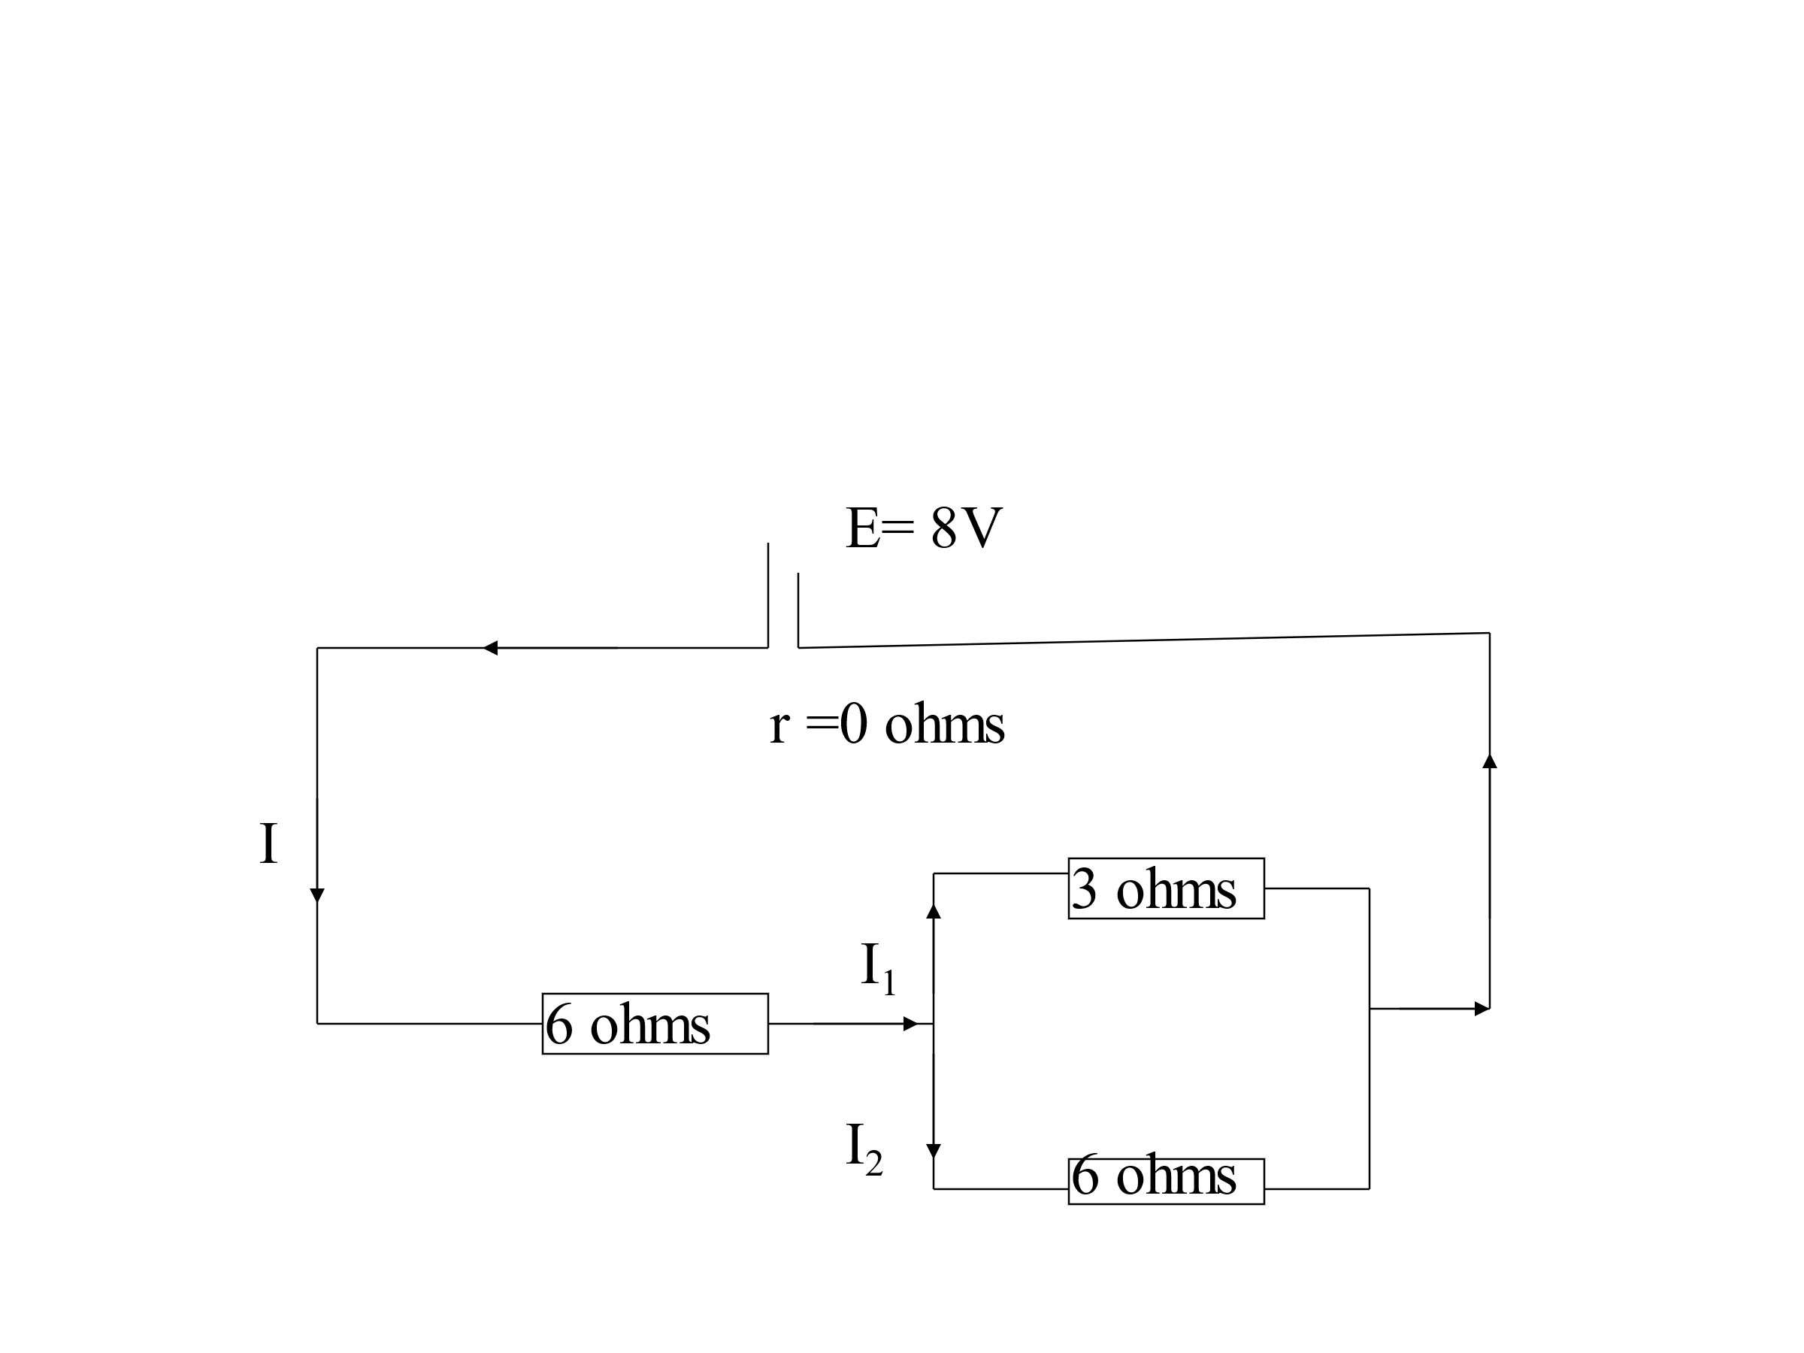

End/Diwedd of Paper
.

