Name: Shazia Kausar
Student Number: 2512942
Module: Principles of Health and Social Care Practice
Module Code: BMHP5016
Assignment 1: Reflective Report
Lecturer: Kennedy Obohwemu

Table of Contents

INTRODUCTION 3
TASK 1: REFLECTION ON THE IMPORTANCE OF PRINCIPLES 3
TASK 2: PRACTICAL EXAMPLE IN PRACTICE 5
TASK 3: SELF-REFLECTION 7
1. Description 8
2. Feelings 8
3. Evaluation 8
4. Analysis 8
5. Conclusion 8
6. Action Plan 9
Ethical Practice 9
CONCLUSION 9
REFERENCES 11

Principles of Health and Social Care Practice

INTRODUCTION
Health and social care practice is based on principles that promote safe, respectful and effective support. Three important principles are person-centred care, partnership working and ethical practice (Beauchamp and Childress, 2019; Skills for Care, 2026). Person-centred care recognises everyone as unique and involves them in decisions about their care (NICE, 2018). Partnership working brings professionals, individuals and families together to meet care needs (Health and Care Act, 2022), while ethical practice supports respect for rights, dignity, choice and wellbeing (GOV.UK, 2014).
Alzheimer’s Society (2026) estimates that nearly one million people in the UK are living with dementia, and this number is projected to increase to 1.4 million by 2040. The financial impact is also significant, with the cost of dementia in the UK forecast to increase from £42 billion in 2024 to £90 billion by 2040 (GOV.UK, 2014; Alzheimer’s Society, 2026). These figures demonstrate the increasing need for health and social care services to provide appropriate, coordinated and person-centred support.
This report examines these principles using relevant theory, legislation, professional guidance and evidence. It applies them to the case of Mrs Smith, an 85-year-old woman with advanced dementia who experiences difficulties with memory, communication and basic self-care. It also reflects on their application to professional practice, including strengths, areas for improvement and future development (Gibbs, 1988; Skills for Care, 2026).

TASK 1: REFLECTION ON THE IMPORTANCE OF PRINCIPLES
Person-centred care, partnership working and ethical practice are central to high-quality health and social care. These principles help professionals respect individuals, respond to their needs and protect their rights (GOV.UK, 2014; NICE, 2018).
According to Dening and Pepper (2023), person-centred care means treating everyone as a unique person rather than focusing only on their illness, disability or care needs. It involves considering preferences, values, beliefs, relationships, experiences and choices when planning and providing care. Maslow’s (1943) hierarchy of needs also supports this approach because it identifies physiological and safety needs alongside belonging, esteem and self-actualisation, as shown in Figure 1 below. It suggests that people are motivated by different levels of needs, starting with basic survival and progressing towards personal growth and fulfilment. Therefore, meeting basic physical needs alone may not provide high-quality care if emotional and social needs are ignored (Maslow, 1943; NICE, 2018).
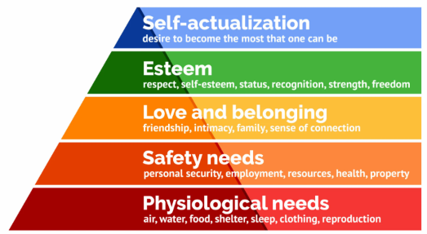
Figure 1: Maslow's Hierarchy of Needs (McLeod, 2025).

A benefit of person-centred care is that it can promote dignity, independence and wellbeing. However, challenges can occur when an individual’s choices create potential risks. Professionals therefore need to balance independence and choice with their responsibility to provide safe care (Mental Capacity Act, 2005).
Partnership working involves different professionals, such as nurses, social workers, care workers, GPs and occupational therapists working together to meet an individual’s needs (NICE, 2018). Health and Care Act (2022) supports greater integration between health and social care services in England. However, partnership working can be challenging when professionals have different opinions, responsibilities or priorities. Effective communication and information sharing are therefore essential to ensure that the individual remains at the centre of decisions (Skills for Care, 2026).
Ethical practice involves making decisions that respect people's rights, dignity and wellbeing (Beauchamp and Childress, 2019). The principles of autonomy, beneficence, non-maleficence and justice can support professionals when dealing with difficult decisions. The Mental Capacity Act (2005) is particularly relevant when supporting adults who may have difficulty making decisions. Where a person lacks capacity for a specific decision, professionals must act in their best interests and consider the least restrictive option (Department for Constitutional Affairs, 2007). This demonstrates the importance of balancing individual choice with protection from harm.
Wellbeing is placed at the centre of adult social care, including dignity, physical and mental wellbeing, relationships and control over day-to-day life (GOV.UK, 2014). These principles are connected; person-centred care keeps the individual at the centre, partnership working brings together appropriate knowledge and skills, and ethical practice supports responsible decision-making (Health and Care Act, 2022). Professionals must continually reflect on their practice and use evidence, legislation and professional guidance to improve the quality and safety of care (Department of Health and Social Care, 2025).
These principles are most effective when applied together rather than separately (Dening and Pepper, 2023). For example, a person-centred approach may identify an individual’s preferences, while partnership working ensures that relevant professionals communicate these preferences, and ethical practice ensures that decisions respect the person’s rights (NICE, 2018).

TASK 2: PRACTICAL EXAMPLE IN PRACTICE
The case study of Mrs Smith, an 85-year-old woman with advanced dementia who experiences difficulties with memory, communication and basic self-care, demonstrates how person-centred care, partnership working and ethical practice can be applied in a health and social care setting (NICE, 2018). These principles can help protect Mrs Smith’s dignity, promote her wellbeing and ensure that her individual needs remain central to the care provided (GOV.UK, 2014).
Person-centred care could be demonstrated by finding out about Mrs Smith’s life history, preferences, routines, relationships and interests (Riachi, 2017). Staff could use this information when planning her daily care, including her preferred food, activities and personal care routines. The social model of health helps carers recognise that a person with dementia is more than their diagnosis (Dziak, 2023). Improving their environment, relationships and social support can improve their quality of life.
Applying the 6 C’s helps protect Mrs Smith’s safety, promote her wellbeing and maintain her dignity and quality of life (NICE. 2018). By showing care and compassion, carers can support her with personal hygiene, eating and drinking while treating her with dignity and respect. Competence and communication help carers recognise her needs, understand her behaviour and provide appropriate support despite her memory and communication difficulties. Courage allows carers to speak up if they notice changes in her health or concerns about her care, while commitment ensures that she receives consistent support from health and social care professionals (Department of Health and Social Care, 2025).
Dening and Pepper (2023) recommend involving people living with dementia in decisions about their care and adapting communication when necessary. Care should be tailored to an individual’s needs and preferences and that people should be treated with dignity and respect (Care Quality Commission, 2024). This could help Mrs Smith feel respected and maintain as much independence as possible.
Staff could use simple language, maintain eye contact, allow additional time for responses and observe non-verbal communication. NICE (2018) recommends using additional or modified communication methods where required and considering individual circumstances. The social model of health (Dziak, 2023) emphasises that social interaction can reduce loneliness and help Mrs Smith maintain a sense of connection and belonging. A challenge may arise if Mrs Smith refuses support or becomes distressed. Staff should consider whether she has capacity for the specific decision and explore the reasons for her response (Mental Capacity Act, 2005; Department for Constitutional Affairs, 2007).
Partnership working would involve Mrs Smith, care workers, nurses, GPs, social workers, occupational therapists and, where appropriate, family members or carers (NICE, 2018). The Health and Care Act (2022) also supports greater integration between health and social care services in England. Effective information sharing could help professionals identify changes in Mrs Smith’s health, behaviour or care needs and respond consistently (Skills for Care, 2026).
However, partnership working can be challenging when professionals or family members have different views about Mrs Smith’s care. This can be addressed through clear communication, accurate record keeping, appropriate information sharing and keeping Mrs Smith’s needs and rights at the centre of discussions (Health and Care Act, 2022).
Ethical practice is particularly important because Mrs Smith may have difficulty making some decisions. The Mental Capacity Act (2005) requires capacity to be considered for a specific decision and individuals to be supported to make their own decisions wherever possible. If Mrs Smith lacks capacity for a particular decision, professionals must act in her best interests and consider the least restrictive option (Department for Constitutional Affairs, 2007).
There may be challenges when applying these principles in practice. Mrs Smith may become distressed, refuse care or find it difficult to communicate her wishes because of her dementia (Riachi, 2017). Professionals can overcome this by using person-centred communication, allowing additional time, identifying possible causes of distress and assessing capacity for the specific decision (Alsawy et al., 2017; NICE, 2018). Partnership working may also be affected by disagreements between professionals or family members. This can be managed through respectful communication, discussing different views and following agreed care plans and professional guidance (Department of Health and Social Care, 2025).

TASK 3: SELF-REFLECTION
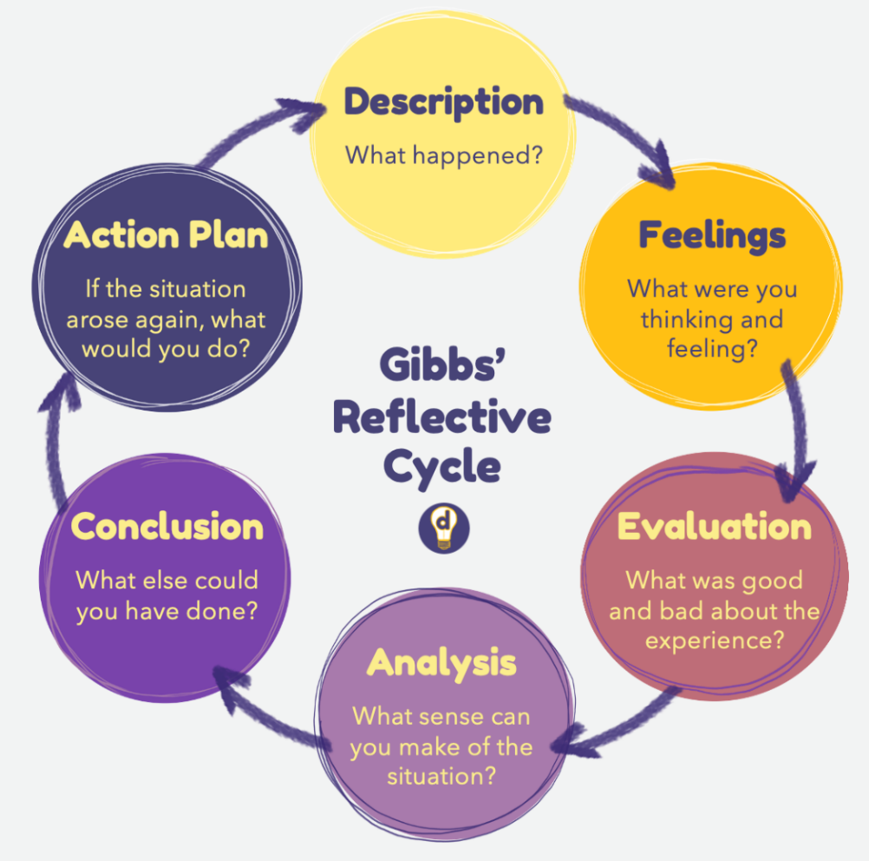
Reflecting on my practice has helped me understand how person-centred care, partnership working and ethical practice influence my responsibilities in health and social care. I need to respect individual choices, protect dignity, communicate effectively and work with others to provide safe care (GOV.UK, 2014; NICE, 2018). I have used Gibbs’ (1988) reflective cycle, which is shown in Figure 2 below. It includes description, feelings, evaluation, analysis, conclusion and action plan to reflect on my work-based experience.

Figure 2: Gibbs' Reflective Cycle (The University of Edinburgh, 2024)

1. Description
During my work-based experience, I supported an individual who became distressed and found it difficult to communicate what was wrong. I remained calm, listened carefully and gave the individual time to respond. I also observed their body language and tone of voice and provided reassurance. This demonstrated person-centred practice because I focused on the individual’s needs rather than simply completing a task (NICE, 2018). I also understood that I should seek support from a colleague if the distress continued or there were concerns about safety (Skills for Care, 2026).

2. Feelings
I felt concerned because I wanted to make sure the individual was safe and understood their needs. I initially felt unsure about the best response because I did not want to increase their distress. However, I became more confident when I realised that remaining calm and patient could help the individual feel respected. Gibbs (1988) identifies feelings as an important part of reflection because they can influence professional response, as shown in Figure 2.

3. Evaluation
A positive aspect was that I remained patient and used both verbal and non-verbal communication. NICE (2018) recommends adapting communication to individual needs, while Alsawy et al. (2017) found that communication difficulties can affect relationships and everyday activities for people living with dementia. However, I recognised that I need greater confidence in identifying possible causes of distress and knowing when to seek additional support.

4. Analysis
This experience helped me understand that distress may indicate an unmet physical, emotional or social need. Person-centred communication can help individuals feel respected and understood (Riachi, 2017; Dening and Pepper, 2023). The Skills for Care Code of Conduct expects workers to communicate effectively, work with colleagues and recognise the limits of their competence (Skills for Care, 2026), so I would need to communicate my concerns to colleagues and seek appropriate support.

5. Conclusion
I identified patience, active listening and observing non-verbal communication as strengths in my practice. I also recognised that I need to improve my confidence in identifying causes of distress and knowing when to seek support. This experience showed me that effective communication, ethical practice and partnership working are closely connected.

6. Action Plan
Over the next six months, I plan to complete training in communication, dementia awareness, safeguarding and the Mental Capacity Act. I will also ask experienced colleagues for feedback and use Gibbs’ (1988) cycle to reflect on challenging situations. When supporting someone who becomes distressed, I will remain calm, allow time for communication, consider possible causes and seek support when necessary. This will help develop my confidence and competence while maintaining individuals’ dignity, rights, safety and wellbeing (GOV.UK, 2014; Skills for Care, 2026).

Ethical Practice
Ethical practice is also important because I need to respect people’s choices, dignity, privacy and rights while considering their safety. The Mental Capacity Act (2005) requires people to be presumed to have capacity and supported to make their own decisions wherever possible. If a person lacks capacity for a specific decision, professionals must act in their best interests and consider the least restrictive option (Mental Capacity Act, 2005; Department for Constitutional Affairs, 2007). For example, if someone refused personal care, I should not automatically assume they lack capacity. I would consider whether they understood the decision, whether I had communicated appropriately and whether another approach could support them.

CONCLUSION
Person-centred care, partnership working and ethical practice are essential for providing safe, respectful and effective health and social care. The case study of Mrs Smith demonstrates how these principles can support dignity, independence, wellbeing and individual choice. The reflection also highlights the importance of effective communication, teamwork, understanding legislation and continuing professional development. These principles are closely connected and should be applied together rather than in isolation. Effective practice requires professionals to balance individual choice with safety, communicate with other professionals and make ethical decisions based on legislation and professional guidance.
Ultimately, high-quality care depends on professionals putting the individual at the centre of decisions while working collaboratively with others. Using legislation, evidence and professional guidance can help ensure that care remains safe, fair and appropriate. Ongoing reflection and learning will also support continuous improvement in professional practice and contribute to better outcomes for individuals.

REFERENCES
Alsawy, S., Mansell, W., McEvoy, P. and Tai, S. (2017). ‘What is good communication for people living with dementia? A mixed-methods systematic review’. International Psychogeriatrics, 29(11), pp.1785–1800. Doi:10.1017/s1041610217001429.
Alzheimer’s Society. (2026). Unlocking the door to dementia diagnosis and treatments. Available at: https://www.alzheimers.org.uk/what-we-do/policy-and-influencing/unlocking-door-dementia-diagnosis-treatments (Accessed 21 Sept. 2026).
Beauchamp, T.L. and Childress, J.F. (2019). Principles of Biomedical Ethics. 8th edn. New York Etc: Oxford University Press.
Care Quality Commission (2024). The fundamental standards - care quality commission. Available at: https://www.cqc.org.uk/about-us/fundamental-standards (Accessed 29 Sept. 2026).
Dening, H.K. and Pepper, A. (2023). Person-centred communication with people with dementia. [online] journals.rcni.com. Available at: https://journals.rcni.com/nursing-older-people/evidence-and-practice/personcentred-communication-with-people-with-dementia-nop.2023.e1430/abs (Accessed 29 Sept. 2026).
Department for Constitutional Affairs (2007). Code of Practice Mental Capacity Act 2005. Gov.uk. Available at: https://assets.publishing.service.gov.uk/media/5f6cc6138fa8f541f6763295/Mental-capacity-act-code-of-practice.pdf (Accessed 19 Sept. 2026).
Department of Health & Social Care (2025). Care and support statutory guidance. Available at: https://www.gov.uk/government/publications/care-act-statutory-guidance/care-and-support-statutory-guidance (Accessed 25 Sept. 2026).
Dziak, M. (2023). Social model of health | EBSCO. EBSCO Information Services, Inc. | www.ebsco.com. Available at: https://www.ebsco.com/research-starters/public-health/social-model-health (Accessed 13 Oct. 2026).
Gibbs, G. (1988). Learning by doing: A guide to teaching and learning methods. Programmed Learning & Educational Technology, 25(2).
GOV.UK (2014). Care act 2014. Legislation.gov.uk. Available at: https://www.legislation.gov.uk/ukpga/2014/23/section/1/enacted (Accessed 23 Sept. 2026).
Health and Care Act (2022). Health and Care Act 2022. Available at: https://www.legislation.gov.uk/ukpga/2022/31/pdfs/ukpga_20220031_en.pdf (Accessed 20 Sept. 2026).
Maslow, A.H. (1943). A theory of human motivation. Psychological Review, 50(4), pp.370–396. Doi: https://doi.org/10.1037/h0054346
McLeod, S. (2025). Maslow’s hierarchy of needs. Simply Psychology. Available at: https://www.simplypsychology.org/maslow.html (Accessed 13 Oct. 2026).
Mental Capacity Act (2005). Mental capacity act 2005. [online] Legislation.gov.uk. Available at: https://www.legislation.gov.uk/ukpga/2005/9 (Accessed 27 Sept. 2026).
NICE (2018). Dementia: Assessment, management and support for people living with dementia and their carers | guidance | NICE. [online] Nice.org.uk. Available at: https://www.nice.org.uk/guidance/ng97 (Accessed 22 Sept. 2026).
Riachi, R. (2017). ‘Person-centred communication in dementia care: A qualitative study of the use of the SPECAL® method by CARE workers in the UK’, Journal of Social Work Practice, 32(3), pp.1–19. Doi:10.1080/02650533.2017.1381948.
Skills for Care (2026). Code of Conduct. Available at: https://www.skillsforcare.org.uk/Support-for-leaders-and-managers/Managing-people/Code-of-Conduct.aspx (Accessed 30 Sept. 2026).
The University of Edinburgh (2024). Gibbs’ reflective cycle. Available at: https://reflection.ed.ac.uk/reflectors-toolkit/reflecting-on-experience/gibbs-reflective-cycle (Accessed 4 Oct. 2026).

