The impact of The De Stijl Movement on Modern Design
Approx. 2000 word. Tariq Marley Bushara – 1703307
Photography in the Arts BA Paul Duerinckx

In this essay we will discuss the De Stijl movement of the early 20th century and its impact on modern art and design. The first chapter will assess the manifestation of The De Stijl movement and the magazine that initiated the organisation, as well as reviewing its founding members Theo Van Doesburg and Piet Mondrian, in addition to important figures associated with the movement such as painters Bart Van Der Leck and Vilmos Huszár. The second chapter will examine the link between De Stijl philosophies and the Suprematism movement that stemmed out of the 1917 Russian Revolution. Third chapter will identify the key components of De Stijl (Dutch for ‘The Style’) that significantly impacted modern art and design, including the new age of web design and the vital impression De Stijl still has over our current understanding of what modern art means.

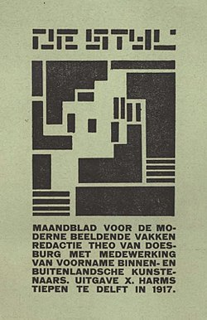

1st Edition front cover design –
De Stijl Magazine, 1917

Chapter one
“The movement that set the style for what the world came to see as ‘modern’” (Bolt, 2017). In 1917, amongst the chaos of world war one, and the necessity for a more idealistic and simplistic representational art form, Theo Van Doesburg and Piet Mondrian issued the first edition of The De Stijl Magazine. The publication included work from several international artists Van Doesburg had befriended after World War One, in an effort to unify various art forms under one organised theoretical mind-set. The artists used the journal as a platform to express a redefinition of art, to strip it back and offer a new set of rules, a dismissal of the decorative excessiveness of Art Nouveau. The key values of the movement concentrated on using the most basic visual elements - geometrical forms, exclusively orthogonal elements, and the primary colours Red, Yellow and Blue – to re-configure the understanding of art. Yet the De Stijl philosophy extends beyond humble aesthetics, it has a deeper social message, where by removing the personality of the artist in favour of a clear universality, embracing the idea of a modern utopia. This theoretical approach aimed to remove false divisions between so-called high art and applied art.
One of the core functions of the magazine was to circulate ‘key’ works that represented the stylistic approach of De Stijl in order to substantiate the collaboration between the contributing artists, as well as a platform to assess each other’s work. Though the magazine never sold more than 300 prints, it manifested a strong influence on art in the Netherlands and abroad, predominately represented in the Stedelijk Museum, Amsterdam. The museum boasts a wide variety of De Stijl works, ranging from Mondrian paintings to Rietveld chairs, as well as de Stijl inspired works from various international artists.
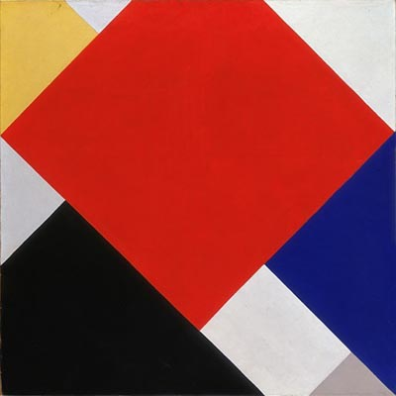

Counter Composition V -
Theo Van Doesburg, 1924, Oil on canvas

Originally a landscape and portrait artist often associated to early Dutch impressionism, Theo Van Doesburg restructured his practice after reading Wassily Kandinsky’s Rückblicke (“Retrospect”), an autobiographical book based upon Kandinsky’s life as an artist and his thoughtful reflections on art. Van Doesburg comprehended the spirituality of painting as a deeper connection within the mind rather than mere depiction of the physical. To support himself as an artist, Van Doesburg wrote articles in art magazines and journals, one particular article states “Piet Mondrian realizes the importance of line. The line has almost become a work of art in itself; one cannot play with it when the representation of objects perceived was all-important. The white canvas is almost solemn. Each superfluous line, each wrongly placed line, any color placed without veneration or care, can spoil everything – that is, the spiritual.” (Van Doesburg, 1912, p. 127)
Piet Mondrian was a Dutch abstract painter, famously known as the originator of ‘neo-plasticism’, an art form similar to the ideology of De Stijl, where by Mondrian used exclusively three principal colours (red, blue and yellow) and primary forms of shape (though not to be confused with the precise use of orthogonal shapes of De Stijl) as pure representation of the human mind.
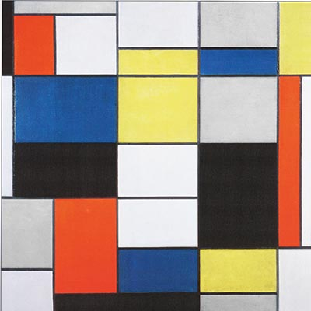

Composition A -
Piet Mondrian, 1923, Oil on canvas

Van Doesburg met with Mondrian in 1915 after Doesburg came into contact with some of Mondrian’s work and saw the similar abstraction of reality he practiced. The pair swiftly began working together and ultimately founded the magazine and movement, alongside the support of like-minded artists Bart Van Der Leck, Antony Kok, Vilmos Huszár and Jacobus Oud. Although many of the artists associated with the movement barely knew each other and rarely, if ever, met in person, they shared stylistic and conceptual characteristics. The artists unanimously absorbed an understanding of De Stijl as a simplified and unified art theory. This reformed combination of modest elements into a new configuration of art was a vital aspect of the language of De Stijl.
One significant artist whose work elevates these components was Dutch painter and designer Bart Van Der Leck. Originally trained as a stained glass artist, Leck moved to the artist’s community of Laren in 1916, where he met Piet Mondrian and began to practice abstract compositions. Although Van Der Leck was only affiliated with the movement for just over two years, his paintings remained a strong demonstration of De Stijl ideologies throughout his developing career.

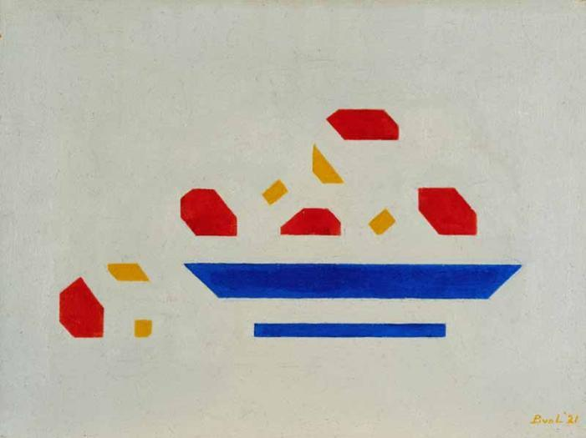

Still life (Bowl with apples) -
Bart Van Der Leck, 1921, Oil on canvas

All of the artists associated with De Stijl shared the belief that art and design have the power to re-shape the future, re-form balance between the individual and the collective and re-imagine naturalistic representation. Following such principles, renowned Hungarian painter and interior designer, Vilmos Huszár, who spent much of his life in the Netherlands where he was exposed to different avant-garde groups, quickly espoused the aesthetic approach of De Stijl. In 1916, Huszár met Theo van Doesburg and assisted in the first review of The De Stijl Magazine. Huszár was the artist tasked with designing the cover for the first official print, and became one of the most important contributors to defining Neo-Plasticism in his many published articles for the magazine in the following years.
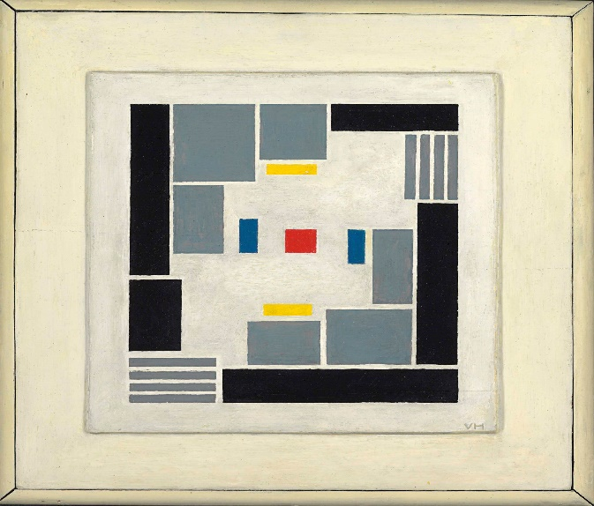

Composition abstraite -
Vilmos Huszár, 1918
Oil on canvas

Chapter 2
1917 was a year of mass civil uprising in Russia, following the outbreak of World War I and the general turmoil directed at the last emperor of Russia, Tsar Nicholas II. Whilst the nation was engaged in a movement of nationalism, increasing numbers of defeats and deprived domestic environments shortly overturned the nation's opinion of the ruling class and declared an act of change. Nicholas II attempted to relieve the situation by taking personal command of the army two years prior, but he failed to avail his plans and was held accountable for the continuing defeats Russia suffered. During the war, poor conditions in the country led to a downfall in morale within the Russian Army and the general public. This was particularly noticeable within the cities, where by the disruption to agriculture led to a shortage of food, which in turn led to a rise in prices. In a desperate act of revolution, thousands of Russian inhabitants held mass riots and strikes in St Petersburg, in an effort to abolish the czarist regime and end the scarcity of food and unrest within the country.
Art has continuously played a vital role in documenting and portraying war over past centuries, predominately through detailed visual narrative. Yet as a result of the anarchy produced via world war one, artists such as Kazimir Malevich declared a reform of art through simplified non-figurative representation and abstract geometric clarity. Generated from the turmoil of World War One and the Russian Revolution, Kazimir Malevich established The Suprematism movement. Essentially an abstract art form developed by Malevich in around 1913-1914, in an eager effort to free art from the rigidness of reality, Suprematism concentrated on the simplicity of shape and colour. Malevich established an exclusive use of forms, including rectangles, squares and circles alongside passionate and bold colours.
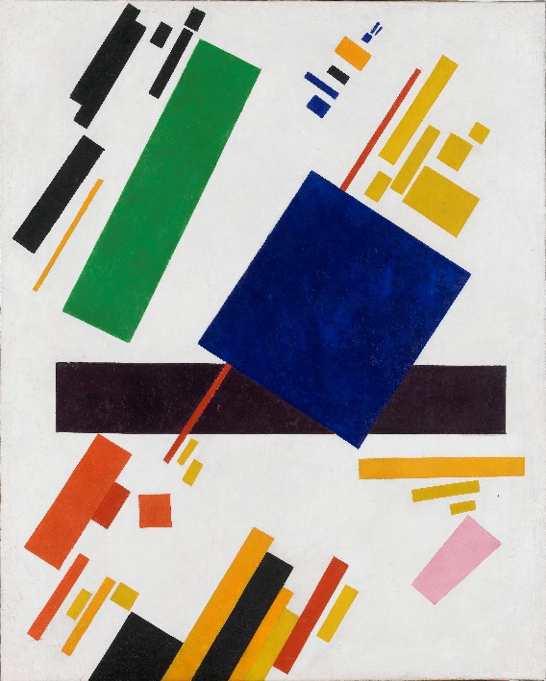

Suprematist composition –
Kazimir Malevich, 1915 Oil on canvas

The impression of colour and space within Suprematism paintings played a crucial role in the theoretical ideologies of the movement, significantly resembling the ideologies of De Stijl. Both movements pursued a comprehensive re-evaluation of art through distinct characteristics commonly represented in their respected works. Both Suprematism and De Stijl essentially aimed to restructure traditional forms of painting and design into a simplistic methodology. Placing prominence on the evolution of their collective standards, both movements based profound theoretical ideals and beliefs as of equal importance to the creation of works and designs. Such philosophies were vital to the ever-developing knowledge of art.
German philosopher and sociologist, Herbert Marcuse, argued “When art is faithful to its own aesthetic form, it breaks open a dimension inaccessible to other experience, a dimension in which human beings, nature and things no longer stand under the law of the established reality principle.” (Marcuse, 1969).
Chapter 3
De Stijl artists ultimately designed art for the future, they theorised a collective understanding of what modern art should adhere to, and implemented their beliefs within their designs and magazine articles in an effort to sway the comprehensive world of art. The creative impact of De Stijl is particularly apparent in contemporary vision such as graphic and website design. A significant example of such influence is the considerably recognizable logo for Microsoft Windows. The tech giant’s first emblem was a minimal, four panel concept with a single colour scheme, adhering to modern standards of simplicity. With four rectangle forms in various sizes, unifying into one rectangle, the design shows a sense of unity and geometric synchronization, which is the main idea of De Stijl philosophy.


Microsoft Windows Logo – 1985

The artists of De Stijl promoted a design resonant of contemporary art, with strong lines, solid colours and simplistic compositions. The basic principles of De Stijl remain a concrete position within modern art and design, as their simplistic approach to colour and form is the fundamental standard of modern aesthetics. Reyner Banham contended “they (The De Stijl collective) seem to have the best right to be considered the true founders of that enlightened machine aesthetic that inspired the best works of the twenties” (Banham, 1960). De Stijl was intended to be universally understood regardless of status or wealth. Today, many graphic designers aim to produce universally recognizable logos and designs, reviving the general aesthetic of De Stijl and fundamentally creating a standard of beauty that can be understood by everyone in every part of the world, regardless of language or social circumstances. De Stijl, in a way, predicted a lot of today’s web and logo design, manifesting a state of imagination that held pure compositional aspects as authority of creativity.

The De Stijl Magazine was aptly named so because the founding members contended to demonstrate a modern style, applicable to all manner of two and three-dimensional design. The key values of De Stijl will form the way for designing an increasingly digital world, driving the creative engines of painters, architects and graphic designers alike. The movements articles and creative works define modern aspects of depersonalisation within art and design, intently concentrating on the purest form of artistic language, the composition of shape and colour.

Reference list/Bibliography
In text citations:
- Banham, R. (1960). Theory and design in the first machine age. Oxford: Butterworth Architecture, p.153.
- Bolt, R. (2017) ‘The most important art movement you've never heard of’, The Telegraph, 9th January. Available at: https://www.telegraph.co.uk/travel/destinations/europe/netherlands/articles/de-stijl-the-most-important-art-movement-you-have-not-heard-of/ (Accessed on 24th Nov 2018)
- Marcuse, H. (1969). An Essay on Liberation.
Van Doesburg, T. (1912) Eenheid Issue No. 127, 9th November.
Websites:
- https://www.telegraph.co.uk/travel/destinations/europe/netherlands/articles/de-stijl-the-most-important-art-movement-you-have-not-heard-of/
- https://en.wikipedia.org/wiki/Theo_van_Doesburg
- https://www.tate.org.uk/art/art-terms/n/neo-plasticism
- https://humphries346.wordpress.com/category/mondrian-and-van-doesburg/
- https://www.holland.com/global/tourism/holland-stories/mondrian-de-stijl/bart-van-der-leck-4.htm
- https://www.britannica.com/event/Russian-Revolution-of-1917
- https://www.stedelijk.nl/en/digdeeper/suprematism-and-neoplasticism
Books:
- De Stijl - Paul Overy 1969.
- Permanent Red - John Berger, 1960.
- Aesthetics after Modernism - Peter Fuller, 1983.
- De Stijl and Dutch Modernism - Michael White, 2003.
- Theory and design in the first machine age - Reyner Banham, 1960.

