Sophie Michelle Evans (2108843)

Amazon
Contemporary Management Approaches (BMSP4002)
Introduction
Amazon
Contemporary Management Approaches (BMSP4002)
The purpose of this report is to analyse Amazons organisational functions. This report will look at a variety of topics relating to organisational function including organisational context, approaches to organisation and management, work and satisfaction and perception and communication.

As Hartmans, A (2021) explains Amazon was founded by Jeff Bezos in 1994 as a website that solely sold books. Jeff Bezos had a vision for the company’s spectacular expansion and ecommerce dominance. Amazon has come a long way from selling books in a garage, with added expansion such as digital streaming, E – readers, cloud computing, artificial intelligence, Fire stick, fire tablets and many more. Amazon has thrived over the decades and is now according to Capitalism.com (2020) one of the world's largest e-commerce marketplaces and serves as a platform for new entrepreneurs to make a profit by selling goods online. Amazon is known as "The Everything Store" because it sells almost anything you can imagine, from coffee cups to high-end laptops.

Organisational Context
As Foster, K (No Date) mentions Organisational theory seeks to understand how organisations function, why they are formed in certain ways, and why some organisations are more successful than others.
As Meyer, P (2019) mentions, the organisational structure of Amazon allows for great control over global e-commerce operations. The design and system of interactions among business members are established by an organisational or corporate structure. The organisational structure of Amazon, for example, dictates how managers control and influence operational activity across multiple business divisions. Amazon, as a top online retailer, must maintain an organisational structure that can support its growing market reach. As Dudovskiy, J (2020) mentions Amazon employs a hierarchical organisational structure. The senior management team consists of three CEOs and three senior vice presidents who oversee various critical elements of the business and report directly to Amazon CEO Jeff Bezos. Amazons Organisational structure includes three key features:
- Hierarchical cooperate structure - Because of the company's enormous scale, Amazon has evolved a hierarchical structure. The world's largest internet retailer by revenue employs over 647,00 employees worldwide.

- Flexibility of the Business - Despite its scale, Amazon is highly flexible in adapting to frequent changes in the external marketplace, unlike many other organisations with hierarchical organisational structures. Furthermore, the online retailer drives changes in the external business environment, has sparked disruptive innovation in e-commerce, and is about to do so in the global logistics industry. This is largely due to Amazon founder and CEO Jeff Bezos' visionary and efficient leadership.

- Stability in the top Management - One of Amazon's most important characteristics is its stability. In particular, the world's largest internet corporation by sales has "relatively minimal turnover among its most critical power players, with many of them having been at the company for years.

The importance of organisational behaviour is to understand Individual and group behaviour patterns, examine factors that can create and improve performance and effectiveness in an organisation. It looks at how people behave within an organisation, how they relate to one an another and how they get work done within the organization's structure. As Tejra, B. (2020) mentions Amazon has an organisational culture that allows it to respond to the e-commerce market's expectations. Amazon's business culture encourages employees to think outside the box to come up with innovative ideas and solutions. As the world's best-performing online retailer, the company is always looking for new talent. However, to keep capable staff, Amazon must strengthen its organisational culture to shape human resource development for long-term competitive advantage.
As Mathot, A (2021) explains, CEO Jeff Bezos invented the two-pizza rule, this was implemented to promote meeting success and for meetings to function well. The two-pizza rule stipulated that meetings at Amazon be limited to the number of people who could comfortably share two pizzas.

Approaches to Organisation and Management
Management is an important role in the formation of an organisation, good management is essential to ensure that all organisations are working toward a single purpose or objective. As Sling (No Date) mentions theorist Douglas McGregor described two different management techniques (theories X and Y). Each management style is influenced by the manager's perceptions of their employees' motivations. Theory X explains employees are disinterested or dislike their jobs. Managers that agree to Theory X are frequently authoritarian and will control everything since they lack trust in their employees. Theory Y explains employees are self-motivated, responsible, and eager to acquire ownership of their work. Managers that follow Theory Y include their employees in decision-making and promote creativity at all levels.
There are four types of management approaches such as Classical, Human Relations, Systems and Contingency.
Classical
“The classical management theory is a style of management that emphasizes hierarchy, specialized roles and single leadership for optimized efficiency in the workplace.” (Indeed, Editorial Team 2021). As Villanova University (2021) explains, Classical management theory is founded on the assumption that workers only have physical and economic demands. Unlike more recent workplace management ideas, it does not consider social requirements or job satisfaction. Instead, classical management theory promotes labour specialisation, centralised leadership and decision-making, and profit maximisation.

Human Relations
As Ward, P (2021) mentions Human Relations management theory suggests that by forming positive social relationships and acknowledging workers as unique individuals, improving well-being in the workplace increases employee productivity and motivation. As Harappa (2021) mentions the Human Relations Theory was established by Elton Mayo. He carried out a series of studies one being the Hawthorne Experiments. He concluded that people have distinct tastes and cannot be regarded like robots. Elton Mayo explains that humans are complicated beings whose behaviour is influenced by a variety of variables. Managers must recognise that each employee has different demands and that communication between managers and employees is crucial. Employees want to find a purpose in their work and aren’t just motivated by money incentives.

Systems
As Gordon, J (2021) explains the Systems Approach to management theory, widely regarded as the foundation of organisational development, sees the organisation as an open system comprised of interconnected and interdependent pieces that interact as sub-systems. As Strategic Management: Formulation and Implementation (No Date) explains, systems theory is credited to Ludwig von Bertalanffy. The system approach is founded on the idea that an organization is a system. A system is described as a collection of interconnected pieces that work together to achieve a common goal. There are five components in this case: inputs, a transformation process, outputs, feedback, and the environment. In general management analysis, the systems approach is critical. The concepts of open vs closed systems, subsystems, subsystems and interdependencies, synergy, and entropy have had a significant impact on management thought.

Contingency
The contingency approach to management holds that management techniques should be dependent upon the circumstances. As Gordon, J (2021) mentions the contingency method is founded on the assumption that all management is essentially situational. The circumstances of a given situation will influence (if not control) all managerial actions. Contingencies emerge because of a variety of environmental circumstances. As a result, when making decisions that influence the organisation, managers must consider these eventualities.

In comparison to the management theories, Amazon approaches to its Organisation and Management meets the criteria of McGregor`s theory X and the Classical Management Approach regarding how employees work within Amazons Organisation. With Jeff Bezos being a transactional leader with having everything done his way, Yohn, D (2020) mentions that Jeff Bezos requires his employees to be focused, fulfilled, productive and purposeful for his vision to be achieved. As Impraise (No Date) mentions, managing a firm of Amazon's size and ambition involves careful management of its employees as well as strict adherence to company values. Employees at amazon are to abide to the 14 leadership principles, centralising around “Customer Obsession” which is regarding the company’s dedication to serve its customers, which is supposedly valued before staff involvement and satisfaction.

Work Motivation and Satisfaction

Motivation and satisfaction within an organisation are crucial, it provides a positive effect on the overall performances. Regardless of the size of the organisation, it is critical that the organisation understands that their employees should always be looked after and valued. Theorist Abraham Maslow developed a hierarchy of needs to explain human motivation. The five stages of Maslow’s hierarchy are:
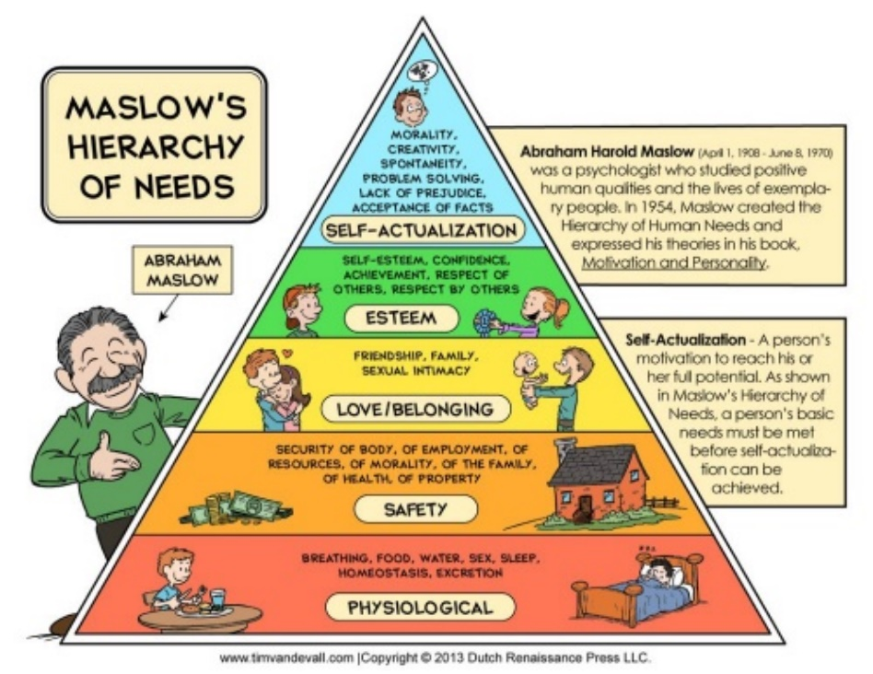
- Physiological
- Safety
- Love and Belonginess
- Esteem
- Self – Actualization

As CFI (No Date) mentions the Hierarchy of needs is based on a theory that explains human motivation by focusing on different levels of needs. According to the theory, people are motivated to meet their needs in a hierarchical sequence. The most fundamental demands are addressed first, followed by more advanced requirements. According to Maslow’s theory, the ultimate goal is to attain the fifth level of the hierarchy which is self-actualization.
Job satisfaction is when an individual feels fulfilment from their workplace, feels self – motivated, has a good work life balance and is meeting their expectations. When an employee is satisfied this then enhances their work performance. Job satisfaction can be a useful predictor of whether or not an organization's employee engagement strategy is working.

Regarding Amazons Organisation for job satisfaction and motivation, As Amazon (No Date) mentions offers a range of benefits to its employees such as.
- Starting wage from $15 per hour
- Health Care Coverage
- Ways To Save for the future
- Resources to improve health and well being
- Own Amazon Stock

As Amazon (No Date) mentions, Amazon also offers opportunities for employees to receive free education and skills training, allowing them to advance their careers.
As Amazon (No Date) mentions, Amazon recognises that cultivating a welcoming and inclusive culture is critical to employees performing at their best and to the company's success. Amazon constantly recruits employees from a variety of backgrounds to create a welcoming and inclusive environment. Amazon takes steps to ensure that employees feel like they belong, are valued, and have opportunities.
As Empire Resume (2020) explains as an employee of Amazon working within its warehouse or as a delivery driver has an Intense work culture, with its obsession with speed, high production quotas, being monitored on work performance regarding how quick items are picked from shelves or delivered, sometimes leaving no time for breaks, this then causes mental and physical pressure on the employees. As Kantor J, & Streitfield, B (2015) mention, that several former employees of amazons were interviewed and had mixed reviews on the company, a former employee recalls the culture of Amazon as “Purposeful Darwinism”. Employees with health issues were evaluated unfairly others would cry at their desks with all the pressure they were under. Whilst other employees thrived at Amazon as it pushed them beyond their limits and the Amazon way of working became embedded into their system.
When mental and physical pressure is upon employees this then causes stress and anxiety, tiredness, their overall well-being suffers therefore there is a lack of motivation and downward spiral of job satisfaction. As Hastwell, C (2021) mentions, Individuals want to be praised and recognised for the work they undertake, this makes them feel valued and their contribution towards their team and organisation is a success. As Education Library (No Date) mentions, Herzberg's two-factor theory, mentions that individuals are driven by two variables which are motivators and hygiene factors. Both elements are important for motivation, motivators promote job satisfaction, while hygiene aspects prevent job dissatisfaction. Variables that influence job satisfaction are referred to as motivational factors they address internal demands such as achievement, acknowledgment, and progression. Employees are more likely to be satisfied with their jobs when they are motivated. Hygiene variables are factors that are unrelated to workplace satisfaction yet must be present to prevent dissatisfaction. External needs such as pay grade, workplace rules, and peer relations are covered by hygiene factors.

Perception and Communication

Perception is how individuals see or hear things, everyone sees or hear things differently. Individuals interpret perception differently such as how something is viewed for example it could be regarding a work notice, everyone that has read the memo of the notice will have a different view of how the notice is interpreted. As Organisation Behaviour Study Guide (No Date) mentions one of the most crucial pieces of perception in an organisation is how an individual views other, as this can have a significant impact on how that person acts inside the company. It's also a factor in how employees are motivated in the workplace. If they preserve individuals in a specific way, they may assume that this person dislikes them, does not listen to them, or ignores them, and so their incentive to accomplish anything will be reduced.
Communication is a process in which an individual or individuals use verbal or nonverbal communication to try to stimulate meaning to another individual or individuals. Communication within an organisation is important, it involves conveying, interpreting, and storing messages to achieve goals or tasks. As The Classroom (2019) mentions, the culture of an organisation can influence the efficiency of organisational communication. The organisational culture determines the flow of information vertically from managers to employees and widely across department levels. An organisation with an open culture, may have a free flow of information among all levels of the business. A culture that focuses heavily on structure and hierarchy may stifle good communication or stifle information flow. As Drew, C (2019) mentions the Shannon Weaver model of communication was designed to develop effective communication between sender and receiver, it is made up of 5 components:
- Sender - is the individual who is sending the message
- Encoder – is the message translated into signals. This can be expressed in writing, speech, signing or body language.
- Channel - The method by which the communication is delivered. This could be sound transferred over the airways in a spoken discussion, by email or text.
- Decoder - This stage is how the message is interpreted and translated by the receiver.
- Receiver – When the brain interoperates the message.

As Impraise (No Date) mentions Amazon conducts business reviews on a weekly or monthly basis, and each employee is held accountable for a variety of criteria. Amazon now employs an internal application to facilitate employee feedback. Employees can use the system's Anytime Feedback Tool to directly convey praise or criticism about their co-workers. The input is delivered directly to the manager of the individual getting the feedback, and only the manager knows who provided the feedback. As Querysprout (No Date) mentions employees can be fired for as little as 6 points under Amazon's termination policy, which is in line with their points system. Employees are given points and can be fired for infractions such as taking time off without permission, being chronically late to shifts, clocking off too late or too early, and other similar behaviours. “Consistent, honest, and open communication with our employees allows us to continuously improve our workplace experience, empowering individuals to raise concerns and have them directly addressed by leadership. Our goal is to hear from and listen to everyone.” (Amazon No Date). As Amazon (No Date) mentions, Amazon has a range method for employees to communicate with their managers, such as open-door policy, in person meetings, ethics hotline, appeals process, associate insight surveys and pulse surveys, freedom of association, voice of the associate boards, connections and executive escalations.

Conclusion

As discussed in this report Amazon is an intriguing place to work. Relaying back to the theories, managers within Amazon’s organisation need to come up with innovating ways to motivate their employees to enhance job satisfaction therefore increasing performance and productivity within the workplace. Mangers could do more to build bonds with employees to make them feel valued and respected, trust needs to be established to build bonds. Amazon is a ray of mixed reviews to whether it’s a positive environment to work in, with employees being pushed to their limits and being able to criticize on another, with its endless performance reviews on employees that make it a difficult culture to work within. The managers goals are customer satisfaction, meeting their targets above their employees. It is all down to the certain individual and how they are portrayed whether or not employees succeed at amazon or not, but that’s not how It should be. Amazon might reconsider their approach to employees and transform it into a positive, which could then contribute with their goal for a successful vision of Amazon.

References

Amazon (No Date) Employee Benefits. About Amazon. Retrieved From: Amazon Employee Benefits (aboutamazon.com)

Amazon (No Date) Employee Engagement. About Amazon. Retrieved From: Employee Engagement (aboutamazon.com)

Amazon (No Date) Our Upskilling Commitments. About Amazon. Retrieved From: Our Upskilling Commitments (aboutamazon.com)

Amazon (No Date) Diversity, Equity and Inclusion. About Amazon. Retrieved From: Diversity and inclusion at Amazon (aboutamazon.com)

Capitalism.com(2020) History of Amazon: From Garage Startup to The Largest E – Commerce Marketplace. Capitalism.com. Retrieved From: History of Amazon: From Garage Startup to The Largest E-Commerce Marketplace - Capitalism.com

CFI, (No Date) Maslow’s Hierarchy Of Needs. Retrieved From: Maslow's Hierarchy of Needs - Overview, Explanation, and Examples (corporatefinanceinstitute.com)

Drew, C (2019) Shannon Weaver Model of Communication – 7 Key Concepts. HelpfulProfessor.com. Retrieved From: Shannon Weaver Model of Communication - 7 Key Concepts (2021) (helpfulprofessor.com)

Dudovskiy, J (2020) Amazon Organizational Structure: a brief overview. Business Research Methodology. Retrieved From: Amazon Organizational Structure: a brief overview - Research-Methodology

Empire Resume (2020) What it`s Really Like Working for Amazon. Empire Resume. Retrieved From: What it’s Really Like Working for Amazon | Empire Resume

Education Library ( No Date) Herzberg`s Motivation – Hygiene Theory: Two Factor. Retrieved From: Herzberg's Motivation-Hygiene Theory: Two-factor - Education Library

Foster, K (No Date) Organization Theory. Britannica. Retrieved From: organization theory | Britannica

Gordon, J (2021) What is the systems approach to management? The Business Professor. Retrieved From: Systems Theory of Management - Explained - The Business Professor, LLC

Gordon, J (2021) Contingency Approach or Situation Approach to management – explained. The Business Professor. Retrieved From: Contingency Approach or Situational Approach to Management - Explained - The Business Professor, LLC

Holland, M (2019) When Mental Health Goes Digital. Transtech. [Photograph]. Retrieved From: When Mental Health Goes Digital. With Mental Health Awareness month… | by Matthew Holland | Transformative Technology | Medium

Hastwell, C (2021) Creating a Culture of Recognition. Great Place To Work. Retrieved From: Creating a Culture of Recognition | Great Place to Work®

Hartmans, A (2020) Jeff Bezos originally wanted to name Amazon `Cadabra,` and 14 other little – known facts about the early days of the e – commerce giant. Insider. Retrieved From: Amazon's Early Days: Little-Known Facts and Company History (businessinsider.com)

HARAPPA (2021) Elton Mayo`s Human Relations Theory For Management. Retrieved From: Elton Mayo’s Human Relations Theory - Harappa

Indeed Editorial Team (2021). Q&A What is Classical Management Theory? Indeed. Retrieved From: Q&A: What Is the Classical Management Theory? | Indeed.com

Impraise (No Date) The Amazon Controversy: What is missing in its performance management. Retrieved From: The Amazon controversy: what is missing in its performance management | Impraise

Kantor, J & Streitfield B (2015) Inside Amazon: Wrestling Big Ideas In a Bruising Workplace. Business. New York Times. Retrieved From: Inside Amazon: Wrestling Big Ideas in a Bruising Workplace - The New York Times (nytimes.com)

Meyer, P (2019) Amazon.com Inc.`s Organizational Structure Characteristics (An analysis). Panmore Institute. Retrieved From: Amazon.com Inc.’s Organizational Structure Characteristics (An Analysis) - Panmore Institute

Mathot, A (2021). The Two Pizza Rule. SEEBURGER Business Integration Blog. Retrieved From: Jeff Bezos and his 2-Pizza Rule (seeburger.com)

Organisation Behaviour Study Guide (No Date) Perceptions In Organisations. Retrieved From: Perceptions in Organisations - Organisational Behaviour Study Guide (myorganisationalbehaviour.com)

SLING (No Date) The 11 Most Important Management Theories for Small Business. Retrieved From: The 11 Most Important Management Theories For Small Business - Sling (getsling.com)

Strategic Management: Formulation and Implementation. (No Date) The Systems Approach. Retrieved From: Strategic Management :: The Systems Approach (24xls.com)

Tejra, B. (2020) Organisational behaviour at Amazon. M`S BLOG. Retrieved From: ORGANISATIONAL BEHAVIOR AT AMAZON – M's blog (home.blog)

The Classroom (2019) Organizational Communication Research Paper Topics. Retrieved From: Organizational Communication Research Paper Topics (theclassroom.com)

Villanova University (2021). What is Classical Management Theory?. Retrieved From: Classical Management Theory Explained (villanovau.com)

Ward, P (2021) Human Relations Management Theory: Summary, Examples. NanoGlobals. Retrieved From: Human Relations Management Theory: Summary, Examples | NanoGlobals

Yohn, D. (2020) Amazon Faces A Crucible movement with employees. Forbes. Retrieved From: Amazon Faces A Crucible Moment With Employees (forbes.com)

Querysprout (No Date) Amazon Termination Policy (All You Need To Know). Retrieved From: Amazon Termination Policy In 2021 (All You Need To Know) (querysprout.com)

