Student Name: Rehina Zinovieva
Student ID: 2425418
Module Code: ACCA5023
Module Name: Network Operating Systems and Services
Lecturer: Md Abrar Jahin Almazi Bipon
Date: 22.03.2026

Network Topology Overview
This coursework continues directly from Coursework 1, extending the virtualised environment to include routing, domain services, VPN, DHCP, IIS, and Remote Desktop Services across two simulated sites: Birmingham and London.
The following IP addressing scheme was used throughout the deployment:
Birmingham LAN: 172.16.1.0/24 | Gateway: B-DC (172.16.1.1)
London LAN: 172.16.2.0/24 | Gateway: L-CD (172.16.2.1)
WAN Link: 10.0.0.0/30 | B-DC: 10.0.0.1 | L-CD: 10.0.0.2
Hypervisor: Oracle VM VirtualBox 7.x | Domain: rehina.acca

Task 1

1.1 Routing in Birmingham Network (RRAS)
Routing and Remote Access Service (RRAS) was installed on B-DC to enable IP routing between the Birmingham and London networks.
The following steps were performed:
Step 1: The Remote Access role was installed via PowerShell:
Install-WindowsFeature RemoteAccess -IncludeManagementTools
Install-WindowsFeature -Name Routing -IncludeManagementTools
Step 2: RRAS was configured using the Routing and Remote Access console. Right-click on the server name, then Configure and Enable Routing and Remote Access. Custom Configuration was selected with LAN routing enabled.
Step 3: ICMP (ping) traffic was enabled through Windows Firewall using the following commands:
netsh advfirewall firewall add rule name="Allow ICMPv4" protocol=icmpv4:8,any dir=in action=allow
netsh advfirewall firewall add rule name="Allow ICMPv4 Out" protocol=icmpv4:8,any dir=out action=allow
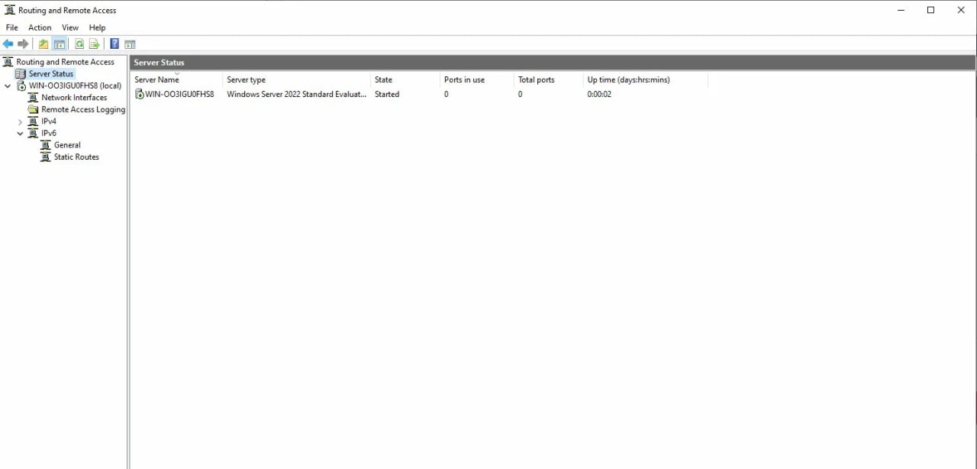

1.2 Routing in London Network (Debian - IP Forwarding)
On the London Debian server (L-CD), persistent IP forwarding was configured to allow packets to be routed between interfaces.
Step 1: IP forwarding was enabled persistently by editing /etc/sysctl.conf:
net.ipv4.ip_forward=1
sysctl -p
Step 2: A persistent static route was added to reach the Birmingham network via the WAN interface. The following line was added to /etc/network/interfaces:
post-up ip route add 172.16.1.0/24 via 10.0.0.1
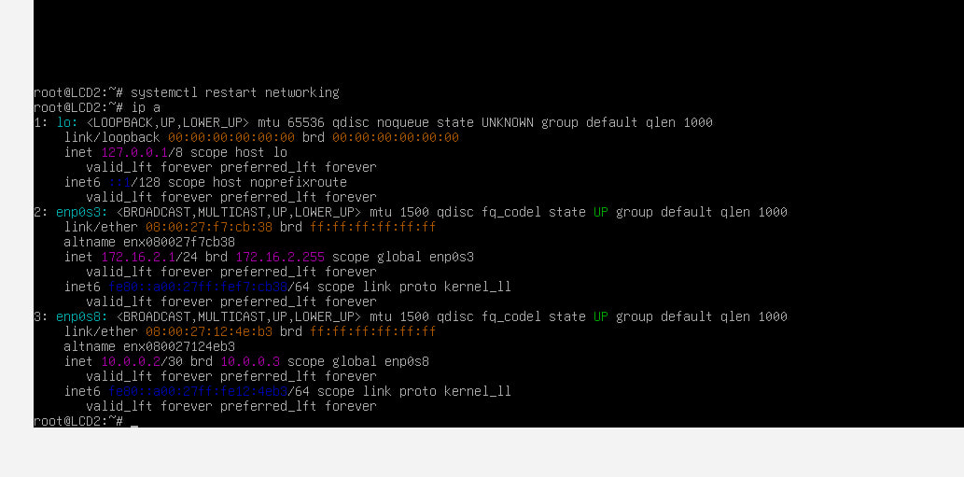

Task 2 - Domain Server (Birmingham)

2.1 Create Forest: rehina.acca
Active Directory Domain Services (AD DS) was installed and a new forest named rehina.acca was created on B-DC.
Step 1: AD DS role was installed:
Install-WindowsFeature -Name AD-Domain-Services -IncludeManagementTools
Step 2: Server was promoted to Domain Controller with the following command:
Install-ADDSForest -DomainName "rehina.acca" -DomainNetbiosName "REHINA" -SafeModeAdministratorPassword (ConvertTo-SecureString "NotebooK@123" -AsPlainText -Force) -InstallDns -Force
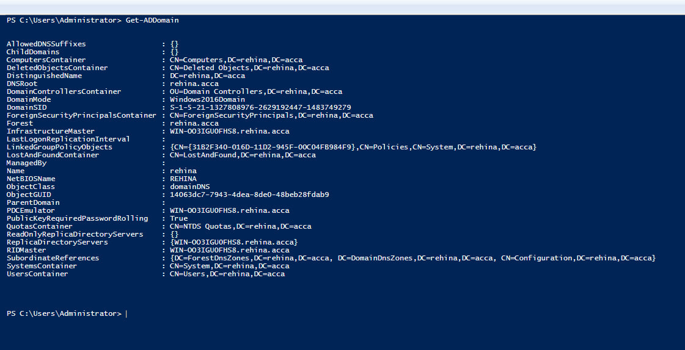

2.2 DNS A Records for All Servers
Forward lookup zone A records were created for all servers in both Birmingham and London networks using the following PowerShell commands:
Add-DnsServerResourceRecordA -ZoneName "rehina.acca" -Name "b-dc" -IPv4Address "172.16.1.1"
Add-DnsServerResourceRecordA -ZoneName "rehina.acca" -Name "l-cd" -IPv4Address "172.16.2.1"
Add-DnsServerResourceRecordA -ZoneName "rehina.acca" -Name "clients1" -IPv4Address "172.16.1.10"
Add-DnsServerResourceRecordA -ZoneName "rehina.acca" -Name "clientl1" -IPv4Address "172.16.2.10"
Add-DnsServerResourceRecordA -ZoneName "rehina.acca" -Name "webs" -IPv4Address "172.16.1.1"
Add-DnsServerResourceRecordA -ZoneName "rehina.acca" -Name "rds" -IPv4Address "172.16.1.1"
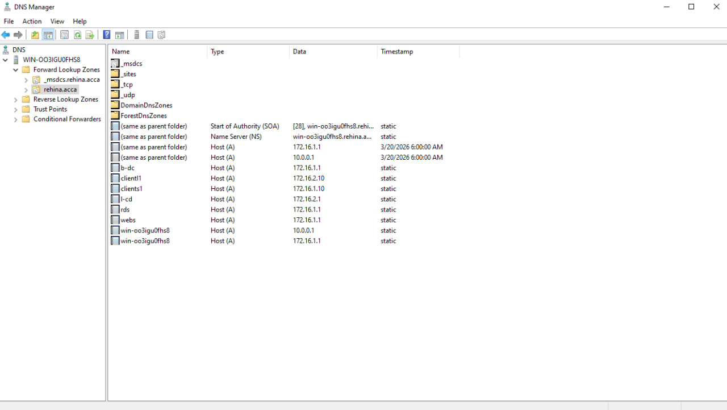

2.3 Reverse Lookup Zone and PTR Records
Reverse lookup zones were created for both subnets, and PTR records were added for all servers:
Add-DnsServerPrimaryZone -NetworkId "172.16.1.0/24" -ReplicationScope "Forest"
Add-DnsServerPrimaryZone -NetworkId "172.16.2.0/24" -ReplicationScope "Forest"
Add-DnsServerResourceRecordPtr -ZoneName "1.16.172.in-addr.arpa" -Name "1" -PtrDomainName "b-dc.rehina.acca"
Add-DnsServerResourceRecordPtr -ZoneName "2.16.172.in-addr.arpa" -Name "1" -PtrDomainName "l-cd.rehina.acca"
Add-DnsServerResourceRecordPtr -ZoneName "1.16.172.in-addr.arpa" -Name "10" -PtrDomainName "clients1.rehina.acca"
Add-DnsServerResourceRecordPtr -ZoneName "2.16.172.in-addr.arpa" -Name "10" -PtrDomainName "clientl1.rehina.acca"
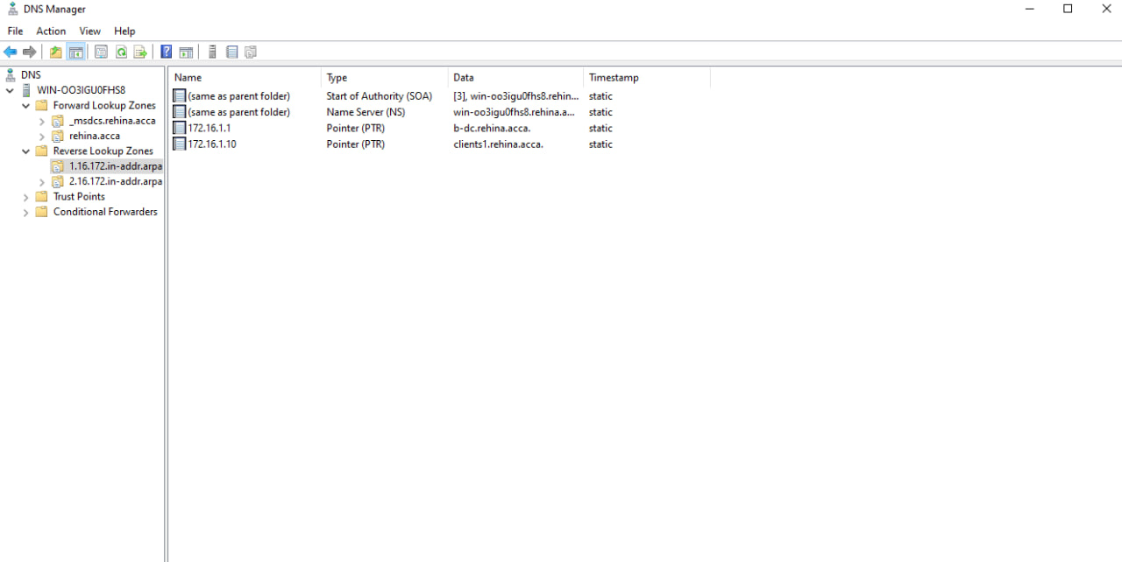
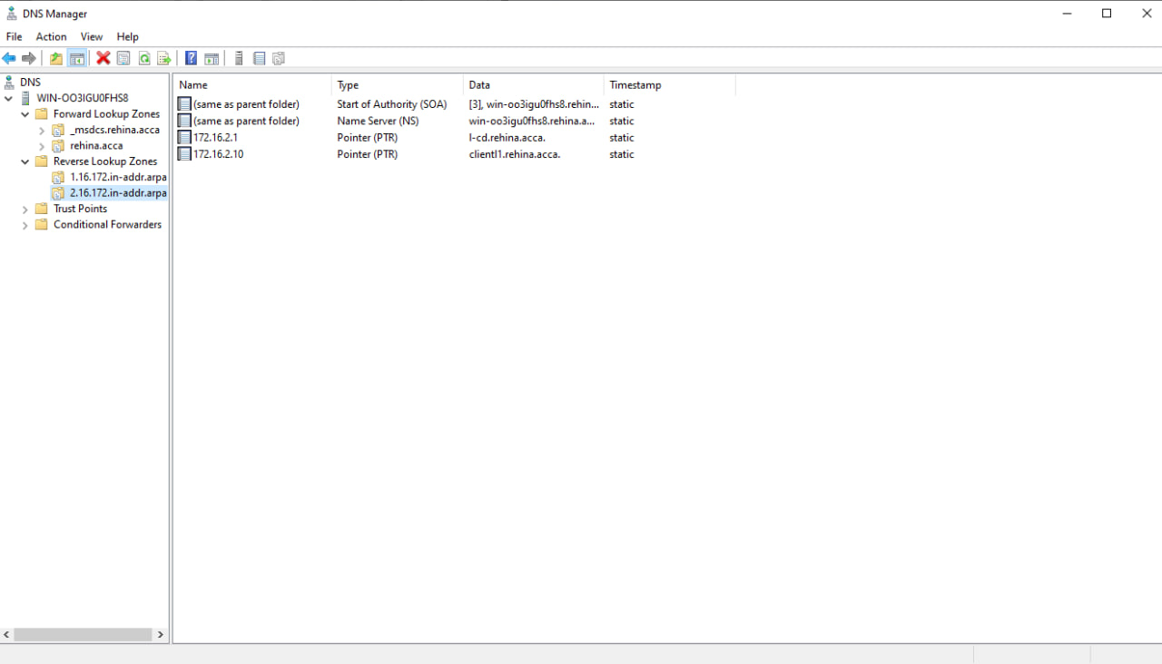

Task 3 - Encrypted Connection: Site-to-Site VPN

3.1 Configure Site-to-Site VPN
A persistent Site-to-Site VPN was configured between the Birmingham (B-DC) and London (L-CD) networks using IKEv2 with strong encryption via StrongSwan on the Debian server.
On B-DC (Windows Server) - RRAS was configured to accept IKEv2 connections. Firewall rules were added for UDP 500, UDP 4500, and ESP protocol 50. The RRAS Properties Security tab was configured with a Pre-Shared Key.
On L-CD (Debian) - StrongSwan was installed and configured:
apt-get install strongswan -y
The swanctl configuration file was created at /etc/swanctl/conf.d/birmingham.conf:
connections {
Birmingham-London {
local_addrs = 10.0.0.2
remote_addrs = 10.0.0.1
local { auth = psk }
remote { auth = psk }
children {
Birmingham-London {
local_ts = 172.16.2.0/24
remote_ts = 172.16.1.0/24
start_action = start
}
}
}
}
secrets { ike-1 { secret = "NotebooK@123" } }
A static route was also added on B-DC to ensure routing to the London network:
route add 172.16.2.0 mask 255.255.255.0 10.0.0.2 -p
Connectivity between Birmingham and London was successfully verified with ping tests in both directions.
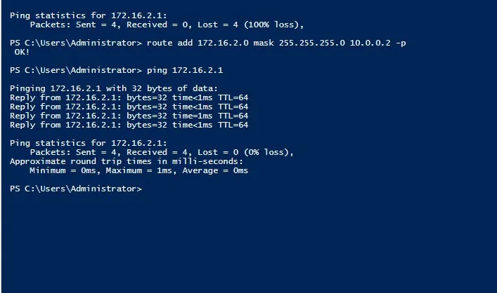

Task 4 - User Accounts

4.1 Bulk Create Users via PowerShell
User accounts were created in the rehina.acca domain using PowerShell from the users_list_updated CSV file. SAMAccountName format: first letter of first name + dot + last name (e.g. r.zinovieva).
A CSV file was first created containing all user data, then the following PowerShell script was executed to bulk-create all 15 users:
Import-Module ActiveDirectory
$users = Import-Csv "C:\users.csv"
foreach ($user in $users) {
$sam = ($user.GivenName[0] + "." + $user.SurName).ToLower()
$upn = $sam + "@rehina.acca"
$pass = ConvertTo-SecureString "Pa55worD" -AsPlainText -Force
New-ADUser -Name "$($user.GivenName) $($user.SurName)" -GivenName $user.GivenName -Surname $user.SurName -SamAccountName $sam -UserPrincipalName $upn -AccountPassword $pass -Enabled $true -Path "CN=Users,DC=rehina,DC=acca"
}
All 15 users were successfully created with correct SAMAccountName format as confirmed by Get-ADUser output.
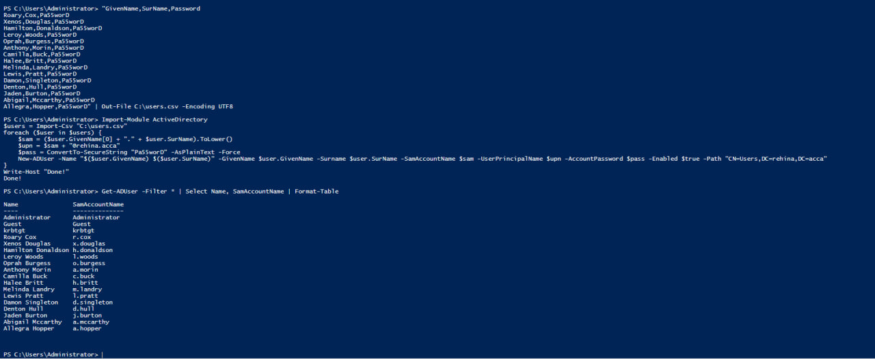

Task 5 - Domain Membership

5.1 Join L-CD, ClientS1, ClientL1 to rehina.acca
All three machines were joined to the rehina.acca domain to enable centralised authentication and Group Policy application.
On Windows machines (ClientS1, ClientL1) - PowerShell command was used:
Add-Computer -DomainName "rehina.acca" -Credential (Get-Credential) -Restart
On Debian (L-CD) - The realm utility was used to join the domain:
apt-get install realmd sssd sssd-tools adcli -y
echo 'nameserver 172.16.1.1' > /etc/resolv.conf
realm discover rehina.acca
realm join rehina.acca -U Administrator
realm list
All three machines were successfully joined to the rehina.acca domain as confirmed by the screenshots below.
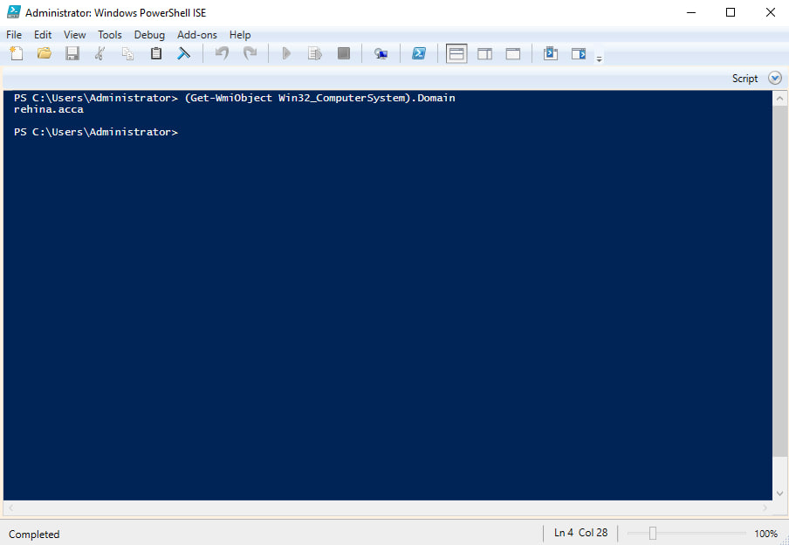

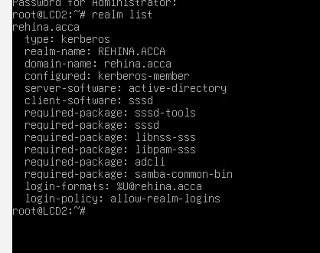
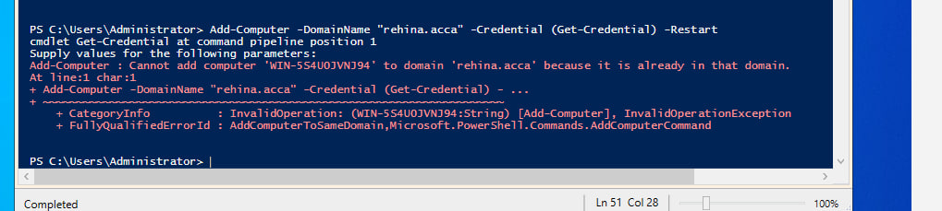

Task 6 - DHCP Server

6.1 Configure B-DC as DHCP Server
DHCP Server role was installed on B-DC and two scopes were created - one for Birmingham (172.16.1.x) and one for London (172.16.2.x).
Install-WindowsFeature DHCP -IncludeManagementTools
Add-DhcpServerInDC -DnsName "b-dc.rehina.acca" -IPAddress 172.16.1.1
Add-DhcpServerv4Scope -Name "Birmingham" -StartRange 172.16.1.10 -EndRange 172.16.1.20 -SubnetMask 255.255.255.0 -State Active
Set-DhcpServerv4OptionValue -ScopeId 172.16.1.0 -Router 172.16.1.1 -DnsServer 172.16.1.1 -DnsDomain "rehina.acca"
Add-DhcpServerv4Scope -Name "London" -StartRange 172.16.2.10 -EndRange 172.16.2.20 -SubnetMask 255.255.255.0 -State Active
Set-DhcpServerv4OptionValue -ScopeId 172.16.2.0 -Router 172.16.2.1 -DnsServer 172.16.1.1 -DnsDomain "rehina.acca"

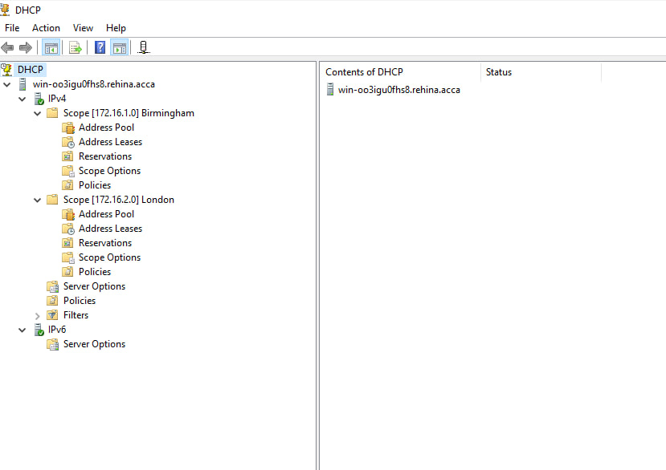6.2 Configure L-CD as DHCP Relay Agent
The isc-dhcp-relay package was installed on L-CD and configured to forward DHCP requests from the London network to the Birmingham DHCP server.
apt-get install isc-dhcp-relay -y
The /etc/default/isc-dhcp-relay file was configured with the following settings:
SERVERS="172.16.1.1"
INTERFACES="enp0s3"
systemctl enable isc-dhcp-relay
systemctl start isc-dhcp-relay
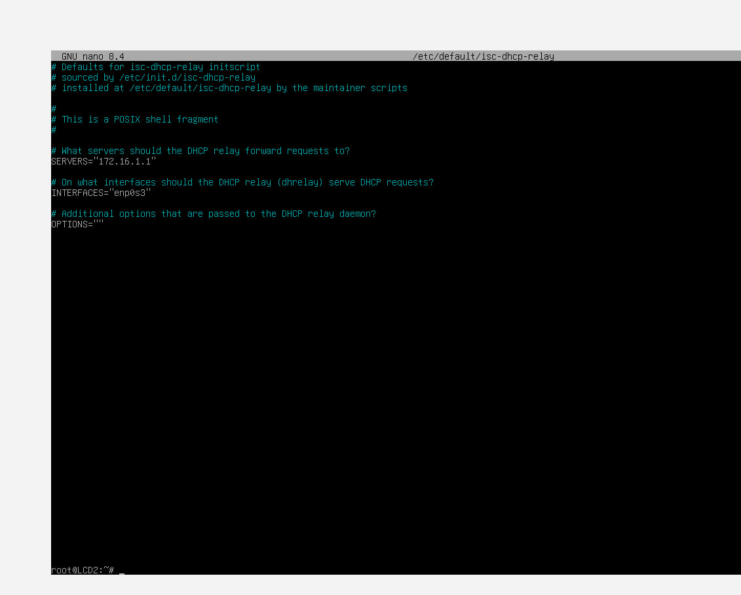

6.3 Client DHCP Verification
Both ClientS1 and ClientL1 were configured to receive IP addresses automatically via DHCP. ClientS1 receives an address from the Birmingham scope (172.16.1.10-20) directly, while ClientL1 receives an address from the London scope (172.16.2.10-20) via the DHCP relay on L-CD.

Task 7 - Test and Troubleshoot

7.1 Network Connectivity Tests
Full connectivity tests were performed to verify that both networks are operational and connected.
Test 1: Ping from B-DC to L-CD London interface (172.16.2.1) - SUCCESS
ping 172.16.2.1
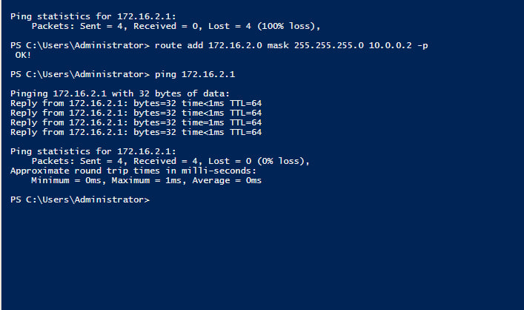Test 2: Ping from L-CD to B-DC Birmingham interface (172.16.1.1) - SUCCESS
ping -c 4 172.16.1.1
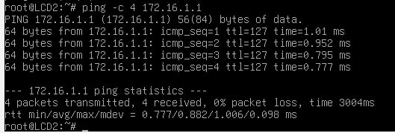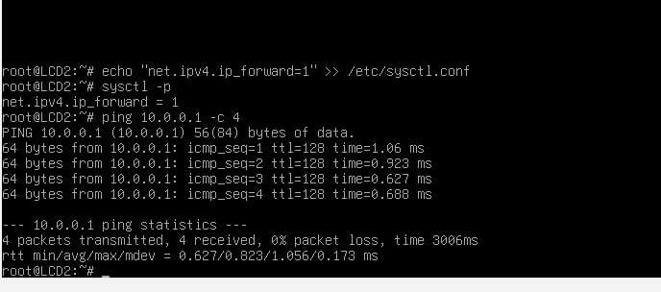

Task 8 - Disk Drive

8.1 Mount Second Disk, Share and Set Permissions
A second virtual disk was added to B-DC in VirtualBox Settings. The disk was then initialised, formatted, and mounted to E:\BirminghamFiles.
Get-Disk | Where-Object PartitionStyle -eq RAW | Initialize-Disk -PartitionStyle MBR
New-Partition -DiskNumber 1 -UseMaximumSize -AssignDriveLetter
Format-Volume -DriveLetter E -FileSystem NTFS -NewFileSystemLabel "BirminghamFiles"
The folder was created, shared over the network, and NTFS permissions were configured so that Domain Users have Full Control and all other network users have Read Only access:
New-Item -ItemType Directory -Path "E:\BirminghamFiles"
New-SmbShare -Name "BirminghamFiles" -Path "E:\BirminghamFiles" -FullAccess "REHINA\Domain Users" -ReadAccess "Everyone"
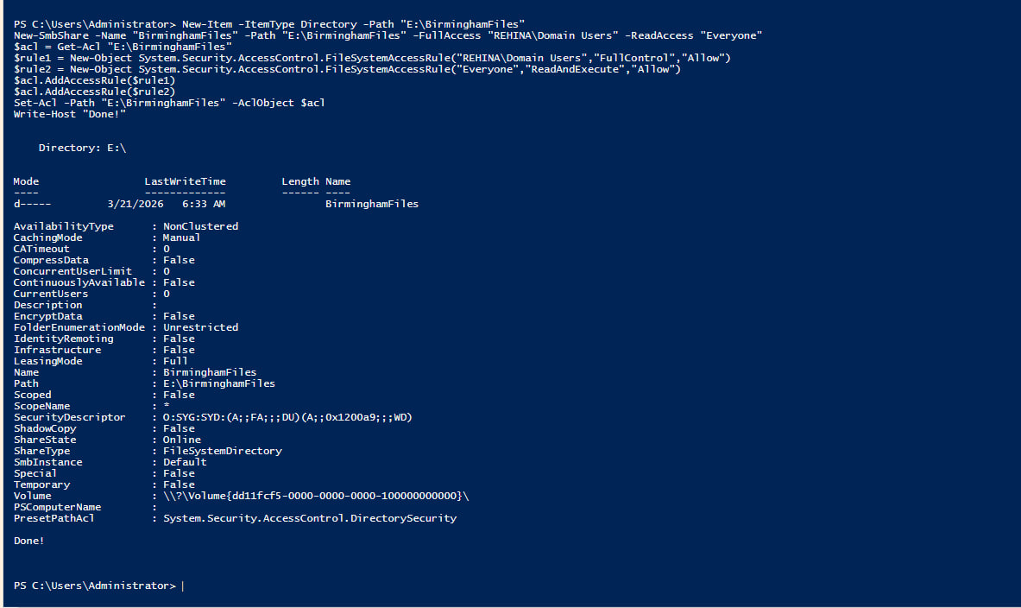

Task 9 - IIS Web Server

9.1 Create webs.rehina.acca with Windows Authentication
IIS was installed on B-DC and a website was configured at https://webs.rehina.acca with Windows Authentication enabled. All domain users are greeted with a welcome message.
Install-WindowsFeature Web-Server,Web-Windows-Auth,Web-Mgmt-Console -IncludeManagementTools
New-Item -ItemType Directory -Path "C:\inetpub\webs"
Set-Content -Path "C:\inetpub\webs\index.html" -Value "Welcome to Birmingham Website"
$cert = New-SelfSignedCertificate -DnsName "webs.rehina.acca" -CertStoreLocation "Cert:\LocalMachine\My"
New-WebSite -Name "webs.rehina.acca" -PhysicalPath "C:\inetpub\webs" -Port 443 -HostHeader "webs.rehina.acca" -Ssl
Windows Authentication was enabled and Anonymous Authentication was disabled via IIS Manager under Authentication settings for the webs.rehina.acca site.
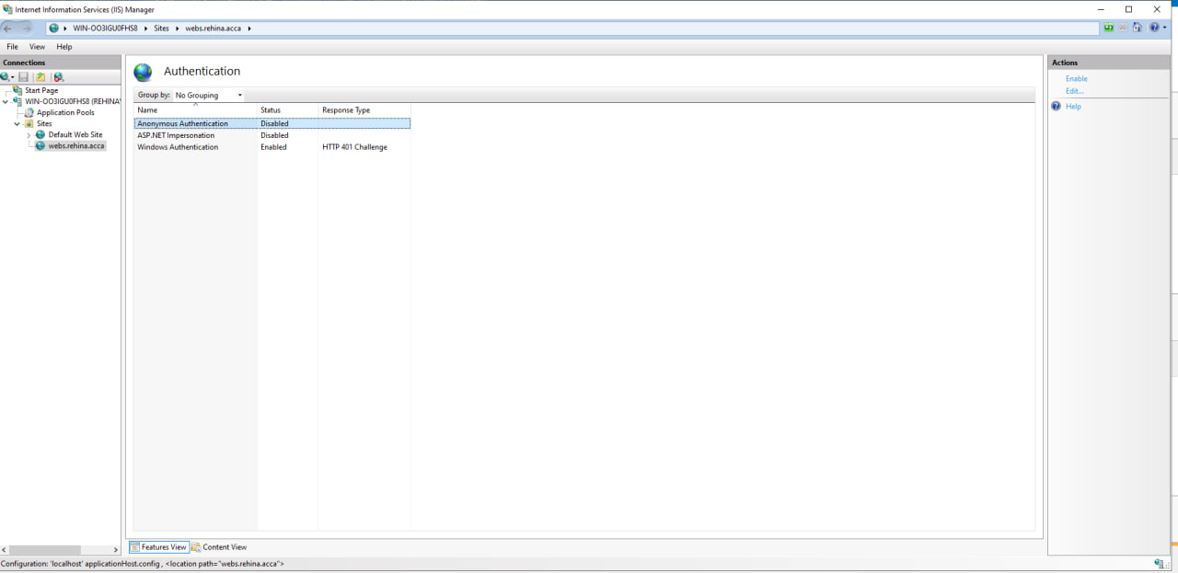

Task 10 - Remote Desktop Services

10.1 Configure Remote Desktop Access for B-DC
Remote Desktop Services was configured on B-DC to allow remote access from any machine in the network, accessible via https://rds.rehina.acca/RDWeb with a signed certificate.
Set-ItemProperty -Path "HKLM:\System\CurrentControlSet\Control\Terminal Server" -Name fDenyTSConnections -Value 0
Enable-NetFirewallRule -DisplayGroup "Remote Desktop"
Install-WindowsFeature RDS-Gateway,RDS-Web-Access -IncludeManagementTools
$cert = New-SelfSignedCertificate -DnsName "rds.rehina.acca" -CertStoreLocation "Cert:\LocalMachine\My"
The RD Web Access login page was successfully accessed via https://localhost/RDWeb from a browser on B-DC, confirming that Remote Desktop Services is operational.
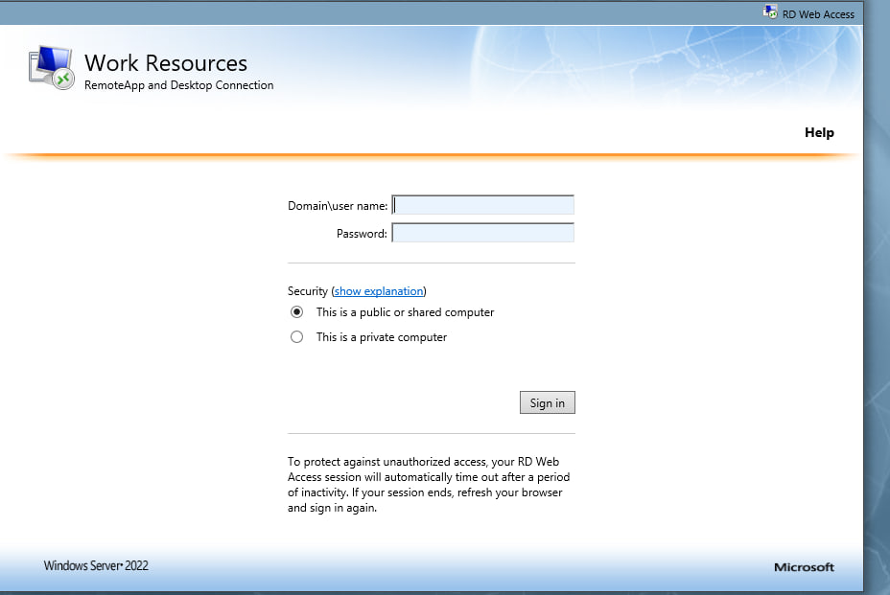

Conclusion
This coursework successfully extended the virtualised enterprise network from Coursework 1 by implementing a full suite of network services across the Birmingham and London sites. The following components were deployed and verified:
Task 1: RRAS routing configured on B-DC (Birmingham) and persistent IP forwarding on L-CD (London) with static routes enabling full inter-site connectivity.
Task 2: Active Directory forest rehina.acca created with comprehensive DNS A records and reverse lookup PTR records for all network infrastructure.
Task 3: Site-to-Site IKEv2 VPN configured between Birmingham and London using StrongSwan on Debian and RRAS on Windows Server, with static routing ensuring full network reachability.
Task 4: 15 user accounts bulk-created via PowerShell from CSV data, with correct SAMAccountName format (first initial + surname).
Task 5: All three machines (L-CD, ClientS1, ClientL1) successfully joined to the rehina.acca domain.
Task 6: Centralised DHCP server on B-DC with two scopes, DHCP relay on L-CD forwarding London client requests to Birmingham.
Task 7: Full network connectivity verified with successful ping tests between all sites.
Task 8: Second disk mounted to E:\BirminghamFiles, shared with appropriate NTFS and SMB permissions for Domain Users and Everyone.
Task 9: IIS website webs.rehina.acca configured with HTTPS and Windows Authentication, serving Welcome to Birmingham Website to authenticated domain users.
Task 10: Remote Desktop Services accessible via https://rds.rehina.acca/RDWeb with self-signed certificate.

