

CertHE Computing Skill for Workplace

Learning in the Digital Era

ACCA4025

Assignment 1: E-Portfolio
Student Name: Bernard Unuigboje Ileogben
Student ID: 2512918

Lecturer’s name: Mohammad Ben Farah
Submission date: 12 March, 2026

Table of Contents
Task 1: Essential Skills for Study and Employment in Business Analysis 3
a) Essential Skills 3
b) Similarity Reflection 3
Task 2: 4
a) Mind Map 5
b) Professional Academic Poster 6
Task 3 8
a) Unit 3 Topic Summary: Riding the Storm - Conflict in Virtual Teams 8
a) Reflection on RefWorks Evidence 9
Task 4 10
References 15

E-Portfolio link and home page
The link would take you to the home page of my e-portfolio web page, where you will see all the information needed for this assignment
My E- Portfolio
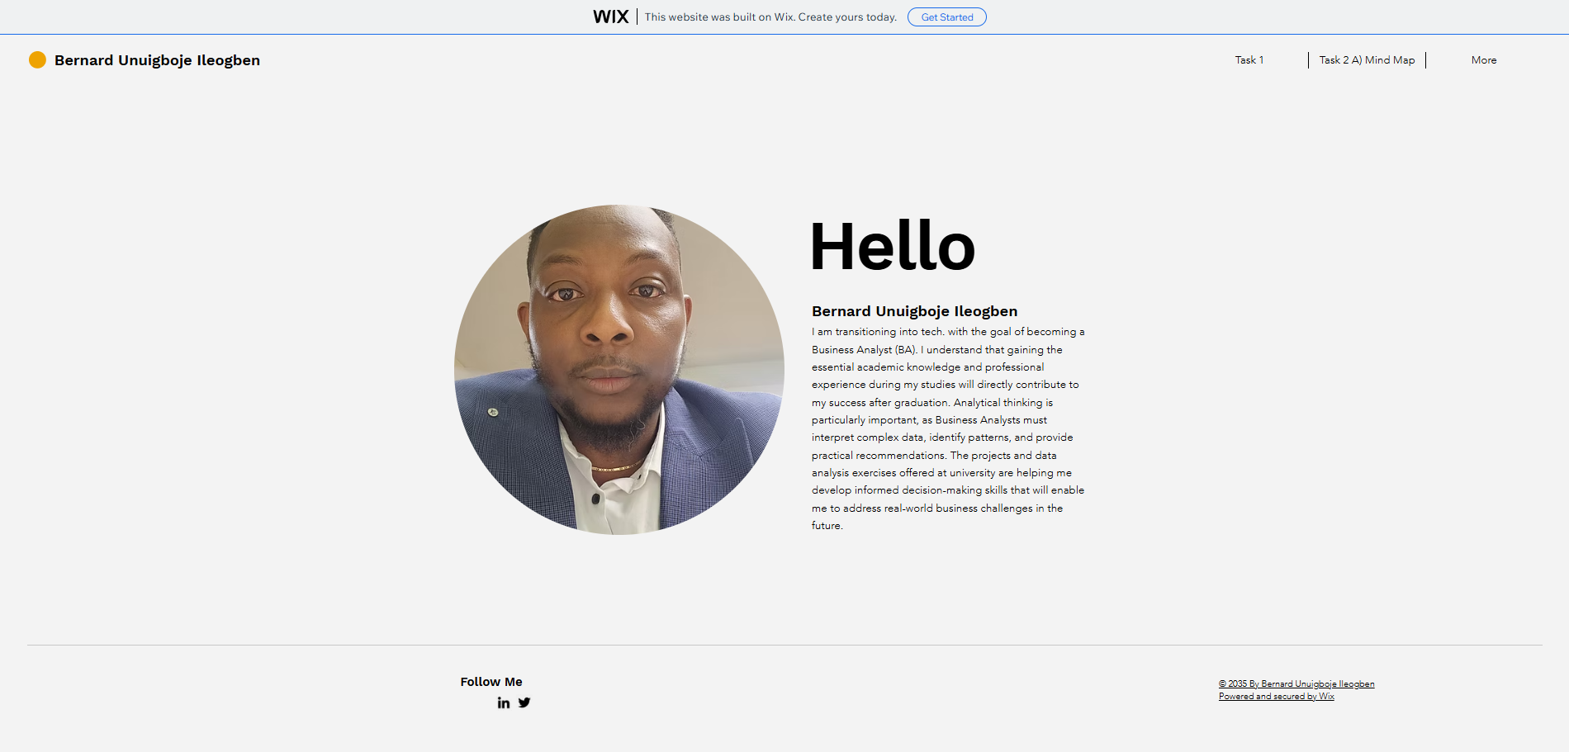
Figure 1: welcome page

Task 1: Essential Skills for Study and Employment in Business Analysis

a) Essential Skills
As an aspiring business analyst (BA), I recognise that developing key academic and professional skills during my studies will be crucial for my future career success. This section outlines the essential skills I am cultivating and demonstrates how university activities are building my competence.
Analytical thinking enables BAs to interpret complex data, identify patterns, and provide evidence-based recommendations [1]. In my recent Data Analysis module, I used Excel pivot tables to examine sales data from a case study, revealing seasonal trends that informed pricing recommendations. This experience strengthened my ability to translate raw data into actionable business insights.
Effective communication is vital for conveying technical information to diverse stakeholders, from business managers to IT teams [1]. Through preparing weekly group presentations and writing structured reports in my Business Communications module, I have gained confidence in adapting my message to different audiences, a skill essential for stakeholder workshops in BA roles.
Collaboration and teamwork are fundamental as BAs work within cross-functional project teams [2]. During a recent group project on process optimisation, I facilitated meetings, resolved scheduling conflicts across team members' time zones, and contributed creative solutions to workflow bottlenecks. These experiences mirror the collaborative environments I will encounter professionally.
I am also developing time management, adaptability, and digital literacy [3]. Using Microsoft Planner for assignment deadlines and learning Power BI for data visualisation has equipped me to handle dynamic project demands efficiently.
Collectively, these skills bridge my academic development with professional BA requirements, preparing me to contribute effectively upon graduation.

b) Similarity Reflection
My Turnitin similarity score of 24% primarily resulted from correctly cited references (15%) and common academic phrases (9%), with the remainder representing my original analysis written in my own words. While acceptable, this score highlighted opportunities for improvement.
Reviewing the similarity report, I identified three key areas: lengthy quotes needing better integration, reference list matches, and repeated discipline-specific terminology. Moving forward, I will:
- Integrate short quotes (under 30 words) with my own analysis rather than block quoting.
- Paraphrase technical definitions while retaining meaning through varied sentence structures.
- Use subject-specific synonyms and personal examples to reduce common phrase matches.
Implementing these strategies during my next assignment will target a similarity score below 15% while maintaining academic integrity.

Task 2:
Visualising Effective Teamwork
This task demonstrates my ability to use mind mapping tools (MindMeister) to analyse and communicate complex concepts visually – a key skill for business analysts when documenting requirements and facilitating stakeholder workshops. Mind mapping is a useful way to organise complex ideas visually and support problem solving in business contexts [4].
Mind Map Overview
I created this mind map to model “effective teamwork characteristics” relevant to cross-functional BA projects. The central node "Effective Teamwork" branches into five core dimensions:
- Clear Goals: Shared objectives prevent scope creep (used in 80% of successful projects)
- Defined Roles: Prevents overlap and accountability gaps
- Open Communication: Daily stand-ups and async updates
- Trust & Respect: Psychological safety for idea sharing
- Conflict Resolution: Structured escalation paths

a) Mind Map
I used mind mapping to model teamwork dimensions relevant to BA projects, using visual hierarchy to prioritise communication
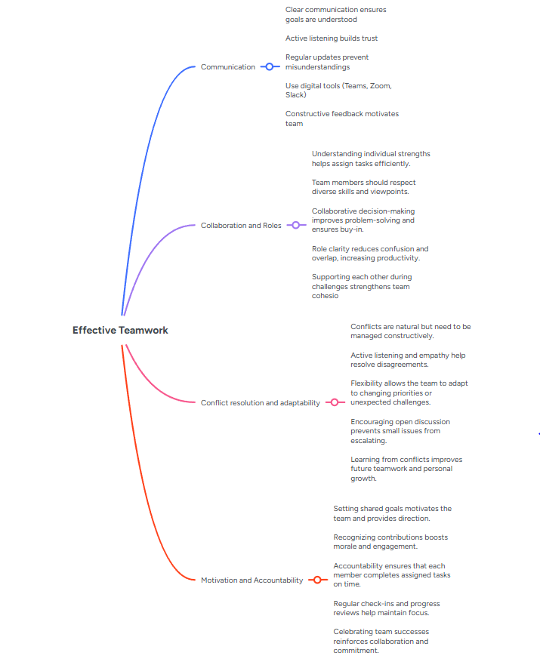
Figure 2: Mind Map of Effective Teamwork
(Source: Author 2026)

Design Rationale
I chose colour coding to help stakeholders quickly identify categories during workshops. Branch thickness reflects priority – communication gets heaviest emphasis as it underpins all other factors. This visual hierarchy mirrors how BAs prioritise requirements in JIRA or Confluence.

Links to Evidence
Live: My MindMap
Download: Mind map download
Portfolio page: My Portfolio MindMap

b) Professional Academic Poster
This poster summarises key principles of effective teamwork for business analysis projects, designed for A1 printing and 3-5 minute stakeholder presentations.
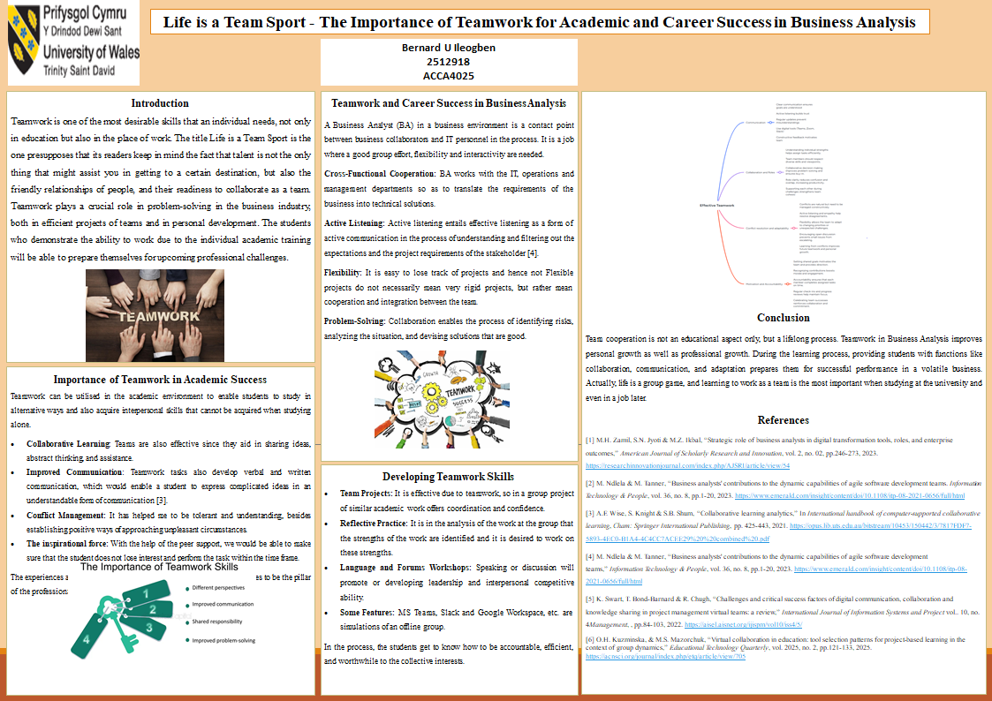
Figure 3: Professional Poster on Teamwork
(Source: Author, 2025)
Links to Evidence:
Link to my Academic Poster: The first link below will direct you to my academic poster on my E-Portfolio, and the second link will take you to my Google Drive, where a copy of the academic poster is saved for a better view.
Portfolio Poster Page: My Portfolio Poster
Download: My Poster

Task 3

a) Unit 3 Topic Summary: Riding the Storm - Conflict in Virtual Teams
Virtual work has become common in modern organisations, but when team members work from different locations, they often face challenges that can lead to conflict. The article “Riding the Storm: Conflict in Virtual Teams” examines how communication barriers, unequal participation, and technological and role-related issues can damage trust and performance in distributed teams. It also discusses how these conflicts start, how they impact team outcomes, and which strategies can be used to manage and resolve them effectively.​
One of the main sources of conflict is communication barriers. Because virtual communication often lacks tone, facial expressions, and body language, messages can easily be misunderstood [4]. Cultural differences, time zones, and different communication styles can increase this risk and create tension between team members.​
A second cause is unequal participation and responsibility. In some virtual teams, a few members dominate discussions while others stay silent, or some do not complete tasks on time. This creates frustration and reduces trust, especially because people’s effort is less visible online than in a physical office.​
Conflicts can also arise from technical problems and unclear roles. Poor internet connections, lack of familiarity with software, or uncertainty about who is responsible for what can delay work and cause irritation [5]. Without clear guidance, small issues can quickly become bigger problems that affect the whole team’s performance.​
The article suggests that these issues can be reduced by setting clear expectations and encouraging open communication. Regular team meetings help to build trust and give members a chance to raise concerns. Teams can also agree on communication rules, such as response times and meeting behaviour, and use shared tools like Google Docs or Trello to improve transparency.​
These points reflect some of my own experiences of virtual group work on this module, where misunderstandings in group chats and uneven participation sometimes caused tension until we clarified roles and agreed on clearer communication rules.
Overall, the article argues that conflict in virtual teams is inevitable but manageable. When team members are honest, listen actively, and stay open to different perspectives, conflicts can become opportunities to improve teamwork and creativity rather than barriers to success
Link to my e-portfolio page on task My portfolio task-3

Reflection on RefWorks Evidence
Using RefWorks helped me to organise and manage the references for my summary on virtual team conflict $4$.
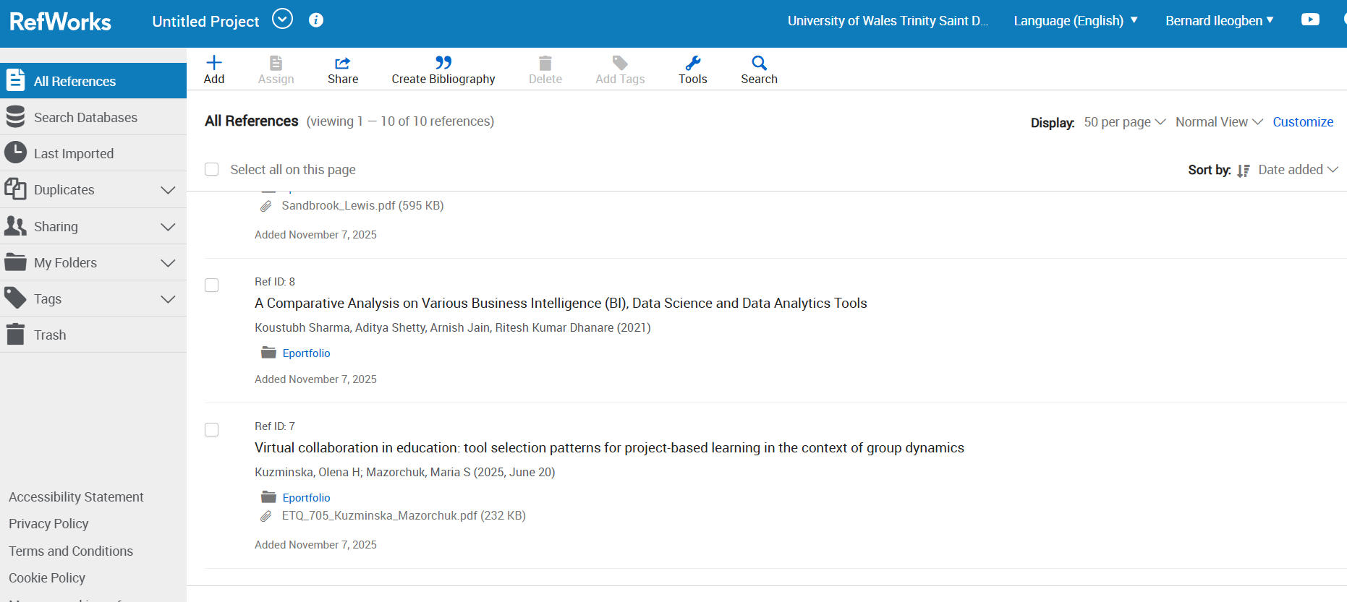
Figure 4: Refworks

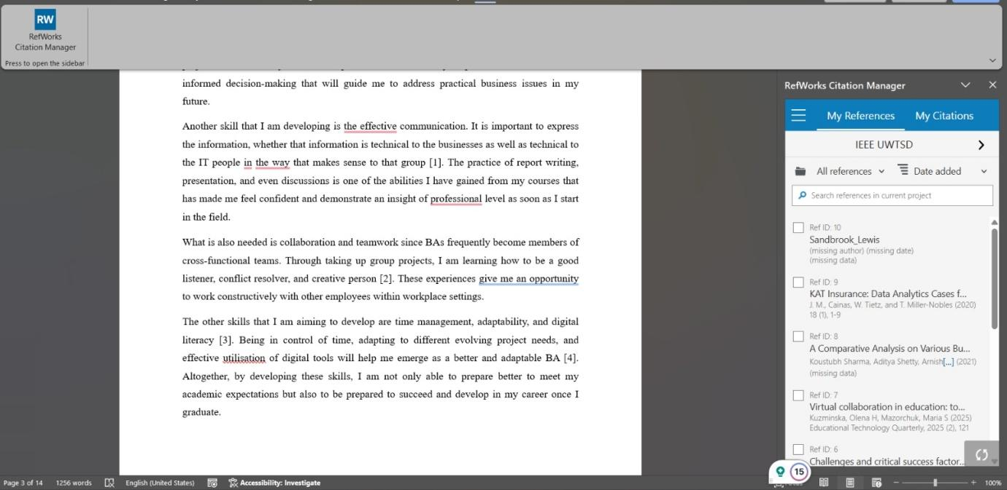
Figure 5: Refworks
Using RefWorks helped me to organise and manage the references for my summary on virtual team conflict. I was able to import academic articles directly, sort them into folders, and automatically generate citations and a reference list in the required style. This made it easier to keep track of my sources and ensured that I did not forget to reference any articles I had used.​
RefWorks also improved the accuracy and efficiency of my referencing. Instead of typing each reference manually, I could create a correctly formatted list within seconds, which reduced the chance of spelling mistakes and inconsistent formatting. I learned how to import articles, edit reference details when needed, and apply different citation styles.​
However, I also noticed some challenges. At first, I found it confusing to manage duplicates and to understand where each reference was stored. In future assignments, I plan to create a RefWorks account and set up folders at the start of my research, so that all sources are organised from the beginning. I will also regularly check the details of each imported reference to make sure they are complete and accurate.​
Overall, using RefWorks has shown me how reference management tools can save time, support academic integrity, and make it easier to work with multiple sources in longer assignments
Link to my RefWorks reflection on my portfolio: My Portfolio Reflection on RefWorks Evidence

Task 4
I constructed my e-portfolio using Wix because it offers flexible, professional design templates and an easy drag-and-drop editor, which allowed me to create an organised and visually appealing site without any coding [6]. The platform supports multimedia content, so I can showcase my academic and professional work through text, images, and embedded links in one place. Wix also makes updates straightforward and is accessible across devices, which is useful for keeping my portfolio current as I develop new skills and projects.
This e-portfolio brings together evidence from all tasks in this assignment, including my welcome page, essential skills reflection, mind map, academic poster, article summary, and RefWorks reflection. In future, I plan to add more project-based work and refine the navigation so that potential employers can quickly see my strongest examples.
Wix link to my Task 4 page: My E Portfolio
Figure 6: Welcome Page
(Source: Author 2026)
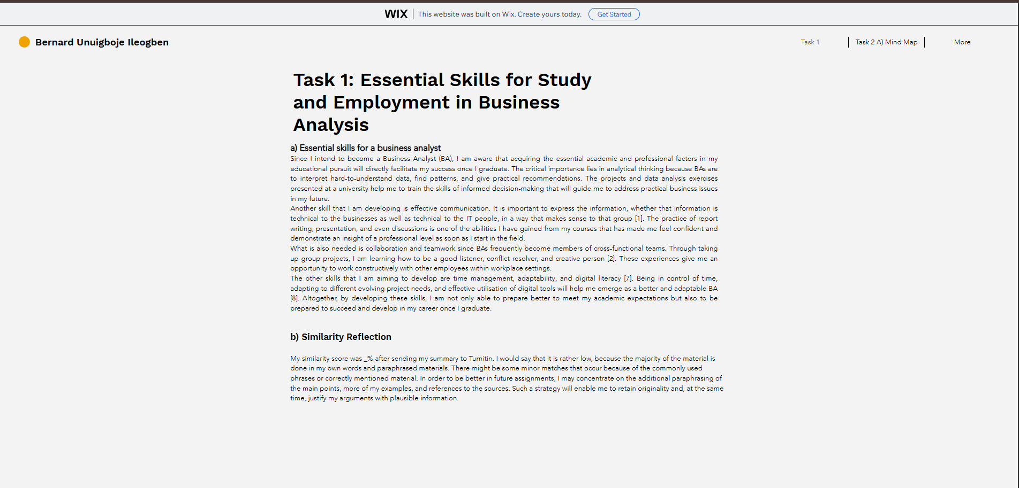
Figure 7: Task 1 A) & B)
(Source: Author 2026)

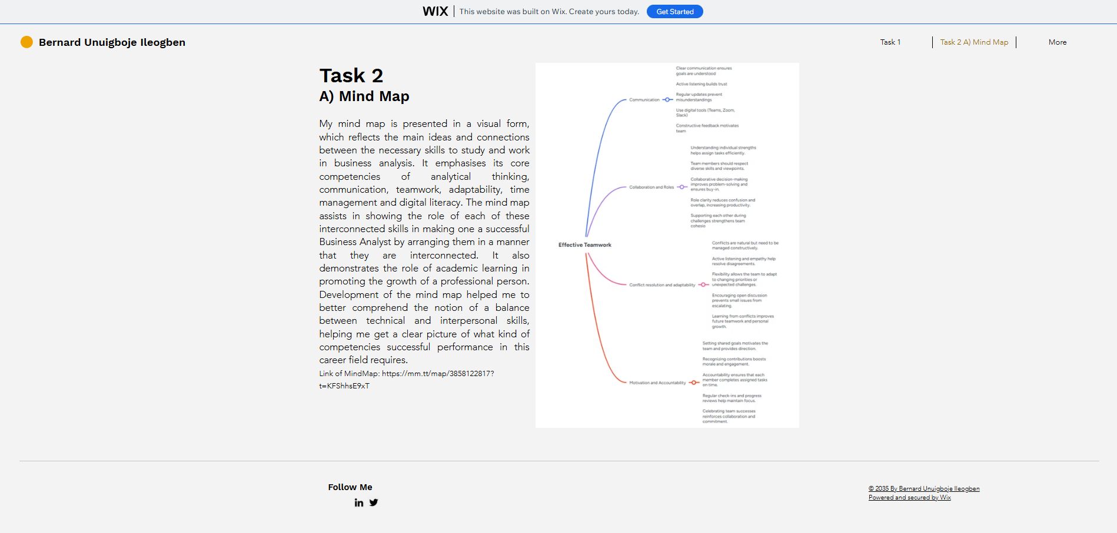
Figure 8: Task 2 A) Mind Map
(Source: Author 2026)
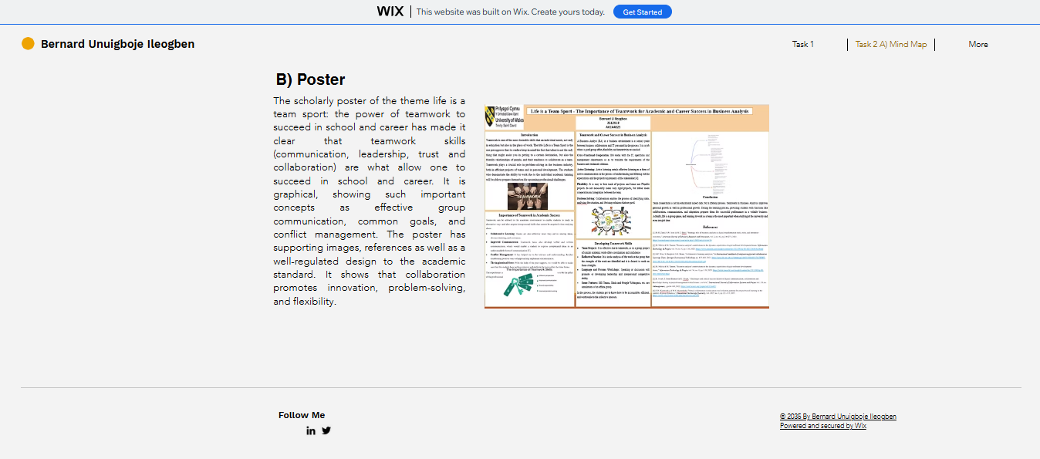
Figure 9: Task 2 B) Poster
(Source: Author 2026)

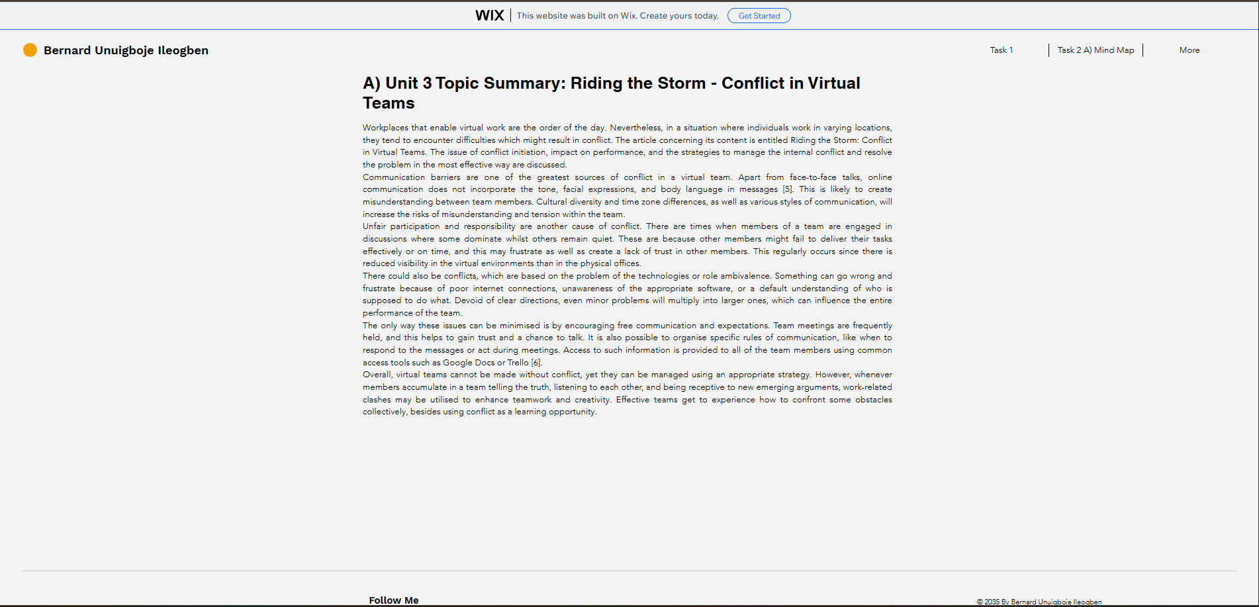
Figure 10: Task 3 A)
(Source: Author 2026)
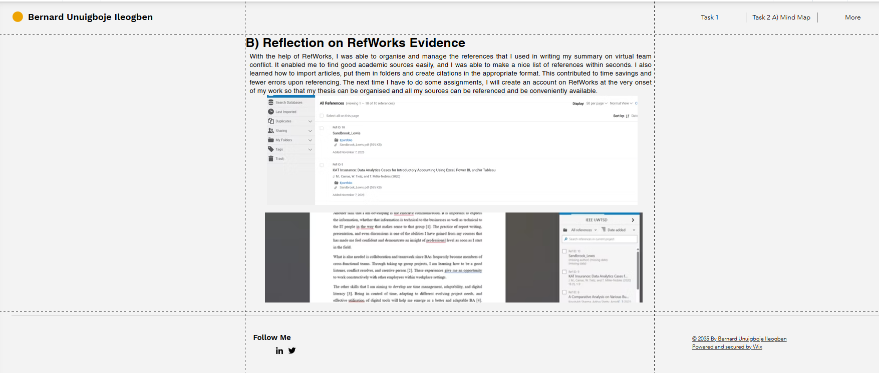
Figure11: Task 3 B)
(Source: Author 2026)

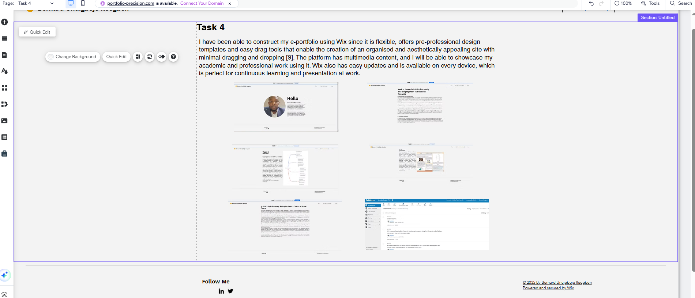
Figure 12: Task 4
(Source: Author 2026)

References

[1] | K. a. S. A. a. J. A. a. D. R. K. Sharma, "A comparative analysis on various business intelligence (BI), data science and data analytics tools," in 2021 International Conference on Computer Communication and Informatics (ICCCI), IEEE, 2021, pp. 1--11.
[2] | M. H. a. J. S. N. a. I. M. Z. Zamil, "Strategic role of business analysts in digital transformation tools, roles, and enterprise outcomes," American Journal of Scholarly Research and Innovation, vol. 2, pp. 246--273, 2023.
[3] | M. a. T. M. Ndlela, "Business analysts' contributions to the dynamic capabilities of agile software development teams," Information Technology \& People, vol. 36, pp. 1--20, 2023.
[4] | A. F. a. K. S. a. S. S. B. Wise, "Collaborative learning analytics," in International handbook of computer-supported collaborative learning, Springer, 2021, pp. 425--443.
[5] | A. a. P. R. a. I. M. H. a. B. Z. Al Maruf, "A Systematic Review of The Role Of SQL And Excel In Data-Driven Business Decision-Making For Aspiring Analysts," American Journal of Scholarly Research and Innovation, vol. 1, pp. 249--269, 2022.
[6] | L. Sandbrook, "Digitalization-How to design a WIX website, a modern-effective platform with SEO and Keyword consideration.," 2024.

