Research Proposal

An investigation into the relationship between branding and consumer behaviour in the international airline industry: A case study of British Airways

STUDENT NAME: OLAWUNMI A OSHODI
STUDENT ID: 1706254

Table of Contents
1. Introduction 1
1.1 Research Rationale 1
1.2 Research Question 2
1.3 Research Aim and Objectives 2
2. Literature Review 3
3. Research Methodology 5
3.1 Research Approach 5
3.2 Population and Sample 5
3.3 Data Collection Methods 5
3.4 Data Analysis Methods 6
4. Ethical Considerations 7
5. Timetable 8
5.1 Time schedule 8
5.2 Gantt Chart 10
Reference 11

Introduction

Research Rationale
British Airways is facing a falling on their brand image due to the IT failure occurred in May 2017. This IT outage in last year impacted thousands of flights in the weekend and there are signs that this problem impact on the business performance of the British Airways as well. There were more than 75,000 complaints from the travellers who were affected by the IT failure and this failure is occurred due to the poor communication process on the ground (Vizard, 2017). As the Times claimed, most of the affected passengers said that they boycott the British Airways (BA). Even though the BA has a significant brand value, there is a danger for their brand after such an issue. According the annual report of BA, their brand has been erosion which impact over the market position as well as the future profitability of the company (British Airways, 2017).
The worth of the brand at the end of 2017 was $3.7bn and BA becomes the ninth valuable airline brand in the international airline industry however, this is a decrease valuation of 20% compared to the 2016 brand value (Brand Finance, 2017). It is a known factor that unlike in other sectors, consumers are not often forgiving the failures of the aviation industry. Failures like BA result in major expense to the travellers resulting discomfort and inconvenience experience which directly impact on their buying behaviour and purchase intention. On the other hand, BA is operating in a highly competitive business environment where multiple airlines serving the similar destinations. Unlike in other sectors, consumer switching is frequent and consumers more often switch to another carrier soon they dissatisfied. This will result in fairly infrequent purchases of the brand and passengers might give years to give another chance to the brand (Vizard, 2017). Therefore, the brand damages could be substantial for BA.
It is evidenced that the consumer perception of the brand of BA according to the YouGov Brand Index (2017) reflects a significance decrease of 9.5 points. This brand score is measured combining reputation, value and quality of the brand. More importantly, it is noted that consumer purchase intention is also decreased by 8.5 points (YouGov, 2017). Coupled with the brand damage, another significance reason for decreased purchase intention of customers is the expensive tickets of BA (YouGov, 2017). There are rivals who offer competitively lower prices such as Ryanair and EasyJet which are the cheaper budget airlines. Even though consumers see a clear difference between BA and these budget airline, they now tend to select budget airlines over BA due to its recent loss
es of the brand value. According to Stacey of YouGov (2017) due to the damage of the brand of BA, consumers no longer will pay extra money for BA even the BA claimed to have increased quality. The aura of BA highlights a direct relationship between the branding and the consumer buying behaviour and purchase intention which gives a rationale to undertake the proposed research study. The study will therefore, mainly have carried out to examine the relationship between the branding and consumer buying behaviour in the international airline industry giving especial reference to British Airlines.

Research Question
What is the relationship between branding and consumer behaviour in British Airways?

Research Aim and Objectives
Research aim: To examine the relationship between branding and consumer behaviour in British Airways

Research Objectives
- To assess the factors associated with the brand of British Airways
- To determine the impact of brand of British Airways on consumer behaviour
- To suggest appropriate strategies to enhance the brand image of British Airways towards stimulating consumer behaviour

Literature Review
As Kotler and Armstrong (2017) explain, brand image is how the consumer perceived the brand and how the organisation communicates their products and service to the customer. The brand image is derived on the consumers mind based on the association of the brand. In the literature, there are three factors associated with the brand which creates a positive brand image on the consumer mind. These factors of the brand image help consumers to differentiate the brand from the customers. According to Keller (2010) these factors are namely brand favourability, brand uniqueness and brand strength.
Brand favourability is directly related to the valence of the brand. According to Keller (2010), brand favourability is resulted when the consumers perceived a particular brand positively due to its perceived ability to satisfy the consumer expectations. In order to enhance the brand favourability, the particular brand should have the ability to keep a fit between consumer impression and the corporate image. On the other hand, brand uniqueness is how the consumers can differentiate the brand from the competing brands (Keller, 2010). Therefore, in order to ensure the brand uniqueness, organisation needs to position their brand on the consumer’s minds differently from their competitors. The strength of the brand is relevant to the functional facilities of the brand (Kolter and Keller, 2010). Brand strength is determined by the information quantity that consumers taken into the minds and the information quality which they used to process the brand image. As Keller (2010) argues, when consumers think actively about a specific brand, there will be a stronger association on the consumer brand regarding the brand.
As empirically evidenced, favourable, unique and strong brands have the ability to reinforce consumer behaviour and result them loyal customers (Davis et al., 2005). Vinhas and Faridah (2008) also found that consumers become brand loyal, if the brand is unique, favourable and strong compared to the competitive brands. However, it is also significance for the organisation to regularly predict the changing consumer demand and behavioural patterns otherwise, consumers will go for another brand (Miller and Muir, 2005). In the literature, there are many
evidences to prove the association between branding and consumer buying behaviour. Khasawneh and Hosouneh (2010) found that among the branding and demographic characteristics of the consumers, brand is the most influential factor to make the purchase decision. Consumers often perceive that branded products are of greater quality therefore, brand of the product stimulates the consumers most than the price of the products (Khasawneh and Hosouneh, 2010).
It is the Nepalia’s (2011) view that the brand image act as a signal of the quality of the product to the customers which could reinforce the consumer purchase preference. It is also evidenced that brands that are associated with sustainability such as social and environmental friendly aspects have a high tendency to influence consumers buying behaviour and purchase intention (Shah et al., 2012). According to the explanation of Doostar et al. (2012) brand becomes a devise that differentiate the company from their competitors. The combination of brand image, brand awareness, brand identity and perceived quality of the brand significantly impact on the consumer brand choice, behavioural intention and purchase decision (Doostar et al., 2012). Even though the brand of the company is an intangible asset it generates competitive advantages and influence the consumer behaviour towards choosing the brand and purchase it (Rubini, 2010).

Research Methodology

Research Approach
Social research studies can be either deductive or inductive. In using inductive approach researcher adopt a bottom up method where he collects data to build theory for a particular research problem. In contrast, researchers adopt deductive approach to test the identified theories by collecting data (Saunders et al., 2012). The proposed study intends to use deductive approach as it first collects theoretical evidence particular to the research problem and them using a suitable methodology, collects data to test the applicability of the identified theory (Bell and Waters, 2014). The present study will collect literature evidence concerning the branding and its association of consumer behaviour and established a theoretical assumption of ‘there is a relationship between branding and consumer behaviour’ and then using a structured methodology collects primary data and test whether a relationship exists between the variables statistically. Deductive approach is suitable because as said by Saunders et al. (2012), a quantitative reasoning is facilitated by the deductive research approach.

Population and Sample
The population of this study would be the customers of British Airways since the study is directly related to the assessing of consumer buying behaviour through branding. The number of passengers is not available therefore, a sample of 50 passengers will be served as the sample of the study. Researcher will be able to obtain a list of passengers of BA for last few months and the respondents to the survey will be randomly selected from the passenger list. They will be contacted through e-mails and will be taken the consent to take part in the data collection process

Data Collection Methods
Secondary data – the study will use secondary data in terms of theories and empirical findings concerning the branding and consumer behaviour. These will be collected from numerous secondary sources such as journals, research papers and textbooks. Information containing the BA will be collected from reviews and annual reports published in the Internet.
Primary data – The study will use survey strategy to collect quantitative data as among different research strategies, survey strategy enables collecting standardised data in a cost effective and convenient manner. Survey strategy is associated with the deductive approach which is used by the most of business and management studies due to its ease of use to collect large amount of standardised data. Under survey strategy, the proposed study indents to use questionnaire method to collect quantitative standardised data. According to Bryman and Bell (2015), survey-based questionnaire method enables collecting quantitative data that allows statistical data analysis compared to other strategies such as interviews, observations and focused groups which are qualitative data collection tools. Questionnaire will design using closed-ended questions (demographic factors) and five-point Likert scale statements (independent and dependent variable)

Data Analysis Methods
Since the study will collect quantitative data, a statistical analysis is appropriate to test the relationship between the branding and consumer behaviour. Therefore, the proposed study will employ statistical tools to analyse the primary data to prove a statistical relationship between brand and consumer behaviour. Analytical tools such as frequency analysis (to calculate the percentage distribution of demographic factors of the sample), descriptive statistics (mean values to understand the arithmetic average of research variables) and Pearson correlation (to analyse the relationship between the variables) and regression analysis (to test the significance of impact of brand on consumer behaviour) will be used.

Ethical Considerations
The proposed study will be conducting ethically by considering the ethical guidelines applicable to the human participation. The sample of the study will not comprise with young children and vulnerable individuals. All the respondents will be target randomly without considering the personal interest and judgements of the researcher. Sample respondents will provide the information regarding their participation and after they understood the research process, the informed consent will be taken. Participants will be informed that they are free to opt out from the survey anytime they wish. Research investigation will make sure that the personal identities will not be collected and any of their information will not disclose to the outsiders. All the information will be kept secret in a personal computer of the researcher and will destroy them soon the objectives of the research project completes. There will nor forcible harm or risk to the respondents due to their participation for the survey.

Timetable

Time schedule
Milestone | Duration | Resources
Finalise the research topic and prepare research proposal | 21/05/2018 – 01/06/2018 | Computer, Internet, secondary sources such as journals, research papers and textbooks particular to branding and customer behaviour, supervisor instructions
Literature survey | 21/05/2018 – 29/06/2018 | Access to secondary sources such as journals, research papers and textbooks particular to branding and customer behaviour, supervisor instructions
Finalise the research methodology | 04/06/2018 – 12/06/2018 | Computer, supervisor instructions
Prepare survey questionnaire | 13/06/2018 – 15/06/2018 | Computer, supervisor instructions
Completion of first three chapters | 18/06/2018 –29/06/2018 | Computer, Ms Office software
Communicate with sample, get the approval and consent and questionnaire administration | 02/07/2018 – 10/08/2018 | Computer, e-mail facilities, vehicle
Data analysis | 13/08/2018 – 17/08/2018 | MS office software, statistical software, supervisor instructions
Completion of next chapters (data analysis, conclusion and recommendations) | 20/08/2018 – 31/08/2018 | Computer, MS office software, supervisor instructions
Proof read and finalization of theses | 03/09/2018 – 07/09/2018 | Computer, MS office software, supervisor instructions, stationeries

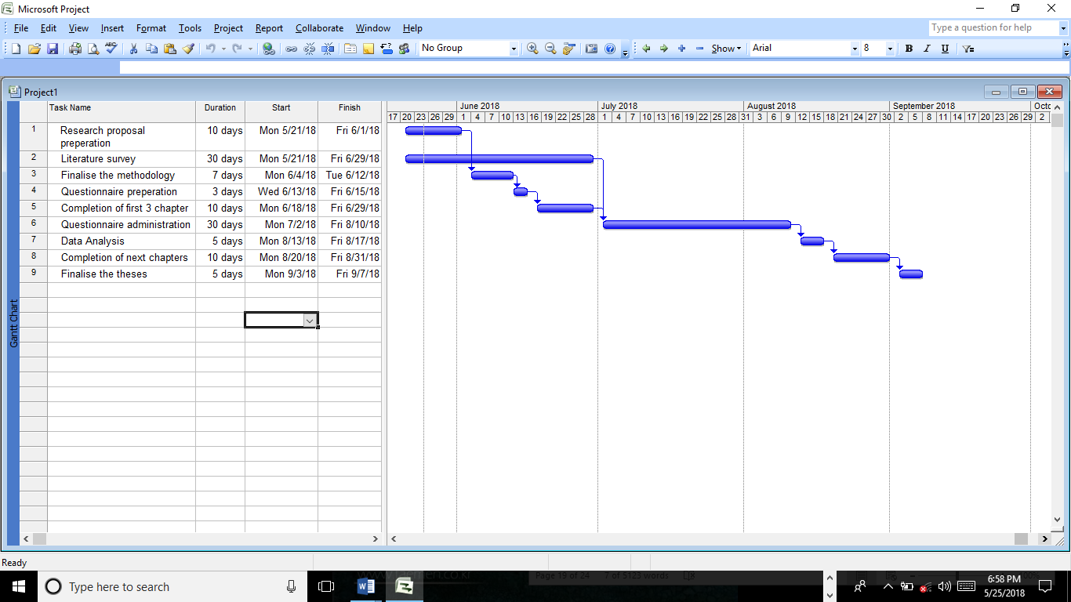
Gantt Chart

Reference
Bell, J. and Waters, S. (2014), Doing your research project, 6th ed., McGraw-Hill Education
Brand Finance (2017), Airlines 50 2017: The annual report on the world’s most valuable airline brands, [online], available from:

http://brandfinance.com/images/upload/brand_finance_airlines_50_2017_locked.pdf, [accessed on 25/05/2018]
Bryman, A. and Bell, E. (2015), Business research methods, 4th ed., Oxford University Press
Davies, G., Chun, R., daSilva, R., and Roper, S. (2005), Corporate Reputation and Competitiveness, 2nd ed., London: Routledge
Doostar, M., Abadi, M.K.I. and Abadi, R.K.I. (2012), Impact of Brand Equity on Purchase Decision of Final Consumer Focusing on Products with Low Mental Conflict, Journal of Basic Applied Scientific Research, 2(10): 10137-10144
Keller, K. L. (2010), Strategic Brand Management: Building, Measuring and Managing Brand Equity, 4thed., New Jersey: Pearson Prentice Hall
Khasawneh, and Hasouneh. (2010), The effect of familiar brand names on consumer behaviour: A Jordanian Perspective, International Research Journal of Finance and Economics, 43, pp.33-57
Kotler, P and Armstrong, G., (2017), Principles of Marketing, 17th ed., Upper Saddle River (N.J.), Pearson Prentice Hall.
Kotler, P., and Keller, K. L. (2010), A Framework for Marketing Management, 5th ed., Upper Saddle River, NJ: Pearson/Prentice Hall
Miller, J. and Muir, D. (2005), The Business of Brands,2nd ed., West Sussex: Chichester
Nepalia, A., (2011), Brand management and its impact on consumer buying behavior. International Referred Research Journal, 1(17): 113-114
Rubini, A., (2010), Role of Brand in Consumer Behavior: case How Sneakers Have Turned into Status Symbols, Thesis, pp: 48
Saunders, M, Lewis, P., and Thornhill, A. (2012), Research Methods for Business Students, 6th ed., New Jersey: Financial Times/Prentice Hall
Shah, S.S.H., Aziz, J., Jaffari, A.R., Waris, S., Ejaz, W., Fatima, M., and Sherazi, S. K., (2012), The Impact of Brands on Consumer Purchase Intentions, Asian Journal of Business Management, 4(2), pp.105-110
Vinhas, D. S. R. and Faridah, S. A. S. (2008), Online Corporate Brand Image, Satisfaction, and Loyalty, Journal of Brand Management, 16 (3),pp.119−144
Vizard, S., (2017), British Airways brand reputation nosedives in wake of IT meltdown, [online], available from: https://www.marketingweek.com/2017/05/30/british-airways-brand-reputation-nosedives-wake-meltdown/, [accessed on 25/05/2018]
YouGov Brand Index (2017), Is British Airways losing altitude with the public?,[online], available from: https://yougov.co.uk/news/2017/11/07/british-airways-losing-altitude-public/, [accessed on 25/05/2018]

