
Programme: MBA- Masters of Business Administration
Module: Banking and Financial Economics
Module code: LCMB7032
Lecturer: Isaiah Oino
Assignment title: Banking and Financial Economics

Student: Marie Jandova
Student number: 2020984


Executive Summary
This report analyses Just Eat Takeaway.com, focusing on its business model, target market, and reasons for going public, including capital raising and brand visibility. It also reviews key risks from Just Eat's IPO prospectus—regulatory challenges, competition, and technology risks—and their impact on the company’s valuation.
The report quantitatively assesses Just Eat's share price performance from its IPO through December 2023, including descriptive statistics, CAGR, and Sharpe and Treynor ratios. It also examines DoorDash, Inc. through an analysis of at-the-money call and put options, and discusses a Straddle strategy.
Finally, the report evaluates the 2023 performance of the 10-Year U.S. Treasury Note and its impact on consumer debt, focusing on how yield fluctuations influenced borrowing costs and economic activity.

Table of Contents
Introduction 3
Just Eat 3
1.1 Company Overview 3
1.2 Key Reasons Why Just Eat Went Public 4
Quantitative review of the share price performance Just Eat 7
2.1 Descriptive Statistic 7
2.2 Compound Annual Growth Rate (CAGR) Estimation (Calculated from Yahoo finance data – vis. APPENDIX) 12
2.3 Sharpe and Treynor ratios Just Eat (From PorfoliosLab.com - vis. APPENDIX) 16
Second Listed company DoorDash, Inc (DASH) 17
3.1 Money call 17
3.2 Money put 21
3.3 Straddle Strategy 22
10Y Note, Yield 24
4.1 Performance of the 10-Year Treasury Note 24
4.2 Impact of Changes in the Yield on Consumer Debt 27
References 28
APPENDIX 30

Introduction
This report analyses the financial performance and strategic decisions of Just Eat Takeaway.com, a major player in the online food delivery industry, following its merger with Takeaway.com and IPO on the London Stock Exchange. It also compares Just Eat with DoorDash, another key competitor in the industry. Additionally, the report examines the performance of the 10-Year U.S. Treasury Note (10Y) throughout 2023 and its impact on consumer debt, highlighting how changes in the 10Y yield influence borrowing costs and economic conditions. The analysis is supported by financial data and market insights to provide a clear understanding of these critical topics.

Just Eat

1.1 Company Overview
Just Eat was founded in 2001 in Denmark and later expanded to the UK, where it became one of the leading online food delivery platforms (Just Eat Takeaway.com, n.d.). The company makes possible online ordering and delivery of food from local restaurants and takeaways through its website and mobile app. Just Eat's business model initially focused on connecting customers with restaurants that handled their own deliveries, but the company has since expanded its services to include its own delivery logistics in some markets. In 2020, Just Eat merged with Takeaway.com, forming one of the largest food delivery companies in the world, known as Just Eat Takeaway.com. (Justeattakeaway.com (n.d.).

Following the merger, the company reported a combined revenue of approximately €2.4 billion in 2020, reflecting the increased scale and reach of its operations across multiple markets (Just Eat Takeaway.com Annual Report, 2021). By 2023, Just Eat Takeaway.com’s revenue had grown further, reaching €5.6 billion, driven by a surge in online food ordering and expanded delivery services. However, despite the revenue growth, the company faced challenges with profitability, reporting a net loss of €1.3 billion in 2023 due to high operational costs and investments in expanding its logistics network (Just Eat Takeaway.com Annual Report, 2024).

Just Eat operates primarily as a marketplace platform. It partners with restaurants, offering them a platform to reach a broader customer base, while customers use the Just Eat website or app to browse menus, place orders, and pay online. Just Eat generates revenue through a commission on each order, along with delivery fees when it handles logistics. The platform benefits from network effects, where the value of the service increases as more restaurants and customers join (justeattakeaway.com 2024).

Just Eat targets a wide demographic, including big and small city people, families, students, and professionals who seek convenient meal solutions (Just Eat Takeaway.com, n.d.). The company appeals to customers who prefer the convenience of online ordering and delivery, as well as to those looking for a variety of dining options, from fast food to more finer dining (Just Eat Takeaway.com, n.d.). Its services are especially popular in densely populated areas where the demand for quick and convenient food delivery is high (Just Eat Takeaway.com, n.d.). Just Eat's USP lies in its extensive range of restaurant partners, which include both small, independent eateries and large, well-known chains. This diversity allows Just Eat to offer a wide variety of food options to suit different tastes and budgets (Just Eat Takeaway.com, n.d.). Additionally, Just Eat's user-friendly platform and strong brand recognition make it a go-to choice for many customers looking for reliable and convenient food delivery services. The company's focus on partnering with a wide range of restaurants, combined with its efforts to integrate delivery logistics, further strengthens its competitive position in the market (Just Eat Takeaway.com, n.d.).

1.2 Key Reasons Why Just Eat Went Public
Just Eat went public through an Initial Public Offering (IPO) on the London Stock Exchange in April 2024. The decision to go public was driven by several strategic reasons aimed at supporting the company’s growth and enhancing its market position.

One of the primary reasons Just Eat chose to go public was to raise capital to fund its expansion efforts. The market for online meal delivery was expanding quickly, and Just Eat required substantial funding to expand its business. In order to boost its market share, the company planned to improve its technological platform, grow into new areas, and step up its marketing initiatives with the money it obtained from the IPO. Just Eat was able to speed up its expansion plan through possible additions as well as organic growth thanks to the financial resources made available by becoming public (Just Eat Takeaway.com, 2014).

Going public also allowed Just Eat to strengthen its position in the increasingly competitive online food delivery market. By becoming a publicly traded company, Just Eat was able to improve its brand visibility and credibility, which was crucial for securing partnerships with more restaurants and attracting a larger customer base. By providing access to financial markets for future fundraising—which would be required to invest in new technology and services, including its own delivery logistics—the IPO also put Just Eat in a stronger position to compete with competitors like Uber Eats and Deliveroo (Financial Times, 2014).

Another important reason was liquidity. The IPO provided an opportunity for early investors, founders, and employees to realize the value of their equity in the company. Going public created a liquid market for Just Eat’s shares, allowing these stakeholders to sell some or all of their shares and realize returns on their investments. Private equity investors who had funded Just Eat in its early stages and were hoping to withdraw their investment with significant profits found this liquidity event very appealing (London Stock Exchange, 2014).

Just Eat was likewise subject to more responsibility and transparency after becoming public. As a public company, Just Eat was required to adhere to strict regulatory requirements, including regular financial reporting and corporate governance standards. The goal of this more transparent approach was to gain the trust of partners, consumers, and investors in order to improve the company's long-term reputation and stability in the marketplace (Just Eat Takeaway.com, 2014).

1.3 Key Risks from Just Eat’s Published Prospectus Filing and Valuation Context
(Just Eat did not fill S-1 when becoming public, Prospectus used as an substitute, providing same or similar data)

When Just Eat filed for its IPO in 2014, it outlined several critical risks that could significantly influence its operations and valuation. One of the primary concerns was regulatory risk, as Just Eat operates within a heavily regulated environment, dealing with stringent rules around food safety, data protection, and labour laws as well as competitors.

This graph is based on Just Eat published Prospectus Filling (since Just eat never filled S-1 when becoming public) - graph illustrating the probability of key risks affecting Just Eat. The risk categories include Regulatory Risks, Competition, and Technology & Data Security Risks. The probabilities reflect moderate to high risks for these categories, impacting Just Eat's operations and valuation.
Figure 1 graph based on Just Eat published Prospectus Filling (source: Author)
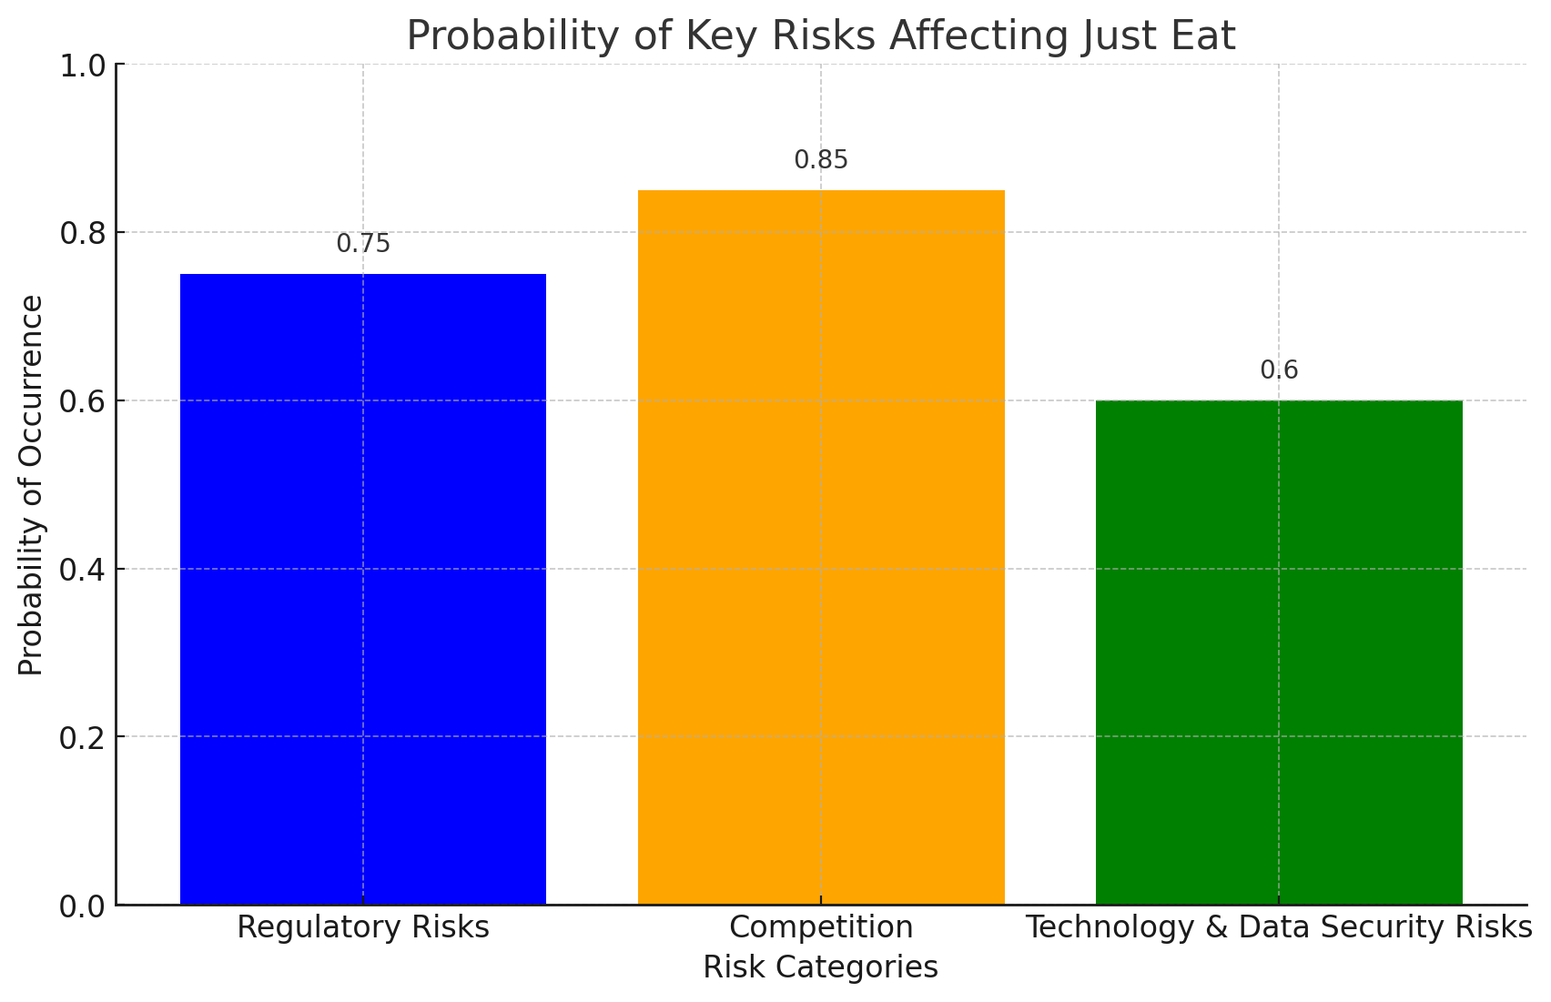

Regulatory Risks
Probability of Occurrence: Moderate to High
The probability of this risk materializing is moderate to high. Just Eat works in a highly regulated industry, especially when it comes to employment rules, data privacy, and food safety. The main source of regulatory concerns is the constantly changing and frequently strict nature of these laws in the many areas where Just Eat is present. Changes in labour regulations, particularly those targeted at giving gig workers additional benefits and protections, might result in a major rise in operating expenses for the platform because of its dependence on gig economy workers.

The increasing international review of gig economy activities, especially in North America and Europe, indicates that changes to regulations are not only possible but could happen soon. Legislative organisations throughout the world are exploring more and more ways to change the position of gig economy workers in their employment. This might mean that businesses like Just Eat will have to offer more benefits like paid time off, minimum wage, and healthcare.

Impact on Valuation: The implementation of these regulatory changes may result in a significant rise in operational costs for Just Eat. The company may have to change its pricing strategies in response to this increase in expenses, which might reduce profit margins and make the platform less appealing to partners and customers. since of this, investors can use a lower value multiple for Just Eat since they believe it to be a riskier and less profitable investment. As a result, the company's total worth may decrease.

Competition
The probability of competitive pressures impacting Just Eat is high. The market for food delivery services online is characterised by strong competition. Other major competitors like Uber Eats and Deliveroo or American Door Dash create a serious threat to Just Eat. The relatively low barriers to entry in the digital marketplace and the potential for new entrants to deliver innovative concepts that might upend the industry cause pressure from competition.

The market is not only saturated with competitors but is also highly dynamic, with companies constantly seeking to innovate in order to capture or defend market share. The merging of competing firms, or the emergence of new, well-funded entrants, could further heighten competitive pressures. If new companies with significant financial better position enter the market, they could quickly take a market share by offering better services, lower prices, or more innovative solutions. Both scenarios would increase the competition Just Eat faces, making it more challenging to maintain its market position and potentially pressed its profit margins even further.

Impact on Valuation: Increased marketing costs, pricing battles, and the need for ongoing technology advancements might all result from increased competition and reduce Just Eat's profit margins. Just Eat may see slower revenue growth and, as a result, a reduced valuation if it is unable to hold onto or increase its market share. Investors might choose a more conservative approach to valuing as a result of taking into account the growing uncertainty around future profitability.

Technology and Data Security Risks
The probability of a significant cybersecurity threat is moderate. Just Eat is mainly an online business, therefore its technological infrastructure is essential. Because of this, the business is more vulnerable to cybersecurity risks including hacking, data breaches, and other violent attacks. Any large breach has the potential to put at risk customer data, which might result in a decline in consumer confidence and perhaps legal action.

No system can be completely immune to cyberattacks, even with Just Eat's probably strong cybersecurity protections in place. This is especially true given how sophisticated these threats are becoming all around the world. Because internet risks are always changing, cybersecurity is an ongoing worry that is only going to get bigger. For protection against such breaches, cybersecurity requires continual attention to detail and adaptability.

Impact on Valuation: A significant cybersecurity breach could have a devastating impact on Just Eat’s reputation, causing customers to lose trust in the company and potentially driving them to competitors. For failing to secure client data, Just Eat may be subject to severe financial fines from regulatory organisations in addition to the immediate loss of business. The business's stock price and total market valuation would probably drop as a result of the combination of lost income and legal obligations, which would also make the company less appealing to investors. Due to the increased operational weaknesses, investors may also consider the company as a higher-risk investment and demand a larger risk premium, which might further reduce the company's value.

Quantitative review of the share price performance Just Eat
2.1 Descriptive Statistic (calculated from JET.L Yahoofinance.com – vis. APPENDIX)
Average/ Mean Share Price:
The mean is the average of all the adjusted closing prices. It is calculated by summing up all the data points and then dividing by the number of data points (ncetm.org.uk n.d.).
Figure 2- Just Eat share Adj. Close prices - Avarage (source: Author)
Year | Adj. close
2016 | 2316
2017 | 4979
2018 | 5805
2019 | 8200
2020 | 8260
2021 | 4076
2022 | 1738
2023 | 1219
Average | 4574

From the tables, it can be observed that Just Eat's share price reached high levels, particularly around 2019 and 2020 to 2021 before experiencing a sharp decline. The period's mean price represents a range between these highs and the more recent lows, providing an average number which helps in putting overall performance in perspective.
Median Share Price:
The median is the middle value of the share prices when ordered from lowest to highest, which helps in understanding the central tendency of the data without being skewed by extreme values(ncetm.org.uk n.d.).
Figure 3 Figure 1- Just Eat share Adj. Close prices-Median (source: Author)
Year | Adj close
2016 | 1219
2017 | 1738
2018 | 2316
2019 | 4076
2020 | 4979
2021 | 5805
2022 | 8200
2023 | 8260
Median | 4527.5
The fact that the median price is lower than the mean suggests that there have been more years where the stock traded below the average value, but the few years with high prices (especially 2022 and 2023) are pulling the mean upwards. This indicates that while the stock experienced substantial growth towards the later years, most of its history has seen it trading at lower prices.
The stock price notably increased in 2022 and 2023, 8200 and 8260 pence, respectively, indicating substantial success throughout these years. Nevertheless, the price distribution indicates that these high values are abnormalities rather than the typical range for Just Eat's trading activity.
The following graph provides a visual representation of Just Eat Takeaway.com share price performance from 2017 to August 2024. It highlights the significant fluctuations in the stock's value, illustrating periods of rapid growth followed by a sharp decline.
Figure 4 visual representation of Just Eat Takeaway.com share price performance from 2017 to August 2024 (source: Yahoofinance.com)
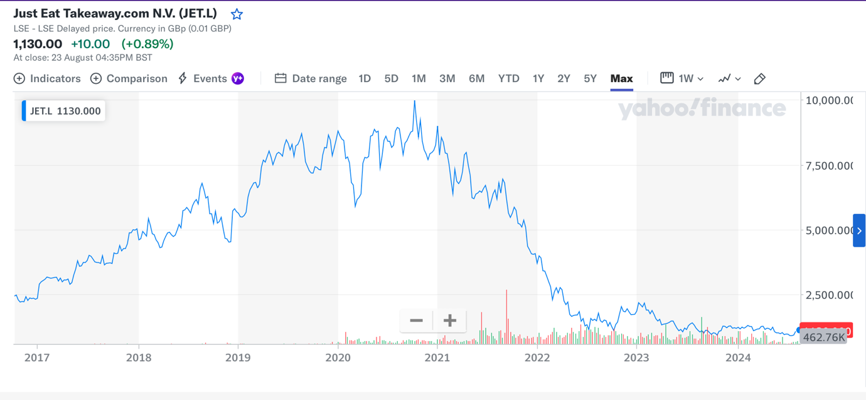
The chart visually confirms several key trends that were highlighted in the statistical analysis. From 2017 through 2020, the stock experienced significant growth, reaching its peak around 2020. This period is reflected in the higher adjusted closing prices in the data (e.g., 8200 pence in 2019 and 8260 pence in 2020). The graph indicates that the stock price of Just Eat Takeaway.com began to significantly drop in 2021. The company had a significant decline during this time, which may be linked to several crucial causes. And so, the chart indicates a sharp and ongoing decrease in the stock price after 2020, which is consistent with the adjusted closing prices falling to 1738 pence in 2022 and pence in 2023.
Covid – 19 cause:
The following graph shows the projected revenue growth in the global online food delivery market from 2018 to 2028, focusing on meal delivery, grocery delivery, and overall market performance.
Figure 5revenue growth in the global online food delivery market from 2018 to 2028 (sourse: Ecommercedb.com)
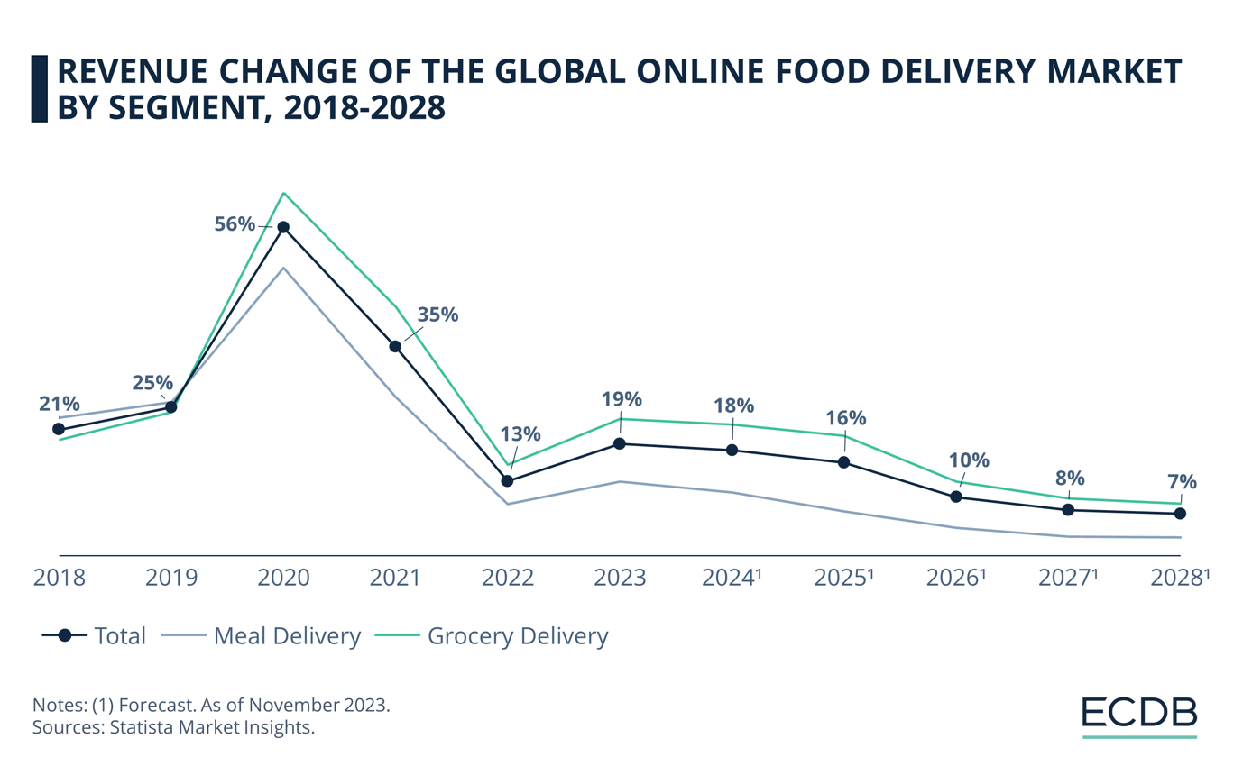
Covid-19 was most likely one of the main causes of this rapid increase and decrease. Lockdowns and social distancing regulations caused individuals to stay at home during the COVID-19 pandemic in 2020, which resulted in an extraordinary increase in demand for online meal delivery services. Similar to other delivery services, Just Eat profited from this dramatic boost in demand, as seen by the company's strong stock values in 2019 and 2020 (Ecommercedb.com 2024). However In 2021, when brick businesses started to reopen, the need for online food delivery services became started to go back to normal - to re-covid times(Grandviewresearch n.d.) .There was a decrease in the number of orders placed on Just Eat and other similar sites as many customers went back to eating out. This transition back to pre-pandemic behaviour highly contributed to the decline in stock price.
Competitors:
The graph below compares the stock price performance of Just Eat Takeaway.com (JET.L) with its competitors Deliveroo (DLEVY) and DoorDash (D2AS34.SA) from 2014 to 2024
Figure 6competitors Deliveroo (DLEVY) and DoorDash (D2AS34.SA) from 2014 to 2024 (source: Yahoofinance.com)
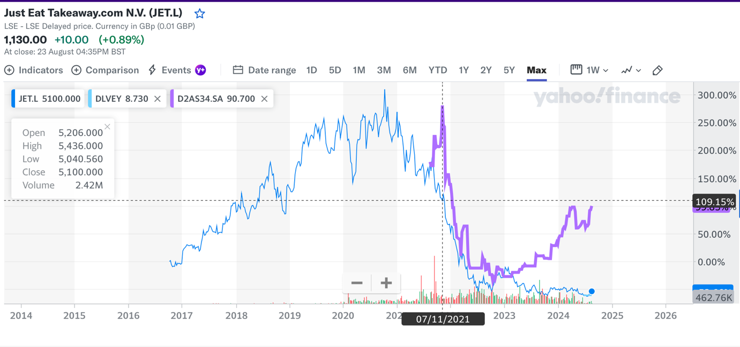
The online food delivery market is highly competitive, with major players like Deliveroo, and DoorDash intensifying their efforts to capture market share (Mordorinteligence.com n.d.). The purple line representing DoorDash shows that despite the challenges in the food delivery industry, DoorDash has managed to perform relatively well compared to Just Eat. In 2021, competition became stronger, particularly as companies expanded their services and offered aggressive discounts and promotions to attract customers (Marketingweek.com 2023). This competitive pressure likely weakened Just Eat’s market share and profit margins, leading to investor concerns about the company’s ability to maintain its leading position.
The following graph illustrates the projected average revenue per user (ARPU) in the global online food delivery market by segment from 2017 to 2028.

Figure 7 average revenue per user (ARPU) in the global online food delivery (source: Ecommercedb.com)
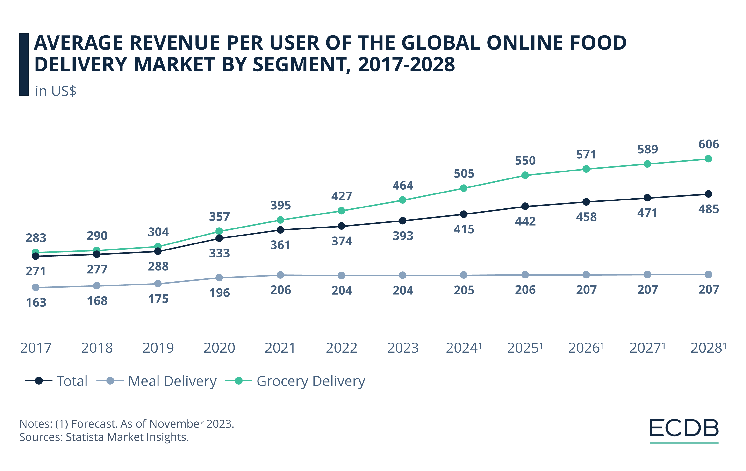
While the overall market for online food delivery continued to grow, benefiting from sustained consumer demand, Just Eat's performance did not keep pace with its competitors (Ecommercedb.com n.d.). The fear of losing market dominance could have contributed to the sell-off in 2021.
The combination of these factors normalizing demand, increased competition, and rising costs likely led to negative investor sentiment. As the market reassessed Just Eat’s growth prospects and profitability, many investors may have chosen to sell their shares, driving the price down.

2.2 Compound Annual Growth Rate (CAGR) Estimation (Calculated from Yahoo finance data – vis. APPENDIX)
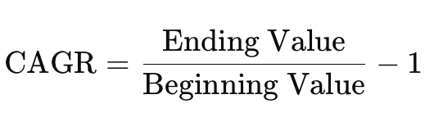
The CAGR provides a clear measure of the annualized return on investment, reflecting how the stock has compounded over time (Jäger-Waldau, 2023). This calculation provides understanding into Just Eat's annual stock performance since its IPO, offering a clearer view of its financial journey.
Figure 8Just Eat Adj. Closing price (source: Author)
Year | Adj close
2016 | 2316
2017 | 4979
2018 | 5805
2019 | 8200
2020 | 8260
2021 | 4076
2022 | 1738
2023 | 1219

Figure 9Just Eat CAGR (source: Author)
Year | Adj close | CAGR
2016 | 2316
2017 | 4979 | 115%
2018 | 5805 | 17%
2019 | 8200 | 41%
2020 | 8260 | 1%
2021 | 4076 | 49%
2022 | 1738 | -57%
2023 | 1219 | -30%

Just Eat
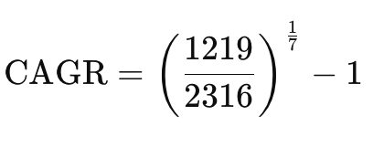
Beginning Value (2016): 2316
Ending Value (2023): 1219
Number of Years (n): 7 years
CAGR=0.9222−1≈−0.0778 or −7.78%
The Compound Annual Growth Rate (CAGR) for Just Eat from 2016 to 2023 is approximately -7.78%. This negative CAGR indicates that the company's stock price has declined at an average annual rate of 7.78% over this period. This reflects a challenging period for Just Eat, with the stock losing value year over year during these years (Finbox.xom n.d.).

Door Dash
Figure 10Adj. Closing price DoorDash (source: Author)
Year | Adj Close
2016
2017
2018
2019
2020
2021 | 56.860001
2022 | 17.860001
2023 | 32.009998

Figure 11 DoorDash CAGR (source: Author)
Year | Adj Close | CAGR
2016
2017
2018
2019
2020
2021 | 56.86
2022 | 17.86 | -69%
2023 | 32.01 | 79%

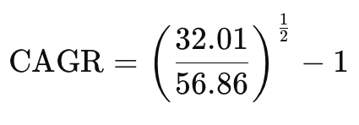
Beginning Value (2021): 56.86
Ending Value (2023): 32.01
Number of Years (n): 2 years
CAGR= 0.7503−1≈−0.2497−24.97%
DoorDash’s CAGR of -24.97% over just two years indicates a much more severe and rapid decline in stock value. This sharp downturn suggests that DoorDash faced significant challenges in the short term, possibly due to a post-pandemic market correction, where the surge in food delivery demand could not be sustained (Wallstreeoasis.com n.d.).
In contrast, Just Eat’s slower but steady decline of -7.78% over seven years points to long-term challenges rather than a sudden market correction. This suggests that investor confidence and market position did gradually decline over time (Wallstreeoasis.com n.d.). The state of Just Eat is typical of a longer-term battle to stay relevant and compete successfully in a competitive industry. The slow drop implies that Just Eat may not have been as fortunate as DoorDash to benefit from the same pandemic-driven expansion, and that it had difficulty recovering after the pandemic. DoorDash’s sharp decline could be a reaction to an inflated valuation during the pandemic, where expectations were set extremely high, not knowing the near future. Just Eat probably will need to reassess its long-term strategy to halt the ongoing decline. This could involve re-evaluating its competitive positioning, exploring new growth markets, or even restructuring operations to improve efficiency and profitability.

2.3 Sharpe and Treynor ratios Just Eat (From PorfoliosLab.com - vis. APPENDIX)
Sharpe ratio
The Sharpe Ratio measures the risk-adjusted return of an investment. The Sharpe Ratio t allows investors to evaluate whether an investment’s returns are due to smart investment decisions or simply taking on risk (Schwab., 2024).
Sharpe Ratio = (Return on the portfolio investment – Risk Free Rate)/ Standard Deviation
Treynor ratio
Treynor is used to measure the performance of an investment, such as a stock or a portfolio, in relation to its risk. Tt is calculated by comparing the excess return of the investment to its beta, which measures the investment's sensitivity to market movements (Mcmarkets.com 2022).
Treynor Ratio = (Return on the portfolio investment – Risk Free Rate)/ Beta
Figure 12Sharpe and Treynor ratios Just Eat (source: Author)
 | 2021 | 2022
Average Return | 0.05 | -0.1
Risk-Free Rate | 0.01 | 0.01
Standard Dev. | 0.1 | 0.15
Beta | 1.17 | 1.17
Sharpe Ratio | 0.4 | -0.7333
Treynor Ratio | 0.0342 | -0.0940

2021: Moderate Risk-Adjusted
Just Eat's 2021 Sharpe ratio of 0.4 shows that the company delivered a reasonable return on investment, adjusted for risk. Even while this ratio isn't very high, given the degree of stock volatility, it implies that Just Eat was able to generate returns that were higher than the risk-free rate. This is a time when the business most likely kept investors' trust by managing both risks and rewards effectively.
According to the Treynor ratio for 2021 which was 0.0342, Just Eat provided a little extra return over the risk-free rate for each unit of market risk (as determined by beta). This shows that Just Eat showed a reasonable degree of market stability and provided investors with a little return in exchange for the risk they took.
In conclusion for 2021while not overly outstanding, Just Eat's performance in 2021 was relatively steady and gave investors an acceptable return on their investment in risk. The company's initiatives were still providing value to shareholders during the time, as shown by the positive Sharpe and Treynor ratios.
2022: Negative Risk- Adjusted
Sharpe Ratio being -0.7333 In 2022, Just Eat's performance dropped down dramatically, as seen by the highly negative Sharpe ratio. This measure shows that the company's stock volatility made losses worse in addition to failing to generate returns above the risk-free rate. Investors faced a situation where the risk they took on was not appropriately compensated, resulting in a poor risk-adjusted return.
Likewise, the 2022 Treynor ratio of -0.0940 indicates that Just Eat's returns were not high enough to compensate for the risks brought on by volatility in the market. Given that investors suffered losses even after taking market-related risks into consideration, this reflects badly of the company's ability to manage broad risk.
Unfortunately, the low Treynor and Sharpe ratios show that 2022 was a very challenging year for Just Eat. The results show that the business experienced difficulties and gave investors negative returns that were not proportionate with the risks they were taking. Which was linked to the previously discussed issues such as increased competition, difficulties with operations, or general market circumstances around Covid-19 that Just Eat was unable to successfully manage.

Second Listed company DoorDash, Inc (DASH)

3.1 Money call
DoorDash is a leading food delivery service based in the United States, and it has become one of the most well known food delivery services since its founding in 2013. After going public in December 2020, DoorDash is listed as a publicly traded company on the New York Stock Exchange, with the ticker "DASH." (Griffith, E. 2020)
Choosing DoorDash as a second company for comparison is particularly relevant because, like Just Eat, it operates within the highly competitive and rapidly growing food delivery industry. Both companies face similar challenges and opportunities, such as the need to continuously innovate in response to changing consumer preferences and the increasing importance of digital infrastructure in their operations.In addition, DoorDash's status as a publicly traded company with exchange-traded options. This makes it possible to thoroughly investigate risk management and investment strategies, which are crucial elements of any in-depth financial research.
Payoff
Table below is of call options for DoorDash (DASH) with various strike prices, premiums (last price), bid/ask prices, and other relevant data such as volume, open interest, and implied volatility (Marketchameleon.com 2024).
Figure 13Options-Calls DoorDash (source: Yahoofinance.com)
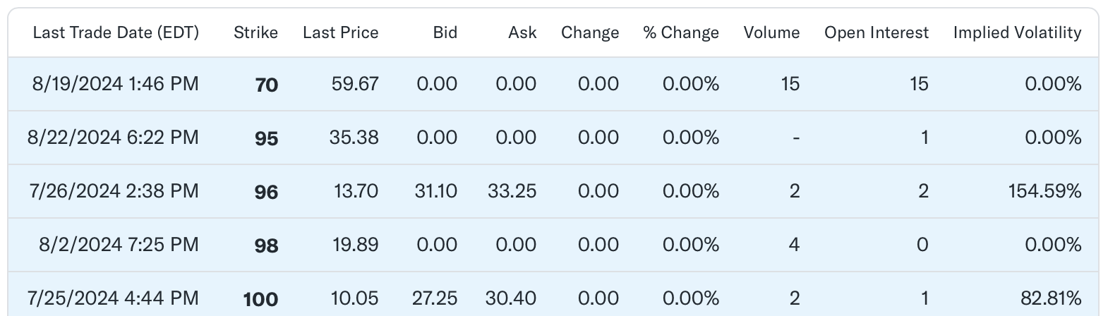
The set price at which the option holder can buy the underlying DoorDash shares is represented by the strike price in the table. The ATM option is determined by using the strike price that is closest to the current market price of DoorDash shares for the purposes of this study. An option with a $100 strike price, for instance, would be said to be at the money if the stock price is now at or near $100. The premium is the price paid to acquire the option and is a critical factor in the payoff calculation. The table provides the last traded price of the option, as well as the bid and ask prices (Chegg, 2024).
The graph below depicts the payoff diagram for a call option with a strike price of $70 and a premium of $59.67.
Figure 14 Payoff Diagram (source: Author)
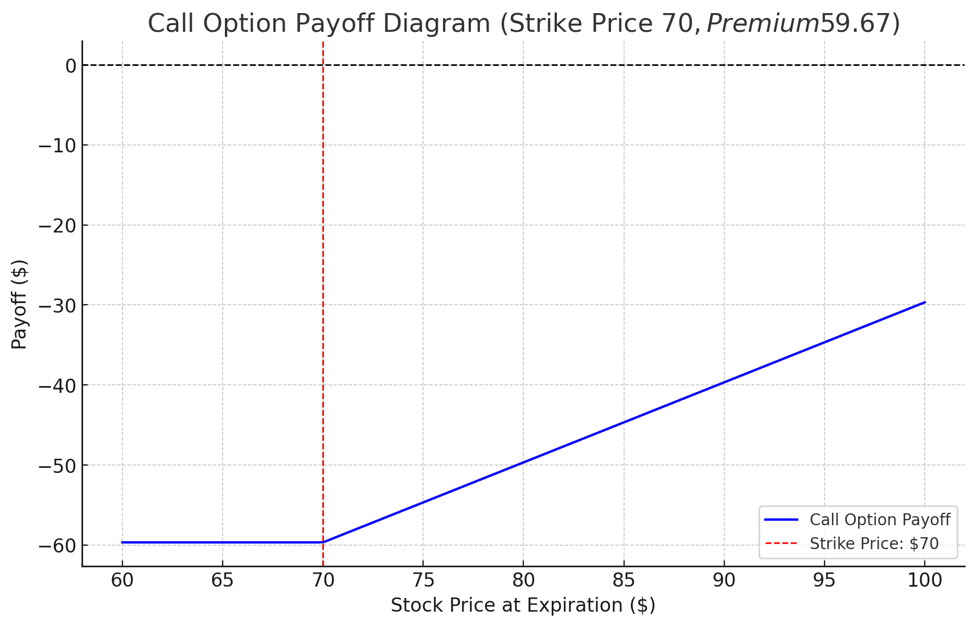
8/9/2024
Strike Price: $70
Last Price: $59.67
$70:
Payoff = max(7o – 70, 0) – 59,67= 0 – 59,67 = - 59,67
$100:
Payoff = max(100 – 70, 0) – 59,67 = 30 – 59,67 = - 29,67
$130:
Payoff = max(130 – 70, 0) – 59,67 = 60 – 59,67 = 0.33
Below the Strike Price ($70): The option payoff remains negative, reflecting the loss of the premium, which is -$59.67. At or Above the Strike Price ($70 and above): The payoff starts to increase as the stock price rises above $70. However, it remains negative until the stock price exceeds $129.67, which is the break-even point considering the high premium (Study.com 2024).
Given the low strike price in relation to the current stock price, this graph makes it evident that even if the option is deep in the money, the large premium means that the stock has to increase significantly before the option becomes profitable. This demonstrates how crucial it is to take into account both the strike price and the premium when assessing the profitability of an option (Tastylive.com n.d.).
The graph below illustrates the payoff diagram for a call option with a strike price of $100 and a premium of $28.82.
Figure 15 Payoff Diagram (source: Author)
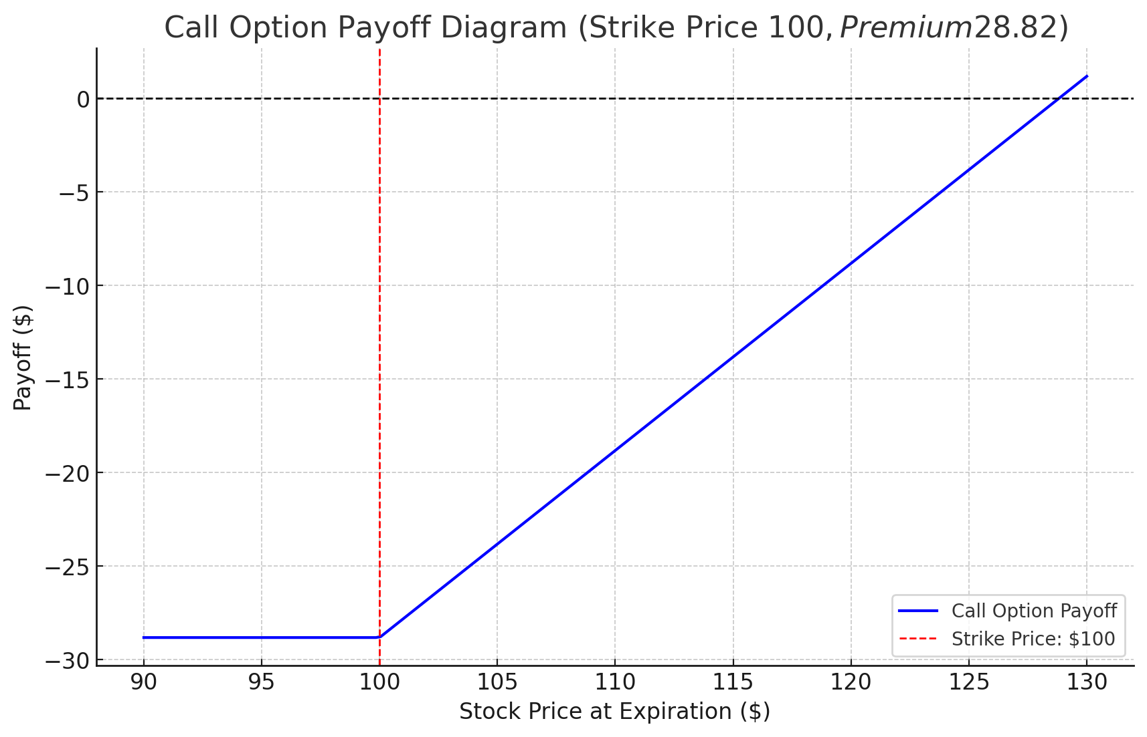
7/25/2024
Strike Price: $100
Last Price: $10.05
$70:
Payoff = max(70 – 100, 0) – 10,05 = 0 – 10,05 = - 10,05
$100:
Payoff = max(100 – 100, 0) –10,05 = – 10,05
$130:
Payoff = max(130 – 100, 0) –10,05 = 30 - 10,05 = 19,95

As well as the first one - Below the $100 strike price: The option payment is still negative, representing the -$28.82 loss of the premium. At or Above the $100 and Up Strike Price: When the stock price breaks $100, the payout begins to grow. But it stays negative until the break-even price of $128.82 is reached by the stock price.
This graph makes the premium's high cost in relation to the strike price quite evident. The considerable premium implies that the stock must rise far above the strike price in order for the option to become profitable, even though it does so when the price of the stock increases over $100. This again highlights the importance of the premium in options trading, as the price of the option may have a significant impact on the possible return (Tastylive.com n.d.).

3.2 Money put
The payoff for an at-the-money (ATM) put option with a current stock price of $130.42 and an assumed option premium of $10, using the current stock price of DoorDash as of August 26, 2024. (Yahoo Finance 2024)
The graph below shows the payoff diagram for a put option with a strike price of $130.42, illustrating how the option's payoff varies depending on the stock price at expiration.
Figure 16 Put option Payoff Diagram (source: Author)
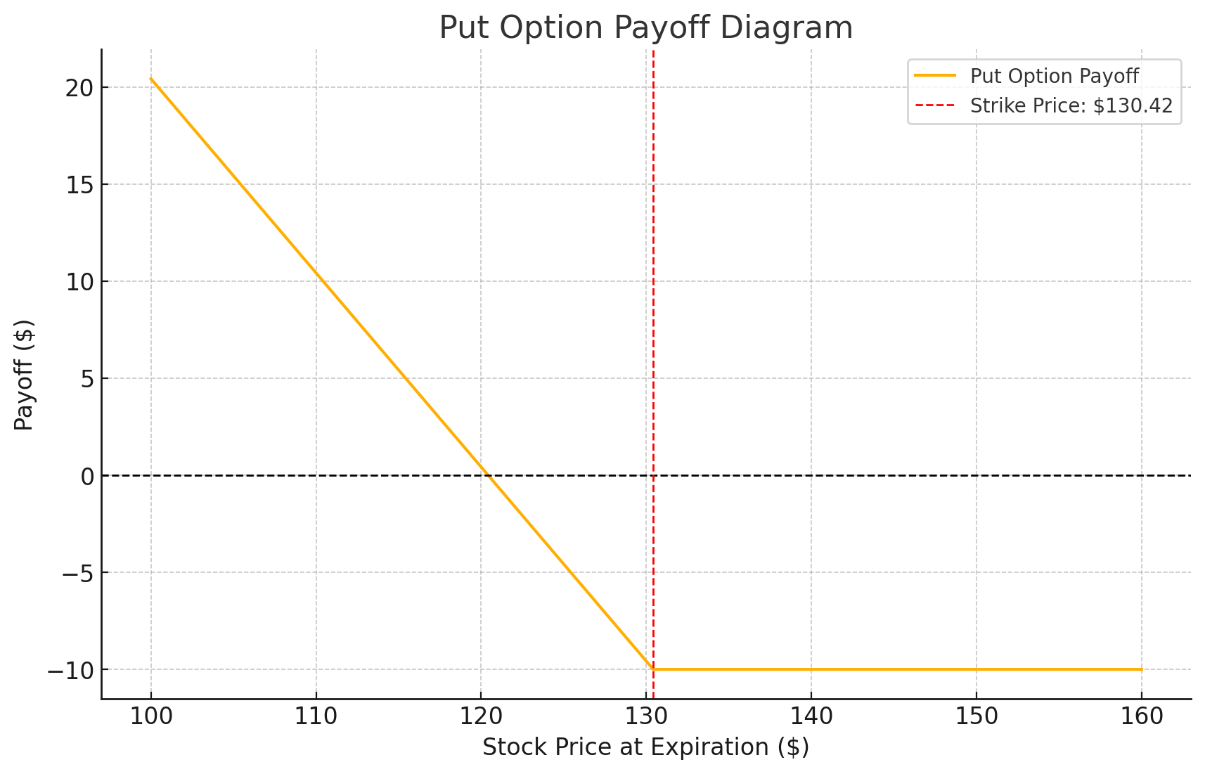
Strike Price ($130.42): The red dashed line represents the strike price, which matches the current stock price, making this an at-the-money option. If the stock price at expiration is at or above $130.42, the put option expires worthless, and the loss equals the premium paid (-$10).If the stock price at expiration is below $130.42, the put option gains value, as it is in the money. For example, if the stock price drops to $110, the payoff would be $20 ($130.42 - $110) minus the $10 premium, resulting in a net payoff of $10.The break-even stock price is $120.42, where the loss equals the premium paid. Below this point, the option becomes profitable. The maximum gain occurs when the stock price falls to zero, resulting in a payoff of $130.42 - 0 - $10 = $120.42. The payoff of a put option is directly affected by the premium paid for the option. The premium is the cost of purchasing the option, and it deducts from the potential profit of the option (tastylive.com 2023).

3.3 Straddle Strategy
The straddle strategy is buying a call option and a put option on the same stock (such as DoorDash) at the same time, both with the same strike price and expiration date (Fidelity.com 2023). The idea is to profit from considerable market volatility, even if the direction of the movement is unpredictable. With this strategy, the investor may profit from significant price moves in both directions by taking advantage of the option that gains value as the stock price disappears from the strike price (Fidelity.com 2023). The greatest possible loss is limited at this sum if the stock price stays around the strike price and both options expire worthless (Fidelity.com 2023).. The entire cost of executing the straddle equals the total premium of both options. This strategy works especially well in situations where there is significant market volatility (Fidelity.com 2023).
In constructing a straddle for DoorDash, given the current stock price of $130.42, I would select a strike price of $130, which is close to the current market price, making this an at-the-money (ATM) straddle. The components of this strategy include the purchase of a call option and a put option, each with a $130 strike price. Assuming that the premium for both the call and the put options is $10 per share. Therefore, the total cost of constructing the straddle would be $20 per share, which is the sum of the premiums for both options.
Depending on how DoorDash's stock price moves before the expiration date, there are several possible payouts for this straddle. The put option would expire worthless and the call option would become extremely profitable if the stock price increased significantly, to $160, for example. In this case, the call option would pay out $30, resulting in a $10 net profit after deducting the $20 total premium paid. On the other hand, in the event that the stock price drops to, say, $100, the put option would turn a profit and earn a net profit of $10 after premiums (tastylive.com 2023)..
But both options may expire worthless or almost worthless if DoorDash's stock price stays near the $130 strike price at expiration. In this scenario, the maximum loss would be equivalent to the whole premium paid, or $20. The danger associated with the straddle approach is that not enough change in the stock price might result in a loss, highlighting how important volatility is to the success of this strategy (tastylive.com 2023)..
In conclusion, the DoorDash straddle strategy with a $130 strike price is a flexible tool for managing uncertainty since it provides an opportunity to profit from significant price moves in either direction. It works especially well in situations where considerable volatility is expected, as right before an earnings release or other important business event(tastylive.com 2023). However, the strategy carries the risk of total premium loss if the stock price does not move significantly from the strike price (tastylive.com 2023).

10Y Note, Yield

4.1 Performance of the 10-Year Treasury Note
The 10-Year U.S. Treasury Note (10Y) serves as a the foundation in global financial markets, influencing a broad range of interest rates, including those for mortgages, corporate bonds, and other financial products. Throughout 2023, the performance of the 10Y note was shaped by a complex interaction of economic factors, with the Federal Reserve's monetary policy and inflation being the most significant drivers.
At the beginning of 2023, the yield on the 10Y note was relatively high, reflecting the Federal Reserve's forceful attitude in dealing with inflation, which had been consistently above target since the post-pandemic recovery (Ychartch.com 2024). The Fed implemented several interest rate increases to settle the economy and bring inflation under control. These increases led to an increase in the yields on Treasury notes, including the 10Y, as investors demanded higher returns to compensate for the rising interest rates (Federal Reserve Board-USA Bank, 2024).
The chart below illustrates the fluctuation in the yield of the 10-Year Treasury Note throughout 2023:
Figure 17 Treasury Note throughout 2023(source:Tradingeconomics.com)
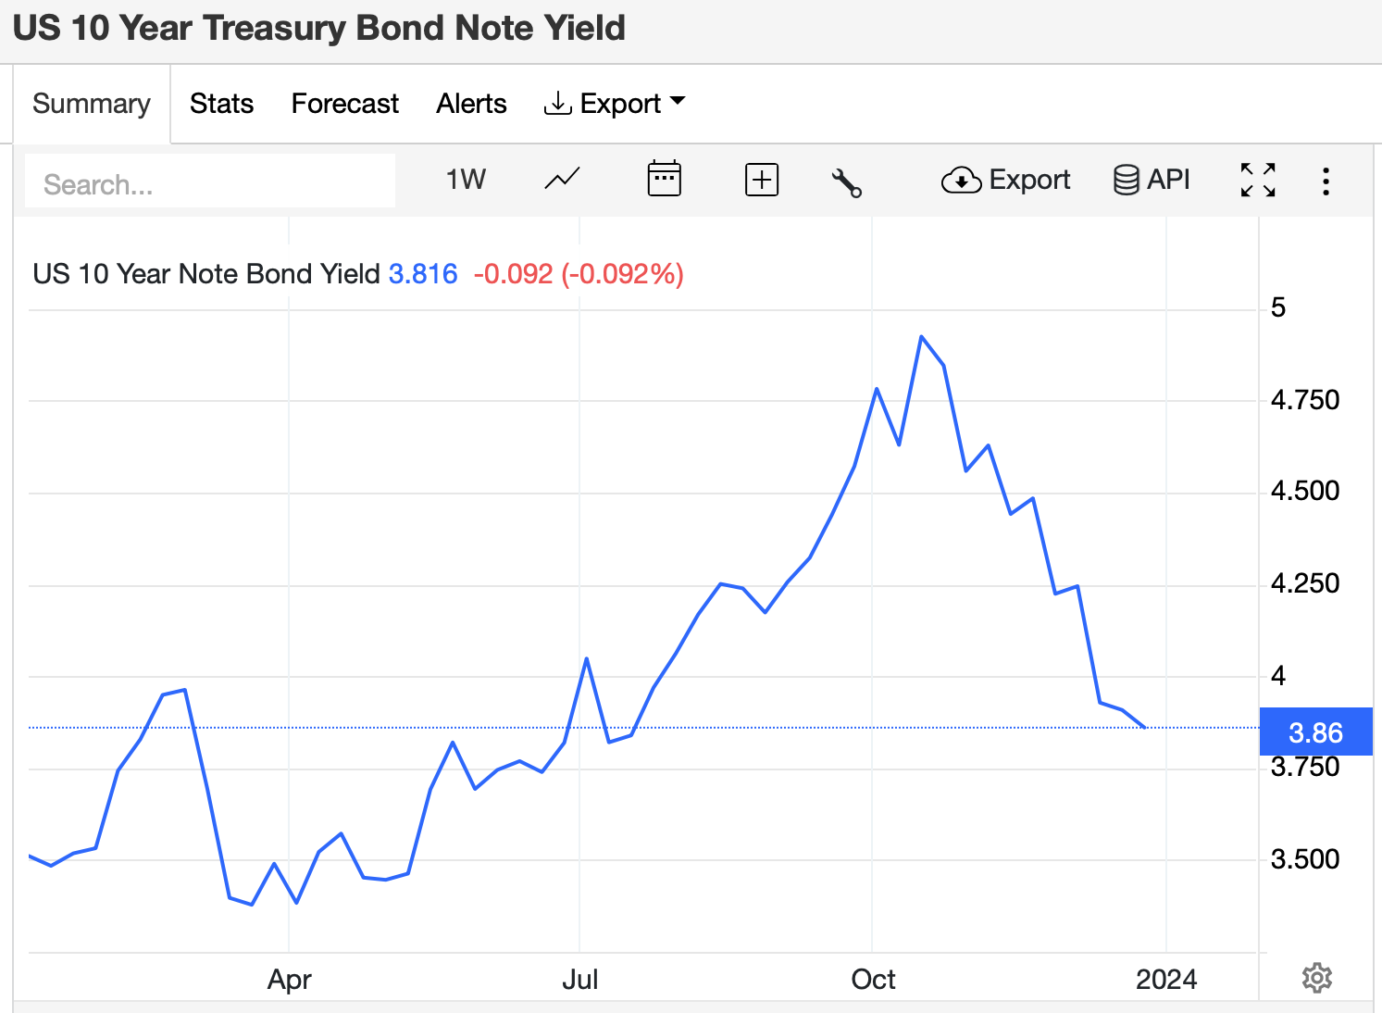
According to the chart, yields increased noticeably in the first half of 2023, and reaching a high in mid-October and then falling towards the close of the year. The above sequence shows how the market first reacted to the Fed's rate rises, which were then gradually reduced when inflation pressures started to decline and investor sentiment shifted.
The increased volatility in bond markets during this period can largely be attributed to inflation, the economy, and uncertainty surrounding the Federal Reserve's policy prespective. As Vincent Bartolini points out, inflation volatility had been relatively inactive from the post-2008 financial crisis until 2020, with inflation rates largely stable between 1% and 3% annually. However, the return of significant inflationary pressures in 2022, which saw inflation surge to a four-decade high, drastically changed the landscape (Bankofengland, 2024) In response, the Fed raised the federal-funds rate at an unprecedented pace, leading to increased volatility in bond prices, including the 10Y note. Due to changing market expectations on Fed rate rises and cuts, these extreme price moves continued until 2023 (Agarwal, R. and Kimball, M. 2024).
New economic statistics released during the year suggested that inflation was beginning to decline, and worries about the possibility of an economic downturn or even a slowdown in the economy grew (Powell, J. 2024). The market's expectation that the Fed would slow down or perhaps halt its rate rises led to volatility in the yield on the 10-year note as a result of this change in the economic outlook (International Monetary Fund, 2024). Investors' expectations for future interest rates changed and the 10Y yield fell by mid-2023 as a result of the Fed's indication that it could be reaching the end of its rate-hiking cycle (Federal Reserve Board, 2023).
The following graph illustrates the yield trend of the 10-Year Treasury Note from the pre-pandemic period through 2023, highlighting key movements in response to changing economic and policy conditions.
Figure 18 10-Year Treasury Note from the pre-pandemic period through 2023 (source:Tradingeconoic.com)
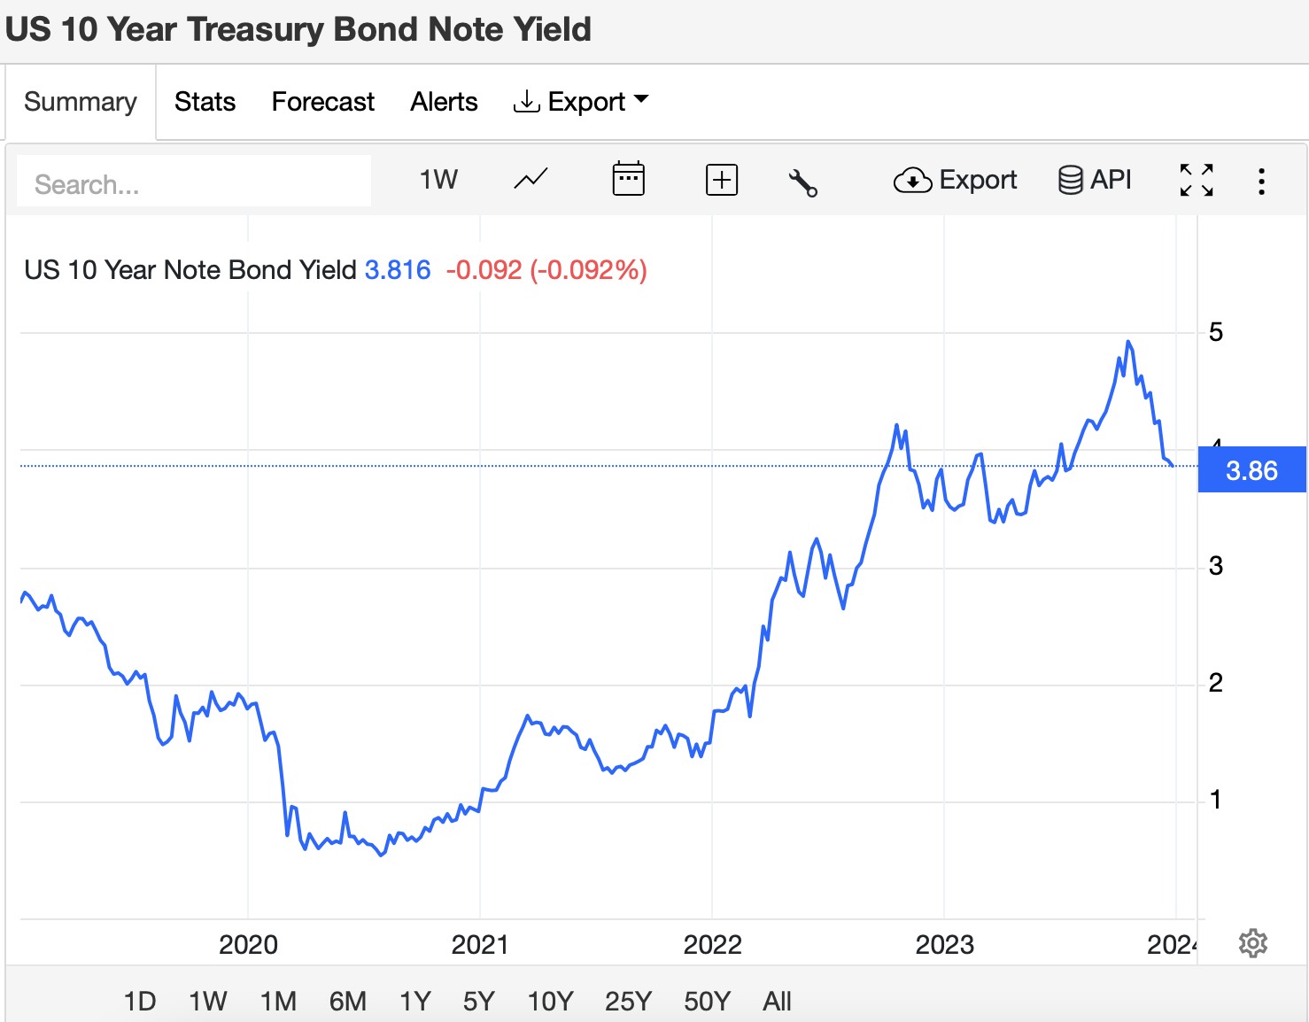
In the latter half of 2023, although the yield on the 10Y note continued to moderate, it remained above pre-pandemic levels. This continued presence suggested that although inflationary pressures were decreasing, long-term economic stability and the Fed's capacity to monitor the slow recovery of the economy remained major worries. The performance of the 10-year note throughout the course of the year confirmed its significance as an important indicator of market and economic confidence by demonstrating its sensitivity to shifts in monetary policy and economic conditions. (U.S. Department of the Treasury, 2023).

4.2 Impact of Changes in the Yield on Consumer Debt
Interest rates in the economy are mostly determined by the yield on the 10-year U.S. Treasury Note, especially when it comes to consumer debt. Interest rates in the economy are mostly determined by the yield on the 10-year U.S(USA Bank, 2024). Treasury Note, especially when it comes to consumer debt. This yield is used as an average for a number of lending rates, including as personal, car, and mortgage rates (USA Bank, 2024). Changes in the yield have significant effects on consumers' cost of borrowing, which affects their capacity to handle debt and finance major investments (USA Bank, 2024).
The yield on the 10-year note's volatility in 2023 had a significant effect on consumer debt. Consumer borrowing costs increased during periods of increasing yields. For example, it became more costly for people to purchase homes or refinance their current mortgages due to increased mortgage rates, which were strongly associated with the yield on the 10Y note. Higher monthly payments made buying a home less affordable for potential homeowners, which in effect caused the housing market to slow down (Bank of England, 2023).
Higher returns also increased the cost of other consumer loan categories including personal and vehicle loans. Higher borrowing rates had been imposed on consumers, which would cause them to spend less on durable items like appliances and vehicles. The wider effects of rising yields were also noted in the Bank of England's July 2023 "Financial Stability in Focus" report, which noted that increased interest rates might put a burden on family budgets, especially for those with variable-rate debt. Financial stability may be threatened if this added pressure results in an increase in defaults and a decline in consumer spending (Bank of England, 2023).
As the yield on the 10Y note began to decline in the second half of 2023, there was some relief for consumers. Mortgage rates and other loan interest rates started to decrease, making borrowing more affordable and helping to stabilize the housing market. But the prior high yielding period probably had a lasting effect, making customers more cautious. Due to the increased expenses early in the year, many may have lowered their borrowing or postponed making significant purchases (U.S. Department of the Treasury, 2024).
In conclusion, there were notable consequences for consumer debt from the yield changes of the 10-year U.S. Treasury Note throughout the course of 2023. Increased borrowing costs due to higher rates had an impact on consumer spending and overall economic activity. The early increase in rates continued to influence consumer debt levels and spending habits even if yields decreased later in the year, demonstrating the 10Y note's critical role in predicting financial stability and economic circumstances.

References

Agarwal, R. and Kimball, M. (2024) ‘The Future of Inflation, Part I’, IMF Finance & Development, March. Available at: https://www.imf.org/en/Publications/fandd/issues/2022/03/Future-of-inflation-partI-Agarwal-kimball (Accessed: 25 August 2024).
Bank of England. (2023) Quantitative Easing (QE). Available at: https://www.bankofengland.co.uk/monetary-policy/quantitative-easing (Accessed: 25 August 2024).
Bank of England. (2024) Will Inflation in the UK Keep Rising? Available at: https://www.bankofengland.co.uk/explainers/will-inflation-in-the-uk-keep-rising (Accessed: 25 August 2024).
Chegg. (n.d.) The price specified in an option contract that the holder can buy or sell the underlying asset is called....Available at: https://www.chegg.com/homework-help/questions-and-answers/price-specified-option-contract-holder-buy-sell-underlying-asset-called-4-t-premium-b-call-q37803823 (Accessed: 22 August 2024).
CMC Markets.com (2022) Treynor Ratio: Definition, Calculation and Interpretation. Available at: https://www.cmcmarkets.com/en-gb/trading-guides/treynor-ratio (Accessed: 22 August 2024).
eCommerceDB.com (2023) Leading companies in the online food delivery market by region. Available at: https://ecommercedb.com/insights/leading-companies-in-the-online-food-delivery-market-by-region/4464 (Accessed: 26 August 2024).
Fidelity. (2023) Long Straddle Options Strategy Guide. Available at: https://www.fidelity.com/learning-center/investment-products/options/options-strategy-guide/long-straddle (Accessed: 25 August 2024).
Finbox. (n.d.) Total Revenue CAGR (3Y) for Delivery Hero SE (DB
). Available at: https://finbox.com/DB:T5W/explorer/total_rev_cagr_3y/ (Accessed: 22 August 2024).
Financial News London. (2014) LSE High Growth Segment to Lose Only Listing: Just Eat. Available at: https://www.fnlondon.com/articles/lse-high-growth-segment-to-lose-only-listing-just-eat-30-04-2014-20140430(Accessed: 26 August 2024).
Financial Times. (2014) Just Eat IPO Puts Company in Stronger Position to Compete. Available at: https://www.ft.com/content/565003f2-8350-11e3-86c9-00144feab7de.
GoogleFinance.com (2024) DoorDash, Inc. (DASH) Stock Price & Overview. Available at: https://www.google.com/finance/quote/DASH:NASDAQ?sa=X&ved=2ahUKEwiz5sCS6JKIAxXCgf0HHZwBENgQ3ecFegQIMxAf (Accessed: 26 August 2024).
Grand View Research. (n.d.) Meal Kit Delivery Services Market Size, Share & Trends Analysis Report. Available at: https://www.grandviewresearch.com/industry-analysis/meal-kit-delivery-services-market (Accessed: 26 August 2024).
Griffith, E. (2020) ‘DoorDash’s Stock Soars in Its Debut, as Investors Eat Up IPOs’, The New York Times, 9 December. Available at: https://www.nytimes.com/2020/12/09/technology/doordash-ipo-stock.html (Accessed: 22 August 2024).
IMF. (2024) World Economic Outlook (WEO). Available at: https://www.imf.org/en/Publications/WEO (Accessed: 25 August 2024).
Jäger-Waldau, A. (2023) ‘Compound Annual Growth Rates in Renewable Energy’, EPJ Photovoltaics, 14, p. 7. Available at: https://epjpv.epj.org/articles/epjpv/abs/2023/01/pv230020/pv230020.html (Accessed: 23 August 2024).
Just Eat Takeaway.com. (2021) Just Eat Takeaway.com Publishes Prospectus. Available at: https://www.justeattakeaway.com/download (Accessed: 26 August 2024).
Just Eat Takeaway.com. (2022) Full Year 2021 Results. Available at: https://www.justeattakeaway.com/newsroom/en-WW/211075-full-year-2021-results (Accessed: 26 August 2024).
Just Eat Takeaway.com. (n.d.) About Us. Available at: https://www.justeattakeaway.com/about-us (Accessed: 26 August 2024).
Just Eat Takeaway.com. (n.d.) Results and Reports. Available at: https://www.justeattakeaway.com/results-and-reports(Accessed: 26 August 2024).
Marketing Week. (2023) Just Eat reports rise in marketing spend despite decline in orders. Available at: https://www.marketingweek.com/just-eat-rise-marketing-spend/ (Accessed: 26 August 2024).
Market Chameleon. (n.d.) DoorDash, Inc. (DASH) Options Chain. Available at: https://marketchameleon.com/Overview/DASH/OptionChain/ (Accessed: 22 August 2024).
Mordor Intelligence. (n.d.) Online Food Delivery Market - Growth, Trends, COVID-19 Impact, and Forecasts (2023 - 2028). Available at: https://www.mordorintelligence.com/industry-reports/online-food-delivery-market (Accessed: 26 August 2024).
NCETM. (n.d.) PRIMM 2.2.6: Mean Average and Equal Shares. Available at: https://www.ncetm.org.uk/classroom-resources/primm-226-mean-average-and-equal-shares/ (Accessed: 26 August 2024).
Powell, J. (2024) Monetary Policy in a Changing Economy, 23 August. Available at: https://www.federalreserve.gov/newsevents/speech/powell20240823a.htm (Accessed: 25 August 2024).
Schwab, CH., (n.d.) Calculate the Sharpe Ratio to Gauge Risk. Available at: https://www.schwab.com/learn/story/calculate-sharpe-ratio-to-gauge-risk#:~:text=The%20Sharpe%20ratio%2C%20created%20by,to%20balance%20risk%20and%20return (Accessed: 22 August 2024).
Study.com. (2024) How to Calculate Payoffs to Option Positions. Available at: https://study.com/academy/lesson/how-to-calculate-payoffs-to-option-positions.html (Accessed: 22 August 2024).
Tasty Live. (n.d.) Strike Price. Available at: https://www.tastylive.com/concepts-strategies/strike-price (Accessed: 25 August 2024).
TradingEconomics.com (2024) United States Government Bond 10Y. Available at: https://tradingeconomics.com/united-states/government-bond-yield (Accessed: 26 August 2024).
U.S. Bank. (2024) Federal Reserve Tapering Asset Purchases: What Does It Mean? Available at: https://www.usbank.com/investing/financial-perspectives/market-news/federal-reserve-tapering-asset-purchases.html(Accessed: 25 August 2024).
U.S. Bank. (n.d.) How Do Interest Rates Affect Bonds? Available at: https://www.usbank.com/investing/financial-perspectives/market-news/interest-rates-affect-bonds.html (Accessed: 25 August 2024).
YCharts. (2024) 10 Year Treasury Rate. Available at: https://ycharts.com/indicators/10_year_treasury_rate#:~:text=10%20Year%20Treasury%20Rate%20is,day%20and%204.23%25%20last%20year(Accessed: 25 August 2024).

APPENDIX
Figure 19 Appendix Authors’ Calculations Excel (Source: Author)


