Georgia Passmore - Methodology Chapter 3

Introduction

The previous chapter, the Literature Review, succeeded in its objective to:

"Analyse sustainable academic literature based on the topic of How does unethical behaviour affect the brand image of an Organisation".

This provided an in-depth focus into the models and techniques developed within Business Ethics. Although a sufficient amount of research was discovered in relation to the topic, it was evident there is a lack of research conducted on why consumers will boycott organisations with an unethical position in Business.

This chapter aims to complete the second objective:

"To explore and find the best suited research approach for the investigation into why Ethics can create positive and negative outcomes for an Organisation".

To help achieve this objective, the use of the Research Onion developed by (Saunders et al. 2016) will be used as a clear step by step guide to the decision making of Research Methods.

This chapter will also be taking into account the models of Validity, Reliability, Ethics and any Limitations.

Research Onion

The Research Onion Model was developed by Saunders, Thornhill and Lewis in a book they had written called 'Research Methods for Business Students'. The Research Onion itself shows the way in which the different elements work together to create a final piece of Research. The Research Onion is made up of six layers: Philosophy, Approach, Strategy, Choice of Methods, Time Horizons, Data Collection and Analysis (Melnikovas, 2018).

Figure 3.1 - Research Onion available from (Saunders et al. 2016.)
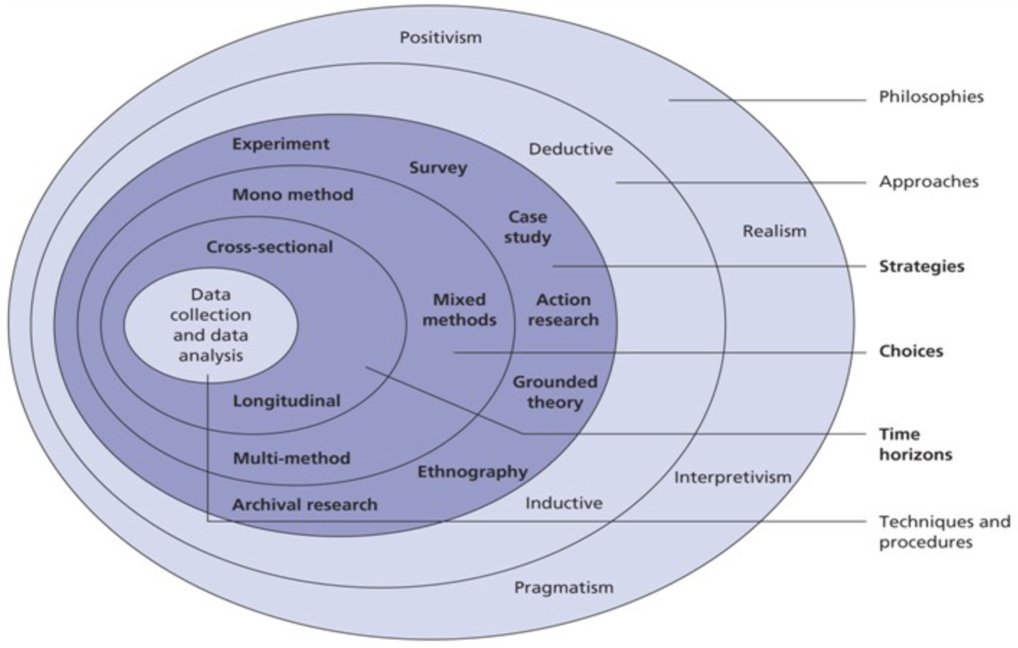
Figure 3.1 - The figure is highlighted to include the Researchers choices in terms of each layer of the Research Onion.

The approach chosen to take when investigating will be an Exploratory Research approach, Exploratory Research can be defined as a particular method of research that investigates an issue or problem that is not clearly defined and therefore lacks research. It has a clear understanding of the problem but is not concluding a set solution for it (Stebbins, 2001).

3.2 Philosophy

The first layer of the Research Onion is the Research Philosophy, more simply it is the set of beliefs in which the research is based on. It can be described from two perspectives; Ontological and Epistemological (Crossley and Jansen, 2021). In this investigation, the said researcher will be taking the perspective of Interpretivism, due to this belief focuses on the social factors and what people's opinions and views provide. Typically, Interpretivism uses qualitative data although quantitative data can provide a much clearer understanding (O'Donoghue, 2007). This is best suited to this case of research because of the link between exploratory approach.

3.3 Approach

In this research, an inductive approach will be used to observe the data as it entails generating different theories through the research. Inductive approach is linked to qualitative and quantitative data theories, it is believed as a common theory that qualitative data works best within an Inductive Approach. This is the best option for this particular research as there is a lack of literature based on this topic (Saunders et al. 2009).

3.4 Strategy

This Research in particular would benefit from using surveys, more specifically questionnaires to gain views and opinions on the matter from the public. Retrieving feedback from the public will help investigate why the general consumer buys certain products/services from organisations or according to the research question, what is it about organisations performing unethical behaviour that causes damage to their brand equity. The advantages of questionnaires are that large amounts of information can be obtained in a short period of time and it is more compatible when using qualitative data as the main source of research in this case (Lambert, 2019). The surveys used in this research are in the form of questionnaires and were first made in drafts on survey monkey then finalised through Google Forms. The questionnaire was posted on social media such as Facebook and Instagram via a link, sent out to contact members through Whatsapp and posted on public forums where it could reach a lot more people. Background questions were asked and included stating that all responses would remain anonymous. Contact details of the Researcher and the University were provided to the participants if they wanted to discuss the questionnaire further.

3.5 Choice

The section of choices is simply based on how many methods of data the researcher uses (Sahay, 2016). Mono Method simply is the choice of using either qualitative or quantitative data sources (Hassard and Pym, 1990). As previously mentioned, this technique of Mono Method is best suited to this particular research due to the use of qualitative research throughout.

3.6 Time Horizon

In this Research it will use Cross Sectional Research, which is the best option for the options chosen. A Time Horizon is simply explained as a period of time in which the data will be collected (Armstrong, 2001). Cross Sectional Research is quicker than other types.

Techniques for Data Collection, Processes and Analysis

Data Collection

In this Research there will be various types of data used, both Primary and Secondary research will benefit the investigation as content from already written text by other Researchers will be used hugely and also the researcher will be conducting the questionnaire created and using the results and findings from it to provide other views and opinions to further the knowledge. Primary data is one found firstly by a researcher and Secondary data is one already by another researcher and available for others to use (Hox and Boeije, 2005).

Questionnaire Design

The questionnaire is built up of five demographics questions to build up an idea of the participants' background, the rest of the questions are mixed between closed questions and open questions. The closed questions are simply to get a straightforward answer to use statistically while the open questions so the participant can elaborate if they wish. The closed questions have been marked as required on the questionnaire, and the open questions are simply there for the participant to add further detail if they wish. This will benefit the research because the required answers will provide large amounts of opinions to include and the non-required questions will help even more for the research to provide an in-depth knowledge of participants opinions.

Questionnaire

Q1. Do you give your consent for the anonymous responses to be used in a Research Proposal?

Q2. What age category do you belong to?

Q3. What do you identify as?

Q4. What is the highest level of education you have undertaken?

Q5. What is your occupation?

Q6. Do you consider yourself to be an ethical person?

Q7. I would buy a product/service from an organisation who tests on animals

Q8. I would buy a product/service from an organisation that uses child labour?

Q9. If an organisation you had previously bought from conducted unethical behaviour, would you still continue to buy from them?

Q10. If an organisation you were interested in did not take part in a political/social/cultural campaign (such as Black Lives Matter and using the hashtag 'Blackout') would you buy from them?

Q11. How would you define good ethical behaviour?

Q12. Do you think that organisations should contribute to the local area/community that they operate from within?

Q13. Do you think that ethics are important to the success of an organisation?

Q14. All an organisation has to do to be ethical is follow the law?

