University of Wales
Trinity Saint David

Student: Dominic Artiom
ID: 2027538

Module – Cloud Computing Administration.
ACCA-6025

Reference Standard: IEEE
Lecturer: Renuga Jayakumar
Data: 11/11/2024

Table of Contents
Benefits of Cloud Solutions for Aspire Retailers 4
Load Balancing: Enhancing Performance and Reliability 5
Load balancing 5
1. High Availability 5
2. Scalability and Flexibility 5
3. Enhanced Performance 5
4. Geographic Load Distribution 5
Implementing Cloud-Based Load Balancing 5
Security Features in Cloud-Based Load Balancing 6
Conclusion 6
B) Analysis of Cloud Providers for Aspire Retailers: AWS, Microsoft Azure, and Google Cloud 6
Key Cloud Providers: AWS, Azure, and Google Cloud 7
1. Amazon Web Services (AWS) 7
2. Microsoft Azure 7
3. Google Cloud Platform (GCP) 8
Cost-Management and Optimization Tools Comparison 8
AWS Cost Management: 8
Azure Cost Management: 9
Google Cloud Billing: 9
Conclusion 9
Computing Configurations: 9
С) Estimating Cloud Spending for Aspire Retailers 11
1. Create a Tenant 11
2. Add Users and Groups: 11
3. Assign Permissions 11
4. Integrate Applications 11
Supporting BYOD Policies 12
Steps to Configure BYOD Support: 12
Summary 12
D) Why Identity Is the New Perimeter 13
E) Cloud Governance: Keeping Aspire Retailers Secure and Efficient 16
1. Azure Policy: The Rule Enforcer 16
2. Azure Role-Based Access Control (RBAC): Managing Permissions 16
• Global Administrators 16
• Users 16
3. Conditional Access: Smart Access Management 17
• Multi-Factor Authentication (MFA) 17
1. RBAC 17
2. Azure Policy 17
3. Conditional Access 17
Why Cloud Governance Is Critical 17
1. Security Vulnerabilities 18
2. Uncontrolled Spending 18
• Compliance Failures: 18
Final Thoughts 18
F) A Disaster Recovery Plan for Aspire Retailers 20
Key Considerations for a Cloud Disaster Recovery Plan 21
Data Backup and Replication 21
Application Availability and Failover 21
Testing and Automation 21
Step 2: Ensure Application Resilience with Azure Site Recovery 21
Step 3: Automate and Test the Recovery Plan 22
1. Regular 22
2. Automation with Azure Runbooks: 22
3. Monitoring and Alerts 22
Suggested Disaster Recovery Plan 22
1. Data Backup: Use Azure Backup 22
2. Application Replication 22
3. Testing and Automation 22
4. Monitoring: 22
References: 24

A) Cloud Solutions for Aspire Retailers: Immediate Computing Services and Load Balancing
Aspire Retailers, a home improvement retailer, currently operates an on-premises data center to host its website and store data for various applications. The company’s IT team manages tasks such as hardware and software procurement, installation, deployment, and network monitoring. However, this setup limits flexibility and delays service delivery to end users. Aspire Retailers’ management has decided to explore cloud solutions to enhance efficiency, allowing immediate access to computing resources. This transition would allow Aspire to develop, deploy, and scale applications quickly, with features like load balancing providing key support for performance and reliability.

Benefits of Cloud Solutions for Aspire Retailers
Transitioning to cloud-based infrastructure offers several benefits, including scalability, flexibility, and cost efficiency. Cloud platforms such as Amazon Web Services (AWS), Microsoft Azure, and Google Cloud provide on-demand resources, allowing Aspire Retailers to avoid the delays of procuring, installing, and managing physical hardware. The cloud also allows elasticity, scaling resources up or down based on demand, helping Aspire Retailers control costs while maintaining service quality [1].
In the cloud, Aspire’s IT team could instantly provision additional servers or storage during peak times, such as major sale events, eliminating the bottlenecks of on-premises setups. This scalability also enables faster deployment of new applications, as the team no longer needs to manage hardware for testing or production environments. Additionally, cloud solutions operate on a pay-as-you-go model, where Aspire only pays for resources used, further reducing costs associated with over-provisioning [2].

Load Balancing: Enhancing Performance and Reliability
Load balancing is an essential feature in cloud environments that optimizes resource use and improves application availability. A load balancer distributes incoming network traffic across multiple servers, reducing strain on individual servers and ensuring consistent performance. For Aspire Retailers, where uptime and responsiveness are critical, load balancing offers significant benefits:
- High Availability: Load balancing improves uptime by distributing traffic across servers. If one server fails, the load balancer redirects traffic to other operational servers, preventing disruption. This setup is vital for Aspire Retailers, as it ensures website availability even in the event of server issues.
- Scalability and Flexibility: Cloud-based load balancing adapts automatically to changing traffic levels. For example, during holiday seasons, Aspire’s load balancer can increase server allocation to handle higher demand, scaling down once traffic normalizes. This approach maximizes efficiency, enabling Aspire Retailers to meet peak demand without maintaining unnecessary server capacity year-round.
- Enhanced Performance: By distributing requests across multiple servers, load balancing reduces response times, leading to faster page loading and improved user experience. In a competitive retail environment, where website speed influences customer satisfaction and retention, reliable performance is essential. A faster site also improves search engine ranking, potentially increasing traffic to Aspire’s online store.
- Geographic Load Distribution: Many cloud providers offer global load balancing, directing users to the closest server based on their location. This geographic distribution minimizes latency, providing a faster experience for users across different regions. For Aspire Retailers, this feature supports potential expansion into new markets by delivering an efficient, localized experience for customers worldwide [3].

Implementing Cloud-Based Load Balancing
Cloud providers offer integrated load balancing services, such as Amazon Elastic Load Balancing, Azure Load Balancer, and Google Cloud Load Balancing, that are easy to configure and scalable to fit specific application needs. These services come with built-in monitoring and analytics, allowing Aspire’s IT team to track performance metrics, server health, and traffic patterns. This data enables Aspire Retailers to adjust resource allocation and optimize infrastructure, ensuring that services remain reliable and responsive.

Security Features in Cloud-Based Load Balancing
Security is crucial for Aspire Retailers’ online operations, and cloud-based load balancers provide essential protection. Many load balancers offer Distributed Denial of Service (DDoS) protection, which blocks malicious traffic that could disrupt service. Some load balancers also support SSL termination, handling encryption and decryption of data to secure customer interactions without overburdening application servers. These security features protect user data and enhance server efficiency, delivering a secure, smooth shopping experience [4].

Conclusion
For Aspire Retailers, moving to a cloud-based infrastructure offers a strategic advantage in managing IT resources, ensuring operational efficiency, and supporting business growth. Load balancing in particular provides a means to handle traffic effectively, delivering consistent performance and scalability. By adopting cloud solutions with load balancing capabilities, Aspire Retailers can create a reliable, cost-effective IT environment that supports a responsive online platform, helping to meet customer expectations and foster future expansion.

B) Analysis of Cloud Providers for Aspire Retailers: AWS, Microsoft Azure, and Google Cloud
As Aspire Retailers considers moving its North European data center to the cloud, evaluating different cloud providers is essential to understand their service offerings, pricing structures, and overall cost management capabilities. The management team has already shown interest in Microsoft Azure, but before finalizing their choice, a comparative analysis with other providers like Amazon Web Services (AWS) and Google Cloud Platform (GCP) can help identify cost-saving opportunities and the best fit for Aspire's needs. Below is a breakdown of each provider, with a particular focus on managing ongoing expenses and maximizing value.

Key Cloud Providers: AWS, Azure, and Google Cloud
Each major cloud provider offers a variety of services, including virtual machines, databases, storage, and network management. However, their cost structures and tools for managing expenses vary significantly, which impacts the overall cost-effectiveness for companies like Aspire Retailers.

1. Amazon Web Services (AWS)
AWS is the largest and most established cloud provider, offering a broad range of services and flexibility. AWS provides various instance types that can be customized based on CPU, memory, storage, and operating system needs, giving Aspire Retailers the flexibility to optimize configurations to meet specific requirements. AWS’s pricing model includes pay-as-you-go for flexible usage, reserved instances for discounted rates with long-term commitments, and spot instances that offer significant discounts for using spare capacity [5].

AWS’s Elastic Load Balancing and Auto Scaling features automatically adjust resources based on traffic, helping Aspire manage costs while maintaining performance. AWS also offers a Total Cost of Ownership (TCO) Calculator and Pricing Calculator to help organizations estimate and manage costs based on selected configurations. For Aspire Retailers, using AWS’s TCO Calculator could help forecast cloud costs by comparing existing data center expenses with AWS’s pay-as-you-go and reserved pricing models.

2. Microsoft Azure
Microsoft Azure is highly compatible with organizations already using Microsoft products, which could simplify integration for Aspire Retailers. Azure’s Virtual Machines (VMs) come in a variety of configurations for both Linux and Windows OS, allowing Aspire Retailers to choose specific options that best suit their needs. Azure’s cost models include pay-as-you-go, reserved instances (for 1- or 3-year terms), and spot pricing. Reserved instances provide significant cost savings for long-term use, which is ideal for organizations planning to run stable workloads over time.

To help Aspire Retailers estimate costs, Azure provides the Total Cost of Ownership (TCO) Calculator and Azure Cost Management and Billing tools. These tools allow Aspire’s IT team to set budgets, monitor usage, and receive cost-saving recommendations. Additionally, Azure offers App Service Plans, which allow developers to deploy and scale applications based on demand, without needing to manage underlying infrastructure manually. This feature will be particularly beneficial as Aspire Retailers moves applications to the cloud, helping them maintain performance and control expenses [6].

Azure’s focus on cost management aligns well with Aspire Retailers’ needs, as it offers detailed cost-tracking, budgeting features, and forecasts that allow the IT team to monitor and manage ongoing cloud expenses. With its compatibility with Microsoft products and robust cost-management tools, Azure presents itself as a strong candidate for Aspire’s cloud migration.

3. Google Cloud Platform (GCP)
Google Cloud Platform, though newer to the market, has gained popularity due to its strong capabilities in analytics, machine learning, and data processing. GCP’s Compute Engine offers various VM configurations, which can be tailored to specific CPU, memory, and storage requirements. One of GCP’s unique cost advantages is its sustained use discounts, which automatically lower prices for VMs based on usage levels, offering additional savings for organizations with consistent workloads.

GCP also provides Cloud Load Balancing and Autoscaler to manage traffic and allocate resources as demand fluctuates. GCP’s Pricing Calculator and Total Cost of Ownership (TCO) tools allow Aspire Retailers to project costs based on anticipated workloads and help the IT team compare current data center costs with GCP’s cloud-based solutions. These tools provide flexibility and transparency in managing costs, enabling Aspire to allocate resources efficiently and prevent unnecessary expenses [7].

Cost-Management and Optimization Tools Comparison
Managing costs is a primary concern for Aspire Retailers’ migration, as the finance manager needs an estimate of monthly expenses and potential savings over the next three years. Here’s how each cloud provider compares in terms of cost-management tools:

AWS Cost Management: AWS provides detailed billing dashboards and cost forecasts, helping Aspire Retailers track real-time spending and set custom alerts for budget management. AWS’s reserved instance model and spot pricing options offer flexibility for optimizing costs.

Azure Cost Management: Integrated within Azure’s dashboard, this tool allows Aspire Retailers to track costs, set budgets, and receive optimization suggestions. The TCO Calculator and reserved pricing options help Aspire evaluate and manage long-term costs effectively, particularly with 3-year reserved pricing.

Google Cloud Billing: GCP’s cost-management tool provides project-based cost breakdowns and alerts, helping Aspire Retailers allocate resources by department or project. Sustained use discounts add value by reducing expenses for steady workloads.

Conclusion
For Aspire Retailers, Microsoft Azure stands out as a favorable choice due to its compatibility with existing Microsoft products, extensive cost-management tools, and flexibility in handling workloads. Azure’s TCO Calculator, Cost Management, and reserved pricing provide the detailed insights and budgeting capabilities Aspire’s finance manager needs to forecast ongoing expenses and identify potential savings. While AWS and GCP offer similar features, including load balancing and autoscaling, Azure’s integration with Microsoft products makes it the most convenient choice for Aspire’s operational structure. By leveraging Azure’s robust cost-management features, Aspire Retailers can confidently transition to the cloud, reduce infrastructure expenses, and improve service efficiency.

Computing Configurations:

[Img1]
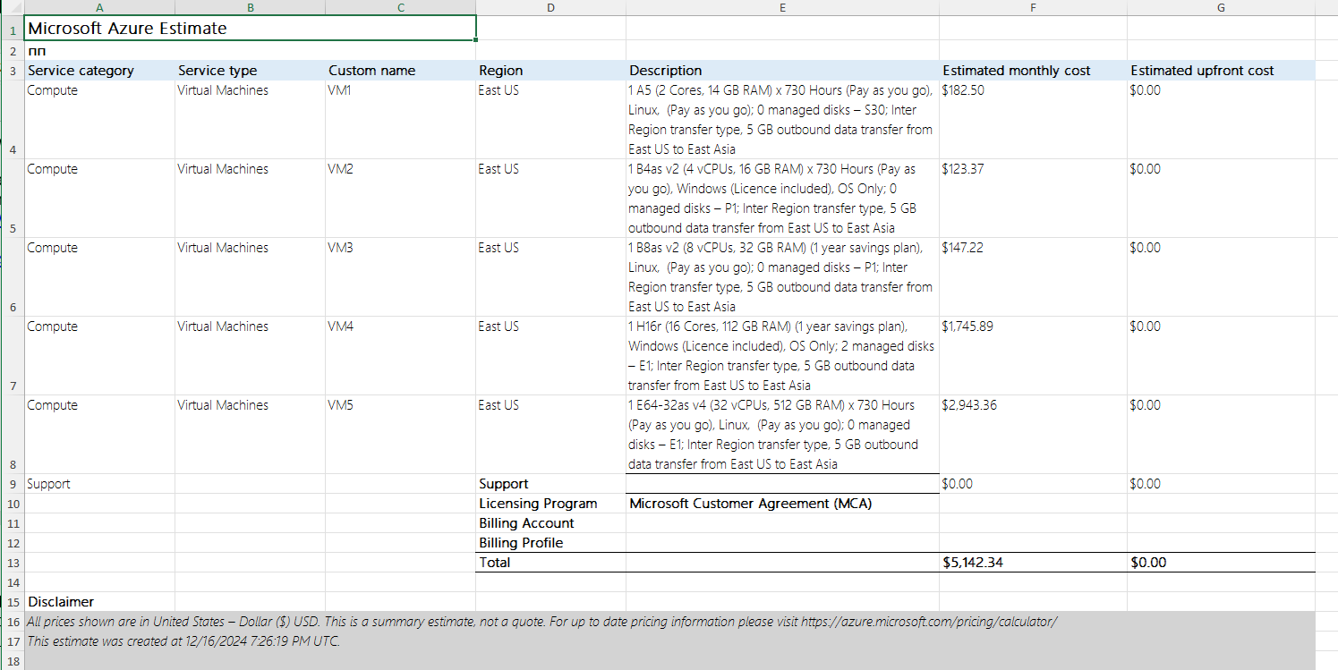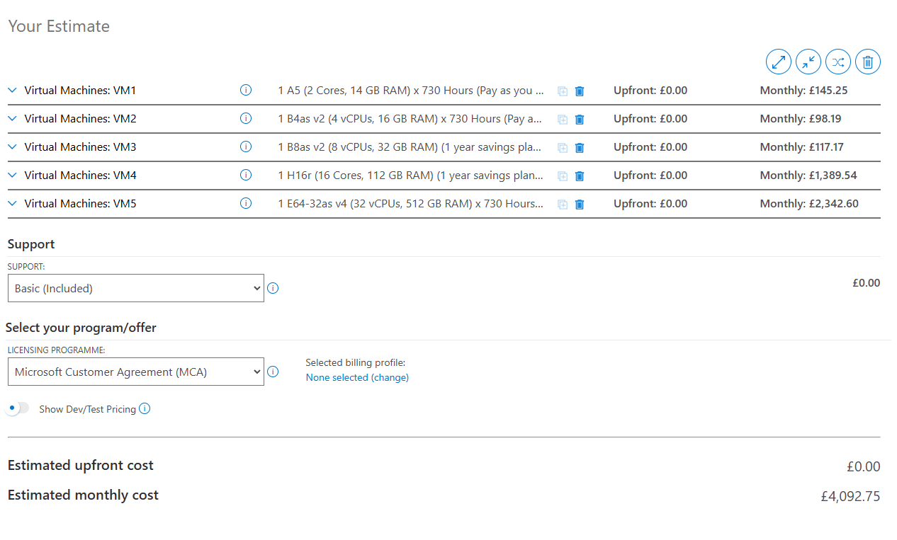

С) Estimating Cloud Spending for Aspire Retailers
Aspire Retailers made a strategic decision to migrate to Azure to optimize costs and improve flexibility. Based on the TCO analysis, the company is projected to save $360,720 over five years compared to maintaining its on-premises infrastructure. Azure’s total estimated cost for the same period is $133,622, broken down into categories such as compute resources, storage, and IT labor [8].
The compute costs account for the largest share at $75,557.76, reflecting the use of reserved instances for virtual machines optimized for business applications. Storage costs, at $46,563.77, cover file storage, database backups, and tiered storage solutions, while IT labor costs are reduced to $11,500 due to Azure’s automation and integrated management features [8].
This cost model is built on Azure’s flexibility, where Aspire Retailers only pays for what they use, scaling resources as needed. For example, during high-demand periods like holiday sales, additional virtual machines can be deployed temporarily, ensuring uninterrupted service for customers. On the other hand, costs reduce during slower periods, thanks to Azure’s pay-as-you-go model. This dynamic scalability provides the company with a competitive edge while keeping costs predictable.
Azure Active Directory for User and Group Management
As Aspire Retailers expands, managing user accounts and integrating outsourced teams is critical. Azure Active Directory (AAD) offers secure identity management through single sign-on (SSO), role-based access control (RBAC), and multi-factor authentication (MFA). These features make AAD an excellent choice for managing employees and external marketing teams [9].
Azure AD also ensures compliance with data protection regulations like GDPR and HIPAA, which are crucial for companies operating globally. With built-in security features, such as conditional access, the IT department can monitor access attempts and block suspicious activities. For example, login attempts from untrusted regions or unfamiliar devices can trigger alerts or additional verification steps.
To implement AAD, Aspire Retailers would need to:
- Create a Tenant: Establish a new AAD tenant in the Azure portal.
- Add Users and Groups: Organize users by roles or departments, such as "Marketing" or "Logistics."
- Assign Permissions: Use RBAC to control access levels based on user responsibilities.
- Integrate Applications: Link business-critical apps with AAD for seamless access and security [9].
This setup ensures secure collaboration between internal teams and third-party partners.

Supporting BYOD Policies
To support global operations and enable employees to use personal devices for business tasks (BYOD), Aspire Retailers can leverage Azure Intune. Intune works with AAD to enforce device compliance policies and secure access to corporate resources. For example, it ensures only devices with encryption enabled and the latest software updates can connect to the company network [10].
Azure Intune also reduces the risks of data breaches from lost or stolen devices. With remote wipe functionality, IT administrators can erase sensitive corporate data while leaving personal files intact. This ensures that company information remains secure without disrupting employees’ personal device usage.

Steps to Configure BYOD Support:
- Conditional Access Policies: Restrict resource access to compliant devices.
- Application Protection Policies: Protect company data on personal devices by controlling how data can be shared.
- Multi-Factor Authentication: Enhance security for all BYOD users.
- Device Enrollment in Intune: Enroll devices to monitor and manage them without compromising user privacy [10].
These measures allow Aspire Retailers to maintain data security while improving user productivity across the globe.
Estimating Costs for Azure Active Directory and BYOD
Azure Active Directory is available in multiple tiers, with Premium P1 being most suitable for Aspire Retailers. At $6/user/month, P1 provides advanced features such as conditional access and device management. For 100 users, this amounts to $7,200/year [9].
Azure Intune adds an additional $6/user/month, or $7,200/year, bringing the total cost of BYOD management and identity services to $14,400/year. Combined with the infrastructure costs from the TCO analysis, the total yearly spending for Aspire Retailers is approximately $41,124/year [8][10].

Summary
Migrating to Azure provides Aspire Retailers with significant cost savings and operational benefits. Beyond the financial advantages, Azure Active Directory and BYOD support ensure secure, scalable solutions for managing a growing workforce and external partners. These services not only meet current needs but are also prepared to accommodate future growth, including the addition of new users, applications, and locations.
By leveraging cloud solutions, Aspire Retailers demonstrates its commitment to innovation while maintaining a focus on cost efficiency and security. Whether it’s ensuring safe access for marketing teams or empowering employees worldwide with BYOD capabilities, Azure equips the company with the tools it needs to thrive in a competitive market.

[ TCO 1-5 ]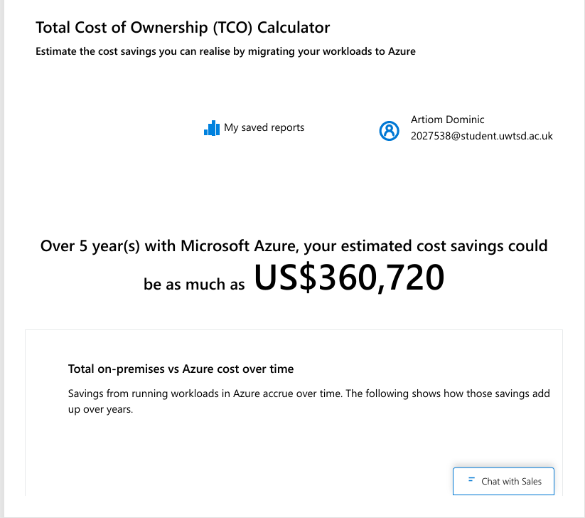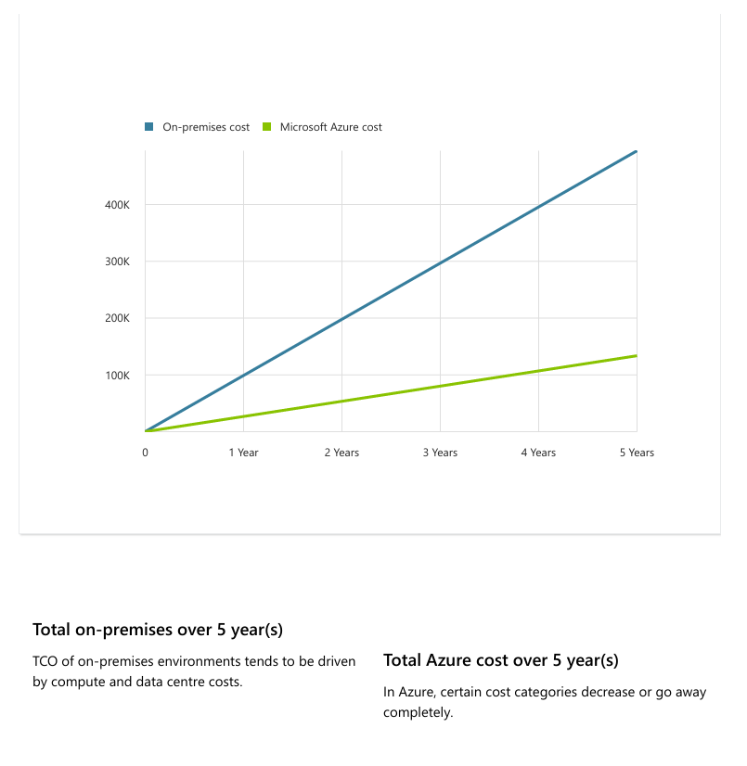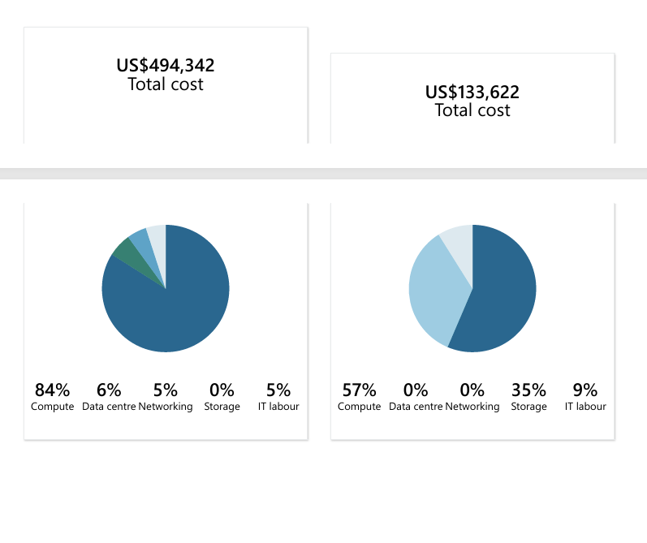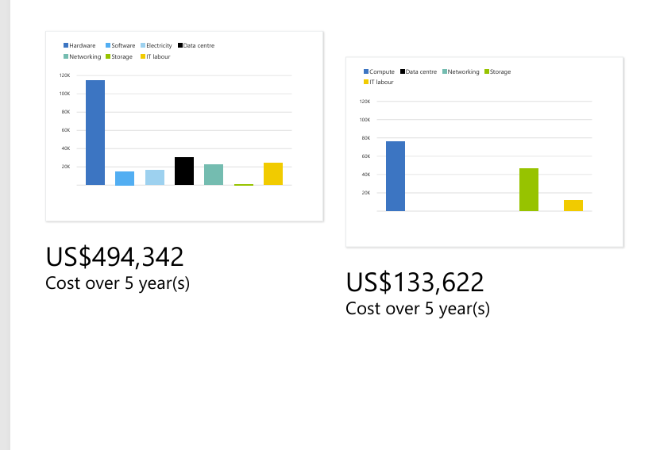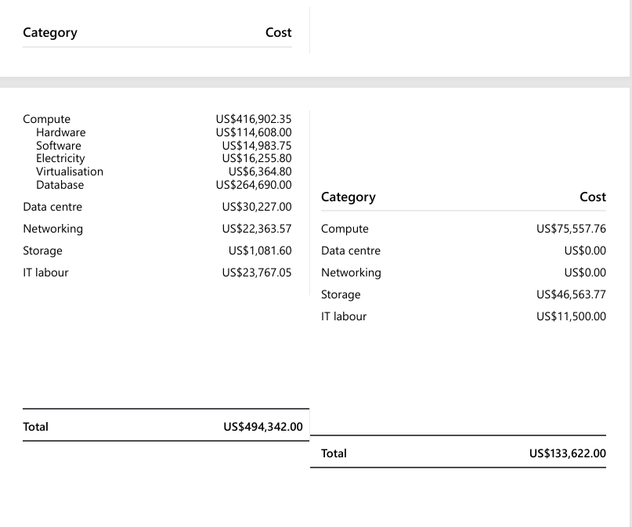

D) Why Identity Is the New Perimeter
Picture this: You’re managing a business in a world where your employees are scattered across continents, using a mix of personal and company-owned devices. Some are accessing cloud applications; others are logging into the corporate network through mobile apps. The traditional idea of a "security boundary" being limited to firewalls and office walls? That’s long gone.
Welcome to the era of identity as the new security perimeter. In this landscape, Azure Active Directory (Azure AD) is your go-to toolkit. It’s not just about letting people into systems—it’s about knowing exactly who they are, what they need to do, and how they’re accessing your data [11], [12].

Using Azure AD to Configure User Accounts[img3]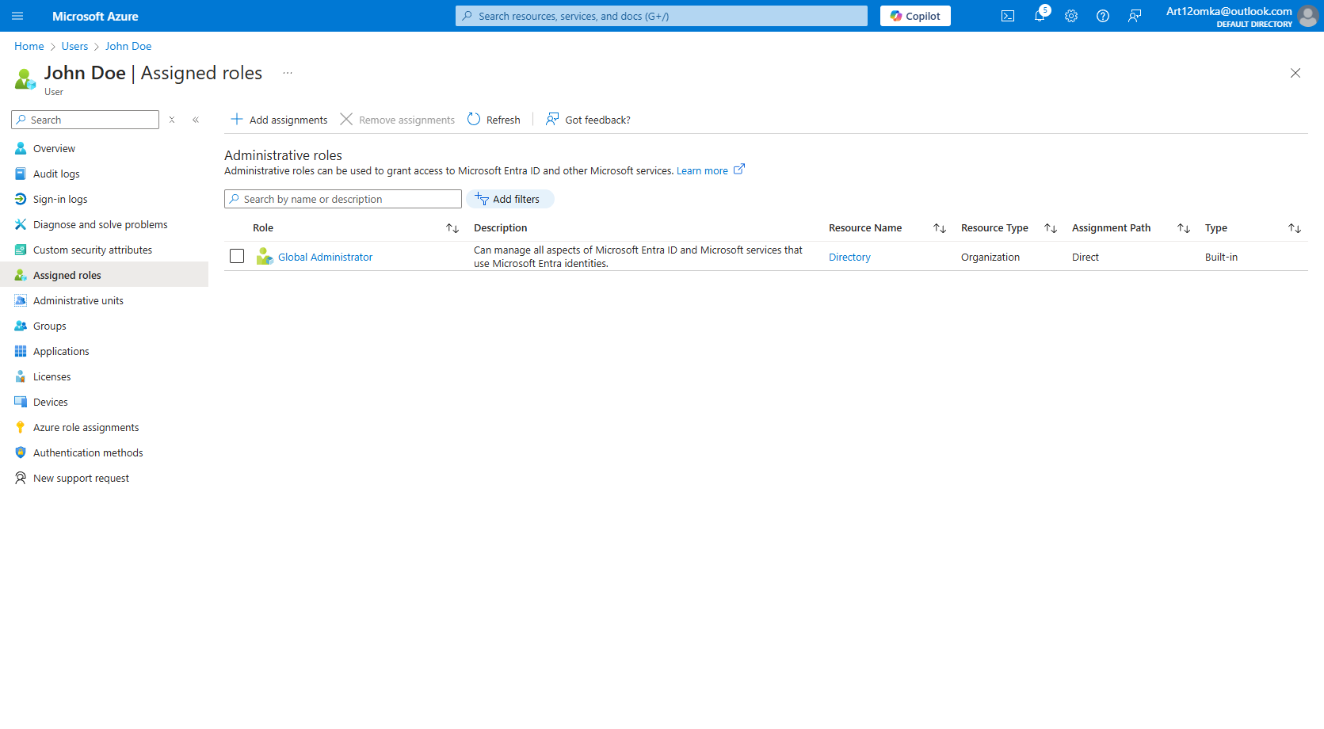
Azure AD provides a centralized way to configure and manage user accounts. Here’s an example from my lab activity:
- Created John Doe: Assigned him the Global Administrator role, granting full control over the directory and resources.[img2]
- Created Jane Smith: Left her with the default User role for restricted access.
These roles represent the core of Azure AD’s Role-Based Access Control (RBAC) system. The idea is to ensure that every user has only the permissions they need to perform their tasks—no more, no less. This approach drastically reduces the risk of accidental or malicious system changes [11].

Why Roles Matter
Think of roles in Azure AD like keys to a building. A global admin has a master key, unlocking every door, while a regular user has access only to their workspace. Mismanaging these keys can lead to trouble. If a user with admin-level access is compromised, it’s like giving an intruder access to the entire building.
From my lab:
- John Doe, an IT Manager, was assigned the Global Administrator role to oversee the entire system. [img2]
- Jane Smith, working in customer support, retained the default User role, which restricts her access to the tools she needs for her job.
Assigning roles effectively not only protects sensitive data but also keeps users focused on their specific tasks [12].

Security Features for Modern Workflows
Azure AD shines when dealing with the complexities of remote work, BYOD policies, and cloud applications. Features like Multi-Factor Authentication (MFA) and Conditional Access are critical tools for modern identity management:
- MFA: Combines something you know (a password) with something you have (a phone app or SMS code), making it much harder for attackers to gain access even if a password is stolen.
- Conditional Access: Sets rules for granting or blocking access based on factors like device compliance, location, or user behavior. For instance, you can require additional verification if a user logs in from an unrecognized device or location.
In my lab, enabling MFA for Jane Smith added an extra layer of security to her account. Similarly, Conditional Access could ensure that John Doe’s admin access is granted only when he logs in from a company-managed device [11], [12].

Governance and Compliance
Azure AD isn’t just about security; it also supports cloud governance by helping organizations manage users, costs, and compliance. For instance:
- User Management: By defining roles and using group-based access, administrators can streamline permissions.
- Cost Control: Allocating licenses and permissions efficiently ensures that no resources are wasted.
- Compliance: Azure AD’s auditing and reporting tools make it easier to demonstrate compliance with GDPR, HIPAA, and other regulations.
These features ensure that organizations not only protect their data but also operate efficiently and responsibly [12].

Conclusion
Azure AD is a cornerstone of identity management in today’s cloud-first world. By creating and managing roles like Global Administrator and User, organizations can secure their resources while empowering employees to work effectively. The additional security features, like MFA and Conditional Access, make it easier to adapt to the challenges of remote work and BYOD policies.
The takeaway? Managing identity and access isn’t just an IT function anymore—it’s a critical business strategy.

[img3]
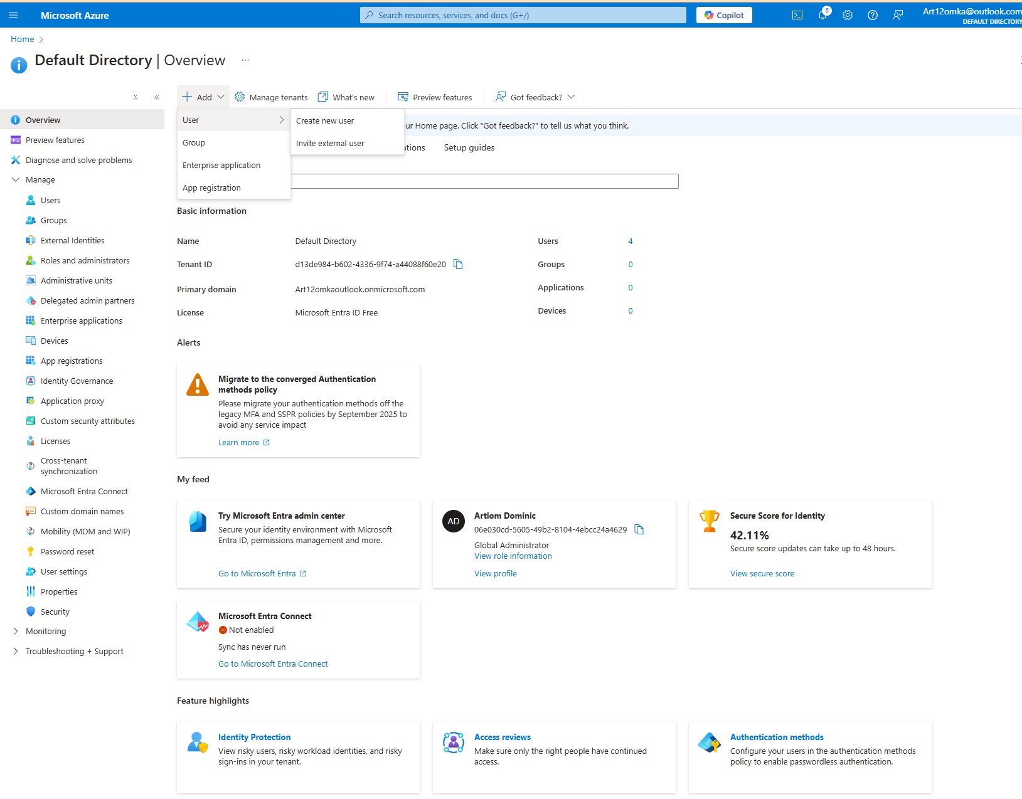

E) Cloud Governance: Keeping Aspire Retailers Secure and Efficient
Moving Aspire Retailers’ operations to the cloud is a game-changer. But with that shift comes responsibility: if you don’t control access, budgets, and policies, it can quickly turn chaotic. Enter cloud governance—the strategy that keeps everything organized and secure.
In simple terms, cloud governance defines the rules for using cloud resources. It answers key questions: Who has access? What can they do? How do we enforce security? Microsoft Azure has a robust toolkit to help businesses like Aspire Retailers stay in control, from managing identities to enforcing security rules and budgets [13].
Azure’s Tools for Cloud Governance

1. Azure Policy: The Rule Enforcer
Think of Azure Policy as your cloud's “guardrails.” It ensures every resource—whether it’s a database, storage account, or virtual machine—follows your company’s rules. For example, Aspire Retailers might decide that all storage accounts must have encryption enabled[img4]. Azure Policy can enforce that automatically and block anything non-compliant [14].
I tested this in my lab by creating a policy to enforce encryption. If someone tries to create a storage account without encryption, Azure flags it immediately and stops the process. It’s like having an automatic security check.

2. Azure Role-Based Access Control (RBAC): Managing Permissions
RBAC is about giving the right people the right level of access. You wouldn’t let every employee have the keys to the server room, would you? The same applies in the cloud.
For Aspire Retailers, roles might look like this:
- Global Administrators: Full access to everything. In my lab, I assigned this role to John Doe, who needs complete control as the IT manager.
- Users: Limited access, just enough to do their job. Jane Smith, a customer service representative, kept the default User role [15].[img5]
By limiting permissions, Aspire Retailers minimizes risks—one stolen password won’t bring down the entire system.

3. Conditional Access: Smart Access Management
Conditional Access is Azure’s way of saying, “You can’t just log in from anywhere, anytime, on any device.” It sets rules for how and when users can access company systems.[img6]
For example, Aspire Retailers might require:
- Multi-Factor Authentication (MFA) for anyone accessing critical systems.
- Blocking access from untrusted countries or devices without encryption.[img7]
In my lab, I configured a Conditional Access policy to require MFA for all sign-ins and blocked logins from high-risk regions [16]. It took just a few minutes to set up and added a solid security layer.
Practical Use Case: Combining Governance Tools
Here’s how these tools work together in a real-world scenario for Aspire Retailers:
- RBAC ensures only authorized people have access. John, as a Global Admin, can manage resources, while Jane only sees what she needs.
- Azure Policy enforces encryption rules, so all new storage accounts meet security standards.
- Conditional Access blocks suspicious login attempts and ensures that even if someone’s password is compromised, MFA stops unauthorized access [14], [16].
This layered approach keeps the cloud environment secure, organized, and efficient.
Screenshots from My Lab
During my lab activity, I created two users:
- John Doe (Global Admin)
- Jane Smith (User Role)
I then applied a Conditional Access policy requiring MFA and verified its enforcement. Screenshots include:
- User creation in Azure AD.
- Assigning John the Global Admin role and Jane the default User role.
- The Conditional Access setup page showing MFA enforcement and blocked locations.
These screenshots demonstrate how easily Azure tools can be implemented to create a secure and governed environment.

Why Cloud Governance Is Critical
Without governance, Aspire Retailers would face several risks:
- Security Vulnerabilities: Unauthorized users might gain access to sensitive systems, causing data breaches [17].
- Uncontrolled Spending: Without policies, resources might be created unnecessarily, inflating costs.
- Compliance Failures: Regulatory standards like GDPR require strong security controls. Azure governance tools simplify compliance reporting and enforcement [18].
With Microsoft Azure, Aspire Retailers can address all of these challenges. Tools like Policy, RBAC, and Conditional Access provide the structure needed to manage resources securely and efficiently.

Final Thoughts
Cloud governance isn’t just a set of rules; it’s the backbone of a successful cloud strategy. Aspire Retailers can use Azure Policy to enforce standards, RBAC to manage permissions, and Conditional Access to secure logins. Together, these tools build a cloud environment that’s efficient, secure, and ready for growth.
The good news? Microsoft Azure makes it easy to implement these controls. Once configured, they work quietly in the background, letting Aspire Retailers focus on what matters most—expanding their business into new markets.

[img4]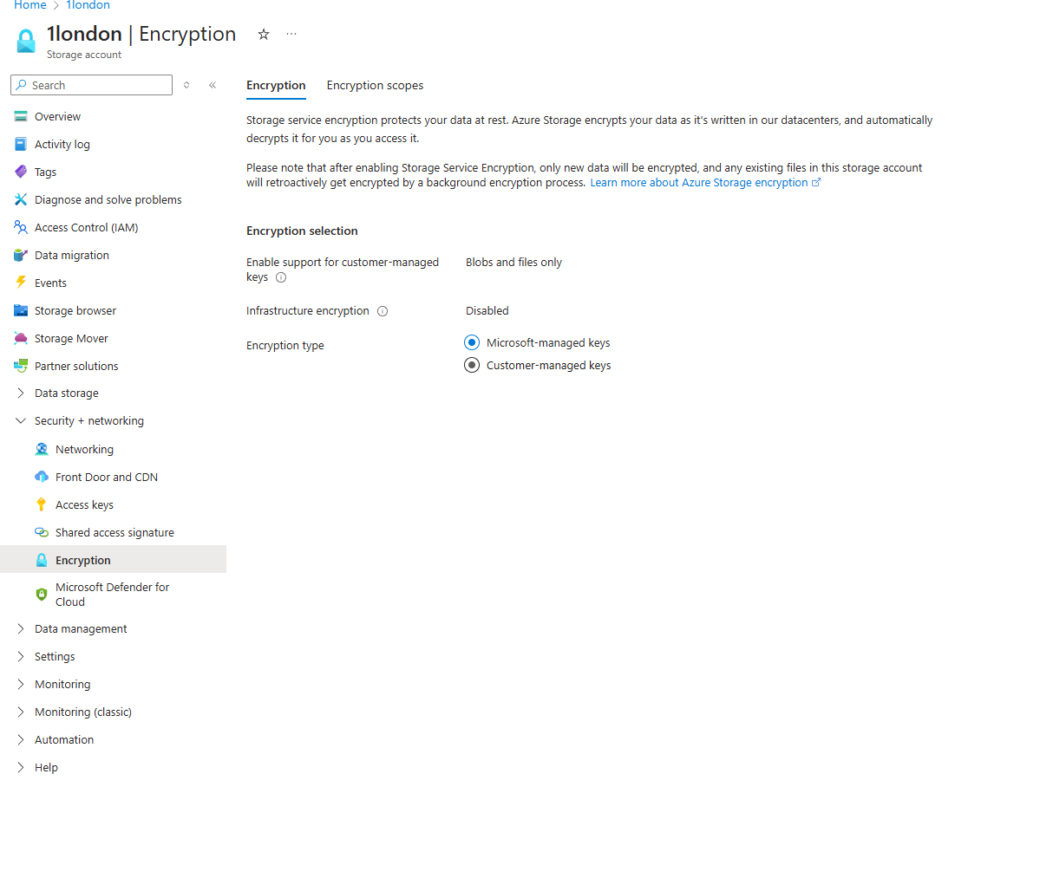

[img5]

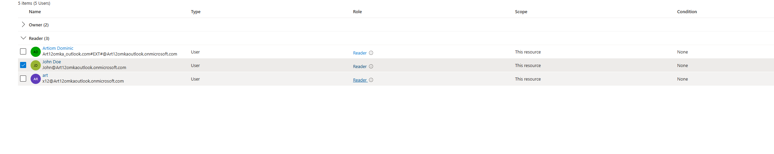
[img6]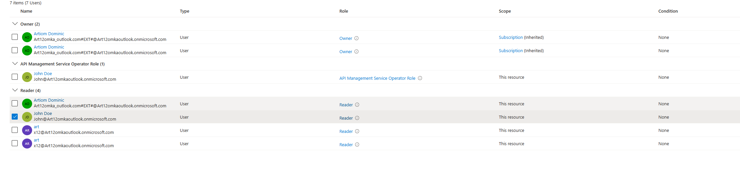
[img7]
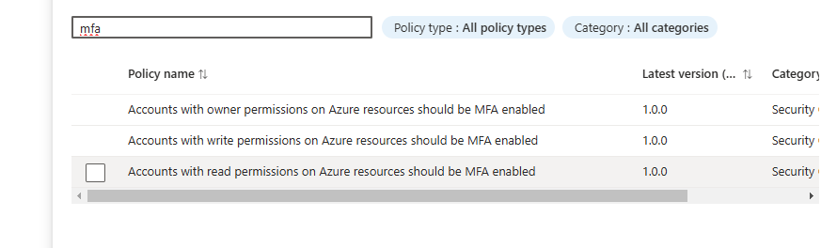

F) A Disaster Recovery Plan for Aspire Retailers
No business, big or small, can afford to leave its operations vulnerable to unexpected disasters. Whether it’s a system failure, cyberattack, or natural disaster, the loss of data or downtime for critical applications can cripple an organization. Aspire Retailers, having moved their systems and applications to the cloud, needs a proper Disaster Recovery (DR) plan to ensure business continuity under all circumstances.
Disaster recovery in a cloud environment isn’t just about backups—it’s about creating a strategy that minimizes downtime and prevents data loss while keeping costs manageable. Microsoft Azure offers tools and services that align perfectly with these goals.

Key Considerations for a Cloud Disaster Recovery Plan
A solid disaster recovery plan consists of three essential pillars:

Data Backup and Replication

Application Availability and Failover

Testing and Automation
For Aspire Retailers, the focus should be on creating a resilient, cost-effective plan using Azure’s built-in services. Let’s break down the steps and tools to achieve this.

Step 1: Backup Data with Azure Backup
Azure Backup is the backbone of any disaster recovery plan. It provides a reliable, scalable, and secure way to back up critical data, applications, and virtual machines. For Aspire Retailers, Azure Backup can be configured to:
- Automatically back up data daily, weekly, or as frequently as required.
- Store backups in geo-redundant storage (GRS), ensuring data is replicated across two geographically separated regions [19].
This guarantees that even if one data center fails, the data is still safe and recoverable. Additionally, Azure Backup encrypts all data both in transit and at rest, maintaining security and compliance.

Step 2: Ensure Application Resilience with Azure Site Recovery
While backups protect data, Aspire Retailers also needs to ensure that applications remain available during a disaster. This is where Azure Site Recovery (ASR) comes into play. ASR replicates virtual machines and critical workloads to another Azure region, ensuring failover capabilities with minimal downtime.
Here’s how it works:
- Aspire Retailers can replicate their virtual machines and databases in real time to a secondary Azure region.
- During an outage, the failover process kicks in automatically, redirecting operations to the replicated systems.
- Once the primary systems are restored, a failback process ensures seamless synchronization.
With ASR, Aspire Retailers can achieve a Recovery Point Objective (RPO) of minutes and a Recovery Time Objective (RTO) of less than an hour, depending on the configuration [20].
For example, the logistics application, which tracks deliveries and manages schedules, can be replicated to ensure it remains operational, even if the primary data center goes offline.

Step 3: Automate and Test the Recovery Plan
A disaster recovery plan is only effective if it works when you need it. Aspire Retailers should implement the following practices:
- Regular Testing:
Using Azure Site Recovery, Aspire Retailers can simulate failover scenarios without affecting production systems. This ensures the plan works as expected and helps identify potential gaps.
- Automation with Azure Runbooks:
Azure Automation Runbooks can automate recovery processes, such as starting replicated VMs, redirecting traffic, or restoring backups. This minimizes manual intervention and reduces recovery time.
- Monitoring and Alerts:
Tools like Azure Monitor and Azure Security Center provide real-time visibility into system health, sending alerts when issues arise. For instance, if a replication lag occurs, IT administrators can address it before it becomes a critical problem [21].

Suggested Disaster Recovery Plan
Bringing it all together, here’s a tailored disaster recovery plan for Aspire Retailers:
- Data Backup: Use Azure Backup to back up all critical systems and data with geo-redundancy enabled.
- Application Replication: Implement Azure Site Recovery to replicate virtual machines and applications to a secondary Azure region for failover during outages.
- Testing and Automation: Schedule quarterly disaster recovery tests and automate failover processes using Azure Automation Runbooks.
- Monitoring: Enable Azure Monitor for real-time tracking of replication status and potential issues.

Why This Plan Works for Aspire Retailers
This disaster recovery strategy ensures Aspire Retailers remains operational under all circumstances. By leveraging Azure Backup and Site Recovery, the company benefits from:
- Minimal Data Loss: Real-time replication reduces RPO to just a few minutes.
- Fast Recovery: Failover capabilities minimize downtime, keeping applications available.
- Cost Efficiency: Azure’s pay-as-you-go model ensures that Aspire Retailers only pays for resources used during a failover event.
For a growing business expanding into new markets, this level of resilience is critical to maintaining customer trust and avoiding financial losses.

Conclusion
A disaster recovery plan is no longer optional—it’s a necessity. Aspire Retailers can rely on Microsoft Azure’s tools like Azure Backup, Site Recovery, and Automation to build a robust and cost-effective strategy. By replicating critical data and applications, automating recovery processes, and regularly testing the plan, Aspire Retailers can ensure uninterrupted operations, even during the most unexpected disruptions.

References:
[1] M. Armbrust et al., "A view of cloud computing," Communications of the ACM, vol. 53, no. 4, pp. 50–58, Apr. 2010.
[2] T. Dillon, C. Wu, and E. Chang, "Cloud computing: Issues and challenges," in Proceedings of the 24th IEEE International Conference on Advanced Information Networking and Applications, Perth, WA, 2010, pp. 27–33.
[3] Z. Mahmood, Ed., Cloud Computing: Challenges, Limitations, and R&D Solutions, Springer, 2014.
[4] S. Subashini and V. Kavitha, "A survey on security issues in service delivery models of cloud computing," Journal of Network and Computer Applications, vol. 34, no. 1, pp. 1–11, 2011.
[5] Amazon Web Services, "AWS Pricing Overview," https://aws.amazon.com/pricing/, accessed Nov. 2023.
[6] Microsoft Azure, "Azure Cost Management and Billing," https://azure.microsoft.com/en-us/services/cost-management/, accessed Nov. 2023.
[7] Google Cloud, "Google Cloud Pricing," https://cloud.google.com/pricing, accessed Nov. 2023.
[8] Microsoft Azure, "Total Cost of Ownership (TCO) Calculator," [Online]. Available: https://azure.microsoft.com/en-us/pricing/tco-calculator/. [Accessed: Dec. 16, 2024].
[9] Microsoft, "Azure Active Directory: Features and Pricing," [Online]. Available: https://azure.microsoft.com/en-us/services/active-directory/. [Accessed: Dec. 16, 2024].
[10] Microsoft Docs, "What is Intune?," [Online]. Available: https://learn.microsoft.com/en-us/mem/intune/fundamentals/what-is-intune. [Accessed: Dec. 16, 2024].
[11] Microsoft Docs, "Azure Active Directory Documentation," [Online]. Available: https://learn.microsoft.com/en-us/azure/active-directory/. [Accessed: Dec. 16, 2024].
[12] Microsoft Docs, "Azure Role-Based Access Control (RBAC)," [Online]. Available: https://learn.microsoft.com/en-us/azure/role-based-access-control/overview. [Accessed: Dec. 16, 2024].
[13] Microsoft, "What is cloud governance?" [Online]. Available: https://learn.microsoft.com/en-us/azure/cloud-adoption-framework/governance/. [Accessed: Dec. 16, 2024].
[14] Microsoft Docs, "Azure Policy Overview," [Online]. Available: https://learn.microsoft.com/en-us/azure/governance/policy/. [Accessed: Dec. 16, 2024].
[15] Microsoft Docs, "Role-Based Access Control," [Online]. Available: https://learn.microsoft.com/en-us/azure/role-based-access-control/. [Accessed: Dec. 16, 2024].
[16] Microsoft Docs, "Conditional Access Policies," [Online]. Available: https://learn.microsoft.com/en-us/azure/active-directory/conditional-access/. [Accessed: Dec. 16, 2024].
[17] Gartner, "Cloud Security Best Practices: Identity is the New Perimeter," Gartner Research, 2023.
[18] Microsoft Azure, "Compliance Offerings," [Online]. Available: https://learn.microsoft.com/en-us/azure/compliance/. [Accessed: Dec. 16, 2024].
[19] Microsoft, “Azure Backup – Cloud Storage and Data Protection,” [Online]. Available: https://learn.microsoft.com/en-us/azure/backup/. [Accessed: Dec. 16, 2024].
[20] Microsoft Docs, “Azure Site Recovery Overview,” [Online]. Available: https://learn.microsoft.com/en-us/azure/site-recovery/. [Accessed: Dec. 16, 2024].
[21] Microsoft, “Azure Monitor – Full-Stack Monitoring for Applications,” [Online]. Available: https://learn.microsoft.com/en-us/azure/azure-monitor/. [Accessed: Dec. 16, 2024].

