Lab – Understanding Ethernet Cable Standards
Topology
Addressing Table
Device | Interface | IP Address | Subnet Mask | Default Gateway
PC-A | NIC | 192.168.10.1 | 255.255.255.0 | N/A
PC-B | NIC | 192.168.10.2 | 255.255.255.0 | N/A
Objectives
Part 1: Analyze Ethernet Cabling Standards and Pinouts
Part 2: Build an Ethernet Crossover Cable
Part 3: Test an Ethernet Crossover Cable
Background / Scenario
In this lab, you will build and terminate an Ethernet crossover cable and test it by connecting two PCs together and pinging between them. You will first analyze the Telecommunications Industry Association/Electronic Industries Association (TIA/EIA) 568-A and 568-B standards and how they apply to Ethernet cables. You will then construct an Ethernet crossover cable and test it. Finally, you will use the cable you just constructed to connect two PCs together and test it by pinging between them.
Note: With autosensing capabilities available on many devices, such as the Cisco 1941 Integrated Services Router (ISR) switch, you may see straight-through cables connecting like devices.
Required Resources
- One length of cable, either Category 5 or 5e. Cable length should be 0.6 to 0.9m (2 to 3 ft.)
- 2 RJ-45 connectors
- RJ-45 crimping tool
- Wire cutter
- Wire stripper
- Ethernet cable tester (optional)
- 2 PCs (Windows 7 or 8)
- Analyze Ethernet Cabling Standards and Pinouts
The TIA/EIA has specified unshielded twisted pair (UTP) cabling standards for use in LAN cabling environments. TIA/EIA 568-A and 568-B stipulates the commercial cabling standards for LAN installations; these are the standards most commonly used in LAN cabling for organizations and they determine which color wire is used on each pin.
With a crossover cable, the second and third pairs on the RJ-45 connector at one end of the cable are reversed at the other end, which reverses the send and receive pairs. The cable pinouts are the 568-A standard on one end and the 568-B standard on the other end. Crossover cables are normally used to connect hubs to hubs or switches to switches, but they can also be used to directly connect two hosts to create a simple network.
Reflection:
Write a research report (Max word count 600) on Cat 5e and 6 Ethernet cable standards.
*Please see below for report*
  - Analyze diagrams and tables for the TIA/EIA 568-A standard Ethernet cable.
The following table and diagrams display the color scheme and pinouts, as well as the function of the four pairs of wires used for the 568-A standard.
Note: In LAN installations using 100Base-T (100 Mb/s), only two pairs out of the four are used.
568-A 10/100/1000Base-TX Ethernet
Pin Number | Pair Number | Wire Color | 10Base-T Signal  100Base-TX Signal | 1000Base-T Signal
1 | 2 | White/Green | Transmit | BI_DA+
2 | 2 | Green | Transmit | BI_DA-
3 | 3 | White/Orange | Receive | BI_DB+
4 | 1 | Blue | Not Used | BI_DC+
5 | 1 | White/Blue | Not Used | BI_DC-
6 | 3 | Orange | Receive | BI_DB-
7 | 4 | White/Brown | Not Used | BI_DD+
8 | 4 | Brown | Not Used | BI_DD-

The following diagrams display how the wire color and pinouts align with an RJ-45 jack for the 568-A standard.
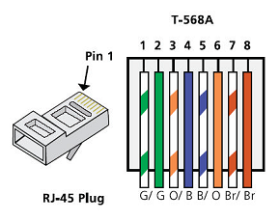
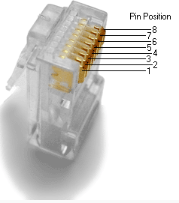
  - Analyze diagrams and tables for the TIA/EIA 568-B standard Ethernet cable.
The following table and diagram display the color scheme and pinouts for the 568-B standard.
568-B 10/100/1000-BaseTX Ethernet
Pin Number | Pair Number | Wire Color | 10Base-T Signal  100Base-TX Signal | 1000Base-T Signal
1 | 2 | White/Orange | Transmit | BI_DA+
2 | 2 | Orange | Transmit | BI_DA-
3 | 3 | White/Green | Receive | BI_DB+
4 | 1 | Blue | Not Used | BI_DC+
5 | 1 | White/Blue | Not Used | BI_DC-
6 | 3 | Green | Receive | BI_DB-
7 | 4 | White/Brown | Not Used | BI_DD+
8 | 4 | Brown | Not Used | BI_DD-
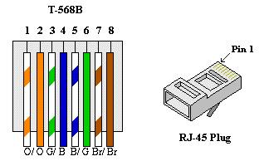

- Build an Ethernet Crossover Cable
A crossover cable has the second and third pairs on the RJ-45 connector at one end, reversed at the other end (refer to the table in Part 1, Step 2). The cable pinouts are the 568-A standard on one end and the 568-B standard on the other end. The two following diagrams illustrate this concept.
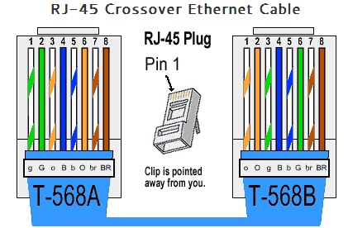
  - Build and terminate a TIA/EIA 568-A cable end.
    - Determine the cable length required. (Your instructor will let you know the cable length you should make.)
Note: If you were making a cable in a production environment, the general guideline is to add another 12 in. (30.48 cm) to the length.
    - Cut off a piece of cable to the desired length and using your wire stripper, remove 5.08 cm (2 in.) of the cable jacket from both ends.
    - Hold the four pairs of twisted cables tightly where the jacket was cut away. Reorganize the cable pairs into the order of the 568-A wiring standard. Refer to the diagrams, if necessary. Take as much care as possible to maintain the twists in the cable; this provides noise cancellation.
    - Flatten, straighten, and line up the wires using your thumb and forefinger.
    - Ensure that the cable wires are still in the correct order for the 568-A standard. Using your wire cutters, trim the four pairs in a straight line to within 1.25 to 1.9 cm (1/2 to 3/4 in.).
    - Place an RJ-45 connector on the end of your cable, with the prong on the underside pointing downward. Firmly insert the wires into the RJ-45 connector. All wires should be seen at the end of the connector in their proper positions. If the wires are not extending to the end of the connector, take the cable out, rearrange the wires as necessary, and reinsert the wires back into the RJ-45 connector.
    - If everything is correct, insert the RJ-45 connector with cable into the crimper. Crimp down hard enough to force the contacts on the RJ-45 connector through the insulation on the wires, thus completing the conducting path. See the following diagram for an example.
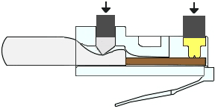
  - Build and terminate a TIA/EIA 568-B cable end.
Repeat steps 1a to 1g using the 568-B color wiring scheme for the other end.
- Test an Ethernet Crossover Cable
  - Test the cable.
Many cable testers will test for length and mapping of wires. If the cable tester has a wire map feature, it verifies which pins on one end of the cable are connected to which pins on the other end.
If your instructor has a cable tester, test the crossover cable for functionality. If it fails, check with your instructor first as to whether you should re-cable the ends and re-test.
  - Connect two PCs together via NICs using your Ethernet crossover cable.
    - Working with a lab partner, set your PC to one of the IP addresses shown in the Addressing Table (see page 1). For example, if your PC is PC-A, your IP address should be set to 192.168.10.1 with a 24-bit subnet mask. You partner’s IP address should be 192.168.10.2. The default gateway address can be left empty.
    - Using the crossover cable you made, connect the two PCs together via their NICs.
    - On the PC-A command prompt, ping the PC-B IP address.
Note: The Windows firewall may have to be temporarily disabled for pings to be successful. If the firewall is disabled, make sure you re-enable it at the conclusion of this lab.
    - Repeat the process and ping from PC-B to PC-A.
Assuming IP addressing and firewall are not issues, your pings should be successful if the cables were properly made.
Reflection
  - Which part of making cables did you find the most difficult?
I found trying to keep the wires in the same order when trying to insert them into the RJ-45 connector, they kept falling out of order when trying to push them in. Trimming the cables once they were in order seemed to help keep that order when inserting them into the connector. I also found that pairing the cables up helped keep them in order.
  - Why do you have to learn how to make a cable if you can easily buy pre-made cables?
Making your own cable allows you to customize the length of it to suit the needs for what it’s required for. Pre made cables are also tested before use, giving assurance that the cable will function correctly.

Ethernet Cable Standards

By Gareth Evans

Introduction

Ethernet cables are used to connect network devices, for example a router to a switch, as long as the device has an ethernet interface. These cables are sorted by specification into numbered categories (CAT) which manufacturers must abide to, allowing us to know what type of cables are needed for a situation [1]. This report is going to look at the Ethernet cable standards of two different categories, Cat 5e and Cat 6.

How Ethernet Cables work

Within an ethernet cable is a pair of twisted wires. Twisting the wires allows for the current to travel in both directions, ensuring travelling data does not get interrupted. Earlier cables would be Unshielded Twisted Pairs (UTP) which had no foil to shield the wires, making it more suitable for shorter distances between devices. Shielded Twisted Pairs (STP) are enclosed in foil, meaning they are less likely to experience interference and can transfer data at faster speeds than UTP [2]

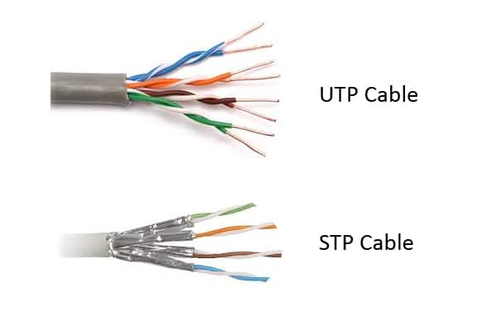
Figure 1 UTP vs STP, showing the difference in shielding [4]

CAT 5E Standards

CAT 5E is short for Category 5 Enhanced due to its higher performance than the previous CAT 5 cables. It can be used in ethernet, fast ethernet and gigabit ethernet networks, meaning it can support up to 1000mbps. It can only travel up to 100 metres and supports a bandwidth of up to 100MHz. It is preferred to CAT 5 as it is less at risk from interference, meaning better performance. CAT 5E is limited to UTP cables, meaning compared to CAT 6 it is still more at risk from interference due to the cables not being encased in foil. CAT 5E cables use the standard RJ45 connector and is currently the most commonly use ethernet cables used today. [3]

CAT 6 Standards

CAT 6 cables also use RJ45 connectors, meaning they are similar in appearance to CAT 5E cables, however they offer a greater bandwidth of up to 250MHz. Similar to CAT 5e, CAT 6 can travel up to 100 metres. It can also offer speeds of up to 10gbps, meaning CAT 6 is currently more aimed at industrial use. Improvements such as the ability to utilise UTP and STP allow for greater performance, whilst the wires within the cable are more tightly wound, usually containing two or more twists per cm. CAT 6 cables also include a “separator” that further reduces interference between the cables by isolating them [3]. Figure 2 below is a table that shows the fundamental differences between CAT 5E and CAT 6 standards, highlighting the improvements that would be seen by using CAT 6 cables.
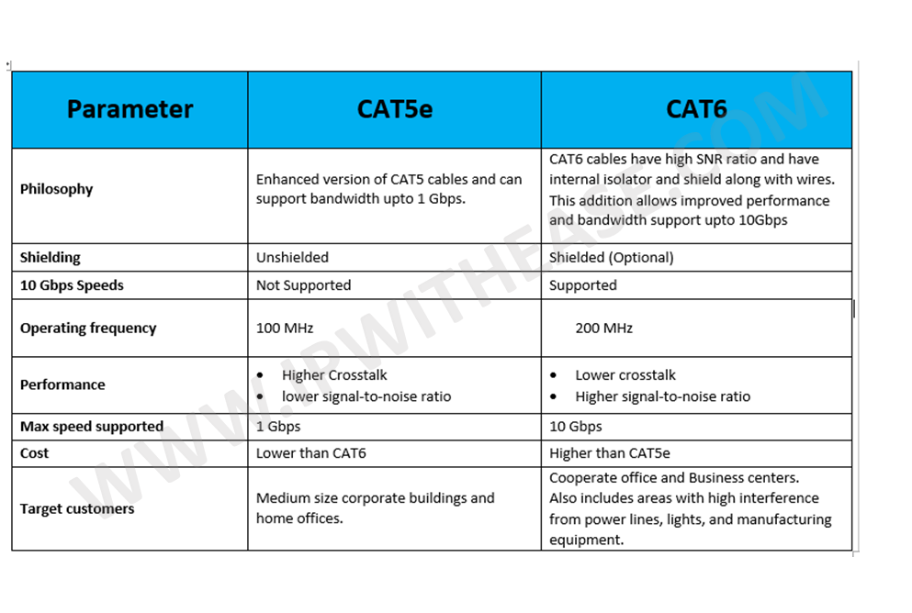
Figure 2 CAT 5E vs CAT 6 [5]

Conclusion

CAT 6 cables demonstrate a higher performance compared to Cat 5E cables, providing faster speed capabilities and offering more protection against interference. However, CAT 5E is more suitable for home use and medium offices and is cheaper than CAT 6, meaning those who design the infrastructure are more likely to opt for it. CAT 6 will become more popular as demand for it goes up, however it will still only be seen in large corporate offices for the time being.

References

[1] | J. Garrison, “What Kind of Ethernet Cable Should I Use?,” howtogeek, 13 December 2016. [Online]. Available: https://www.howtogeek.com/70494/what-kind-of-ethernet-cat-5e6a-cable-should-i-use/. [Accessed 28 Nov 2019].
[2] | Tech Differences, “Difference Between UTP and STP cables,” Tech Differences, 21 Aug 2017. [Online]. Available: https://techdifferences.com/difference-between-utp-and-stp-cables.html. [Accessed 28 11 2019].
[3] | CAT 5 vs CAT 6 Cables, 2018.
[4] | Admin, Fibre Optic Components, 4 Jan 2019. [Online]. Available: http://www.fiber-optic-components.com/shielded-vs-unshielded-ethernet-cable-use.html. [Accessed 28 11 2019].
[5] | IP With Ease, Oct 2017. [Online]. Available: https://ipwithease.com/cat5e-vs-cat6/. [Accessed 29 Nov 2019].

