Strategic Analysis and Sustainable Strategy Development:
Tesla
Module: BMBM6024 Strategic Management and Sustainability
Company selected: Tesla, Inc.
Referencing style: Harvard
Prepared date: 25 March 2026

Tesla Strategic Analysis Report
Executive Summary
Tesla still holds a significant strategic position in the global transformation of automobiles to electric vehicles. However, the current competitive market environment is much more severe than before. The external environment as a whole remains favorable: the demand for electric vehicles is on the rise, battery costs are continuously decreasing, and policies in various countries support the electrification of automobiles. Nevertheless, these factors simultaneously intensify industry competition, presenting Tesla with more severe challenges, price pressure, uncertainties in tariff policies, and diverse tests from the upgrading of consumer demands. (IEA, 2025; Tesla, 2026a).
From an internal structure perspective, Tesla still maintains several core advantages: a unique brand positioning, strong technological strength, a complete system, a vast network of charging stations, customer loyalty, and increasingly important energy generation and storage. However, some of its early advantages are no longer as significant. Tesla's 2025 financial report clearly reveals this contradiction: total revenue dropped to $94.8 billion, the gross margin of its automotive business declined to 17.8%, while the energy generation and storage segment grew more robustly, with a gross margin of 29.8% (Tesla, 2026a).
Tesla is shifting from a focus on a differentiation strategy to a hybrid strategic positioning. This transformation, while expanding the potential market space, relies on price wars that will erode profit margins. The core path for Tesla to achieve sustainable competitive advantages does not lie in merely increasing sales volume, but in deepening the systems of its electric vehicles, enhancing battery cycle utilization, precisely selecting local supply chain solutions, and conducting in-depth research in regulatory compliance, autonomous driving technology, and sustainable development.

1. Introduction
Tesla, Inc. is a US-based company operating across electric vehicles, software-enabled automotive services, charging infrastructure and energy generation and storage. . In practice, Tesla competes not only with car manufacturers, but also with battery producers, clean-energy firms and software-driven mobility platforms. (Johnson et al., 2017; Porter, 2008).
With the development of technology, electric cars are becoming increasingly popular. Figure 1 shows how quickly electric-car sales have increased worldwide. This expansion creates opportunity, but it also changes the basis of competition: scale, cost discipline, charging access, software capability and supply-chain resilience matter more than pioneer status alone. Academic work on Tesla also suggests that the company’s success was never simply about launching a green product; it changed how consumers interpreted electric vehicles in the first place (Thomas and Maine, 2019; Palmié et al., 2024).
The key strategic challenge, Is not whether Tesla helped legitimise electric mobility. It is whether the company can still convert that symbolic and technological advantage into durable profitability in a market where competitors are catching up and sustainability claims fact closer scrutiny.
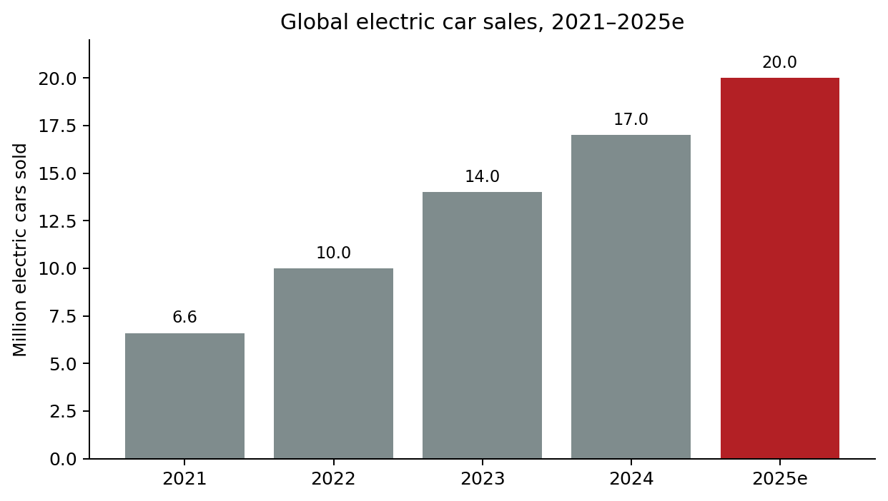
Figure 1. Global electric car sales, 2021–2025e
Source: compiled from IEA (2022, 2023, 2024, 2025). Rounded values are used because the IEA reports describe some annual totals as “about”, “nearly” or “exceeded”; 2025 is an IEA projection.
2. External Analysis
PESTEL analysis
Politically and environmentally, Tesla benefits from the broader push towards decarbonisation. Electric-car sales exceeded 17 million globally in 2024, and the IEA expects sales to pass 20 million in 2025, meaning that the underlying direction of the market remains favourable (IEA, 2025). Yet political support is uneven. Tesla’s own annual report notes that changes in tariffs, tax credits and trade policy can materially affect both demand and costs, particularly in energy storage (Tesla, 2026a). The macro environment is therefore supportive, but far from stable.
Economically, affordability is now central to EV adoption. Lower battery costs and falling EV prices help expand the market, but they also strengthen lower-cost rivals. This matters because the industry is no longer driven mainly by affluent early adopters. Consumer adoption studies show that buyers respond positively to perceived usefulness and ease of use, while cost concerns and perceived risk remain barriers (Jia and Chen, 2021; Pamidimukkala et al., 2024). For Tesla, this means that premium brand power alone is insufficient.
Social and technological trends are mixed in the same way. Demand for cleaner mobility is rising, and Tesla still benefits from a reputation for technological ambition, software integration and over-the-air upgrades. However, technological legitimacy does not remove legal risk. Direct-sales restrictions, regulatory investigation of automation claims and changing safety expectations all complicate strategy. Taken together, the PESTEL analysis suggests that the environment is favourable for EV diffusion but less favourable for effortless value capture.
Porter’s Five Forces and key economic trends
Porter’s Five Forces indicate a market with strong long-run growth but declining ease of profitability. Rivalry is high because major incumbents, EV specialists and Chinese manufacturers are contesting similar segments, often through price cuts and accelerated product launches. Buyer power has also risen because switching options are widening. Supplier power remains moderate to high because battery materials, cells and semiconductors are strategically sensitive and geographically concentrated, despite falling battery-pack prices (Porter, 2008; Barman et al., 2023).
The threat of entry is not negligible. Automotive manufacturing still requires scale, capital and execution discipline, yet Tesla’s own history proves that industry boundaries can be disrupted when new firms combine engineering innovation with new business models. The threat of substitutes remains moderate because hybrids, efficient ICE vehicles and alternative mobility models still compete for consumer budgets. Overall, the most important economic trend is this: volume growth in electric mobility continues, but margin protection is getting harder. That trend directly shapes Tesla’s strategic choices.
3. Internal Analysis
RBV / VRIO
From a resource-based perspective, Tesla’s most important assets are not simply factories or assembly capacity. Its more distinctive resources are system-based: its software architecture, connected-vehicle data, charging ecosystem, direct-to-customer interface, brand equity and the organisational ability to combine automotive and energy businesses under one strategic logic. The company also continues to emphasise vertical integration, AI capability and infrastructure build-out as central strengths (Tesla, 2026a).
Under a VRIO lens, these resources are clearly valuable because they support both differentiation and operational learning. Some remain relatively rare, especially where Tesla combines hardware, software, charging and service into a single experience. They are also costly to imitate in full because competitors can copy isolated features faster than they can reproduce the whole ecosystem. This helps explain why Tesla has had an influence on consumer perceptions beyond its market share. Palmié et al. (2024) argue that Tesla altered public evaluations of sustainable innovation by redesigning what buyers valued in electric vehicles. Thomas and Maine (2019) likewise show that Tesla’s early market-entry strategy involved deliberate sequencing rather than simple technological disruption.
Even so, RBV analysis also shows where Tesla’s advantage is weakening. Manufacturing scale in EVs is no longer rare in the way it once was, and Tesla’s 2025 numbers show that strong sales volumes do not automatically translate into stronger automotive margins. Some of Tesla’s resources still generate sustained advantage, but others now look closer to competitive parity.
Value chain and SWOT/TOWS implications
Tesla’s value chain highlights why its strengths are not confined to product design. Upstream, the firm continues to localise procurement, invest in battery technologies and integrate more activities internally. In operations, the Gigafactory model supports scale economies and faster coordination between engineering and production. Downstream, Tesla’s direct-sales model, app-based relationship, mobile service, remote diagnostics and charging network reduce dependence on dealers and preserve customer data and service contact (Tesla, 2026a).
However, the same value chain also creates pressure points. As Tesla itself recognises, rising output must be matched by delivery capability, service capacity and charging-network expansion; otherwise, infrastructure becomes the bottleneck rather than the advantage. Battery supply-chain sustainability raises a second challenge. Recent studies argue that long-term EV competitiveness increasingly depends on traceability, critical-mineral access, recycling pathways and circular business models rather than on assembly economics alone (Gebhardt et al., 2022; Jannesar Niri et al., 2024; Xu et al., 2026).
The SWOT/TOWS implications are summaried in Table 1. The central point is that Tesla’s best opportunities arise when it uses internal capabilities to exploit structural shifts in energy storage, software and infrastructure. The biggest danger is that it allows vehicle price competition to erode the returns that fund those capabilities.
Strengths  Brand; software and OTA updates; direct sales and service; large charging network; growing energy-storage business. | Weaknesses  Automotive margin pressure; narrower vehicle range; regulatory and execution exposure; reliance on ecosystem monetisation.
Opportunities  Energy-storage expansion; software and service revenue; selective international growth; circular battery strategy. | Threats  Price rivalry; tariffs and policy reversals; stronger Chinese competition; critical-mineral concentration; scrutiny of sustainability claims.
Table 1. Condensed SWOT/TOWS summary for Tesla
Source: author synthesis based on Tesla (2026a), IEA (2025), and the academic literature cited in the report.
4. Strategy Formulation and Competitive Positioning
Strategy Clock
Tesla’s current strategic position is best understood through the Strategy Clock rather than through a simple premium-versus-cost dichotomy. In its early years, Tesla clearly occupied focused differentiation and then broader differentiation: it sold performance, design and status alongside sustainability. That mattered because it reframed electric vehicles from compromise products into desirable ones (Palmié et al., 2024).
Today, though, Tesla sits closer to a hybrid position. It still relies on differentiated features such as software functionality, charging access, AI branding and ecosystem convenience, but it has also pursued affordability, production efficiency and broader market reach. In theory, a hybrid strategy can be powerful because it combines acceptable price with strong perceived value. In practice, it is difficult to sustain when competitors can also lower prices. Tesla’s declining automotive gross margin suggests that hybrid positioning works only if ecosystem revenue and operational efficiencies offset weaker vehicle pricing (Tesla, 2026a).
Ansoff’s Matrix and M&A
Ansoff’s Matrix points towards three realistic routes for Tesla. First, market development remains important because EV adoption is spreading across more geographies, including emerging economies where affordability and infrastructure are decisive (IEA, 2025). Second, product development is central: Tesla refreshed the Model Y, expanded software-enabled offerings and continued scaling energy-storage products and Robotaxi-related services in 2025 (Tesla, 2026a). Third, related diversification already forms part of Tesla’s logic because the firm links vehicles, charging, storage and software within a shared platform.
Large-scale transformational M&A appears less attractive. Tesla has historically built advantage through capability development and selective integration rather than blockbuster acquisition. In a turbulent sector, major M&A could dilute focus and create integration risk. A more suitable approach would be selective capability acquisition or partnership around battery recycling, AI infrastructure or regional supply-chain resilience. In short, the company’s next phase of growth should remain adjacent and capability-led rather than acquisitive for its own sake (Ansoff, 1957).
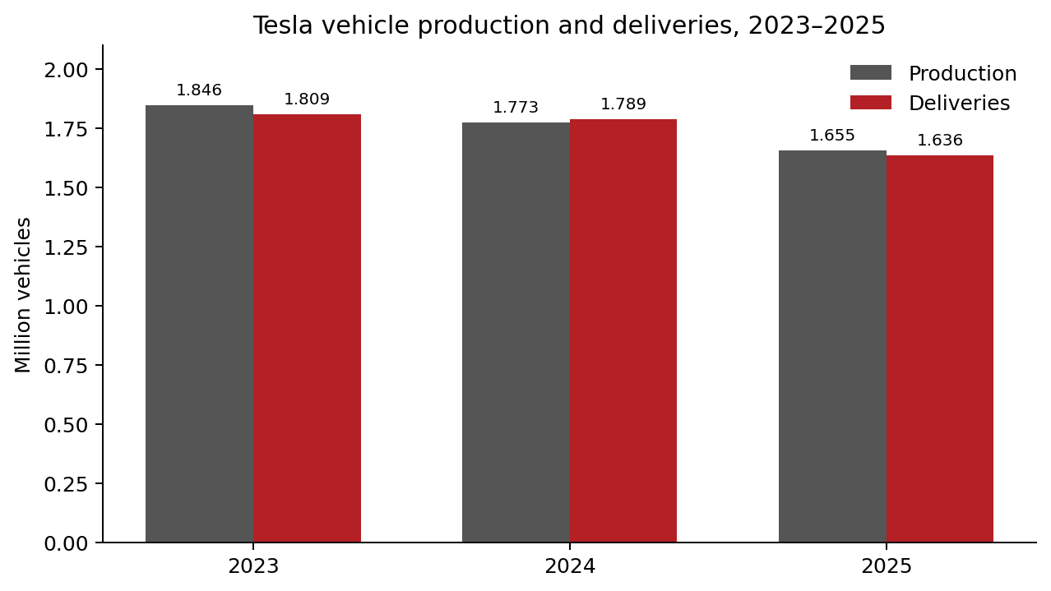
Figure 2. Tesla vehicle production and deliveries, 2023–2025
Source: compiled from Tesla investor relations production and delivery releases for Q4 2023, Q4 2024 and Q4 2025 (Tesla, 2024; Tesla, 2025b; Tesla, 2026b).
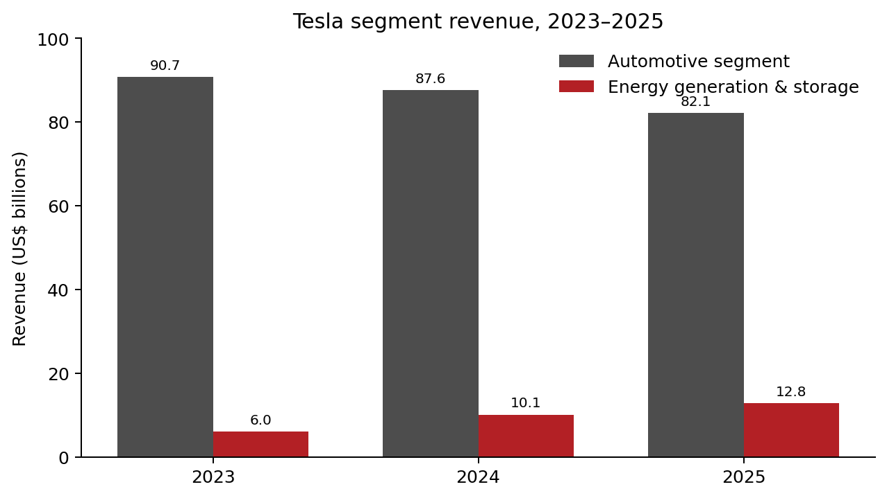
Figure 3. Tesla segment revenue, 2023–2025
Source: Tesla (2026a), segment disclosures for the years ended 31 December 2023, 2024 and 2025.
5. Sustainability and Strategic Recommendations
Tesla’s sustainability position is strategically important, but it should not be treated as beyond criticism. On the positive side, the company is directly linked to transport electrification and energy-system transition. Tesla states that in 2024 its customers avoided nearly 32 million metric tons of CO2e, while the energy generation and storage segment continues to grow faster than the automotive business (Tesla, 2025a; Tesla, 2026a). These claims strengthen the company’s legitimacy and support brand differentiation.
However, the academic literature is much more cautious than corporate reporting. Reviews of EV adoption and sustainability show that environmental gains depend on electricity mix, charging patterns, lifecycle accounting and supply-chain practices, not simply on whether a vehicle is electric (Tilly et al., 2024; Zaino et al., 2024). Battery-related research also highlights significant concerns around critical materials, geographic concentration, labour conditions and end-of-life management (Barman et al., 2023; Jannesar Niri et al., 2024). This means Tesla’s sustainability narrative remains credible, but only conditionally so.
Four recommendations follow. First, Tesla should reduce its dependence on vehicle price cuts and deepen ecosystem monetisation through software subscriptions, charging, insurance, servicing and energy integration. Second, it should accelerate a traceable circular-battery strategy built around supplier transparency, recycling partnerships and second-life use, because circularity is becoming a strategic capability rather than a peripheral CSR issue (Gebhardt et al., 2022; Xu et al., 2026). Third, Tesla should internationalise selectively through more localised production and sourcing in priority markets, while developing a genuinely lower-cost platform instead of relying mainly on price erosion within existing models. Fourth, it should strengthen governance and regulatory credibility around automation, labour and sustainability reporting. In the next phase of competition, legitimacy is not separate from advantage; it is part of advantage.
6. Conclusion
Tesla remains a strategically powerful firm, but the basis of that power is changing. The company no longer competes mainly as a pioneering EV manufacturer. It competes as an ecosystem business in a market where scale has become normal, prices are contested and sustainability claims are tested more carefully. External analysis shows that electric mobility still offers strong growth, yet the profitability structure of the industry is becoming tougher. Internal analysis suggests that Tesla still holds meaningful advantages in software, charging, infrastructure integration and energy storage, but not all of these are equally rare or equally secure.
The report therefore concludes that Tesla’s future advantage depends less on being first and more on being difficult to replicate at system level. A credible hybrid strategy is possible, but only if ecosystem revenues, circular supply chains and stronger governance support it. In a sustainable business environment, strategic management matters because market growth by itself does not guarantee durable competitive advantage.
References
Ansoff, H.I. (1957) ‘Strategies for diversification’, Harvard Business Review, 35(5), pp. 113–124.
Barney, J. (1991) ‘Firm resources and sustained competitive advantage’, Journal of Management, 17(1), pp. 99–120.
Barman, P., Dutta, L. and Azzopardi, B. (2023) ‘Electric Vehicle Battery Supply Chain and Critical Materials: A Brief Survey of State of the Art’, Energies, 16(8), 3369.
Gebhardt, M., Beck, J., Kopyto, M. and Spieske, A. (2022) ‘Determining requirements and challenges for a sustainable and circular electric vehicle battery supply chain: A mixed-methods approach’, Sustainable Production and Consumption, 33, pp. 203–217.
IEA (2022) Global EV Outlook 2022. Paris: International Energy Agency.
IEA (2023) Global EV Outlook 2023. Paris: International Energy Agency.
IEA (2024) Global EV Outlook 2024. Paris: International Energy Agency.
IEA (2025) Global EV Outlook 2025. Paris: International Energy Agency.
Jannesar Niri, A., Poelzer, G.A., Zhang, S.E., Rosenkranz, J., Pettersson, M. and Ghorbani, Y. (2024) ‘Sustainability challenges throughout the electric vehicle battery value chain’, Renewable and Sustainable Energy Reviews, 191, 114176.
Jia, W. and Chen, T.D. (2021) ‘Are individuals’ stated preferences for electric vehicles (EVs) consistent with real-world EV ownership patterns?’, Transportation Research Part D: Transport and Environment, 93, 102728.
Johnson, G., Whittington, R., Scholes, K., Angwin, D. and Regnér, P. (2017) Exploring Strategy. 11th edn. Harlow: Pearson.
Mamkhezri, J. (2025) ‘Public preferences for battery electric vehicle policies considering energy mix: A US choice experiment study’, Energy Economics, 143, 108210.
Palmié, M., Miehé, L., Mair, J. and Wincent, J. (2024) ‘Valuation entrepreneurship through product-design and blame-avoidance strategies: How Tesla managed to change the public perception of sustainable innovations’, Journal of Product Innovation Management, 41(3), pp. 644–676.
Pamidimukkala, A., Kermanshachi, S., Rosenberger, J.M. and Hladik, G. (2024) ‘Adoption of electric vehicles: An empirical study of consumers’ intentions’, Transport Economics and Management, 2, pp. 359–366.
Porter, M.E. (2008) ‘The five competitive forces that shape strategy’, Harvard Business Review, 86(1), pp. 78–93.
Tesla, Inc. (2024) ‘Tesla Vehicle Production & Deliveries and Date for Financial Results & Webcast for Fourth Quarter 2023’, press release, 2 January.
Tesla, Inc. (2025a) Impact Report 2024. Austin, TX: Tesla, Inc.
Tesla, Inc. (2025b) ‘Tesla Fourth Quarter 2024 Production, Deliveries & Deployments’, press release, 2 January.
Tesla, Inc. (2026a) Annual Report 2025 (Form 10-K). Austin, TX: Tesla, Inc.
Tesla, Inc. (2026b) ‘Tesla Fourth Quarter 2025 Production, Deliveries & Deployments’, press release, 2 January.
Thomas, V.J. and Maine, E. (2019) ‘Market entry strategies for electric vehicle start-ups in the automotive industry – Lessons from Tesla Motors’, Journal of Cleaner Production, 235, pp. 653–663.
Tilly, N., Yigitcanlar, T., Degirmenci, K. and Paz, A. (2024) ‘How sustainable is electric vehicle adoption? Insights from a PRISMA review’, Sustainable Cities and Society, 117, 105950.
Xu, M., Duong, Q.H., Arranz, C.F.D.A., Sun, W. and Zhou, L. (2026) ‘Developing a holistic circular business model framework for the EV battery closed-loop supply chain: A data-driven approach’, Technovation, 152, 103487.
Zaino, R., Ahmed, V., Alhammadi, A.M. and Alghoush, M. (2024) ‘Electric Vehicle Adoption: A Comprehensive Systematic Review of Technological, Environmental, Organizational and Policy Impacts’, World Electric Vehicle Journal, 15(8), 375.

