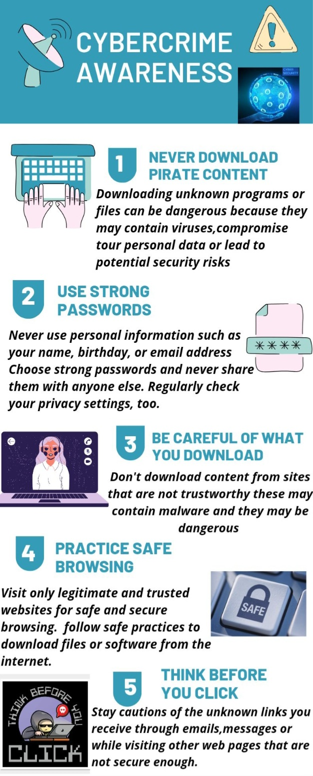
CERT HE BUSINESCERT HE S SKILLS FOR THE WORKPLACE TASK 2.
What is cybercrime?
Cybercrime is criminal activity that either targets or uses a computer, a computer network or a networked device. Most cybercrime is committed by cybercriminals or hackers who want to make money. However, occasionally cybercrime aims to damage computers or networks for reasons other than profit. These could be political or personal.

Cybercrime can be carried out by individuals or organizations. Some cybercriminals are organized, use advanced techniques and are highly technically skilled. Others are novice hackers.

What are the types of cybercrime?
Types of cybercrime include:

Email and internet fraud.
Identity fraud (where personal information is stolen and used).
Theft of financial or card payment data.
Theft and sale of corporate data.
Cyberextortion (demanding money to prevent a threatened attack).
Ransomware attacks (a type of cyberextortion).
Cryptojacking (where hackers mine cryptocurrency using resources they do not own).
Cyberespionage (where hackers access government or company data).
Interfering with systems in a way that compromises a network.
Infringing copyright.
Illegal gambling.
Selling illegal items online.
Soliciting, producing, or possessing child pornography.
Cybercrime involves one or both of the following:

Criminal activity targeting computers using viruses and other types of malware.
Criminal activity using computers to commit other crimes.
Cybercriminals that target computers may infect them with malware to damage devices or stop them working. They may also use malware to delete or steal data. Or cybercriminals may stop users from using a website or network or prevent a business providing a software service to its customers, which is called a Denial-of-Service (DoS) attack.

Cybercrime that uses computers to commit other crimes may involve using computers or networks to spread malware, illegal information or illegal images.

Cybercriminals are often doing both at once. They may target computers with viruses first and then use them to spread malware to other machines or throughout a network. Some jurisdictions recognize a third category of cybercrime which is where a computer is used as an accessory to crime. An example of this is using a computer to store stolen data.

