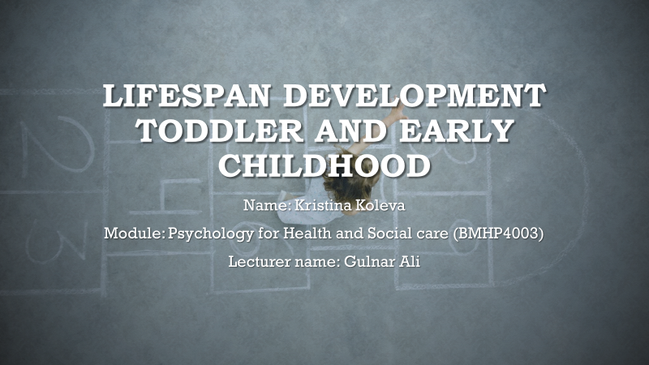
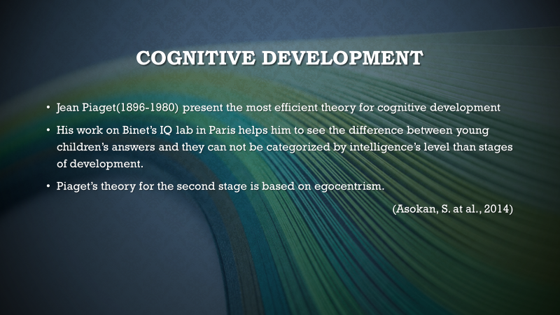
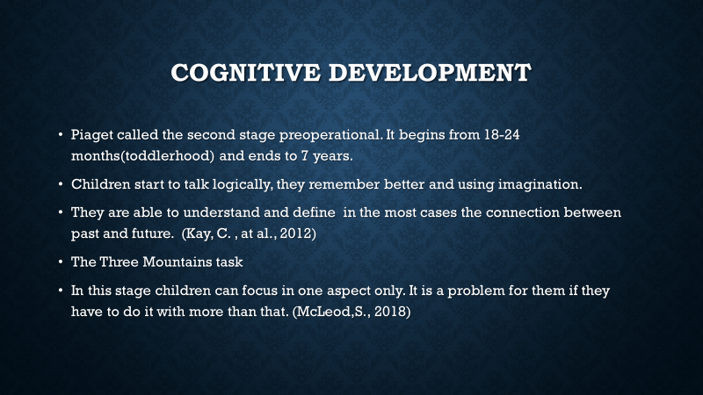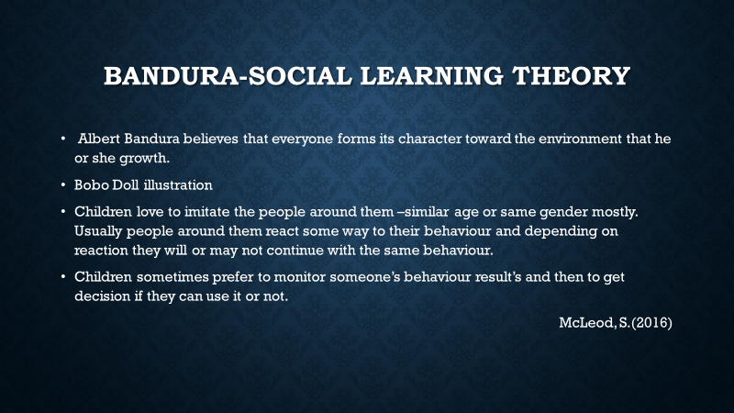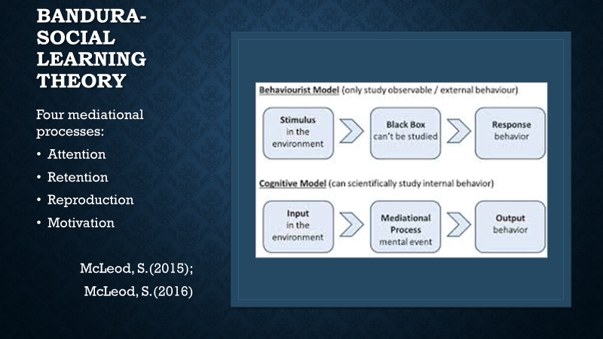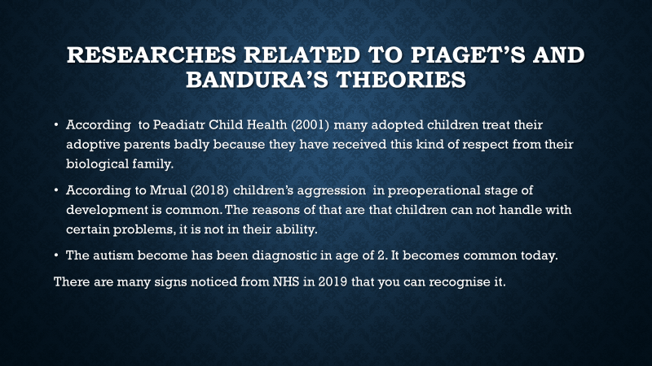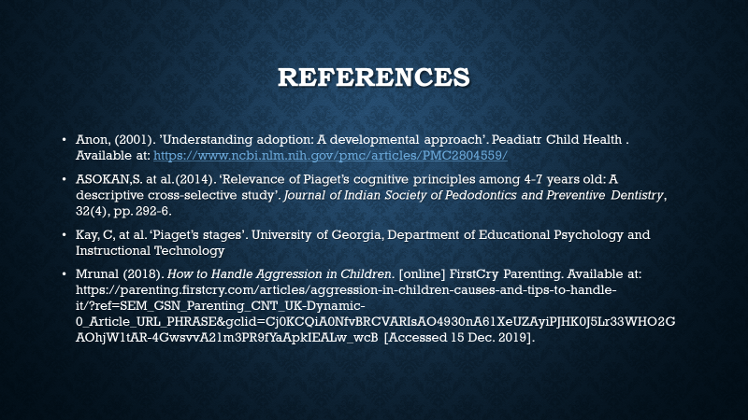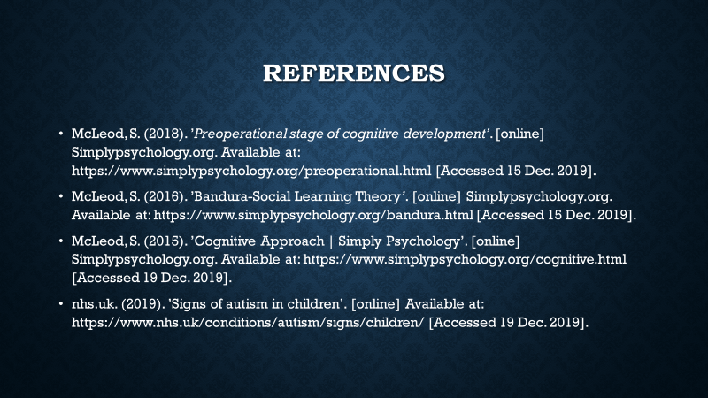

Lifespan Development
Toddler and early childhood
Name: Kristina Koleva
Module: Psychology for Health and Social care (BMHP4003)
Lecturer name: Gulnar Ali
Report

Jean Piaget-Cognitive Development 2-7 years old
I choose cognitive development of age between 2 and 7 years old because I am working with children at that age. For me children in this age are so cute and in the same time they can be absolutely devils. In my country people say that this is the most important period of development. Everyone has formed his or her character till this age.
The swiss Jean Piaget explains in detail the theory of cognitive development. He first noticed that children respond differently depending of their stage of development and not so much on the intellectual level. According his theory there are 4 stages of cognitive development: sensorimotor stage (0-2), preoperational stage (2-7), concrete operational stage (7-11) and formal operational stage (12 and up). The stage that I want to describe more in details is the preoperational stage. This is a stage of egocentrism. It lies on the fact that someone cannot understand the other’s view, or he/she is incapable of accepting a different one (Asokan, S.at al,2014).
Preoperational stage defines the development of children from 18-24 months to 7 years of age. In this stage children can use their imagination, enrich their language and start thinking rationally. They can understand and define in the most cases the connection between past and future (Kay, C. at al., 2012).
One of the methods Piaget to shows children’s egocentrism is the three mountains task. There are three mountains with different shapes and size. He chooses children of different ages and allows them to look and analyse what they can see. There is a doll in the other side of the mountains. He shows them different pictures and ask to find the doll’s view. Children between 3 and 6 years old are sure that doll see what they see. This completely confirms the theory that at this age children are egocentric. Only 7 years old child can give the correct answer.
In this stage children can focus in one aspect only. It is a problem for them if they must do it with more than that. (McLeod,S., 2018)
Bandura’s social learning theory
Albert Bandura thinks that children copy behaviour of people from the surrounding environment. He uses the Bobo Doll illustration to prove his theory. For his research he uses children between 3 and 6 years old. They watch a video with person who become nasty with the doll. He kicks it, bang it, tosses it, etc. And using his norms of behaviour children repeat the same. Children love to imitate the people around them –similar age or same gender mostly. Usually people around them react some way to their behaviour and depending on reaction they will or may not continue with the same behaviour. Children sometimes prefer to monitor someone’s behaviour result’s and then to get decision if they can use it or not. (McLeod, S.,2016)
Mediational Process- In behaviourist model has been proven that only external processes can be investigate and internal processes cannot be investigated, because it is not possible to know what is happened in somebody’s mind. Cognitive model can be research as internal behaviour. It is same as computer processor. Information arrives as input, the mind sort it out and then it is saved to be reviewed and processed later. ‘The mediational (i.e., mental) event could be memories, perception, attention or problem solving, etc. These are known as mediational processes because they mediate (i.e., go-between) between the stimulus and the response. They come after the stimulus and before the response.
Therefore, cognitive psychologists’ say if you want to understand behaviour, you have to understand these mediational processes.’ (McLeod, S.,2015)
Bandura thinks that there are four mediational processes: attention, retention, reproduction and motivation. We monitor every day many behaviours, but it does not mean that we are going to copy each of them. It must be interesting for us to be noticed by us. The attention is one of the most important. The other step is retention. Someone reaction can be seen by us, but it cannot be remembered. This mean they cannot be copy. The reproduction is a skill and not everyone can complete it. This is ability to copy somebody’s behaviour in the same way it is presented. For example, a 90 years old lady watching Dancing on Ice and she is trying to do the same but in fact her ability does not allow her to achieve the same result. Motivation is the fourth process. This is the desire to achieve the certain behaviour. If it is interesting enough for the observer, he will repeat it, if not it can be probably forgotten (McLeod, S.,2015).
Peadiatr Child Health (2001) made research between adopted children and they found that many of them do not treat their adoptive parents well. They are becoming nasty with them. This is because their birth parents were rude with them or because they are trying to protect themselves from new disappointment.
Another study by Mrual in 2018 shows that children’s aggression in preoperational stage of development is comment today and it increase. The reason of that fact is that so many children can not find the way to handle with certain problems. They are not able to do that, and this is their way to show to people around him or her that they need of help.
The autism become has been diagnostic in age of 2. It becomes common today. There are many signs noticed from NHS in 2019 that you can recognise it. Children are not able to respond when you call them, they eye contact should be avoided, they are not speaking as same as the children at their age, repeating the same words many times, they have a different reaction when they do not like something, etc.

References

Anon, (2001). ’Understanding adoption: A developmental approach’. Peadiatr Child Health.Available at: https://www.ncbi.nlm.nih.gov/pmc/articles/PMC2804559/
ASOKAN,S. at al.(2014). ‘Relevance of Piaget’s cognitive principles among 4-7 years old: A descriptive cross-selective study’. Journal of Indian Society of Pedodontics and Preventive Dentistry, 32(4), pp. 292-6.
Kay, C, at al. ‘Piaget’s stages’. University of Georgia, Department of Educational Psychology and Instructional Technology
Mrunal (2018). How to Handle Aggression in Children. [online] FirstCry Parenting. Available at: https://parenting.firstcry.com/articles/aggression-in-children-causes-and-tips-to-handle-it/?ref=SEM_GSN_Parenting_CNT_UK-Dynamic-0_Article_URL_PHRASE&gclid=Cj0KCQiA0NfvBRCVARIsAO4930nA61XeUZAyiPJHK0J5Lr33WHO2GAOhjW1tAR-4GwsvvA21m3PR9fYaApkIEALw_wcB [Accessed 15 Dec. 2019].
McLeod, S. (2018). ’Preoperational stage of cognitive development’. [online] Simplypsychology.org. Available at: https://www.simplypsychology.org/preoperational.html [Accessed 15 Dec. 2019].
McLeod, S. (2016). ’Bandura-Social Learning Theory’. [online] Simplypsychology.org. Available at: https://www.simplypsychology.org/bandura.html [Accessed 15 Dec. 2019].
McLeod, S. (2015). ‘Cognitive Approach | Simply Psychology’. [online] Simplypsychology.org. Available at: https://www.simplypsychology.org/cognitive.html [Accessed 19 Dec. 2019].
nhs.uk. (2019). ‘Signs of autism in children’. [online] Available at: https://www.nhs.uk/conditions/autism/signs/children/ [Accessed 19 Dec. 2019].

