Advanced Chemistry Applications in Ordnance, Munitions and Explosives: Group Presentation and Technical Summary
ACDA6020

Contents
Introduction 1
Importance of Crystal Properties to Energetic Materials 4
Crystal Formation 4
Sensitivity 6
Performance 9
Conclusion 10
References 11

Introduction
The purpose of this assignment is to detail the author’s contribution and understanding of crystallography in relation to a presentation on the subject of Polymer Bonded Explosives (PBXs), delivered on 28 November 2025. Due to the challenging nature of the subject, the author concluded that it would have been more advantageous to present a concise question set detailing how crystallography influences OME and specifically PBXs. Those questions would have consisted of the following:

- What are crystals?
- What is their relevance to OME?
- Why do they form?
- What examples are there in OME?
- What threats do they pose?
- How can this be managed within an in-service context?

The following will detail the application of crystallography to energetic materials within the context of PBXs, with references made to the presentation slides delivered by the author and additional material researched as part of this assignment.

To begin it is worth defining what is meant by the following foundational concepts which can vary between literature, but they appear to capture the following concepts:

- Crystal: with reference to Figure 1, which demonstrates the coffin structure of crystal TNT, it can be seen that there is a clearly defined regular structure. A simplified definition can be condensed down to:

  - ‘Crystalline solids are those solids in which the molecules or ions in the particles of the solid are arranged in a small repeating volumetric unit, referred to as the unit cell, throughout the whole of the particle.’ [1]

Figure 1 - The coffin crystalline structure of TNT [2]
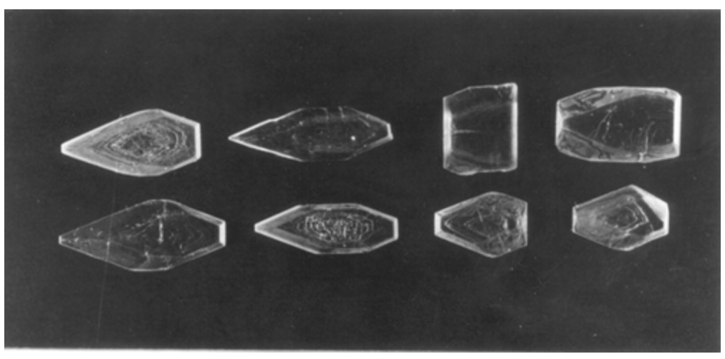

- Polymorph: a solid crystalline phase of a given compound resulting from the possibility of at least two different arrangements of the molecules of that compound in the solid state [3]. Polymorphism is common in crystalline materials including energetics and can be demonstrated in the different forms of HMX in Figure 2.

Figure 2 - Polymorphism of HMX
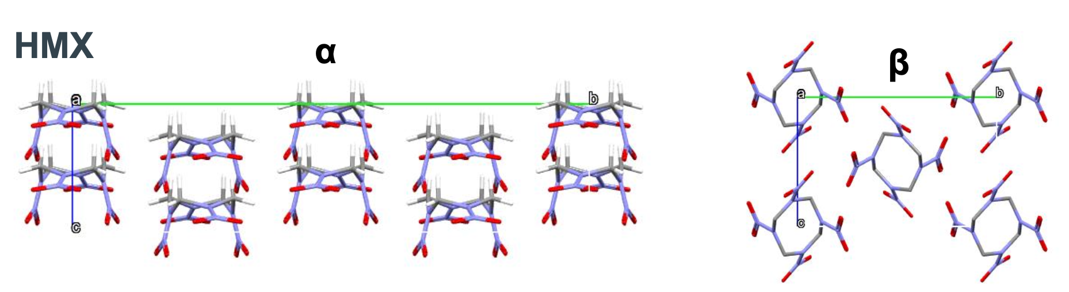

- Conformer: molecules that can be interconverted by rotation around a single bond (Figure 3).

Figure 3 - Conformers of HNIW/CL-20
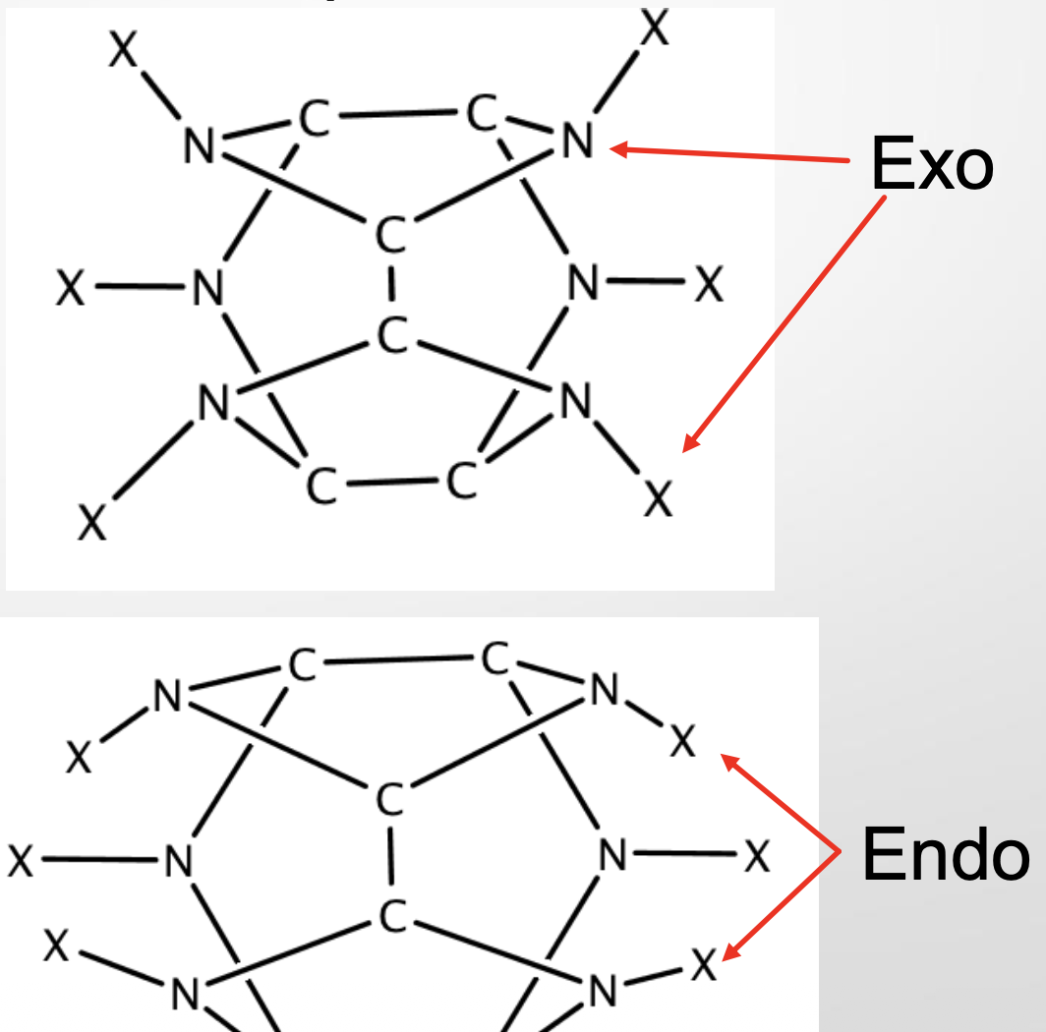

Before exploring why an energetic crystal structure would influence OME, it is first worth answering why would a substance/s form into a crystalline structure in the first place? Why would a solution of reactants spontaneously shift from a point of high enthalpy to a position of low enthalpy as found in an organised crystal structure? This can perhaps best be explained by Gibbs Free Energy:

$$∆G= ∆H-T∆S$$

For the crystalline structure to form it requires ΔG to be negative, therefore due to entropy increasing (ΔS is positive) the enthalpy of formation needs to be more negative and/or a temperature change significant enough to result in a net negative value.

It is important to distinguish between those properties which are intrinsic and cannot be altered, to those properties that are controllable. This will enable the generation of energetics with the desired performance characteristics.

Table 1 - Intrinsic and Controllable Crystal Properties
Intrinsic Properties | Controllable Properties
Crystal habit and interfacial angles | Particle size
Refractive index | Particle size distribution
Fracture properties / cleavage planes | Crystal habit / morphology
Melting points | Degree of perfection
Solubility
Densities
Spectroscopic properties

The techniques applied in processing that can generate energetic particles with the desired qualities include:

- Crystallization from solution under controlled conditions (choice of solvent, temperature, and concentration)

- Mechanical processing techniques to physically breakdown the material to the desired particulate size e.g. milling. This will increase the density of the energetic material and thus raise its velocity of detonation.

- Spray crystallisation

- Crystallisation through the rapid expansion of supercritical solutions

- Spheroidization to create smoothed particles with reduced surface defects. Again, this can raise the density of the energetic material and introduce voids which, if desired, can raise the sensitivity of the material.

Importance of Crystal Properties to Energetic Materials

The effect of crystal properties on energetic materials is far reaching, influencing or determining:

- The performance of the energetic which depends on:
  - Crystal density
  - Heat of formation

- The sensitivity of the energetic is heavily dependent on:
  - The arrangement of molecules in the crystal
  - The degree of perfection of the crystals has a significant impact on the behaviour of energetic materials and is detailed within Table 3.

- The processability is dependent upon the crystal size and morphology. This can be seen in Figure 3 and Figure 4, and expanded upon in the following paragraphs.

- Aging / long-term stability / service life

Crystal Formation

It is important to distinguish between those properties which are intrinsic and those properties that are controllable, as this enables the generation of energetics with the desired performance characteristics.

Table 2 - Intrinsic and Controllable Crystal Properties
Intrinsic Properties | Controllable Properties
Crystal habit and interfacial angles | Particle size
Refractive index | Particle size distribution
Fracture properties / cleavage planes | Crystal habit / morphology
Melting points | Degree of perfection
Solubility
Densities
Spectroscopic properties

The techniques applied in processing that can generate energetic particles with the desired qualities include:

- Crystallization from solution under controlled conditions (choice of solvent, temperature, and concentration).

- Mechanical processing techniques to physically breakdown the material to the desired particulate size e.g. milling. This will increase the density of the energetic material and thus raise its velocity of detonation.

- Spray crystallisation – a rapid form of crystal formation from a liquid feed [1].

- Crystallisation through the rapid expansion of supercritical solutions.

- Spheroidization to create smoothed particles with reduced surface defects. Again, this can raise the density of the energetic material and introduce voids which, if desired, can raise the sensitivity of the material [4].

The formation of crystals from a solution is one of the most common methods of producing particles of organic compounds, including energetic material compounds. With reference to the formation of methyl-3-nitrobenzoate crystals from a solution of methyl benzoate and nitric acid (Figure 4, Figure 5), is one that can be considered in successive steps, namely nucleation and the crystal growth step. This is where molecular particles aggregate forming a nucleus which then has the potential to form into macroscopic crystals in the process of crystal growth.

With reference to Figure 4 and Figure 5, there is a clear difference in their structure which has practical implications for energetics. Literature notes that kinetics is the fundamental driver of the nucleation step and drives the quality of the crystal form and quality. It was noted that during the practical exercise to generate the desired crystals, the amorphous form experienced significant thermal cycling above that required and relative to the acicular form.

The morphology has broad implications with amorphous material proving be challenging to process (lack of reproducibility etc); whereas the acicular crystalline form, whilst not suitable for energetics without further modification, is able to be processed by methods such as milling to generate the required form.

Figure 4 – Amorphous morphology of methyl-3-nitrobenzoate
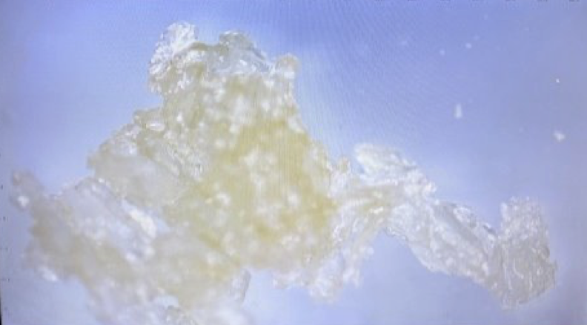

Figure 5 – Acicular morphology of methyl-3-nitrobenzoate


Sensitivity

The degree of crystal perfection has been demonstrated to have far ranging implications in energetics and can be split into two categories: defects and impurities. Defects are found in different forms, ranging from the atomic level with a missing or replaced atom, through to the molecular structure through dislocations and grain boundary disruptions. The friction generated between adjacent crystals particles is not the only mechanism of concern, as detailed in an analysis of the polymorphism exhibited by 2,4,6 trinitrotoluene: …..‘It has been shown to be feasible that dislocation pile-up can cause localised “hot-spots” and can lead to premature detonation’ [4].

Table 3 - The effect of Defects and Impurities on a Crystal Structure
The effect of defects | The effect of impurities
Crystal growth | Crystal growth
Mechanical properties | Stability
Initiation sites | Intrinsic properties such as melt temperature

From Figure 6 it can be seen that a crystalline material can exist in multiple different forms (polymorphs) above its most stable state, and are termed metastable. It can be further seen that the metastable forms exist due to there being no energetically available pathway for the polymorphs to transition into the thermodynamically most stable state. This can be further detailed in the Ostwald Rule of Stages [1], which can be seen from Figure 6 to display equivalency to the Arrhenius equation:

$$k=Ae^{\frac{-Ea}{RT}}$$

Figure 6 - Different polymorphs due to different phases
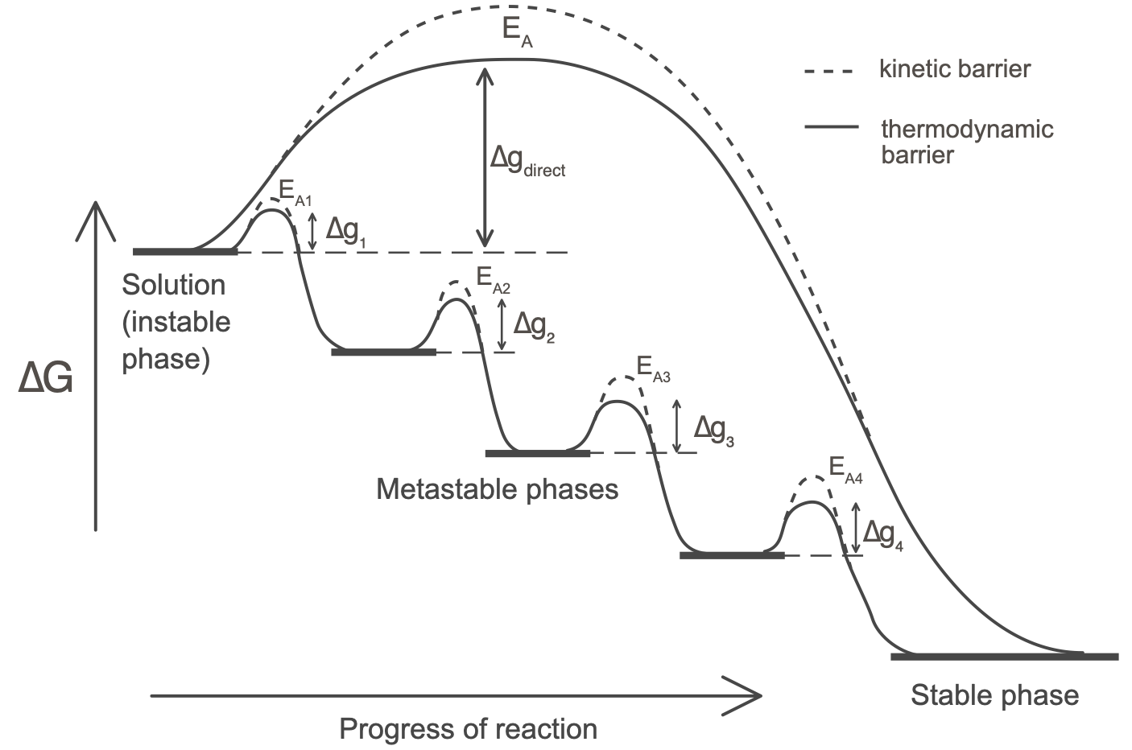

The implications for energetic materials can be exemplified by ammonium nitrate which exhibits a complex phase diagram (Figure 7) across its normal operational environment i.e. the temperatures, pressures and various humidity levels etc. it is expected to be subjected to. Without a sufficient level of phase stabiliser to limit the transition into different polymorphic forms, the porosity and decrepitation of the energetic have been found to increase and directly impact the sensitivity and controllability of the release of energy when initiated: it becomes less stable and controllable [1].

Figure 7 - Phase diagram of AN-KN system [1]
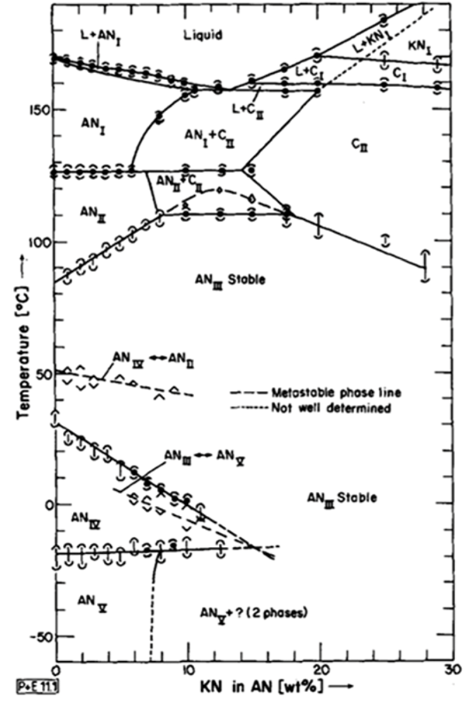

An example on the practical application of the recrystallisation of an energetic material can be seen through the research conducted on the spheroidization of hexanitrostilbene (HNS) IV [5]. This secondary energetic material is used as part of a low energy exploding foil initiator (LEEFI) within modern safety arming units. Due to its high resistance to external stimuli and the removal of the necessity to use a primary explosive as part of a weapon system’s explosive train, it exhibits strong insensitive munition (IM) qualities.
Figure 8 - Spheroidization of HNS IV [5]
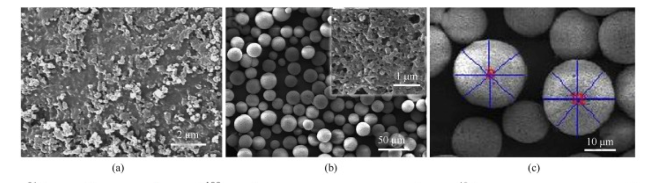
However, the high resistance to stimulus means it is necessary to apply a significant level of energy (~1000V) for it to initiate. This can prevent its application in smaller weapon systems, and therefore the spheroidization of HNS IV aims to reduce this stimulus whilst maintain its intrinsic thermal resistance qualities.

It can be seen from Figure 1 that the use of spherical HNS IV introduces voids or nanopores between the energetic material. This enables the generation of hot-spots by adiabatic compression, thus reducing the initiation required for it to successfully detonate. However, the reduction in the level of energy required to initiate the material and thus raising its reactivity may cause concerns regarding its safe operation. Whereby, although it maintains resistance to thermal stimulus, other stimuli such as electromagnetic may be more susceptible.

Performance

A crucial parameter which affects the performance of an energetic which can be directly attributable to crystal formations is density. This is known to drive the velocity of detonation of a material and its importance can be linked to the following equation [6]:

$$P=Kρ_{o}^{2}ϕ$$

Where the pressure (p) is dependent on the square of the material’s initial density (ρ₀). Therefore, a greater crystal density results in a greater explosive force.

Table 4 - Effect of density in relation to VOD [1]
Compound | Single Crystal (VOD ms⁻¹) | Powder (density) (VOD ms⁻¹)
RDX | 8650 | 7950 (1.50)
HMX | 9300 | 9100 (1.90)
TNT | 7000 | 6620 (1.50)

From Table 4 it can be seen that the anisotropy, or the crystal habit, whereby the orientation of the crystal can affect the velocity of detonation and therefore its performance. However, these values seem to be relatively small when compared to other factors but it is still worth noting as they are non-negligible.

Table 5 - Anisotropy of Velocity of Detonation [1]
Explosive Monocrystal | Density (g cm⁻³) | Initiated Face | Velocity of Detonation m sec⁻¹
RDX | 1.80 | (111) | 8437 +/- 60
 |  | (110) | 8587 +/- 50
 |  | (001) | 8699 +/- 70
PETN | 1.78 | (110) | 8087 +/- 37
 |  | (001) | 8042 +/- 42

Conclusion

The effect of crystallography on an energetic material are far reaching and play a crucial role in determining the behaviour of a PBX, notably:

- Phase changes highlighted in the example of ammonium nitrate (although not directly linked to a PBX), can be seen to have implications on the material properties through the changes in polymorphic forms. As it changes from one phase to another, this can directly impact the mechanical properties of the material and introduce cracking within the PBX.

- Sensitivity can be influenced by the nature of the crystal morphology as exhibited by the spheroidization of HNS IV.

- Performance is directly linked to the density of the energetic material which is determined by the density of the energetic crystal.

References

[1] | A. S. Cumming, Energetics Science and Technology: An Integrated Approach, Institute of Physics Publishing, 2023.
[2] | H. G. G. e. al, “Microhardness Indentation Studies of 2-4-6 Trinitrotoluene,” Propellants, Explosives, Pyrotechnics , vol. 46, no. 11, pp. 1733-1739, November 2021.
[3] | RSC, “Polymorphism, what it is and how to identify it: a systematic review,” 2013. [Online]. [Accessed 31 12 2025].
[4] | e. a. A.R. Kennedy, “Polymorphism in 2-4-6 trinitrotoluene,” Pure and Applied Chemistry, Physics.
[5] | e. a. Rui-shan Han, “Thermal and ignition properties of hexanitrostilbene (HNS) microspheres prepared by droplet microfluidics,” Defence Technology, vol. 25, pp. 166-173, July 2023.

Annex A – Presentation
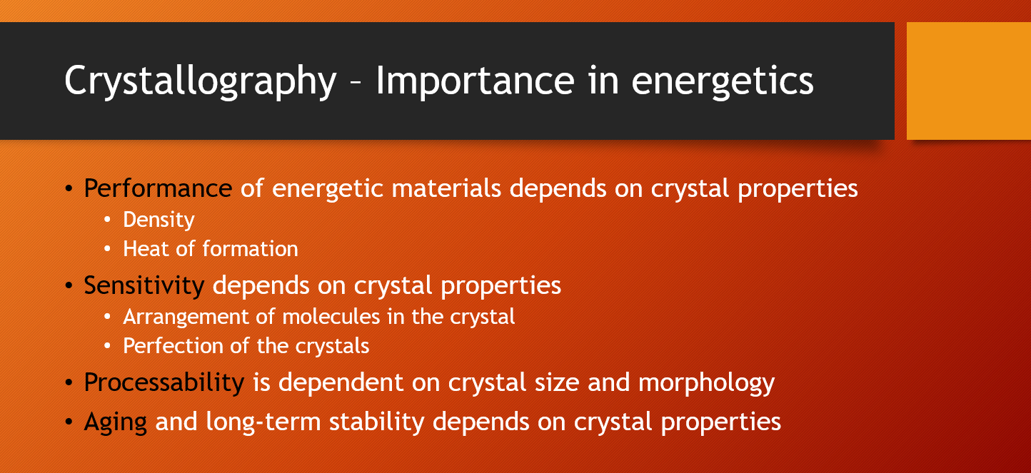

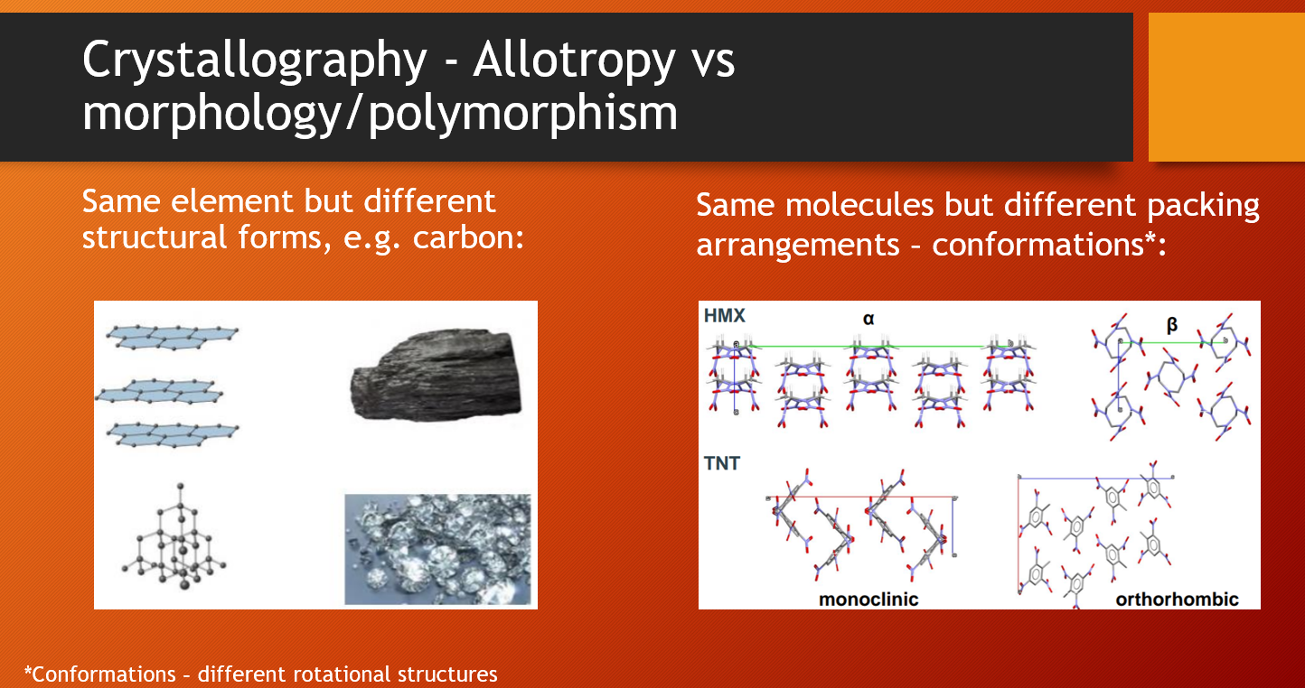

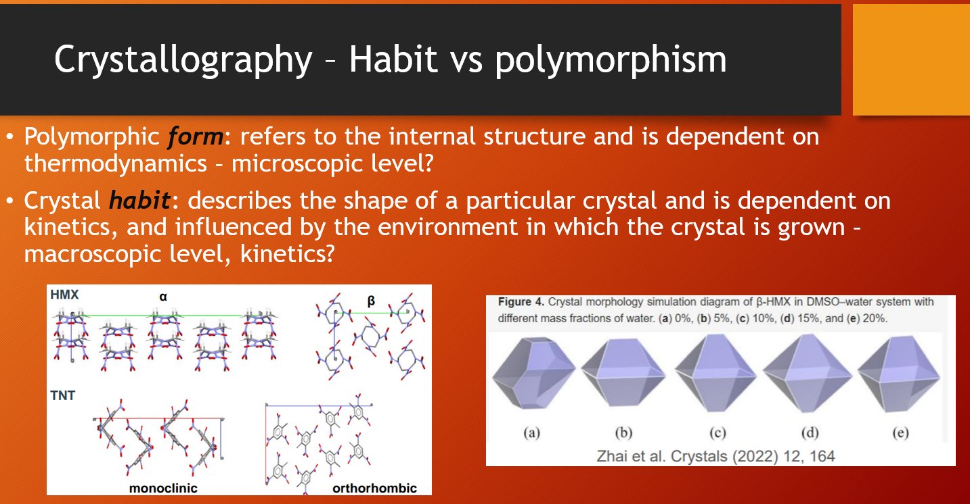

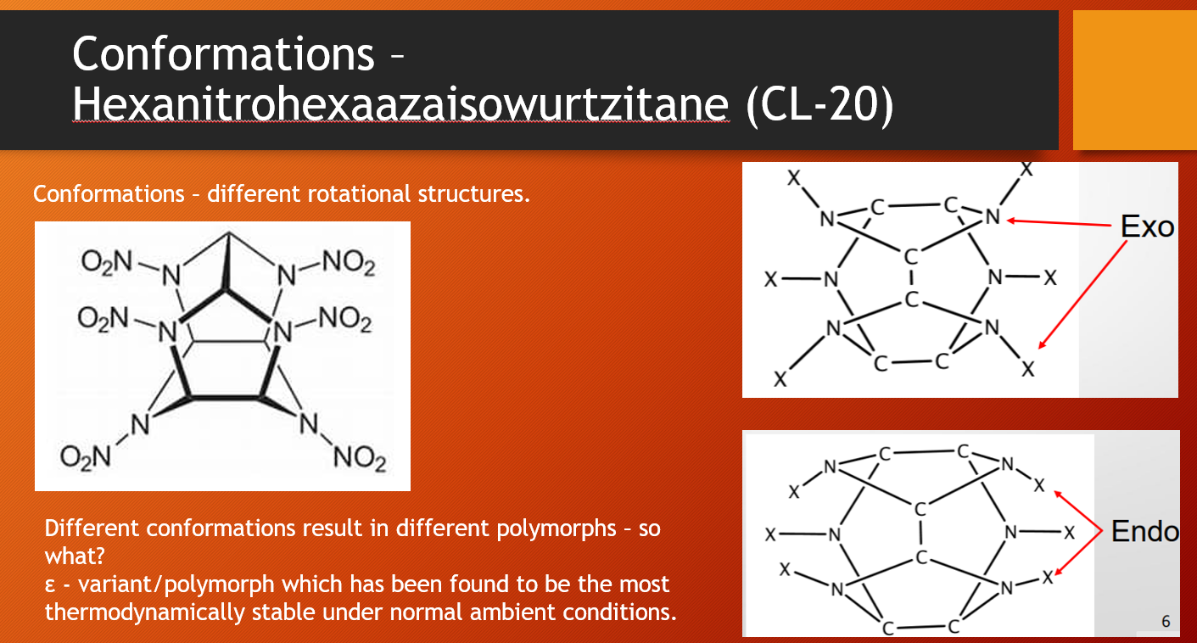

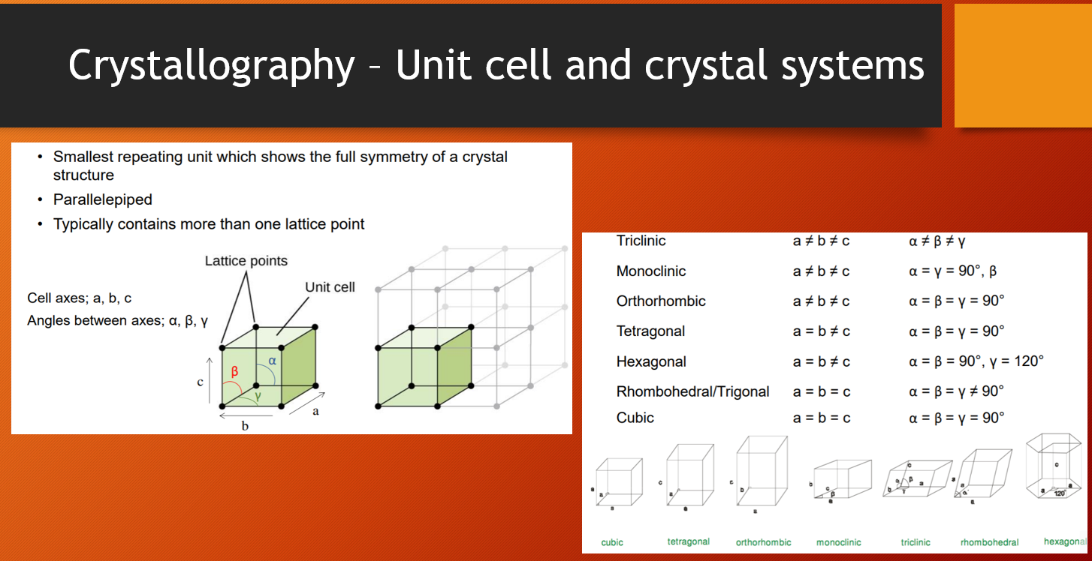

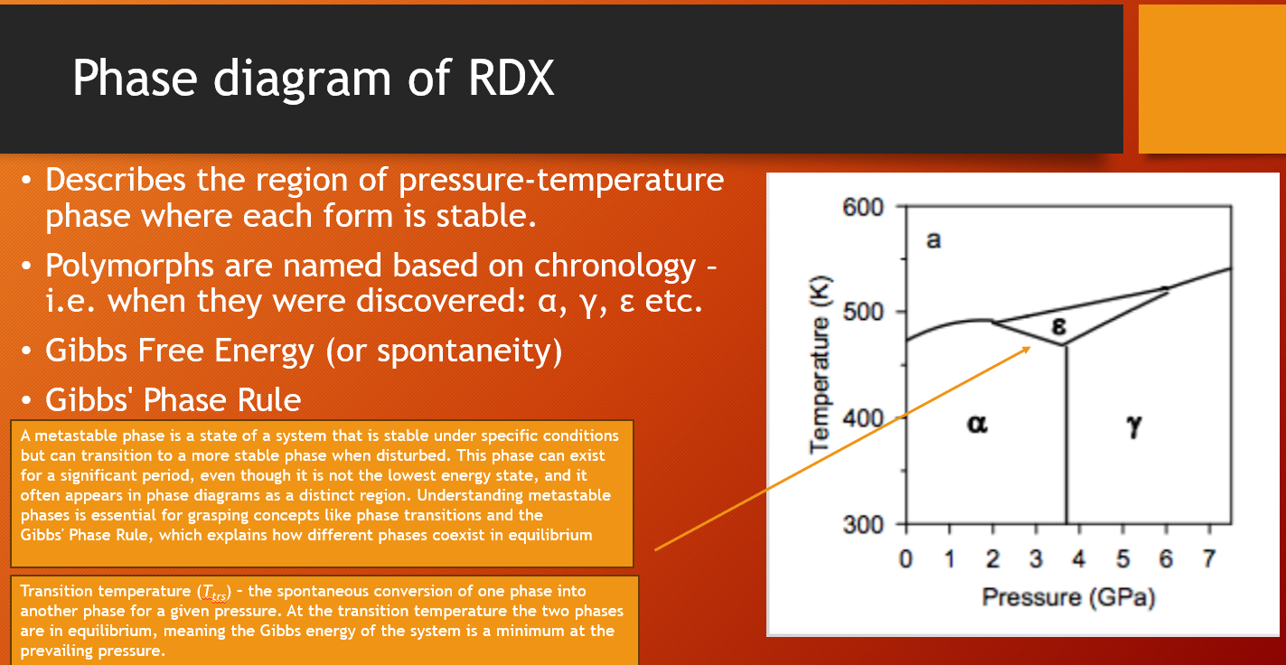

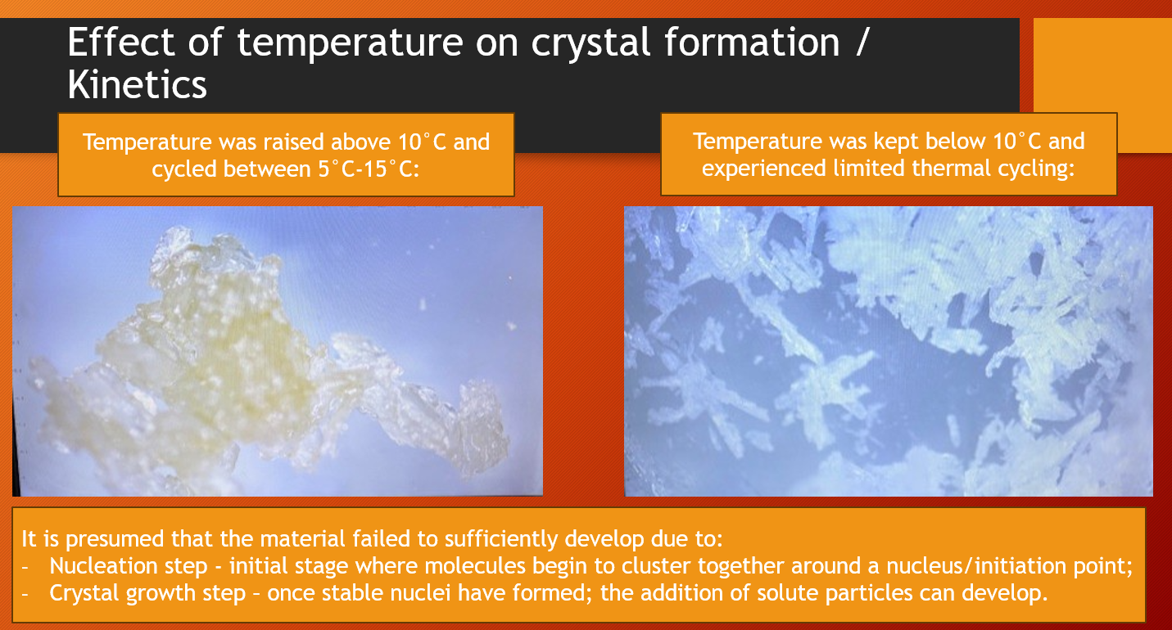

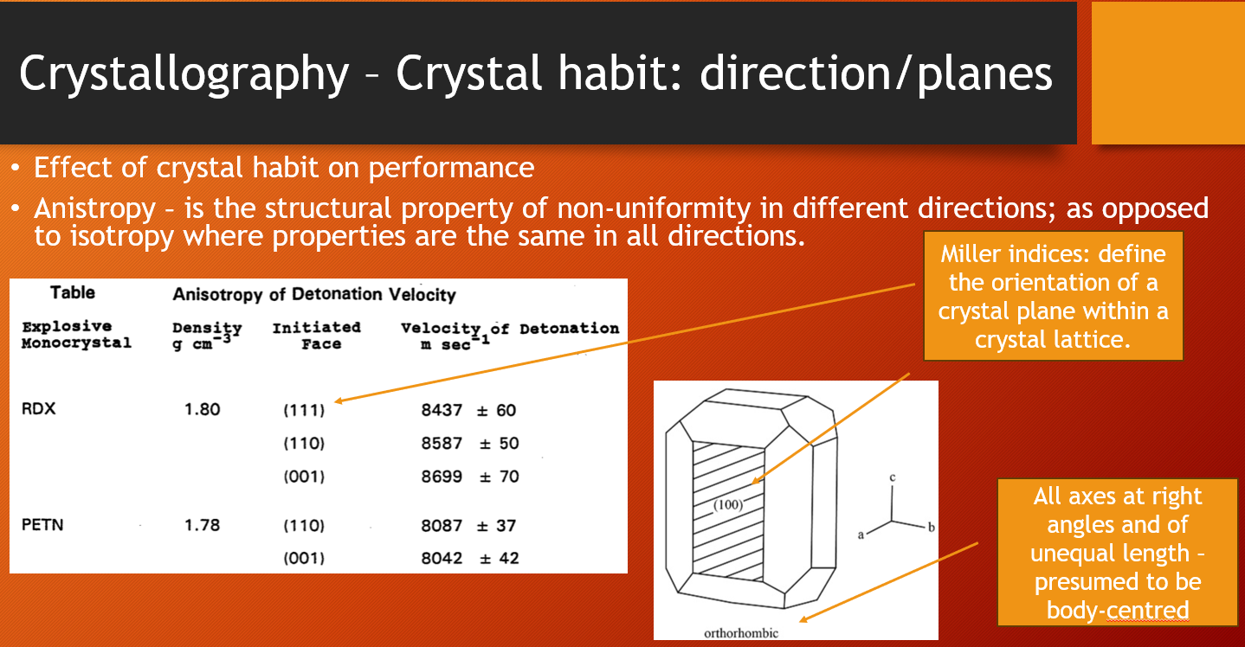

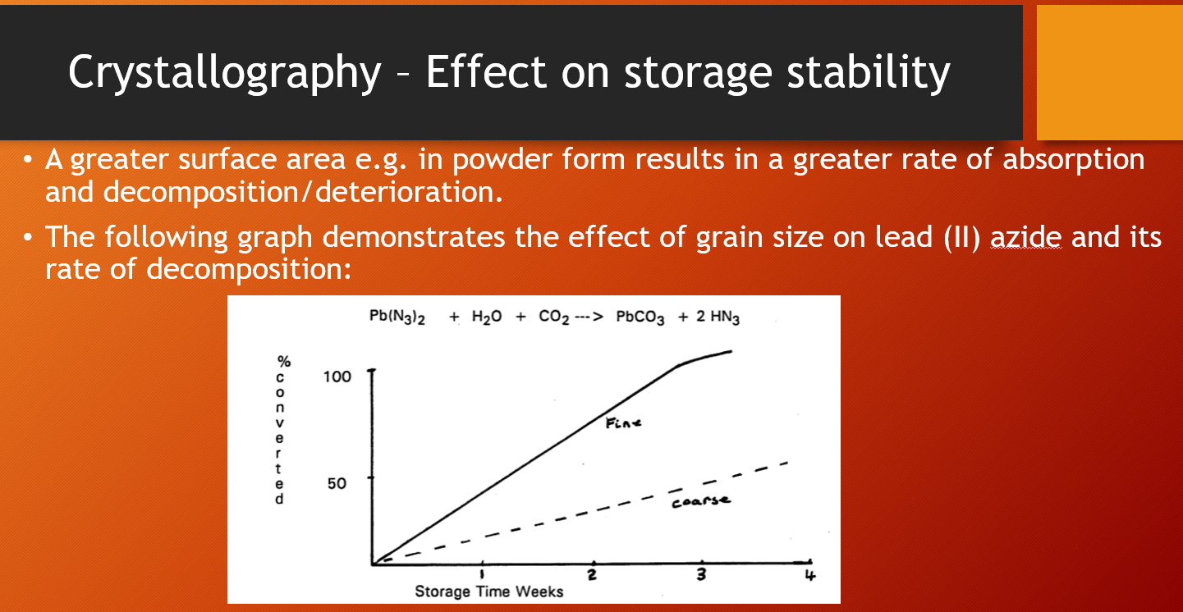

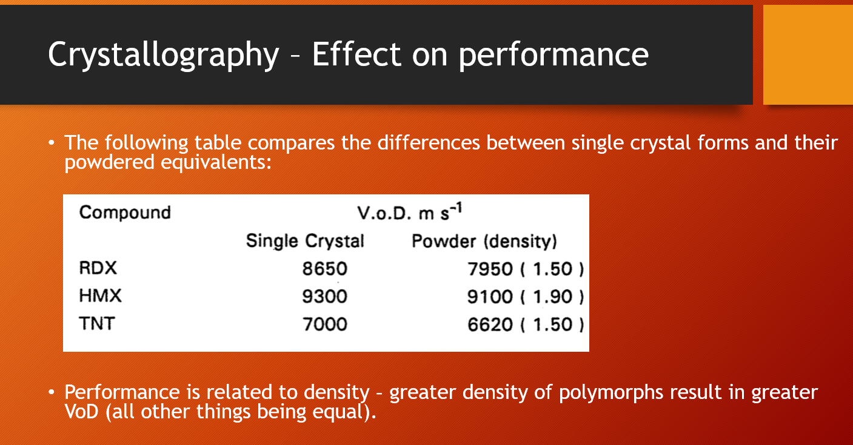

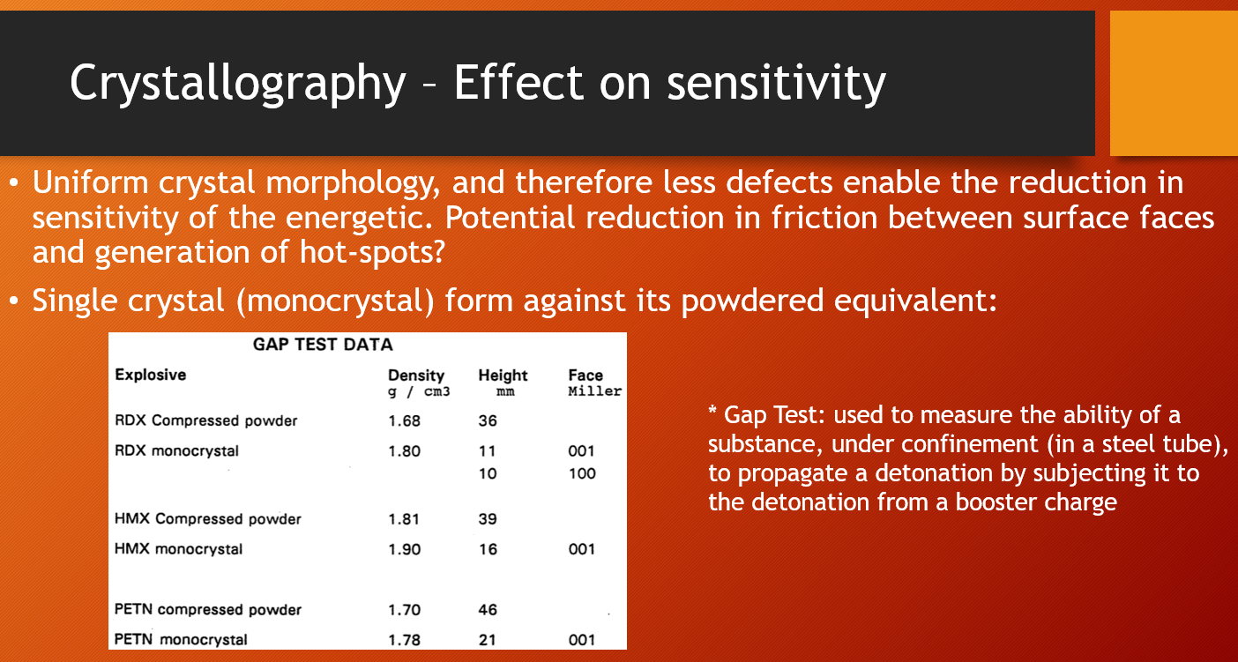

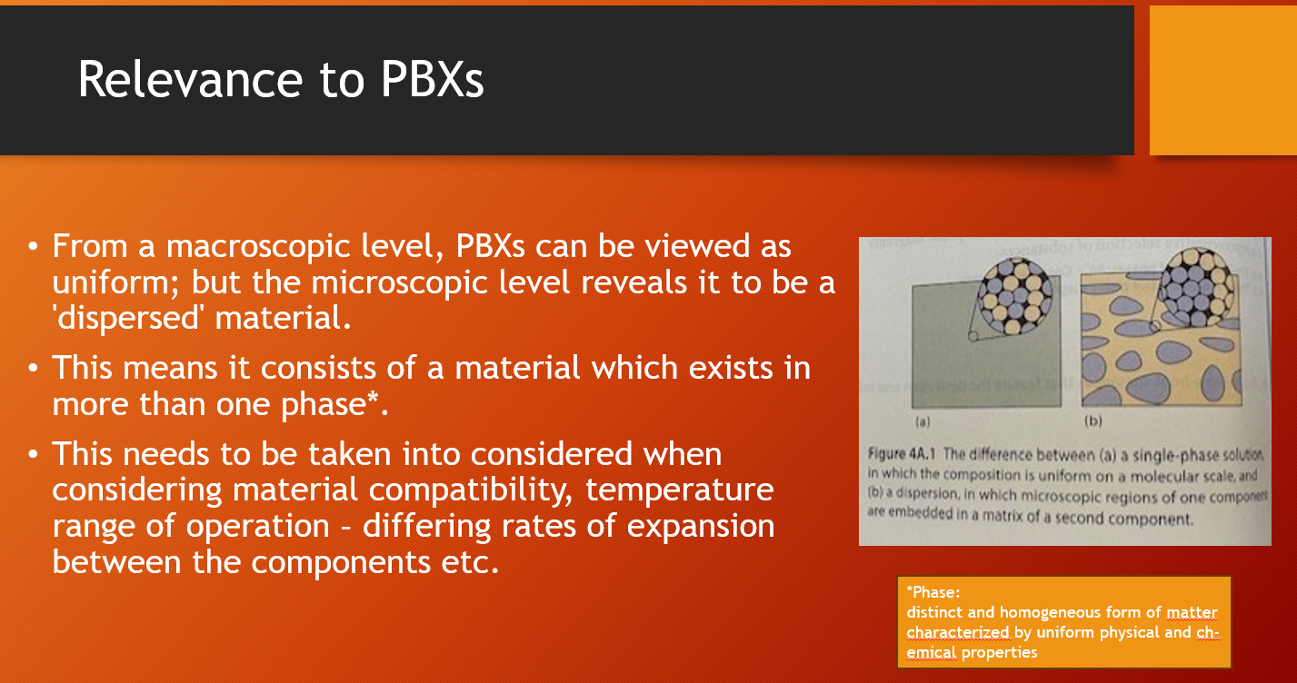

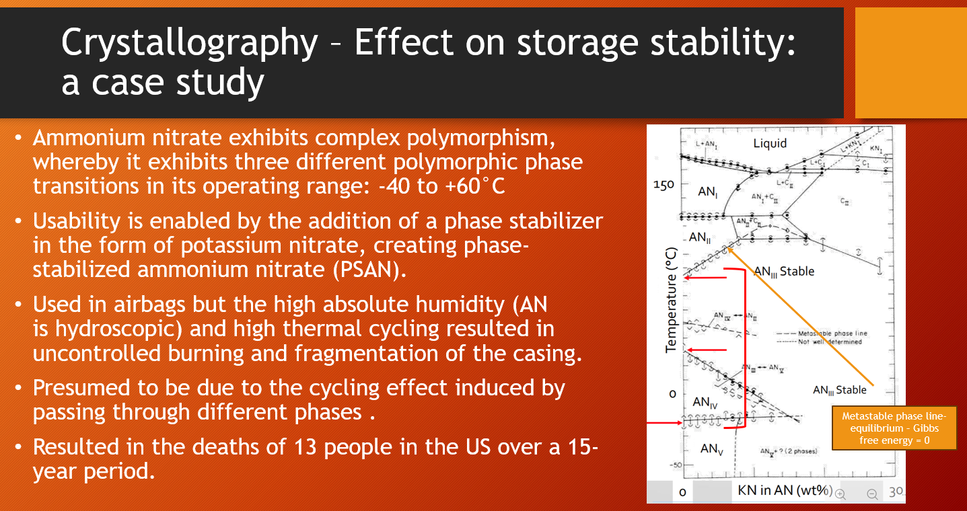

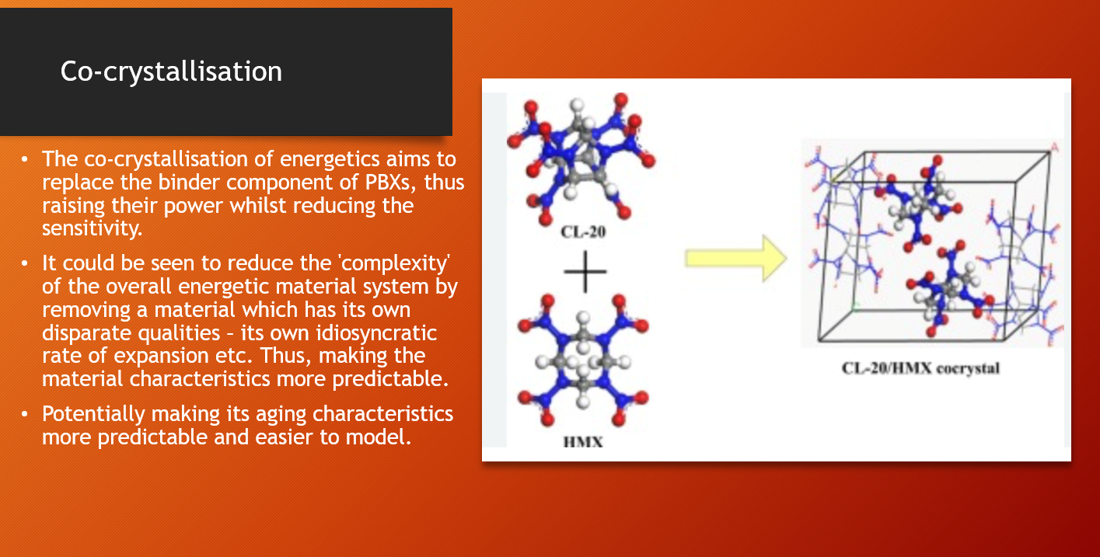

Phase: a state of matter that is uniform throughout, not only in the chemical composition but also in physical state.
Although not an energetic, it demonstrates the principle of crystal formation found in energetic materials.
Metastable: (of a body or system) having a state of apparent equilibrium although capable of changing to a more stable state [6].

