ORGANISATIONAL STRUCTURE AND CULTURE

Module: Introducing the Modern Workplace
Code: LCBB4003
Lecturer: Dr Mohammad Rahman
Student Name: Diana Sharbanova
Student ID: 2131741

Table of Contents
1.0 Introduction 3
2.0 Company background 3
3.0 Organisational structure of the chosen organisation 4
3.1 Organisational Theory 4
3.2 Analysis 4
4.0 Organisational culture of BA 5
4.1 Relation between organisational culture and its performance 5
4.2 Importance of leadership and management in improving organisational performance 6
5.0 Employee motivation within BA 7
5.1 Different factors of employee motivation 7
5.2 Impact of employee motivation strategies on individual performance 8
6.0 Conclusion and Recommendation 8
Reference List 10

1.0 Introduction
Organisational structure means the rules, models and policies that an organisation follows to achieve the goal. Organisational culture is the attitude, values and behaviour of the employees in the organisation. Eventually, both of these are equally important to earn success in the business organisation. The organisational structure impacts the top management's structure of topics that form the organisational structure. Therefore, the organisational structure is a sort of cultural character that is a looking-glass element of assumptions and value authority of an organisation. Besides this, a strong culture can provide direction and consistency, direct actions and decisions that are fuel for the workers and help to reach their objectives. It is the undivided part of a business which helps to fulfil the specific activities that handle the strategic missions of an organisation. In this report, British Airways (BA) organisational structure, organisational culture and individual motivations are elaborated.

2.0 Company background
British Airways (BA) is the UK's flag carrier and global airline that provides excellent service to its customers. It has a headquarter in Harmondsworth in the United Kingdom(UK) and it is formed by nearly 30 companies. It provides facilities in national and international destinations at a low fare as well as passenger and cargo flights. The employee rate gets reduced during the covid situation but it was stable before the pandemic situation arrived. It generated revenue of only 3.7 billion British pounds in the year 2021(Statista, 2023).
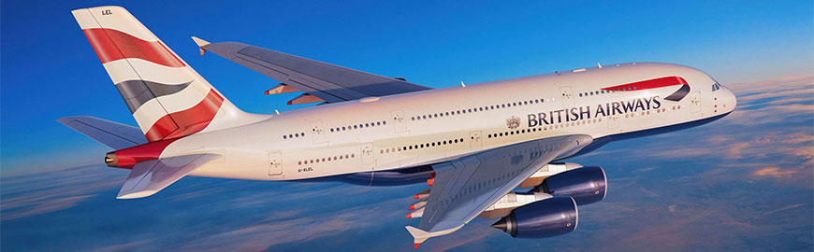
Figure 1: British Airway
(Source: Britishairways, 2023a)

3.0 Organisational structure of the chosen organisation

3.1 Organisational Theory
Organisational theory refers to the relationship between the organisation and their environment which affects the functions of the organisation and distributes privilege to the organisation. Modern organisational management theory covers multiple management development functions and considers the communication relationship between the surrounding environment and the people within an organisation (Doroshuk, 2019). This theory uses mathematical analysis attached with an aim to understand the range of motivation and employees. This theory fits British Airways as it helps to form the organisational structure and organisational culture. Though it helps to measure the employee's performance and to understand their strengths. It also helps to educate the leaders and train the employees through the new business strategy or investments in new equipment. BA increases its employee engagement through an implementation process that takes care of employees' needs and wants. It enhances the strength of making decisions and increases the adaptability of an organisation.

3.2 Analysis
British Airway is the key airline which offers flight facilities within 550 destinations. The two main leadership styles that help BA to expand its operational thoughts are transformed leadership approaches and autocratic leadership approaches. Sean Doyle is the Chairman and Chief Executive Officer (CEO) of British Airways (Britishairways, 2023b). The BA has a functional organisational structure that strongly helps it in building a robust channel of organisational functionalities. These structures have not only worked strategically to target larger customer segments, but also to contribute efficiently in meeting the business needs. It also strongly works for dividing the entire company and its operations into multiple departments according to its expertise to ease of doing business. This also helps in increasing efficiencies and productivities as a whole to meet the business needs and enhancing the customer engagement parameters.
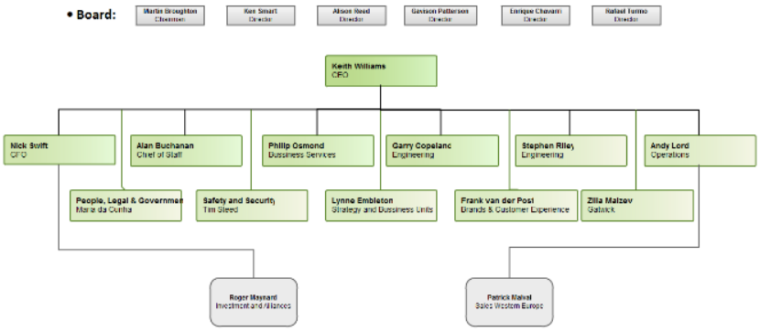
Figure 2: BA Organisational Structure
(Source: BritishAirways, 2023)
BA is ruled by 6 members of the leading team and it includes the posts of Chief Information Officer, Director of Investments and Alignments, Director of Engineering, Commercial Director, General counsel and many more. It has the vision to bring a change in airlines for the betterment of the world. It is supporting the symmetrized carbon discharge from domestic flights and the local people within or outside the UK. The aim of the airline is to generate a return of capital maximum of 15% with an operating profit margin of 12 to 15% but due to covid situation, it reported a net loss of almost 1.6 billion British pounds in the year 2021 (Statista, 2022). It launched its newest multi-channel advertising campaign to increase revenue through sales. It provides excellent facilities to satisfy and attract passengers and it is one of the strategic movements of BA to improve the management structure. BA takes several steps to improvise the organisational structure and give facilities to employees to innovate the organisational structure. Through the help of modern organisational theory, British Airways reached its objectives and earned success and improved its organisational structure.
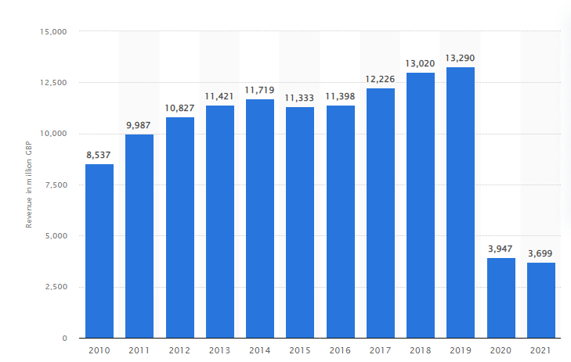
Figure 3: Revenue generation of BA
(Source: Statista, 2023)

4.0 Organisational culture of BA

4.1 Relation between organisational culture and its performance
Organisational culture affects all the sights of business which aptitude and tuning the contract period and employees' benefit. Workplace culture classifies employees’ comforts, support and value. Companies prioritise the cultures to face the changes and to strongly come out from weather in difficult times. It is a key advantage that attracts talent and outperforms the competition. The culture of an organisation is the top indicator of employee satisfaction and one of the crucial reasons that employees stay in their jobs (Joseph and Kibera, 2019). Though, it builds an alignment between the organisation and its employee to achieve the purpose. Appreciation is a part of the organisational culture that motivates the employees for their work. In an organisation, trust is vital to express the situation when trying new things. Organisational culture includes invasion, performance, teamwork, elasticity, safety and many more things.
British Airways' organisational culture is based on the hierarchy system where information is passed down from the boards of directors to the executive manager and then to different departments (Meng and Berger, 2019). Managers overlook all the activities and flow information to upward executive directors. It prefers to use both task and role culture where role culture defines the employee's work and task culture offers some benefits to the employees.

4.2 Importance of leadership and management in improving organisational performance
Leadership increases staff ethics by winning their trust and helps to boost their performance by driving them in the right direction. It is the process of developing and executing plans, securing resources, and identifying and fixing errors. A productive leaders can help to improve their skills by getting the most out of their team (Effendy, 2021). It also entangles inspiring people to cooperate with others and work together to reach common goals. Leadership serves various purposes to assure the smooth operations of an operation. Therefore, it helps to influence the employees, solve internal conflicts, build morality in employees, fulfilling employees' needs, motivate employees, adapt effective management change, increase productivity and make better decisions and many more. Thus, it helps to improve the organisation's performance by developing companies’ morale, facilitating positive interaction, satisfying customers, resulting in productivity, positive facilitation and many more.
British Airways needs the best leaders who help it to struggle in present trading conditions and to achieve its long-term vision. It has introduced a High Potential Leadership (HPL) system to motivate senior leaders. BA is a leading global best airline that needs highly courageous and emerging present leaders (Alrowwad et al 2020). HPL system is a combination of business strategies, rewards, growth and performance appraisal in work. It provides the right tools to the leaders so they can develop the working process continued in the workplace. It allowed the BA to monitor the individual progress and see the way of the overall performance of supervision talents. Leadership also helps to earn the ability that needs to establish the expectation. BA serves facilities like executive coaching, and outside courses to enhance leaders' abilities.

5.0 Employee motivation within BA

5.1 Different factors of employee motivation
5.1.1 Improve training: In simple terms, training and promotion mention the confirming skills, knowledge and ability of an employee. A formal introduction of training and promotion is the attempt to improve the current and future employees' performance by raising their abilities to perform through learning (Girdwichai and Sriviboon, 2020). The main motive of training is changing the employee's attitude by increasing their knowledge and skill. BA established several training centres to train its employees and they trained both mentally and practically. It invested more effectively to improve the employees through standard education and it helps the freshers for the new entire training.
5.1.2 Reward and Recognition: Reward is a very crucial element to recognising the employees towards their work. It helps to feel valued by employees and they contribute more to enhance revenue (Lorincová et al, 2019). British Airways negotiated with two different types of principle-funded defined advantage pension schemes in the UK that are the New Airways Pension Scheme (NAPS) and the Airways Pension Scheme (APS). New employees were allowed to join the British Airways Retirement Plan (BARP). The main aim of BA is to provide a total reward package for its employees which inspires them to perform highly and give excellent customer service.
5.1.3 Workplace: The environment of the workplace helps to motivate the employees to show their best performance. It can be called that the pillar of motivation is the environment of the workplace (Basalamah et al, 2021). BA tries to provide a working environment that engages, supports and develops its employees. It dedicated the employees to their duty and gave them the confidence to deliver better service to their customers. BA set up a strategy for conflict and harassment resolution and hired employees to stop unethical works that can demotivate the employees. This plan recovered and united all sector employees to achieve the goal.

5.2 Impact of employee motivation strategies on individual performance
5.2.1 Employee engagement Theory
Employee engagement theory is the formal idea that inspires employees by supporting and challenging an organisation to increase satisfaction and maximise the output of the staff (Kwon and Park, 2019). According to these theories, organisations with level working motivation and loyal employee engagement provide benefits like high customer satisfaction, increased creativity and innovation, bigger bottom line and many more. These theories also help to set a goal for the major component of employee engagement. It helps the employees share a goal with the team and understand their responsibilities.
5.2.2 Impact of employee motivation strategy
Motivated employees bring more profit as the profit depends on the quality and quantity of employees' work. An increase in profits allows organisational leaders to give better salaries and rewards, increments and benefits that motivate the workers (Ozkeser, 2019). Customer satisfaction is the key factor that helps to enhance revenue and motivated employees help to satisfy them. Motivated employee wants to stay at work which increases work-life quality. Organisations provide training to raise the skills of the employees that give motivation other employees which reduces employee turnover.

6.0 Conclusion and Recommendation
From this report, it concluded that the organisational structure and organisational culture are very important to earn success in this competitive market. Organisational culture helps employees to provide a positive environment for workers to do their work. The organisation structure is the process of planning and implementing the actions that are needed to run a business. From the company's background, it was known that British Airways is the largest and widest airline in the UK. The organisational structure reflects the impression and relation between the employees and the organisation. It also helps to satisfy and attract customers and generate extra revenue. It performed an important role in improving the organisation's environment and it helped to improve the organisation's management through the help of leadership. Proper leadership helps to boost the skills, abilities and knowledge of the employees. BA motivated its employees through training, rewards and other processes. BA applied motivational theories and strategies to motivate employees which help to earn more profit, increase productivity and reduce employee turnover.
Effective working culture: BA should adapt to a better working culture where employees can get the motivation to provide their best. Besides this, better communication plays a key role in business making an effective culture where businesses can manage work in an efficient manner. Besides this, the organisation needs to implement a simple hierarchy model in its business to bring more efficiency to organisational operations.
Effective Engagement of customer relationship Management: Customer relationship management needs to be developed as it helps them to connect with customers which is essential to build an effective business. Organisations have provided power to the employees as it boosts their confidence which is essential to make an effective working culture.
Providing better training facilities to employees: BA needs to train employees in an effective manner where they can work in a team in a positive manner which is also a positive consequence of better culture.
Enhancement of proper organisation student: BA also needs to work on organisational structures also can be better if businesses evaluate the needs of employees as employees help to improve the status to get positive growth in business.

Reference List
Alrowwad, A.A., Abualoush, S.H. and Masa'deh, R.E., (2020). Innovation and intellectual capital as intermediary variables among transformational leadership, transactional leadership, and organizational performance. Journal of Management Development, 39(2), pp.196-222.
Basalamah, M.S.A. and As’ad, A., (2021). The Role of Work Motivation and Work Environment in Improving Job Satisfaction. Golden Ratio of Human Resource Management, 1(2), pp.94-103.
Britishairways, (2023a). Airbus A380-800. Available At: https://www.britishairways.com/en-gb/information/about-ba/fleet-facts/airbus-380-800 [Accessed on: 23.03.2023]
Britishairways, (2023b). ABOUT BA. Available At: https://www.britishairways.com/en-in/information/about-ba [Accessed on: 23.03.2023]
Doroshuk, H., (2019). Organizational development as a modern management tool for transformation of the company (case of Ukrainian energy company). Management, 23(1), pp.61-74.
Effendy, J., (2021). The Impact of Organizational Culture and Work Environment On Employee Performance Through Leadership In Corporate Security Unit Of PT Garuda Indonesia (Persero) Tbk. INTERNATIONAL JOURNAL OF ECONOMICS, MANAGEMENT, BUSINESS, AND SOCIAL SCIENCE (IJEMBIS), 1(1), pp.1-10.
Girdwichai, L. and Sriviboon, C., (2020). Employee motivation and performance: Do the work environment and the training matter? Journal of Security & Sustainability Issues, 9.
Joseph, O.O. and Kibera, F., (2019). Organizational culture and performance: Evidence from microfinance institutions in Kenya. SAGE open, 9(1), p.2158244019835934.
Kwon, K. and Park, J., (2019). The life cycle of employee engagement theory in HRD research. Advances in Developing Human Resources, 21(3), pp.352-370.
Lorincová, S., Štarchoň, P., Weberová, D., Hitka, M. and Lipoldová, M. (2019). Employee motivation as a tool to achieve sustainability of business processes. Sustainability, 11(13), p.3509.
Meng, J. and Berger, B.K., (2019). The impact of organizational culture and leadership performance on PR professionals’ job satisfaction: Testing the joint mediating effects of engagement and trust. Public Relations Review, 45(1), pp.64-75.
Ozkeser, B., (2019). Impact of training on employee motivation in human resources management. Procedia Computer Science, 158, pp.802-810.
Statista, (2022). Annual net profit of British Airways plc from 2011 to 2021. Available At:https://www.statista.com/statistics/1007530/net-profit-british-airways-plc/ [Accessed on: 23.03.2023]
Statista, (2023). British Airways Plc's worldwide revenue from FY 2010 to FY 2021. Available At:https://www.statista.com/statistics/264296/british-airways-worldwide-revenues-since-2006/[Accessed on: 23.03.2023]

