ROOM RATE BOARD
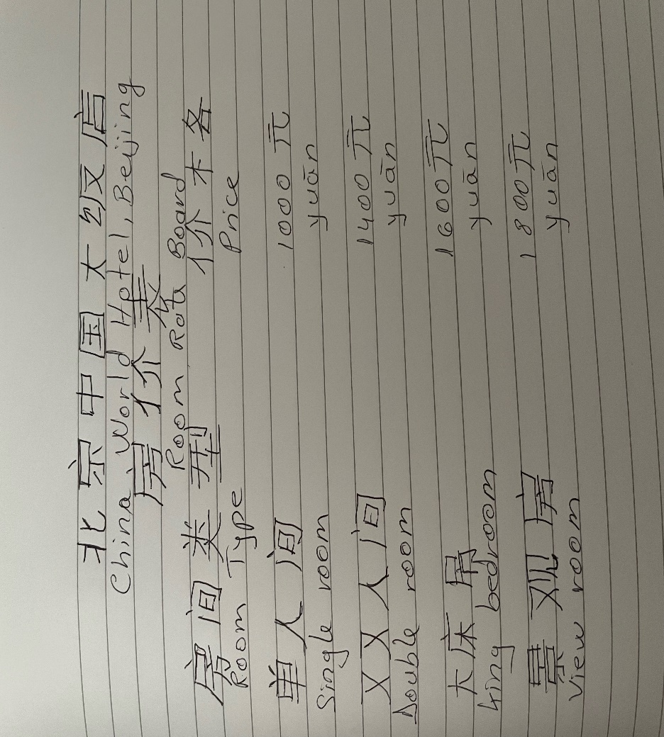#
LENUTA MARIA FURO
Student 2019723
Mandarine (BMHI)5003

