Programme: BA Leadership and Management Skills for the Workplace
Module: Strategic Management for SMEs
Module code: BMSW6104
Lecturer: Paul Bocij
Assignment Title: Strategic Management for SMEs
Student Name: Ameera Khan
Student Number: 1810760

Table of Contents
List of Figures 1
Introduction 2
Vision and Mission Statements 4
Current Strategic direction at Foodworld 4
Porters 5 Forces 5
Value Chain 7
Primary Activities 8
Support Activities 9
Cost Advantage 11
Differential Advantage 11
Advantages and Disadvantages of Value Chain Analysis 11
Balance Score Card 12
Environmental Scanning 14
PESTLE Analysis of Foodworld 14
SWOT Analysis for Foodworld 17
Ansoff Matrix 17
Stakeholder Analysis 18
Stakeholder Mapping 19
Recommendations 21
SFA Matrix 22
Conclusion 24
References 24
Appendix 26

List of Figures
Figure 1, Strategic Management Process ……..page 5
Figure 2, Porters 5 forces………….page 5
Figure 3, Porter’s Generic Value Chain…………….page 8
Figure 3, Hierarchical Structure of Foodworld.page 10
Figure 4, Foodworld Balance Score Card .page 12

Figure 5, Foodworld SWOT Analysis…….page 17
Figure 6, Ansoff Matrix…page 19
Figure 7, Foodworld Stakeholder Map.page 20
Figure 8, Stakeholder Map
Figure 9, Stakeholder Power/Interest Grid for Foodworld
Figure 10, The SFA Matrix
Figure 11, SFA Matrix Key.page 23

Introduction
SMEs are small to medium size businesses (COMMISSION RECOMMENDATION, 2003).
Organisations implement strategies to achieve goals and accomplish objectives. This report will focus on the current strategies in place at Foodworld Superstrore Ltd, an SME located in Washwood Heath. Washwood Heath is bustling, multicultural, diverse and based in the heart of Birmingham. The Washwood Heath area has a high unemployment rate and a higher than the national rate of immigrants (Socio-economic statistics for Washwood Heath, Birmingham, 2021).
Foodworld is a local SME, their market and place of operation is local to the Washwood Heath area. FoodWorld currently employ 15 people. Since opening in October 2018, Foodworld have been plagued with financial and operational difficulties (appendix 1). With the first year of trade only seeing a meagre net profit of £17,414, and narrowly escaping Striking off action in January 2020 (appendix 2).
SMEs have social and economical importance. In the EU, SMEs are representing 99% of around 23 million enterprises and providing an estimated 75 million jobs, which represents two-thirds of the employed. Within the industrial industry, SMEs count for upto 80% of employment, including textiles, construction and furniture (International Finance Corporation, 2005).
Foodworld have been trading since 2018, they have steadily gained popularity and a loyal customer base since the COVID-19 pandemic. FoodWorld maintained their policy to supply a variety of products, without raising prices during the pandemic shortages, unlike other local SME supermarkets. This policy proved popular amongst local residents.
Foodworld does not currently have a vision or mission statement. Foodworlds current objectives are to reduce their debts and maintain the competitive advantage gained during the pandemic. The values of Foodworld are their community focussed spirit. Considering the vision and mission of Foodworld, this report will develop a fitting vision and mission statement.
To provide future strategic directional recommendations for Foodworld, a critical analysis of their current strategy is required. A SWOT analysis will determine Foodworld’s current strengths, weaknesses, opportunities and threats. Establishing the current state is necessary to formulate new strategies, developing weaknesses and opportunities into strengths and counteracting threats.
A PESTLE analysis will help to gain an image of Foodworld’s macro environment and various factors which can impact Foodworld.
A stakeholder analysis will also be carried out to build on Foodworlds customer relations vision and improve relations with employees and the local community.
New strategies will be formulated, with the main emphasis on customer loyalty retention and debt management.
The outcome of the key findings include that Foodworld has a lack of specialist knowledge and trained individuals, which has resulted in amassing debt and spending considerable finances on staffing and not enough on promoting customer relations, company vision and store offers and promotions.
In the future the company could benefit by reducing spending on this and increasing spending on that say man David and taking a differentiation focus this is the outcome and recommendations

Vision and Mission Statements
A vision and mission statement for an organisation can have many benefits, including demonstrating the businesses strategic intentions and align goals and direction for all stakeholders (Flowers, 2007).
Foodworld does not currently have a vision or mission statement.
Suggested new vision statement:
Catering for all our communities’ diverse needs, with a global standard in customer service.
Suggested new mission statement:
Creating value and building trust at Foodworld for our customers and employees, we strive to provide the best quality products and services for our customers and focus on continual development for sustainability.
A vision and mission statement is not only an attractive asset for a business to possess, employees will be empowered with purpose and conviction. When the employees and customers believe in the organisation’s values, they will passionately commit to the company’s mission (Scott, Jaffe, Tobe, 2004).

Current Strategic direction at Foodworld
The strategic management process involves a concise and realistic perspective to formulating, implementing, and evaluating strategies. The purpose of this process is to formulate and implement strategies to achieve the company's long-term missions and near-future objectives (Simerson, 2011).
Every employee is affected by strategy, which serves as a practical means of achieving your company's objectives. Strategic planning has a number of advantages, one of which is that it establishes a single, forward-looking vision that can bring your organisation and its stakeholders closer together.
The strategic management process will be followed to critically appraise Foodworlds current strategy and propose a more successful and effective strategy to implement.
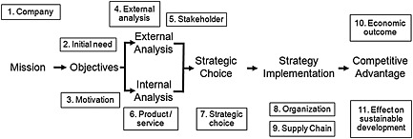

Figure 1, Strategic Management Process (Barney, Hesterly & Hesterly, 2010:6).
‘The advantages of the strategic management application within an enterprise are summarising and offering new clearer visions over the enterprise and a clearer focus over what is important from a strategic point of view’, (Wheelen & Hunger, 2010:6).

Porters 5 Forces

Force | Risk  High/Low | Notes
Threat of new entrants | Low | The threat of new entrants is low as acquiring retail premises for a superstore in the area is costly in Birmingham. New entrants would new a substantial financial backing, to potentially cope with a loss in the initial stages; as to emerge as a strong player, prices and rates would have to be highly competitive; as there s already a high concentration of superstores and supermarkets in the area.
Threat of substitutes | High | The grocery industry offers a wide range of products and services; the big supermarkets can also offer cheaper alternatives of certain products, which would exclusively be available at Tesco. Foodworld would have to provide high quality products and excellence in customer service; which can compel the customers to return.
Bargaining power of customers | High | Customers have high bargaining power. There is a high number of superstores in the vicinity and three large supermarkets; Tesco, Aldi and Iceland within a 2 mile radius. Switching cost is low for customers and they can easily switch from Foodworld to another superstore or supermarket. With the high unemployment rates in the area; the customers will be more attracted to low prices.
Bargaining power of suppliers | High | Within the grocery industry the suppliers have the power to regulate the industry. Local suppliers wield the power; if the retailers don’t pay the price demanded by the supplier, they will not get the goods. As appose to Tesco, as a larger supermarket they have power to dictate the prices they want to pay to the suppliers; if suppliers do not reduce price for the large supermarkets, they are left with a much smaller market for their produce.
Industry rivalry | High | Competition is intense, as competing with larger supermarkets is financially impossible for Foodworld; the supermarkets possess resources to predict buyer behaviour, follow trends and spend on marketing. The smaller superstores compete intensely with regular seasonal promotions, even incurring a loss in some instances, to gain the top position of offering the cheapest promotions.
Competitors | High | With the bigger supermarkets having the finances to spend millions on marketing, smaller superstores like Foodworld rely on competitive leaflet distribution, regular promotions and building a reputation of providing the highest quality. With an abundance of diversity, there is a rise in south eastern theme shops.

An analysis of Porters 5 forces is indicating that Foodworld is operating in an environment of intense rivalry and not only competing with other SMEs, there are also much larger supermarkets to compete with. To gain the local competitive advantage Foodworld is currently offering a range of organic fruits, vegetables, meat and poultry.
To demonstrate their sustainability efforts of reducing waste Foodworld has joined the ‘TooGood-ToGo’ scheme (Join Our Food Waste Movement, 2021), joining many other superstores, supermarkets and restaurants around the UK, offering surplus goods at a fraction of the price, saving the goods from being thrown away. However, Foodworld is yet to showcase their efforts to the local community, which could easily gain them more custom and an appreciated reputation. The local competitors and big supermarkets are not yet part of the scheme, acting as ambassadors and spreading awareness locally could gain Foodworld invaluable positive publicity.
Foodworld could also improve relations with suppliers. Suppliers have access to a wealth of information; with the suppliers sharing more information in regard to stock which is in higher demand, this could gain Foodworld a competitive advantage.
Foodworld is located in a multi-cultural hub, improving customer relations with the diverse local residents. Employing with more diversity is an excellent strategy, as the language barrier will be overcome and many southeastern European and Asian immigrants would feel welcomed and comfortable in an environment where they would not struggle with communication issues.
There has also been a rise in southeastern theme shops, Foodworld would need to stock a more diverse variety of goods. This can be achieved by customer engagement; asking customers directly or by offering an incentive to complete a survey.
Incorporating technology, to connect customers could also be an innovative move for Foodworld. An online platform to let customers know about daily deals or even place meat orders; to save waiting times for specific meat orders.

Value Chain
Porter's Value Chain Analysis can provide a different perspective on a company's strategic direction. This is where management examine a number of business functions and discover areas of opportunity or changes that may be developed to add value and gain the competitive edge.

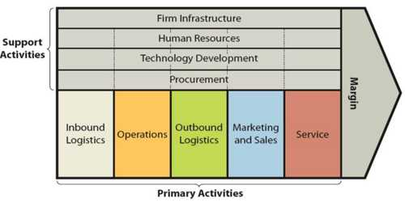
Figure 3, Porter’s Generic Value Chain (Porter, 2014).

Primary Activities
Inbound logistics involves procuring and storing of raw materials and how they are used in the organisation.
Foodworld efficiently manages energy and water, they have two large vans to transport more goods per journey and selecting the nearest suppliers and planning journeys saves fuel.
Outbound logistics is associated with warehousing and distribution of finished products.
Foodworld is also cutting costs by sourcing fresh produce from local farms. The fresh produce and organic label is more attractive and appealing to the customer. By purchasing from local farms were the produce is readily available, Foodworld can reduce costs in terms of storage.
Operation refers to the process of providing a service for businesses in the services sector. In some organisations the procedures of changing raw materials into final commodities are referred to as operations.
Foodworld needs to renovate and replace many features. The store itself requires modernising to be fully appreciated by the customers. The trolleys and baskets are worse for wear; which need replacing and the car park should be levelled and fresh parking bay markings painted.
Marketing and sales refers to the selection and execution of a marketing strategy for communicating a marketing message to the diverse customer base.
Foodworld need to revamp the front of the store for increased curb appeal. An array of posters with their current offers should be regularly updated in English, Urdu and Romanian; the three most commonly spoken languages in the area.
Marketing via an online platform would also be highly beneficial to keep customers connected to the store, with updated offers and online meat counter order service.
Service is related to the support provided to customers after a sale.
Foodworld pride themselves for their after sales support. From bagging grocery, to loading heavier grocery items directly into your car, whether your car is parked in the car park or nearby on the street. Foodworld also take great satisfaction in the provision of quality food and are happy to accept returns when customers are not fully satisfied. However, there is not a sufficient amount of guidance or signage for customers in store.

Support Activities
Infrastructure of an organisation encompasses the organisational structure, the departments and organisational culture.
The organisational culture at Foodworld is hierarchical. This limits innovation and communication. The organisation culture and environment is goal focussed.
A flat organisational structure would lead to improved communication between the staff and management, more innovative suggestions and ideas and customer feedback can be relayed between staff and management more effectively.

Figure 4, Hierarchical Structure of Foodworld
Human Resource Management includes an array of actions relating to recruitment, training and development, appraisals, staff engagement.
Foodworld recruitment is community and local residents based. Jobs are advertised instore and full training is given. regular feedback is given to staff members on performance. However, performance is not recorded, recognised or rewarded.
Foodworld would benefit from offering reward and recognition incentives to improve productivity from staff.
Management could also benefit from taking further training to review legal and financial requirements and not solely rely on the accountants. This could avoid serious action being taken against Foodworld in future.

Technology development involves the use of technology to create more value and an increase in the primary activities effectiveness
Foodworld has many local competitors who offer a multitude of additional services. Foodworld would greatly benefit from offering services such as the National Lottery, Paypoint, Payzone and Parcel drop off shop services.
Procurement is the process of purchasing raw materials, tools, equipment, machinery.
To survive in a highly competitive market Foodworld will need to create value utilising their primary and support activities. Value can be added in a number of ways including;

Cost Advantage
Cost advantage: Foodworld can work to reduce the cost of operations further and wherever possible and utilise the savings to benefit the customer by offering them goods at lower prices.

Differential Advantage
Foodworld can aim to gain a differential advantage. This is when an organisation's products or services differ from their competitors' and the offers are seen as superior. As community orientated ambassadors Foodworld can gain a strong brand identity.
Apple is known for inventing ground-breaking products, such as the iPhone, and for using its market dominance with clever marketing strategies to establish a prestigious brand. Some pharmaceutical companies protect their products with patents, they then market them at exorbitant prices.
This can be an effective strategy for Foodworld; when introducing technology to connect customers to the business. For example, if online orders were taken for meat preparation orders the customers are more likely to purchase the rest of the shopping from Foodworld when collecting their meat order.

Advantages and Disadvantages of Value Chain Analysis
Advantages:
- Value chain analysis can help to recognise business, strategic and tactical issues within the organisation.
2. Value chain analysis can assist businesses to appreciate the sources of competitive advantage.
3. Regardless of the size of the organisation or type of industry, the vale chain framework can be applied.
The vale chain framework is not free from flaws, some of the disadvantages are;
1. The framework cannot always separate the operations in a business into primary and support activities. As some businesses are far more complex.
2. The value chain analysis process can be time-consuming, as it requires a comprehensive analysis of all organisational operations.
3. All the information required may not be accessible, or easy to obtain.

Overall, value chain analysis can be utilised to potentially recognise value improvement opportunities, through various stages of an organisations cycle and improving margin efficiencies.

Balance Score Card
The balanced score card was originally designed to monitor performance, it is utilised nowadays by businesses to formulate and implement strategy. Organisations that use the balanced scorecard create goals in each of these categories, then develop targets and actions to attain those goals, as well as indicators to track how well they're being met (Kaplan, Norton, 1996). Companies can use it to clarify strategy in terms of the multiple dimensions; outlined by the balanced scorecard tool, convey strategic objectives in various areas, develop set targets and combine strategic activities and implement feedback and engagement systems.
Foodworld | Objectives | Measures | Targets | Initiatives
Customer | Maintain loyal customer base.  Offer customers more services, to increase satisfaction. | Connect customers via an online service, to update them with offers and services.  Register with Paypoint, Payzone, National Lottery and become a Parcel drop off point. | Gain 15 to 20 new customers per week.  Increase in sales through gaining 20-25 new customers per week. | Offer discount incentives to the online registered customers.  Promoting new services, marketing with posters, neon signage and training staff to effectively communicatevia word of mouth.
Financial | Expand market share.  Cut costs.  Rise in sales. | By gaining new customers.  Further training to reduce errors food wastage and work more productively.  More intense promotions. | Implemented new strategies gaining 30-35 new customers per week.  Staff productivity increased. More awareness for ‘TooGood, ToGo’ scheme.  Encourage minimum £40 grocery shop per customer. | Not enough marketing and awareness created. Invest in promoting online strategy and technological advances instore.  Offer staff r&r. More signage, explain verbally to customers about the scheme.  Offer discounts off minimum spend of £40.
Business Process | Reduce waste, increase sustainability efforts.  Improve workplace culture. | Recycling, reducing plastics and more awareness for the ‘TooGood, ToGo’ scheme.  Customer satisfaction surveys  Staff appraisals and feedback. | 80% reduction of all waste.  Posters and marketing for the ‘TooGood, ToGo’ scheme.  100% customer satisfaction. | Invest more finances into recycling equipment and marketing campaigns.  Continuous training of staff for excellence in customer service.
Growth & Learning | Provide more training in laws and UK regulations/employment laws.  Improve job and customer satisfaction. | Health and safety inspection, financial audit. | Five-star rating for Health and safety compliance.  100% employee job satisfaction. | Reward and recognition for service.  Continuous training programs for customer service.  Employee feedback and mentoring.
Figure 4, Foodworld Balance Score Card
Key: Red = Not on target Green = On target
“Although there are some criticisms concerning the balance scorecard approach, many of these seem to be practical application problems rather than fundamental flaws” (Atkinson 2006).
The balance score card strategy can assist Foodworld to achieve big goals by breaking them down into smaller more achievable goals.
Analysis of the Porters Five Forces and Balance score card tools have established that Foodworld has many opportunities to gain the local competitive advantage. However, they are yet to utilise resources and invest in these developments for growth.
The balance scorecard can be an effective tool for Foodworld when delving into new technology growth and for increasing customer satisfaction.

Environmental Scanning
Using environmental scanning tools PESTLE and SWOT, the report will now analyse the internal and external environment of Foodworld.
The PESTLE analysis will look at macro environmental external factors that affect Foodworld.
The SWOT analysis will study the internal micro factors which impact Foodworld.

PESTLE Analysis of Foodworld
Government Regulations
Foodworld is a business operating in the UK and is subject to the government and political regulations therefore food world should bear them in mind and follow them accordingly, following safety regulations and offering safe products in accordance with UK standards.
In the past food world was almost stricken off for not following financial guidelines and submitting financial evidence in a timely manner and accordingly.
Political Circumstances
Foodworld is operating its business in the UK, the political environment in the UK is generally stable. However, the Brexit deal has created an environment of uncertainty. The UK's largest foreign food supplier is the EU, bearing this in mind an increase in tariff would increase retail prices which would affect Foodworld customers and their choices (Food Statistics in your pocket: Global and UK supply, 2021).
Economical Factors Impacting Foodworld
Due to the COVID-19 pandemic many businesses have been impacted badly, physical restriction's, social distancing, lockdown and closure of other local retail businesses severely impacted Foodworld. However, as demand grew food world recovered and built a trusted reputation for providing a quality service and ensuring produce was in stock for the usual prices. many businesses took advantage of their customers desperation and increased their prices dramatically which had a negative effect on their brand. Foodworld’s actions have added value to their trusted reputation.
Economic Recession
Although Foodworld survived the impact of the pandemic, many months of lockdown has permanently shutdown many small businesses and as a result many people have become unemployed. With the area of Washwood heath already having a high unemployment rate there is an atmosphere of financial instability and social unrest. The local communities buying power has dropped they have decreased their spending limits. The lower spending has impacted the profitability of Foodworld.
Social Factors Affecting Foodworld
Foodworld must follow local, social and cultural trends of their diverse community and stock products accordingly. For example, Foodworld provide halal meat for the Muslim customers. However, they do not cater for the large local Eastern European community and as a result lose out on that custom.
Many people are also considering switching from meat-based foods two plant based vegan options this is a popular trend and the customers demand full vegan plant based foods has increased dramatically (The Vegan Society Statistics, 2021).
Another way to improve customer relations within the local community is to offer employment opportunity's including school youth work experience opportunities and employment opportunities for young people locally.
Technological Factors Affecting Foodworld
The use of technology is increasing amongst all businesses. It increases efficiency in a variety of processes and provides customers with a better experience and more services. Foodworld must adapt to newer technology to fulfil the customers additional needs and prevent them from going to competitors and losing out on custom.
The pandemic has boosted the online shopping trend and ecommerce. Online shopping has affected Foodworld as customers unable to leave home due to lockdown and isolation, have been using online shopping platforms. Foodworld does not currently possess the resources to build an online shopping platform.
Legal Factors Impacting Foodworld
Foodworld must follow the legal structure and government rules of the UK. They must follow the strict UK employment laws when hiring employees and provide them with minimum wage.
In accordance with UK law Foodworld cannot sell any alcoholic drinks or tobacco products to young underage teenagers.
Foodworld must also be aware of equal opportunities in the workplace culture and avoid gender bias or any kind of discrimination.
Heavy penalties and fines can be issued by the UK court if any kind of fraud is committed.
Employees have the right to file a lawsuit against employers if they feel there is a case of unequal pay. being an employee in the UK awareness of UK laws is essential to operate legally.
Environmental Factors Affecting Foodworld
Foodworld has joined the ‘TooGood, ToGo’ scheme, which involves reducing waste and providing customers with an opportunity to purchase food which is nearing the sell by date at a fraction of the price. This is a positive sustainability effort buy Foodworld.
Foodworld can increase their environmental initiatives and sustainability efforts by sourcing their products more responsibly and reducing plastics when they can.

SWOT Analysis for Foodworld

Figure 5, Foodworld SWOT Analysis.
The SWOT analysis has highlighted Foodworld’s significant success factors and weaknesses. Foodworld can now formulate strategies to diminish their weaknesses.
Training staff in effective customer engagement can assist in planning promotions

Ansoff Matrix
The Ansoff Matrix is a strategic planning tool that provides a framework to assist managers, senior executives, and marketers in developing future development strategies.
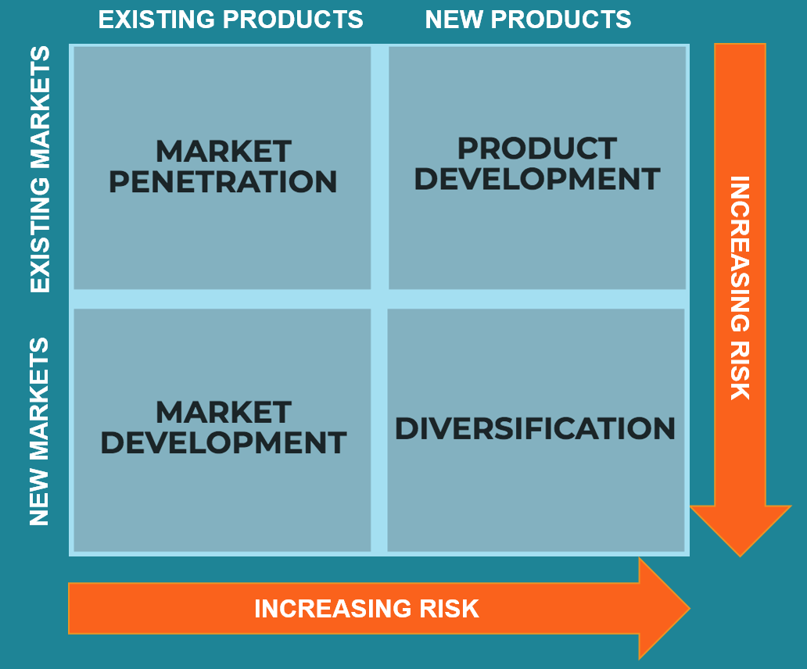
Figure 6, Ansoff Matrix (Ansoff Matrix, 2021).
The external analysis suggests that Foodworld should remain in their current market. Innovative strategies would benefit Foodworld, to offer a wider range of produce to cater for the diverse local community. Source vegan and ‘free from’ range foods to follow market trends.
A product development strategy will ensure future growth of Foodworld.

Stakeholder Analysis

Figure 7, Foodworld Stakeholder Map.

Stakeholder Mapping
Stakeholder mapping is a process to demonstrate the position and power of all the stakeholders of an organisation. The most significant benefit of a stakeholder map is to get a visual representation of all the people who can influence your business and how they are connected (Carroll et al, 2017).
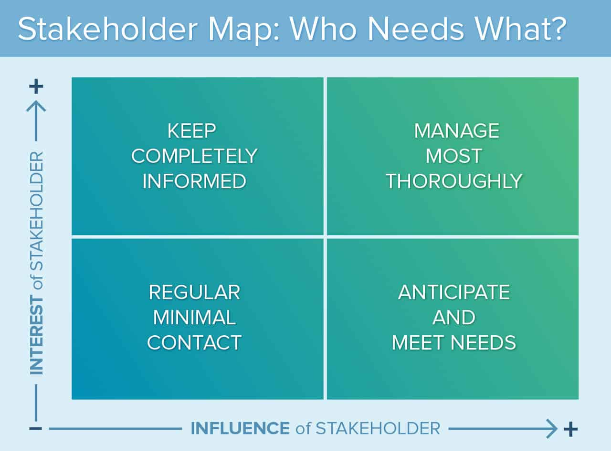
Figure 8, Stakeholder Map (Kelly, Kelly and Gamble, 1997)
Power within a business is determined by the position an individual holds. The impact individual stakeholders can have on a business will vary and is dependant on many factors including those mentioned earlier in the report in the PESTLE analysis.
There are many benefits of stakeholder mapping, such as gaining a valuable viewpoint which is important when planning changes in an organisation.

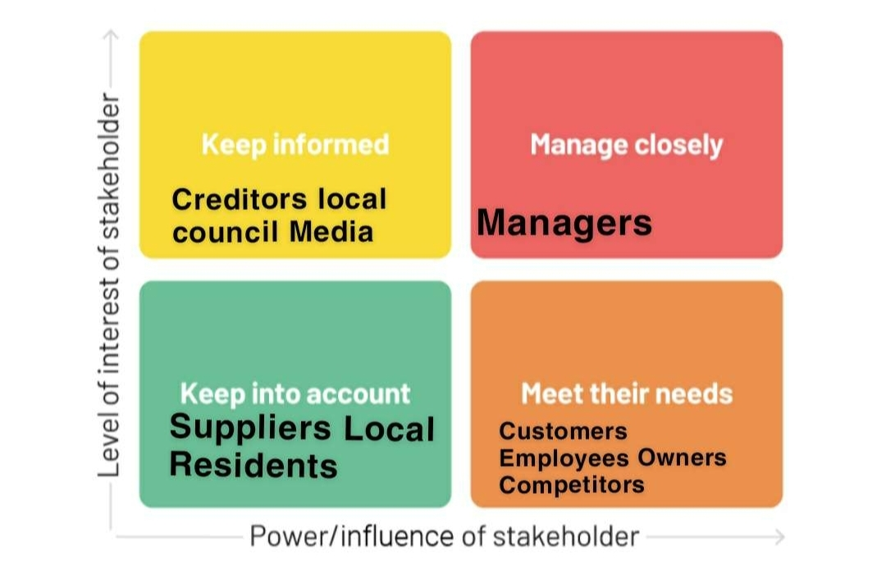

Figure 9, Stakeholder Power/Interest Grid for Foodworld
The key stakeholders include the customers, who have considerable power, as they have the choice to change their buying habits. The change for a customer is low impact, as the change does not cost them. However, during the pandemic when supply was low Foodworld and many other stores had the power. Many stores in the local area abused the power by raising their prices extortionately, some were exposed by local media and reprimanded by the local council. Nonetheless, the buyer power remained low at the time.
A significant stakeholder would be the local competitors, the power of competitors is relatively high. If a competitor gains the advantage by offering a service which Foodworld does not provide, the customers will go were their needs are being met and Foodworld will lose out. It can also be seen from Foodworlds perspective, if Foodworld are providing services and promotions unavailable in other local stores, then they will gain the competitive advantage.

Recommendations
- Product Development Strategy: Operational Level
The Ansoff Matrix analysis results showed that Foodworld would benefit from innovative thinking and introduction of a trendy new product line which would appeal to customers following the latest trends. With a focus on the current vegan, ‘free from range’ trends and also consideration for the eastern European food market.
This strategy would require research and development skills, currently Foodworld does not employ anyone with this expertise. Outsourcing an expert to analyse statistics and local data would be costly. Trials of product lines would also see Foodworld incur loss if the products did not sell.
- Renovation Strategy: Business Level
The SWOT analysis recognised the low curb appeal and dated appearance of Foodworld as a weakness. A fresh and improved look of the store would attract more customers as it would be an improved ambience and inviting place to shop.
The challenges would be the financial aspect. Foodworld is still recovering from the initial financial losses incurred in the first year of trading. Taking on more credit would increase the previous burden and although the threat of new entrants is low, competition locally is fierce and renovation strategy may not pay dividends.
- Technological Update Strategy: Tactical Level
From the PESTLE and SWOT analysis it is evident that Foodworld is lagging in technological advancement. As local competition is so strong, Foodworld require a strategy to ensure all the local customers needs are being met in Foodworld, preventing the customers from making any other pit stops in other local stores and retaining the customers full loyalty.
These investments would require training. However, they would see a return on the investments. All customers visiting Foodworld for Lottery tickets, Payzone, Paypoint or dropping off a parcel; would also see current promotions, buy from the displays at the checkout and see other marketing advertisements to see everything Foodworld is part of and has to offer.

SFA Matrix
The SFA Matrix is a tool used to determine which solution or strategy is the best based on suitability, feasibility and acceptability.
The SFA Matrix is scoring system and is best used with other analysis tools. The report has considered the findings from the Foodworld SWOT, PESTLE analysis, the Ansoff Matrix and Stakeholder Mapping.
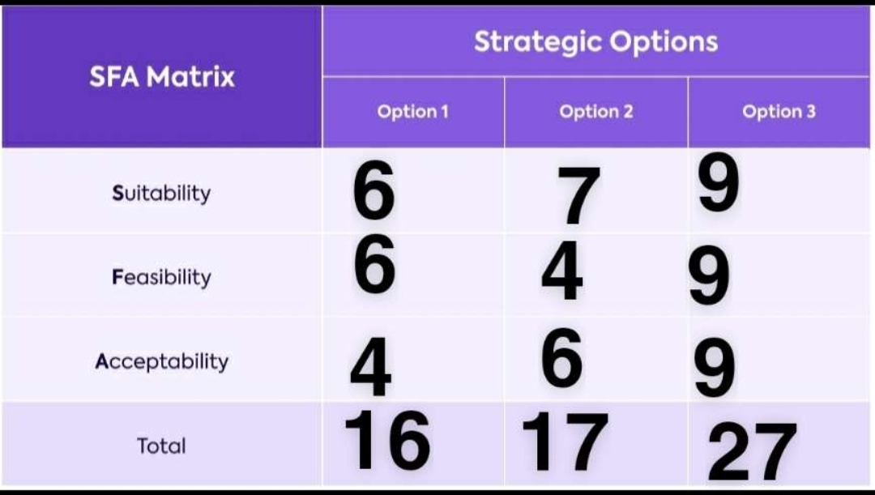

Figure 10, The SFA Matrix
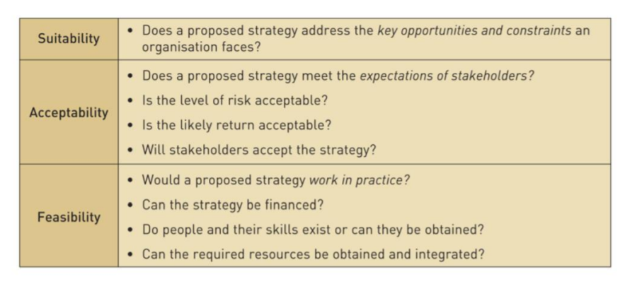
Figure 11, SFA Matrix Key
Based on the results from the SFA Matrix proposal 3. Technological Update Strategy: Tactical Level, would be the best strategy to implement.
Initial stages would involve contacting the various organisations in charge of installing the technologies on to the premises, to ensure suitability, train staff and formulate marketing and awareness strategies.

Conclusion
The main focus of this report was to critically analyse the SME Foodworld and to propose a sustainable business strategy for the business.
Initially the report analysed how Foodworld is currently operating. The results from the Porters five forces and balance score card showed that Foodworld has many areas which require development.
There are many opportunities in the market which Foodworld are not currently catering for; including the eastern European foods, latest trends and technological advancements which offer the ability for Foodworld to offer many more services.
The recommendations considered a product development strategy. Which would see the introduction of new trendy product lines. However, the risk rate was high as there is not enough resources available at Foodworld currently to implement the plan effectively.
The second recommendation was to renovate the floor and improve the aesthetic appeal of the store. This option would be challenging for Foodworld as the costs would be high and with strong competition, dividends would not be guaranteed.
The final recommendation was a tactical strategy to update and introduce the technological features which would bring in more customers. Services which would be locally exclusive at Foodworld would bring in more customers and profits. Going forward recommendation three could generate enough profits to sustain Foodworld and follow through with the other recommendations.
For the future additional features could be added, such as a cash withdrawal machine or even fresh bakery goods.

References
Atkinson. H. (2006) ‘Strategy implementation; a role for the balance scorecard?’ Management Decisions. Vol 44.10. Page 1141-1160.
Barney, J., Hesterly, S. W. & Hesterly, W. (2010) Concepts, Strategic Management and Competitive Advantage, 3/E, Prentice Hall, London.
Carroll, A., Buchholtz, A. and Brown, J., n.d(2017). Business & society.
COMMISSION RECOMMENDATION of 6 May 2003 concerning the definition of micro, small and medium-sized enterprises [notified under document number C(2003) 1422] (Text with EEA relevance) (2003/361/EC) (May 20, 2003).
Corporate Finance Institute. 2021. Ansoff Matrix - Overview, Strategies and Practical Examples. [online] Available at: <https://corporatefinanceinstitute.com/resources/knowledge/strategy/ansoff-matrix/> [Accessed 21 July 2021].
Flowers, J., 2007. Board Revises Mission and Vision Statements. AORN Journal, 86(6), pp.941-942.
GOV.UK. 2021. Food Statistics in your pocket: Global and UK supply. [online] Available at: <https://www.gov.uk/government/statistics/food-statistics-pocketbook/food-statistics-in-your-pocket-global-and-uk-supply> [Accessed 23 July 2021].
iLiveHere - Britain's worst places to live. 2021. Socio-economic statistics for Washwood Heath, Birmingham. [online] Available at: <https://www.ilivehere.co.uk/statistics-washwood-heath-birmingham-41166.html> [Accessed 20 July 2021].
International Finance Corporation, Micro, Small, and Medium Enterprises: A Collection of Published Data (17 May 2005) Available at: <https://www.worldbank.org/en/topic/smefinance> [Accessed 20 July 2021].
Kaplan, R.S. and Norton, D.P. (1996). The balanced scorecard. Harvard: Hbs Press.
Kelly, G., Kelly, D. and Gamble, A., 1997. Stakeholder capitalism. Houndmills, Basingstoke [England]: Macmillan Press.
Porter, M., 2014. Competitive strategy. [Place of publication not identified]: Free Press.
Scott, C., Jaffe, D. and Tobe, G., n.d (2004). Organizational vision, values and mission.
Simerson, B., 2011. Strategic planning. Santa Barbara, Calif.: Praeger.
The Vegan Society. 2021. Statistics. [online] Available at: <https://www.vegansociety.com/news/media/statistics> [Accessed 21 July 2021].
Toogoodtogo.co.uk. 2021. Join Our Food Waste Movement. [online] Available at: <https://toogoodtogo.co.uk/en-gb/> [Accessed 22 July 2021].
Wheelen, T. L and Hunger, J. D. (2010) Concepts in Strategic Management & Business Policy, Prentice Hall, London.

Appendix


