The Tobacco Industry in the UK
Joy James
2114452

Economics
of
Sustainability

Introduction

The production and consumption of tobacco have long been associated with significant costs to society. These costs extend beyond the immediate health impacts on individuals to include broader economic and environmental consequences. Despite the well- documented health and social costs attributed to tobacco use, the market for tobacco products often fails to fully account for these externalities, resulting in a market failure (Flor et al., 2021).

The production of tobacco generates various pollutants, including greenhouse gases, toxic chemicals and particulate matter, which contribute to air and water pollution, soil degradation, and deforestation.
The healthcare costs and productivity losses associated with tobacco-related illnesses impose substantial economic burdens on society (Hendlin & Bialous, 2019).

In response to these challenges, innovative solutions have been developed to address the failing market for tobacco by internalizing the externalities associated with its production and consumption.
This essay examines the problems, the attempted solution and whether this solution has proved successful in achieving both economic efficiency and environmental sustainability (Parrish, 2017).

Reasons for market failure

Research suggest that an externality can be defined as the effect of when the production or consumption of a product affects someone else. Where this produces a negative effect, the products are known as demerit goods. This can be a negative or positive effect depending on how it affects others (Kenton, 2022).

The World Health Organisation (WHO) suggests that the tobacco epidemic kills around 8000 people per year. Alarmingly over 7000 of those deaths are contributed to smoking whereas over 1300 are caused by passive smoking or being exposed to second hand smoke (World Health Organization, 2023).

Studies show that these costs to society are not reflected in the cost of cigarettes and so cause an overconsumption of cigarettes from a societal perspective. The cost to society in England is around £17.04 billion per year, this research suggests, is £5 billion over the initial estimated costs of around £12.5 billion. These costs are due to loss of productivity due to sickness, workers dying at an earlier age and absenteeism for cigarette breaks in the workplace .These costs include £2.4 billion to the National Health Service (NHS) for treating illnesses associated with smoking or passive smoking. Social care costs associated with smoking related needs amount to £1.2 billion pounds (Action on Smoking and Health, 2022)
.

Research suggests that this major problem for society can be lessened by tackling the use of tobacco. It would help reduce fifteen types of cancer including lung, throat cancers and leukaemia (Khan, 2022).
Recent data states that one in four deaths are linked to smoking and could have been prevented (NHS, 2022).
The risks to health associated with smoking are often downplayed by manufacturers, this contributes to imperfect information in the marketplace (World Health Organization, 2023).

The addictive nature of nicotine in cigarettes make it very difficult for an individual to stop smoking and this can result in demand for the product even when people want to give up.
Research suggests that vulnerable people are more at risk to becoming addicted to cigarettes. People from lower socio-economic areas are shown to be more likely to smoke than those from other areas (Garrett et al., 2019).
The World Health Organisation, 2023 (WHO) suggests that approximately 80% of the world 1.3 million tobacco users are from low- and middle-income countries. Research suggests that the use of tobacco contributes to poverty in these areas as people use their money to buy tobacco instead of food and are unable to stop due to the addictive nature of nicotine (WHO,2023).
This can have a negative effect on efforts to try and combat smoking, where perhaps the price is increased due to taxation. This could have a detrimental effect on the very people it is aiming to help by making their finances even worse (Blakely & Gartner, 2019).

The environmental issues associated with smoking are primarily the air pollution, and the costs of littering. However, the filters or butts seep into soil and the waterways causing far wider reaching problems to the environment. These filters are made from, or contain cellulose acetate which is a plastic, nicotine, heavy metals and other toxic chemicals. Research states that these filters can stop growth in plants and can easily be mistaken for food by marine life (NatGeoUK, 2019). The environmental problems are demonstrated in (Appendix 1).

The negative externalities of cigarette smoking result in the marginal social benefits being lower than the marginal private benefits showing a social deficit as shown in the following diagram (Figure 1).

D= MSB
Marginal Social Benefit
D= MPB
Marginal Private Benefit
Figure 1
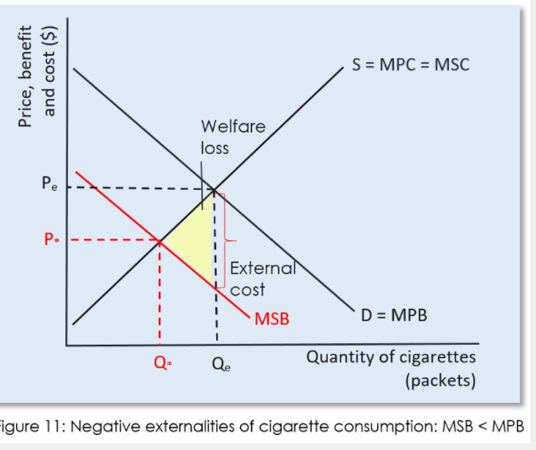
Negative externalities of smoking MSB<MPB

This figure shows that negative externalities are produced when someone is smoking, and the marginal social benefits are less than the marginal private benefits.
This translates to the smoker or person receiving the private marginal benefits, not worrying about the effects on anything or anyone else but the benefits that they experience themselves.
This means that the consumer will consume at the quantity Q1 where the marginal social costs are equal to the private benefits, rather than the socially desired level of Q* where the marginal social benefits are equal to the marginal social costs. The outcome of this is a welfare loss to society shown in the yellow shaded area.
This scenario is known as a market failure and can be defined in economics as a situation where market forces cause a reduction in societal welfare (Finch et al., 2020).
Research suggests that this could have a detrimental effect on society and would result in the Governments efforts in England to achieve a smoke free country by 2030, where only 5% of the population would be smokers an impossibility. Appendix 2 shows how the smoking trends are reflected of people stopping smoking, this demonstrates that the target would not be met until 2037. The rate at which people are stopping smoking he suggests needs to increase by 40% for that deadline to be met (Khan,2022).

Solutions for Improvement of Market Failure

To combat this negative effect of market failure on society there are some things which can be done to change the social effect and the environmental impact (Pettinger, 2020).
Khan, 2022, suggests that there could be a tax imposed on cigarettes to increase the price then the amount that people are buying or smoking should be lower. He further suggests that vaping could be offered as a substitute and Government could provide ‘Swap to stop’ free packs in deprived areas. He stressed however that young people should not be encouraged to try vapes if they don’t already smoke. Another deterrent to smoking is the position of cigarettes in a shop, in April 2012, the Government made it compulsory for every shop to keep cigarettes in a cabinet out of sight. Research states that this could help deter smokers and would be smokers to want a cigarette. Educating people as to the adverse effects of smoking on the individual and anyone around them, and also the effects to the environment could have a positive effect on the person to be encouraged to stop smoking.(Health, 2012)

Solution 1 – Tax & Restricting use.

Research states that Tobacco taxes are the most cost-effective way to reduce tobacco use. If tax is increased by 10% research shows that the consumption of tobacco falls by about 4% in high income countries and falls to 5% in lower income countries (World Health Organization, 2023).

The aim of this tax is to discourage smoking among younger people and smokers in general. By increasing the selling price of cigarettes its further aim is to reduce the demand. This reduction in demand could then lead to positive externalities such as reduced costs to the NHS and decreased environmental pollution from the waste associated with smoking; and the health problems associated with passive smoking (WHO,2025).
There are statistics which suggest that 5% of children aged 11-15 are regular smokers. More than 39% declared that they had started smoking before 16 years old. Research suggests that 300,000 under 16’s try smoking each year. This shows the importance of combatting this social problem
Research states that a year after the government introduced a ban on smoking in public places, there has already been a 12% reduction on hospital admissions for children with respiratory problems. (Kmietowicz, 2015).

The other advantage of imposing a tax on cigarettes would be increased revenue for the government. This money could then be spent on healthcare campaigns to encourage people to stop smoking.

This diagram (figure 2) shows how the effect of imposing a tax on cigarettes can have a positive effect on society.

Diagram showing the effect of Tax on Cigarettes

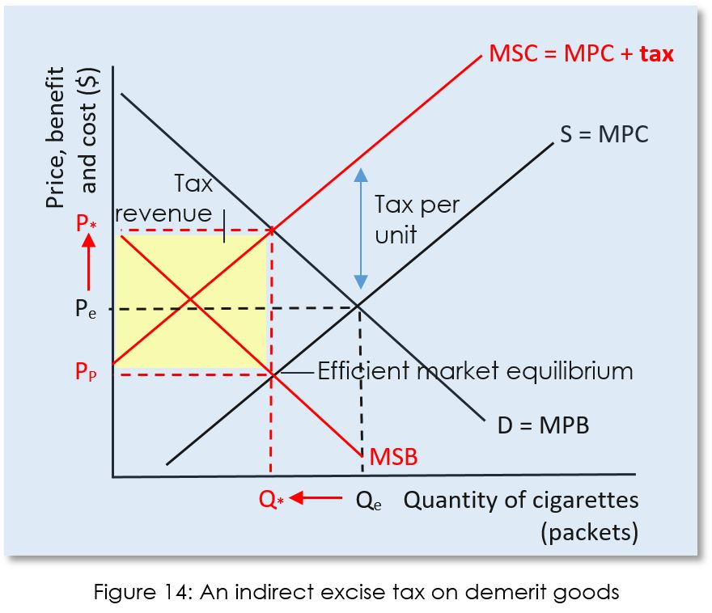
Figure 2

The results after the imposed tax on cigarettes.
The tax results in a higher cost to the smokers and a lower cost being received by the tobacco company, and at this higher price the allocatively efficient quantity of the cigarettes are being consumed and produced. Therefore the negative externality of the consumption has now been internalised.
Price
£
Research states that after this tax was imposed on cigarettes of approximately 5% the probable result would be a decline in consumption of 33.1% (Beard et al., 2022).

Solution 2 – Educating people and providing information

Educating people about the health risks and consequences of smoking can help reduce the externalities.
The education to raise awareness about the harmful effects of smoking on the individual and the health of other people include information on diseases such as lung cancer, respiratory complications and heart disease.
The passive smoking issue is another concern to be highlighted where family, co-workers and friends who are exposed to this second-hand smoke can also be at risk of lung cancer, respiratory complaints and heart disease.
Research suggests that educating people can lead to individuals being able to make informed decisions regarding their behaviour. This could make them more inclined to not smoke or at least show consideration to others who don’t smoke.
Support services who are pro-active in educating about cessation programs and offer resources to help cease smoking can lead to a decrease in the numbers of people who smoke. This in turn can reduce the externalities associated with smoking related illnesses and therefore costs to the health service.
This education means that people are more likely to support policies such as smoke- free laws and tobacco control measures. This can encourage public support for campaigns to protect the environment and reduction of the social externalities of smoking (Khan,2022).
Khan,2022, further suggests that as Secretary of state for health and social care he will commit £70 thousand pounds in the bid to prevent smoking measures.
The WHO framework convention on tobacco control (WHO FCTC) established in 2023 introduced a treaty to help control the tobacco epidemic. Research suggests that there are currently 182 countries supporting this treaty.
This method of smoking prevention includes the encouragement of every NHS worker to promote the benefit of stopping smoking at every opportunity (Khan, 2022).
Benham-Clarke et al., 2021 suggests that the influence of education on individuals where education can play a role is by promoting awareness, influencing attitudes and encouraging individuals to make better choices. Policy holders can concentrate their efforts on communities where smoking rates are highest so that they can promote the use of education as a powerful tool in reducing tobacco related harm (Benham-Clarke et al., 2021).

The typical effect this will have if implemented is that the price of cigarettes will remain the same but the demand for cigarettes should fall. This can be seen in the following diagram.

Diagram showing the effects of education on smoking
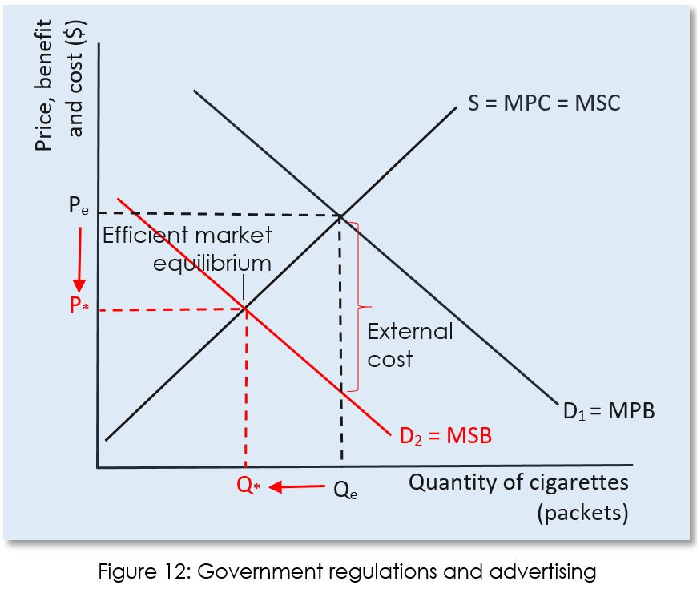
Figure 3

The results after educating people on smoking.

The results show that as demand decreases due to the educating of the individual in the dangers of smoking Qe decreases to Q* and the price falls from Pe to P* as the manufacturers reduce prices to reduce their excess stock of demerit goods.

Research shows that the rates of smoking during 2001-2016 was reduced by 10.8% due to stop smoking programmes. The attempts to quit had a higher success rate than those without the support and education of the support groups showing a 15.1% as compared to aa.3% in the groups without the cessation groups aids (Song et al., 2019).
This shows an positive success rate for the effect of education on cessation of smoking.

Solution 3 – Alternative solution- Nicotine Replacement Theory.

Providing alternative options to smoking can help reduce the social externalities of smoking by reducing health risks.
Products such as nicotine patches, gums, lozenges, electronic cigarettes and vapes are less harmful than cigarettes. Smokers who switch to these are generally thought to be at less risk than by traditional smoking. This would prove to be less demand on the healthcare service (Cao et al., 2015).

Research suggests that the emissions from e cigarettes are less harmful to people who are exposed to second hand smoke so this would result in cleaner air and protect the individual from exposure to by-products of nicotine (Cao et al., 2015).

There is research that suggests that electronic non-nicotine delivery systems (ENNDS) when used by children could be potentially harmful to health. This means that it is essential for the information on this potential hazard to public health to be related to individuals (Yoong et al., 2021).

Khan, 2022, suggests that the promotion of vapes as an alternative to smoking can be effective and not as dangerous to the passive smoker or the environment, he further states that even though they are not totally without problems, the alternative is worse.
Nicotine is an addictive substance, and this is the biggest problem when people are attempting to give up smoking. The use of chewing gum or patches are thought to help with the cravings and withdrawal symptoms allowing the smoker to be more successful in the attempt to give up.
This would result in the cost of cigarettes staying the same, but the demand would be less This is shown in the following diagram (fig.4).
Diagram showing the effects of Vaping on smoking

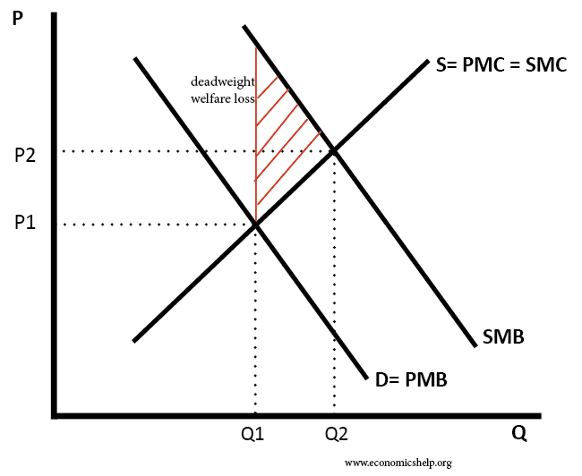
Figure 4

Results after the use of vapes as an alternative to smoking.

Research states that vapes are used by around 2.8 million people as an aid to quit smoking. 1 millions of these are current smokers whilst 1.5 million have been successful in giving up the habit. This data suggests that vaping is highly effective as an aid to stop smoking (Selbie, 2018).

Conclusion

This paper aimed to highlight the problems associated with the market failure of cigarettes and the negative externalities that were associated with such failure. These externalities include imperfect information, the addictive nature of nicotine, the market power of tobacco companies and the vulnerabilities of the lower socio- economic populations. These factors have all contributed to an overconsumption of cigarettes and the underestimation of the costs to society.
Research suggests that the scale of human, social and environmental impact of smoking is unacceptable and preventable.
The need to address these market failures requires government intervention using policies such as taxation, public education campaigns and the regulation of how, where and to whom these products are sold. This paper has looked at these measures and hypothetically shown the possible results of such campaigns. This demonstrates that by implementing these measures societies can mitigate some of the adverse effects of smoking and promote public health and wellbeing.

Words- 2531

Appendix 1
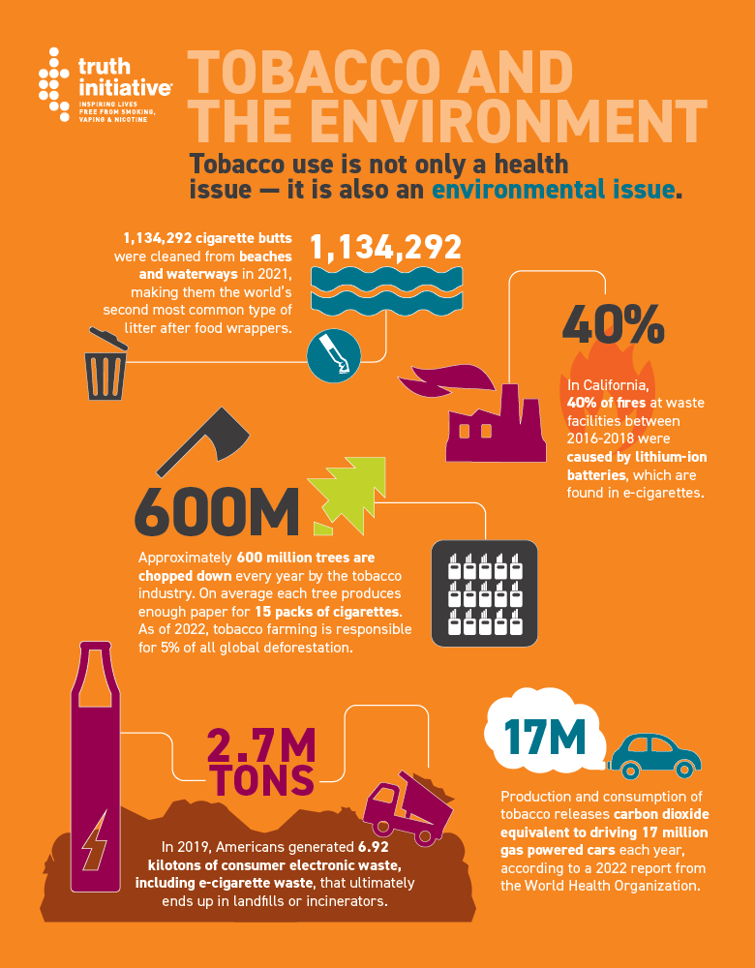

(Truth Initiative, 2023)

Appendix 2

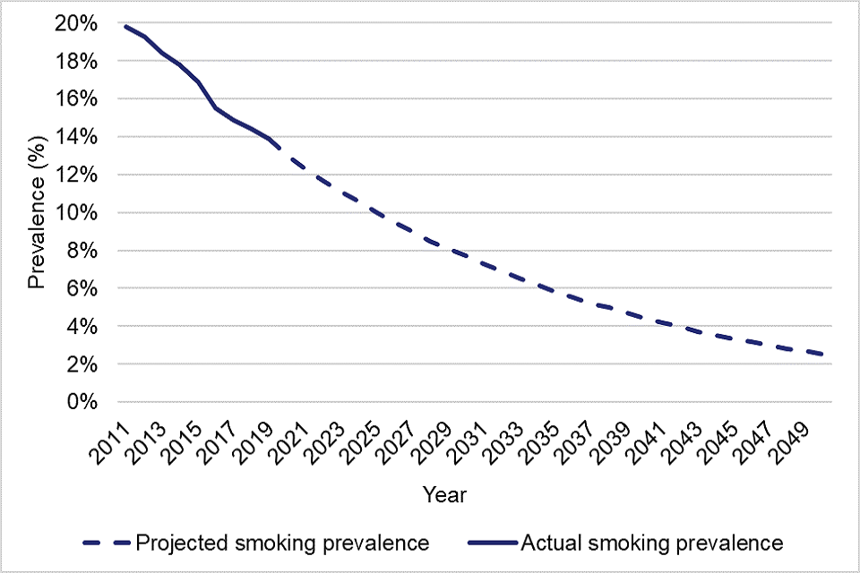

(Khan, 2022b)

References

AP MICROECONOMICS. 2022. Externalities - AP Microeconomics. [online] Available at: <https://www.microeconomicsap.com/externalities-ap-microeconomics.html> [Accessed 23 February 2022].
ASH. (2017, March). The Economics of Tobacco. ASH.
https://ash.org.uk/resources/view/the-economics-of-tobacco
Action on Smoking and Health. (2022, January 14). Smoking costs
society £17bn – £5bn more than previously estimated. ASH.
https://ash.org.uk/media-centre/news/press-releases/smoking-costs-
society-17bn-5bn-more-than-previously-estimated

Beard, E., Brown, J., & Shahab, L. (2022). Smoking prevalence following
the announcement of tobacco tax increases in England between 2007
and 2019: an interrupted time‐series analysis. Addiction.
https://doi.org/10.1111/add.15898

Benham-Clarke, S., Ford, T., Mitchell, S. B., Price, A., Newlove-
Delgado, T., Blake, S., Eke, H., Moore, D. A., Emma Russell, A., &
Janssens, A. (2021). Role of education settings in transition from child to
adult health services for young people with ADHD. Emotional and
Behavioural Difficulties, 26(4), 341–358.
https://doi.org/10.1080/13632752.2021.1989844
Blakely, T., & Gartner, C. (2019). Tobacco taxes have mixed effects on
socioeconomic disparities. The Lancet Public Health, 4(12), e595–e596.
https://doi.org/10.1016/s2468-2667(19)30223-3
Finch, D., Briggs, A., & Tallack, C. (2020, February 19).
Improving health by tackling market failure - The Health
Foundation.
Www.health.org.uk.failure#:~:text=The%20cost%20price%20of%20a

Flores, M. C. (2008). Plastic Materials and Environmental Externalities: Structural Causes and Corrective Policy. Opus.uleth.ca. https://opus.uleth.ca/items/8b9996d1-c4d5-410d-a5b2-28727bff9735

Flor, L. S., Reitsma, M. B., Gupta, V., Ng, M., & Gakidou, E. (2021). The
Effects of Tobacco Control Policies on Global Smoking Prevalence.
Nature Medicine, 27(2), 239–243. https://doi.org/10.1038/s41591-020-
01210-8

Garrett, B. E., Martell, B. N., Caraballo, R. S., & King, B. A. (2019). Socioeconomic Differences in Cigarette Smoking Among Sociodemographic Groups. Preventing Chronic Disease, 16(16). https://doi.org/10.5888/pcd16.180553

Health. (2012, April 6). Tobacco displays in shops to end from today.
GOV.UK.
https://www.gov.uk/government/news/tobacco-displays-in-shops-to-end-
Healton, C. G., Cummings, K. M., O’Connor, R. J., & Novotny,
T. E. (2011). Butt really? The environmental impact of cigarettes.
Tobacco Control, 20(Supplement 1), i1–i1. https://doi.org/10.1136/tc.2011.043729
Hendlin, Y. H., & Bialous, S. A. (2019). The environmental externalities
of tobacco manufacturing: A review of tobacco industry reporting. Ambio,
49(1), 17–34. https://doi.org/10.1007/s13280-019-01148-3

Hussen, A. M. (2019). Principles of environmental economics and sustainability an integrated economic and ecological approach (4th ed.). London: Routledge.
Kenton, W. (2022, December 31). Externality: What It Means in
Economics, with Positive and Negative Examples.
Investopedia.https://www.investopedia.com/terms/e/externality.asp

Khan, J. (2022, June 9). Independent review published to help
meet 2030 smokefree target. GOV.UK.
https://www.gov.uk/government/news/independent-review-
published-to-help-meet-2030-smokefree-target

Khan, J. (2022b, August 25). Making smoking obsolete: summary.
GOV.UK. https://www.gov.uk/government/publications/the-khan-review-making-smoking-obsolete/making-smoking-obsolete-summary

Kmietowicz, Z. (2015). Smoking ban cuts admissions for child
respiratory infections. BMJ, 350(jun01 8), h2913–h2913.
https://doi.org/10.1136/bmj.h2913

NatGeoUK. (2019, August 12). Cigarette butts are toxic.
plastic pollution. Should they be banned? National Geographic.
https://www.nationalgeographic.co.uk/environment-and-
conservation/2019/08/cigarette-butts-are-toxic-plastic-pollution-
should-they-be-banned.

Parrish, E. (2017, March 28). Smoking and It’s Negative Externalities. Bear Market https://bearmarketreview.wordpress.com/2017/03/28/smoking-and-its-negativeexternalities/#:~:text=Smoking%20has%20a%20major%20negative

Pettinger, T. (2020, March 10). Policies to overcome market failure.
Economics Help.
policies/#:~:text=Policies%20to%20overcome%20market%20failure%2
1%20Taxes%20on
Selbie, D. (2018, July 3). Turning the tide on tobacco: Smoking in England hits a new low - UK Health Security Agency.Ukhsa.blog.gov.uk.
https://ukhsa.blog.gov.uk/2018/07/03/turning-the-tide-on-tobacco-smoking-in-england-hits-a-new-low/

Sloman, J. (2019). Economics for business. Harlow, England: Pearson.

Song, F., Elwell-Sutton, T., & Naughton, F. (2019). Impact of the NHS
Stop Smoking Services on smoking prevalence in England: a simulation
modelling evaluation. Tobacco Control, 29(2), tobaccocontrol-2018
054879. https://doi.org/10.1136/tobaccocontrol-2018-054879

Truth Initiative. (2023, April 26). Tobacco and the environment. Truth Initiative.environment#:~:text=Land%2C%20Coastal%20and%20Water%20Pollution

World Health Organization. (2023, July 31). Tobacco. World Health
Organization;

World Health Organization. https://www.who.int/news-room/fact
sheets/detail/tobacco

Yoong, S. L., Hall, A., Leonard, A., McCrabb, S., Wiggers, J., Tursan
d’Espaignet, E., Stockings, E., Gouda, H., Fayokun, R., Commar, A.,
Prasad, V. M., Paul, C., Oldmeadow, C., Chai, L. K., Thompson, B., &
Wolfenden, L. (2021). Prevalence of electronic nicotine delivery systems
and electronic non-nicotine delivery systems in children and
adolescents: a systematic review and meta-analysis. The Lancet Public
Health, 6(9), e661–e673. https://doi.org/10.1016/s2468-2667(21)00106-

