Essential Academic and Employment Skills: Summary
Academic and professional skills are essential for success in both education and the workplace. The ability to communicate, think critically, use information literacy, and manage time are key academic skills [1]. Strong communication—both written and verbal—supports effective assignment completion, class participation, and collaboration.
Students who use critical thinking can assess evidence, analyze issues, and come up with logical answers. Students who possess information literacy can recognize reliable sources, analyze data, and ethically use information [2]. Maintaining productivity, meeting deadlines, and balancing workloads are all made possible by time management.
Employment skills such as teamwork, adaptability, digital literacy, and professionalism are equally important. Teamwork prepares individuals to 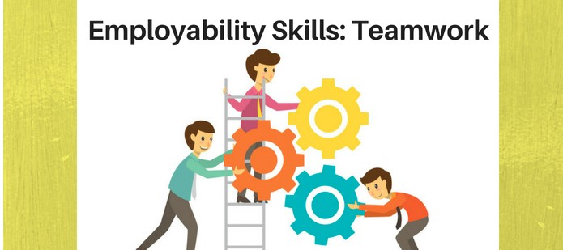
Figure: Employability skills.

work collaboratively in diverse environments, while adaptability enables them to adjust to changing technologies and workplace expectations [3].
As businesses depend on software tools, communication platforms, and data systems, digital literacy has become crucial for modern jobs. Professionalism, which includes accountability, dependability, and moral conduct, promotes trust at work and long-term job development.

Career choice and planning are directly supported by these academic and employment skills. Career paths aligned with individual strengths, including communication skills, analytical thinking, and digital competency, can be identified by understanding personal strengths.
Gaining proficiency in these areas also boosts self-esteem, enhances employability, and expands employment options in a variety of industries [4].
Ultimately, the combination of academic education and workplace skills equips individuals to make informed career decisions and succeed in a competitive job market.

References (IEEE Style):

References

[1] | P. Race, The Lecturer’s Toolkit: A Practical Guide to Assessment, Learning and Teaching (5th ed.), London: Routledge, 2020.
[2] | U. I. f. I. T. i. Education, “Digital Literacy in Education,” 2011. [Online]. Available: https://iite.unesco.org/publications/3214688/.
[3] | L. Harvey, “Quality in Higher Education,” vol. 27, no. 1, pp. 1-15, 2021.
[4] | T. H. &. P. M. P. J. Robertson, The Oxford Handbook of Career Development, Oxford,UK: Oxford University Press, 2020.

