
Katya Koleva
sTUDENT iD: 2123449 |
lecture: Anita nAN
EFFECTIVE TEAM WORKING AND COMMUNICATION- REPORT
Module code: BMSW4002_LON

Contents:
Introduction………………2
Models of communication…………
- Shannon and Weaver………3
- Schamm’s Model………………..4
- Berlo’s SMCR…………..6
Communication skills……….
- Verbal (oral)………….7
- Verbal (writinging communication)……………..7
- Non –Verbal………………..8
Listening…………………9
- Good listening depend on
- Active listening requires
- Key for better lisening
The advantages and disadvantages of technology in communication……..10
Conclusion………………………….11
References……………………….12

Introduction:
To communicate is sending and reciving information. Communication some times could be misunderstanding.Communication is when their is two people sharing information or talking to each other.Someties we say something but we meant something else.Communication some times is really hard and we have to know more about the communication process.In this report I am going to describe the models we learn in class which are Shannon and Weaver, Schamm’s Model, Berlo’s SMCR. Furthermore, I will deliberate the communication skills which are Verbal (speaking), Verbal (writing),Non –Verbal and listening. Lastly, the report will describe the advantages and disadvantages of technology in communication.I will finish with my conclusion and references in the end.

Three models of communication:
Shannon and Weaver
The first model of communication I am going to describe is the Shannon and Weaver:The Shannon and Weaver Model of Communication is theory which believes that the human communication can be divide in 6 key concepts: sender,encoder,channel,noise,decode,an receiver. This model is individually created to improve the effective communication between sender and receiver. Also they find factors which affecting the communication process called “Noise”.
Sender -is someone who send the message.
Encoder-is someone who encode the message.Channel-is the Noise which doesn’t allow the message to to the right place.Decoder- this is the person who converts signals into messageReceiver- this is person who receive the message. I will use Pedro and Maria case study show an example of Shannon and Weaver communication.This case study show us what happened when their a noise.Pedro works on a building site and Maria is his wife.Maria call him and ask for a chicken but because of the noise in his workplace he did not hear her,what he hear was “I will see you in the kitchen!”
This is the diagram of Shannon and Weaver:
(shannon and weave, 2022)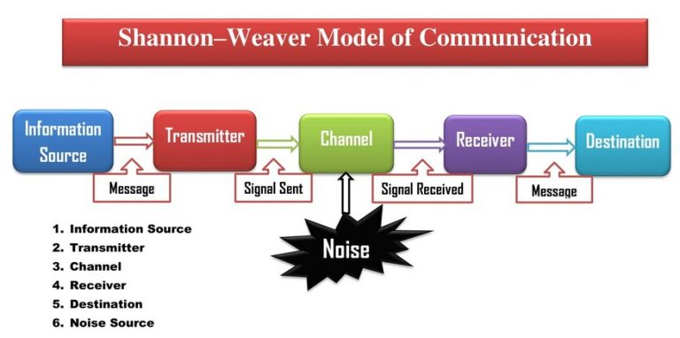

Schamm’s Model of communication
Schramm shown as that communication always requires three elements – the source, the message and the destination. He highlights that the communication is incomplete unless and until the sender receives a response from the receiver.
Schramm said that communication is truly a two-way process between one person and another person. This model brings a simple method to describe the flow of communication. It suggests that communication is a two-way path with the message continually passing between the sender and receiver. The model underlines that communication is not full until the sender gets feedback from the receiver.
The sender is someone who send the message.
Encoder is someone who encode the message.
Message: The idea,that the sender wants to communicate.
Communication channel: The method of delivering the message.
Receiver: The target audience of the message.
Decoding: The interpretation of the message.
Feedback: The response or action a receiver takes after decoding a message.
Example from my workplace is: Sometimes the backround noise outside the building do not allow my and my collegues to understand each other.
(Wilbur Schramm , 2022)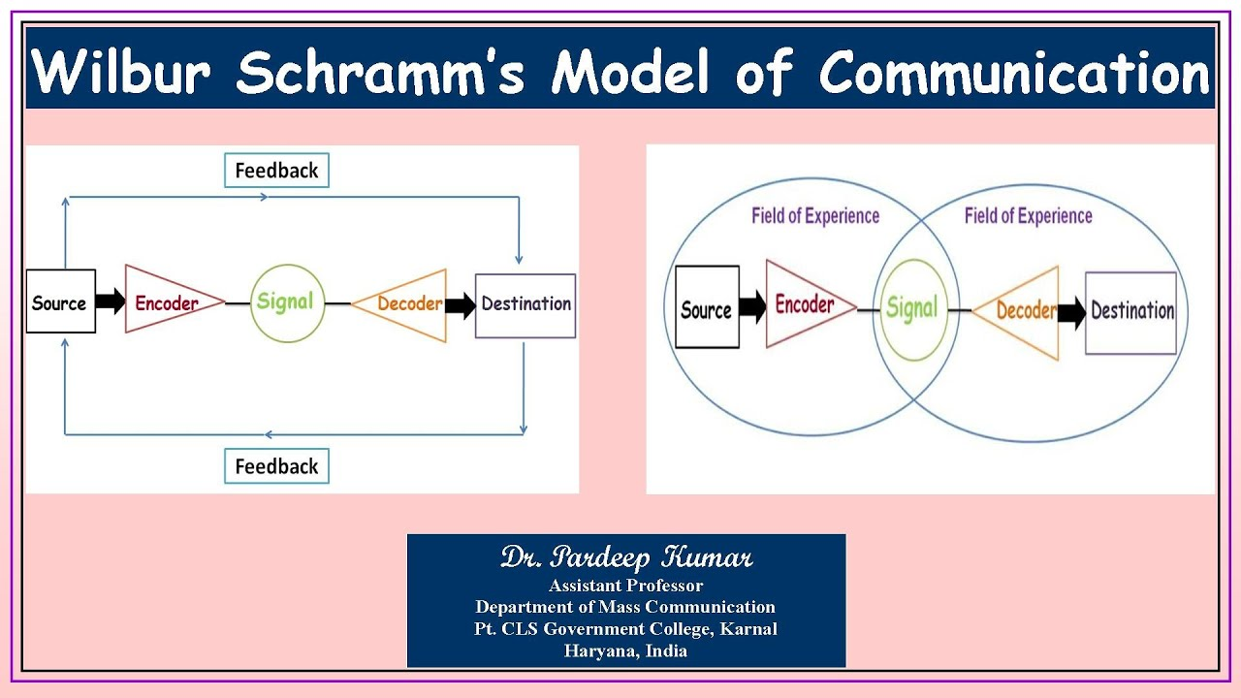
Berlo’s model of communiction
David Berlo developed Berlo’s model of communication. The model also focuses on encoding and decoding which happens before sender sends the message and before receiver receives the message respectively.Berlo’s Model has mostly, four components to describe the communication process. They are sender, message, channel and receiver.The sender:is someone who send the message.The message: is the information that is sent from sender to receiver.Channel: This is the one used to send the message.Receiver:The person who receive and decode the message.
I will use the “Professior in the village case study” to give an example of Berlo’s model of communication.The professor fell asleep while smoking his pipe onto the carpet and everything was on fire.He was looking for a help but because of the noise people did not hear him.I will give example from my workplace “Sometimes when my manager gives instruction,the backround noise in the next room do not allow us to understand the instruction.”
(Berlo’s SMCR diagram, 2022)
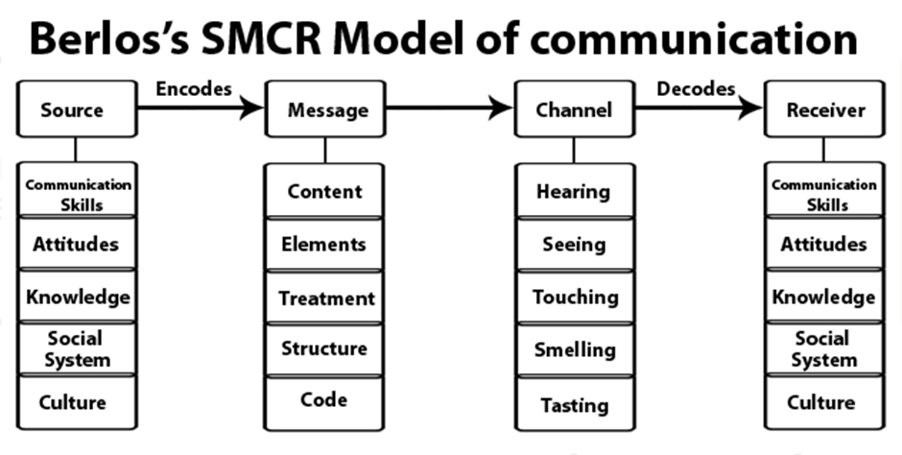
Communication skills in the workplace
Verbal and Non- Verbal
The verbal communication is the things we say
Non-verbal communication is the things we don’t say, but communicate through our body language, signs and signals.
Both verbal and non-verbal communication are important and can say different things.
It is important we are aware of our own verbal and non-verbal communication and that of others.
First I will start with the Verbal.This is oral and written communication.
Oral communication is the things we say. The oral communiacation should be clear and loud the people can understand it.Oral is when you talking to others by share your ideas,communicate thoughts and exchange information.There is some advantages of oral communication which are:People can understand you easily, the feedback is natural in case of oral communication.The decision can be made quickly,oral communication is saving your time.When you are working in a team the oral communication is essential.There is always disadvantages aswell.Sometimes may be misunderstanding in the oral communication,also the oral communication is less reliable than written communication as it is informal and not as organized as written communication.
There is written communication aswell and this is when you communicate with others by the written words such as:Email,text messaging,cards and letters.I write down some of the advantages of written communication which are:This type of communication it provides you with records and references aswell while in the oral communication you can not prove what people are saying to you.
Written communication can help you to putting down your policies and principles.I will list down some of the disadvantages aswell.Writen communication takes time,it takes money for stationary,the feedback is not immediately.
There is a formal and informal communication.
Formal communication is the discussion of information officially. It is also known as ‘official communication’. In this type of communication, information is transmitted through proper official channels and routes.The formal communication is when your are talking or writing to someone you do not know for example business letters, post descriptions, work command,reports and council letters.Informal communication is when you are talking to your friends face-to-face communication and telephonic conversations. The main point of informal communication is to talk about personal interests and needs,infornal language is used without any rules,you are talking to your frrinds in informal communication.
Non-verbal communication is the things we don’t say, but communicate through our body language, signs and signals. There is some examples for non-verbal communication which are:body movement,eyecontact,space,facial expressions and touch.
LISTENING The capability to be a good listener is main key in business. You have to be able to listen to your customers.Lisesning is one of the soft skills which everyone must have. Without active listening skills, you will not receive and understand the message.As a result of this the communication will break down and you will make the person front of you upset.With the good listening skills you can improve your communication skills.
Active Listening:Active listening is a communication skills which inovles you to hear what the person is saying to you but also you must understand the message.There is some techniques which can be used to improve the acrive listening.
- Be fully present
- Encourage yourself to listen
- Do not interrupt
- Ask positive questions
- Listening to understand rather than to respond
- Showing interest by practicing good eye contact.
Good listening depends on: Paying attention,you have to show you are listening,providing feedback,Putting aside any inflexible ideas,building an open mind,active arrangement with the speaker and silences is communication as well.
Active listening requires:Attention, commitment and availability.
Keys for better listening:You have to give your attention to the speaker,stay open-minded,don’t interrupt people,Include yourself in the communication.
Good elements of communication skills in the workplace can reduce conflicts,can improve the communication between collages and employees.We can improve the communication skills in the workplace by building good relationship with our employee. We can avoid conflicts by having good communication with our colleagues. Communication is really the grease that makes any business run well.For good communication in the workplace their some essential communication skills such as:
Listening skills-First of all people need to lisen to each other.
Another one is the empathy:After listening to the instruction the second thing you have to is understanding and empathise with people.You have to understand how the people feel,trying to understand and help them.
The third one is patience:When you have patience you can calmy communicate about your feelings.
The fourth one can be the positive attitude:When you are positive you are making the life better place for you and others as well.
Being honest and open-minded – that will get you go much further.
Giving and receiving feedback:That will help you to movw forward after a problem.Everyone likes to receive good feedback but we have to accept the bad ones aswell.
Self-improvement-Continuous improvement isn’t just for the business. Life-long learning is good for you, giving you new perspectives and ideas, and widening your experience and your viewpoint.

The advantages and disadvantages of technology in communication:
Advantages
You can communicate with your lectures through email and you do not have to go the campus for a feedback.Student can communicate with their colligues trough teams and what’s app group.Also students can write their assignment by using any PC or laptop.Student do not have to write their assignment with pen and paper they can use Word.
There is a lot of disadvantages aswell.
Disadvantages can be that while your resurcching for information for your report you might have some virus which will destroy your computer.Another dissadvatges is that the student sometimes had problems with the internet and they cannot join their sessions.Sometimes student can be distruct by many other things while they study online.Many students prefer to study online because they do not have to travel, they do not have to pay for breakfast or lunch and many others factors. One of the most dengarous disadvantages Is the On-line Bullying.Cyber Bullying is around the students and have been for a long time, but the use of social media, are now giving them much a freedom do to whatever they want to do. A lot of students are bullying around the social media they are bullying another students sometimes just because they don’t like them and many other things. People are using fake profiles to bullying.
The phones and computers are good for students because they can chat to their collegus trhout teams or what’s upp.They can communicate with their lectures through email,lectures can give them feedbacks.We can use them to study online,writing our reports,learning trough Module.
They are not good because sometimes while you are looking for information for your report you report hackers can steal your privarcy information,you can open some virus and that will destroy your computer.

Conclusion
This report will give a brief description of what we learn in this particual module here you find out information about the three models of communication, namely Shannon and Weaver, Schamm’s Model, Berlo’s SMCR. There is information about the communication skills,Verbal and non-verbal communication,listening,active listening and also the advantages and disadvantages of technology in communication.On the last page you can see my references.

References:
https://topadvantagesof.com/advantages-and-disadvantages-of-technology-on-communication-impact-types-and-ways/
https://www.communicationtheory.org/berlos-smcr-model-of-communication/#:~:text=Berlo's%20model%20believes%20that%20for,the%20receiver%20should%20be%20similar.
https://www.communicationtheory.org/shannon-and-weaver-model-of-communication/
http://kell.indstate.edu/public-comm-intro/chapter/3-2-defining-verbal-communication/
http://kell.indstate.edu/public-comm-intro/chapter/3-2-defining-verbal-communication/
https://managementstudyguide.com/written-communication.htm
https://www.managementstudyguide.com/written-communication.htm

