Campus Club Management System (CCMS)
Database Design and Implementation Report
Tyler Bate (2304031)
ACCA5026 Database and App Development
Contents
1. Introduction 1
2. Database Design 1
2.1 Entities and Relationships 2
2.2 Normalisation and Design Decisions 3
3. Implementation Documentation 3
3.1 Table Creation 3
3.2 Constraint Implementation 3
3.3 Sample Data Insertion 4
3.4 Trigger and Stored Procedure Execution 4
4. Stored Procedures and Transactional Scenario 5
4.1 CRUD Stored Procedures 5
4.2 Transactional Scenario 6
5. Performance Tuning Enhancement 6
5.1 Indexing Strategy 6
5.2 Performance Benefits 7
6. Conclusion and Reflection 7
7. References 8

1. Introduction
The Students' Union contributes significantly to the quality of student life by sponsoring a diverse range of clubs and organisations, including intellectual, cultural, and sporting activities. These clubs rely on precise membership records, well-organised event management, and effective member communication. However, the Students' Union's existing system is mainly based on paper data and disconnected spreadsheets. This disjointed approach makes it difficult to assess student involvement, manage memberships effectively, and maintain data veracity across numerous activities.
The Campus Club Management System (CCMS) was created to overcome these issues by implementing a centralised relational database with MySQL. The fundamental goal of the CCMS is to enhance data integrity, decrease redundancy, and facilitate efficient data storage and retrieval. This report describes the design and implementation of the CCMS database and assesses how well the final solution fits the functional and technical objectives described in the case study brief.

2. Database Design
The CCMS database was built on a relational format to ensure scalability, consistency, and long-term maintenance. A relational method was chosen because it allows data to be organised into well-defined tables, with relationships enforced by keys and constraints. This is especially appropriate for a system like CCMS, where several entities are linked and data accuracy is critical.
An Entity Relationship Diagram (ERD) was constructed at the design stage to model entities, properties, and relationships before any implementation work began. This helped to determine how data would be integrated and ensured that all functional criteria from the case study were met. The final database is made up of six main entities: Students, Clubs, Memberships, Events, Participation, and Announcements, each reflecting an important part of campus club management.

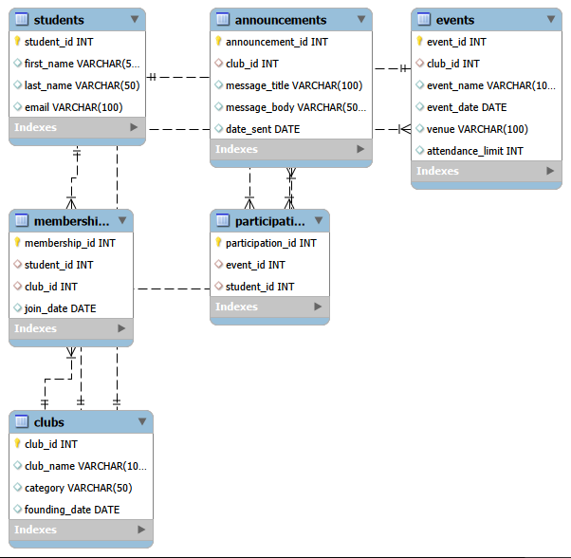
Figure 1: Entity Relationship Diagram (ERD) for the Campus Club Management System.

2.1 Entities and Relationships
The Students entity contains basic student information such as first name, last name, and email address. This data uniquely identifies students in the system and facilitates membership and participation tracking. The Clubs entity maintains information about each club, such as its name, category, and creation date, making it possible to combine and administer clubs more effectively.
Because students can join many clubs and clubs can have a large number of members, there is a many-to-many relationship between them. This link is addressed using the Memberships junction table, which keeps track of when a student joins a given club. Using a junction table eliminates duplicating student or club data and enables for the analysis of membership trends throughout time.
Similarly, the link between Students and Events is many-to-many, with students attending several events and events hosting multiple participants. This relationship is resolved by the Participation table. The Events entity has a one-to-many relationship with Clubs because each event is organised by a single club. Furthermore, clubs can make many announcements, creating a one-to-many link between Clubs and Announcements. These relationships guarantee that all interactions among students, clubs, and activities are appropriately reflected.

2.2 Normalisation and Design Decisions
The CCMS database uses the Third Normal Form (3NF) to reduce redundancy and increase data integrity. Each table represents a single entity, and all non-key properties are determined only by the primary key. This eliminates partial or transitive dependencies and assures that data modifications can only be made in one location.
Junction tables were created to decrease redundancy and avoid update anomalies. For example, membership data is not duplicated in the Students or Clubs databases, so changes to a student's or club's information do not necessitate updating multiple records. This approach increases consistency, simplifies maintenance, and adheres to recognised database design principles and best practices [1]. This technique adheres to traditional database normalisation principles, which seek to decrease redundancy and improve data consistency by arranging data into well-defined relationships [7].

3. Implementation Documentation

3.1 Table Creation
The CCMS database was built in MySQL with SQL Data Definition Language (DDL). Each table has an auto-incrementing primary key that uniquely identifies records. Foreign key constraints were implemented to ensure that tables had valid relationships.
Figure 2 shows the successful creation of all tables within the CCMS database.
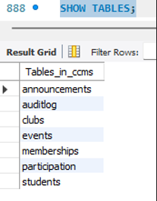
Figure 2: Creation of core CCMS database tables in MySQL.

3.2 Constraint Implementation
Several limits were imposed to ensure data integrity. Foreign key constraints avoid orphan records and guarantee that linkages are genuine, such as prohibiting a membership from referring to a non-existent student. Unique limitations were used to avoid duplicate student email addresses, memberships, and participation data.
Where supported, CHECK constraints were used to enforce logical principles, such as avoiding negative attendance restrictions for events. Constraint validity was tested by purposely inserting erroneous values, which produced MySQL error messages. Figure 3 shows constraint enforcement during data validation. The employment of primary key, foreign key, UNIQUE, and CHECK constraints is consistent with typical SQL constraint procedures used to ensure data integrity at the database level [5].

Figure 3: Enforcement of database constraints ensuring referential integrity.

3.3 Sample Data Insertion
Sample data was entered into each table to test and validate the database design. This comprised students joining several clubs, clubs planning activities, and students attending those events. The added data reflects realistic operational settings and indicates that the table linkages are correct.
Figure 4 displays populated tables with sample data utilised for testing.
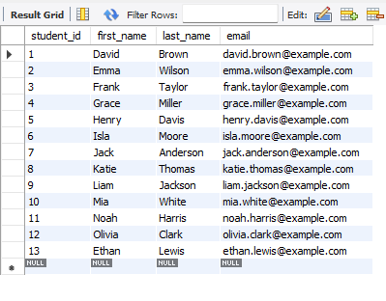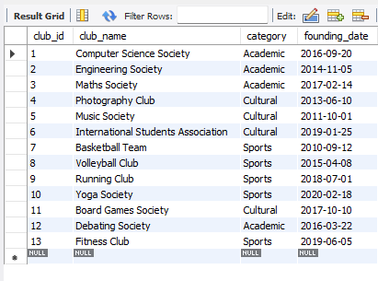
Figure 4: Sample data successfully inserted into CCMS tables.

3.4 Trigger and Stored Procedure Execution
Triggers and stored procedures were evaluated using controlled insert, update, and delete actions. Audit triggers automatically documented changes to critical tables, and stored procedures guaranteed that database operations were executed consistently. Figure 5 depicts trigger execution and the subsequent audit log entries. Database triggers, which provide an automated mechanism for responding to data changes, are extensively used for auditing and monitoring in relational database systems [8].
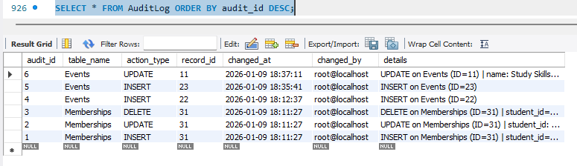
Figure 5: Audit triggers logging changes to the Events table.

4. Stored Procedures and Transactional Scenario

4.1 CRUD Stored Procedures
Stored procedures were used to support Create, Read, Update, and Delete (CRUD) activities on the major database tables. Each procedure ensures atomicity by using transaction control statements like START TRANSACTION, COMMIT, and ROLLBACK. This ensures that operations are either fully finished or not applied at all, lowering the likelihood of inconsistent data states [2].
Using stored procedures further enhances security by restricting direct table access and centralising database logic. This method enhances consistency while reducing the possibility of user error during data editing. Stored procedures are frequently used in SQL-based systems to encapsulate functionality, increase consistency, and eliminate repetitive query execution, especially in transactional systems [6].
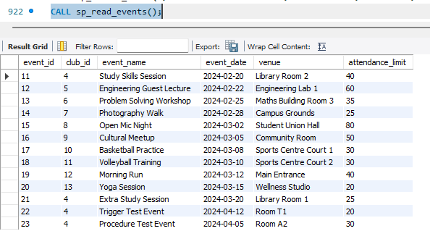

Figure 6: Execution of stored procedures supporting CRUD operations.

4.2 Transactional Scenario
A multi-step transactional stored procedure was used to replicate a genuine operational scenario at the Students' Union. As part of a single transaction, the operation generates an announcement, registers many participants, and organises an event. If any step fails, such as an invalid foreign key reference, the entire transaction is reverted.
This prevents partial modifications, such as creating an event with no attendees or announcements. Figure 7 shows a rollback scenario in which no data is committed owing to a validation error. This clearly demonstrates the importance of transaction management in ensuring data integrity [3].
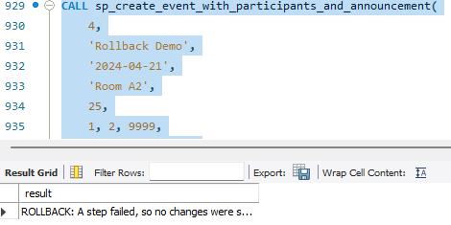
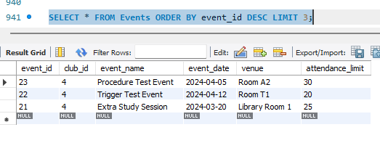
Figure 7: Verification that no records were committed following rollback.

5. Performance Tuning Enhancement

5.1 Indexing Strategy
To boost query performance, secondary indexes were established on performance-critical columns in the CCMS database. These indexes were created for columns that are commonly utilised in JOIN operations and filtering conditions, such as Memberships.student_id, Memberships.club_id, and Events.club_id. These columns are frequently used when getting information regarding student memberships, club members, and event listings.
Junction tables were chosen for indexing because they are heavily used in relational queries that connect numerous entities. For example, the Memberships database connects students and groups and is commonly accessed when generating membership lists or determining student activity. Indexing these columns allows the database to more efficiently resolve joins between tables, especially as the dataset grows in size.

5.2 Performance Benefits
Indexing considerably decreases the need for full table scans by allowing the database engine to quickly discover important records via indexed routes. This is especially crucial for operational questions such as locating all clubs to which a student belongs, listing all members of a certain club, or identifying participants in a specific event.
As the volume of data grows, queries that use indexed columns run more effectively, resulting in faster response times and better overall system performance. Figure 6 depicts the indexes used on the Memberships table, demonstrating how indexing was designed to enable frequent access patterns. Overall, indexing ensures that the CCMS database is responsive, scalable, and appropriate for real-world usage scenarios in the Students' Union environment [4]. Effective indexing is an important part of database performance optimisation since it helps maintain acceptable query performance as system utilisation and data volume grow [9].
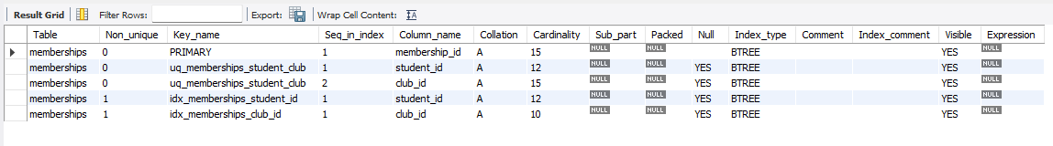
Figure 8: Secondary indexes applied to the Memberships table.

6. Conclusion and Reflection
The Campus Club Management System database meets all of the requirements specified in the case study. The final solution offers a centralised and structured method to managing students, clubs, activities, participation, and announcements. Constraints ensure data integrity, whilst audits and transaction processing promote reliability and accountability.
One of the most difficult difficulties during development was controlling transaction management and trigger syntax in MySQL, specifically delimiter handling. These issues necessitated thorough troubleshooting and iterative testing. Another problem was ensuring that limitations and indexes were aligned with realistic usage cases rather than being inserted arbitrarily.
Overall, the process of creating and implementing the CCMS database demonstrated the value of meticulous planning, iterative testing, and matching technical decisions with real-world organisational needs.
If this system is expanded further, further enhancements could include role-based access control, connectivity with a web application interface, and more thorough reporting capabilities. Overall, the CCMS database is a reliable and scalable solution that efficiently supports campus club operations.

7. References
[1] R. Elmasri and S. Navathe, Fundamentals of Database Systems, 7th ed. Pearson, 2016.
[2] Oracle, “Using Transactions in MySQL,” 2024.
https://dev.mysql.com/doc/refman/8.0/en/commit.html
[3] Oracle, “START TRANSACTION, COMMIT, and ROLLBACK,” 2024.
https://dev.mysql.com/doc/refman/8.0/en/transactions.html
[4] Oracle, “How MySQL Uses Indexes,” 2024.
https://dev.mysql.com/doc/refman/8.0/en/mysql-indexes.html
[5] W3Schools, “SQL Constraints,” 2024.
https://www.w3schools.com/sql/sql_constraints.asp
[6] W3Schools, “SQL Stored Procedures,” 2024.
https://www.w3schools.com/sql/sql_stored_procedures.asp
[7] GeeksforGeeks, “Database Normalization,” 2024.
https://www.geeksforgeeks.org/database-normalization/
[8] GeeksforGeeks, “SQL Triggers,” 2024.
https://www.geeksforgeeks.org/sql-trigger/
[9] Oracle, “MySQL Performance Optimization,” 2024.
https://dev.mysql.com/doc/refman/8.0/en/optimization.html

