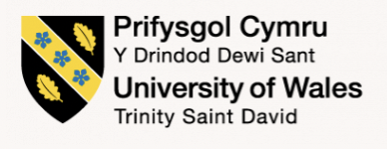

Self-evaluation and Personal Development Reflection

Student name: Agata Anna Kruczek
Student number: 2007078
Module: Professional Career Development
Module code: BMSW4005_LON
Lecturer: Gulnar Ali

Table of contents

- Introduction 3
- Reflection on role play 3
Description 3
Feelings 3
Evaluation 4
Analysis 4
Conclusion 4
Action plan 4

- Self-evaluation review 5
Self-motivation 5
Learning style 5

- Johari Window review 5

- SWOT analysis 7

- Review of the world of employment 7

- Personal Development Plan 7

- Conclusion 8

- References 9

Appendix 1 11
Appendix 2 13
Appendix 3 14

1.Introduction

This report will show the self-evaluation process of a Professional Career Development (PCD) module student during the Health and Social Care level 4 University course. With reflection of my life line, through many years of experience, I got to the point where I decided to move forward academically to improve my ability to get a better profession and achieve my goals.
I came to the UK from Poland at the age of 32, 13 years ago, as a single mother of two girls, suffering from broken marriage. I was struggling raising them on my own, but I must say I managed to help them to become an independent, smart and educated young women. I feel that this experience changed me as a person, made me stronger and capable of my own development and progress. I work hard to achieve my goals to support my kids and my future. I discovered a lot of self-motivation in myself. Since a young age, I have enjoyed helping people and believe I have many skills and experience to become a good social worker. At the moment I work as a dental nurse but I have ambition to get closer to people from different backgrounds, their needs and problems. I would love to have the ability to be a part of the process of changing people’s lives. With a university degree and gaining essential skills, I am confident I will achieve my goals.

2. Reflection on role play (Gibbs model, 1998)

Graham Gibbs developed reflective cycle in 1998 to give shape to learning, based on experience. It allows to learn and plan from experiences that either went or didn’t go well. In this report, the Gibbs model is used to examine the experience of role play, ‘task 1’ for the Personal Career Development module.
This model explains how to work through an experience and develop an action plan for the future. I will show my personal reflection on role play, while enacting an interviewer and applicant for a healthcare profession. I would like to show my reflection on both roles.

Description

I started by preparing the questions I wanted to ask the applicant during the interview by reading the job description and important skills related to the position. I wanted to be as professional, accurate and relevant as possible. I also prepared how to present myself and make the interviewee feel welcomed and comfortable during the interview.

As an applicant I prepared myself to apply for my chosen job by reading the job description and matching my skills with it, so I knew I will fit the position. I also prepared myself to look professional.

Feelings

I felt very confident that the questions I prepared are relevant and perfectly matching the job description. I also had a feeling that the other person felt confident and well equipped for the
task. Looking back, I feel satisfied that I decided to ask questions I prepared. After the teacher review, I had to make some changes, but that made us both work harder to make suggested changes.

On the other side, I had a feeling that I was the right candidate and answered questions honestly according to my skills and knowledge. I feel that I could do better, but due to stress I was less confident as usual, and not as fluent in speech as I wish I was.

Evaluation

I believe I prepared good questions that gave me answers which allowed to know the applicant better, especially position related skills, strengths and weaknesses and future plans. I put a lot of effort to look and behave professional, however I was a bit stressed, which could make my colleague feel a bit uncomfortable.

I did my best to answer the questions honestly. I believe I was on point and direct with my answers, and gave the interweaver good profile of myself as a future employee. I know I have to work on my body language and facial expressions to appear more confident.

Analysis

I think the interview went well. I managed to ask questions as planned and was able to answer one question from the applicant. I believe I still could have asked more specific questions to get better understanding of interviewee job related skills. In the future, I would like to expand my knowledge to fit this role better. I found a few books I would like to read. Mary Hanson and Brian McIvor (2013), give a lot of tips how to be a good interviewer and ask right questions to make the whole process interesting, and, most importantly, how to hire the right person.

I believe I did well as an applicant as I was well prepared and very interested in getting into this particular job position. I wish, I could be more relaxed, to speak more openly. Furthermore, I acknowledge that time management is also very important. I believe, I have all skills required and was a great candidate.

Conclusion

From this experience I’ve learned how to prepare an interview, be an applicant, and how to behave in a stressful situation. It is very important to stay calm and listen to what the applicant has to offer. And from the applicant point of view, its necessary to have good knowledge about the job offer and company. It is also important to have good body language and facial expressions.

Action Plan

If I had to do this task again, I would focus more on the skills a good interviewer should have.
I would be calmer and appear with better body language. However, it was my first time, and I felt a bit uncomfortable in this role due to lack of experience. I think I should focus on details more than on general overview, to choose the best candidate.
As an applicant I have to focus on communication skills, good knowledge of the hiring company and what they look for from prospective employees. It is also important to present past experiences and knowledge of the health and social care regulations.

3. Self-evaluation review

According to Ziv, self-evaluation is when individuals or groups are stimulated to assess themselves in determination of getting close to their goals (Ziv, Lehrer and Smith,2011). Self-evaluation is very important, as it lets individuals judge their strengths and areas they need to improve (Conducting a Self- Evaluation, n.d.). From the Personal Development module, I have learned that communication with the lecturer and other students is very important for my future career choice. During class activities, I exchanged opinions and judgement about different subject related topics. That helped me to communicate better with a good manner and taught me that listening to other opinions is one of the skills I have to work on. I developed the right attitude towards my colleagues and understood that team work helps achieve any goal faster. My self-evaluation process must mainly focus on my weakness to ‘think before I speak’ and ‘say more by saying less’ (viaMaven: The #1 Performance Review Generator, n.d.).

Self- motivation

According to Geller, ‘Self-motivation is at the heart of creativity, responsibility, healthy behaviour and lasting change’ (Geller,2016). Self-motivation is the force which pushes humans to constant change and improvement. The PCD module provided a lot of knowledge about self-motivation related to my future career. It also helped me to discover skills like being assertive or goal orientated, to push me towards job opportunities. Richelle E. Goodrich in her book says ‘You may be the only person left who believes in you, but its enough. Never give up.’ (Goodrich,2015).
I have also learned during my university course, that team work builds my self-motivation. As a group of four, we submitted a few power point presentations receiving good grades and feedback.

Learning style

Learning styles are intellectual and emotional qualities which shows how learners perceive and interact with learning environment (Keefe,1982). Visual, Auditory, Kinaesthetic (VAK) learning models divide learners into three categories. Visual - learn by sight, Auditory - by sound, and Kinaesthetic - by moving (Macmillan,2018). After doing a self-assessment VAK questionnaire, I found out I have a visual learning style. I learn through observation; I like seeing things myself and watching someone doing the task before I can follow. It is easy for me to use written instructions, maps, pictures or diagrams.

4. Johari Window review

Johari window is a psychological tool created in 1955 by Joseph Luft and Harry Ingham. Since then, it has been used to understand personal development, interpersonal communication, self-awareness, or team development and relations. It is a simple easy to use model, which can be applied in different situations (self awareness,2013). It was created to help people to recognise their psychical and emotional relationship with self and others.

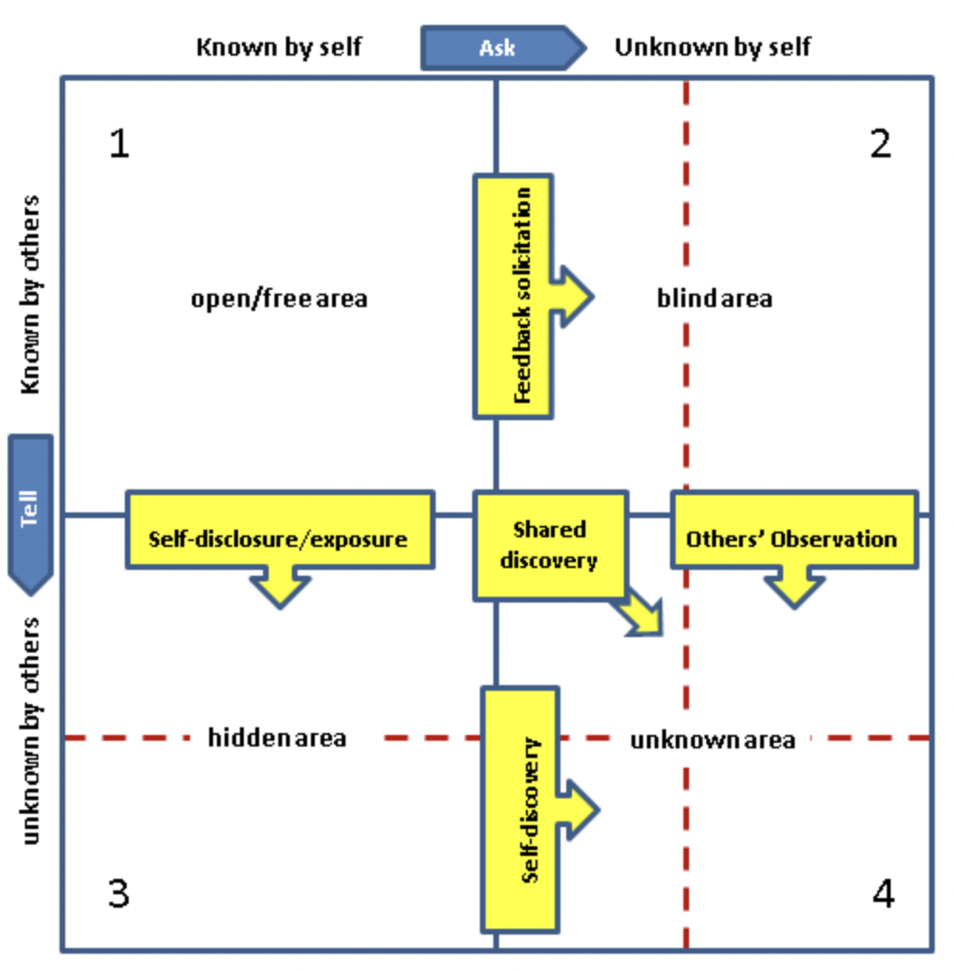

Firstly, there is an open space, where I know about my behaviour and it is also known to others. I can work in a group at work and during module tasks and assignments. This means that I have good communication skills. I am empathetic, as it is a main skill required for my work as a dental nurse. I work with people of different backgrounds, disabilities and gender. I don’t hold anger; my personal skill related to my calm nature and my background.
As a negative, I, and others notice that I am talkative and sometimes it’s hard for me to stop. also, I think I know better and don’t consider opinions of others straight away.

Blind area is the space with a lack of knowledge about myself with others pointing the strengths and weaknesses they see in me. I am organised when it comes to work and assignments, but I can see myself being a bit messy in my private life. Others can see me as relaxed, but I can be stressed especially if it comes to personal life events. Others also noticed that I share too much of my personal life, however I see it as I’m sharing my experience and reflecting on my mistakes.

Third factor is the hidden area where I put the part of my behaviours which are known for me and not known for others. I am reflective, learning mostly from my own mistakes and repeating success. I hide my past bad experiences, which bring unpleasant memories only known to myself. I am sensitive and many situations have an impact on my decision or make me take the step forward or not as I don’t want to get hurt. My sensible character helps me with everyday tasks, as I always see the practical part of every task.

Unknown area always occurs with the task I submit and I’m not aware I have skills and I can complete it. Although I am aware, I can behave differently according to situation and to achieve my goals. I can be creative using English, which is not my first language, to write a good quality work.

5.SWOT analysis

SWOT analysis is a way of organizing and recognising strengths, weaknesses, opportunities and threats to focus on achieving my full potential and planning a future career (MindTools,2009).
My main strengths are communication skills and empathy. I need these to become a good social worker and to understand problems of my clients.
As a main weakness, I point my friendly character which could lead into problematic situations. Secondly, I’d have to work on my patience, because not all progress can be quickly visible.
The main opportunity is growth of knowledge and experience, meaning I can develop the skills I need to perform better. I can also count my determination to achieve my goals, my work experience and volunteering for different people.
I can see threats in big competition from others having the same qualification, and family related issues which may have an impact on my studies and time management.

6. Review of the world of employment

A social worker must have a degree in social work (Bachelor or master). I plan to finish level 5&6 Health and Social Care and continue with a Master degree in social work after. Three quarters of social work graduates are in employment 15 months after graduation. There is only 2,3% of unemployed with a social work degree. (Prospects.ac.uk,2017). After completing the degree, I plan to apply to register with the Health and Care Professions Council which will let me work legally in England. It is recommended to get some experience gained through paid or voluntary work in places like community centres for children, youths or vulnerable adults.
There are many employers I would be able to work for like for example: children’s homes, prisons, charities or hospitals. There are government, non- government and community organisations offering vacancies for social workers.
Personally, I would like to work with young people, mainly young offenders, to change their lives for better and protect the public, as I believe I have the skills and experience working with young people and dealing with different kind of behaviours.
Social workers are some of the most in demand professionals in the UK. There are also many opportunities to look for a related job during studies, like family support worker or charity officer (www.mastersportal.com,n.d.)

7. Personal Development Plan

In my personal development plan, I chose becoming a social worker as my future long-term goal. It will require continuous learning and development. In the short term, I’d like to continue with my level 5 degree in health and social care. That means I have to focus on my studies and decrease my work hours to focus on my education. In the next 12 months, I’d like to finish level 5 with good degree. Would love to become more organised and self-motivated, and continue with voluntary work with variety of different people to gain more experience. As a long time goal, I’d like to decide what area of social work I’d like to focus on, complete the social work degree and register as a social worker in England.

8. Conclusions

This report shows many features that can be used for career development planning. All of them focus on self-assessment related to a future career and show how suitable we are for the world of employment. I believe getting the necessary academic knowledge with work related skills gets me closer to my personal goal and future I plan for myself.

9.References

Conducting A Self-Evaluation. (n.d.). [online] . Available at: https://hr.virginia.edu/sites/default/files/PDFs/Conducting_a_Self_Evaluation.pdf

Geller, E.S. (2016). Applied Psychology. [online] Google Books. Cambridge University Press. Available at: https://books.google.co.uk/books?hl=en&lr=&id=EBl-CwAAQBAJ&oi=fnd&pg=PA83&dq=self+motivation+&ots=fAul_hczvy&sig=qfzFeCvVsyD3l4acFBSgZgYJia8#v=onepage&q=self%20motivation&f=false [Accessed 1 Sep. 2021].

Goodrich R.E. (2015) Smile Anyway. [online] Available at: https://www.goodreads.com/book/show/19107118-smile-anyway.

Gibbs, G. (1988). Learning by doing: A guide to teaching and learning methods. London: Further Education Unit.

Hanson, M. and McIvor, B. (2013). The Interviewer’s Book: Hiring the Right Person. [online] Google Books. Orpen Press. Available at: https://www.google.co.uk/books/edition/The_Interviewer_s_Book/8HOBDwAAQBAJ?hl=en&gbpv=1&dq=interviewer+book&printsec=frontcover [Accessed 31 Aug. 2021].

Keefe, J.W. 1982. Assessing student learning styles: An overview. In: Student learning styles and behaviour, ed. J.W. Keefe. Reston, VA: National Association of Secondary School Principals

Macmillan, F. (2018). VAK learning styles: what are they and what do they mean? [online] AUS. Available at: https://engage-education.com/aus/blog/vak-learning-styles-what-are-they-and-what-do-they-mean/#.

Prospects.ac.uk. (2017). What can I do with a social work degree? | Prospects.ac.uk. [online] Available at: https://www.prospects.ac.uk/careers-advice/what-can-i-do-with-my-degree/social-work.

Self awareness (2013). Self Awareness. [online] Self Awareness. Available at: https://www.selfawareness.org.uk/news/understanding-the-johari-window-model.

viaMaven: The #1 Performance Review Generator. (n.d.). 58 Self-Evaluation Phrases for Communication Skills. [online] Available at: https://www.viamaven.com/blog/communication-skills-self-evaluation-phrases [Accessed 1 Sep. 2021].

www.google.com. (n.d.). gibbs reflective cycle - Google Search. [online] Available at: https://www.google.com/search?q=gibbs+reflective+cycle&rlz=1C5CHFA_enGB928GB929&source=lnms&tbm=isch&sa=X&ved=2ahUKEwiZj83nxtvyAhVTT8AKHVmbBNAQ_AUoAXoECAIQAw&biw=684&bih=704&dpr=2#imgrc=iMnA6Di_vWPM_M [Accessed 31 Aug. 2021].

www.mastersportal.com. (n.d.). 5 Good Reasons to Study a Social Work Master’s in the United Kingdom - MastersPortal.com. [online] Available at: https://www.mastersportal.com/articles/2676/5-good-reasons-to-study-a-social-work-masters-in-the-united-kingdom.html [Accessed 1 Sep. 2021].

Ziv, A.K., Lehrer, K. and Schmid, H.B. (2011). Self-Evaluation: Affective and Social Grounds of Intentionality. [online] Google Books. Springer Science & Business Media. Available at: https://www.google.co.uk/books/edition/Self_Evaluation/jOhqIQarw78C?hl=en&gbpv=1&dq=self+evaluation&printsec=frontcover [Accessed 31 Aug. 2021].

‌

‌

‌

Apendix 1
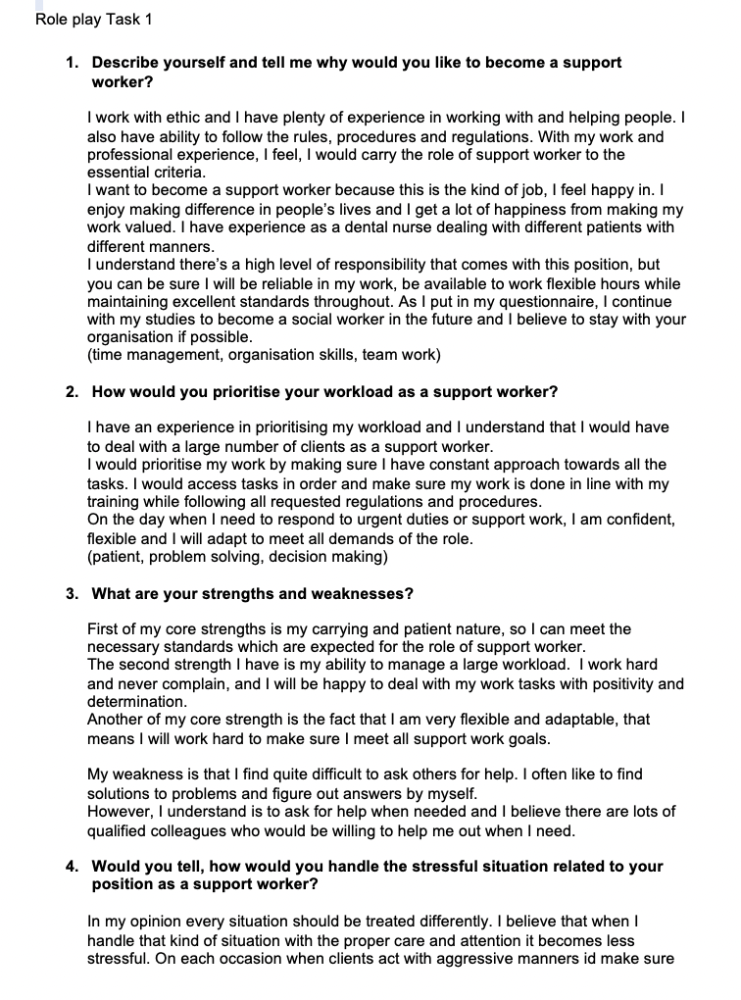

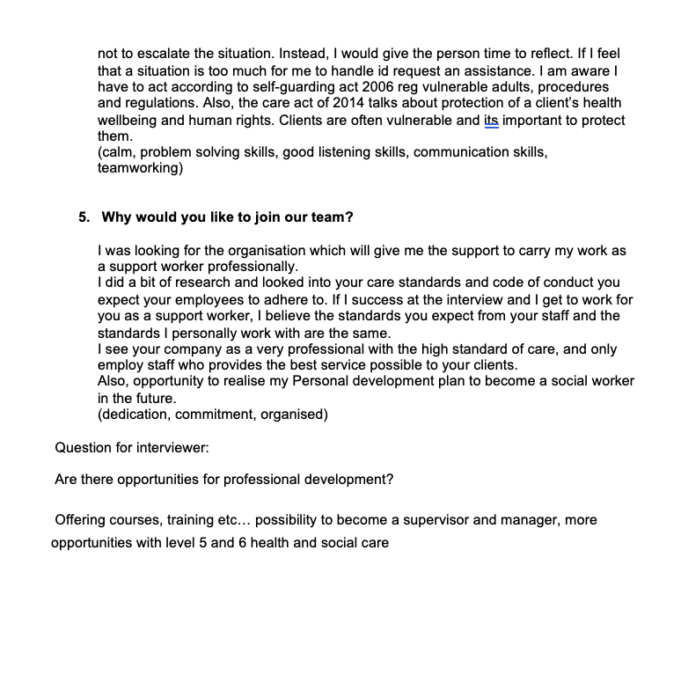

Appendix 2
Johari window

Open area  Good communication skills  Empathetic  Assertive  Friendly  Doesn’t hold anger  Calm  Carrying  Talkative  Helpful  Not listening to others opinion  open | Blind area  Kind  Organised  Confident  Relaxed  Wise  Not private (share too much of personal information unnecessarily)  Supportive
Hidden area  Past experience  Sensible  Self-conscious  Reflective  Sensitive | Unknown area  Proud  Powerful  Quiet  Shy  Creative

Appendix 3

SWOT analysis:

Strengths:  Communication skills  Experience working with different people  Empathetic  Good work ethic  Trustworthy | Opportunities:  Growth of knowledge  Determination to achieve goals  Voluntary work for different group of people
Weaknesses:  Overfriendly  Impatient  Don’t push hard enough  Poor conflict management  Not relevant work experience | Threads:  Family impact on studies and time management  Competition from other with similar qualifications

Personal Development Plan:

0-3 months | Continue with study on level 5 Health and Social Care  Work as a dental nurse  Voluntary work for Royal Voluntary Service  Getting a level 4 certificate of higher education
6-12 months | Finish level 5 /start level 6 for university bachelor degree  Social care related voluntary work  Working on Being assertive and better organised  Yoga lessons to keep calm and better wellbeing
12 months + | Finish level 6 and apply for master degree in social work  Finish master degree  Register as a professional social worker with HCPC  Choose the work field  Change people’s lives

