ADVANCED CYBERSECURITY

INTERNET OF THINGS AND SMART CITY SECURITY ISSUES – ACCA6000
Ross Thomas P146741
School of Applied Computing
University of Wales Trinity Saint David’s
Swansea, United Kingdom
Dr. Carlene Campbell

Abstract – Imagine a campus, fully controlled through the use of Smart Technology. UWTSD (University of Wales Trinity Saint David) plan to do this, they require a technician to design a network for their new campus. This campus will include a different array of Smart Devices that will allow the campus to run smoothly and effortlessly with ease of life for its students and lectures. Through the implementation of features like remote access VPN’s and BYOD policies, this will bring the new campus into the 21st century.

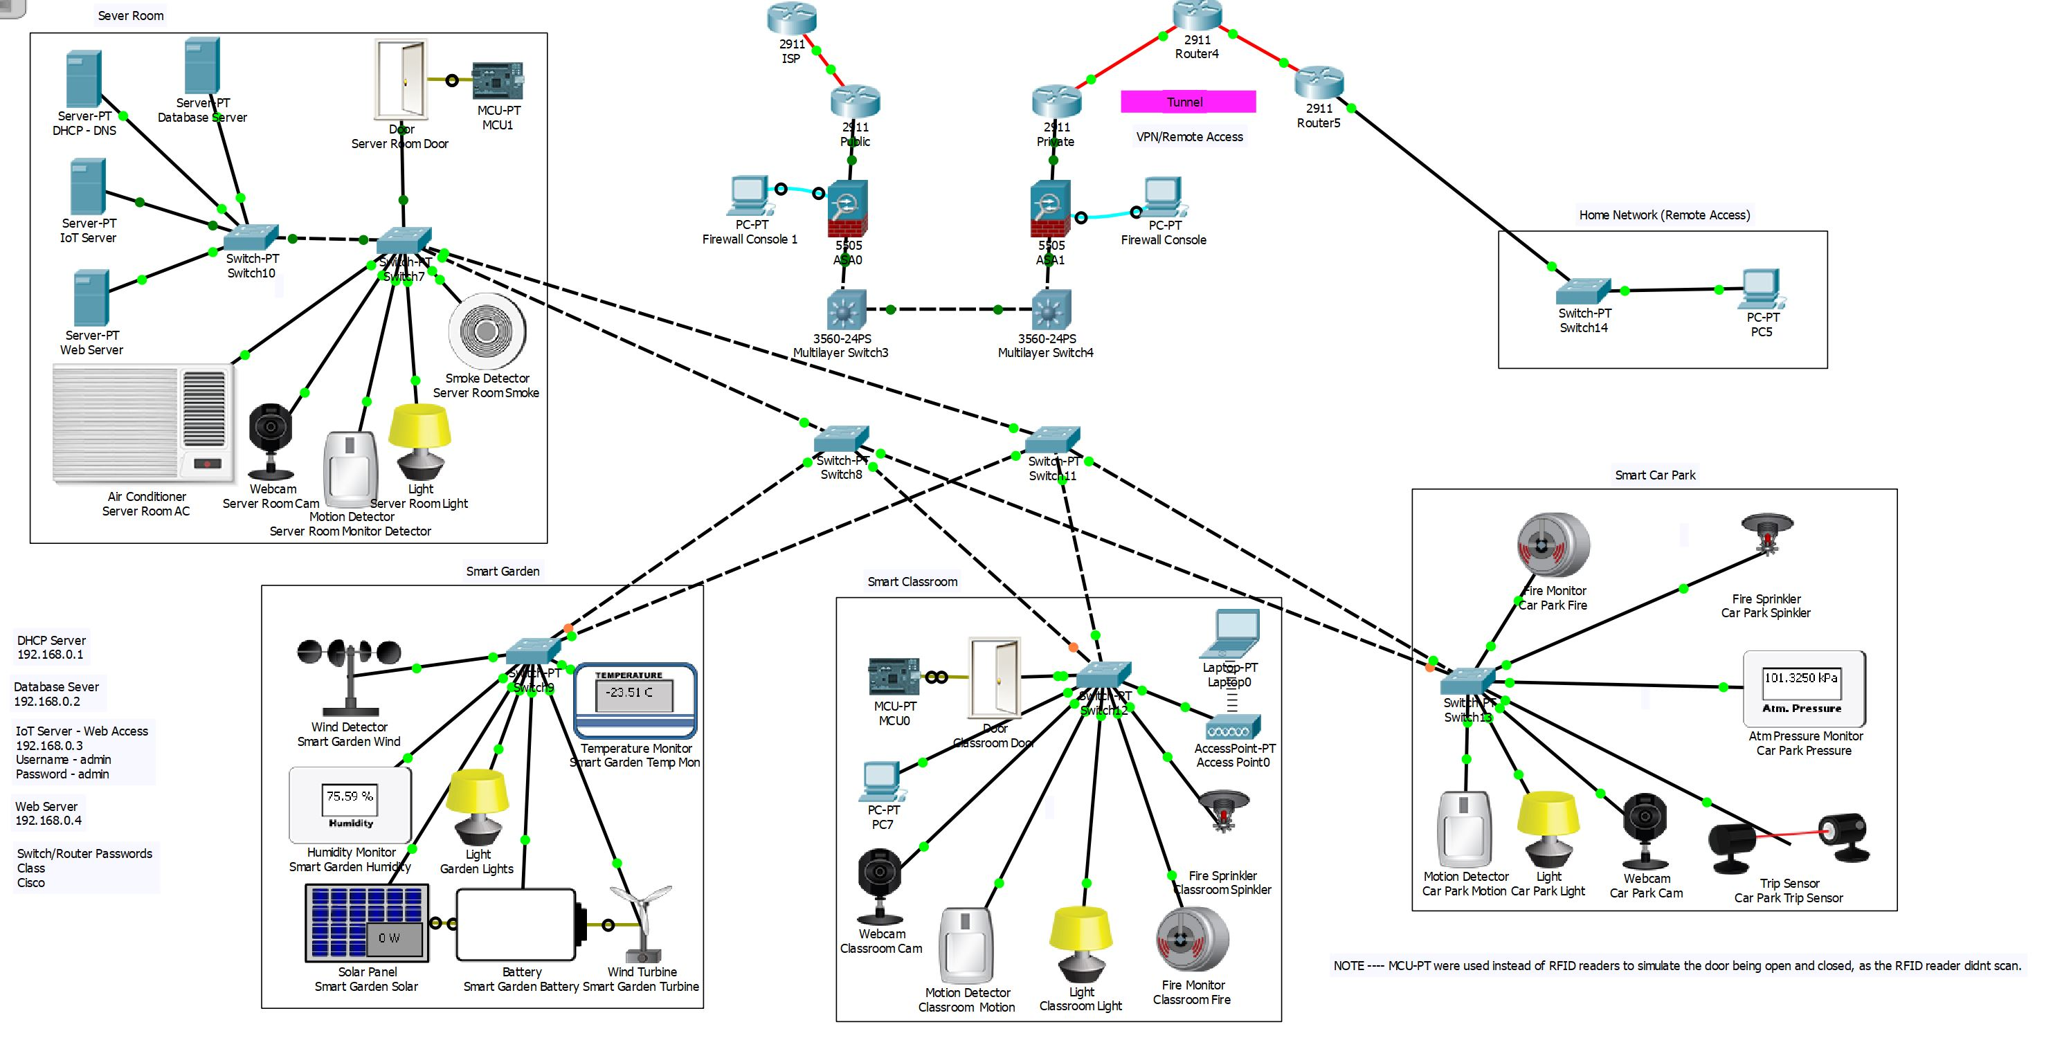
Once the design has been completed with the necessary steps configured in order to make the network comply with what was asked by UWTSD. A network is not complete without the necessary protection of security measurement in place.

Keywords – Cybersecurity, Internet of Things, Smart Cities, Smart Campus, BYOD (Bring Your Own Device), Cisco Packet Tracer, Network Simulation

Introduction
UWTSD (University of Wales Trinity Saint David are relocating to a new building based in SA1, Swansea. Due to this move they require a complete new network infrastructure which implements certain features, along with implementing the right levels of security that will be needed for this campus.

However, along with these basic features, the new campus will also feature a vast array of Smart Technology. Later in this report, it is expected IoT will be discussed along with a possible solution to correcting the security flaws within the Smart Technology its self. It was advised by UWTSD that the whole campus be Smart, because this will enhance the quality and performance of university services for its lectures and students.

Through the rise and constant innovation of Smart Technology, the university aims to implement it in any and every form possible, from smart gardens, smart classrooms and even to a smart car park. Along with this, lectures and students are able to BYOD (Bring Your Own Device), with other ideas like Remote Access also being implemented into the network design which will give more freedom to lectures and students. With such innovation, challenges will arise and the security of the university network is at a big risk from attackers.

Network Design
As seen in Fig 1. Based on the scenario discussed in the introduction section of this report, the plan was to build a Smart University Campus using Cisco Packet Tracer. In this section, the steps taken in order to create this network design for UWTSD will be discussed in full, along with screenshots to show and support the implementation.
Figure 1. Showing the complete design of the UWTSD Smart Campus. (Larger image in Appendix)

DHCP (Dynamic Host Configuration Protocol) Server
The first thing set up in this simulation of UWTSD, was a DHCP [1] server, this server allows for IP addresses to be automatically allocated to devices on the network. “The Dynamic Host Configuration Protocol (DHCP) provides a method for passing configuration information to hosts on a TCP/IP network.” [2]

Before this was possible, static addresses has to be set for each server, “A Static IP address is an address that does not change over time unless changed manually.” [3] Once this was done a pool was create that started after 192.168.0.64 making the next device 192.168.0.65 and so on until the pool runs out. As seen in figure 2. This pool as a maximum of 190 more IP address, until it runs out completely equaling to 254 total addresses with a 255.255.255.0 subnet.

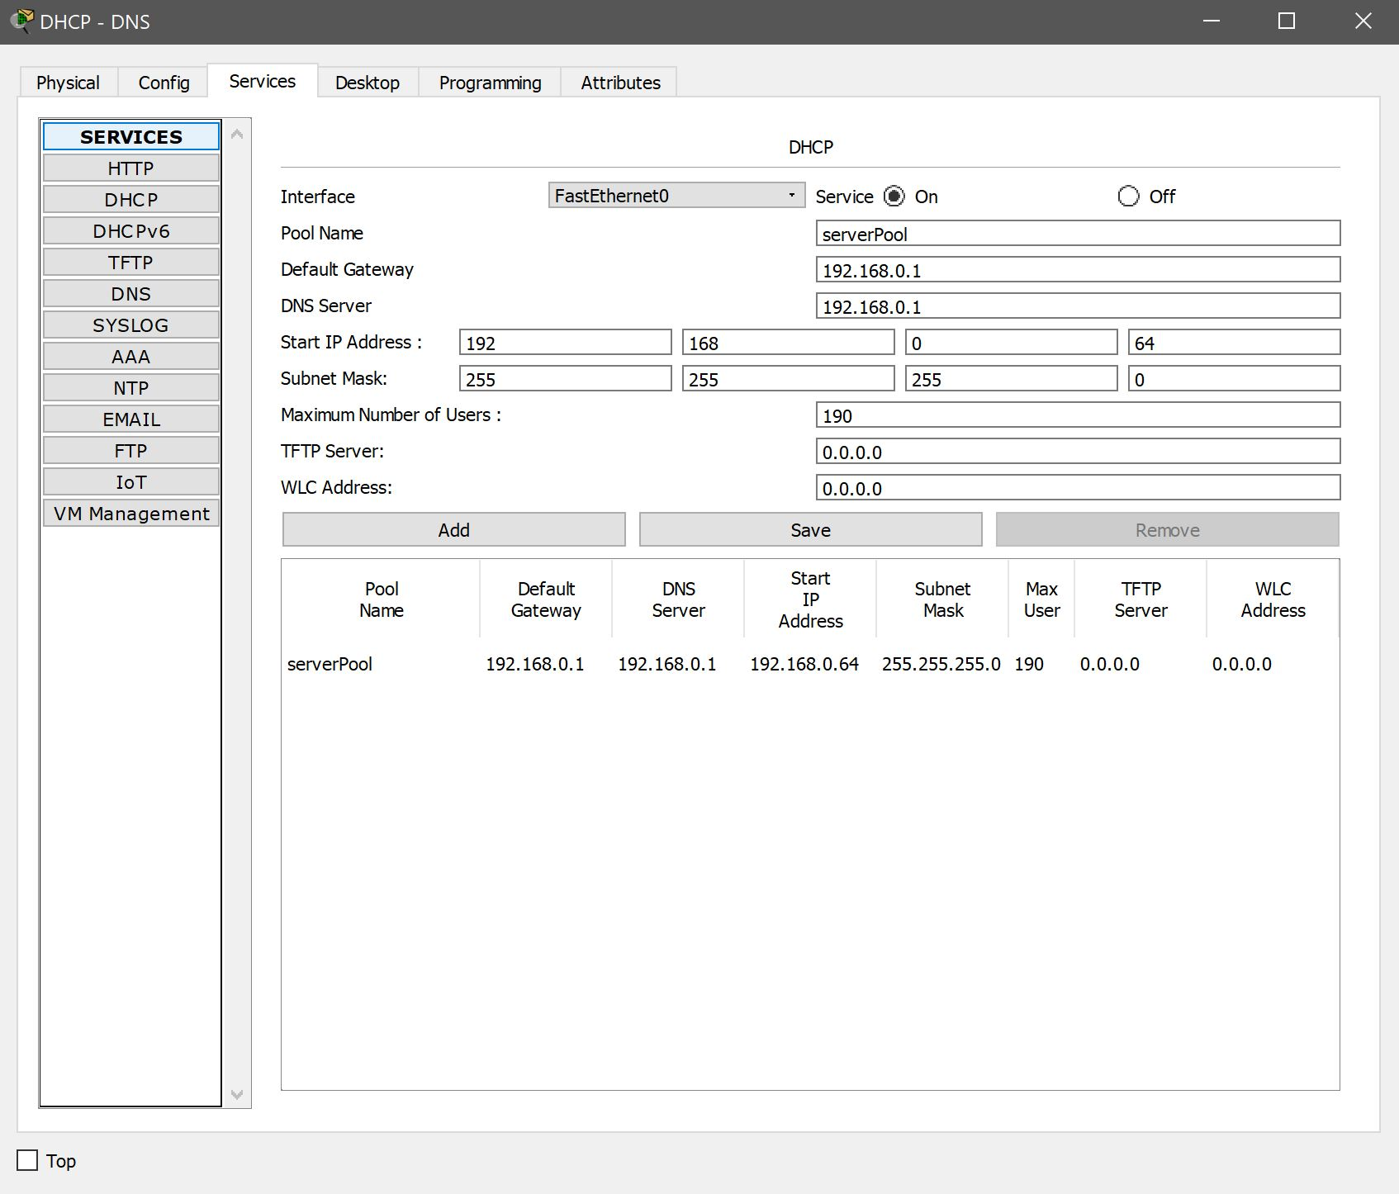
Figure 2. Showing the complete setup of the DHCP Pool.

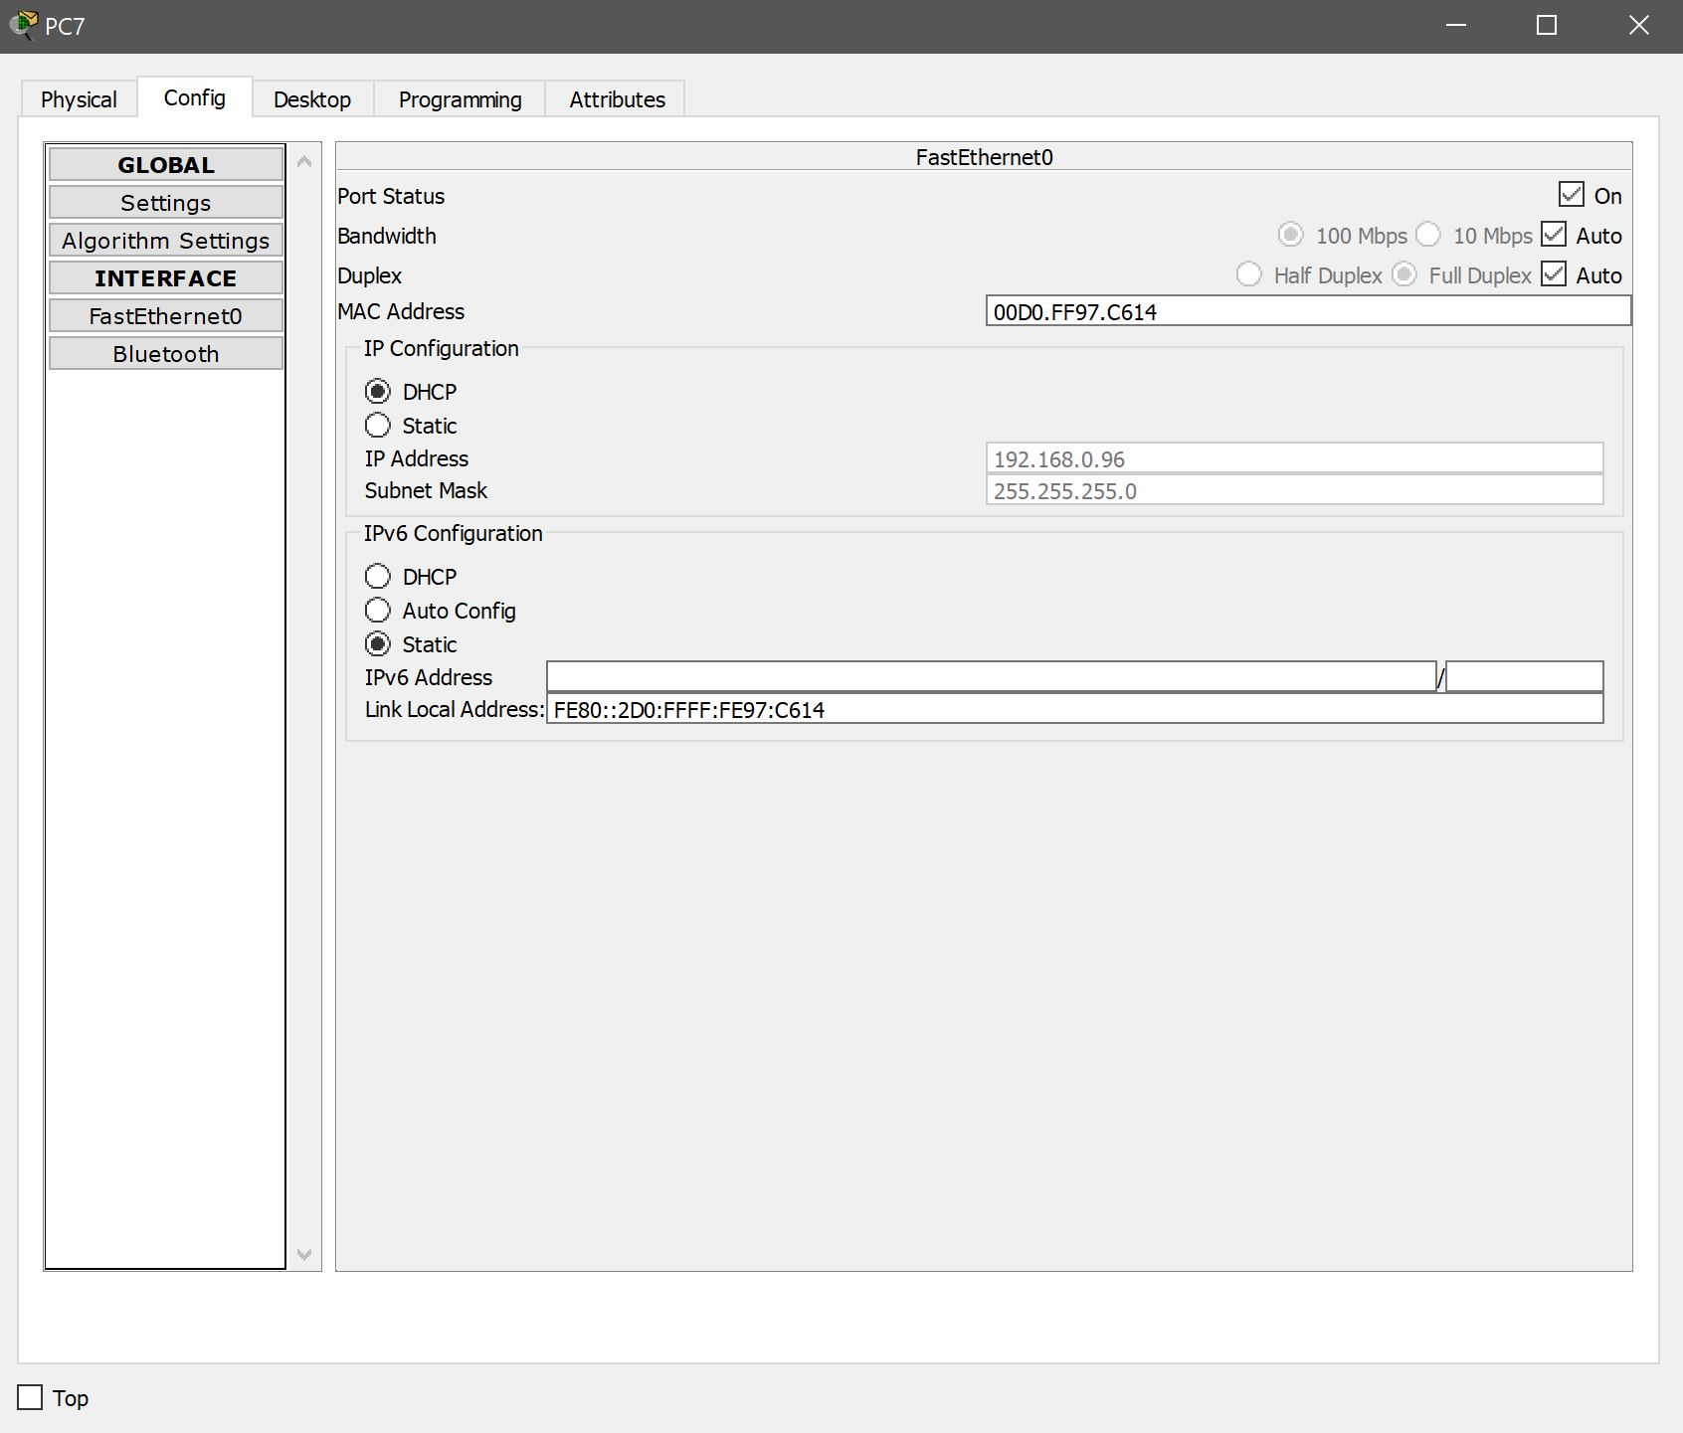
Figure 3. Showing the Success of DHCP, allocating 192.168.0.95.

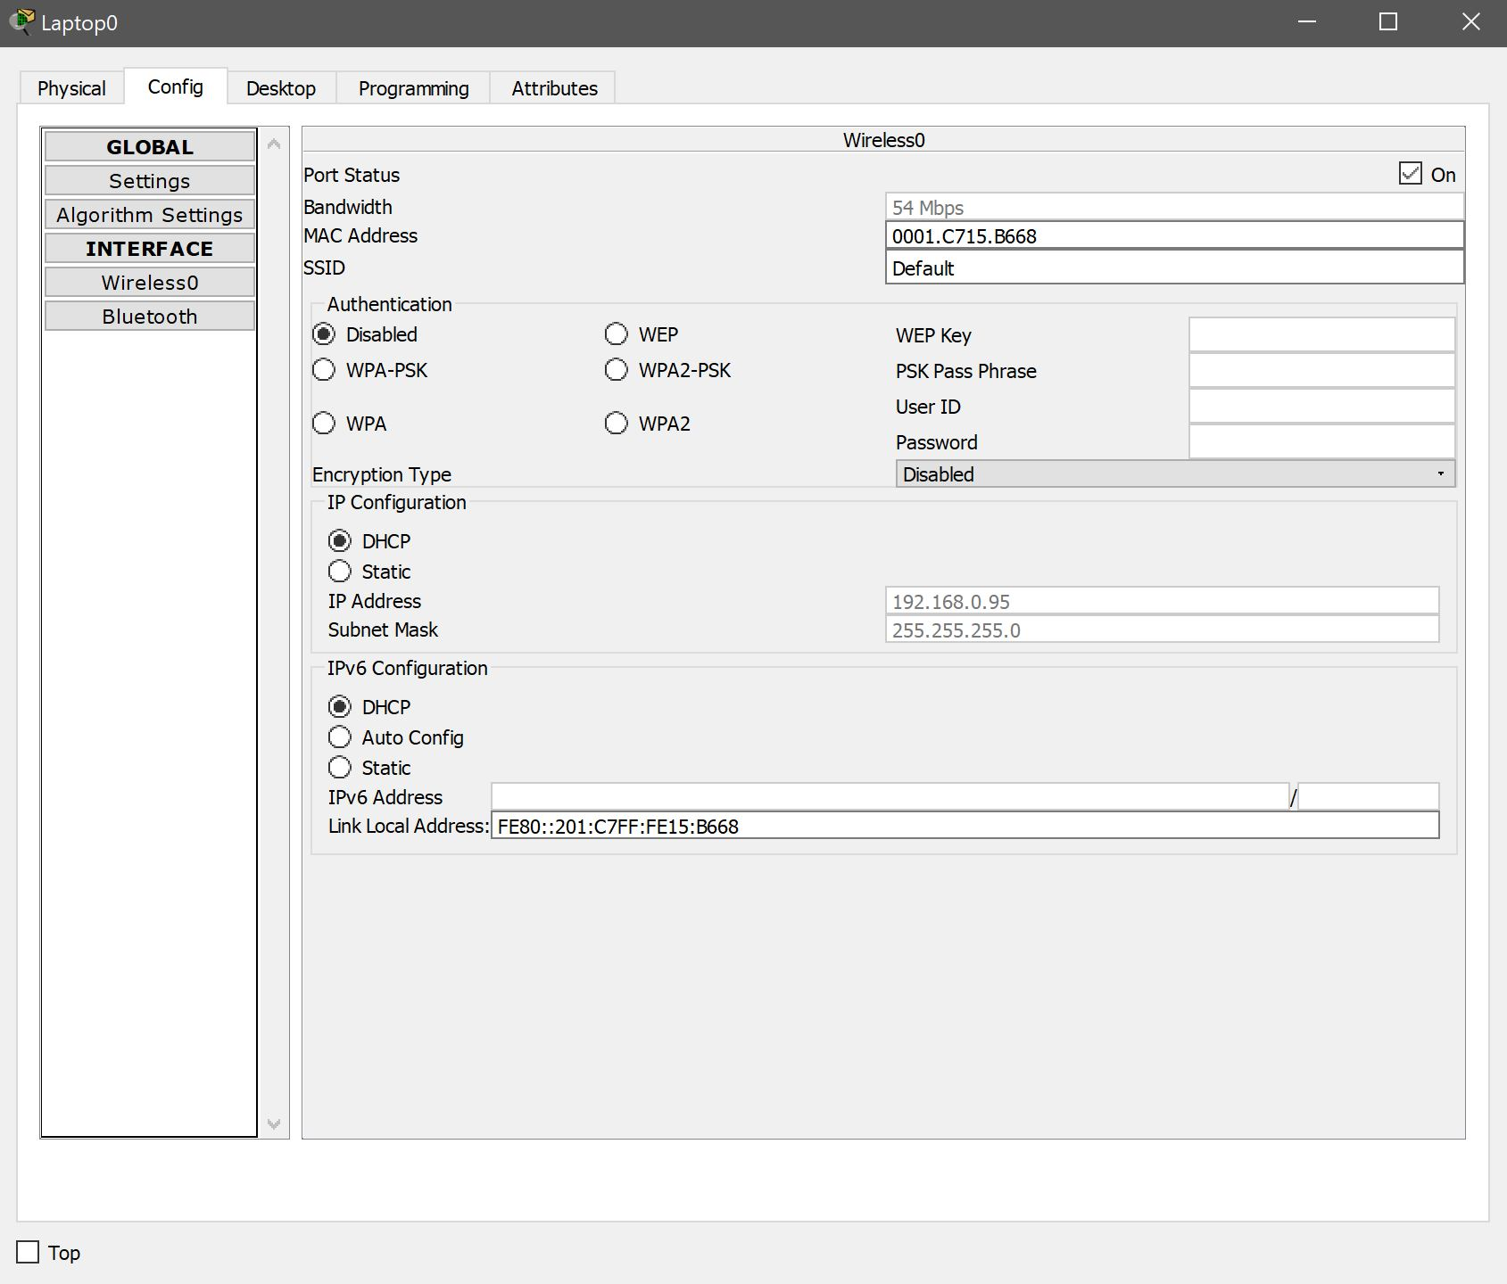
Figure 4. Showing the Success of DHCP, allocating 192.168.0.96

As seen in figure 3 & 4, the DHCP is working successful but sadly has its flaws. After having many issues with setting up DHCP and testing the server with devices on the complete network it was found, by involving layer 3 switches, this would interrupt the DHCP server throwing the pool created off. Causing devices to be allocated an IP address outside of the pool, for example 192.168.1.1. This is why in figure 1, the Layer 3 switches are not connected correctly, this was a choice chosen so proof of concept could be achieved for the simulation.

IoT (Internet of Things) Server
In this design and simulation of a campus network that implements IoT devices throughout, there must firstly be a server allocated purely for IoT devices. To note, he type of devices and how they are setup in the design will be discussed further on. However, they have conditions other IoT devices can follow, as seen in figure 5. Essentially depending on the conditions set, will also depend on the action of the room. For example, a motion detector could be set, using an IF Statement. With this If Statement, if the motion detector is activated or true, the room lights and anything else in the rule will be turned on which “organizations can use IoT to drive considerable cost savings by improving asset utilization, enhancing process efficiency and boosting productivity.” [4] If the detector is false, the room would simply turn off.
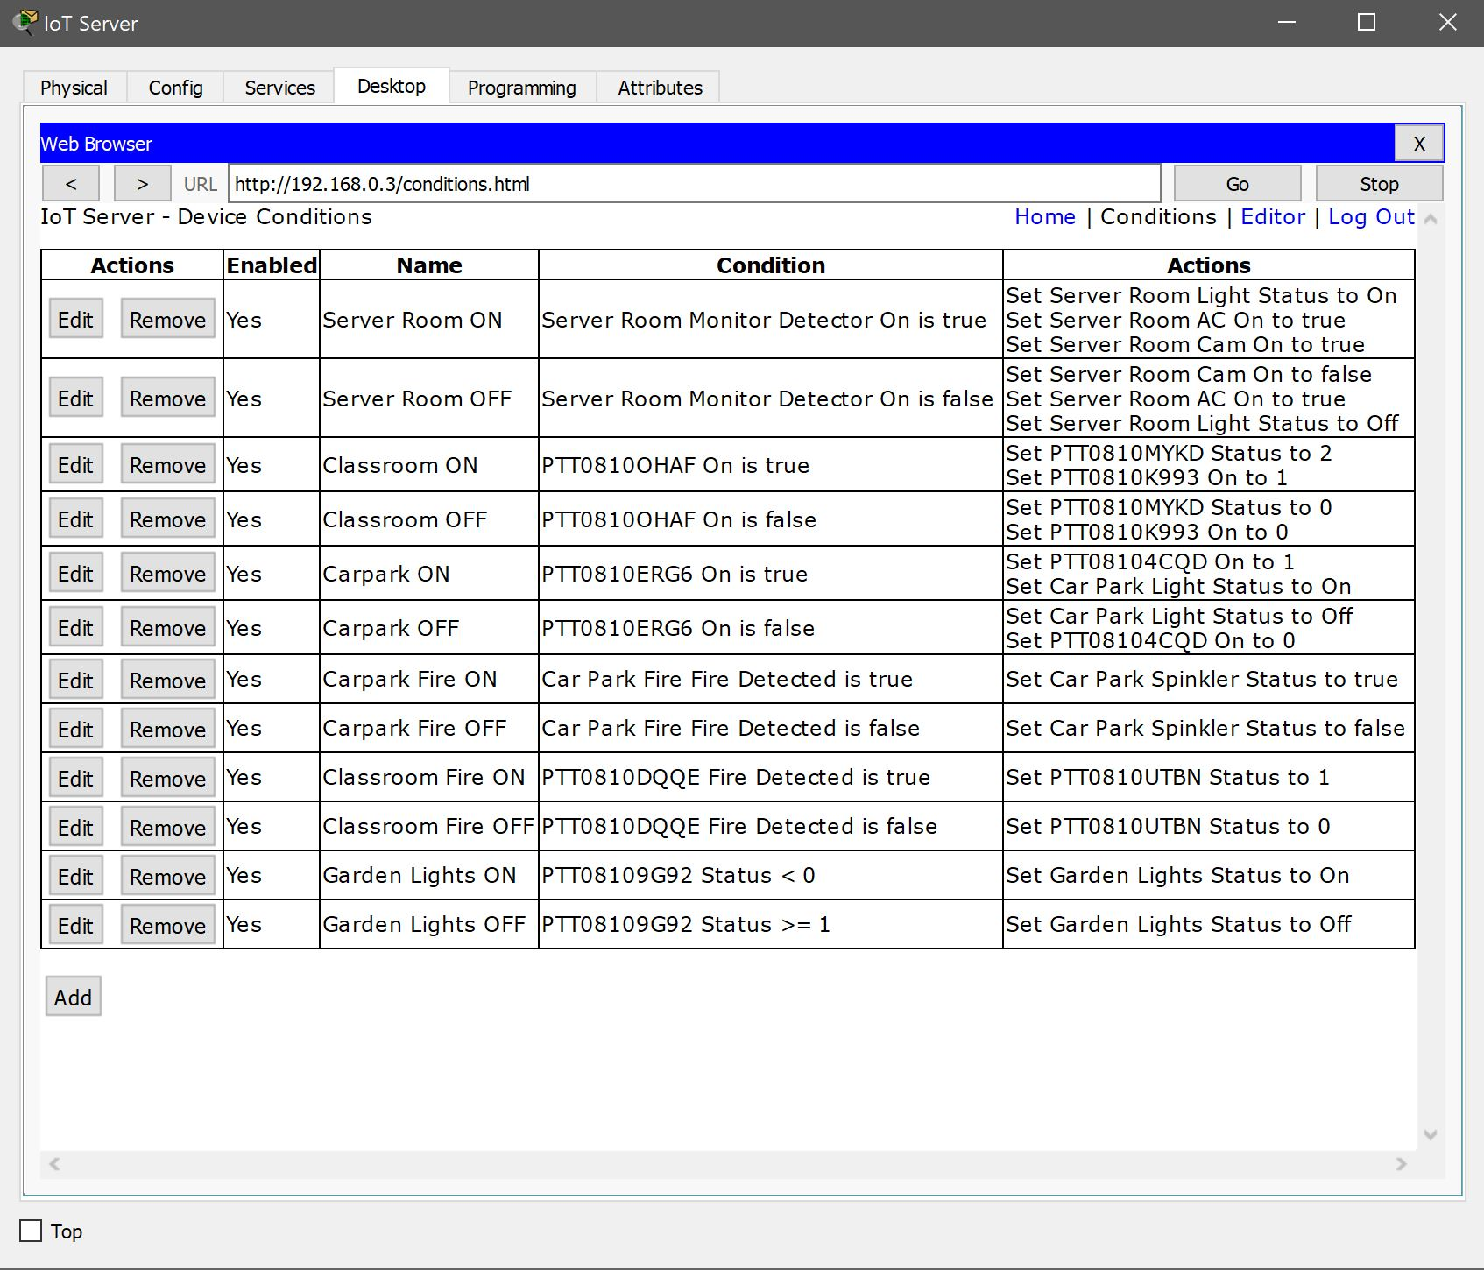
Figure 5. Showing the conditions that all IoT devices must follow in a given scenario.

Web Server / DNS (Domain Name System) Server
In this section, two types of servers were setup for the sole purpose of web access through an onsite webserver. A protocol called HTTP (Hypertext Transfer Protocol) is used, “it is used to submit requests from browsers to servers and to carry responses back.” [5]

DNS (Domain Name System), is a system put in place so IP addresses can be easily remembered in a naming format. For example, essentially a conversion process so IP address like 192.168.0.4 is changed to some more memorable like cisco.com. However, DNS is not just a process for mapping names to numbers. “DNS is the crucial underlying system that we all rely on for all digital communications.” [6]

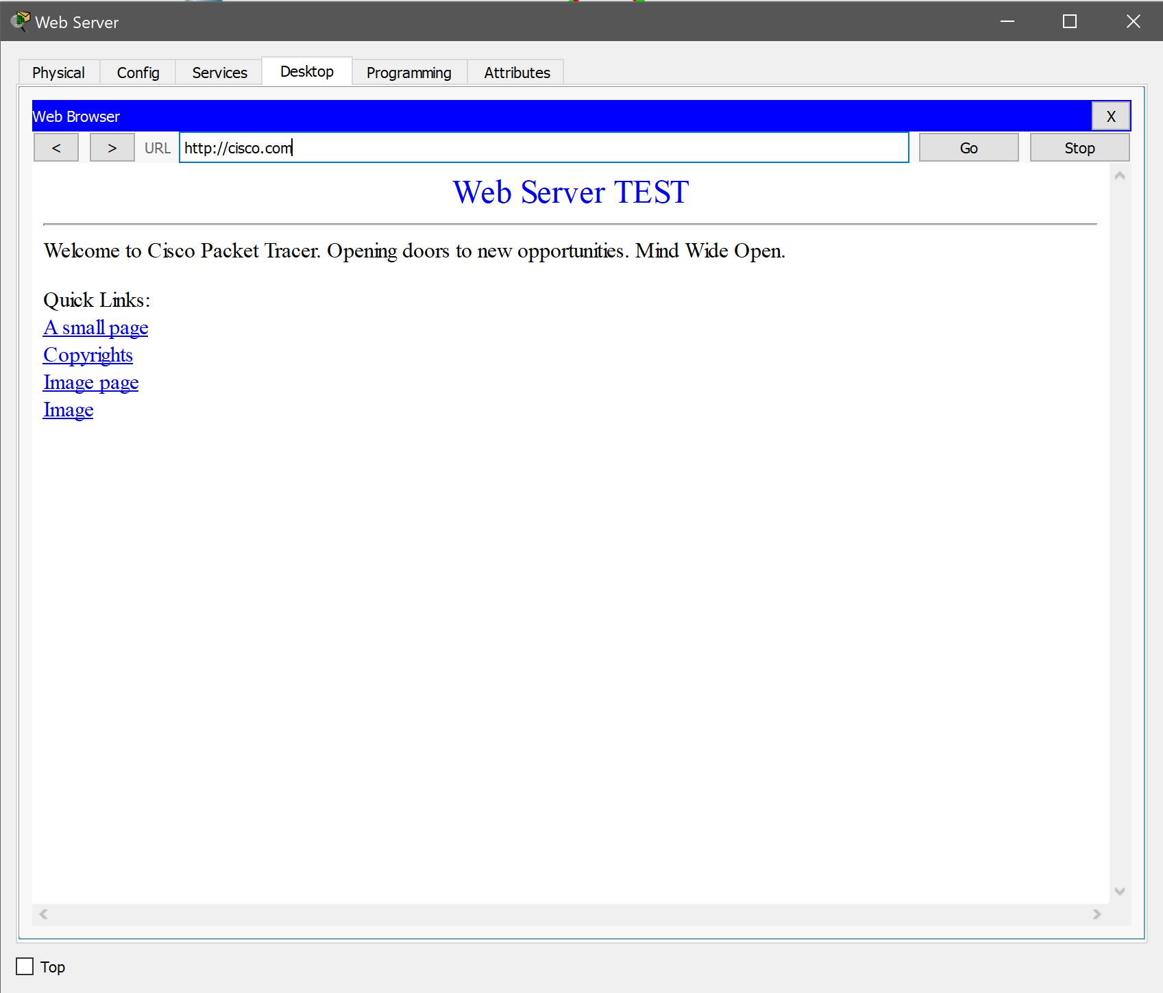
Figure 6. Showing the success of setting up a web page by connecting to the webserver on the network. Also showing DNS working as http://cisco.com as an example, related to figure 7.

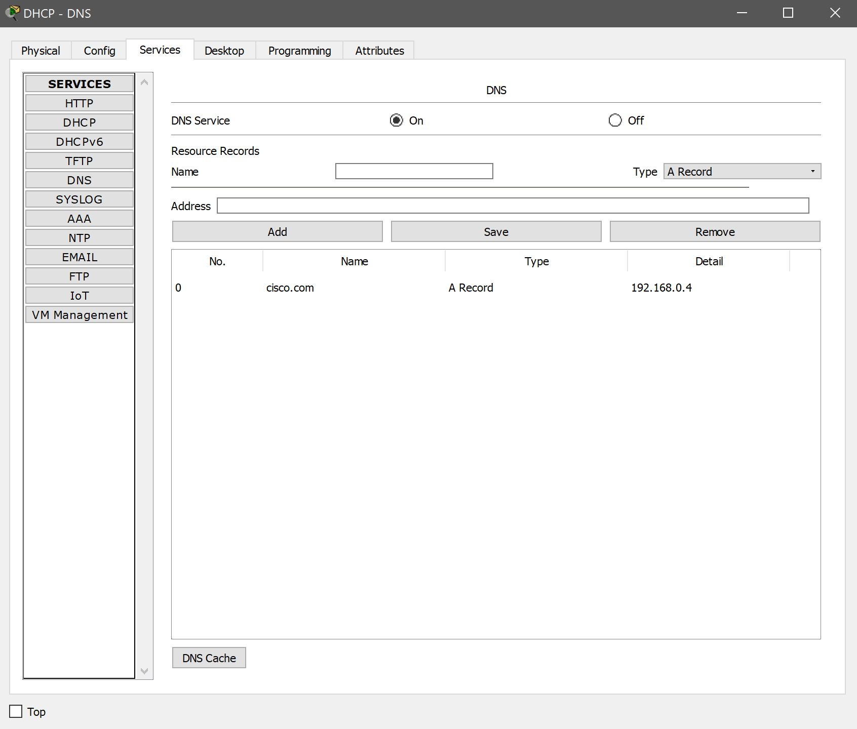
Figure 7. Showing DNS completely setting up.

Having a DNS server on side grants a big bonus for UWTSD, though it also can pose a massive threat is the network is not secured well enough. There are a number of attacks that can in fact be attempted on this type of server, more so than any other server on any network. Recently it has been discovered by networkworld.com that DNS type attacks are on the rise since 2015.

According to networkworld.com [7], this is simply due to firewalls failures. As they tend to lead port 53 open, which is in fact the same port that DNS use for their queries. Making attacks on this server very easy for an experienced hacker.

An example of such an attack is, DNS Spoofing [8]. This leads the user to believe they are connecting to cisco.com (192.168.0.4) but is in fact spoofed to appear as cisco.com but is connecting to a different IP address.

Database Server
In this design, a database server was created and included, but not fully configured. The university requires such a server purely for how much data is going to be stored on database, for example accounting systems. There are many database applications that can be used for many different types of data being stored. SAP ERP (Enterprise Resource Planning) [9] is an example of such a company that creates software purely based for accounting-based data.

Remote Access (Tunneling)
Remote access was included in this network design for lectures and students, allowing them to remote access any data that is stored within the university that needs to be accessed remotely from a home or anywhere else where connectivity is possibly. This is in fact a very important feature for all businesses to have, as there are regulations that need to be met for employees and students who for example have to travel, called the Clean Air Act [10], which reduces the need for travel to work. Another example is Family Leave Act, by implementing remote access this allows for beneficial results, resulting in work resources to always be available even if such scenarios come up in the workplace, providing flexibility and scalability.

However, this could not be possible unless a GRE (Generic Routing Encapsulation) [11] tunneling system was implemented. “Tunneling encapsulates data packets from one protocol within a different protocol and transports the packets on a foreign network.” [12] For example, if a user at home is using IPv6 and the university is still using IPV4, these systems will be able to connect through this method. Most of the time, this is never a physical interface but a logical interface that will be used to connect foreign systems to the main network as seen in figure 1.

Devices
Throughout this network design there were many different IoT, routing and switching devices used for the sole purpose of ease of life, while including the beneficial resources for the campus. All devices were setup correctly, with conditions as seen in figure 5, with the exception of automatic doors. This posed a problem as cisco packet tracer would not allow a condition for motion sensors and door compatibility. With this issue, it was resolved by using an MCU (Microcontroller Unit) [13], this allowed for a simulation of the doors opening and closing by programming (see figure 8) the doors to open and close, simulating proof of concept that this can in fact happen.

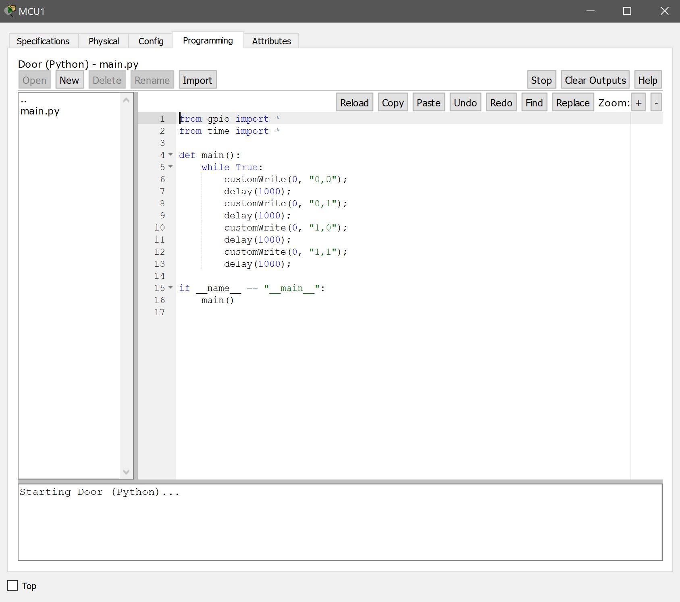
Figure 8. Showing the code used for the MCU (Microcontroller Unit).

IoT Devices
Examples of other devices can be seen in Figure 1. Where different IoT devices were implemented in each part of the university, all being connected by layer 2 switches. Because these devices have been set with conditions and IF Statements, its allows all devices to talk to each other. A great example of the use of IoT devices is between the Smart Garden and the rest of the campus. The garden consists of solar panels and wind turbines that’s will charge a battery, for which the campus will use resulting in the conservation of power throughout the campus.

Another example of a simple implementation is in the Smart Carpark, where trip sensors are used at the entrance, connecting to the camera. The camera will take a picture of the car, holding the records of the vehicle for payment etc. The system will also note where the car is parked by a pressure censor that connects to a possible app showing how many carpark spaces are left in the carpark which users can view before entering.

Backbone
The layer 2 switches that connect from each classroom, carpark etc. Can be seen linking to more layer 2 switches in the backbone of the network infrastructure, eventually connecting to layer 3 switch, that allow routing capabilities before firewalls are implemented to filter out the necessary traffic.

https://ti.tuwien.ac.at/ecs/teaching/courses/mclu/theory-material/Microcontroller.pdf

Network Security
For a successful network, a design can be made to look good and run well. But without security the design made will be vulnerable to all types of attacks. In this network design the necessary security steps were taken on the routers and switches with simple passwords and the use of encryption as seen in figure 9 & 10.

Routers were implemented throughout this network, providing built in software-based firewalls. By adding in additional firewalls called ACL (Access Control List) firewalls, this provided the whole network design for UTWSD with added security through physical hardware. “A firewall is a system that enforces an access control policy between two networks—such as your private LAN and the unsafe, public Internet.” [14]

Unfortunately, in this network design, the ACL firewalls were not fully configured due to complications with the firewalls and what seemed to be problems with Cisco Packet Tracer. This resulted in traffic being blocked throughout the whole network design, causing pings across the network to fail. By using the console PC for the firewalls, they can be configured to filter out the necessary traffic that could be harmful to the campus and the vulnerable IoT devices connected to it. Later in this report, a method will be discussed on how IoT devices could potentially be secured.

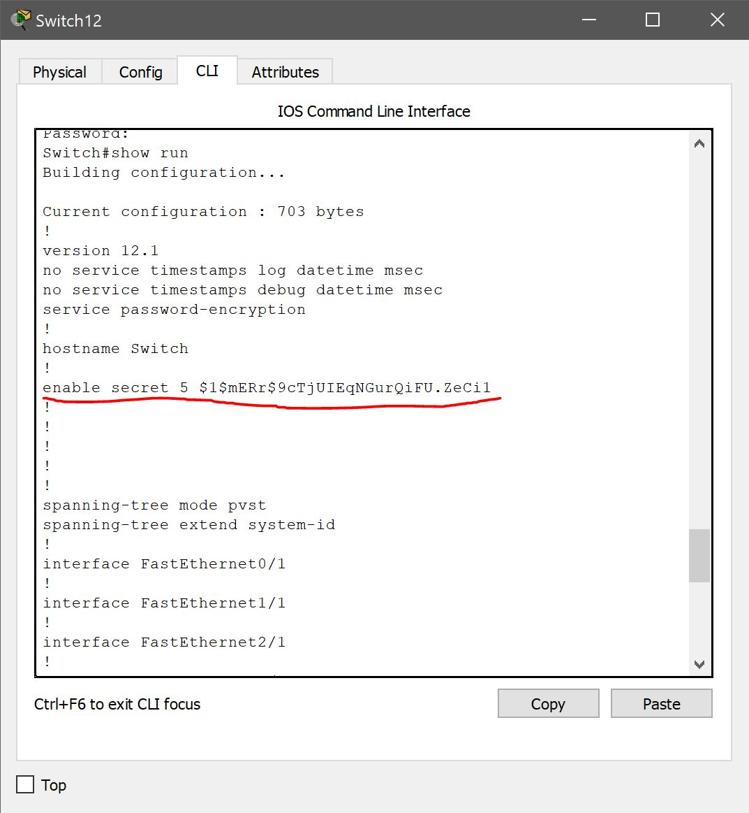
Figure 9. Showing the necessary security and encryption on the switches.

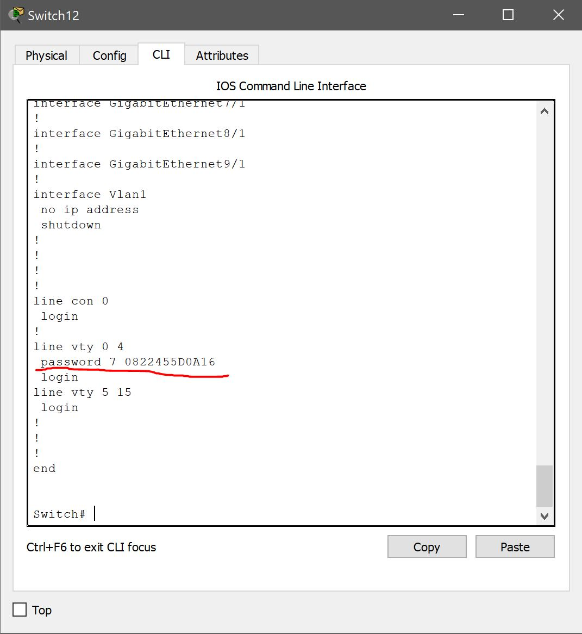
Figure 10. Showing the necessary security and encryption on the switches.

BYOD (Bring Your Own Device)
In this network design, the last thing implemented was a BYOD network, where campus employees and students can bring their own device and connect it to the university campus through a wireless access point.

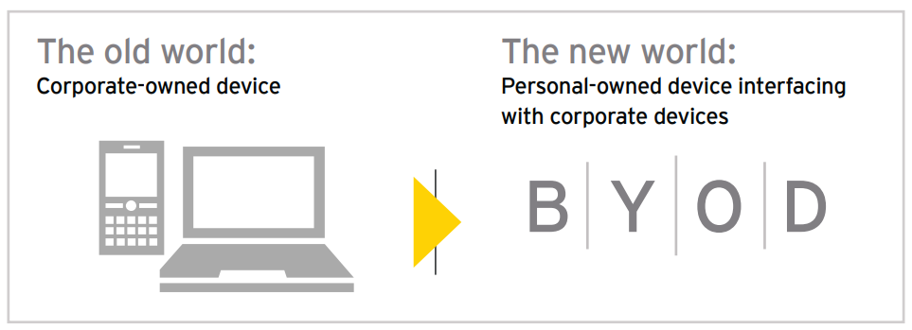
Figure 11. Old world vs New world. [15]

“A major driver of BYOD is the productivity advantage resulting from improved employee satisfaction and worker mobility.” [16] This in opinion, like remote access is a very beneficial tool that the university should implement due to the advantages it could bring the campus employees and students.

However, if users are connecting to a network with their own devices, they must follow some sort of policy. By creating a BYOD policy, this enforces the users that bring in devices to follow strict rules the university issues. A perfect example of a university policy can be seen with the university of Edinburgh [17].

Results of Implementation
The results of this implementation were not able to recorded, the plan was to use Wireshark, in conjunction with Cisco Packet Tracer as a method to analyses data, but unfortunately Wireshark is no longer compatible with Cisco Packet Tracer.

Due to all the different types of configuration on the network, from IoT device to device security configuration, it is felt that the design is a sufficient design that could be implemented into the real world and tested further. Allowing for further results to improve on in the future. However, there were a few complications to configuring firewalls on the simulations, and this would not be the case in a real-world application.

IoT & Smart City Overview
IoT (Internet of Things), has not been a recently invention, IBM told a story where they in fact created the first ever smart soda machine in the early 80’s. [18] Since then, the world has been adapted, IoT is becoming a major thing and most cities are incorporating IoT into their own communities. “The idea is that not only your computer and your smartphone can talk to each other, but also all the things around you. From connected homes and cities to connected cars and machines to devices that track an individual’s behavior and use the data collected for new kind of services.” [19]
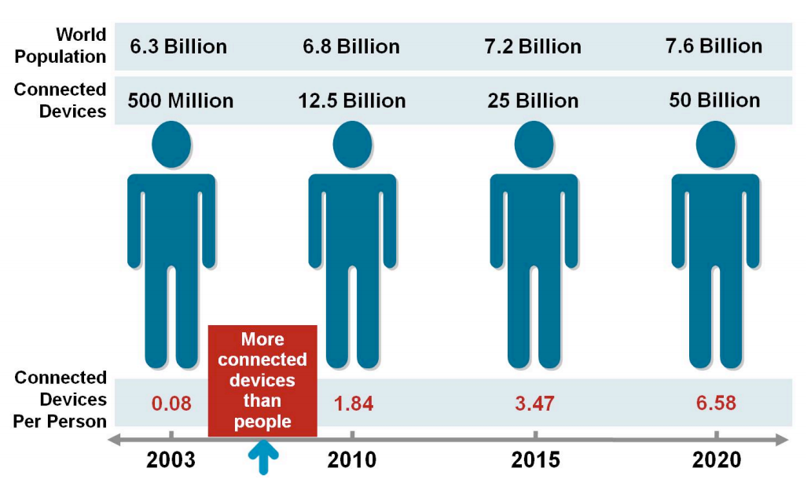
Figure 12. Showing the rapid increase of IoT devices since 2003. [20]

Despite, IoT being on the rise. There are still vast security issues that need to be amended. There are many techniques that can be implemented and tests for the purpose. It seems innovators of this technology, are taking an approach where innovation is more important than security of the devices, and security is being left behind while these devices advance. As seen in figure 12. IoT device numbers are rising rapidly, and with more devices being made, security will need to become more secure. This is due to the advancement of the technology.

IoT & Smart Cities Security Issues
Before being able to secure a system, one must understand the types of attacks and the steps that an attacker will go through in order to attack these vulnerable IoT systems. Through an attack on an IoT device, an attacker can inflict serious damage to any business, resulting in anything from financial disability to reputable damage, resulting in the company losing clients etc.

According to ACS in 2016. 46% of the world was connected to the internet. [21] 2 years later, over half of the world is now connected to the internet and is rising rapidly until the whole world is connected. This will happen with every city in the world eventually adapting smart technology in their own communities.


Figure 13. Showing the impact of IoT in 2015. [22]

As seen in figure 13. A good example of how beneficial connected life is to the world, is the fact that one in nine lives are saved purely because of mobile enabled in car emergency services. By 2025, this number will rise which means more lives saved. But nothing could stop an attacker from going after these connected cars, stopping all emergency services from noticing an accident. This is why security should be a number one priority based in the modern world.

Figure 14. Showing the stages of a cyber security attack. [23]

To be able to stop an attack, one must first know how an attack is made, to help prevent damage in the future. Most of the time, an attacker will use any tools necessary, from open source to custom programmed tools, to analyze a network for any vulnerabilities they can exploit. Delivery is where the attacker gets to the point of the attack to exploit the vulnerability found on the system. Once the exploit is found a breach can be made, allowing the attack full control over IoT systems. With the full control, an attacker is able to do what was set out originally. For example, hacking into a home network that uses automated home systems like Amazon Alexa. Attacking this could release any information stored on the device. From banking details to personal details recorded on the online calendar. Amazon Alexa also houses a built-in microphone which means, if the attacker wishes, could listen into private conversations retrieving even more sensitive information that can be used for a devastating effect to the household in question.

There are two types of attacks that can be made on any network, passive and active. As seen in figure 15.

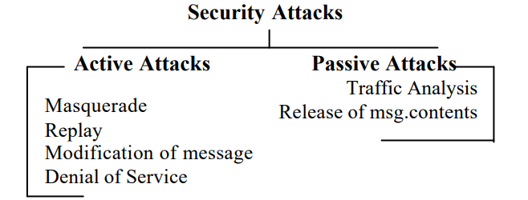

Figure 15. Showing the difference between both types of attacks. [24]

Securing a Network
After understanding how an attack is made steps can be made in order to secure the network from such threats. Most of the time, simple methods are overlooked by companies and this nativity leads to the fall of a network. In this section, simple methods are explained as methods to securing a network, along with one advanced method that could be implemented in the future called Publish/Subscribe.

There are two simple methods, if followed can result in a secure network. One being a logical system called the CIA Triad [25], and another being physical encryption to all devices on the network.

The CIA Triad, is an important feature to any system that deals with big data, most of the time any IoT service deals with big data. A method of securing such data, is simply by complying to rules set through the CIA Triad. CIA stands for, Confidentially, Integrity and Availability, by knowing these guidelines for a potential security method, all networks should be setup in a way where these are applied to complete system. For example, Confidentially, the most important part of the CIA Triad, this ensures that all data should be kept confidential between the company and the user. Other parts of the Triad, availability, data should also be available at hand when the user requests the information needed, meaning there should be hardly any downtime on the system. Integrity means, that all data stored should always be returned to the user the way it was given.
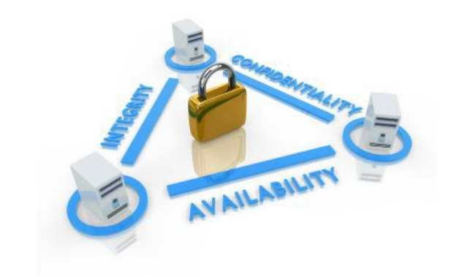
Figure 16. Showing the CIA model. [26]

The other method of securing a network is encryption, there are many types of encryption but the main two are Asymmetric or Symmetric encryption. Encryption is the method of turning plain text into jumbled text that can not be read, the only way to read the information that has been scrambled is by the use of private and public keys. [27]

Symmetric Encryption [28] – Symmetric, is the process of concealing information of any size, usually passwords and messages send online.

Asymmetric Encryption [28] – Asymmetric, is the process of concealing information that is very small, for example digital signatures.

Every business should make sure they secure from top to bottom, but they a lot of business do not know when they are being attacked, and a lot do not have software in place to deal with it. An Intrusion Detection System should be implemented in order to defend against this, an example of this is a software called SNORT. “Using intrusion detection methods, you can collect and use information from known types of attacks and find out if someone is trying to attack your network or particular hosts.” [29]

To advance security further, there is a system recently in development called a Publish/Subscribe system. This type of method is purely for IoT devices, because IoT does not include any built-in security like most other computer systems. Most devices talk through the opening of inbound ports, “Any device on the Internet with an open inbound port will be attacked. It’s a matter of when, not if.” [30] However, in this method outbound connections are used in order to deliver packets across the network. Examples that use this protocol, can be see in HTTP 2.0 & WebSocket’s.

Conclusion
To conclude, it is felt the overall design of the network for UWTSD was achieved well, by implementing everything that was possibly. Due to limitations, with minor errors that occurred during Cisco Packet Tracer, for example firewall configuration and DHCP compatibility with Layer 3 switches. There were even compatibility issues with Cisco Packet Tracer and Wireshark which led to the idea of an analysis of the complete network design to never be attempted. Through research, trial and error and different experimental methods, the design created is a detailed and realistic attempt of a network design that implements such realistic features like DHCP, DNS, backbone devices, webservers and so on. Due to the advancing knowledge throughout this report/simulation, it could be improved upon slightly and pushed out physically for real world usage in the future. It is believed that the task was not fully completed because the software used was not at a standard in which would give a realistic result.

Further, after discussing IoT later in the report, going into detail about security based around IoT. It can be seen why there is such a need for security to be taken as a priority over the innovation of such IoT devices. For if a secure network is not fully protected, an IoT device which holds no built-in security is surely going to be attacked, and if attacked there is no way of defending against it. By following various steps discussed, and even possibly venturing out to implementing a Publish/Subscribe system. Off the shelf Smart Devices could finally be secured in the future.

References

[1] Cisco, “Cisco ASA Series Firewall CLI Configuration Guide,” pp. 3–1, 2015.
[2] W. Goralski, “Dynamic Host Configuration Protocol,” in The Illustrated Network, 2009, pp. 459–482.
[3] “The Difference Between Static and Dynamic IP Addresses STATIC IP ADDRESS.”
[4] A. Santhosh Reddy and C. Technology Solutions, “Reaping the Benefits of the Internet of Things.”
[5] J. Warbrick, “Web Server Management: Securing Access to Web Servers.”
[6] Infoblox, “The Importance of a Resilient DNS and DHCP Infrastructure.”
[7] S. Fulton, “Top 10 DNS attacks likely to infiltrate your network | Network World.” [Online]. Available: https://www.networkworld.com/article/2886283/security0/top-10-dns-attacks-likely-to-infiltrate-your-network.html. [Accessed: 09-May-2018].
[8] A. AlHajeri, “GCIH Practical Assignment version 2.1 DNS Spoofing Attack Support of the Cyber Defense Initiative.”
[9] “What is ERP | Enterprise Resource Management Definition | SAP.” [Online]. Available: https://www.sap.com/products/what-is-erp.html. [Accessed: 09-May-2018].
[10] N. Mustafa and T. Peltier, “F UNDAMENTALS OF R EMOTE A CCESS.”
[11] V. P. Network et al., “IP Tunneling and VPNs,” pp. 1–78.
[12] D. Farinacci, T. Li, S. Hanks, D. Meyer, and P. Traina, “Generic Routing Encapsulation (GRE),” 2000.
[13] G. Gridling and B. Weiss, “Introduction to Microcontrollers,” 2007.
[14] A. Traffic and M. Through, “W h i t e pa p e r,” Quality.
[15] EY, “Bring Your Own Device,” 2013.
[16] C. Technology Solutions, “Making BYOD Work for Your Organization Executive Summary,” 2012.
[17] University of Edinburgh, “BYOD Policy: Use of Personally Owned Devices for University Work,” pp. 1–4, 2015.
[18] Teicher Jordan IBM, “The little-known storyof the first IoT device.” [Online]. Available: https://www.ibm.com/blogs/industries/little-known-story-first-iot-device/. [Accessed: 09-May-2018].
[19] K. Lueth Lasse, “IoT basics: Getting started with the Internet of Things,” 2015.
[20] D. Evans, “The Internet of Things How the Next Evolution of the Internet Is Changing Everything,” 2011.
[21] acs, “Cybersecurity Threats Challenges Opportunities,” 2016.
[22] “Understanding the Internet of Things (IoT),” 2014.
[23] GCHQ and Cert-UK, “Common Cyber attacks,” UK Gov., p. 17, 2015.
[24] M. Hussain, “PASSIVE &amp; ACTIVE ATTACKS AGAINST WIRELESS LAN’S.”
[25] Kinamik, “The CIA triad: Have you thought about Integrity?”
[26] stevanovic igor, “Secured data transfer.”
[27] E. Jung, “Public Key Cryptography Basic Public Key Cryptography.”
[28] W. Stallings, “DATA AND COMPUTER COMMUNICATIONS Eighth Edition,” Education.
[29] R. M. Pir, “Intrusion Detection Systems with Snort,” vol. 3, no. 1, pp. 479–488, 2015.
[30] “5 Key Requirements to Securing IoT Communications A New Approach to IoT Security.”

APPENDIX
Figure 1. A larger image of the overall design.

marking criteria and Student FEEDBACK

This section details the assessment criteria. The extent to which these are demonstrated by you determines your mark. The marks available for each criterion are shown. Lecturers will use the space provided to comment on the achievement of the task(s), including those areas in which you have performed well and areas that would benefit from development/improvement.

Common Assessment Criteria Applied (Assignment 1) | Marks available | Marks  awarded
1. Research-informed Literature
Extent of research and/or own reading, selection of credible sources, application of appropriate referencing conventions.
Inclusion of a wide range of research-informed literature, but you could utilised more updated peer reviewed articles. Some areas could do with more referencing. (Grade mark: 73.33%) | 15 | 11
2. Knowledge and Understanding of Subject
Extent of knowledge and understanding of concepts and underlying principles associated with the discipline.
Clear awareness of challenges to established views and the limitations of the knowledge base. (Grade mark: 73.33%) | 15 | 11
3. Analysis
Analysis, evaluation and synthesis; logic, argument and judgement; analytical reflection; organisation of ideas and evidence
The discussion of your research aspect could inter-relate to your design to provide more convincing argument. Overall very good report. (Grade mark: 80.00%) | 30 | 24
4. Practical Application and Deployment
Deployment of methods, materials, tools and techniques; application of concepts; formulation of innovative and creative solutions to solve problems.
A good design highlighting the areas as required in the brief, however the lack of SSH and shutdown ports is disappointing. However that said the console ports are all configured along with basic VTY. (Grade mark: 63.33%) | 30 | 19
5. Skills for Professional Practice
Attributes in professional practice: individual and collaborative working; deployment of appropriate media; presentation and organisation.
Your work flow. Require format alignment (justify) Some areas sentence could be written much clear or more appropriate choice of words.  (Grade mark: 65.00%) | 10 | 6.5

Assignment Mark (Assessment marks are subject to ratification at the Exam Board. These comments and marks are to give feedback on module work and are for guidance only until they are confirmed. ) | Late Submission Penalties (tick if appropriate) |  | 72%
 | Up to four weeks late |  | 72%
 | First Attempt? |  | 72%

