LEVEL 7 ASSESSMENT
INFORMATION BOOKLET
RHEUMATOID ARTHRITIS
A Whole-Person Approach to Long-Term Condition Management in the UK
Programme | MSc Public Health and Social Care in Practice
Module | LCHS7003 - Community Care and Management of Longer-term Conditions
Assessment | Component 1 - Information Booklet of Long-term Condition Management
Student name
Student ID
Lecturer | Dr Aishat Bakre
Word count | 3000
Audience: UK health and care service users and professionals
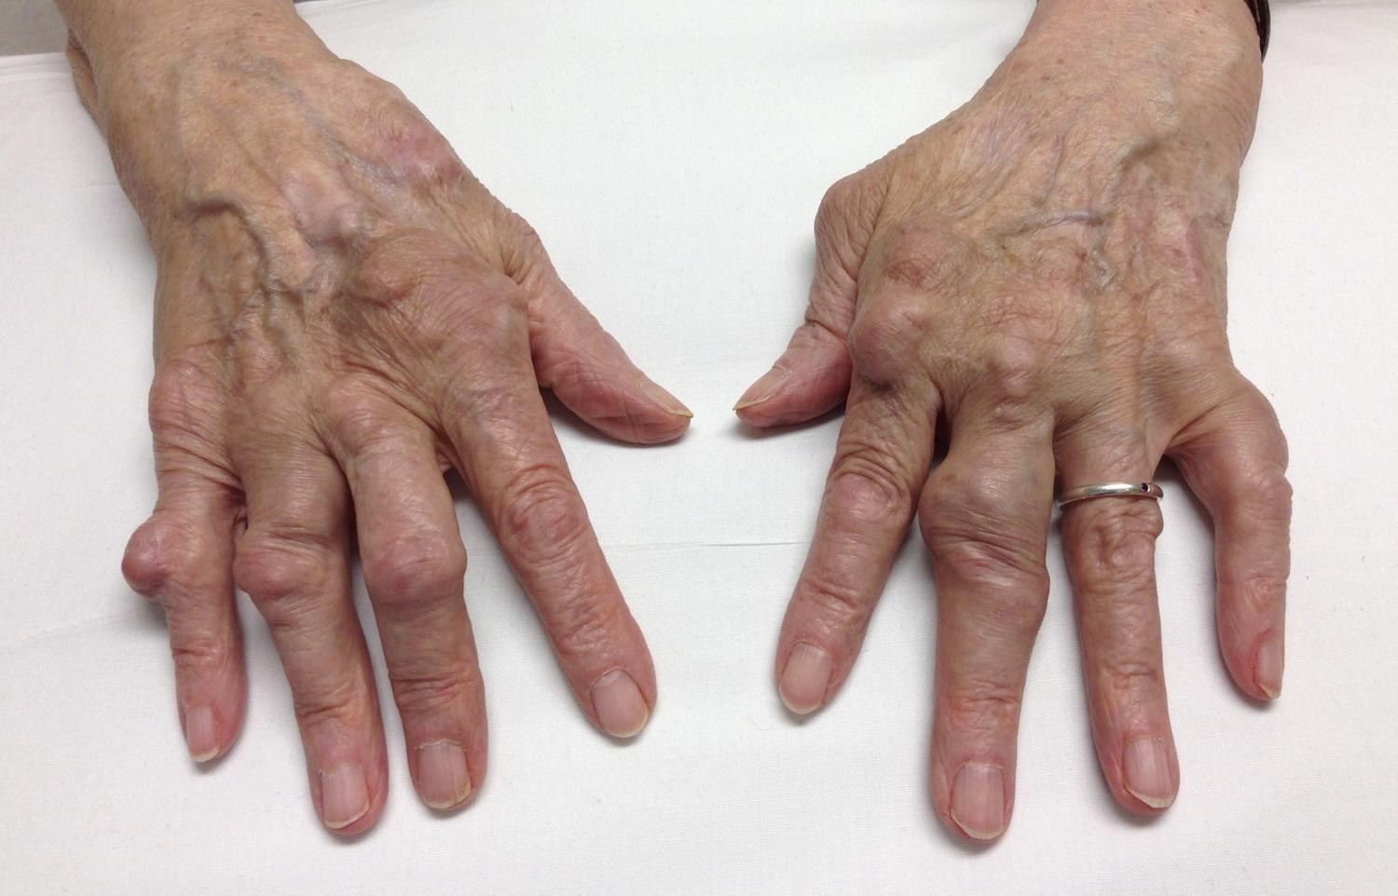
Figure 1. Rheumatoid arthritis in the hand: clinical photograph showing multiple rheumatoid nodules.
Source: Albert (2024).

Table of Contents
Definition 5
Burden / Prevalence: UK and Worldwide 5
Risk Factors 5
Physical, Psychological and Social Implications of Rheumatoid Arthritis 6
Physical implications 6
Joint pain, swelling and morning stiffness 6
Reduced mobility and daily function 7
Fatigue and comorbidity 7
Psychological implications 7
Depression and emotional wellbeing 7
Anxiety 7
Psychological stress and coping 7
Social implications 7
Employment and productivity 7
Inequalities in access and outcomes 7
Social participation and quality of life 8
Family and carer implications 8
Evidence-Based Treatment and Management Through the NHS 8
Theoretical Models and Frameworks for Improving Outcomes 9
UK model: House of Care 9
International model: Chronic Care Model 10
Comparison of the Models 11
Local and National Health and Social-Care Policy and Implementation 12
Person-Centred Care and Self-Management 13
End-of-life care where appropriate 14
Recommendations for Improvement 14
Earlier referral and access 14
Individualised care and support plans 15
Blended self-management options 15
Routine psychosocial assessment 15
Outcome monitoring 15
Conclusion 15
Reference List 16

Rheumatoid arthritis at a glance
Global prevalence | 18 million people were living with rheumatoid arthritis worldwide in 2019 (World Health Organization, 2023).
UK prevalence context | England: 0.79% of people aged 16 and over in 2024/25; earlier estimates were 0.78% in Scotland (adults aged 18+) and 0.94% in Wales (people aged 16+). Northern Ireland publishes a separate register series; years and age groups differ (NHS England, 2025; Versus Arthritis, 2021; Department of Health Northern Ireland, 2026).
Treatment within six weeks | 60% started a disease-modifying antirheumatic drug within six weeks of referral in the 2024/25 National Early Inflammatory Arthritis Audit (Healthcare Quality Improvement Partnership, 2025).
Symptoms for six months or more before referral | 38% had symptoms for at least six months before referral, showing continuing delay before specialist assessment (Healthcare Quality Improvement Partnership, 2025).
Core management idea | Early disease control plus rehabilitation, self-management and person-centred care.

Definition
Rheumatoid arthritis (RA) is an autoimmune chronic inflammatory condition. The immune system malfunctions and results in constant inflammation of the synovium, the tissue lining the joints. Uncontrolled inflammation leads to cartilage and bone damage and impairment over time. RA may also target tissues beyond the joints, meaning that management has to take into account the whole patient rather than just joint symptoms (Romao and Fonseca, 2021; Ciofoaia, Pillarisetty and Constantinescu, 2022).

Burden / Prevalence: UK and Worldwide
The World Health Organization estimated that 18 million individuals had rheumatoid arthritis globally in 2019 (World Health Organization, 2023). Prevalence in the UK needs to be interpreted with caution since national registers use different years and ages. In 2024/25, NHS England indicated that 0.79% of the population aged 16 and above was on the RA register. Previous estimates for 0.78% among adults aged 18 and older in Scotland and 0.94% among individuals aged 16 and above in Wales have been based on 2016 and 2017 data respectively (NHS England, 2025; Versus Arthritis, 2021). There is a separate register series for Northern Ireland, where 2025/26 data will be released in 2026 (Department of Health Northern Ireland, 2026). These statistics cannot be used as the one current, comparable UK prevalence. The recorded prevalence could be related to the change in demographics and registration practices; however, these statistics do not determine the cause. Rheumatoid arthritis has a connection with chronic pain, disability, absenteeism from work, and comorbidities.
A meta-analysis conducted in 2024 has established that there is greater all-cause and cause-specific mortality compared to controls, suggesting a relationship between RA management and quality of life and survival (Lee and Song, 2024). Unequal health status and unequal access to health services are factors that influence the outcome, which means that the joint-only strategy is inadequate (Ciofoaia, Pillarisetty and Constantinescu, 2022).

Risk Factors
RA has a multifactorial pathogenesis. Genetic predisposition, immunological dysregulation and environmental factors work together, rather than a single factor causing disease (Romao and Fonseca, 2021). In people at risk, anti-citrullinated protein antibodies, symptoms and subclinical inflammation on imaging can help assess risk, although their predictive value varies between populations (Mankia et al., 2021). Risk factors inform assessment but cannot show that an individual will definitely develop RA.
Smoking is a risk factor for seropositive rheumatoid arthritis, as it may increase protein citrullination and interact with genetic susceptibility (Ishikawa and Terao, 2020). Obesity is linked to risk, but is a risk modifier rather than a cause (Ohno, Aune and Heath, 2020). Periodontal disease has been associated with rheumatoid arthritis, but results are inconsistent, and no causal relationship has been established (Qiao et al., 2020).
Genetic susceptibility, such as leukocyte antigen shared-epitope variants, can interact with environmental factors, but does not dictate that an individual will develop the disease (Mankia et al., 2021). Rheumatoid arthritis affects more women than men, but hormonal influences are not sufficient to explain the sex difference (Venetsanopoulou et al., 2023). The condition can develop at different ages, with prevalence varying by age group and geographical location, and age should be considered in relation to likelihood, rather than suggesting certainty (GBD 2021 Rheumatoid Arthritis Collaborators, 2023).
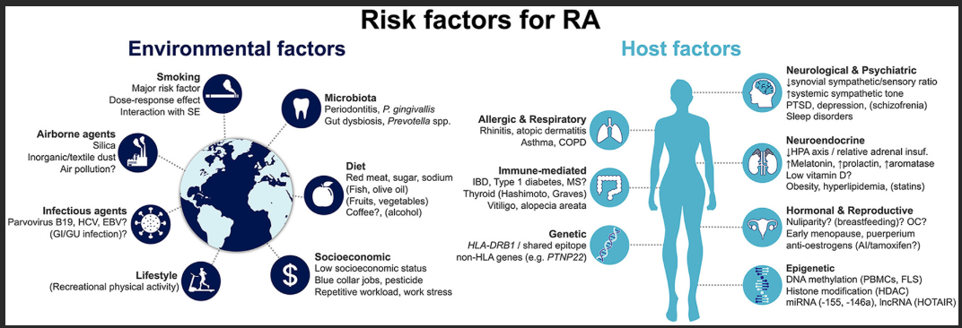
Figure 2. Risk factors for the development of rheumatoid arthritis.
Source: Romão and Fonseca (2021), Figure 1.
The aim of this booklet is to inform UK health and care service users and professionals about rheumatoid arthritis. It examines the condition's burden, causes and whole-person impact, evaluates evidence-based National Health Service (NHS) management, considers UK and international care models and relevant UK policy, and recommends improvements in person-centred care and self-management.

Physical, Psychological and Social Implications of Rheumatoid Arthritis

Physical implications

Joint pain, swelling and morning stiffness
Joint inflammation (synovitis) may cause pain, swelling, morning stiffness and reduced range of motion, consistent with the clinical features addressed in guidance from the National Institute for Health and Care Excellence (NICE) (NICE, 2020). These symptoms can fluctuate and may make daily tasks difficult, even when visible joint damage is limited (NICE, 2020).

Reduced mobility and daily function
Disease activity and structural damage may affect walking, manual dexterity, household activities and work. Occupational therapy can help people adapt activities and build practical self-management skills, although interventions and outcome measures differ between studies (Gavin et al., 2024).

Fatigue and comorbidity
Fatigue is an important patient experience and is not explained exclusively by inflammatory activity. Comorbidity adds further burden; a review of 33 studies estimated hypertension prevalence at 37.7% among people with RA, although estimates vary across studies (Hill et al., 2022).

Psychological implications

Depression and emotional wellbeing
Psychological impact may be persistent and bidirectional. A systematic review and meta-analysis found an association between RA and depression in both directions, indicating that mental wellbeing is more than a reaction to physical symptoms (Ng et al., 2022).

Anxiety
The meta-analysis of 33 studies estimated anxiety-disorder prevalence at 62.1% and depression prevalence at 32.1% among people with RA. High statistical heterogeneity means that these figures should not be treated as universal rates (Hill et al., 2022).

Psychological stress and coping
A scoping review linked psychological distress with pain, uncertainty, fatigue, social pressure and coping challenges (De Cock et al., 2022). Care should therefore assess mood, sleep, coping and health literacy. Clinically controlled joints may coexist with poor psychological wellbeing.

Social implications

Employment and productivity
RA may affect employment, productivity and the ability to perform usual social roles. A systematic review and meta-analysis found that employment outcomes were worse with longer disease duration and greater disease burden, showing that RA can create continued social and economic pressure (Kirkeskov and Bray, 2023).

Inequalities in access and outcomes
Social and demographic differences can influence diagnosis, access to healthcare, treatment and prognosis. These inequalities mean that average outcomes may conceal unmet need in some groups and that services should review access and outcomes across their local populations (Ciofoaia, Pillarisetty and Constantinescu, 2022).

Social participation and quality of life
RA can limit social participation and affect quality of life through its combined physical, psychological and social effects. A systematic review found that RA-specific, general and psychosocial factors all contribute to health-related quality of life (Hassen et al., 2025).

Family and carer implications
Family members may be impacted through changes in care roles, supportive assistance and emotional strain. The family's participation may positively affect continuity when the patient wants relatives or carers to participate, but patient wishes and confidentiality must remain a priority (Oliver, Roberts and Haines, 2020; NHS England, 2023).
A broader review of chronic care organisational models found that caregiver outcomes are assessed less often than those of patients, which is an important service gap (Longhini et al., 2022). As far as RA is concerned, family involvement must be person-centred and service-enabled rather than a shift of clinical responsibilities onto relatives.

Evidence-Based Treatment and Management Through the NHS
Within the NHS, early and targeted disease control is a key clinical principle. The National Institute for Health and Care Excellence recommends treating active rheumatoid arthritis to achieve remission or low disease activity through a treat-to-target strategy. For newly diagnosed active disease, a conventional disease-modifying antirheumatic drug (DMARD), such as methotrexate, leflunomide or sulfasalazine, should start as soon as possible and preferably within three months of persistent symptoms (NICE, 2020). Glucocorticoids may be used as bridging treatment, while non-steroidal anti-inflammatory drugs (NSAIDs) may help control pain or stiffness when needed. Symptom relief alone is not the goal: disease-modifying treatment aims to suppress inflammation and reduce the risk of structural damage and loss of function (NICE, 2020; Smolen et al., 2023).
If conventional disease-modifying antirheumatic drugs do not provide sufficient control, biological or targeted synthetic disease-modifying antirheumatic drugs may be considered according to disease severity, previous response, safety and cost-effectiveness. Evidence reviews by the European Alliance of Associations for Rheumatology (EULAR) report clinical benefits from synthetic and biological therapies, although safety differs by medicine class and patient group (Kerschbaumer et al., 2023; Sepriano et al., 2023). A 2024 systematic review found better outcomes with treat-to-target strategies than usual care in most included comparisons, with a pooled relative risk for remission of 1.68 at one year (Hao, Oon and Nikpour, 2024). Reaching the target depends on timely review, repeated measurement and treatment adjustment. Safety monitoring is also essential, particularly for immunosuppression and co-morbidity (Sepriano et al., 2023).
Drug treatment should be accompanied by rehabilitation and self-management. NICE recommends access to multidisciplinary team, including physiotherapy and occupational therapy, and annual review of disease activity, functional status, comorbidities and impact of RA on daily life (NICE, 2020). A systematic review in 2024 showed that occupational therapy helps to support self-management through education, problem-solving and adaptation of the activity, although interventions and measures differed between studies (Gavin et al., 2024). Exercise therapy is also appropriate. Evidence on physical activity in lifestyle proved its potential to improve patient-relevant outcomes, and a network meta-analysis from 2025 confirmed benefits of various types of exercises (Brady et al., 2023; Zhang et al., 2025).
Due to different certainty and responsiveness, the programs should be adjusted to the patient's symptoms, fitness, preferences and safety rather than prescribed as the same routine.
Digital support can be additional but not replacement of clinical care. Systematic review showed that telehealth can support RA self-management, but results depended on the intervention and long-term effects were not always clear (MacIver, Hollinger and Carolan, 2021). Digital solutions should be provided along with non-digital ones in order to ensure that people who lack digital skills, Internet access or communication ability are not left behind.

Theoretical Models and Frameworks for Improving Outcomes

UK model: House of Care
House of Care is a UK personalised care approach. Care and support planning discussion links together key building blocks; in rheumatoid arthritis (RA), they have to integrate disease control with functional capacity, confidence and quality of life (Oliver, Roberts and Haines, 2020; NHS England, 2023).
Engaged, informed individual and carer. Information on RA, medication, fatigue management, flares and treatment options in clear language. Encourage individual to define their priorities like dressing, work or taking care of their family members and agree on reasonable goals. Carers get involved after receiving permission from the person.
Care and support planning discussion. Use the review to integrate disease activity and medicine safety with what matters to the person. Document agreed goals, responsible persons for each task and time for reviewing it so that the care plan becomes a guideline for the care and not just a documentation of it.
Health and care professionals working in partnership. Clinicians working in rheumatology, specialist nurse, GP, physiotherapist, occupational therapist and psychological services need to coordinate treatment, rehabilitation and referrals. Pain, fatigue, mood and functionality get reviewed with joint symptoms.
Organisational processes and arrangements. Ensure prompt appointments, testing, monitoring of medication safety, annual review and easy access to urgent advice. Named coordinator keeps track of referrals and outstanding tasks. Accessible information, interpreters and telephone availability minimize the obstacles.
Commissioning and community resources ("more than medicine"). Ensure integration of care plan with community exercise, peer support, welfare or employment advice and psychological services if necessary. In case of absence of local services, document this fact and find a way out (Dup, 2020).
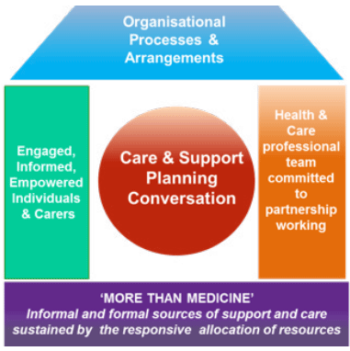
Figure 3. House of Care framework for person-centred coordinated care.
Source: Scottish Government (2019), Figure 1.

International model: Chronic Care Model
The Chronic Care Model (CCM) is based on the concept of the relationship between an informed and activated patient and a prepared and proactive team, supported by organized services. All six elements of the model can be used as a framework for organized care of patients with RA (Goh et al., 2022; Longhini et al., 2022).
Healthcare organization. Establish responsibility for early referral, treatment escalation, and annual review and audit to ensure timely delivery of care at the level of the health service and not depending on each patient.
Community resources and policies. Maintain connections to local rehabilitation, physical activity, peer support, and employment services to ensure that the options are relevant to patient location, mobility and language abilities.
Self-management support. Train in pacing, joint protection, safe physical activity, medicines adherence and flare management. Provide problem-solving and psychological support, and review the goals of the person, rather than expect patients to manage by themselves.
Delivery system design. Organize proactive rheumatology consultations with involvement of nurses, physiotherapy, and occupational therapy as needed. Identify responsible individuals for test results, referrals and follow-up so that functional changes would not be overlooked.
Decision support. Use NICE guidelines, validated tools to measure disease activity and tools to facilitate shared decision-making about treatment escalation, its potential benefits and risks and patient preferences. Review decisions in case the set target is not achieved.
Clinical information systems. Collect and organize symptoms, disease activity, medications, blood tests results, function, fatigue, referrals and patient-reported outcomes in one shared record. This way teams can identify overdue care and inequalities in access.
Implementation of the model can be evaluated by measuring referral times, disease control, function and patient experience. Much of the cited evidence for the CCM relates to other chronic conditions, so it is necessary to monitor outcomes locally when using the model (Goh et al., 2022; Longhini et al., 2022).

Comparison of the Models
The two models complement each other. The House of Care establishes the structure of a personal conversation and CCM provides a structure for organizing proactive follow-ups and sharing information. An RA pathway can use both models by agreeing personal targets, measuring disease activity and function, evaluating referral to treatment times and identifying inequalities in access (NICE, 2020; NHS England, 2023).
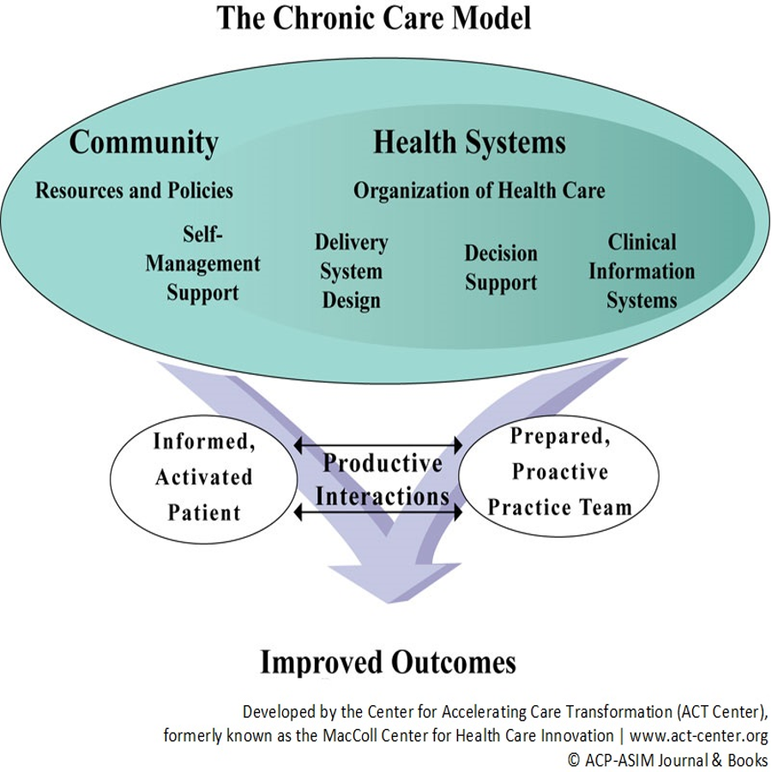
Figure 4. The Chronic Care Model for improving long-term condition outcomes.
Source: Center for Accelerating Care Transformation (ACT Center) (2026).

Local and National Health and Social-Care Policy and Implementation
NICE guidance NG100 advises urgent referral to specialists, disease-modifying drugs, treat to target management, shared decision-making, patient education, multidisciplinary involvement and annual reviews (NICE, 2020). The 2024/25 National Early Inflammatory Arthritis Audit, however, found that only 60% of people started taking a disease modifying anti-rheumatic drug within six weeks of referral, while 38% suffered from symptoms for at least six months prior to referral (Healthcare Quality Improvement Partnership, 2025).
The NHS Long Term Plan and 10 Year Health Plan for England emphasize the need for personalized care and community and digital services (NHS England, 2019; Department of Health and Social Care, 2025). For RA, such policies might be helpful to foster shared care plans and collaboration between general practice, rheumatologists and rehabilitation services. However, the broad policy framework will not provide specialist staffing, funding or referral criteria specifically for RA patients. Implementation needs to be accountable and measure patient-reported outcomes.
Equity has to be considered. Telehealth will suit some patients, but it may alienate those with poor access to the internet or difficulties with using technology, different language or communication barriers. The services have to continue offering face-to-face, interpreted and accessible care. They should monitor referral delay, initiation of treatment, disease activity, functional status, work and patient-reported outcomes by population group and then apply the results along with the patients and carers to close gaps and not just measure activity (Ciofoaia, Pillarisetty and Constantinescu, 2022; NHS England, 2023; Healthcare Quality Improvement Partnership, 2025).

Person-Centred Care and Self-Management
Person-centred RA management involves joint decision-making, plain-language explanation of the evidence, and linking clinical objectives to the things that the person wishes to do. Informed involvement in decisions and clear explanation of benefits and risks of the therapy options throughout the disease process are recommended by NICE (NICE, 2020). Person-centred planning can be more effective if the patient is able to set personal goals, like working, doing housework, or engaging in social activities (NHS England, 2023).
Self-management should be facilitated, not expected of patients. The recommendations of the European Alliance of Associations for Rheumatology (EULAR) include education, goal-setting, problem-solving, psychosocial interventions, health behavior, physical activity, and digital interventions if applicable (Nikiphorou et al., 2021). Systematic analysis revealed the benefits of certain self-management interventions in individuals with rheumatoid arthritis; however, effect sizes and research quality differed, thus recommending personalized rather than standardized programs (Marques et al., 2021). Patient education might also have positive effects on psychological and medical measures (Wu et al., 2022). A 2024 meta-analysis has revealed an improvement in quality of life after patient education; nevertheless, its long-term effects need to be explored (Bounabe et al., 2024).
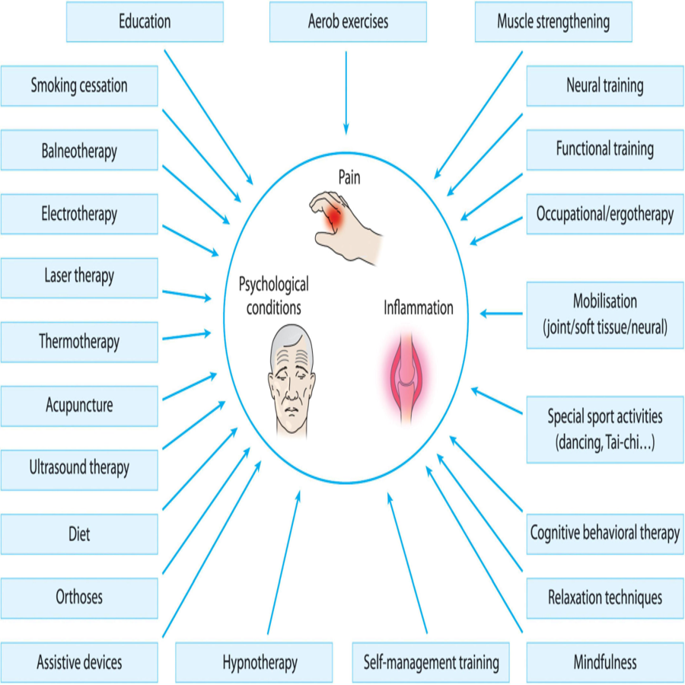
Figure 5: Non-pharmacological treatment options for difficult-to-treat rheumatoid arthritis.
Source: Majnik et al. (2022), Figure 1.

End-of-life care where appropriate
End-of-life care is not an ordinary component of stable RA; however, it may come into play where there is significant co-morbidity, frailty, or some other life-limiting illness. Here, the management should be guided by the individual’s preferences and symptoms, including input from the family where desired. This approach conforms to the tenets of personalized care which stress choice, control, and review (NHS England, 2023). The most important take-away here is that RA cannot be managed in isolation from other diseases or life issues.

Recommendations for Improvement

Earlier referral and access
National Early Inflammatory Arthritis Audit reported that 38% of patients suffered symptoms for more than six months before referral (Healthcare Quality Improvement Partnership, 2025). Proper education to the primary care and proper referral guidelines provided by rheumatology can help overcome avoidable delays (NICE, 2020).

Individualised care and support plans
It can combine NICE "treat-to-target" care plan with House of Care's interest-driven approach (NICE, 2020; NHS England, 2023).

Blended self-management options
Offer a choice of face-to-face or group education, printed material, phone support and digital options. A blended approach is more equitable than digital-only care and should reflect the person’s preferences (Marques et al., 2021; MacIver, Hollinger and Carolan, 2021).

Routine psychosocial assessment
Routine review should assess mood, coping and work impact as well as joint symptoms, because these factors influence quality of life (Ng et al., 2022; Kirkeskov and Bray, 2023).

Outcome monitoring
Track referral time, DMARD initiation, disease activity, function, quality of life, work impact and patient experience. These measures make person-centred care measurable (Healthcare Quality Improvement Partnership, 2025; Longhini et al., 2022).

Conclusion
Rheumatoid arthritis influences joint status, physical functioning, mental well-being, work, social participation, and domestic life. There is evidence for the early use of disease-modifying therapies, treatment to target, rehabilitation, and self-management interventions; however, audit results reveal that this is not universal (NICE, 2020; Healthcare Quality Improvement Partnership, 2025). The House of Care promotes shared planning, and the CCM manages the proactive delivery of services. Combining both involves assessing disease control, functionality, patient experience, tackling inequalities, and incorporating shared decision-making into everyday care (NHS England, 2023; Department of Health and Social Care, 2025).

Reference List
Albert, L. (2024) ‘Rheumatoid arthritis in the hand’, RheumExam Atlas, 16 April. Available at: https://rheumexamatlas.com/2024/04/16/rheumatoid-arthritis-in-the-hand/ (Accessed: 8 October 2026).
Bounabe, A., Elammare, S., Janani, S., Ouabich, R. and Elarrachi, I. (2024) Effectiveness of patient education on the quality of life of patients with rheumatoid arthritis: a systematic review and meta-analysis. Seminars in Arthritis and Rheumatism, 69, 152569. Available at: https://doi.org/10.1016/j.semarthrit.2024.152569
Brady, S.M., Veldhuijzen van Zanten, J.J.C.S., Dinas, P.C., Nightingale, T.E., Metsios, G.S., Elmsmari, S.M.A., Duda, J.L., Kitas, G.D. and Fenton, S.A.M. (2023) Effects of lifestyle physical activity and sedentary behaviour interventions on disease activity and patient- and clinician-important health outcomes in rheumatoid arthritis: a systematic review with meta-analysis. BMC Rheumatology, 7, 27. Available at: https://doi.org/10.1186/s41927-023-00352-9
Center for Accelerating Care Transformation (ACT Center) (2026) Chronic illness care: Chronic Care Model. Seattle, WA: Kaiser Permanente Washington Health Research Institute. Available at: https://www.act-center.org/our-work/primary-care-transformation/chronic-illness-care (Accessed: 8 October 2026).
Ciofoaia, E.I., Pillarisetty, A. and Constantinescu, F. (2022) Health disparities in rheumatoid arthritis. Therapeutic Advances in Musculoskeletal Disease, 14. Available at: https://doi.org/10.1177/1759720X221137127
De Cock, D., Doumen, M., Vervloesem, C., Van Breda, A., Bertrand, D., Pazmino, S., Westhovens, R. and Verschueren, P. (2022) Psychological stress in rheumatoid arthritis: a systematic scoping review. Seminars in Arthritis and Rheumatism, 55, 152014. Available at: https://doi.org/10.1016/j.semarthrit.2022.152014
Department of Health and Social Care (2025) Fit for the future: 10 Year Health Plan for England. Available at: https://www.gov.uk/government/publications/10-year-health-plan-for-england-fit-for-the-future (Accessed: 17 October 2026).
Department of Health Northern Ireland (2026) 2025/26 raw disease prevalence trend data for Northern Ireland. Available at: https://www.health-ni.gov.uk/publications/202526-raw-disease-prevalence-trend-data-northern-ireland (Accessed: 22 October 2026).
Gavin, J.P., Rossiter, L., Fenerty, V., Leese, J., Adams, J., Hammond, A., Davidson, E. and Backman, C.L. (2024) The impact of occupational therapy on the self-management of rheumatoid arthritis: a mixed methods systematic review. ACR Open Rheumatology, 6(4), pp. 214-249. Available at: https://doi.org/10.1002/acr2.11650
GBD 2021 Rheumatoid Arthritis Collaborators (2023) ‘Global, regional, and national burden of rheumatoid arthritis, 1990–2020, and projections to 2050: a systematic analysis of the Global Burden of Disease Study 2021’, The Lancet Rheumatology, 5(10), pp. e594–e610. Available at: https://doi.org/10.1016/S2665-9913(23)00211-4
Goh, L.H., Siah, C.J.R., Tam, W.W.S., Tai, E.S. and Young, D.Y.L. (2022) Effectiveness of the chronic care model for adults with type 2 diabetes in primary care: a systematic review and meta-analysis. Systematic Reviews, 11, 273. Available at: https://doi.org/10.1186/s13643-022-02117-w
Hao, Y., Oon, S. and Nikpour, M. (2024) Efficacy and safety of treat-to-target strategy studies in rheumatic diseases: a systematic review and meta-analysis. Seminars in Arthritis and Rheumatism, 67, 152465. Available at: https://doi.org/10.1016/j.semarthrit.2024.152465
Hassen, N., Moolooghy, K., Kopec, J., Xie, H., Khan, K.M. and Lacaille, D. (2025) Determinants of health-related quality of life in adults living with rheumatoid arthritis: a systematic review. Seminars in Arthritis and Rheumatism, 73, 152717. Available at: https://doi.org/10.1016/j.semarthrit.2025.152717
Hill, J., Harrison, J., Christian, D., Reed, J., Clegg, A., Duffield, S.J., Goodson, N. and Marson, T. (2022) The prevalence of comorbidity in rheumatoid arthritis: a systematic review and meta-analysis. British Journal of Community Nursing, 27(5), pp. 232-241. Available at: https://doi.org/10.12968/bjcn.2022.27.5.232
Healthcare Quality Improvement Partnership (2025) Rheumatic diseases - State of the Nation 2025: National Early Inflammatory Arthritis Audit. Available at: https://www.hqip.org.uk/report/583-neiaa/
Ishikawa, Y. and Terao, C. (2020) The impact of cigarette smoking on risk of rheumatoid arthritis: a narrative review. Cells, 9(2), 475. Available at: https://doi.org/10.3390/cells9020475
Kerschbaumer, A., Sepriano, A., Bergstra, S.A., Smolen, J.S., van der Heijde, D., Caporali, R., Edwards, C.J., Verschueren, P., de Souza, S., Pope, J.E., Takeuchi, T., Hyrich, K.L., Winthrop, K.L., Aletaha, D., Stamm, T.A., Schoones, J.W. and Landewé, R.B.M. (2023) Efficacy of synthetic and biological DMARDs: a systematic literature review informing the 2022 update of the EULAR recommendations for the management of rheumatoid arthritis. Annals of the Rheumatic Diseases, 82(1), pp. 95-106. Available at: https://doi.org/10.1136/ard-2022-223365
Kirkeskov, L. and Bray, K. (2023) Employment of patients with rheumatoid arthritis - a systematic review and meta-analysis. BMC Rheumatology, 7, 41. Available at: https://doi.org/10.1186/s41927-023-00365-4
Lee, Y.H. and Song, G.G. (2024) All-cause and cause-specific mortality in rheumatoid arthritis: a meta-analysis. Zeitschrift fur Rheumatologie, 83(Suppl 3), pp. 314-320. Available at: https://doi.org/10.1007/s00393-024-01538-3
Longhini, J., Canzan, F., Mezzalira, E., Saiani, L. and Ambrosi, E. (2022) Organisational models in primary health care to manage chronic conditions: a scoping review. Health & Social Care in the Community, 30, pp. e565-e588. Available at: https://doi.org/10.1111/hsc.13611
MacIver, A., Hollinger, H. and Carolan, C. (2021) Tele-health interventions to support self-management in adults with rheumatoid arthritis: a systematic review. Rheumatology International, 41, pp. 1399-1418. Available at: https://doi.org/10.1007/s00296-021-04907-2
Majnik, J., Császár-Nagy, N., Böcskei, G., Bender, T. and Nagy, G. (2022) ‘Non-pharmacological treatment in difficult-to-treat rheumatoid arthritis’, Frontiers in Medicine, 9, 991677. doi: 10.3389/fmed.2022.991677. Available at: https://doi.org/10.3389/fmed.2022.991677 (Accessed: 8 October 2026).
Mankia, K., Siddle, H., Di Matteo, A., Alpízar-Rodríguez, D., Kerry, J., Kerschbaumer, A., Aletaha, D. and Emery, P. (2021) A core set of risk factors in individuals at risk of rheumatoid arthritis: a systematic literature review informing the EULAR points to consider for conducting clinical trials and observational studies in individuals at risk of rheumatoid arthritis. RMD Open, 7(3), e001768. Available at: https://doi.org/10.1136/rmdopen-2021-001768
Marques, A., Santos, E., Nikiphorou, E., Bosworth, A. and Carmona, L. (2021) Effectiveness of self-management interventions in inflammatory arthritis: a systematic review informing the 2021 EULAR recommendations. RMD Open, 7(2), e001647. Available at: https://doi.org/10.1136/rmdopen-2021-001647
Mathers, N. and Paynton, D. (2016) ‘Rhetoric and reality in person-centred care: introducing the House of Care framework’, British Journal of General Practice, 66(642), pp. 12–13. doi: 10.3399/bjgp16X683077. Available at: https://doi.org/10.3399/bjgp16X683077 (Accessed: 8 October 2026).
Ng, C.Y.H., Tay, S.H., McIntyre, R.S., Ho, R., Tam, W.W.S. and Ho, C.S.H. (2022) Elucidating a bidirectional association between rheumatoid arthritis and depression: a systematic review and meta-analysis. Journal of Affective Disorders, 311, pp. 407-415. Available at: https://doi.org/10.1016/j.jad.2022.05.108
NHS England (2019) The NHS Long Term Plan. Available at: https://www.england.nhs.uk/statistics/wp-content/uploads/2022/07/nhs-long-term-plan-version-1.2.pdf (Accessed: 17 October 2026).
NHS England (2023) Personalised care and support planning: a brief summary guide. Available at: https://www.england.nhs.uk/long-read/personalised-care-and-support-planning-a-brief-summary-guide/
NHS England (2025) Musculoskeletal health in England: rheumatoid arthritis prevalence indicator, people aged 16 years and over. Available at: https://fingertips.phe.org.uk/static-reports/health-trends-in-england/England/musculoskeletal_health.html
NICE - National Institute for Health and Care Excellence (2020) Rheumatoid arthritis in adults: management (NG100). Available at: https://www.nice.org.uk/guidance/ng100/chapter/Recommendations
Nikiphorou, E., Ferreira Santos, E.J., Marques, A., Böhm, P., Bijlsma, J.W.J., Immediato Daien, C., Appel Esbensen, B., Ferreira, R.J.O., Fragoulis, G.E., Holmes, P., McBain, H., Metsios, G.S., Moe, R.H., Stamm, T.A., de Thurah, A., Zabalan, C., Carmona, L. and Bosworth, A. (2021) 2021 EULAR recommendations for the implementation of self-management strategies in patients with inflammatory arthritis. Annals of the Rheumatic Diseases, 80(10), pp. 1278-1285. Available at: https://doi.org/10.1136/annrheumdis-2021-220249
Ohno, T., Aune, D. and Heath, A.K. (2020) ‘Adiposity and the risk of rheumatoid arthritis: a systematic review and meta-analysis of cohort studies’, Scientific Reports, 10, 16006. Available at: https://doi.org/10.1038/s41598-020-71676-6
Oliver, L., Roberts, S. and Haines, R. (2020) Care and support planning: a new approach for patients with long term conditions. Practice Nurse. Available at: https://practicenurse.co.uk/articles/long-term-conditions/care-and-support-planning-a-new-approach-for-patients-with-long-term-conditions
Qiao, Y., Wang, Z., Li, Y., Han, Y., Zhou, Y. and Cao, X. (2020) ‘Rheumatoid arthritis risk in periodontitis patients: a systematic review and meta-analysis’, Joint Bone Spine, 87(6), pp. 556–564. Available at: https://doi.org/10.1016/j.jbspin.2020.04.024
Romao, V.C. and Fonseca, J.E. (2021) Etiology and risk factors for rheumatoid arthritis: a state-of-the-art review. Frontiers in Medicine, 8, 689698. Available at: https://doi.org/10.3389/fmed.2021.689698
Scottish Government (2019) Person-centred care: advice for non-executive board members. Published 15 November 2019. Available at: https://www.gov.scot/publications/person-centred-care-non-executive-members/pages/7/ (Accessed: 14 October 2026).
Sepriano, A., Kerschbaumer, A., Bergstra, S.A., Smolen, J.S., Van Der Heijde, D., Caporali, R., Edwards, C.J., Verschueren, P., De Souza, S., Pope, J. and Takeuchi, T., 2023. Safety of synthetic and biological DMARDs: a systematic literature review informing the 2022 update of the EULAR recommendations for the management of rheumatoid arthritis. Annals of the rheumatic diseases, 82(1), pp.107-118. Available at: https://doi.org/10.1136/ard-2022-223357
Smolen, J.S., Landewé, R.B., Bergstra, S.A., Kerschbaumer, A., Sepriano, A., Aletaha, D., Caporali, R., Edwards, C.J., Hyrich, K.L., Pope, J.E. and De Souza, S., 2023. EULAR recommendations for the management of rheumatoid arthritis with synthetic and biological disease-modifying antirheumatic drugs: 2022 update. Annals of the rheumatic diseases, 82(1), pp.3-18. Available at: https://doi.org/10.1136/ard-2022-223356
Venetsanopoulou, A.I., Alamanos, Y., Voulgari, P.V. and Drosos, A.A. (2023) ‘Epidemiology and risk factors for rheumatoid arthritis development’, Mediterranean Journal of Rheumatology, 34(4), pp. 404–413. Available at: https://doi.org/10.31138/mjr.301223.eaf
Versus Arthritis (2021) The state of musculoskeletal health 2021. Available at: https://www.lancashire.gov.uk/media/929825/state-of-msk-health-2021.pdf (Accessed: 22 October 2026).
World Health Organization (2023) Rheumatoid arthritis. 28 June. Available at: https://www.who.int/news-room/fact-sheets/detail/Rheumatoid-arthritis (Accessed: 17 October 2026).
Wu, Z., Zhu, Y., Wang, Y., Zhou, R., Ye, X., Chen, Z., Li, C., Li, J., Ye, Z., Wang, Z., Liu, W. and Xu, X. (2022) The effects of patient education on psychological status and clinical outcomes in rheumatoid arthritis: a systematic review and meta-analysis. Frontiers in Psychiatry, 13, 848427. Available at: https://doi.org/10.3389/fpsyt.2022.848427
Zhang, Y., He, Z., Yin, Z., Wang, J., Gao, W. and Jie, L. (2025) Effect of exercise interventions for rheumatoid arthritis: a systematic review and network meta-analysis of randomised controlled trials. Journal of Pain Research, 18, pp. 5109-5126. Available at: https://doi.org/10.2147/JPR.S537227

