ISAAC ASAMOAH

1705783
BMSK 4001-LON

INTRODUCTION
Every field in life has got its own prerequisite skills. For example, cooking for a family or individual has got different skill to that of commercial. Complacency can make one backward or stagnant hence one need to be dynamic in his or her field in other to progress. Robinson, J. (2000) said “employability skills are those basic skill necessary for getting, keeping and doing well on a job.” This definition by Dr Robinson has really stimulated my thoughts and assumptions about this topic.
(Kaynes 2016) also propounded four theories that makes people highly employable. First spoke about improving organisational foresight and reputation. He also claimed decrease in disutility of workforce saves time. His third assertion is increasing in productivity and lastly saving money. I categorised Kaynes’ ideology into two thus being resourceful and increasing organisational image makes one highly employable (what employers looks for).
Agreeing with both scholars, it is therefore logical and safe to deduct that all required employable skills need to work to prove that one is resourceful and can help build and maintain a brand.
As an ambitious team leader who wants to get to the apex of the managerial ladder, I aught to consider these thoughts in my planning, organisations, leadership and controlling activities.
Hence, the skills I have and the ones I am trying to acquire or improving needs to be in accordance to being resourceful and organisational image building oriented.
People management skill
The most sensitive and difficult skill which can make or break a manager(leader). Since every organisation works with people and not in a vacuum, it is therefore important to manage this resource sensitively since that is what brings results. According to Patterson et al. (1997) “people are the most valuable resource of an organisation, and that the management of people makes differences to company performance.”
According to Oakland and Oakland (2010, p. 185) quoted from The European Foundation for Quality Management’s(EFQM) guidelines and stated that people management is “how the organisation releases the full potential of its people”. They went further to propound three areas to concentrate in other to be a good people manager thus communication, motivation and participation.
From the two above proponents of people management and my initial idea of the subject, it is obvious that people are most important asset that needs controlling well with care to propel the organisation to its targeted potential. By reading from the above mention scholars, research other documents and enrolling in skill for the workplace course I have learnt to improve on my communication skills as a team leader. I have now learnt to engage my team more and given them more roles by motivating them to achieve.
I used to get home tired because I was always doing every task myself and struggling to beat deadlines because I was not engaging my team(delegation). Learning from scholars like Oakland’s and more, I realised participation of team brings the best thus saves money, make money save time and quality. It fosters efficiency and effective management.
I saved time because I can concentrate on doing other and extra task and company saves money and good reputation because we always ahead of production demand and customers are happy. Our reputation has been enhanced and we were recently listed in ‘The Sunday Times’ best company to work for.
My team and I were recommended for producing high quality products recently and it is as the results of knowing my team’s needs and wants. I have learnt to appreciate my performing team members and rewarding them whiles putting non-performing members on training and developmental programs through regular appraisals. This people management skill is saving the company money because everyone knows what they need to do and enhancing quality, good reputation because of less customer complaints. Team members feels valued and belonged.
For effective and efficient team, people need to work in a serene and friendly atmosphere hence managing team conflict is very essential in people management. There was always chaos and misunderstanding in my team because I lacked how to manage conflict. I learnt how to sit individuals down and explained to them the effect of their actions on the team and the company. If I was not able to resolve, I normally refer to higher or appropriate authority for resolution.
In addition, I have come to realise after research managing people comes with respect and it is reciprocal. I have built a strong team through briefing and team orientations how to respect people from different backgrounds (cultural, religious and social). This has fostered united team and I occasionally organises team day out and other social events off work.
I occasionally check the welfare of team members and sometimes sends individuals seasonal cards to feel they are thought of, important and recognised. This have boosted team bonding, trust and efficiency because they also want to give back their best.
Self management
According to (Lorig and Holman, 2003) explained self- management is knowing your problems and taking charge in solving or making it better. They also gave four skills in self-management thus decision making, problem solving, utilising resources and helping people to team up to solve problems. From this definition, I knew I was poor planner and messy but decided to make myself and situation better.
In addition, from what I have learnt from lectures, books, experience, friends, work and from above scholars, I will define self-management as taking charge of your life to bring out the best in you. Being better than you were and to a resource person by following the principles enhances good reputation (Kaynes 2016).
I used to have only my job and home thus from work to bed. It was tiring and was very messy both home and work (not organised and unkept) just some few months ago. But after enrolling in university this year and learning and broadening my mind in management, though I have got extra duties such family (married and baby) plus university life (assignments, library), my life has rather become more organised and easy. I have more time for family life, myself leisure and work because am not enlightened to prioritising my time.
I have also learnt to strategically plan my life by getting myself a diary for the first and timetable for myself (time saving). I used to go to shopping without a shopping list and end up wasting more time guessing what to buy and end up buying things I will not need. Having a shopping list now, I spend less time at the shop, buy things I need (save money), save energy and fuel (I will not have to go back again).
I also set goals for myself to enrol in university not only for certificate but also broaden my knowledge. I am in the progressive process. It will also make me better (financially) with certificate and boost my curriculum vitae (cv). My reputation will also be boosted with university certificate. My chances of promotion (my ambition) will be high or getting a better job.
Besides, not only has it helped in my family and personal life but made me a better team leader. I was a development team leader for eight years but was recently made outright team leader(promoted) and now development manager.
I am now using my knowledge to save money for the company whereas they could have hired and pay more for my training and development. Am now a better person and more responsible(resourceful) and saving and earning more money.
Time Management skills
Time management is one of the most important skill employees look out for. Employees makes more money earn good reputation when they save time as the popular saying by Benjamin Franklin goes “time is money”. I used to have this false notion that time management is just working to beat targeted time or avoiding lateness until I read about “The 7 Habit of Highly Effective People” by Stephen Covey which totally transformed my perception about time management.
“organise things according to importance and urgency” (Covey, S 1979) has thought me the most practical idea about time management thus prioritising and strategic planning is the key other than just beating lateness.
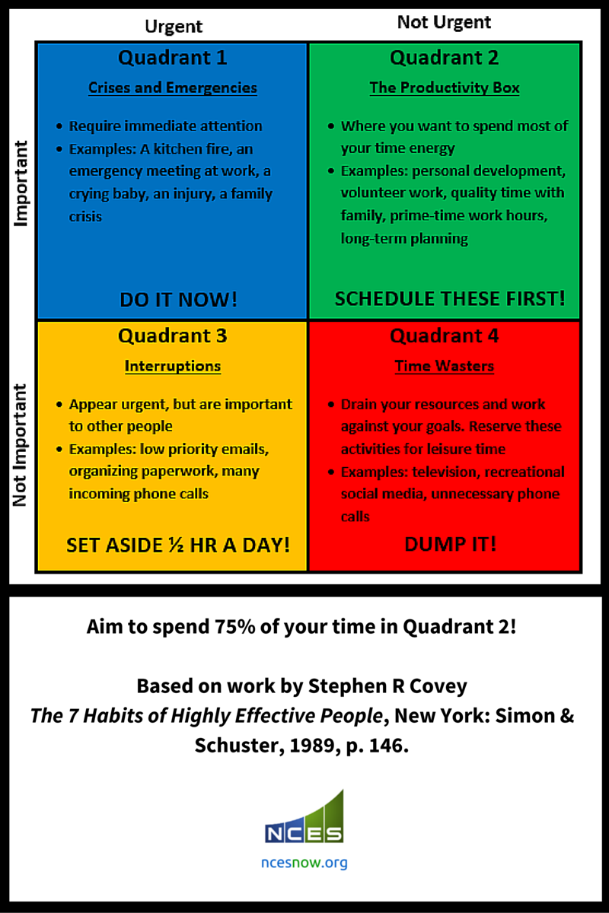The quadrant depicts four areas in my life that shows me how to strategically plan and
Prioritise my daily, weekly and life long activities according to importance, urgency and aiding me to know tasks which draws my attention away(disrupt) from my focus and activities that waste my precious time.
According to Mr Covey, most successful people spend their lives at the upper quadrant. Knowing what is important and doing it right at the right time and being at the right place at the right time. from accessing myself after studying the quadrant, I realised I was always at the right place the wrong time and vice versa.
I have come to realise, I was always found under the lower quadrant (not important) because I had misplaced priorities. Instead of doing my assignment ahead, which when planned should not be urgent. But I leave it till deadline and end up doing panic work and getting poor results (becomes urgent).
By the help of Mr Covey, when am asked to prepare a delivery for customers, I plan which is urgent and attend to that, then to the not urgent. I have also learnt to do my assignments start of the semester in other to have ample time for proper research, avoid panic work and for good academic presentation.
In addition, I now plan my work schedules ahead in other to make room for emergency activities, machine breakdowns, shortage of staff and projects. It helps me save time and do extra projects and earn extra salary. I also have more time for team briefing and appraisals which I use to struggle to do.
I only spend free time on the third quadrant to avoid interruptions and draw backs. I have also decided to totally eradicate the forth quadrant (time wasters). Playing games at lectures, watching movies instead of doing assignments and research. They no more add any value to my busy schedules of family life, university workloads, and promotional driven projects. I now know my needs and wants kudos to the time management quadrant.
According to (Brown, J 1991) we all have same time of the day as great people like Thomas Jefferson, Albert Einstein. They are great because they use time wisely. Another philosophy I have added to my time management skills.
Conclusion
There are several employable skills but I delved into writing about the most pressing and challenging ones in my managerial career. I had always thought just writing a good curriculum vitae(CV) with good qualifications and experience is enough to win you a contract (though it’s a plus) until I enrolled to study ‘skills for the workplace’ program.
But far from that, I have learnt employers wants people who would make their organisation better, that is protect its brand very profitable. My notion about life have changed and with my managerial ambition, I have already started building myself towards that.
In addition, reading and researching about scholars like Mr Covey and being taught by Shao Lan have made me a strategic planner (not just a planner). I have also learnt and began to prioritise my task according to urgent, important and not important by (Covey, S. 1979).
I now believe and have confidence in myself and I know promotion awaits.

REFERENCES:
Dr Jackquelyn P. Robinson, ‘The workplace’. Sep. 15, 2000 volume, issue 3. Alabama cooperative Extension system.
John Maynard Keynes. The theory of Employment, Interest and Money. Atlantic pub. Dist.(p) ltd 2016
Malcolm G Patterson, Michael a West, Rebecca Lawthorn, Stephen Nickell. Impact of people management practice on Business performance. The inst. Of personnel and devp(publisher) 1997
John S Oakland and Susan Oakland. Total quality management vol 9 issue 4 & 5 1998
Oakland consulting plc. 25 Aug 2010. Taylor and Francis
Annals of Behavioural medicine. Aug 2003 vol 26 issue 1 pp1-7
Self- management education: History, definition, outcomes. Kate R Lorig, Halsted R Holman

