Jawad Safi
Network and Cybersecurity
2511186
Due: 23/07/2026
Table of Contents
Contents | Page
Executive Summary | 1
1. Introduction | 2
2. Company Background | 3
3. Identification of Cyber Security Threats | 4
3.1 Internal Threats | 4
3.2 External Threats | 6
4. Threat Assessment Using the CIA Triad | 8
5. Security Policies | 10
5.1 Access Control Policy | 10
5.2 Password and Authentication Policy | 11
5.3 Data Protection Policy | 11
5.4 Acceptable Use Policy | 12
5.5 Incident Response Policy | 12
5.6 Remote Working Policy | 13
5.7 Backup and Recovery Policy | 13
6. Alignment with Security Frameworks | 14
7. Mitigation Measures and Implementation Plan | 15
7.1 Multi-Factor Authentication | 15
7.2 Encryption | 16
7.3 Next-Generation Firewalls and Intrusion Prevention | 16
7.4 Endpoint Protection | 17
7.5 Network Segmentation | 17
7.6 Security Patch Management | 18
7.7 Backup Strategy | 18
7.8 Zero Trust Security Model | 19
8. Implementation Priorities | 20
9. Network Monitoring and Incident Response | 21
9.1 Network Monitoring Introduction | 21
9.2 Security Information and Event Management (SIEM) Architecture | 22
9.3 Continuous Monitoring | 23
9.4 Incident Response Procedure | 24
10. Staff Training and Awareness Programme | 27
10.1 Induction Training | 27
10.2 Annual Refresher Training | 28
10.3 Phishing Simulations | 29
10.4 Role-Based Training | 30
10.5 Measuring Success | 31
11. Conclusion | 32
References | 33
Appendix A – Board of Directors Presentation | 35

Cyber Security Threat Assessment and Security Improvement Strategy for FinSecure Ltd

Executive Summary
FinSecure Ltd is involved in the financial services industry and emails thousands of financial and customer records on a daily basis. With the rise in attacks on computer systems—both in frequency and complexity—Financial institutions are especially at risk from external attackers, from their own employees and from new and emerging technologies. In recent times, cyber criminals have employed numerous techniques to wreak havoc on an organization, including data breaches, ransomware attacks and phishing.
This report investigates the present state of threats in the cyber security field that are at issue with FinSecure Ltd as well as provides an extensive cyber security improvement plan. They are aligned with internationally recognised standards like ISO/IEC 27001:2022, NIST Cybersecurity Framework (CSF) 2.0 and the mandate of the General Data Protection Regulation (GDPR) in UK. This report determines security loss, vulnerabilities within and outside the organization, practical security policies developed, mitigation measures and a proposed staff cyber security awareness programme, along with an outline monitoring and incident response plan.
Proper implementation can enhance the security of the information of an organisation in terms of confidentiality, integrity and availability and will diminish the risk of operations, increase regulatory compliance and build trust amongst customers.

Introduction
One of the biggest challenges organising are faced in the financial domain is in the area of Cyber security. Financial institutions have an enticing proposition because of their possession of an extremely valuable personal information, banking records and monetary assets. The financial sector also had some of the highest average costs of data breaches, owing to the sensitivity of financial data and regulatory requirements, according to IBM [1].
FinSecure Ltd is heavily dependent on digital technologies, cloud services, on-line banking and working remotely. While these technologies help with operational efficiency, they also add to the organisation's risk of being attacked by online threats like ransomware, phishing, malware, 'insider threat' (also known as 'people we know' attacks) and unauthorised access.
The aim of this report is to evaluate the level of risk to FinSecure Ltd with the aim of producing a realistic and realistic cyber risk strategy that is in line with well-established frameworks within the industry. Recommendations are meant to enhance the organisation's security posture and ensure that the organization complies with legal and regulatory obligations.

Company Background
FinSecure Ltd is a medium sized financial services company which offers banking, financial and investment management services to businesses and individuals in the United Kingdom. The organisation holds a lot of sensitive and confidential data about customers that are stored and include:
- Personal identification data
- Banking information
- Financial transactions
- Investment portfolios
- Employee records
- Business financial information
The confidential nature of the information makes it especially vital that FinSecure Ltd maintains high standards of information security to ensure that it does not incur financial losses, suffer from identity-theft, fraud or reputational damage.
The organisation will also have to adhere with the UK GDPR’s criteria to guarantee that individual information is obtained legally, securely and clearly [2].

Identification of Cyber Security Threats
There are internal and external threats in the cyber world. Awareness of these threats helps FinSecure Ltd set up adequate security measures.

Internal Threats

Insider Threats
Staff members' intentional or inadvertent access to sensitive information. Customer data can be accessed for financial gain by malicious insiders, and negligent employees can provide confidential information if their cyber security practices are inadequate.
Examples include:
- Sharing passwords
- Issuing emails to wrong people that convey private information.
- Email confidential information to wrong people.
- Downloading unauthorised software
- Weak Password Management
Reusing or weak passwords make it far easier to access or break. Comprised credentials often come from previous data breaches or phishing attacks by attackers.
Examples include:
- Using simple passwords
- Sharing login credentials
- Not enabling multi factor authentications
- Managing unauthorised USB connection
- Poor Patch Management
By failing to keep the operating system and applications up to date, you create opportunities for exploiters to take advantage of these gaps.
Cybercriminals know and exploit common software weaknesses and vulnerabilities in outdated programs through automated attack programs.
The Verizon Data Breach Investigations Report shows that human error is still a major factor in data breaches when it comes to organisations [3].

Employee Negligence
Employees are unaware of cyber security risks leading to many cyber incidents.
Examples include:
- Clicking phishing emails
- Opening malicious attachments
- Ignoring software updates
- Mobile communications that aren't secure
It's quite possible that these risks are greatly reduced through regular training.

External Threats

Ransomware
Ransomware captures organisational data and requires a ransom to be paid to release it.
Frequent targets are financial institutions since financial losses and reputational damage can result due to a disturbance of service.
Threatening to leak stolen customer data has become a tactic taken by ransomware groups now more than ever.

Phishing Attacks
Phishing is still one of the top methods to conduct a cyber-attack.
Attackers pretend to be from trusted companies in e-mails, phone calls, or web pages to some other companies to steal:
Passwords
Banking details
Personal information
Phishing attacks can, when successful, give attackers a starting point to get into organisation networks.

Malware
Malware contains software and viruses that are used to impair systems or steal information, such as worms, spyware and Trojan horses.
Common ways of malware infections include:
- Email attachments
- Malicious websites
- Infected USB devices
- Software downloads

Distributed Denial-of-Service (DDoS) Attacks
A DDoS attack is one where the servers are bombarded with too much junk traffic to allow the use of online services by legitimate users.
If the company cannot provide services for extended periods of time, then the users will have a hard time accessing banking services, which could over time cause loss of trust in FinSecure Ltd.

Social Engineering
Social engineering tricks is a trick to deceive employees into divulging sensitive information.
Common techniques include:
- Impersonating IT support
- Fake invoices
- Telephone scams
- CEO fraud
- Business email compromise
Social engineering is not a technical attack but rather takes advantage of human nature.

Supply Chain Attacks
The systems of the organisation may be available to third parties.
As a trusted supplier, an attacker could exploit a breach in our systems to breach FinSecure Ltd.'s systems.In the event a supplier suffers a cyber breach, an attacker could exploit a breach of the supplier to compromise FinSecure Ltd.
Famous incidents of the last few years have shown that supply chain security is gaining in significance.

Threat Assessment In The Lens Of CIA Triad
Confidentiality, integrity and availability are the three attributes outlined by the CIA Triad that are widely recognised as components of the framework for cybersecurity risk [4].

+----------------------+
| Confidentiality |
| Protect sensitive |
| information |
+----------+-----------+
|
|
+-------------------+-------------------+
| |
+-------+--------+ +--------+-------+
| Integrity | | Availability |
| Ensure data | | Systems remain |
| remains | | accessible |
| accurate | | |
+----------------+ +----------------+

Confidentiality
Confidentiality provides that personal customer data is accessible to only authorised users. The protection of confidentiality will otherwise lead to identity theft, financial fraud and regulatory punishment.

Integrity
Integrity will ensure that the accuracy of financial records is maintained and unauthorized records are not made. A lack of integrity may result in fraudulent transactions and miscommunications in financial reporting.

Availability
Availability means that banking systems will be up when customers need them. However, cyber-attacks like ransomware and DDoS can be direct threats to the availability of systems.
Threat | Likelihood | Business Impact | Overall Risk
Phishing | High | High | High
Ransomware | High | Very High | Critical
Insider Threat | Medium | High | High
Malware | High | High | High
Weak Passwords | High | Medium | High
DDoS | Medium | High | High
Supply Chain Attack | Medium | High | High
Software Vulnerabilities | High | High | Critical

References (IEEE)
[1] IBM Security, Cost of a Data Breach Report 2024. IBM, 2024.
[2] UK Government, UK General Data Protection Regulation (UK GDPR), 2024.
[3] Verizon, 2024 Data Breach Investigations Report. Verizon Business, 2024.
[4] National Institute of Standards and Technology, Cybersecurity Framework (CSF) 2.0. NIST, 2024.

Security Policies
FinSecure Ltd needs to adopt a formal framework of information security policies compatible with the aims of the company's cyber risk reduction strategies to reduce their cyber risk effectively.
ISO/IEC 27001:2022 and the NIST Cybersecurity Framework. Policies set clear expectations and enable regulatory compliance of employees, contractors and third-party suppliers to the use of policies by under UK GDPR.

Access Control Policy
Purpose: To allow users access to only require data and systems to accomplish their tasks.
Key requirements:
- Gain access to role-based access control (RBAC).
- Follow principle of least privilege.
- Check user permissions on a quarterly basis.
- Immediately remove access when employees leave the organisation.
- Restrict access by managers.
Rationale: This helps minimise the risk of insider misuse or the damage that could be done if an account is hacked.

Password and Authentication Policy
Key requirements:
- Old Google passwords will not be allowed.
- Previously made Google passwords will not be accepted.
- Don't use top words.
- Do not use phrases.
- Don't allow the reuse of passwords on systems.
- Allow MFA for All Staff Members.
- Temporarily close accounts upon multiple unsuccessful logins.
Why it's important: Thousands of stolen identities are responsible for the majority of data breaches. The MFA is highly effective in preventing credential theft attack [5].

Data Protection Policy
Key requirements:
- Evaluate and categorize data as Public, Internal, Confidential or Restricted.
- Secure sensitive information, both at rest and in transit.
- Restrict the use of removable media.
- Implement retention schedules following with UK GDPR.
- Report private or sensitive data breach within regulatory time limits.
Aim: To provide added security for financial institutions that deal with vast amounts of personal information, which is required to show suitable technical and organisational measures.

Acceptable Use Policy
Employees must not:
- Install unauthorised software.
- Companies provide illegal activities with company devices.
- Use personal email accounts for sharing confidential information.
- Wire in un-authorized devices to the corporate network.
- Bypass security controls.
The rationale of this approach is that the intent to have clear behavioural expectations means that accidental security incidents will be reduced.

Incident Response Policy
The policy should specify:
- The way in which incidents are reported.
- Roles and responsibilities.
- Escalation procedures.
- Evidence preservation requirements.
- Contact with regulatory bodies and customers.
- Post-incident review processes.
Compelling reasons: Quick and similar counter-response leaves minimal impact on business and recovery time.

Remote Working Policy
Requirements:
- Use company-managed devices.
- Use a secure VPN connection.
- Enable full-disk encryption.
- Don't store your customer information on personal equipment.
- Only use approved cloud services.
It is recommended that employees are more exposed to insecure internet connections and unmanaged devices with hybrid working.

Backup and Recovery Policy
Requirements:
- Start performing a 3-2-1 backup.
- Keep offline / immutable backups.
- Test restoration procedures monthly.
- Explain Recovery Time Objectives (RTOs) and Recovery Point Objectives (RPOs).
- Rationale: The best protection against data loss due to ransomware attacks is the ability to make effective backups.

Establish clarity with Security Frameworks
Framework | How it is applied
ISO/IEC 27001:2022 | Information security management system, risk assessment and continuous improvement.
NIST CSF 2.0 | Identify, Protect, Detect, Respond and Recover functions.
UK GDPR | Protection of personal data, breach reporting and accountability.
CIA Triad | Protection of confidentiality, integrity and availability across all controls.

Mitigation Measures and Implementation Plan
The following controls provide practical and achievable improvements for FinSecure Ltd.

Multi-Factor Authentication
Implementation:
- Deploy MFA for email, VPN, cloud platforms and privileged accounts.
- Use authenticator applications or hardware tokens rather than SMS where possible.
- Enforce MFA through central identity management.
Benefit: Significantly reduces unauthorised access resulting from stolen passwords.

Encryption
Implementation:
- Use AES-256 for stored data.
- Use TLS 1.3 for network communications.
- Encrypt laptops, mobile devices and backup media.
- Manage encryption keys centrally.
Benefit: Protects sensitive information even if devices or storage media are lost or stolen.

Next-Generation Firewalls and Intrusion Prevention
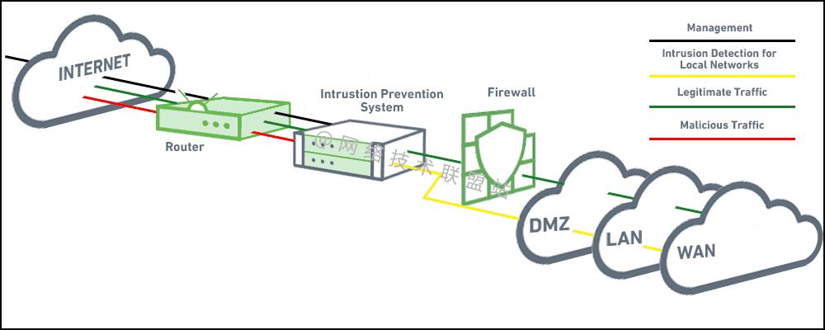
Implementation:
- Deploy next-generation firewalls at internet gateways.
- Enable intrusion prevention system (IPS) functionality.
- Block malicious domains and known attack signatures.
- Review firewall rules quarterly.
Benefit: Reduces exposure to external attacks and malware.

Endpoint Protection
Implementation:
- Install endpoint detection and response (EDR) on all servers and workstations.
- Enable behavioural malware detection.
- Isolate infected devices automatically.
- Monitor security alerts centrally.
Benefit: Improves detection of ransomware and advanced threats.
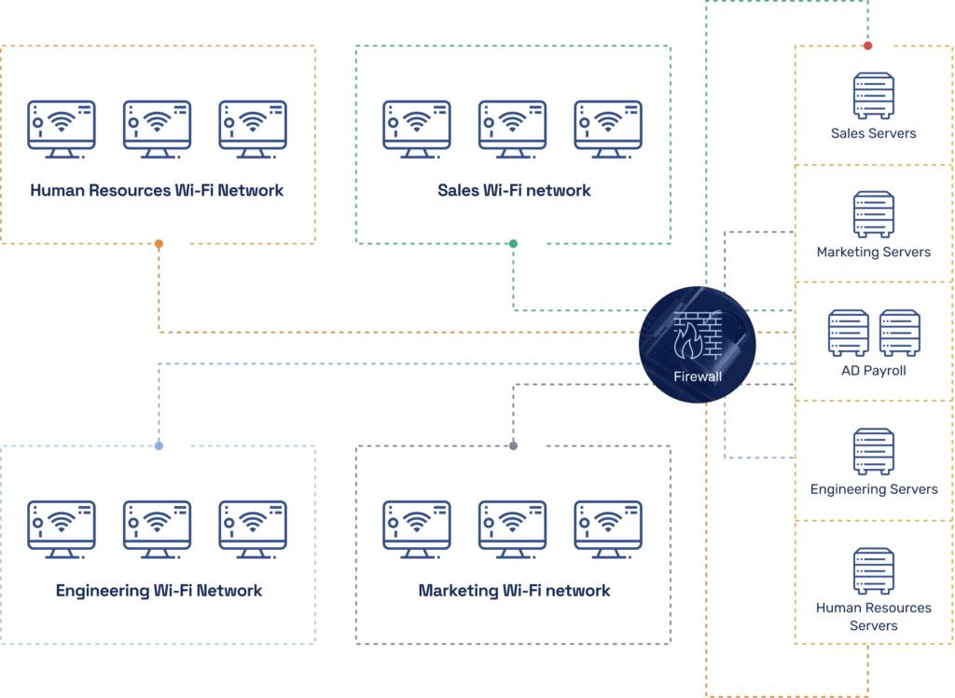
Implementation:
- Separate user devices, servers, databases and guest networks into different VLANs.
- Restrict traffic between segments using firewalls.
- Place public-facing services within a demilitarised zone (DMZ).
Benefit: Prevents attackers from moving freely across the network after initial compromise.

Security Patch Management
Implementation:
- Keeping a record of all hardware and software assets.
- Install in time critical security patches within a maximum of 14 days.
- Test patches in a test environment before deploying.
- Make use of automation where applicable.
As a result of this benefit, an interface will be less susceptible to vulnerabilities that are currently breached by attackers.

Backup Strategy
Implementation:
- Keep three copies of important information.
- For backup: Copy two different types of media.
- Maintain an offline or immutable copy.
- Test complete restoration processes every month.
The benefit: Quickly recover from ransomware or system failure, or accidental deletion.

Zero Trust Security Model
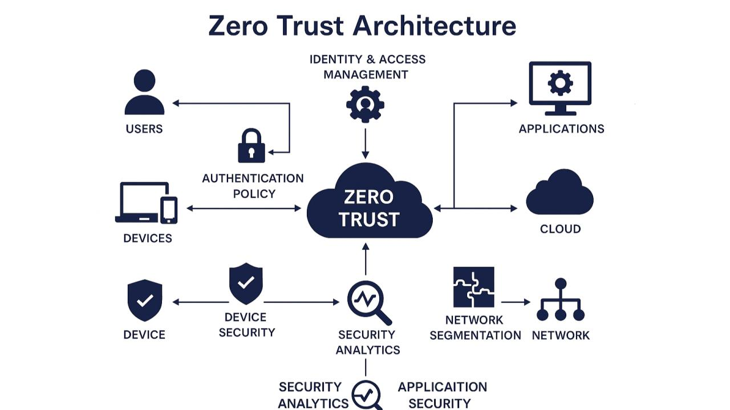
Implementation:
- Double check all users and devices before allowing access.
- Continuously assess risk during active sessions.
- Restrict lateral flow in micro-segmentation.
- Manage conditional access policies, utilizing device health and location.
Warning: Protects users better when operating in a remote environment and accessing cloud resources.

Implementation Priorities
Immediate (0–3 months)
Highest priority:
- Enable MFA.
- Patch critical vulnerabilities.
- Deploy endpoint protection.
- Begin phishing awareness training.
Medium term (3–6 months)
Planned:
- Implement SIEM monitoring.
- Segment the network.
- Formalise security policies.
- Conduct backup recovery testing.
Long term (6–12 months)
Strategic:
- Adopt a Zero Trust architecture.
- Pursue ISO/IEC 27001 certification.
- Perform regular penetration testing.
- Expand supplier security assurance.

References (IEEE)
International Organization for Standardization, ISO/IEC 27001:2022 Information Security Management Systems — Requirements, Geneva: ISO, 2022.
National Institute of Standards and Technology, Cybersecurity Framework (CSF) 2.0, Gaithersburg, MD: NIST, 2024.
UK Government, UK General Data Protection Regulation (UK GDPR), London: UK Government, 2024.
W. Stallings, Network Security Essentials: Applications and Standards, 7th ed., Harlow: Pearson, 2023.
Microsoft, The Value of Multi-Factor Authentication, Microsoft Security Research, 2024.
Using the style and content of your old report, here is a trimmed down paragraph to place as part of "9. Network Monitoring and Incident Response".

Network Monitoring Introduction
Network monitoring is therefore an integral part of FinSecure Ltd's cyber security strategy, considering the amount of financial and customer information that it holds and handles. There are numerous risks involved with cyber threats, including ransomware, phishing, malware, and unauthorised access, which can happen at any moment; either the network needs to be active at all times, or evolutions in its configuration have to be made and tested. Cyber threats can happen at any time, including ransomware, phishing attacks, malware, and unauthorised access, so the network must be on at all times, or alterations to its configuration need to be put in place and tested. The continuous monitoring of the network allows the organisation to quickly detect abnormalities in real-time and thereby allow the IT security team to intervene in time to avoid major damage. Monitoring also can alert to unusual patterns of activity, failed logon attempts and malicious network traffic, ensuring information is kept confidential, protected in integrity and provisioned for availability. In addition, ongoing monitoring helps to facilitate the 'Detect' and 'Respond' tracks of NIST Cybersecurity Framework (CSF) 2.0 to enhance the cyber-resilience of the business, reduce impact and enable adherence to industry best practice and regulations [4, 6].
Architecture for Security Information and Event Management (SIEM)
A Security Information and Event Management (SIEM) system is a unified security tool that allows FinSecure Ltd to oversee, identify and react to cyber threats throughout its network. The SIEM gathers and unifies log information from various sources, such as firewalls, servers, employee PCs, cloud applications, and network equipment, offering an extensive overview of network activity. It examines this data in real time by employing established rules and behaviour analytics to detect suspicious or atypical occurrences, such as multiple failed login attempts, unauthorized access, or malware activity. Upon detection of a potential threat, the SIEM automatically creates alerts, enabling security analysts to quickly examine the situation. Should the inquiry verify that a cyber-attack has taken place, the organization's incident response plan is initiated to control, eliminate, and recuperate from the danger. By adopting a SIEM solution like Microsoft Sentinel, FinSecure Ltd could bolster threat detection abilities, accelerate incident response, and facilitate ongoing monitoring in alignment with the Detect and Respond functions of the NIST Cybersecurity Framework [4], [6].
Internet
│
Next Generation Firewall
│
┌─────────┴─────────┐
│ │
Internal LAN Cloud Services
│ │
Servers & PCs Microsoft 365
│ │
└─────────┬─────────┘
│
SIEM Server
│
Detects unusual behaviour
│
Security Operations Team
Figure 4. Proposed SIEM Monitoring Architecture
Ongoing Surveillance
Ongoing surveillance is crucial for FinSecure Ltd to detect possible cyber security threats before they escalate into significant security events. The entity must consistently observe unsuccessful login attempts, admin account actions, firewall incidents, malware alerts, network activity, file modifications, user activity, and remote VPN access. Observing these actions allows the organization to identify suspicious activities, including frequent authentication failures, unauthorized modifications to essential files, or abnormal network traffic patterns that could suggest a cyber-attack. Through the real-time collection and analysis of this data via the SIEM system, FinSecure Ltd can swiftly detect unusual activity and react promptly to prevent any compromise of sensitive customer information or business operations. Any exceptional or unauthorized actions should trigger security alerts automatically, enabling the IT security team to investigate promptly, thus minimizing the chances of data breaches, financial loss, and extended interruptions to business operations.
Procedure for Responding to Incidents
Readiness
The preparation phase centers on making certain that FinSecure Ltd is equipped to effectively address cyber security incidents before they happen. This entails creating and upholding detailed security policies, distinctly outlining incident response roles and responsibilities, and offering regular cybersecurity awareness training for every employee. Monitoring solutions like the SIEM system, endpoint detection and response (EDR) applications, and intrusion prevention systems must be properly set up to ensure ongoing visibility throughout the network. Moreover, routine backups must be established and recovery procedures assessed to guarantee that essential systems and data can be promptly restored after a security breach.
Identification
The detection phase starts when the SIEM system recognizes questionable or harmful activity throughout the network. Instances that could activate an alert consist of several unsuccessful login attempts, malware findings, atypical downloads of confidential information, unforeseen administrator actions, or irregular network traffic behaviour. Upon detection of suspicious activity, automated notifications are created and sent to the security operations team for prompt investigation. Timely identification is crucial as it allows the organization to act quickly and lessen the possible effects of an assault.
Examination
In the analysis phase, the security team examines the alerts to establish if a real cyber security incident has taken place. Analysts review system logs, network activity, and security incidents to pinpoint the attack's origin, identify impacted systems, and evaluate if sensitive customer or financial information has been breached. The incident's severity is assessed to ensure an adequate response can be put in place. Precise evaluation guarantees that attention is directed towards real dangers while minimizing unnecessary disturbances from false alerts.

Control
Upon confirming a cyber-attack, swift measures must be implemented to stop the threat from disseminating across the organization’s network. This might include isolating infected computers from the network, disabling compromised user accounts, blocking harmful IP addresses via the firewall, and limiting access to affected systems. Efficient containment safeguards essential business services and reduces additional harm while the security team proceeds with its investigation and recovery efforts.
Elimination and Restoration
After effective containment, the organization must eliminate the incident's root cause by eradicating malware, fixing security weaknesses, and implementing the latest software updates. Systems should be reinstated using validated backup copies, guaranteeing that all restored data stays precise and secure. Prior to restoring systems to standard operation, further monitoring must be conducted.
Security Alert
│
▼
SIEM Generates Alert
│
▼
Security Team Reviews Alert
│
▼
Is it a real incident?
│
┌────┴─────┐
│ │
No Yes
│ │
Close Contain Attack
│
▼
Remove Threat
│
▼
Restore Systems
│
▼
Review & Improve
Figure 5. Incident Response Process

Induction Training
Induction training should be provided to all new employees before they are granted access to FinSecure Ltd's systems and networks. The programme should introduce staff to the organisation's cyber security policies and explain their responsibilities for protecting sensitive customer and financial information. Training should cover the importance of creating strong passwords and using multi-factor authentication to prevent unauthorised access. Employees should also receive guidance on recognising phishing emails, suspicious links and other forms of social engineering that are commonly used by cyber criminals. In addition, the induction should explain the key principles of the UK General Data Protection Regulation (UK GDPR), including the lawful handling of personal data, confidentiality requirements and the procedures for reporting potential data breaches. By ensuring that all new employees understand these security requirements from the beginning of their employment, FinSecure Ltd can promote compliance with company policies and reduce the risk of security incidents caused by human error.

Annual Refresher Training
FinSecure Ltd should require all employees to complete annual cyber security refresher training to ensure they remain aware of evolving cyber threats and continue to comply with the organisation's security policies. As cyber criminals constantly develop new attack techniques, the training should provide up-to-date information on emerging threats such as ransomware, phishing campaigns and malware. Employees should also receive further guidance on recognising and preventing social engineering attacks, including email scams, telephone fraud and business email compromise. In addition, the programme should reinforce the importance of protecting personal and financial data in accordance with the UK General Data Protection Regulation (UK GDPR) and the organisation's data protection policies. As remote and hybrid working have become increasingly common, the training should also include best practices for securely accessing company systems through virtual private networks (VPNs), using company-managed devices and avoiding unsecured public Wi-Fi networks. Regular refresher training helps reinforce good cyber security practices, reduces the risk of human error and promotes a strong culture of security awareness across the organisation.

Phishing Simulations
FinSecure Ltd should conduct regular phishing simulation exercises to assess employees' ability to recognise and respond to phishing attacks. The IT department should periodically send realistic but harmless phishing emails that imitate common cyber threats, such as fake login requests, fraudulent invoices or messages appearing to come from trusted organisations. These simulations allow the organisation to measure staff awareness and identify individuals who may be more vulnerable to phishing attacks. Employees who click on malicious links, open suspicious attachments or provide login credentials during the simulation should receive additional cyber security training to help them recognise similar threats in the future. The results of each simulation should be reviewed to identify trends and improve future awareness programmes. By carrying out regular phishing simulations, FinSecure Ltd can strengthen employees' ability to detect phishing attempts, reduce the likelihood of successful cyber-attacks and promote a proactive cyber security culture throughout the organisation.

Role-Based Training
Different staff receive different training.
Staff | Training
Finance | Payment fraud
IT | Incident response
HR | Employee data
Managers | Risk management

Measuring Success
To ensure that the staff training and awareness programme remains effective, FinSecure Ltd should regularly evaluate its performance using measurable indicators. One of the most important measures is the training completion rate, ensuring that all employees complete mandatory cyber security training within the required timescales. The organisation should also review the results of phishing simulation exercises to assess whether employees are becoming better at identifying and reporting phishing attempts over time. In addition, the number of security incidents reported by employees should be monitored, as an increase in reported suspicious activity may indicate greater staff awareness and engagement with cyber security. Regular internal and external audit results should also be reviewed to determine whether employees are complying with the organisation's security policies and regulatory requirements, such as UK GDPR and ISO/IEC 27001. Finally, staff feedback should be collected through surveys or questionnaires to evaluate the quality and relevance of the training programme and identify areas for improvement. By reviewing these performance indicators regularly, FinSecure Ltd can continuously improve its cyber security awareness programme, strengthen employee compliance and develop a proactive security culture throughout the organisation.

Conclusion
In conclusion, this report has demonstrated that FinSecure Ltd faces a wide range of both internal and external cyber security threats that could compromise sensitive customer information, disrupt business operations and damage the organisation's reputation. To address these risks, a comprehensive set of security policies has been recommended to strengthen information security governance and support compliance with recognised standards and legal requirements, including UK GDPR, ISO/IEC 27001:2022 and the NIST Cybersecurity Framework (CSF) 2.0. The proposed mitigation measures, including multi-factor authentication, encryption, network segmentation, endpoint protection and a Zero Trust approach, provide practical solutions to reduce cyber risk and improve the organisation's overall security posture. Furthermore, implementing continuous network monitoring, supported by a Security Information and Event Management (SIEM) system and a structured incident response process, will enable FinSecure Ltd to detect, respond to and recover from cyber incidents more effectively. Finally, establishing an ongoing staff training and awareness programme will encourage employees to follow security policies, recognise emerging cyber threats and contribute to a strong culture of cyber security. By implementing these recommendations, FinSecure Ltd will improve the confidentiality, integrity and availability of its information assets while enhancing regulatory compliance, strengthening organisational resilience and maintaining the trust of its customers and stakeholders.

References
[1] IBM Security, Cost of a Data Breach Report 2024. IBM Corporation, 2024.
[2] UK Government, UK General Data Protection Regulation (UK GDPR). London: UK Government, 2024.
[3] Verizon, 2024 Data Breach Investigations Report. Verizon Business, 2024.
[4] National Institute of Standards and Technology, Cybersecurity Framework (CSF) 2.0. Gaithersburg, MD: National Institute of Standards and Technology, 2024.
[5] International Organization for Standardization, ISO/IEC 27001:2022 Information Security, Cybersecurity and Privacy Protection — Information Security Management Systems — Requirements. Geneva, Switzerland: ISO, 2022.
[6] W. Stallings, Network Security Essentials: Applications and Standards, 7th ed. Harlow, UK: Pearson Education, 2023.
[7] Microsoft, The Value of Multi-Factor Authentication. Microsoft Security Research, 2024.
[8] Microsoft, Microsoft Digital Defense Report 2024. Redmond, WA: Microsoft Corporation, 2024.
[9] National Cyber Security Centre (NCSC), 10 Steps to Cyber Security. London: National Cyber Security Centre, 2023.
[10] National Cyber Security Centre (NCSC), Exercise in a Box. London: National Cyber Security Centre, 2024.
[11] Cisco Systems, Cisco Annual Cybersecurity Report. San Jose, CA: Cisco Systems, 2024.
[12] ISACA, State of Cybersecurity 2024. Schaumburg, IL: ISACA, 2024.
[13] IBM Security, X-Force Threat Intelligence Index 2024. IBM Corporation, 2024.
[14] A. Silberschatz, P. B. Galvin and G. Gagne, Operating System Concepts, 10th ed. Hoboken, NJ: John Wiley & Sons, 2018.
[15] W. Stallings, Cryptography and Network Security: Principles and Practice, 8th ed. Harlow, UK: Pearson Education, 2023.



